Appendix 1. Extrapolation with a second-degree polynomial of the costs and number of crimes for the years 2013 and 2014 for the “car burglary/theft” and “robbery” categories in Poznan.
Black dots and lines refer to available data, and red dots and lines refer to fitted model.

Figure A1. Extrapolation of data in the category “car burglary/theft”:
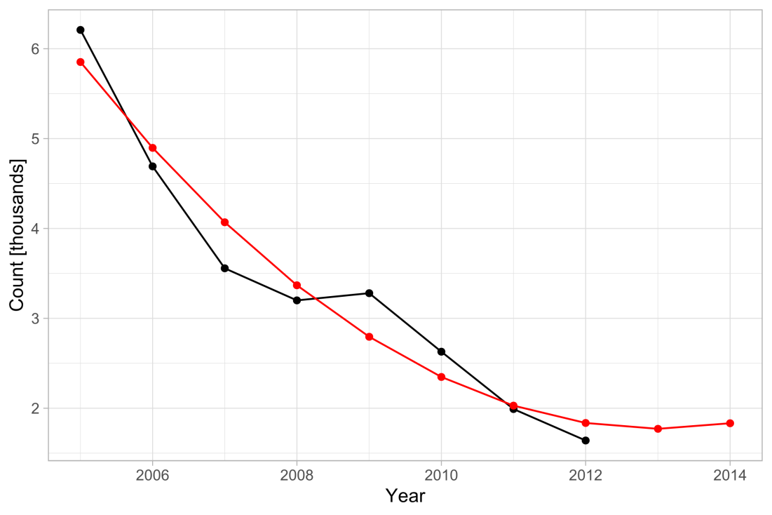
- number of crimes
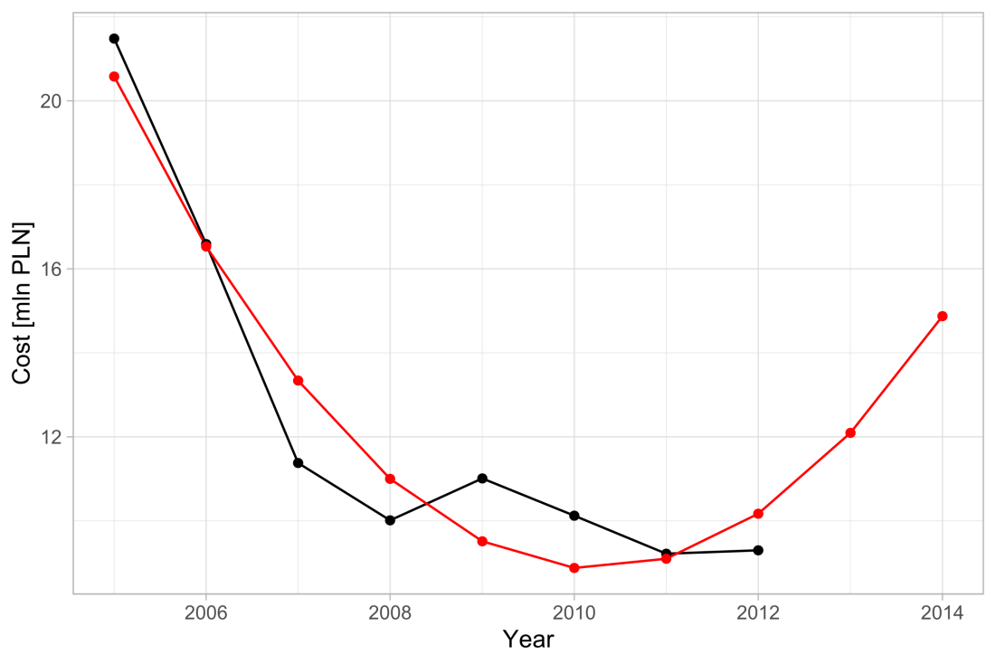
- cost (in PLN)

Figure A2. Extrapolation of data in the category “robbery”:
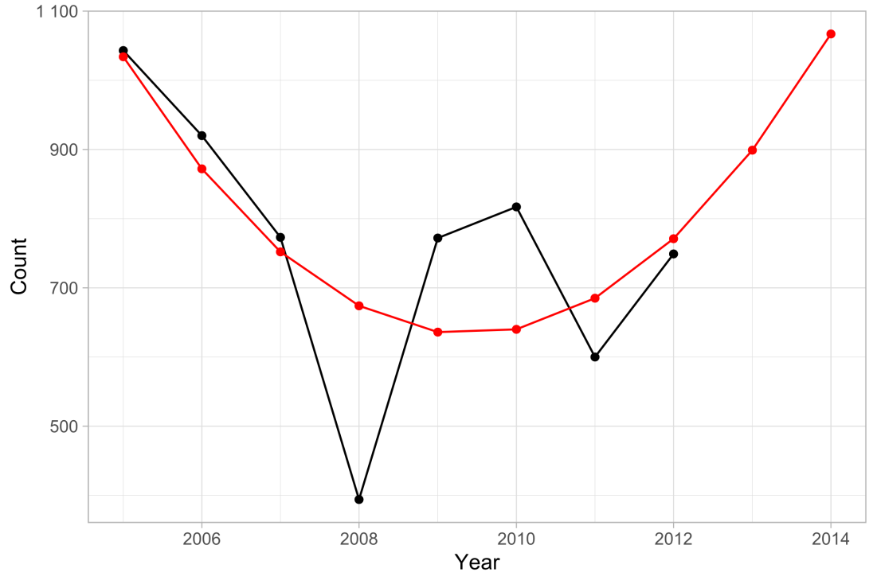
- number of crimes
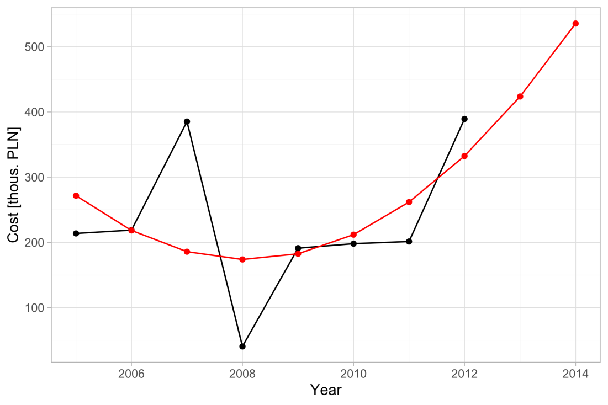
- cost (in PLN)

Analysis of the extrapolated data on the cost per crime incident in each category, shows consistency in the last two (extrapolated) years (Figure A3).

Figure A3. Crime cost per incident (in PLN, log scale).
