Supplementary Information

A simplified in vitro disease-mimicking culture system can determine the angiogenic effect of medicines on vascular diseases

SongHo Moon¹, Yuzuru Ito^{1,2,3*}

¹Faculty of Life and Environmental Sciences, University of Tsukuba, Tsukuba, Ibaraki, Japan
²Life Science Development Department, CHIYODA Corporation, Yokohama, Kanagawa, Japan
³National Institute of Advanced Industrial Science and Technology (AIST), Tsukuba, Ibaraki, Japan

*Corresponding author
Yuzuru Ito
ORCID ID: 0000-0001-7923-865X
Email: ito.yuzuru.fe@u.tsukuba.ac.jp

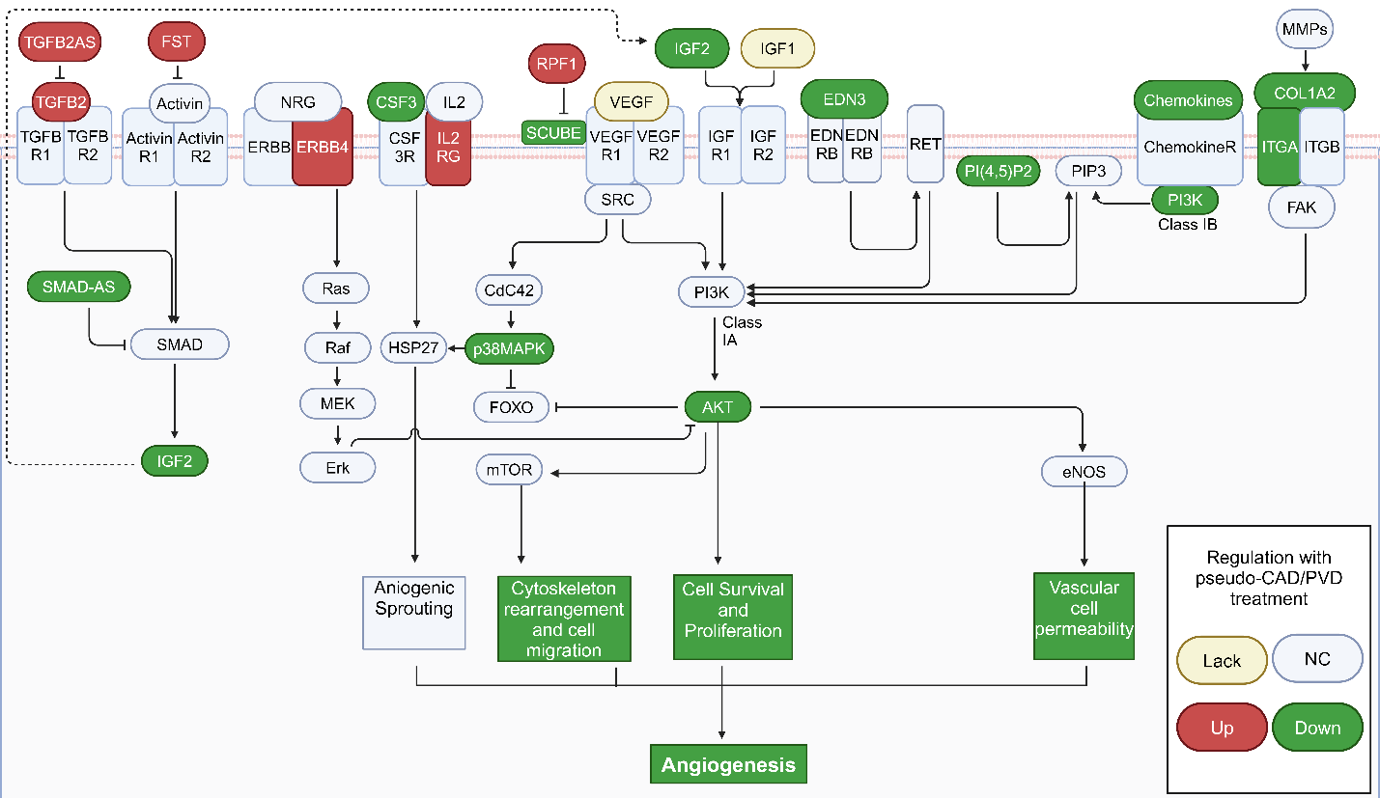
Online Resource 7 Involvement of PI3K/Akt signaling athway in the vasculogenic pathway. Genes related to vascular genesis that were upregulated and downregulated in the pseudo-CAD/PVD environment are indicated in red and green, respectively.

