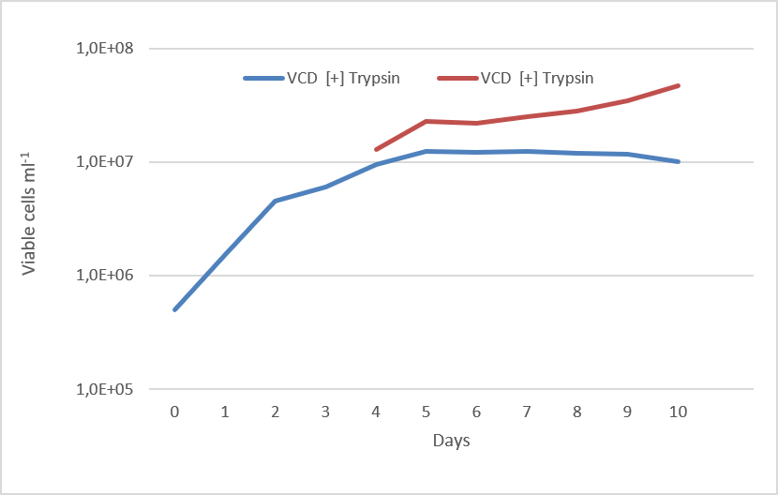
Figure S1. Comparison of viable cell density (VCD) over time measured with and without enzymatic dissociation (trypsin treatment). The samples from innovative bioreactor, which presented clump formation, were treated with a 0.5% trypsin-EDTA solution at 37°C for 8 minutes. The analysis highlights a progressive divergence between the two methods at later culture stages, with trypsin-treated samples showing higher VCD values, indicating a potential underestimation of cell concentration when cell aggregates are not dissociated.
Table S1. Estimated Gompertz model parameters for CHO growth on different bioreactor. The data were fitted to the model $y(t)=A⋅exp⁡\{-exp⁡[(μ⋅e/A)(λ-t)+1]$, where A represents the maximum growth asymptote, μ the maximum specific growth rate, and λ the lag phase duration. Values are reported along with 95% confidence intervals (CI). The goodness of fit is expressed by the coefficient of determination (R²).
 | A | CI95 A | μ | CI95 μ | λ | CI95 λ | R²
Traditional bioreactor | 7.06e+06 | ±4.9e+05 | 2.04e+06 | ±6.76e+05 | 0.662 | ±0.60 | 0.8943
Innovative bioreactor | 1.75e+07 | ±2.7e+06 | 6.90e+06 | ± 5.29+06 | 2.988 | ±1.023 | 0.7455

Table S2. Two-way repeated-measures ANOVA results for the effect of bioreactor type and time on mAb production
Source | Df | Sum of Squares | Mean Square | F value | p-value
Reactor | 1 | 0.329 | 0.329 | 5.29 | 0.047 *
Time | 9 | 9.247 | 1.027 | 165.2 | < 0.001 ***
Reactor × Time | 9 | 1.876 | 0.208 | 33.5 | < 0.001 ***
Residuals | 18 | 0.112 | 0.006 | — | —
Notes: * p < 0.05, *** p < 0.001. Repeated-measures ANOVA with time as within-subject factor.

Table S2.1. Post-hoc pairwise comparisons (Bonferroni correction)
Time (days) | p-value | Bonferroni-adjusted p-value | Significance
1 | 2.57e-02 | 0.257 | ns
2 | 2.65e-04 | 2.65e-03 | **
3 | 5.54e-01 | 1.000 | ns
4 | 1.71e-01 | 1.000 | ns
5 | 4.82e-01 | 1.000 | ns
6 | 5.79e-02 | 0.579 | ns
7 | 8.05e-03 | 0.0805 | ns
8 | 1.35e-04 | 1.35e-03 | **
9 | 3.54e-05 | 3.54e-04 | ***
10 | 3.51e-04 | 3.51e-03 | **
Significance: * p < 0.05; ** p < 0.01; *** p < 0.001; ns = not significant.

