Supplemental file.
Figure 1. The source and biological structure of circ-TTC17. (A) The sample correlation diagram reflected the similarity between the 15 samples. The cell valued at the lower left is the correlation coefficients of the corresponding two samples. The color and area of the upper right circle indicated the correlation degree of the corresponding sample, and the larger the circular area was, the higher the correlation between the two samples was. (B) The fold change of 10 selected circRNAs from case1 vs control of circRNA microarray and their expression levels in 20 plasma samples including 10 from normal patients and 10 from ESCC patients. The -ΔCt value of expressions in plasma were presented using plots. (C) The source and Sanger sequencing of circ-TTC17. (D) The agarose gel electrophoresis of circ-TTC17. (E) Random or oligo (dT)18 primers were used in the reverse transcription experiments. The relative RNA levels were analysed by qRT-PCR and normalized to the value using random primers. * P＜0.05,**P＜0.01,*** P＜0.001.
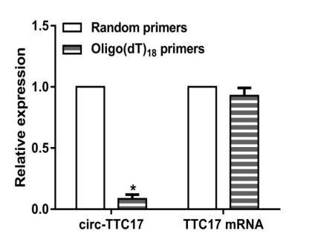
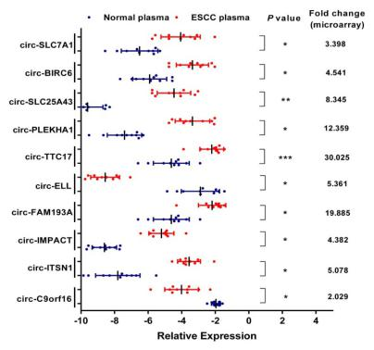
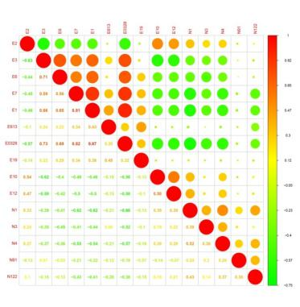
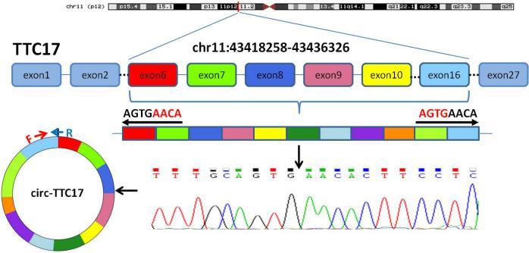
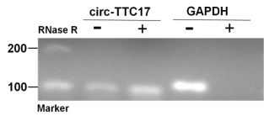
A C
D
E
B
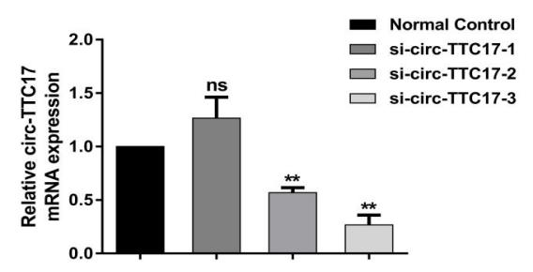
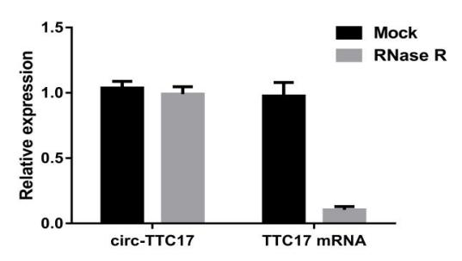
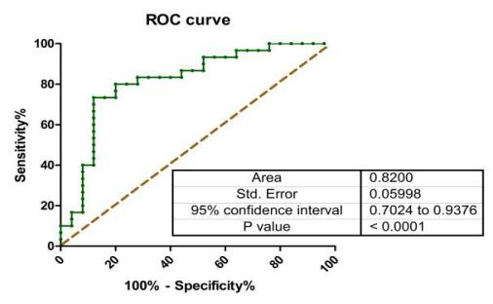
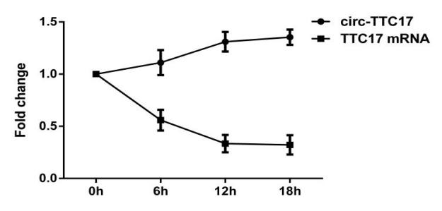
Figure 2. Supplementary experiments to verify related features and functions of circ-TTC17. (A) QRT-PCR for the abundance of circ-TTC17 and TTC17 mRNA in EC cells treated with actinomycin D. (B) QRT-PCR for the abundance of circ-TTC17 and TTC17 mRNA in EC cells treated with RNase R. (C) The ROC curve has been used to evaluate circ-TTC17 potential diagnostic value, the area under the ROC curve (AUC) was 0.8200. (D) Knockdown of circ-TTC17 was verified by qRT-PCR, showing the knockdown effectiveness in ESCC cells.
B
A
C
D

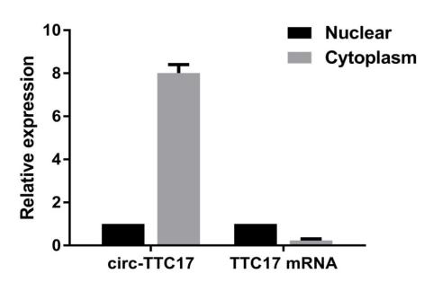
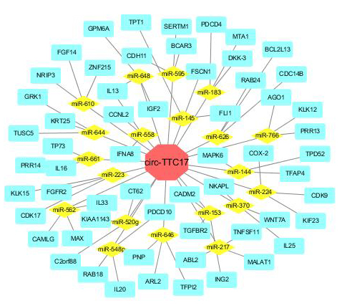
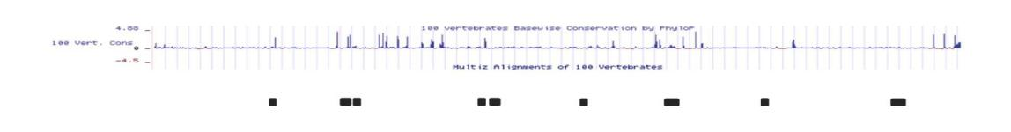
Figure 3. Prediction of circRNA-miRNA-mRNA associations and bioinformatics analysis. (A) The nucleus-cytoplasm fractionation exprement indicated that circ-TTC17 was preferentially localized in the cytoplasm and its source gene TTC17 was mainly located in nuclear. (B) The circ-TTC17 was predicted to have binding sites for AGO2. (C) The circ-TTC17 might serve as a sponge for multiple miRNAs. A schematic drawing showed the miRNAs associated with circ-TTC17.
B
A

C

