Supplemental Table 1. Relative abundance of the major phyla in the duodenum and stool in the same subjects (Group 1, n=53)
 | Relative abundance %
Phylum level | Duodenum (n=53) | Stool (n=53)
Verrucomicrobia | 0 | 3
Bacteroidetes | 6 | 50
Firmicutes | 55 | 40
Fusobacteria | 5 | 1
Proteobacteria | 21 | 5-6
Actinobacteria | 11 | 1
TM7 | <2 | 0

Supplemental Table 2. Relative abundance of the major phyla in different small intestinal segments in the same subjects (Group 2, n=23).

 | Relative abundance %
Phylum | Duodenum | Jejunum | Farthest distance (FD) | FDR P-value*
Actinobacteria | 9 | 8 | 7 | 0.84
Bacteroidetes | 4 | 2 | 4 | 1.13E-5
Firmicutes | 47 | 47 | 52 | 0.84
Fusobacteria | 7 | 4 | 5 | 1.50E-7
Proteobacteria | 32 | 37 | 29 | <0.0001
TM7 | <1 | <2 | <2 | 0.84
* Likelihood Ratio test

Supplemental Table 3. Microbial family differences between small intestinal segments in the same subjects (Group 2, n=23).

 | Jejunum vs. Duodenum |  |  | FD vs. Duodenum |  |  | FD vs. Jejunum
 | Log₂ fold change | P-value | FDR P-value | Log₂ fold change | P-value | FDR P-value | Log₂ fold change | P-value | FDR P-value
Bradyrhizobiaceae | -4.39 | 3.30E-06 | 6.34E-04 | -2.15 | 3.77E-03 | 0.12 | 2.24 | 0.02 | 0.6
Clostridiaceae | 3.39 | 9.43E-05 | 9.06E-03 | 3.67 | 2.42E-05 | 2.32E-03 | 0.28 | 0.72 | 0.95
Fusobacteriaceae | -1.86 | 4.75E-03 | 0.3 | 0.98 | 0.12 | 1 | 2.84 | 1.57E-05 | 1.73E-03
Peptostreptococcaceae | 1.79 | 0.03 | 0.92 | 4.46 | 4.86E-09 | 9.33E-07 | 2.67 | 1.80E-05 | 1.73E-03
Bacillaceae | -0.09 | 0.87 | 0.95 | -1.92 | 2.73E-03 | 0.1 | -1.83 | 4.65E-03 | 0.18
Bacteroidaceae | 0.33 | 0.79 | 0.92 | 3.08 | 0.01 | 0.23 | 2.75 | 0.02 | 0.6
Enterobacteriaceae | 2.49 | 0.03 | 0.92 | 3.7 | 8.81E-04 | 0.06 | 1.21 | 0.28 | 0.95
Enterococcaceae | -0.08 | 0.94 | 0.98 | 2.93 | 2.04E-03 | 0.1 | 3.02 | 2.70E-03 | 0.13
Moraxellaceae | -1.05 | 0.44 | 0.98 | -1.38 | 0.035 | 0.95 | -1.31 | 0.23 | 0.98
Neisseriaceae | -1.61 | 0.53 | 0.98 | -1.32 | 0.026 | 0.95 | -0.64 | 0.99 | 0.92
Pasteurellaceae | -0.47 | 0.54 | 0.92 | 1.89 | 0.01 | 0.23 | 2.36 | 1.72E-03 | 0.11
Prevotellaceae | -1.4 | 0.06 | 0.92 | -1.57 | 0.04 | 0.7 | -0.17 | 0.82 | 0.95
Pseudomonadaceae | -0.45 | 0.58 | 0.92 | -2.37 | 5.19E-03 | 0.14 | -1.91 | 0.02 | 0.6
P-value and FDR P-value < 0.05 are in bold.

Supplemental Table 4. Fold change in the relative abundance of major families from phylum Firmicutes in different small intestinal segments compared to stool, in the same subjects (Group 3, n=8).

 | Stool vs. Duodenum |  | Stool vs. Jejunum |  | Stool vs. Farthest Distance
Families from Firmicutes phylum | Fold change | FDR P-value | Fold change | FDR P-value | Fold change | FDR P-value
Ruminococcaceae | 21.64 | 1.58E-07 | 675.86 | 0 | 351.21 | 1.56E-11
Lachnospiraceae | 5.29 | 9.21E-11 | 4.5 | 1.99E-05 | 2.68 | 0.01
Christensenellaceae | 277 | 0 | 665.94 | 0 | 698.11 | 0
Veillonellaceae | -7.95 | 0 | -6.07 | 1.28E-08 | -3.82 | 1.62E-04
Lactobacillaceae | -18.7 | 5.85E-09 | -4.51 | 0.04 | 2.79 | 0.27
Clostridiaceae | -20.33 | 4.88E-09 | -27.71 | 2.08E-06 | -15.69 | 4.45E-04
Streptococcaceae | -45.86 | 0 | -41.4 | 0 | -43.46 | 0
Carnobacteriaceae | -950.62 | 0 | -814.67 | 0 | -862.95 | 0

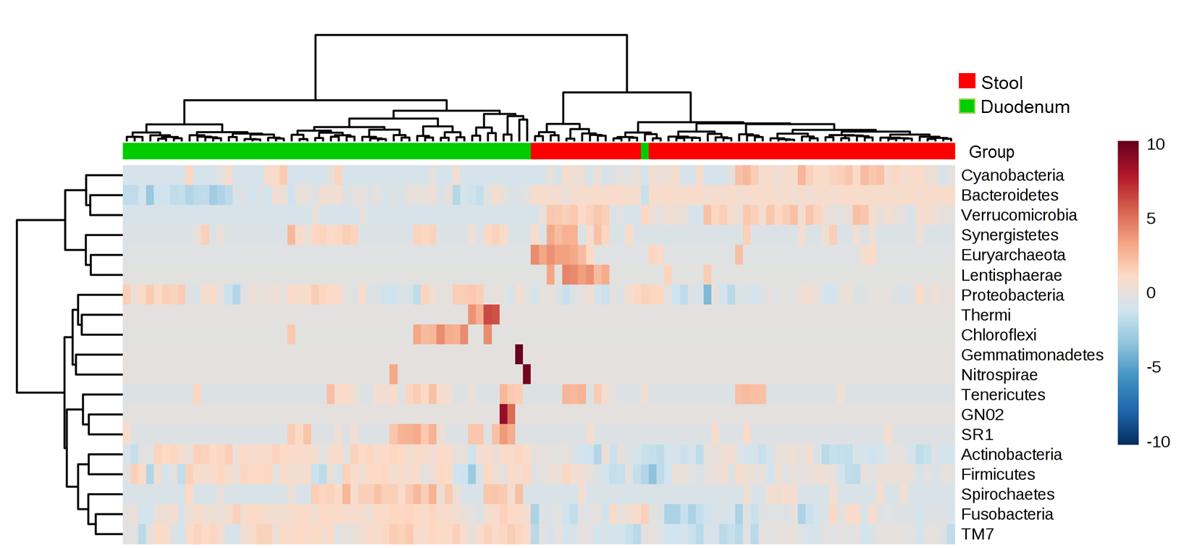

Supplemental Figure 1. Heatmap of the Euclidean Ward clustering analysis of all phyla in the duodenum and stool in the same subjects (Group 1, n=53). Each colored cell corresponds to the relative abundance value of each normalized microbial phylum included in this analysis.

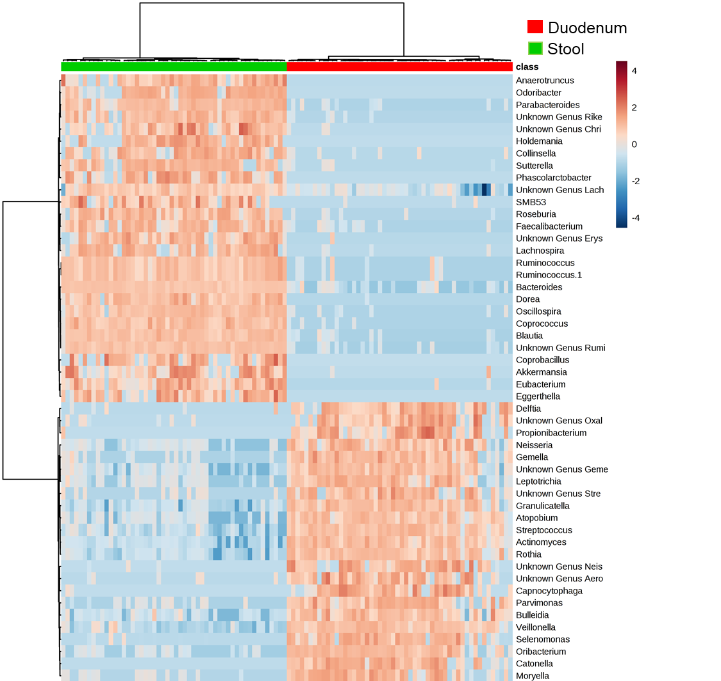

Supplemental Figure 2. Heatmap of the Euclidean Ward clustering analysis of the top 50 statistically significant microbial genera in the duodenum and stool (Group 1, n=53). Each colored cell corresponds to the relative abundance value of each normalized microbial genus included in this analysis.

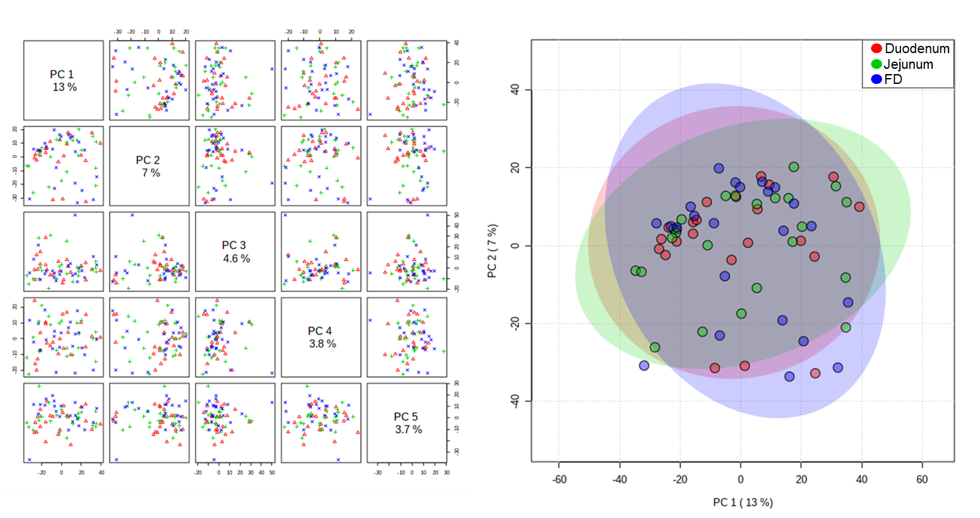
Supplemental Figure 3. PCoA plot of the microbial profiles in different small intestinal segments in the same subjects (Group 2, n=23). Duodenum - red, jejunum - green and farthest distance reached during DBE (FD) - blue. Transparent circles indicate the 95% confidence region.

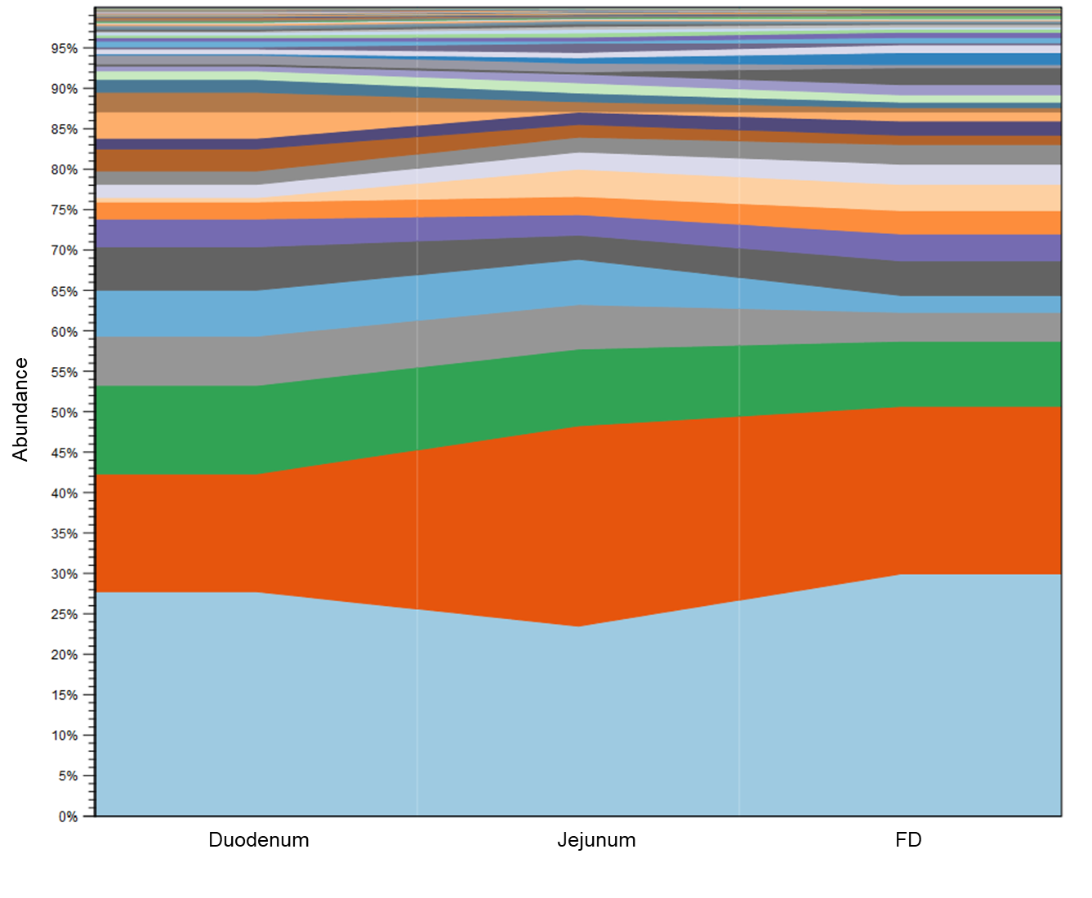
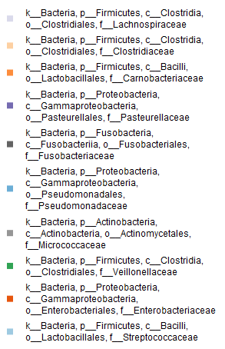

Supplemental Figure 4. Relative abundance of microbial populations at the family level in the duodenum, jejunum and FD, in the same subjects (Group 2, n=23).

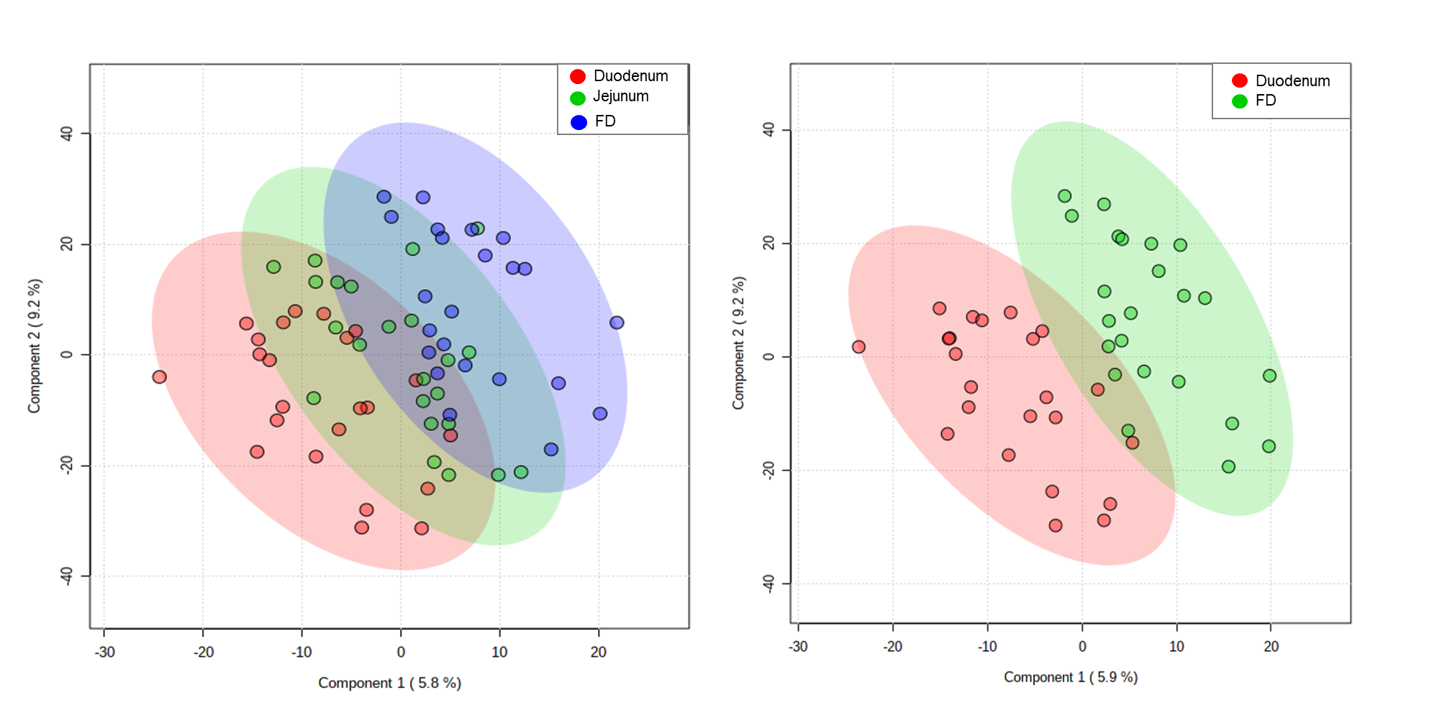
Supplemental Figure 5. A - PLS-DA plot of the microbial populations at the family level in different segments of the small intestine (duodenum - red, jejunum - green and farthest distance reached during DBE (FD) - blue) in the same subjects (Group 2, n=23). Transparent circles indicate the 95% confidence region. B - PLS-DA plot of the microbial populations at the family level in the duodenal and FD in the same subjects (Group 2, n=23). Duodenum – red, FD - green. Transparent circles indicate the 95% confidence region.

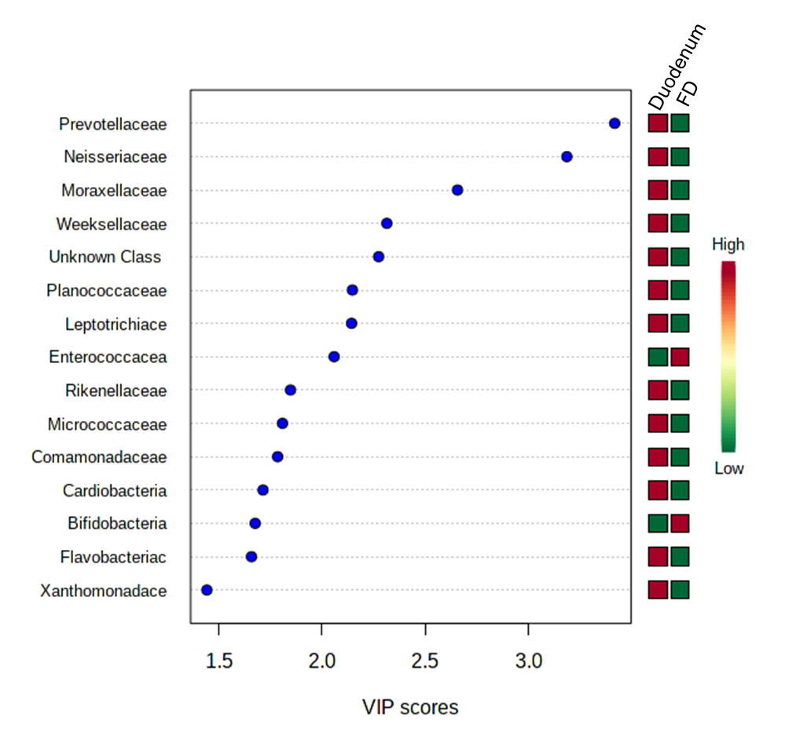
Supplemental Figure 6. Variable importance in projection (VIP) selected during PLS-DA analysis of families identified in duodenum and farthest distance (FD) in the same subjects (Group 2, n=23). Each colored cell on the right side corresponds to the relative abundance value of each normalized microbial family included in this analysis.

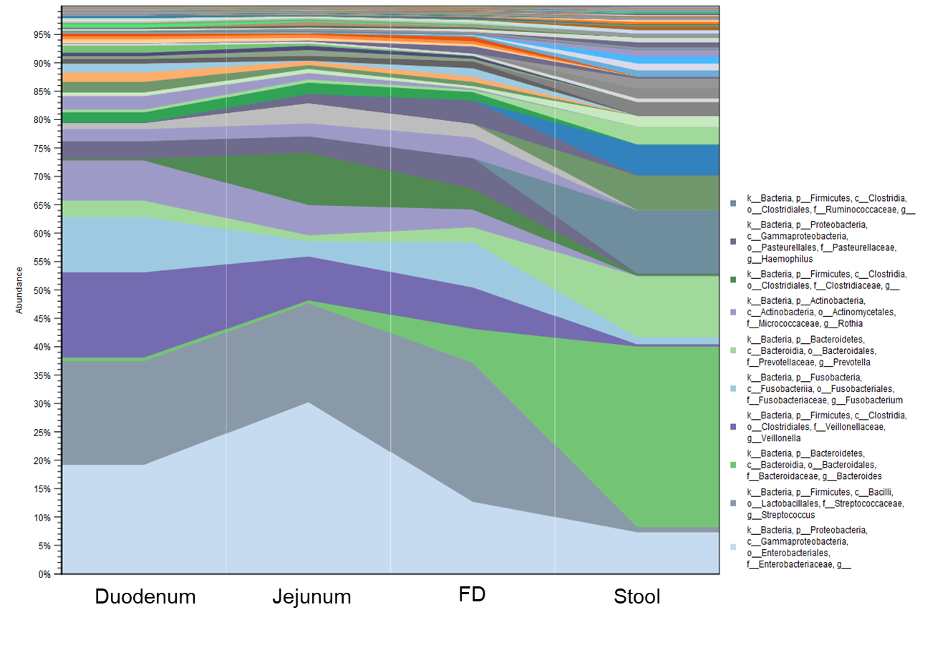
Supplemental Figure 7. Relative abundance of microbial populations at the genus level in the duodenum, jejunum, FD and stool in the same subjects (Group 3, n=8).

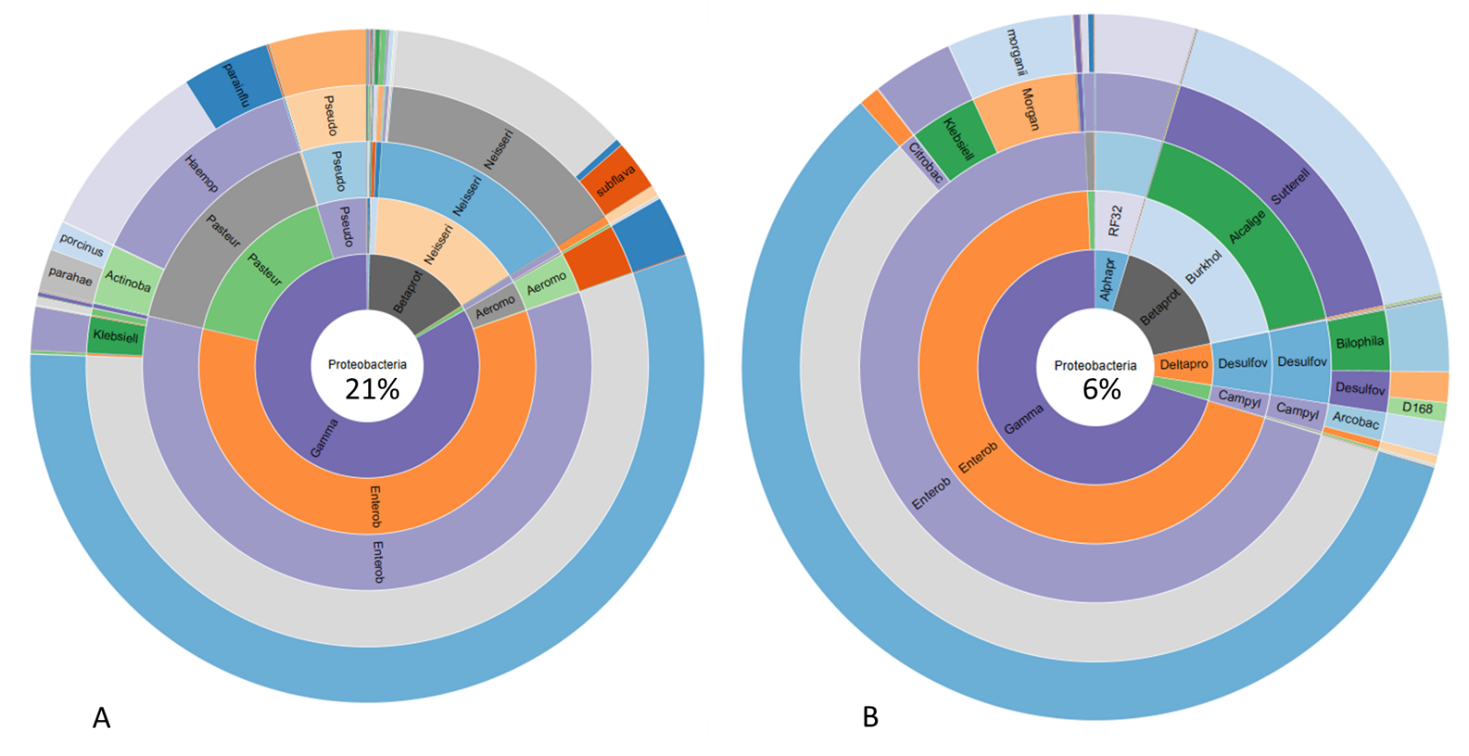

Supplemental Figure 8. Composition of phylum Proteobacteria in the small intestine (A) and stool (B).

