Supplementary materials for: Comparative Efficacy of Subcutaneous and Intravenous Infliximab and Vedolizumab for Maintenance Treatment of Inflammatory Bowel Disease

Dig Dis Sci

L. Peyrin-Biroulet, P. Bossuyt, D. Bettenworth, E. V. Loftus Jr., S. I. Anjie, G. D’Haens, M. Saruta, P. Arkkila, H. Park, D. Choi, D-H. Kim, W. Reinisch

Corresponding author: W. Reinisch
Postal address: Department of Internal Medicine III, Medical University of Vienna,
1090 Vienna, Austria
Email: walter.reinisch@meduniwien.ac.at
ORCID ID: 0000-0002-2088-091X

Search strategy for Crohn’s disease cohort

PubMed
Search no. | Search terms for Crohn’s disease | No. of articles
#1 | (("inflammatory bowel disease"[All Fields] OR "crohn's disease"[All Fields]) OR "IBD"[All Fields]) OR "Crohn"[Title/Abstract] | 97,072
#2 | #1 AND ("Biological Therapy"[Mesh] OR "Tumor Necrosis Factors"[Mesh] OR "infliximab"[Mesh] OR "vedolizumab"[Mesh] OR "Biosimilar Pharmaceuticals"[Mesh] OR biologic[Title] OR biologics[Title] OR biological therap[Title] OR biotherap[Title] OR TNF[Title] OR anti-TNF[Title] OR tumor necrosis factor*[Title] OR anti-tumor necrosis factor*[Title] OR infliximab[Title] OR remicade[Title] OR "MAb cA2"[Title] OR "monoclonal antibody cA2"[Title] OR vedolizumab[Title] OR entyvio[Title] OR "MLN0002"[Title] OR Inflectra[Title] OR “CT-P13”[Title] OR “SB2”[Title] OR “GP1111” OR “ABP710”[Title] OR “PF06438179”[Title] OR Renflexis[Title] OR Avsola[Title] OR Flixabi[Title] OR Zessly[Title] OR remsima[Title]) | 13,532
#3 | #2 AND ("Randomized Controlled Trials as Topic"[Mesh] OR "Randomized Controlled Trial"[Publication Type] OR randomized[Title/Abstract] OR randomised[Title/Abstract] OR placebo*[Title/Abstract] OR randomly[Title/Abstract] OR randomized controlled trial*[Title/Abstract] OR randomised controlled trial*[Title/Abstract] OR randomized clinical trial*[Title/Abstract] OR randomised clinical trial*[Title/Abstract] OR randomized trial*[Title/Abstract] OR randomised trial*[Title/Abstract] OR randomization[Title/Abstract] OR randomisation[Title/Abstract] OR random*[Title/Abstract]) | 1,236

Embase
Search no. | Search terms for Crohn’s disease | No. of articles
#1 | ('inflammatory bowel disease'/exp/mj OR 'inflammatory bowel disease':ti OR 'inflammatory bowel diseases':ti OR 'ibd':ti OR 'crohn disease'/exp/mj OR 'crohns disease':ti) AND [english]/lim AND [embase]/lim AND [1997-2022]/py | 98,472
#2 | #1 AND ('biological therapy'/exp OR 'tumor necrosis factor'/exp OR 'infliximab'/exp OR 'vedolizumab'/exp OR 'biosimilar agent'/exp OR biologic:ti OR biologics:ti OR tnf*:ti OR infliximab:ti OR remicade:ti OR 'mab ca2':ti OR 'monoclonal antibody ca2':ti OR vedolizumab:ti OR entyvio:ti OR 'mln0002':ti OR inflectra:ti OR renflexis:ti OR CT-P13:ti OR SB2:ti OR ABP710:ti OR PF06438179:ti OR Avsola:ti OR Flixabi:ti OR Zessly:ti OR remsima:ti) AND [english]/lim AND [embase]/lim AND [1997-2022]/py | 38,757
#3 | #2 AND ('randomized controlled trial (topic)'/exp OR 'randomized controlled trial'/exp OR randomized:ti,ab OR randomised:ti,ab OR placebo*:ti,ab OR 'double blind method':ti,ab AND ((blind*:ti,ab OR mask*:ti,ab)) OR randomization:ti,ab OR randomisation:ti,ab OR random*:ti,ab) AND [english]/lim AND [embase]/lim AND [1997-2022]/py | 4,568

Search strategy for ulcerative colitis cohort

PubMed
Search no. | Search terms for ulcerative colitis | No. of articles
#1 | (("inflammatory bowel disease"[All Fields] OR "ulcerative colitis"[All Fields]) OR "IBD"[All Fields]) OR "colitis ulcerosa"[Title/Abstract] | 97,662
#2 | #1 AND ("Biological Therapy"[Mesh] OR "Tumor Necrosis Factors"[Mesh] OR "infliximab"[Mesh] OR "vedolizumab"[Mesh] OR "Biosimilar Pharmaceuticals"[Mesh] OR biologic[Title] OR biologics[Title] OR biological therap[Title] OR biotherap[Title] OR TNF[Title] OR anti-TNF[Title] OR tumor necrosis factor*[Title] OR anti-tumor necrosis factor*[Title] OR infliximab[Title] OR remicade[Title] OR "MAb cA2"[Title] OR "monoclonal antibody cA2"[Title] OR vedolizumab[Title] OR entyvio[Title] OR "MLN0002"[Title] OR Inflectra[Title] OR “CT-P13”[Title] OR “SB2”[Title] OR “GP1111” OR “ABP710”[Title] OR “PF06438179”[Title] OR Renflexis[Title] OR Avsola[Title] OR Flixabi[Title] OR Zessly[Title] OR remsima[Title]) | 11,838
#3 | #2 AND ("Randomized Controlled Trials as Topic"[Mesh] OR "Randomized Controlled Trial"[Publication Type] OR randomized[Title/Abstract] OR randomised[Title/Abstract] OR placebo*[Title/Abstract] OR randomly[Title/Abstract] OR randomized controlled trial*[Title/Abstract] OR randomised controlled trial*[Title/Abstract] OR randomized clinical trial*[Title/Abstract] OR randomised clinical trial*[Title/Abstract] OR randomized trial*[Title/Abstract] OR randomised trial*[Title/Abstract] OR randomization[Title/Abstract] OR randomisation[Title/Abstract] OR random*[Title/Abstract]) | 1,112

Embase
Search no. | Search terms for ulcerative colitis | No. of articles
#1 | ('inflammatory bowel disease'/exp/mj OR 'inflammatory bowel disease':ti OR 'inflammatory bowel diseases':ti OR 'ibd':ti OR 'ulcerative colitis'/exp/mj OR 'colitis ulcerosa':ti) AND [english]/lim AND [embase]/lim AND [1997-2022]/py | 98,480
#2 | #1 AND ('biological therapy'/exp OR 'tumor necrosis factor'/exp OR 'infliximab'/exp OR 'vedolizumab'/exp OR 'biosimilar agent'/exp OR biologic:ti OR biologics:ti OR tnf*:ti OR infliximab:ti OR remicade:ti OR 'mab ca2':ti OR 'monoclonal antibody ca2':ti OR vedolizumab:ti OR entyvio:ti OR 'mln0002':ti OR inflectra:ti OR renflexis:ti OR CT-P13:ti OR SB2:ti OR ABP710:ti OR PF06438179:ti OR Avsola:ti OR Flixabi:ti OR Zessly:ti OR remsima:ti) AND [english]/lim AND [embase]/lim AND [1997-2022]/py | 36,059
#3 | #2 AND ('randomized controlled trial (topic)'/exp OR 'randomized controlled trial'/exp OR randomized:ti,ab OR randomised:ti,ab OR placebo*:ti,ab OR 'double blind method':ti,ab AND ((blind*:ti,ab OR mask*:ti,ab)) OR randomization:ti,ab OR randomisation:ti,ab OR random*:ti,ab) AND [english]/lim AND [embase]/lim AND [1997-2022]/py | 3,078

Supplementary Fig. 1 Quality assessment for studies contributing to A Crohn’s disease and B ulcerative colitis analyses, evaluated using the Cochrane Risk of Bias tool version 1.0 [1]
D1-1, random sequence generation; D1-2, allocation concealment; D2, blinding of participants and personnel; D3, blinding of outcome assessment; D4, incomplete outcome data; D5, selective reporting; D6, anything else, ideally prespecified;
SC, subcutaneous

Supplementary Fig. 2 Rank probability of clinical remission during IFX or VDZ maintenance therapy in TNFi-naïve patients with moderate-to-severe A Crohn’s disease or B ulcerative colitis; and of C mucosal healing in TNFi-naïve patients with moderate-to-severe UC. Darker green shading corresponds to a higher probability of a given treatment having a given rank. Rank 1 is the best option and rank 7 (A) or 8 (B) is the worst option. Within each rank, the treatment with the darkest shading (denoting the highest rank probability) is considered to rank in that position, i.e., IFX SC 120 mg Q2W has the best rank and PBO has the worst rank in both panels
ª Only responders by the end of the induction phase were re-randomized and assessed in the maintenance phase
IFX, infliximab; IV, intravenous; PBO, placebo; QnW, every n weeks; SC, subcutaneous; TNFi, tumor necrosis factor inhibitor; VDZ, vedolizumab

Supplementary Fig. 3 Forest plots for endoscopic outcomes in patients with moderate-to-severe CD who received A IFX IV 5 mg/kg Q8W (proportional
meta-analysis; integrated outcome: mucosal healingª and endoscopic remission^{b}),
B IFX IV 10 mg/kg Q8W (outcome: mucosal healingª), C IFX SC 120 mg Q2W (proportional meta-analysis; outcome: endoscopic remission^{b}), or D VDZ SC 108 mg Q2W (outcome: endoscopic remission^{c})
A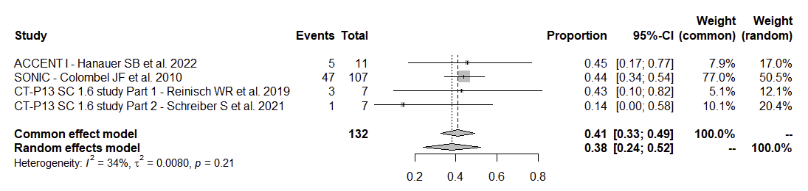B
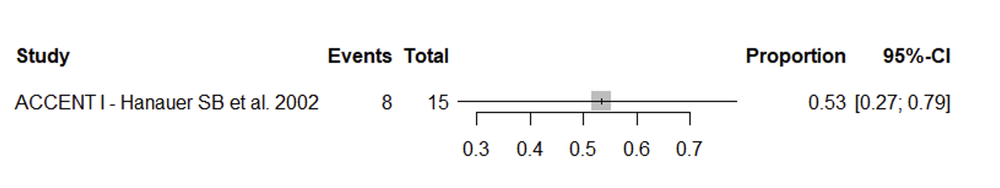
C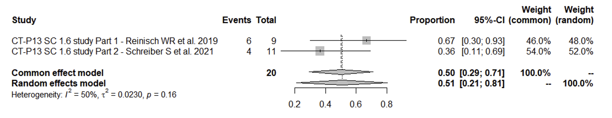D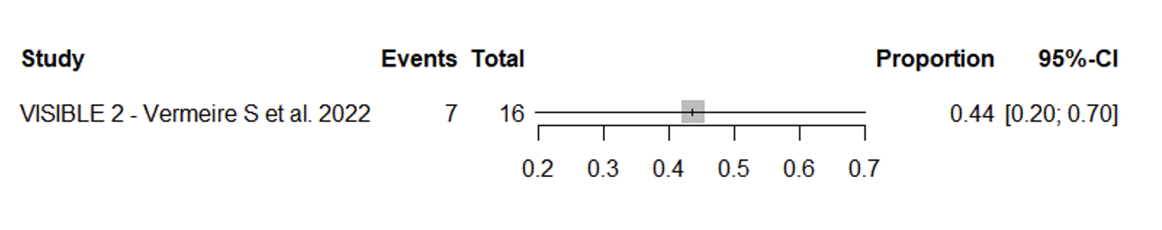
ª Mucosal healing (ACCENT I, SONIC): absence of all ulcers
^{b} Endoscopic remission (CT-P13 SC 1.6 study Part 1/2,): absolute SES‑CD of ≤2 points
^{c} Endoscopic remission (VISIBLE 2): SES-CD subscore of ≤2 points
CD, Crohn’s disease; CI, confidence interval; IFX, infliximab; IV, intravenous; QnW, every n weeks; SC, subcutaneous; SES-CD, Simple Endoscopic Score for Crohn’s Disease; VDZ, vedolizumab; W, Week

Supplementary reference
1. Higgins JP, Altman DG, Gotzsche PC, et al. The Cochrane Collaboration's tool for assessing risk of bias in randomised trials. BMJ. 2011;343:d5928.

