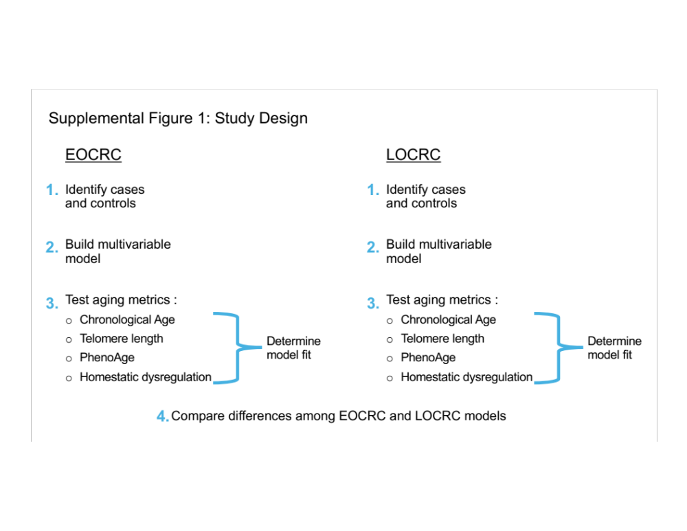
Supplemental Figure 1: Study Design

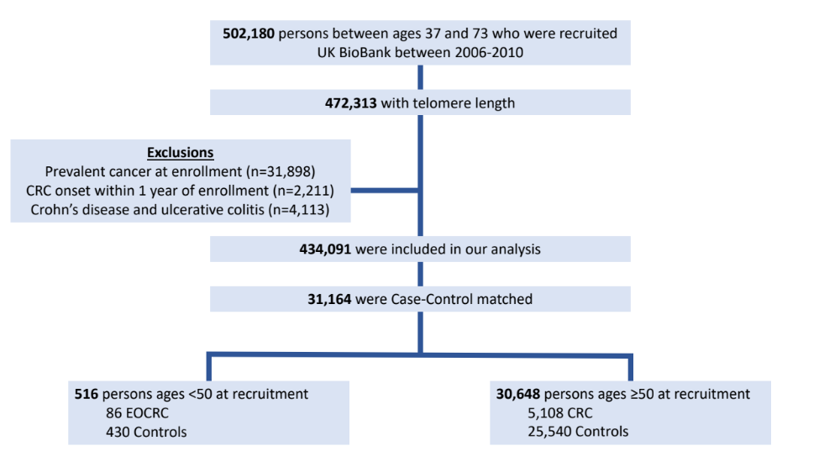
Supplemental Figure 2: Flow chart, depicting participant inclusion

Supplemental Table 1: Additional variables in cohort characteristics

 | EOCRC |  |  | Later-onset CRC
 | Controls (n=430) | Cases  (n=86) | p-value | Controls (n=25,540) | Cases  (n=5108) | p-value
Waist Circumference (cm), median (IQR) | 86.0 [78.0, 97.0] | 86.5 [75.0, 94.0] | 0.48 | 92.0 [84.0, 101.0] | 94.0 [85.0, 103.0] | <0.05
Missing | 0 (0%) | 0 (0%) | 0.48 | 45 (0.2%) | 11 (0.2%) | <0.05
Hip Circumference (cm), median (IQR) | 102.0 [97.0, 107.0] | 100.5 [95.0, 105.0] | 0.17 | 102.0 [98.0, 108.0] | 103.0 [98.0, 108.8] | <0.05
Missing | 0 (0%) | 0 (0%) | 0.17 | 51 (0.2%) | 12 (0.2%) | <0.05
Processed Meat Intake Frequency, n (%) |  |  | 0.80 |  |  | <0.05
Never/Once a week or less | 280 (65.1%) | 54 (62.8%) | 0.80 | 17237 (67.5%) | 3346 (65.5%) | <0.05
Multiple times a week to daily | 148 (34.4%) | 32 (37.2%) | 0.80 | 8238 (32.3%) | 1748 (34.2%) | <0.05
Unknown/Missing | 2 (0.5%) | 0 (0%) | 0.80 | 65 (0.3%) | 14 (0.3%) | <0.05
Alcohol Intake Frequency, n (%) |  |  | 0.68 |  |  | 0.17
Never/Less than once a week | 145 (33.7%) | 26 (30.2%) | 0.68 | 7173 (28.1%) | 1373 (26.9%) | 0.17
More than once a week | 283 (65.8%) | 60 (69.8%) | 0.68 | 18318 (71.7%) | 3723 (72.9%) | 0.17
Unknown/Missing | 2 (0.5%) | 0 (0%) | 0.68 | 49 (0.2%) | 12 (0.2%) | 0.17
Diabetes, n (%)* | 6 (1.4%) | 2 (2.3%) | 0.63 | 1235 (4.8%) | 279 (5.5%) | 0.06
Dyslipidemia, n (%)* | 311 (72.3%) | 62 (72.1%) | 1.00 | 21900 (85.7%) | 4417 (86.5%) | 0.18
Hypertension, n (%)* | 15 (3.5%) | 3 (3.5%) | 1.00 | 4861 (19.0%) | 1023 (20.0%) | 0.10
Breastfed as a baby, n (%) | 209 (48.6%) | 42 (48.8%) | 0.91 | 14256 (55.8%) | 2833 (55.5%) | 0.57
Unknown/Missing | 74 (17.2%) | 13 (15.1%) | 0.91 | 7442 (29.1%) | 1524 (29.8%) | 0.57
Comparative Body Size at Age 10, n (%) |  |  | 0.28 |  |  | 0.17
About average | 189 (44.0%) | 43 (50.0%) | 0.28 | 12871 (50.4%) | 2517 (49.3%) | 0.17
Plumper | 75 (17.4%) | 9 (10.5%) | 0.28 | 3596 (14.1%) | 762 (14.9%) | 0.17
Thinner | 151 (35.1%) | 33 (38.4%) | 0.28 | 8502 (33.3%) | 1699 (33.3%) | 0.17
Unknown/Missing | 15 (3.5%) | 1 (1.2%) | 0.28 | 571 (2.2%) | 130 (2.5%) | 0.17
Sleep Duration (hours), median (IQR) | 7.0 [7.0, 8.0] | 7.0 [7.0, 8.0] | 0.14 | 7.0 [7.0, 8.0] | 7.0 [7.0, 8.0] | 0.78
Missing | 1 (0.2%) | 0 (0%) | 0.14 | 24 (0.1%) | 6 (0.1%) | 0.78
Summed MET Minutes Per Week for All Activity, median (IQR) | 1678.0 [799.5, 3692.6] | 1802.0 [734.0, 3313.5] | 0.95 | 1866 [847.5, 3770.0] | 1774 [808.5, 3546.0] | <0.05
Missing | 68 (15.8%) | 20 (23.3%) | 0.95 | 6039 (23.6%) | 1186 (23.2%) | <0.05
Vitamin D (mmol/L), median (IQR) | 41.4 [28.5, 59.4] | 45.0 [28.8, 59.7] | 0.53 | 48.8 [34.2, 63.6] | 47.2 [32.9, 62.3] | <0.05
Missing | 29 (6.7%) | 6 (7.0%) | 0.53 | 2233 (8.7%) | 464 (9.1%) | <0.05
Calcium (mmol/L), median (IQR) | 2.4 [2.3, 2.4] | 2.4 [2.3, 2.4] | 0.40 | 2.4 [2.3, 2.4] | 2.4 [2.3, 2.4] | 0.36
Missing | 60 (14.0%) | 6 (7.0%) | 0.40 | 3127 (12.2%) | 618 (12.1%) | 0.36
*Due to data availability, these data were only available for males, not females.
Supplemental Table 2: Univariable results of logistic regression models
 |  | EOCRC |  | Later Onset CRC
Covariate | Categories | OR (95% CI) | P-value | OR (95% CI) | P-value
Age |  | 1.00 (0.90-1.10) | 1.000 | 1.00 (0.99-1.01) | 1.000
Sex | Female | - |  | -
 | Male | 1.00 (0.63-1.59) | 1.000 | 1.00 (0.94-1.06) | 1.000
Ethnicity | UK | - |  | -
 | Asian | 0.50 (0.12-1.46) | 0.268 | 0.50 (0.36-0.66) | <0.001
 | Black/African | 1.83 (0.39-6.47) | 0.382 | 0.62 (0.36-0.98) | 0.054
 | Other/Missing | 0.81 (0.19-2.47) | 0.743 | 0.91 (0.71-1.14) | 0.412
Country of Birth | UK | - |  | -
Country of Birth | Non-UK | 0.41 (0.14-0.97) | 0.066 | 0.89 (0.78-1.01) | 0.080
Country of Birth | Unknown/Missing | 0.00 (NA-1.45e+42) | 0.982 | 0.63 (0.26-1.30) | 0.252
Body Mass Index (kg/m²) |  | 0.97 (0.91-1.02) | 0.211 | 1.02 (1.01-1.03) | <0.001
Body Fat (%) |  | 0.99 (0.97-1.02) | 0.702 | 1.01 (1.00-1.01) | <0.001
Trunk Fat (%) |  | 1.00 (0.97-1.03) | 0.786 | 1.01 (1.01-1.01) | <0.001
Waist Circumference (cm) |  | 0.99 (0.97-1.01) | 0.370 | 1.01 (1.01-1.01) | <0.001
Hip Circumference (cm) |  | 0.98 (0.95-1.00) | 0.109 | 1.01 (1.01-1.01) | <0.001
Waist-to-Hip Ratio |  | 1.12 (0.08-16.36) | 0.935 | 3.07 (2.18-4.31) | <0.001
Standard PRS for Bowel Cancer |  | 1.52 (1.21-1.93) | <0.001 | 1.50 (1.46-1.54) | <0.001
Breastfed as a Baby | No | - |  | -
 | Yes | 0.95 (0.57-1.60) | 0.853 | 1.02 (0.93-1.11) | 0.713
 | Unknown/Missing | 0.83 (0.40-1.66) | 0.612 | 1.05 (0.95-1.15) | 0.340
Comparative Body Size at Age 10 | About average | - |  | -
Comparative Body Size at Age 10 | Plumper | 0.53 (0.23-1.09) | 0.102 | 1.08 (0.99-1.18) | 0.077
 | Thinner | 0.96 (0.58-1.58) | 0.875 | 1.02 (0.96-1.09) | 0.529
 | Unknown/Missing | 0.29 (0.02-1.51) | 0.241 | 1.16 (0.95-1.41) | 0.127
Ever had Bowel Cancer Screening | No | - |  | -
Ever had Bowel Cancer Screening | Yes | 1.55 (0.75-3.02) | 0.212 | 0.84 (0.79-0.89) | <0.001
 | Unknown/Missing | 0.00 (NA-2.38e+15) | 0.980 | 0.69 (0.54-0.88) | 0.003
Diabetes | No DM | - |  | -
 | DM | 1.68 (0.24-7.45) | 0.528 | 1.14 (0.99-1.30) | 0.059
Dyslipidemia | No | - |  | -
 | Yes | 0.99 (0.60-1.68) | 0.965 | 1.06 (0.97-1.16) | 0.175
Hypertension | No HTN | - |  | -
 | HTN | 1.00 (0.23-3.11) | 1.000 | 1.07 (0.99-1.15) | 0.099
Father or mother or sibling with bowel cancer | No | - |  | -
 | Yes | 2.21 (1.08-4.34) | 0.024 | 1.31 (1.20-1.42) | <0.001
Ever smoked | No | - |  | -
 | Yes | 1.16 (0.73-1.85) | 0.542 | 1.15 (1.08-1.23) | <0.001
 | Unknown/Missing | 0.00 (NA-1.69e+42) | 0.982 | 0.84 (0.51-1.30) | 0.455
Processed meat intake | Never/Once a week or less | - |  | -
 | Multiple times a week to daily | 1.12 (0.69-1.80) | 0.641 | 1.09 (1.03-1.16) | 0.006
 | Unknown/Missing | 0.00 (NA-8.72e+36) | 0.983 | 1.11 (0.60-1.92) | 0.725
Alcohol intake frequency | Never/Less than once a week | - |  | -
 | More than once a week | 1.18 (0.72-1.98) | 0.513 | 1.06 (0.99-1.14) | 0.082
 | Unknown/Missing | 0.00 (NA-9.09e+36) | 0.984 | 1.28 (0.65-2.33) | 0.446
Sleep Duration |  | 1.21 (0.97-1.51) | 0.093 | 1.00 (0.98-1.03) | 0.797
Summed MET minutes per week for all activity |  | 1.00 (1.00-1.00) | 0.894 | 1.00 (1.00-1.00) | 0.001
Vitamin D (nmol/L) |  | 1.00 (0.99-1.01) | 0.562 | 1.00 (1.00-1.00) | <0.001
Calcium (mmol/L) |  | 1.68 (0.12-22.42) | 0.696 | 0.86 (0.61-1.21) | 0.392
Telomere length (Z-adjusted T/S log) |  | 1.16 (0.92-1.46) | 0.198 | 1.00 (0.97-1.03) | 0.951
PhenoAge-Chronological Age  (years) |  | 1.07 (1.02-1.12) | 0.003 | 1.01 (1.01-1.02) | <0.001
Homeostatic Dysregulation |  | 1.26 (1.02-1.57) | 0.028 | 1.06 (1.03-1.09) | <0.001
Log Homeostatic Dysregulation |  | 1.33 (1.05-1.67) | 0.016 | 1.06 (1.03-1.10) | <0.001

Supplemental Table 3: Model fit for the multivariable logistic regression model with and without different measures of accelerated aging, EOCRC

Variable | BIC  Median (IQR) | AIC  Median (IQR)
Final Model* | 421 [421, 422] | 389 [389, 389]
Final Model + Chronological Age | 427 [427, 427] | 391 [390, 391]
Final Model + Telomere Length | 425 [425, 426] | 389 [388, 389]
Final Model + PhenoAge | 420 [419, 420] | 383 [383, 383]
Final Model + HD Log | 423 [423, 423] | 387 [386, 387]
*Final model contains variables in Table 2

Supplemental Table 4: Odds ratio of EOCRC for different measures of accelerated aging when included in multivariable logistic regression model

Names | OR (95% CI) | P-value
Chronological Age (years) | 0.97 (0.86, 1.08) | 0.552
Telomere Length | 1.22 (0.94, 1.58) | 0.134
PhenoAge – Chronological Age, in years | 1.07 (1.02, 1.12) | 0.005
Log Homeostatic Dysregulation | 1.31 (1.02, 1.68) | 0.032

Supplemental Table 5: Model fit for the multivariable logistic regression model with and without different measures of accelerated aging, LOCRC

Variable | BIC  Median (IQR) | AIC  Median (IQR)
Final Model | 22871 [22869, 22873] | 22805 [22803, 22807]
Final Model + Age | 22878 [22876, 22880] | 22804 [22803, 22807]
Final Model + Telomere Length | 22881 [22879, 22883] | 22807 [22805, 22809]
Final Model + PhenoAge | 22870 [22868, 22872] | 22796 [22795, 22799]
Final Model + HD Log | 22873 [22872, 22876] | 22800 [22798, 22802]

*Final model contains variables in Table 3

Supplemental Table 6: Odds ratio of LOCRC for different measures of accelerated aging when included in multivariable logistic regression model
Variables | OR (95% CI) | P-value
Chronological Age (years) | 1.01 (1.00-1.01) | 0.107
Telomere Length | 1.01 (0.97-1.04) | 0.714
PhenoAge – Chronological Age, in years | 1.01 (1.00-1.02) | 0.002
Log Homeostatic Dysregulation | 1.05 (1.01-1.08) | 0.007

