Supplementary Material S1: search strategy

Pubmed
#1 "UDCA"[Title/Abstract] OR "ursodeoxycholic acid"[Title/Abstract]
#2 (Bile Reflux Gastritis[Title/Abstract])
#3 #1 AND #2

Web of Science
#1 TS=((ursodeoxycholic acid) OR (UDCA))
#2 TS=((Bile Reflux Gastritis) OR (Bile Reflux))
#3 #1 AND #2

EMBASE
#1 'Ursodeoxycholic Acid'.ab,ti OR ‘UDCA’.ab,ti
#2 'Bile Reflux Gastritis'.ab,ti OR ‘Bile Reflux’.ab,ti
#3 #1 AND #2

Cochrane library
#1 (Bile Reflux Gastritis):ti,ab,kw OR (Bile Reflux):ti,ab,kw
#2 (ursodeoxycholic acid):ti,ab,kw OR (UDCA):ti,ab,kw
#3 #1 AND #2

CNKI
“(SU=胆汁反流 OR SU=胆汁反流性胃炎) AND (SU=熊去氧胆酸 OR SU=UDCA) AND (AB=随机 OR AB=随机对照 OR AB=RCT OR AB=临床试验 OR AB=试验 OR AB=对照组 OR AB=试验组)”, SU represents subject，AB represents abstract.

VIP
(UE=胆汁反流 OR UE=胆汁反流性胃炎) AND (UE=熊去氧胆酸 OR UE=UDCA) AND (ME=随机 OR ME=随机对照 OR ME=RCT OR ME=临床试验 OR ME=试验 OR ME=对照组 OR ME=试验组)

WANFANG
主题:("胆汁反流" OR "胆汁反流性胃炎" ) and 摘要:("随机" OR "随机对照" OR "RCT" OR "临床试验" OR "试验" OR "对照组" OR "试验组") and 主题:("熊去氧胆酸" OR "UDCA")

Sinomed
#1 胆汁反流 OR 胆汁反流性胃炎
#2 随机 OR 随机对照 OR RCT OR 临床试验 OR 试验 OR 对照组 OR 试验组
#3 熊去氧胆酸 OR UDCA

Supplementary Material S2: literature quality assessment.
Table S2-1 Quality assessment of included randomized controlled trails by Cochrane Risk of Bias 2 tool.
Unique ID | CAO 2020 | Study ID | CAO 2020 | Assessor
Ref or Label |  | Aim | assignment to intervention (the 'intention-to- treat' effect)
Experimental |  | Comparator |  | Source | Journal article(s) with results of the trial
Outcome |  | Results |  | Weight | 1
Domain | Signalling question |  |  | Response | Comments
Bias arising from  the randomization process | 1.1 Was the allocation sequence random? |  |  | PY | only "randomly allocated" was mentioned without sepecific method
Bias arising from  the randomization process | 1.2 Was the allocation sequence concealed until participants were enrolled and assigned to interventions? |  |  | PY
Bias arising from  the randomization process | 1.3 Did baseline differences between intervention groups suggest a problem with the randomization process? |  |  | N | comparable baseline data
Bias arising from  the randomization process | Risk of bias judgement |  |  | Some concerns | only "randomly allocated" was mentioned without sepecific method
Bias due to  deviations from intended  interventions | 2.1.Were participants aware of their assigned intervention during the trial? |  |  | PY | drugs were different in the two groups, and blinding was not mentioned in the study.
Bias due to  deviations from intended  interventions | 2.2.Were carers and people delivering the interventions aware of participants' assigned intervention during the trial? |  |  | PY
Bias due to  deviations from intended  interventions | 2.3. If Y/PY/NI to 2.1 or 2.2: Were there deviations from the intended intervention that arose because of the experimental context? |  |  | NI | patients and probable awareness of  grouping may influence their willingness to
Bias due to  deviations from intended  interventions | 2.4 If Y/PY to 2.3: Were these deviations likely to have affected the outcome? |  |  | NA
Bias due to  deviations from intended  interventions | 2.5. If Y/PY/NI to 2.4: Were these deviations from intended intervention balanced between groups? |  |  | NA
Bias due to  deviations from intended  interventions | 2.6 Was an appropriate analysis used to estimate the effect of assignment to intervention? |  |  | PY | the sample size was the same with study design.
Bias due to  deviations from intended  interventions | 2.7 If N/PN/NI to 2.6: Was there potential for a substantial impact (on the result) of the failure to analyse participants in the group to which they were randomized? |  |  | NA
Bias due to  deviations from intended  interventions | Risk of bias judgement |  |  | Some concerns
Bias due to  missing outcome data | 3.1 Were data for this outcome available for all, or nearly all, participants randomized? |  |  | PY | the sample size in the result was same with the study design
Bias due to  missing outcome data | 3.2 If N/PN/NI to 3.1: Is there evidence that result was not biased by missing outcome data? |  |  | NA
Bias due to  missing outcome data | 3.3 If N/PN to 3.2: Could missingness in the outcome depend on its true value? |  |  | NA
Bias due to  missing outcome data | 3.4 If Y/PY/NI to 3.3: Is it likely that missingness in the outcome depended on its true value? |  |  | NA
Bias due to  missing outcome data | Risk of bias judgement |  |  | Low
Bias in  measurement of the outcome | 4.1 Was the method of measuring the outcome inappropriate? |  |  | N
Bias in  measurement of the outcome | 4.2 Could measurement or ascertainment of the outcome have differed between intervention groups? |  |  | N | analysis in the two groups was the same.
Bias in  measurement of the outcome | 4.3 Were outcome assessors aware of the intervention received by study participants? |  |  | PY | Blinding was not mentioned in the study.
Bias in  measurement of the outcome | 4.4 If Y/PY/NI to 4.3: Could assessment of the outcome have been influenced by knowledge of intervention received? |  |  | PN | the primary outcome is the 24 hours bile  reflux monitor, which is a objective outcome.
Bias in  measurement of the outcome | 4.5 If Y/PY/NI to 4.4: Is it likely that assessment of the outcome was influenced by knowledge of intervention received? |  |  | NA
Bias in  measurement of the outcome | Risk of bias judgement |  |  | Low
Bias in selection of  the reported result | 5.1 Were the data that produced this result analysed in accordance with a pre-specified analysis plan that was finalized before unblinded outcome data were available for analysis? |  |  | NI | no information about pre-specified analysis plan was mentioned.
Bias in selection of  the reported result | 5.2 . . . multiple eligible outcome measurements (e.g. scales, definitions, time points) within the outcome domain? |  |  | PN
Bias in selection of  the reported result | 5.3 . . . multiple eligible analyses of the data? |  |  | PN
Bias in selection of  the reported result | Risk of bias judgement |  |  | Some concerns
Overall bias | Risk of bias judgement |  |  | Some concerns
Unique ID | CHANG 2021 | Study ID | CHANG 2021 | Assessor
Ref or Label |  | Aim | assignment to intervention (the 'intention-to- treat' effect)
Experimental |  | Comparator |  | Source | Journal article(s) with results of the trial
Outcome |  | Results |  | Weight | 1
Domain | Signalling question |  |  | Response | Comments
Bias arising from  the randomization process | 1.1 Was the allocation sequence random? |  |  | PY | only "randomly allocated" was mentioned without sepecific method
Bias arising from  the randomization process | 1.2 Was the allocation sequence concealed until participants were enrolled and assigned to interventions? |  |  | PY
Bias arising from  the randomization process | 1.3 Did baseline differences between intervention groups suggest a problem with the randomization process? |  |  | N | comparable baseline data
Bias arising from  the randomization process | Risk of bias judgement |  |  | Some concerns | only "randomly allocated" was mentioned without sepecific method
 | 2.1.Were participants aware of their assigned intervention during the trial? |  |  | PY | drugs were different in the two groups, and blinding was not mentioned in the study.
 | 2.2.Were carers and people delivering the interventions aware of participants' assigned intervention during the trial? |  |  | PY
Bias due to  deviations from intended  interventions | 2.3. If Y/PY/NI to 2.1 or 2.2: Were there deviations from the intended intervention that arose because of the experimental context? |  |  | NI | patients and probable awareness of  grouping may influence their willingness to
Bias due to  deviations from intended  interventions | 2.4 If Y/PY to 2.3: Were these deviations likely to have affected the outcome? |  |  | NA | j b
Bias due to  deviations from intended  interventions | 2.5. If Y/PY/NI to 2.4: Were these deviations from intended intervention balanced between groups? |  |  | NA
Bias due to  deviations from intended  interventions | 2.6 Was an appropriate analysis used to estimate the effect of assignment to intervention? |  |  | PY | the sample size was the same with study design.
Bias due to  deviations from intended  interventions | 2.7 If N/PN/NI to 2.6: Was there potential for a substantial impact (on the result) of the failure to analyse participants in the group to which they were randomized? |  |  | NA
Bias due to  deviations from intended  interventions | Risk of bias judgement |  |  | Some concerns
Bias due to  missing outcome data | 3.1 Were data for this outcome available for all, or nearly all, participants randomized? |  |  | PY | the sample size in the result was same with the study design
Bias due to  missing outcome data | 3.2 If N/PN/NI to 3.1: Is there evidence that result was not biased by missing outcome data? |  |  | NA
Bias due to  missing outcome data | 3.3 If N/PN to 3.2: Could missingness in the outcome depend on its true value? |  |  | NA
Bias due to  missing outcome data | 3.4 If Y/PY/NI to 3.3: Is it likely that missingness in the outcome depended on its true value? |  |  | NA
Bias due to  missing outcome data | Risk of bias judgement |  |  | Low
Bias in  measurement of the outcome | 4.1 Was the method of measuring the outcome inappropriate? |  |  | N
Bias in  measurement of the outcome | 4.2 Could measurement or ascertainment of the outcome have differed between intervention groups? |  |  | N | analysis in the two groups was the same.
Bias in  measurement of the outcome | 4.3 Were outcome assessors aware of the intervention received by study participants? |  |  | PY | Blinding was not mentioned in the study.
Bias in  measurement of the outcome | 4.4 If Y/PY/NI to 4.3: Could assessment of the outcome have been influenced by knowledge of intervention received? |  |  | PN | the primary outcome is the 24 hours bile  reflux monitor, which is a objective outcome.
Bias in  measurement of the outcome | 4.5 If Y/PY/NI to 4.4: Is it likely that assessment of the outcome was influenced by knowledge of intervention received? |  |  | NA
Bias in  measurement of the outcome | Risk of bias judgement |  |  | Low
Bias in selection of  the reported result | 5.1 Were the data that produced this result analysed in accordance with a pre-specified analysis plan that was finalized before unblinded outcome data were available for analysis? |  |  | NI | no information about pre-specified analysis plan was mentioned.
Bias in selection of  the reported result | 5.2 . . . multiple eligible outcome measurements (e.g. scales, definitions, time points) within the outcome domain? |  |  | PN
Bias in selection of  the reported result | 5.3 . . . multiple eligible analyses of the data? |  |  | PN
Bias in selection of  the reported result | Risk of bias judgement |  |  | Some concerns
Overall bias | Risk of bias judgement |  |  | Some concerns
Unique ID | HUA 2015 | Study ID | HUA 2015 | Assessor
Ref or Label |  | Aim | assignment to intervention (the 'intention-to- treat' effect)
Experimental |  | Comparator |  | Source | Journal article(s) with results of the trial
Outcome |  | Results |  | Weight | 1
Domain | Signalling question |  |  | Response | Comments
Bias arising from  the randomization process | 1.1 Was the allocation sequence random? |  |  | Y | random number table
Bias arising from  the randomization process | 1.2 Was the allocation sequence concealed until participants were enrolled and assigned to interventions? |  |  | Y | random number table
Bias arising from  the randomization process | 1.3 Did baseline differences between intervention groups suggest a problem with the randomization process? |  |  | N | comparable baseline data
Bias arising from  the randomization process | Risk of bias judgement |  |  | Low
Bias due to  deviations from intended  interventions | 2.1.Were participants aware of their assigned intervention during the trial? |  |  | PY | drugs were different in the two groups, and blinding was not mentioned in the study.
Bias due to  deviations from intended  interventions | 2.2.Were carers and people delivering the interventions aware of participants' assigned intervention during the trial? |  |  | PY
Bias due to  deviations from intended  interventions | 2.3. If Y/PY/NI to 2.1 or 2.2: Were there deviations from the intended intervention that arose because of the experimental context? |  |  | NI | patients and probable awareness of  grouping may influence their willingness to
Bias due to  deviations from intended  interventions | 2.4 If Y/PY to 2.3: Were these deviations likely to have affected the outcome? |  |  | NA | j b
Bias due to  deviations from intended  interventions | 2.5. If Y/PY/NI to 2.4: Were these deviations from intended intervention balanced between groups? |  |  | NA
Bias due to  deviations from intended  interventions | 2.6 Was an appropriate analysis used to estimate the effect of assignment to intervention? |  |  | PY | the sample size was the same with study design.
Bias due to  deviations from intended  interventions | 2.7 If N/PN/NI to 2.6: Was there potential for a substantial impact (on the result) of the failure to analyse participants in the group to which they were randomized? |  |  | NA
Bias due to  deviations from intended  interventions | Risk of bias judgement |  |  | Some concerns
Bias due to  missing outcome data | 3.1 Were data for this outcome available for all, or nearly all, participants randomized? |  |  | PY | the sample size in the result was same with the study design
Bias due to  missing outcome data | 3.2 If N/PN/NI to 3.1: Is there evidence that result was not biased by missing outcome data? |  |  | NA
Bias due to  missing outcome data | 3.3 If N/PN to 3.2: Could missingness in the outcome depend on its true value? |  |  | NA
Bias due to  missing outcome data | 3.4 If Y/PY/NI to 3.3: Is it likely that missingness in the outcome depended on its true value? |  |  | NA
Bias due to  missing outcome data | Risk of bias judgement |  |  | Low
Bias in  measurement of the outcome | 4.1 Was the method of measuring the outcome inappropriate? |  |  | N
Bias in  measurement of the outcome | 4.2 Could measurement or ascertainment of the outcome have differed between intervention groups? |  |  | N | analysis in the two groups was the same.
Bias in  measurement of the outcome | 4.3 Were outcome assessors aware of the intervention received by study participants? |  |  | PY | Blinding was not mentioned in the study.
Bias in  measurement of the outcome | 4.4 If Y/PY/NI to 4.3: Could assessment of the outcome have been influenced by knowledge of intervention received? |  |  | PN | the primary outcome is the 24 hours bile  reflux monitor, which is a objective outcome.
Bias in  measurement of the outcome | 4.5 If Y/PY/NI to 4.4: Is it likely that assessment of the outcome was influenced by knowledge of intervention received? |  |  | NA
Bias in  measurement of the outcome | Risk of bias judgement |  |  | Low
Bias in selection of  the reported result | 5.1 Were the data that produced this result analysed in accordance with a pre-specified analysis plan that was finalized before unblinded outcome data were available for analysis? |  |  | NI | no information about pre-specified analysis plan was mentioned.
Bias in selection of  the reported result | 5.2 . . . multiple eligible outcome measurements (e.g. scales, definitions, time points) within the outcome domain? |  |  | PN
Bias in selection of  the reported result | 5.3 . . . multiple eligible analyses of the data? |  |  | PN
Bias in selection of  the reported result | Risk of bias judgement |  |  | Some concerns
Overall bias | Risk of bias judgement |  |  | Some concerns
Unique ID | HUANG 2017 | Study ID | HUANG 2017 | Assessor
Ref or Label |  | Aim | assignment to intervention (the 'intention-to- treat' effect)
Experimental |  | Comparator |  | Source | Journal article(s) with results of the trial
Outcome |  | Results |  | Weight | 1
Domain | Signalling question |  |  | Response | Comments
Bias arising from  the randomization process | 1.1 Was the allocation sequence random? |  |  | Y | random number table
Bias arising from  the randomization process | 1.2 Was the allocation sequence concealed until participants were enrolled and assigned to interventions? |  |  | Y | random number table
Bias arising from  the randomization process | 1.3 Did baseline differences between intervention groups suggest a problem with the randomization process? |  |  | N | comparable baseline data
Bias arising from  the randomization process | Risk of bias judgement |  |  | Low
Bias due to  deviations from intended  interventions | 2.1.Were participants aware of their assigned intervention during the trial? |  |  | PY | drugs were different in the two groups, and blinding was not mentioned in the study.
Bias due to  deviations from intended  interventions | 2.2.Were carers and people delivering the interventions aware of participants' assigned intervention during the trial? |  |  | PY
Bias due to  deviations from intended  interventions | 2.3. If Y/PY/NI to 2.1 or 2.2: Were there deviations from the intended intervention that arose because of the experimental context? |  |  | NI | patients and probable awareness of  grouping may influence their willingness to
Bias due to  deviations from intended  interventions | 2.4 If Y/PY to 2.3: Were these deviations likely to have affected the outcome? |  |  | NA
Bias due to  deviations from intended  interventions | 2.5. If Y/PY/NI to 2.4: Were these deviations from intended intervention balanced between groups? |  |  | NA
Bias due to  deviations from intended  interventions | 2.6 Was an appropriate analysis used to estimate the effect of assignment to intervention? |  |  | PY | the sample size was the same with study design.
Bias due to  deviations from intended  interventions | 2.7 If N/PN/NI to 2.6: Was there potential for a substantial impact (on the result) of the failure to analyse participants in the group to which they were randomized? |  |  | NA
Bias due to  deviations from intended  interventions | Risk of bias judgement |  |  | Some concerns
Bias due to  missing outcome data | 3.1 Were data for this outcome available for all, or nearly all, participants randomized? |  |  | PY | the sample size in the result was same with the study design
Bias due to  missing outcome data | 3.2 If N/PN/NI to 3.1: Is there evidence that result was not biased by missing outcome data? |  |  | NA
Bias due to  missing outcome data | 3.3 If N/PN to 3.2: Could missingness in the outcome depend on its true value? |  |  | NA
Bias due to  missing outcome data | 3.4 If Y/PY/NI to 3.3: Is it likely that missingness in the outcome depended on its true value? |  |  | NA
Bias due to  missing outcome data | Risk of bias judgement |  |  | Low
Bias in  measurement of the outcome | 4.1 Was the method of measuring the outcome inappropriate? |  |  | N
Bias in  measurement of the outcome | 4.2 Could measurement or ascertainment of the outcome have differed between intervention groups? |  |  | N | analysis in the two groups was the same.
Bias in  measurement of the outcome | 4.3 Were outcome assessors aware of the intervention received by study participants? |  |  | PY | Blinding was not mentioned in the study.
Bias in  measurement of the outcome | 4.4 If Y/PY/NI to 4.3: Could assessment of the outcome have been influenced by knowledge of intervention received? |  |  | PN | the primary outcome is the 24 hours bile  reflux monitor, which is a objective outcome.
Bias in  measurement of the outcome | 4.5 If Y/PY/NI to 4.4: Is it likely that assessment of the outcome was influenced by knowledge of intervention received? |  |  | NA
Bias in  measurement of the outcome | Risk of bias judgement |  |  | Low
Bias in selection of  the reported result | 5.1 Were the data that produced this result analysed in accordance with a pre-specified analysis plan that was finalized before unblinded outcome data were available for analysis? |  |  | NI | no information about pre-specified analysis plan was mentioned.
Bias in selection of  the reported result | 5.2 . . . multiple eligible outcome measurements (e.g. scales, definitions, time points) within the outcome domain? |  |  | PN
Bias in selection of  the reported result | 5.3 . . . multiple eligible analyses of the data? |  |  | PN
Bias in selection of  the reported result | Risk of bias judgement |  |  | Some concerns
Overall bias | Risk of bias judgement |  |  | Some concerns
Unique ID | KANG 2020 | Study ID | KANG 2020 | Assessor
Ref or Label |  | Aim | assignment to intervention (the 'intention-to- treat' effect)
Experimental |  | Comparator |  | Source | Journal article(s) with results of the trial
Outcome |  | Results |  | Weight | 1
Domain | Signalling question |  |  | Response | Comments
Bias arising from  the randomization process | 1.1 Was the allocation sequence random? |  |  | Y | random number table
Bias arising from  the randomization process | 1.2 Was the allocation sequence concealed until participants were enrolled and assigned to interventions? |  |  | Y | random number table
Bias arising from  the randomization process | 1.3 Did baseline differences between intervention groups suggest a problem with the randomization process? |  |  | N | comparable baseline data
Bias arising from  the randomization process | Risk of bias judgement |  |  | Low
Bias due to  deviations from intended  interventions | 2.1.Were participants aware of their assigned intervention during the trial? |  |  | PY | drugs were different in the two groups, and blinding was not mentioned in the study.
Bias due to  deviations from intended  interventions | 2.2.Were carers and people delivering the interventions aware of participants' assigned intervention during the trial? |  |  | PY
Bias due to  deviations from intended  interventions | 2.3. If Y/PY/NI to 2.1 or 2.2: Were there deviations from the intended intervention that arose because of the experimental context? |  |  | NI | patients and probable awareness of  grouping may influence their willingness to
Bias due to  deviations from intended  interventions | 2.4 If Y/PY to 2.3: Were these deviations likely to have affected the outcome? |  |  | NA
Bias due to  deviations from intended  interventions | 2.5. If Y/PY/NI to 2.4: Were these deviations from intended intervention balanced between groups? |  |  | NA
Bias due to  deviations from intended  interventions | 2.6 Was an appropriate analysis used to estimate the effect of assignment to intervention? |  |  | PY | the sample size was the same with study design.
Bias due to  deviations from intended  interventions | 2.7 If N/PN/NI to 2.6: Was there potential for a substantial impact (on the result) of the failure to analyse participants in the group to which they were randomized? |  |  | NA
Bias due to  deviations from intended  interventions | Risk of bias judgement |  |  | Some concerns
Bias due to  missing outcome data | 3.1 Were data for this outcome available for all, or nearly all, participants randomized? |  |  | PY | the sample size in the result was same with the study design
Bias due to  missing outcome data | 3.2 If N/PN/NI to 3.1: Is there evidence that result was not biased by missing outcome data? |  |  | NA
Bias due to  missing outcome data | 3.3 If N/PN to 3.2: Could missingness in the outcome depend on its true value? |  |  | NA
Bias due to  missing outcome data | 3.4 If Y/PY/NI to 3.3: Is it likely that missingness in the outcome depended on its true value? |  |  | NA
Bias due to  missing outcome data | Risk of bias judgement |  |  | Low
Bias in  measurement of the outcome | 4.1 Was the method of measuring the outcome inappropriate? |  |  | N
Bias in  measurement of the outcome | 4.2 Could measurement or ascertainment of the outcome have differed between intervention groups? |  |  | N | analysis in the two groups was the same.
Bias in  measurement of the outcome | 4.3 Were outcome assessors aware of the intervention received by study participants? |  |  | PY | Blinding was not mentioned in the study.
Bias in  measurement of the outcome | 4.4 If Y/PY/NI to 4.3: Could assessment of the outcome have been influenced by knowledge of intervention received? |  |  | PN | the primary outcome is the 24 hours bile  reflux monitor, which is a objective outcome.
Bias in  measurement of the outcome | 4.5 If Y/PY/NI to 4.4: Is it likely that assessment of the outcome was influenced by knowledge of intervention received? |  |  | NA
Bias in  measurement of the outcome | Risk of bias judgement |  |  | Low
Bias in selection of  the reported result | 5.1 Were the data that produced this result analysed in accordance with a pre-specified analysis plan that was finalized before unblinded outcome data were available for analysis? |  |  | NI | no information about pre-specified analysis plan was mentioned.
Bias in selection of  the reported result | 5.2 . . . multiple eligible outcome measurements (e.g. scales, definitions, time points) within the outcome domain? |  |  | PN
Bias in selection of  the reported result | 5.3 . . . multiple eligible analyses of the data? |  |  | PN
Bias in selection of  the reported result | Risk of bias judgement |  |  | Some concerns
Overall bias | Risk of bias judgement |  |  | Some concerns
Unique ID | LAI 2019 | Study ID | LAI 2019 | Assessor
Ref or Label |  | Aim | assignment to intervention (the 'intention-to- treat' effect)
Experimental |  | Comparator |  | Source | Journal article(s) with results of the trial
Outcome |  | Results |  | Weight | 1
Domain | Signalling question |  |  | Response | Comments
Bias arising from  the randomization process | 1.1 Was the allocation sequence random? |  |  | Y | random number table
Bias arising from  the randomization process | 1.2 Was the allocation sequence concealed until participants were enrolled and assigned to interventions? |  |  | Y | random number table
Bias arising from  the randomization process | 1.3 Did baseline differences between intervention groups suggest a problem with the randomization process? |  |  | N | comparable baseline data
Bias arising from  the randomization process | Risk of bias judgement |  |  | Low
data  Bias due to  deviations from intended  interventions | 2.1.Were participants aware of their assigned intervention during the trial? |  |  | PY | drugs were different in the two groups, and blinding was not mentioned in the study.
data  Bias due to  deviations from intended  interventions | 2.2.Were carers and people delivering the interventions aware of participants' assigned intervention during the trial? |  |  | PY
data  Bias due to  deviations from intended  interventions | 2.3. If Y/PY/NI to 2.1 or 2.2: Were there deviations from the intended intervention that arose because of the experimental context? |  |  | NI | patients and probable awareness of  grouping may influence their willingness to
data  Bias due to  deviations from intended  interventions | 2.4 If Y/PY to 2.3: Were these deviations likely to have affected the outcome? |  |  | NA
data  Bias due to  deviations from intended  interventions | 2.5. If Y/PY/NI to 2.4: Were these deviations from intended intervention balanced between groups? |  |  | NA
data  Bias due to  deviations from intended  interventions | 2.6 Was an appropriate analysis used to estimate the effect of assignment to intervention? |  |  | PY | the sample size was the same with study design.
data  Bias due to  deviations from intended  interventions | 2.7 If N/PN/NI to 2.6: Was there potential for a substantial impact (on the result) of the failure to analyse participants in the group to which they were randomized? |  |  | NA
data  Bias due to  deviations from intended  interventions | Risk of bias judgement |  |  | Some concerns
Bias due to  missing outcome data | 3.1 Were data for this outcome available for all, or nearly all, participants randomized? |  |  | PY | the sample size in the result was same with the study design
Bias due to  missing outcome data | 3.2 If N/PN/NI to 3.1: Is there evidence that result was not biased by missing outcome data? |  |  | NA
Bias due to  missing outcome data | 3.3 If N/PN to 3.2: Could missingness in the outcome depend on its true value? |  |  | NA
Bias due to  missing outcome data | 3.4 If Y/PY/NI to 3.3: Is it likely that missingness in the outcome depended on its true value? |  |  | NA
Bias due to  missing outcome data | Risk of bias judgement |  |  | Low
Bias in  measurement of the outcome | 4.1 Was the method of measuring the outcome inappropriate? |  |  | N
Bias in  measurement of the outcome | 4.2 Could measurement or ascertainment of the outcome have differed between intervention groups? |  |  | N | analysis in the two groups was the same.
Bias in  measurement of the outcome | 4.3 Were outcome assessors aware of the intervention received by study participants? |  |  | PY | Blinding was not mentioned in the study.
Bias in  measurement of the outcome | 4.4 If Y/PY/NI to 4.3: Could assessment of the outcome have been influenced by knowledge of intervention received? |  |  | PN | the primary outcome is the 24 hours bile  reflux monitor, which is a objective outcome.
Bias in  measurement of the outcome | 4.5 If Y/PY/NI to 4.4: Is it likely that assessment of the outcome was influenced by knowledge of intervention received? |  |  | NA
Bias in  measurement of the outcome | Risk of bias judgement |  |  | Low
Bias in selection of  the reported result | 5.1 Were the data that produced this result analysed in accordance with a pre-specified analysis plan that was finalized before unblinded outcome data were available for analysis? |  |  | NI | no information about pre-specified analysis plan was mentioned.
Bias in selection of  the reported result | 5.2 . . . multiple eligible outcome measurements (e.g. scales, definitions, time points) within the outcome domain? |  |  | PN
Bias in selection of  the reported result | 5.3 . . . multiple eligible analyses of the data? |  |  | PN
Bias in selection of  the reported result | Risk of bias judgement |  |  | Some concerns
Overall bias | Risk of bias judgement |  |  | Some concerns
Unique ID | LEI 2018 | Study ID | LEI 2018 | Assessor
Ref or Label |  | Aim | assignment to intervention (the 'intention-to- treat' effect)
Experimental |  | Comparator |  | Source | Journal article(s) with results of the trial
Outcome |  | Results |  | Weight | 1
Domain | Signalling question |  |  | Response | Comments
Bias arising from  the randomization process | 1.1 Was the allocation sequence random? |  |  | Y | random number table
Bias arising from  the randomization process | 1.2 Was the allocation sequence concealed until participants were enrolled and assigned to interventions? |  |  | Y | random number table
Bias arising from  the randomization process | 1.3 Did baseline differences between intervention groups suggest a problem with the randomization process? |  |  | N | comparable baseline data
Bias arising from  the randomization process | Risk of bias judgement |  |  | Low
Bias due to  deviations from intended  interventions | 2.1.Were participants aware of their assigned intervention during the trial? |  |  | PY | drugs were different in the two groups, and blinding was not mentioned in the study.
Bias due to  deviations from intended  interventions | 2.2.Were carers and people delivering the interventions aware of participants' assigned intervention during the trial? |  |  | PY
Bias due to  deviations from intended  interventions | 2.3. If Y/PY/NI to 2.1 or 2.2: Were there deviations from the intended intervention that arose because of the experimental context? |  |  | NI | patients and probable awareness of  grouping may influence their willingness to
Bias due to  deviations from intended  interventions | 2.4 If Y/PY to 2.3: Were these deviations likely to have affected the outcome? |  |  | NA | j b
Bias due to  deviations from intended  interventions | 2.5. If Y/PY/NI to 2.4: Were these deviations from intended intervention balanced between groups? |  |  | NA
Bias due to  deviations from intended  interventions | 2.6 Was an appropriate analysis used to estimate the effect of assignment to intervention? |  |  | PY | the sample size was the same with study design.
Bias due to  deviations from intended  interventions | 2.7 If N/PN/NI to 2.6: Was there potential for a substantial impact (on the result) of the failure to analyse participants in the group to which they were randomized? |  |  | NA
Bias due to  deviations from intended  interventions | Risk of bias judgement |  |  | Some concerns
Bias due to  missing outcome | 3.1 Were data for this outcome available for all, or nearly all, participants randomized? |  |  | PY | the sample size in the result was same with the study design
Bias due to  missing outcome | 3.2 If N/PN/NI to 3.1: Is there evidence that result was not biased by missing outcome data? |  |  | NA
Bias due to  missing outcome | 3.3 If N/PN to 3.2: Could missingness in the outcome depend on its true value? |  |  | NA
data | 3.4 If Y/PY/NI to 3.3: Is it likely that missingness in the outcome depended on its true value? |  |  | NA
data | Risk of bias judgement |  |  | Low
Bias in  measurement of the outcome | 4.1 Was the method of measuring the outcome inappropriate? |  |  | N
Bias in  measurement of the outcome | 4.2 Could measurement or ascertainment of the outcome have differed between intervention groups? |  |  | N | analysis in the two groups was the same.
Bias in  measurement of the outcome | 4.3 Were outcome assessors aware of the intervention received by study participants? |  |  | PY | Blinding was not mentioned in the study.
Bias in  measurement of the outcome | 4.4 If Y/PY/NI to 4.3: Could assessment of the outcome have been influenced by knowledge of intervention received? |  |  | PN | the primary outcome is the 24 hours bile  reflux monitor, which is a objective outcome.
Bias in  measurement of the outcome | 4.5 If Y/PY/NI to 4.4: Is it likely that assessment of the outcome was influenced by knowledge of intervention received? |  |  | NA
Bias in  measurement of the outcome | Risk of bias judgement |  |  | Low
Bias in selection of  the reported result | 5.1 Were the data that produced this result analysed in accordance with a pre-specified analysis plan that was finalized before unblinded outcome data were available for analysis? |  |  | NI | no information about pre-specified analysis plan was mentioned.
Bias in selection of  the reported result | 5.2 . . . multiple eligible outcome measurements (e.g. scales, definitions, time points) within the outcome domain? |  |  | PN
Bias in selection of  the reported result | 5.3 . . . multiple eligible analyses of the data? |  |  | PN
Bias in selection of  the reported result | Risk of bias judgement |  |  | Some concerns
Overall bias | Risk of bias judgement |  |  | Some concerns
Unique ID | REN 2019 | Study ID | REN 2019 | Assessor
Ref or Label |  | Aim | assignment to intervention (the 'intention-to- treat' effect)
Experimental |  | Comparator |  | Source | Journal article(s) with results of the trial
Outcome |  | Results |  | Weight | 1
Domain | Signalling question |  |  | Response | Comments
Bias arising from  the randomization process | 1.1 Was the allocation sequence random? |  |  | Y | random number table
Bias arising from  the randomization process | 1.2 Was the allocation sequence concealed until participants were enrolled and assigned to interventions? |  |  | Y | random number table
Bias arising from  the randomization process | 1.3 Did baseline differences between intervention groups suggest a problem with the randomization process? |  |  | N | comparable baseline data
Bias arising from  the randomization process | Risk of bias judgement |  |  | Low
Bias due to  deviations from intended  interventions | 2.1.Were participants aware of their assigned intervention during the trial? |  |  | PY | drugs were different in the two groups, and blinding was not mentioned in the study.
Bias due to  deviations from intended  interventions | 2.2.Were carers and people delivering the interventions aware of participants' assigned intervention during the trial? |  |  | PY
Bias due to  deviations from intended  interventions | 2.3. If Y/PY/NI to 2.1 or 2.2: Were there deviations from the intended intervention that arose because of the experimental context? |  |  | NI | patients and probable awareness of  grouping may influence their willingness to
Bias due to  deviations from intended  interventions | 2.4 If Y/PY to 2.3: Were these deviations likely to have affected the outcome? |  |  | NA
Bias due to  deviations from intended  interventions | 2.5. If Y/PY/NI to 2.4: Were these deviations from intended intervention balanced between groups? |  |  | NA
Bias due to  deviations from intended  interventions | 2.6 Was an appropriate analysis used to estimate the effect of assignment to intervention? |  |  | PY | the sample size was the same with study design.
Bias due to  deviations from intended  interventions | 2.7 If N/PN/NI to 2.6: Was there potential for a substantial impact (on the result) of the failure to analyse participants in the group to which they were randomized? |  |  | NA
Bias due to  deviations from intended  interventions | Risk of bias judgement |  |  | Some concerns
Bias due to  missing outcome data | 3.1 Were data for this outcome available for all, or nearly all, participants randomized? |  |  | PY | the sample size in the result was same with the study design
Bias due to  missing outcome data | 3.2 If N/PN/NI to 3.1: Is there evidence that result was not biased by missing outcome data? |  |  | NA
Bias due to  missing outcome data | 3.3 If N/PN to 3.2: Could missingness in the outcome depend on its true value? |  |  | NA
Bias due to  missing outcome data | 3.4 If Y/PY/NI to 3.3: Is it likely that missingness in the outcome depended on its true value? |  |  | NA
Bias due to  missing outcome data | Risk of bias judgement |  |  | Low
Bias in  measurement of the outcome | 4.1 Was the method of measuring the outcome inappropriate? |  |  | N
Bias in  measurement of the outcome | 4.2 Could measurement or ascertainment of the outcome have differed between intervention groups? |  |  | N | analysis in the two groups was the same.
Bias in  measurement of the outcome | 4.3 Were outcome assessors aware of the intervention received by study participants? |  |  | PY | Blinding was not mentioned in the study.
Bias in  measurement of the outcome | 4.4 If Y/PY/NI to 4.3: Could assessment of the outcome have been influenced by knowledge of intervention received? |  |  | PN | the primary outcome is the 24 hours bile  reflux monitor, which is a objective outcome.
Bias in  measurement of the outcome | 4.5 If Y/PY/NI to 4.4: Is it likely that assessment of the outcome was influenced by knowledge of intervention received? |  |  | NA
Bias in  measurement of the outcome | Risk of bias judgement |  |  | Low
Bias in selection of  the reported result | 5.1 Were the data that produced this result analysed in accordance with a pre-specified analysis plan that was finalized before unblinded outcome data were available for analysis? |  |  | NI | no information about pre-specified analysis plan was mentioned.
Bias in selection of  the reported result | 5.2 . . . multiple eligible outcome measurements (e.g. scales, definitions, time points) within the outcome domain? |  |  | PN
Bias in selection of  the reported result | 5.3 . . . multiple eligible analyses of the data? |  |  | PN
 | Risk of bias judgement |  |  | Some concerns
Overall bias | Risk of bias judgement |  |  | Some concerns
Unique ID | WANG 2022 | Study ID | KANG 2020 | Assessor
Ref or Label |  | Aim | assignment to intervention (the 'intention-to- treat' effect)
Experimental |  | Comparator |  | Source | Journal article(s) with results of the trial
Outcome |  | Results |  | Weight | 1
Domain | Signalling question |  |  | Response | Comments
Bias arising from  the randomization process | 1.1 Was the allocation sequence random? |  |  | Y | random number table
Bias arising from  the randomization process | 1.2 Was the allocation sequence concealed until participants were enrolled and assigned to interventions? |  |  | Y | random number table
Bias arising from  the randomization process | 1.3 Did baseline differences between intervention groups suggest a problem with the randomization process? |  |  | N | comparable baseline data
Bias arising from  the randomization process | Risk of bias judgement |  |  | Low
Bias due to  deviations from intended  interventions | 2.1.Were participants aware of their assigned intervention during the trial? |  |  | PY | drugs were different in the two groups, and blinding was not mentioned in the study.
Bias due to  deviations from intended  interventions | 2.2.Were carers and people delivering the interventions aware of participants' assigned intervention during the trial? |  |  | PY
Bias due to  deviations from intended  interventions | 2.3. If Y/PY/NI to 2.1 or 2.2: Were there deviations from the intended intervention that arose because of the experimental context? |  |  | NI | patients and probable awareness of  grouping may influence their willingness to
Bias due to  deviations from intended  interventions | 2.4 If Y/PY to 2.3: Were these deviations likely to have affected the outcome? |  |  | NA
Bias due to  deviations from intended  interventions | 2.5. If Y/PY/NI to 2.4: Were these deviations from intended intervention balanced between groups? |  |  | NA
Bias due to  deviations from intended  interventions | 2.6 Was an appropriate analysis used to estimate the effect of assignment to intervention? |  |  | PY | the sample size was the same with study design.
Bias due to  deviations from intended  interventions | 2.7 If N/PN/NI to 2.6: Was there potential for a substantial impact (on the result) of the failure to analyse participants in the group to which they were randomized? |  |  | NA
Bias due to  deviations from intended  interventions | Risk of bias judgement |  |  | Some concerns
Bias due to  missing outcome data | 3.1 Were data for this outcome available for all, or nearly all, participants randomized? |  |  | PY | the sample size in the result was same with the study design
Bias due to  missing outcome data | 3.2 If N/PN/NI to 3.1: Is there evidence that result was not biased by missing outcome data? |  |  | NA
Bias due to  missing outcome data | 3.3 If N/PN to 3.2: Could missingness in the outcome depend on its true value? |  |  | NA
Bias due to  missing outcome data | 3.4 If Y/PY/NI to 3.3: Is it likely that missingness in the outcome depended on its true value? |  |  | NA
Bias due to  missing outcome data | Risk of bias judgement |  |  | Low
Bias in  measurement of the outcome | 4.1 Was the method of measuring the outcome inappropriate? |  |  | N
Bias in  measurement of the outcome | 4.2 Could measurement or ascertainment of the outcome have differed between intervention groups? |  |  | N | analysis in the two groups was the same.
Bias in  measurement of the outcome | 4.3 Were outcome assessors aware of the intervention received by study participants? |  |  | PY | Blinding was not mentioned in the study.
Bias in  measurement of the outcome | 4.4 If Y/PY/NI to 4.3: Could assessment of the outcome have been influenced by knowledge of intervention received? |  |  | PN | the primary outcome is the 24 hours bile  reflux monitor, which is a objective outcome.
Bias in  measurement of the outcome | 4.5 If Y/PY/NI to 4.4: Is it likely that assessment of the outcome was influenced by knowledge of intervention received? |  |  | NA
Bias in  measurement of the outcome | Risk of bias judgement |  |  | Low
Bias in selection of  the reported result | 5.1 Were the data that produced this result analysed in accordance with a pre-specified analysis plan that was finalized before unblinded outcome data were available for analysis? |  |  | NI | no information about pre-specified analysis plan was mentioned.
Bias in selection of  the reported result | 5.2 . . . multiple eligible outcome measurements (e.g. scales, definitions, time points) within the outcome domain? |  |  | PN
Bias in selection of  the reported result | 5.3 . . . multiple eligible analyses of the data? |  |  | PN
Bias in selection of  the reported result | Risk of bias judgement |  |  | Some concerns
Overall bias | Risk of bias judgement |  |  | Some concerns
Unique ID | XING 2025 | Study ID | KANG 2020 | Assessor
Ref or Label |  | Aim | assignment to intervention (the 'intention-to- treat' effect)
Experimental |  | Comparator |  | Source | Journal article(s) with results of the trial
Outcome |  | Results |  | Weight | 1
Domain | Signalling question |  |  | Response | Comments
Bias arising from  the randomization process | 1.1 Was the allocation sequence random? |  |  | Y | random number table
Bias arising from  the randomization process | 1.2 Was the allocation sequence concealed until participants were enrolled and assigned to interventions? |  |  | Y | random number table
Bias arising from  the randomization process | 1.3 Did baseline differences between intervention groups suggest a problem with the randomization process? |  |  | N | comparable baseline data
Bias arising from  the randomization process | Risk of bias judgement |  |  | Low
Bias due to  deviations from intended  interventions | 2.1.Were participants aware of their assigned intervention during the trial? |  |  | PY | drugs were different in the two groups, and blinding was not mentioned in the study.
Bias due to  deviations from intended  interventions | 2.2.Were carers and people delivering the interventions aware of participants' assigned intervention during the trial? |  |  | PY
Bias due to  deviations from intended  interventions | 2.3. If Y/PY/NI to 2.1 or 2.2: Were there deviations from the intended intervention that arose because of the experimental context? |  |  | NI | patients and probable awareness of  grouping may influence their willingness to
Bias due to  deviations from intended  interventions | 2.4 If Y/PY to 2.3: Were these deviations likely to have affected the outcome? |  |  | NA
Bias due to  deviations from intended  interventions | 2.5. If Y/PY/NI to 2.4: Were these deviations from intended intervention balanced between groups? |  |  | NA
Bias due to  deviations from intended  interventions | 2.6 Was an appropriate analysis used to estimate the effect of assignment to intervention? |  |  | PY | the sample size was the same with study design.
Bias due to  deviations from intended  interventions | 2.7 If N/PN/NI to 2.6: Was there potential for a substantial impact (on the result) of the failure to analyse participants in the group to which they were randomized? |  |  | NA
Bias due to  deviations from intended  interventions | Risk of bias judgement |  |  | Some concerns
Bias due to  missing outcome data | 3.1 Were data for this outcome available for all, or nearly all, participants randomized? |  |  | PY | the sample size in the result was same with the study design
Bias due to  missing outcome data | 3.2 If N/PN/NI to 3.1: Is there evidence that result was not biased by missing outcome data? |  |  | NA
Bias due to  missing outcome data | 3.3 If N/PN to 3.2: Could missingness in the outcome depend on its true value? |  |  | NA
Bias due to  missing outcome data | 3.4 If Y/PY/NI to 3.3: Is it likely that missingness in the outcome depended on its true value? |  |  | NA
Bias due to  missing outcome data | Risk of bias judgement |  |  | Low
Bias in  measurement of the outcome | 4.1 Was the method of measuring the outcome inappropriate? |  |  | N
Bias in  measurement of the outcome | 4.2 Could measurement or ascertainment of the outcome have differed between intervention groups? |  |  | N | analysis in the two groups was the same.
Bias in  measurement of the outcome | 4.3 Were outcome assessors aware of the intervention received by study participants? |  |  | PY | Blinding was not mentioned in the study.
Bias in  measurement of the outcome | 4.4 If Y/PY/NI to 4.3: Could assessment of the outcome have been influenced by knowledge of intervention received? |  |  | PN | the primary outcome is the 24 hours bile  reflux monitor, which is a objective outcome.
Bias in  measurement of the outcome | 4.5 If Y/PY/NI to 4.4: Is it likely that assessment of the outcome was influenced by knowledge of intervention received? |  |  | NA
Bias in  measurement of the outcome | Risk of bias judgement |  |  | Low
Bias in selection of  the reported result | 5.1 Were the data that produced this result analysed in accordance with a pre-specified analysis plan that was finalized before unblinded outcome data were available for analysis? |  |  | NI | no information about pre-specified analysis plan was mentioned.
Bias in selection of  the reported result | 5.2 . . . multiple eligible outcome measurements (e.g. scales, definitions, time points) within the outcome domain? |  |  | PN
Bias in selection of  the reported result | 5.3 . . . multiple eligible analyses of the data? |  |  | PN
Bias in selection of  the reported result | Risk of bias judgement |  |  | Some concerns
Overall bias | Risk of bias judgement |  |  | Some concerns
Unique ID | YANG 2020 | Study ID | YANG 2020 | Assessor
Ref or Label |  | Aim | assignment to intervention (the 'intention-to- treat' effect)
Experimental |  | Comparator |  | Source | Journal article(s) with results of the trial
Outcome |  | Results |  | Weight | 1
Domain | Signalling question |  |  | Response | Comments
Bias arising from  the randomization process | 1.1 Was the allocation sequence random? |  |  | Y | random number table
Bias arising from  the randomization process | 1.2 Was the allocation sequence concealed until participants were enrolled and assigned to interventions? |  |  | Y | random number table
Bias arising from  the randomization process | 1.3 Did baseline differences between intervention groups suggest a problem with the randomization process? |  |  | N | comparable baseline data
Bias arising from  the randomization process | Risk of bias judgement |  |  | Low
Bias due to  deviations from intended  interventions | 2.1.Were participants aware of their assigned intervention during the trial? |  |  | PY | drugs were different in the two groups, and blinding was not mentioned in the study.
Bias due to  deviations from intended  interventions | 2.2.Were carers and people delivering the interventions aware of participants' assigned intervention during the trial? |  |  | PY
Bias due to  deviations from intended  interventions | 2.3. If Y/PY/NI to 2.1 or 2.2: Were there deviations from the intended intervention that arose because of the experimental context? |  |  | NI | patients and probable awareness of  grouping may influence their willingness to
Bias due to  deviations from intended  interventions | 2.4 If Y/PY to 2.3: Were these deviations likely to have affected the outcome? |  |  | NA
Bias due to  deviations from intended  interventions | 2.5. If Y/PY/NI to 2.4: Were these deviations from intended intervention balanced between groups? |  |  | NA
Bias due to  deviations from intended  interventions | 2.6 Was an appropriate analysis used to estimate the effect of assignment to intervention? |  |  | PY | the sample size was the same with study design.
Bias due to  deviations from intended  interventions | 2.7 If N/PN/NI to 2.6: Was there potential for a substantial impact (on the result) of the failure to analyse participants in the group to which they were randomized? |  |  | NA
Bias due to  deviations from intended  interventions | Risk of bias judgement |  |  | Some concerns
 | 3.1 Were data for this outcome available for all, or nearly all, participants randomized? |  |  | PY | the sample size in the result was same with the study design
Bias due to  missing outcome data | 3.2 If N/PN/NI to 3.1: Is there evidence that result was not biased by missing outcome data? |  |  | NA
Bias due to  missing outcome data | 3.3 If N/PN to 3.2: Could missingness in the outcome depend on its true value? |  |  | NA
Bias due to  missing outcome data | 3.4 If Y/PY/NI to 3.3: Is it likely that missingness in the outcome depended on its true value? |  |  | NA
Bias due to  missing outcome data | Risk of bias judgement |  |  | Low
Bias in  measurement of the outcome | 4.1 Was the method of measuring the outcome inappropriate? |  |  | N
Bias in  measurement of the outcome | 4.2 Could measurement or ascertainment of the outcome have differed between intervention groups? |  |  | N | analysis in the two groups was the same.
Bias in  measurement of the outcome | 4.3 Were outcome assessors aware of the intervention received by study participants? |  |  | PY | Blinding was not mentioned in the study.
Bias in  measurement of the outcome | 4.4 If Y/PY/NI to 4.3: Could assessment of the outcome have been influenced by knowledge of intervention received? |  |  | PN | the primary outcome is the 24 hours bile  reflux monitor, which is a objective outcome.
Bias in  measurement of the outcome | 4.5 If Y/PY/NI to 4.4: Is it likely that assessment of the outcome was influenced by knowledge of intervention received? |  |  | NA
Bias in  measurement of the outcome | Risk of bias judgement |  |  | Low
Bias in selection of  the reported result | 5.1 Were the data that produced this result analysed in accordance with a pre-specified analysis plan that was finalized before unblinded outcome data were available for analysis? |  |  | NI | no information about pre-specified analysis plan was mentioned.
Bias in selection of  the reported result | 5.2 . . . multiple eligible outcome measurements (e.g. scales, definitions, time points) within the outcome domain? |  |  | PN
Bias in selection of  the reported result | 5.3 . . . multiple eligible analyses of the data? |  |  | PN
Bias in selection of  the reported result | Risk of bias judgement |  |  | Some concerns
Overall bias | Risk of bias judgement |  |  | Some concerns
Unique ID | ZHANG 2020 | Study ID | ZHANG 2020 | Assessor
Ref or Label |  | Aim | assignment to intervention (the 'intention-to- treat' effect)
Experimental |  | Comparator |  | Source | Journal article(s) with results of the trial
Outcome |  | Results |  | Weight | 1
Domain | Signalling question |  |  | Response | Comments
Bias arising from  the randomization process | 1.1 Was the allocation sequence random? |  |  | Y | random number table
Bias arising from  the randomization process | 1.2 Was the allocation sequence concealed until participants were enrolled and assigned to interventions? |  |  | Y | random number table
Bias arising from  the randomization process | 1.3 Did baseline differences between intervention groups suggest a problem with the randomization process? |  |  | N | comparable baseline data
Bias arising from  the randomization process | Risk of bias judgement |  |  | Low
Bias due to  deviations from intended  interventions | 2.1.Were participants aware of their assigned intervention during the trial? |  |  | PY | drugs were different in the two groups, and blinding was not mentioned in the study.
Bias due to  deviations from intended  interventions | 2.2.Were carers and people delivering the interventions aware of participants' assigned intervention during the trial? |  |  | PY
Bias due to  deviations from intended  interventions | 2.3. If Y/PY/NI to 2.1 or 2.2: Were there deviations from the intended intervention that arose because of the experimental context? |  |  | NI | patients and probable awareness of  grouping may influence their willingness to
Bias due to  deviations from intended  interventions | 2.4 If Y/PY to 2.3: Were these deviations likely to have affected the outcome? |  |  | NA
Bias due to  deviations from intended  interventions | 2.5. If Y/PY/NI to 2.4: Were these deviations from intended intervention balanced between groups? |  |  | NA
Bias due to  deviations from intended  interventions | 2.6 Was an appropriate analysis used to estimate the effect of assignment to intervention? |  |  | PY | the sample size was the same with study design.
Bias due to  deviations from intended  interventions | 2.7 If N/PN/NI to 2.6: Was there potential for a substantial impact (on the result) of the failure to analyse participants in the group to which they were randomized? |  |  | NA
Bias due to  deviations from intended  interventions | Risk of bias judgement |  |  | Some concerns
Bias due to  missing outcome data | 3.1 Were data for this outcome available for all, or nearly all, participants randomized? |  |  | PY | the sample size in the result was same with the study design
Bias due to  missing outcome data | 3.2 If N/PN/NI to 3.1: Is there evidence that result was not biased by missing outcome data? |  |  | NA
Bias due to  missing outcome data | 3.3 If N/PN to 3.2: Could missingness in the outcome depend on its true value? |  |  | NA
Bias due to  missing outcome data | 3.4 If Y/PY/NI to 3.3: Is it likely that missingness in the outcome depended on its true value? |  |  | NA
Bias due to  missing outcome data | Risk of bias judgement |  |  | Low
Bias in  measurement of the outcome | 4.1 Was the method of measuring the outcome inappropriate? |  |  | N
Bias in  measurement of the outcome | 4.2 Could measurement or ascertainment of the outcome have differed between intervention groups? |  |  | N | analysis in the two groups was the same.
Bias in  measurement of the outcome | 4.3 Were outcome assessors aware of the intervention received by study participants? |  |  | PY | Blinding was not mentioned in the study.
Bias in  measurement of the outcome | 4.4 If Y/PY/NI to 4.3: Could assessment of the outcome have been influenced by knowledge of intervention received? |  |  | PN | the primary outcome is the 24 hours bile  reflux monitor, which is a objective outcome.
Bias in  measurement of the outcome | 4.5 If Y/PY/NI to 4.4: Is it likely that assessment of the outcome was influenced by knowledge of intervention received? |  |  | NA
Bias in  measurement of the outcome | Risk of bias judgement |  |  | Low
 | 5.1 Were the data that produced this result analysed in accordance with a pre-specified analysis plan that was finalized before unblinded outcome data were available for analysis? |  |  | NI | no information about pre-specified analysis plan was mentioned.
Bias in selection of  the reported result | 5.2 . . . multiple eligible outcome measurements (e.g. scales, definitions, time points) within the outcome domain? |  |  | PN
Bias in selection of  the reported result | 5.3 . . . multiple eligible analyses of the data? |  |  | PN
Bias in selection of  the reported result | Risk of bias judgement |  |  | Some concerns
Overall bias | Risk of bias judgement |  |  | Some concerns
Unique ID | ZHAO 2021 | Study ID | ZHAO 2021 | Assessor
Ref or Label |  | Aim | assignment to intervention (the 'intention-to- treat' effect)
Experimental |  | Comparator |  | Source | Journal article(s) with results of the trial
Outcome |  | Results |  | Weight | 1
Domain | Signalling question |  |  | Response | Comments
Bias arising from  the randomization process | 1.1 Was the allocation sequence random? |  |  | Y | Random sequence was generated by computer.
Bias arising from  the randomization process | 1.2 Was the allocation sequence concealed until participants were enrolled and assigned to interventions? |  |  | Y | Random sequence was generated by computer.
Bias arising from  the randomization process | 1.3 Did baseline differences between intervention groups suggest a problem with the randomization process? |  |  | N | comparable baseline data
Bias arising from  the randomization process | Risk of bias judgement |  |  | Low
Bias due to  deviations from intended  interventions | 2.1.Were participants aware of their assigned intervention during the trial? |  |  | PY | drugs were different in the two groups, and blinding was not mentioned in the study.
Bias due to  deviations from intended  interventions | 2.2.Were carers and people delivering the interventions aware of participants' assigned intervention during the trial? |  |  | PY
Bias due to  deviations from intended  interventions | 2.3. If Y/PY/NI to 2.1 or 2.2: Were there deviations from the intended intervention that arose because of the experimental context? |  |  | NI | patients and probable awareness of  grouping may influence their willingness to
Bias due to  deviations from intended  interventions | 2.4 If Y/PY to 2.3: Were these deviations likely to have affected the outcome? |  |  | NA | j b
Bias due to  deviations from intended  interventions | 2.5. If Y/PY/NI to 2.4: Were these deviations from intended intervention balanced between groups? |  |  | NA
Bias due to  deviations from intended  interventions | 2.6 Was an appropriate analysis used to estimate the effect of assignment to intervention? |  |  | PY | the sample size was the same with study design.
Bias due to  deviations from intended  interventions | 2.7 If N/PN/NI to 2.6: Was there potential for a substantial impact (on the result) of the failure to analyse participants in the group to which they were randomized? |  |  | NA
Bias due to  deviations from intended  interventions | Risk of bias judgement |  |  | Some concerns
Bias due to  missing outcome data | 3.1 Were data for this outcome available for all, or nearly all, participants randomized? |  |  | PY | the sample size in the result was same with the study design
Bias due to  missing outcome data | 3.2 If N/PN/NI to 3.1: Is there evidence that result was not biased by missing outcome data? |  |  | NA
Bias due to  missing outcome data | 3.3 If N/PN to 3.2: Could missingness in the outcome depend on its true value? |  |  | NA
Bias due to  missing outcome data | 3.4 If Y/PY/NI to 3.3: Is it likely that missingness in the outcome depended on its true value? |  |  | NA
Bias due to  missing outcome data | Risk of bias judgement |  |  | Low
Bias in  measurement of the outcome | 4.1 Was the method of measuring the outcome inappropriate? |  |  | N
Bias in  measurement of the outcome | 4.2 Could measurement or ascertainment of the outcome have differed between intervention groups? |  |  | N | analysis in the two groups was the same.
Bias in  measurement of the outcome | 4.3 Were outcome assessors aware of the intervention received by study participants? |  |  | PY | Blinding was not mentioned in the study.
Bias in  measurement of the outcome | 4.4 If Y/PY/NI to 4.3: Could assessment of the outcome have been influenced by knowledge of intervention received? |  |  | PN | the primary outcome is the 24 hours bile  reflux monitor, which is a objective outcome.
Bias in  measurement of the outcome | 4.5 If Y/PY/NI to 4.4: Is it likely that assessment of the outcome was influenced by knowledge of intervention received? |  |  | NA
Bias in  measurement of the outcome | Risk of bias judgement |  |  | Low
Bias in selection of  the reported result | 5.1 Were the data that produced this result analysed in accordance with a pre-specified analysis plan that was finalized before unblinded outcome data were available for analysis? |  |  | NI | no information about pre-specified analysis plan was mentioned.
Bias in selection of  the reported result | 5.2 . . . multiple eligible outcome measurements (e.g. scales, definitions, time points) within the outcome domain? |  |  | PN
Bias in selection of  the reported result | 5.3 . . . multiple eligible analyses of the data? |  |  | PN
Bias in selection of  the reported result | Risk of bias judgement |  |  | Some concerns
Overall bias | Risk of bias judgement |  |  | Some concerns
Abbreviations: Y: Yes; N: No; PY: probably yes; NI: no information; NA: not applicable; PN: probably no.

Table S2-2 Quality assessment of included cohort study by Newcastle-Ottawa scale.
NEWCASTLE - OTTAWA QUALITY ASSESSMENT SCALE COHORT STUDIES
Study ID | LAI 2019
Selection
1) Representativeness of the exposed cohort | ★
2) Selection of the non exposed cohort | ★
3) Ascertainment of exposure | ★
4) Demonstration that outcome of interest was not present at start of study | ★
Comparability
1) Comparability of cohorts on the basis of the design or analysis
Outcome
1) Assessment of outcome | ★
2) Was follow-up long enough for outcomes to occur
3) Adequacy of follow up of cohorts

Supplementary Material S3: meta-regression analysis results of 24h bile reflux monitor.
Table S3-1 meta-regression analysis results of the number of reflux episodes in 24 hours.
Covariates | R² | Residual τ²（SE） | Residual I² | β(SE) | P value | 95%CI
Publication year | 0.0842 | 8.8889(4.6671) | 0.8519 | 0.6112(0.4331) | 0.1581 | -0.2375,1.46
Mean age of participants | 0.1129 | 8.6101(4.5471) | 0.8444 | 0.5419(0.3493) | 0.1208 | -0.1428,1.2266
Sample size | 0.0364 | 9.3524(4.9104) | 0.8441 | -0.0179(0.0172) | 0.2976 | -0.0515,0.0158
Treatment duration (compared to 4-week therapy) | 0.2094 | 7.6733(4.1563) | 0.8338 | -3.932(1.9621) | 0.0451 | -7.7777,-0.0864
Intervention in control group (compared to PA+MP) | 0.2872 | 6.9188(4.4058) | 0.7682
PA |  |  |  | -4.0483(2.8872) | 0.1609 | -9.707,1.6104
PPI+PA |  |  |  | -3.8283(3.0264) | 0.2059 | -9.7599,2.1033
PPI+PA+MP |  |  |  | 3.7862(2.3378) | 0.1053 | -0.7958,8.3683
Abbreviations. SE: standard error; CI: confidence interval; PA: prokinetic agent; MP: mucosal protectants; PPI: proton pump inhibitors.
Table S3-2 meta-regression analysis results of The longest duration of reflux.
Covariates | R² | Residual τ²（SE） | Residual I² | β(SE) | P value | 95%CI
Publication year | 0 | 38.0067(17.7205) | 0.9899 | 0.4551(0.7862) | 0.5626 | -1.0857,1.996
Mean age of participants | 0 | 36.2875(16.9958) | 0.9825 | 0.6059(0.7244) | 0.4029 | -0.814,2.0257
Sample size | 0 | 38.6259(18.0832) | 0.9884 | -0.0104(0.0335) | 0.7563 | -0.076,0.0552
Treatment duration (compared to 4-week therapy) | 0.3644 | 22.6688(11.0333) | 0.9841 | -8.6076(3.2239) | 0.0076 | -14.9264,-2.2887
Intervention in control group (compared to PA+MP) | 0.2236 | 27.6873(14.8536) | 0.9876 |  |  | ,
PA |  |  |  | -5.7434(5.6265) | 0.3074 | -16.7711,5.2843
PPI+PA |  |  |  | -13.6634(6.1506) | 0.0263 | -25.7184,-1.6085
PPI+PA+MP |  |  |  | 2.9466(5.5977) | 0.5986 | -8.0248,13.9179
Abbreviations. SE: standard error; CI: confidence interval; PA: prokinetic agent; MP: mucosal protectants; PPI: proton pump inhibitors.
Table S3-3 meta-regression analysis results of long reflux episodes.
Covariates | R² | Residual τ²（SE） | Residual I² | β(SE) | P value | 95%CI
Publication year | 44.97% | 0.5795 (0.2598) | 94.02% | 0.3087(0.0938) | 0.001 | 0.1249,0.4924
Mean age of participants | 55.35 | 0.4702 (0.2147) | 93.66% | 0.2836(0.0722) | <0.0001 | 0.1422,0.425
Sample size | 0.00% | 1.1175 (0.4806) | 97.49% | -0.0028(0.0054) | 0.6019 | -0.0135,0.0078
Treatment duration (compared to 4-week therapy) | 36.93% | 0.6641 (0.2937) | 96.21% | -1.4630(0.5073) | 0.0039 | -2.4574,-0.4687
Intervention in control group (compared to PA+MP) | 5.33% | 0.9969 (0.4731) | 96.38%
PA |  |  |  | 0.3921(1.0632) | 0.7123 | -1.6917,2.4759
PPI+PA |  |  |  | -0.5979(1.0845) | 0.5814 | -2.7236,1.5278
PPI+PA+MP |  |  |  | 3.7862(2.3378) | 0.1053 | -0.7958,8.3683
Abbreviations. SE: standard error; CI: confidence interval; PA: prokinetic agent; MP: mucosal protectants; PPI: proton pump inhibitors.

Supplementary Material S4
Table S4 meta-regression analysis of clinical symptom scores.
Covariates | R² | Residual τ²（SE） | Residual I² | β(SE) | P value | 95%CI
Abdominal distension
Publication year | 0.00% | 0.0324(0.0210) | 98.49% | 0.0273(0.0284) | 0.3380 | -0.0285,0.0830
Mean age of participants | 12.03% | 0.0282(0.0183) | 98.14% | 0.0387(0.0289) | 0.1812 | -0.018,0.0954
Sample size | 4.75% | 0.0305(0.0198) | 97.60% | -0.0019(0.0017) | 0.2597 | -0.0051,0.0014
Treatment duration (compared to 4-week therapy) | 0.00% | 0.0339(0.0219) | 98.60% | -0.1296(0.1556) | 0.4049 | -0.4347,0.1754
Score before treatment | 34.20% | 0.0211(0.0138) | 97.17% | -0.3665(0.1828) | 0.0450 | -0.7248,-0.0082
Intervention in control group (compared to PA+MP) | 0.00% | 0.0385(0.0248) | 98.82%
PPI+PA+MP |  |  |  | 0.0028(0.2137) | 0.9894 | -0.4161,0.4218
Abdominal pain
Publication year | 0.00% | 0.0431(0.0276) | 99.18% | 0.0219(0.0326) | 0.5021 | -0.0420,0.0857
Mean age of participants | 0.00% | 0.0398(0.0255) | 99.08% | 0.0323(0.0342) | 0.3444 | -0.0347,0.0993
Sample size | 83.58% | 0.0064(0.0044) | 94.16% | -0.0042(0.0008) | <0.0001 | -0.0057,-0.0027
Treatment duration (compared to 4-week therapy) | 0.00% | 0.0458(0.0293) | 99.51% | 0.0631(0.1804) | 0.7267 | -0.2905,0.4167
Score before treatment | 0.00% | 0.0422(0.0270) | 99.26% | -0.0846(0.1123) | 0.4514 | -0.3046，0.1355
Intervention in control group (compared to PA+MP) | 0.00% | 0.0450(0.0288) | 99.28%
PPI+PA+MP |  |  |  | 0.1107(0.2295) | 0.6296 | -0.3391,0.5605
Heartburn
Publication year
Mean age of participants | 100.00% | 0(0.0019) | 0.00% | -0.0204(0.0104) | 0.0494 | -0.0407,-0.0001
Sample size | 0.00% | 0.0022(0.0060) | 51.72% | 0.0054(0.0092) | 0.5572 | -0.0127,0.0235
Treatment duration (compared to 4-week therapy) | NA | NA | NA | NA | NA | NA
Score before treatment | 0.00% | 0.0032(0.0071) | 64.30% | 0.0565(0.2589) | 0.8272 | -0.4509,0.5639
Intervention in control group (compared to PA+MP) | 100.00% | 0(0.0026) | 0.00%
PPI+PA+MP |  |  |  | -0.0534(0.0298) | 0.0735 | -0.1118,0.0051
Vomiting
Publication year | 0.00% | 0.0031(0.0057) | 75.64% | 0.0159(0.0728) | 0.8275 | -0.1268,0.1585
Mean age of participants | 0.00% | 0.0021(0.0044) | 69.22% | 0.0074(0.0123) | 0.5494 | -0.0168,0.0316
Sample size | 87.82% | 0.0001(0.0008) | 18.76% | 0.0134(0.0076) | 0.0792 | -0.0016,0.0284
Treatment duration (compared to 4-week therapy) | 100.00% | 0(0.0009) | 0.00% | -0.0649(0.0329) | 0.0486 | -0.1294,-0.0004
Score before treatment | 95.95% | 0.0000(0.0010) | 5.01% | -0.3251(0.1761) | 0.0648 | -0.6702,0.0199
Intervention in control group (compared to PA+MP) | 0.00% | 0.0031(0.0057) | 75.64% | 0.0159(0.0728) | 0.8275 | -0.1268,0.1585
bitter taste in mouth
Publication year | 72.42% | 0.0015(0.0034) | 62.77% | -0.0861(0.0425) | 0.0427 | 0.1693,-0.0028
Mean age of participants | 72.42% | 0.0015(0.0034) | 62.77% | -0.1721(0.0849) | 0.0427 | -0.3386,-0.0056
Sample size | 24.96% | 0.0041(0.0101) | 57.46% | -0.0008(0.0006) | 0.2456 | -0.002,0.0005
Treatment duration (compared to 4-week therapy) | 0.00% | 0.0072(0.0139) | 73.29% | 0.0738(0.1092) | 0.4993 | -0.1403,0.2878
Score before treatment | 0.00% | 0.0072(0.0139) | 73.29% | 2.9509(4.368) | 0.4993 | -5.6102,11.5119
Intervention in control group (compared to PA+MP) | NA | NA | NA | NA | NA | NA
Nausea
Publication year | 0.00% | 0.0590(0.0487) | 99.17% | 0.0953(0.1071) | 0.8896 | 0.3737,-0.1146
Mean age of participants | 8.42% | 0.0513(0.0424) | 99.00% | 0.0739(0.0634) | 0.244 | -0.0504,0.1981
Sample size | 58.72% | 0.0231(0.0195) | 96.99% | -0.0037(0.0015) | 0.0103 | -0.0066,-0.0009
Treatment duration (compared to 4-week therapy) | 0.00% | 0.0714(0.0588) | 99.27% | 0.0894(0.2451) | 0.7154 | -0.391,0.5698
Score before treatment | 89.49% | 0.0059(0.0054) | 88.99% | -0.5465(0.0949) | <.0001 | -0.7324,-0.3606
Intervention in control group (compared to PA+MP) | NA | NA | NA | NA | NA | NA
Abbreviations. SE: standard error; CI: confidence interval; PA: prokinetic agent; MP: mucosal protectants; PPI: proton pump inhibitors; NA: not applicable.

Supplementary Material S5
Table S5 meta-regression analysis results of gastrin content
Covariates | R² | Residual τ²（SE） | Residual I² | β(SE) | P value | 95%CI
Publication year | 0.00% | 370.1768(531.2748) | 98.54% | 1.3738(6.5714) | 0.8344 | -11.5060,14.2535
Mean age of participants | 50.30% | 95.1776(138.3695) | 97.28% | 11.6028(6.7809) | 0.0871 | -1.6875,24.8930
Sample size | 0.00% | 207.6173(296.5897) | 99.00% | -0.3403(0.3704) | 0.3582 | -1.0662,0.3857
Treatment duration (compared to 4-week therapy) | NA | NA | NA | NA | NA | NA
Gastrin content before treatment | 0.00% | 318.5966(459.8271) | 97.99% | -0.6358(1.3862) | 0.6465 | -3.3527,2.0811
Intervention in control group (compared to PA+MP) | 100.00% | 0(7.9127) | 0.00%
PPI+PA+MP |  |  |  | 23.2219(2.0527) | <0.0001 | 19.1986,27.2452
Abbreviations. SE: standard error; CI: confidence interval; NA: not applicable; PA: prokinetic agent; MP: mucosal protectants; PPI: proton pump inhibitors.

Supplementary Material S6
Table S6 Safety of included studies
Study ID | adverse effects in treatment group (incidence) | adverse effects in control group (incidence)
YANG 2020 | 1 diarrhea (1.67%) | 1 diarrhea (1.67%)
WANG 2022 | 1 diarrhea, 1 dizziness, 2 abdominal pain，1 gastrointestinal reaction (8.33%) | 1 diarrhea, 1 abdominal pain,  1 gastrointestinal reaction (5.00%)
XING 2025 | 1 dry mouth, 1 diarrhea, 1 gastrointestinal reaction (5.36%) | 1 dry mouth, 1 diarrhea, 2 gastrointestinal reaction, 1 dizziness (8.93%)

Supplementary Material S7: sensitivity analysis
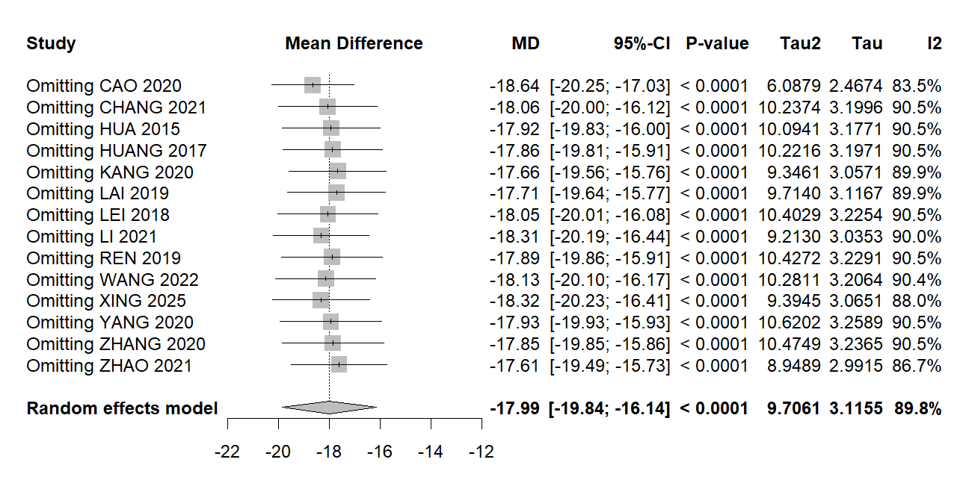
Figure S7-1 Forrest plot of sensitivity analysis: the number of reflux episodes in 24 hours. MD: mean difference; CI: confidence interval.
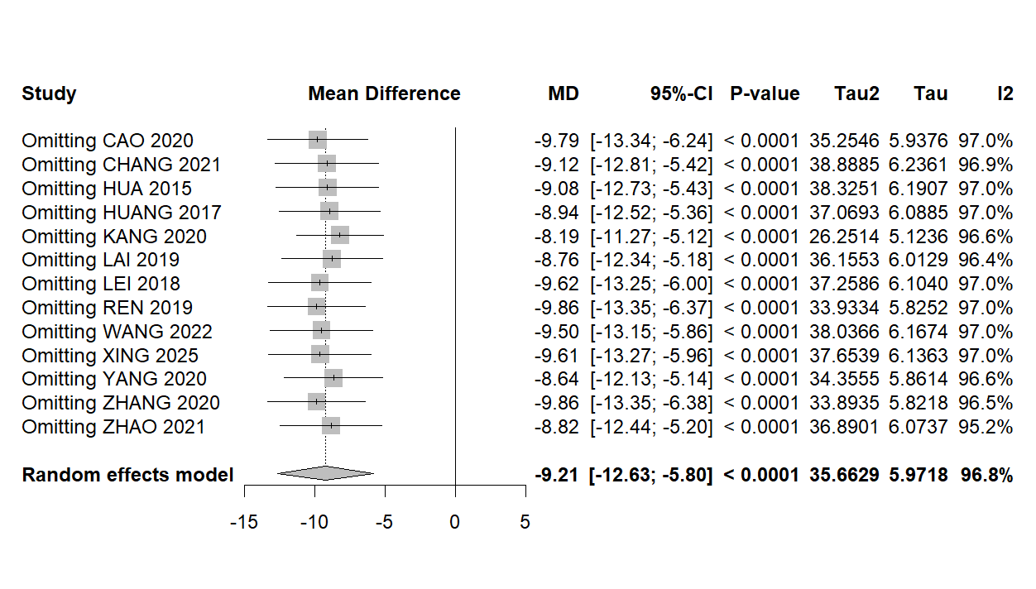
Figure S7-2 Forrest plot of sensitivity analysis: The longest duration of reflux. MD: mean difference; CI: confidence interval.
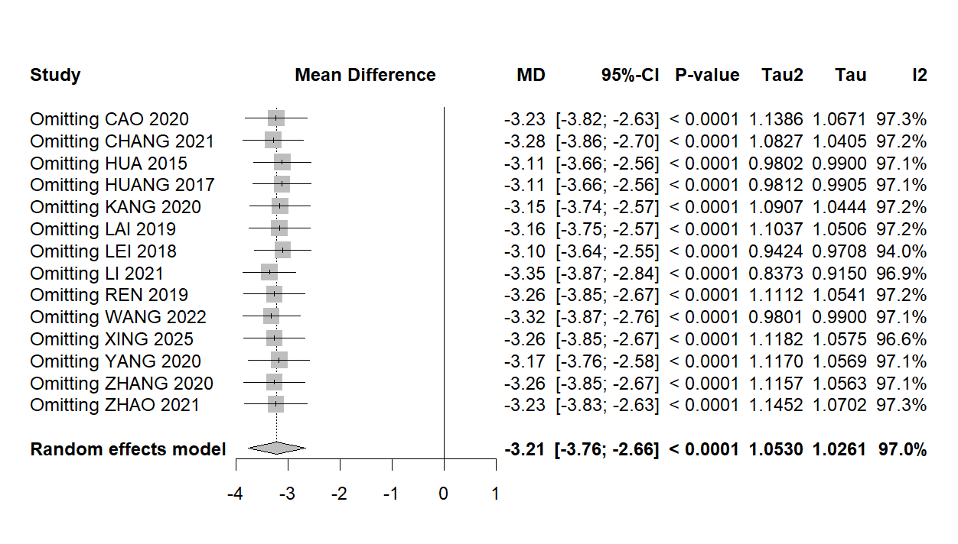
Figure S7-3 Forrest plot of sensitivity analysis: long reflux episodes (≥5 minutes). MD: mean difference; CI: confidence interval.

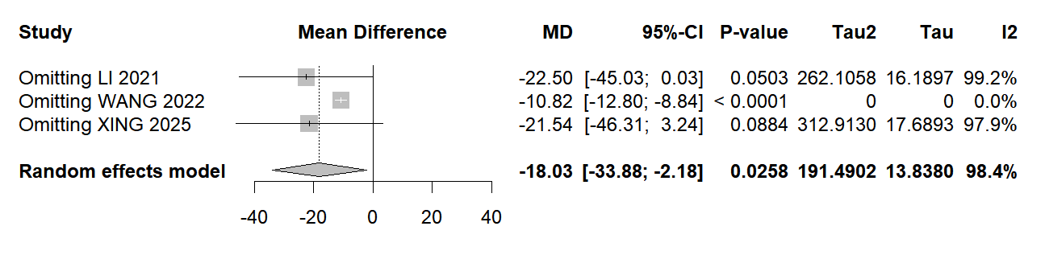
Figure S7-4 Forrest plot of sensitivity analysis: gastrin content. MD: mean difference; CI: confidence interval.

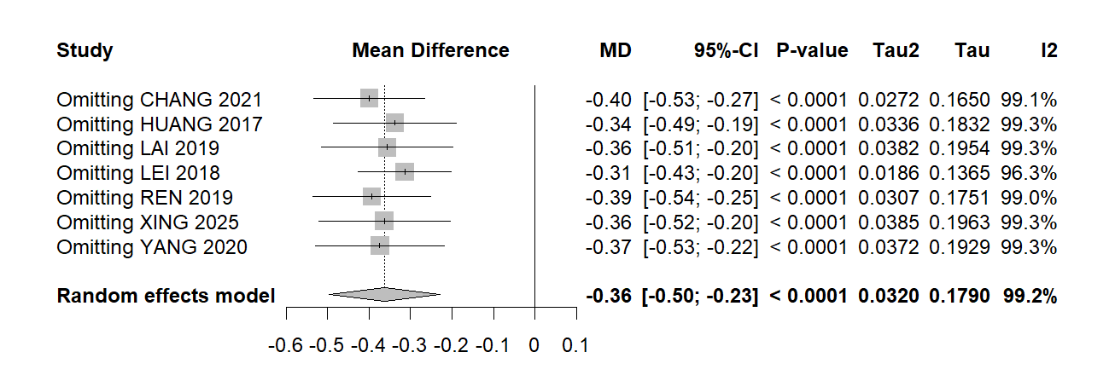
Figure S7-5 Forrest plot of sensitivity analysis: score of abdominal distension. MD: mean difference; CI: confidence interval.
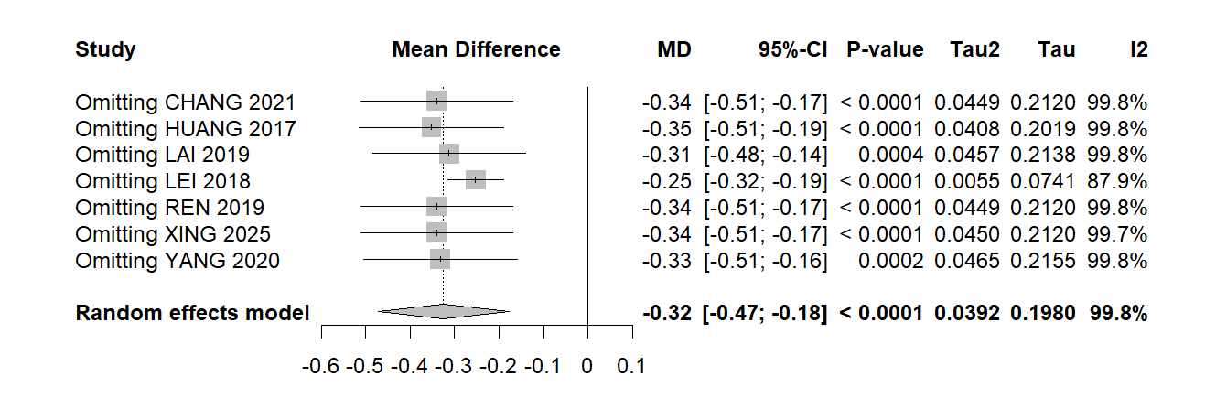
Figure S7-6 Forrest plot of sensitivity analysis: score of abdominal pain. MD: mean difference; CI: confidence interval.

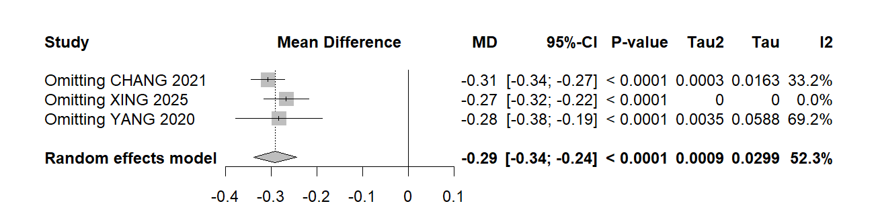
Figure S7-7 Forrest plot of sensitivity analysis: score of heartburn. MD: mean difference; CI: confidence interval.

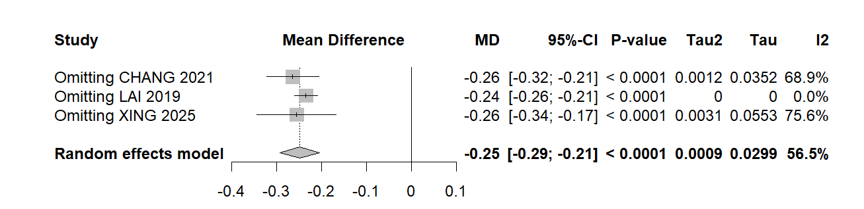
Figure S7-8 Forrest plot of sensitivity analysis: score of vomiting. MD: mean difference; CI: confidence interval.

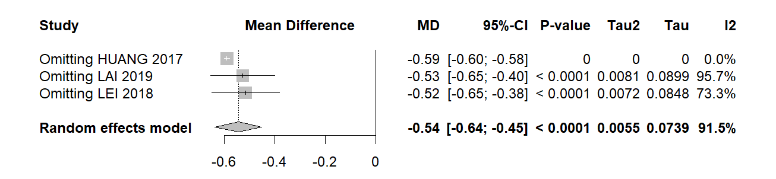
Figure S7-9 Forrest plot of sensitivity analysis: score of bitter taste in mouth. MD: mean difference; CI: confidence interval.

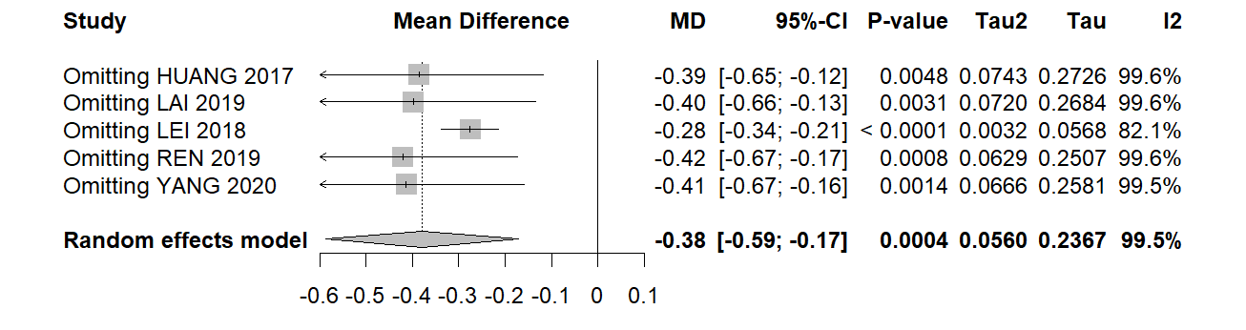
Figure S7-10 Forrest plot of sensitivity analysis: score of nausea. MD: mean difference; CI: confidence interval.

Supplementary Material S8: publication bias
Table S8 Evaluation of publication bias
Outcomes | t value | df | P value | Bias estimate (SE) | tau²
The number of reflux episodes in 24 hours | 0.84 | 12 | 0.4188 | 1.6440 (1.9635) | 9.9964
The longest duration of reflux | -3.86 | 11 | 0.0027 | -5.4724 (1.4194) | 14.3782
Long reflux episodes (≥5 minutes) | -0.73 | 12 | 0.4807 | -2.1491 (2.9532) | 34.834
Clinical response rate | 12.44 | 9 | <0.0001 | 1.7971 (0.1444) | 0.0456
Abbreviations. SE: standard error.

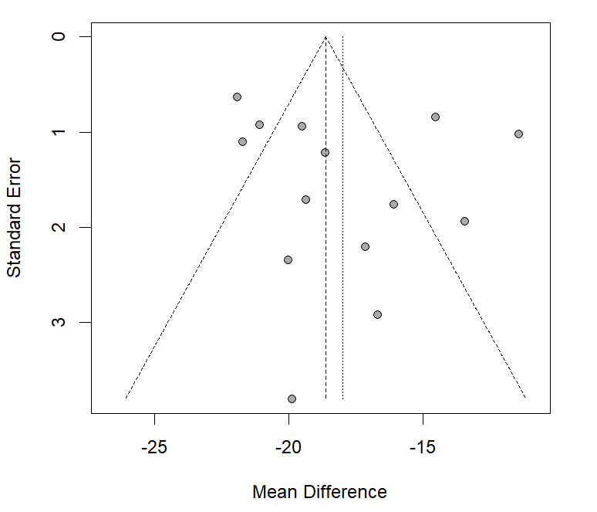
Figure S8-1 Funnel plot: the number of reflux episodes in 24 hours.
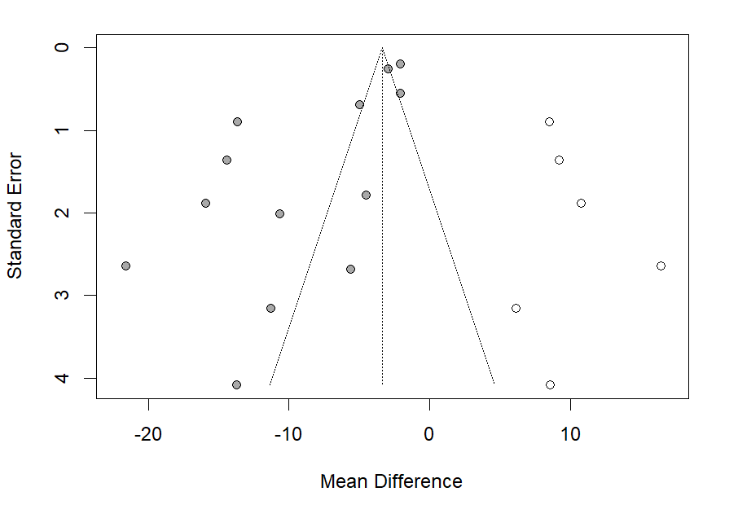
Figure S8-2 Funnel plot: The longest duration of reflux (after trim-and-fill).

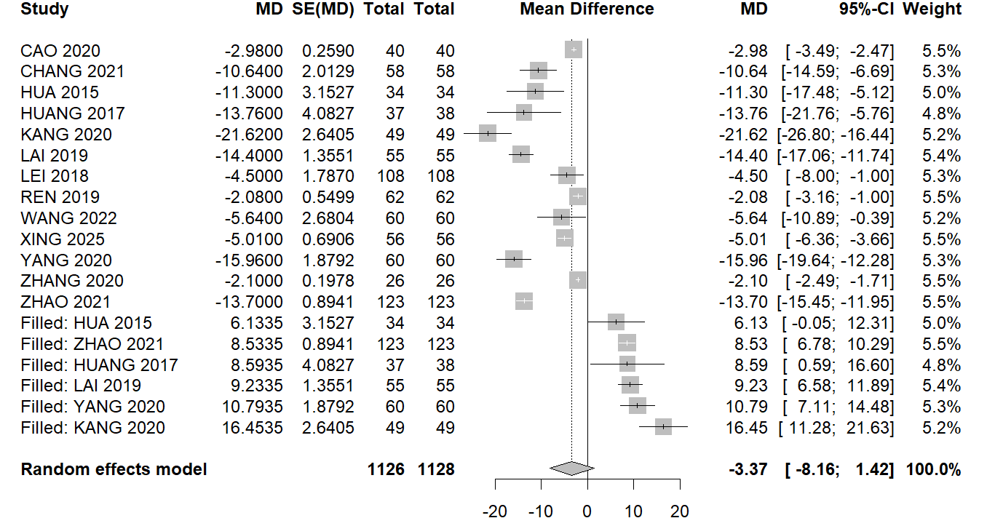
Figure S8-3 Forest plot: The longest duration of reflux (after trim-and-fill). SE: standard error; MD: mean difference; CI: confidence interval.
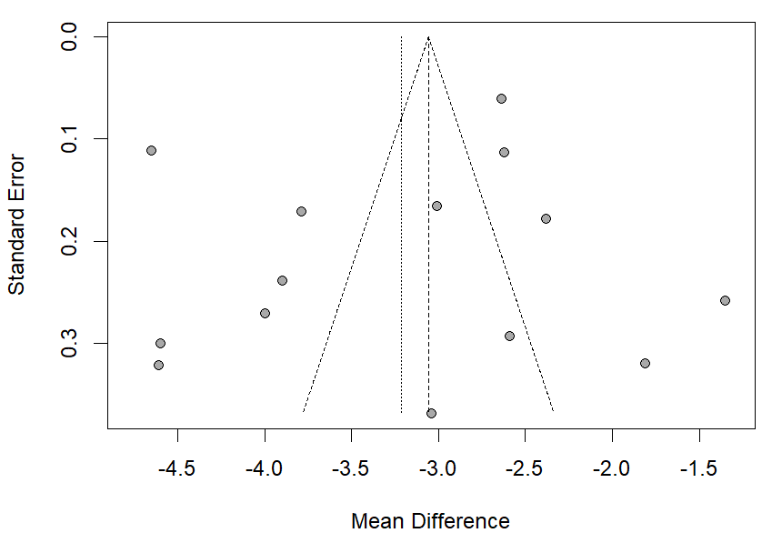
Figure S8-4 Funnel plot: long reflux episodes (≥5 minutes).

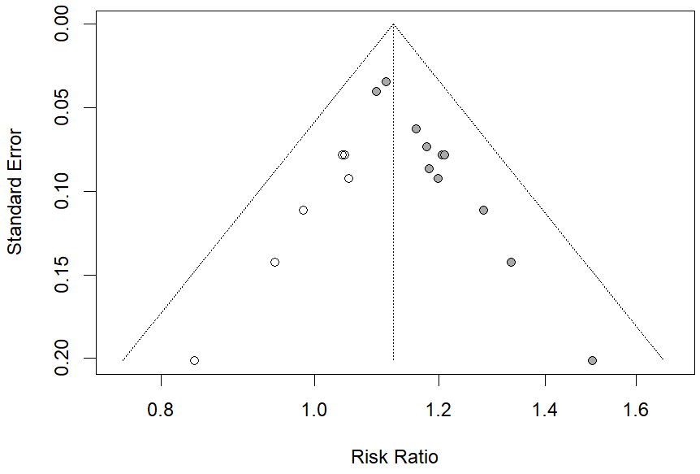
Figure S8-5 Funnel plot: clinical response rate (after trim-and-fill).

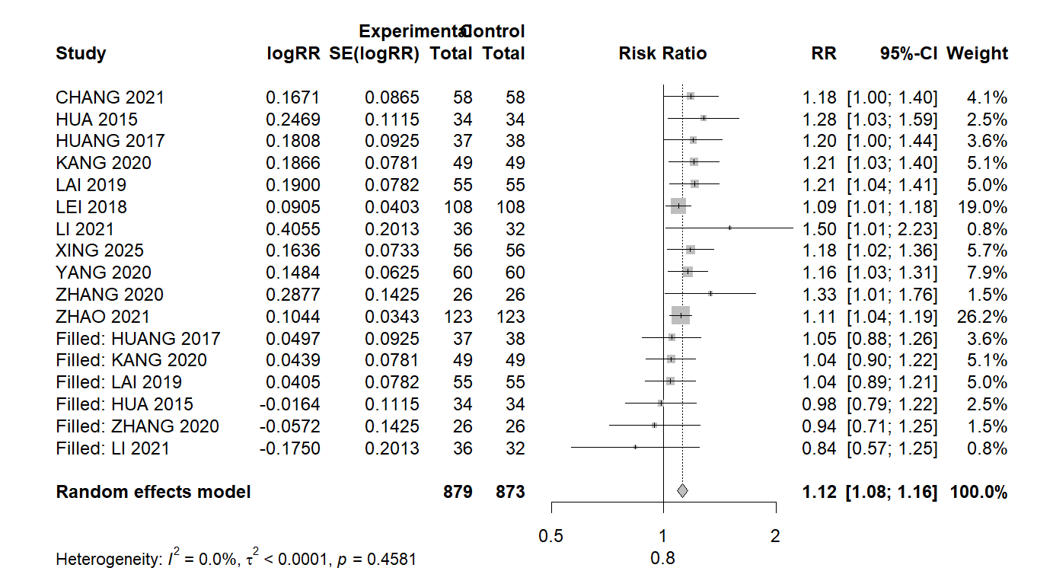
Figure S8-6 Forest plot: clinical response rate (after trim-and-fill). SE: standard error; MD: mean difference; CI: confidence interval.

Supplementary Material S9
Table S9 GRADE assassment
Outcomes | NO. of participants (studies) | Certainty of the evidence (GRADE) | Relative effect (95% CI)
number of reflux episodes in 24 hours | 1605 (14 studies) | Very low ^{a, b, e} | MD: -17.99 (-19.84 to -16.14)
The longest duration of reflux(min) | 1537 (13 studies) | Low ^{a, b} | MD: -9.21 (-12.63 to -5.80)
number of reflux episodes over 5 minutes | 1605 (14 studies) | Very low ^{a, b, e} | MD: -3.21 (-3.76 to -2.66)
clinical total effective rate | 1281 (11 studies) | Very low ^{a, d, e} | RR: 1.15 (1.10 to 1.19)
GAS content | 300 (3 studies) | Very low ^{a, b, e} | MD: -16.43 (-18.15 to -14.71)
symptom score: abdominal distension | 873 (7 studies) | Very low ^{a, b, e} | MD: -0.36 (-0.50 to -0.23)
symptom score: abdominal pain | 873 (7 studies) | Very low ^{a, b, e} | MD: -0.32 (-0.47 to -0.18)
symptom score: heartburn | 348 (3 studies) | Very low ^{a, b, e} | MD: -0.29 (-0.34 to -0.24)
symptom score: vomiting | 338 (3 studies) | Very low ^{a, b, e} | MD: -0.25 (-0.29 to -0.21)
symptom score: bitter taste in mouth | 401 (3 studies) | Very low ^{a, b, e} | MD: -0.54 (-0.64 to -0.45)
symptom score: nausea | 645 (5 studies) | Very low ^{a, b, e} | MD: -0.38 (-0.59 to -0.17)
(a) Risk of bias: there are seven studies with high risk of bias and some concern in several aspects, including randomization, adhering to intervention, missing putcome data, measurement outcome, and selection report result (b) Incosistancy: the results from all of 14 studies are inconsistent, inter-study heterogeneity was high. (c) Indirectness. (d) Imprecision: 95% CI crossing the line of no effect or sample size is too small (less than optimal information size). (e) Publication bias. CI: confidence interval; RR: risk ratio; MD: mean difference.

