Supplement figure 1.
Figure 1A. Distribution of TG based on original data
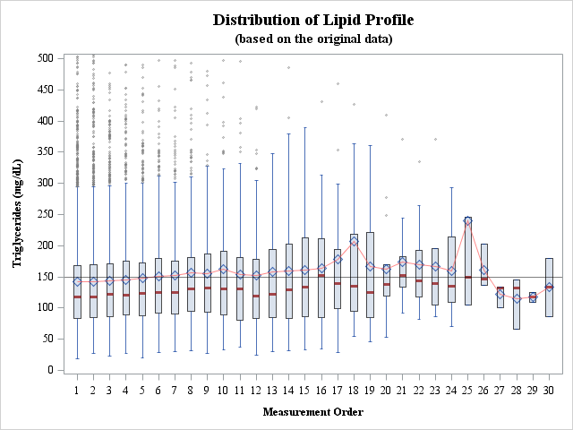
Figure 1B. Distribution of TG based on 1:2 PSM data
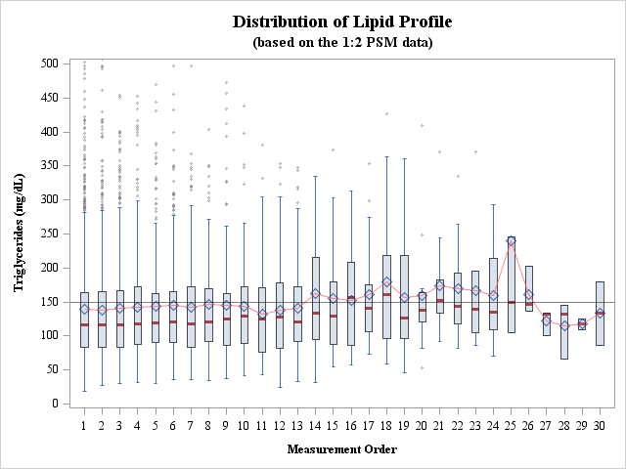

Figure 1C. Distribution of LDL based on original data
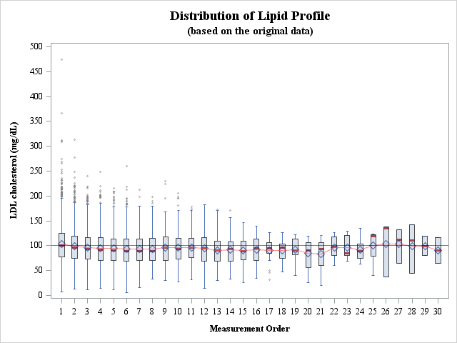
Figure 1D. Distribution of LDL based on 1:2 PSM data
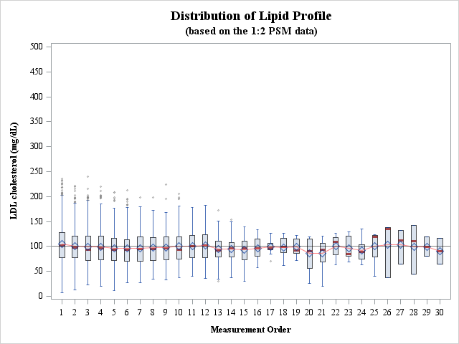

Figure 1E. Distribution of HDL based on original data
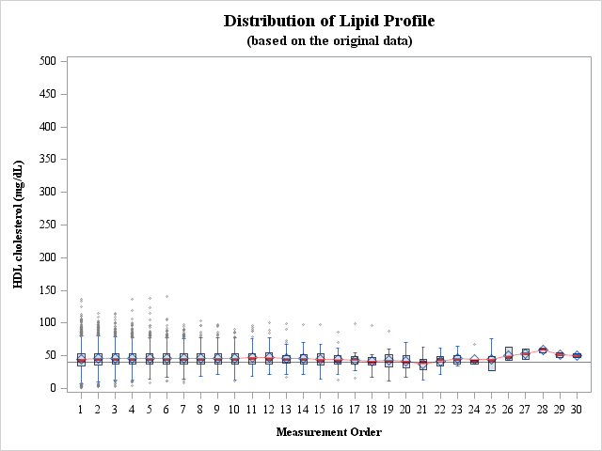
Figure 1F. Distribution of HDL based on 1:2 PSM data
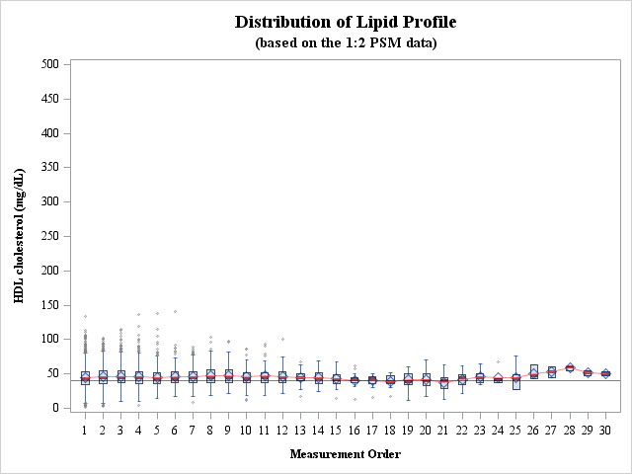

Figure 1G. Distribution of total cholesterol based on original data
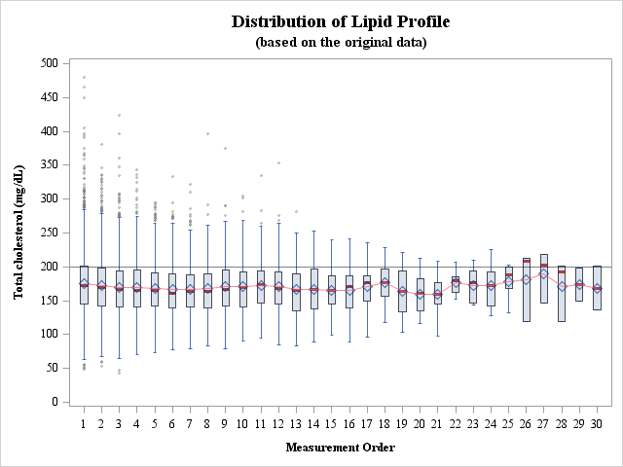
Figure 1H. Distribution of total cholesterol based on 1:2 PSM data
