Supplementary material 1 (results of the pilot study in the group 2)
VEP LATENCY distribution in 51 subjects for pattern reversal R60´and R15´, motion-onset and cognitive EP
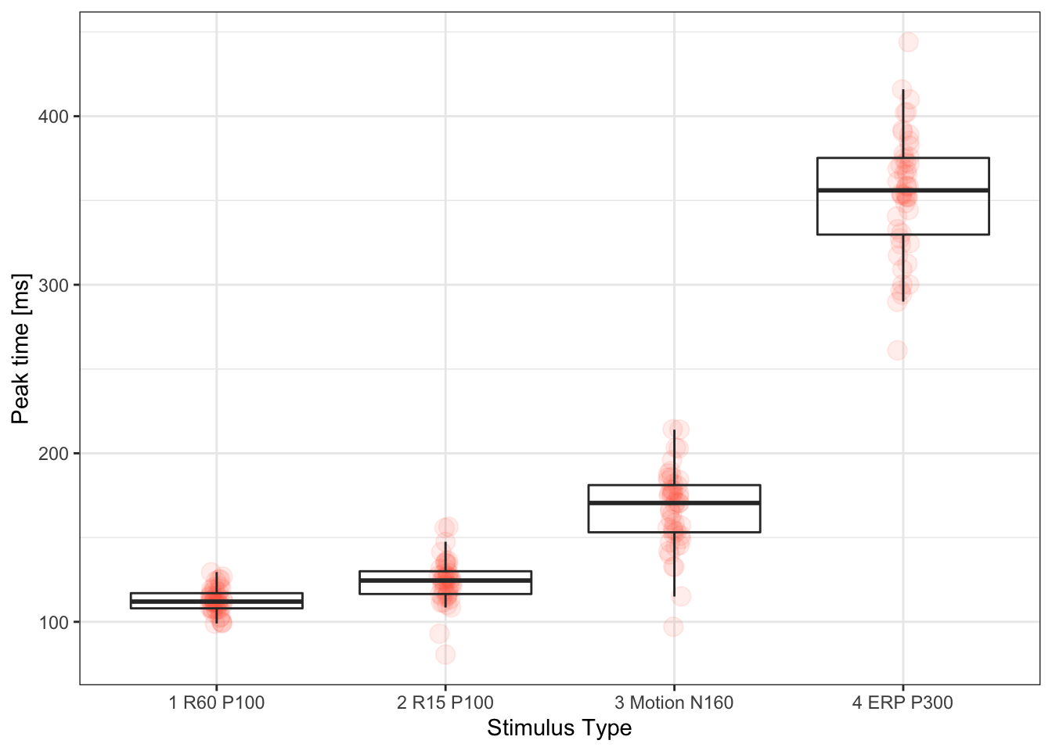

VEP AMPLITUDE distribution in 51 subjecs for pattern reversal 60´and 15´, motion-onset and cognitive EP
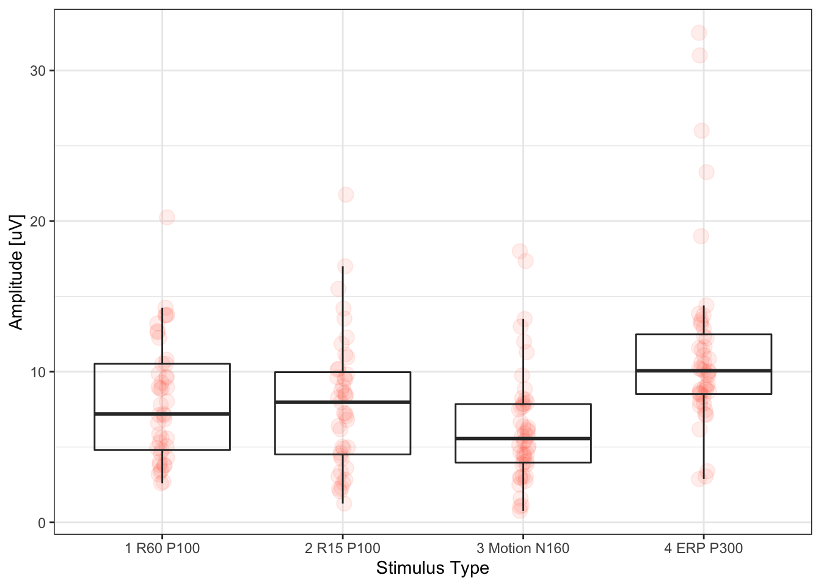
Supplementary material 2 (results of the pilot study in the group 3)
Comparison of VEP parameters (portable device) in 15 subjects between the 1st and 2nd session
(interval between the two sessions – one month)
No statistically significant differences were found between the data of the two sessions.
 |  | 25q | Median | 75q | Mean | SD
1. session R60 P100 L [ms] |  | 100.0 | 101.5 | 110.5 | 103.96 | 6.73
2. session R60 P100 L [ms] |  | 101.5 | 102.0 | 104.5 | 105.04 | 7.85

 |  | 25q | Median | 75q | Mean | SD
1. session R60 P100 A [uV] |  | 9.18 | 11.88 | 17.50 | 12.97 | 5.43
2. session R60 P100 A [uV] |  | 8.43 | 12.05 | 17.75 | 12.93 | 4.66

 |  | 25q | Median | 75q | Mean | SD
1. session R15 P100 L [ms] |  | 103.5 | 104.5 | 115 | 108.35 | 7.93
2. session R15 P100 L [ms] |  | 107.0 | 109.0 | 112 | 111.92 | 7.51

 |  | 25q | Median | 75q | Mean | SD
1. session R15 P100 A [uV] |  | 6.12 | 10.88 | 14.75 | 11.04 | 5.94
2. session R15 P100 A [uV] |  | 6.45 | 11.95 | 18.75 | 12.50 | 6.62

 |  | 25q | Median | 75q | Mean | SD
1. session motion N160 L [ms] |  | 146.50 | 149.50 | 156.88 | 151.21 | 8.01
2. session motion N160 L [ms] |  | 146.00 | 151.75 | 154.38 | 153.25 | 11.70

 |  | 25q | Median | 75q | Mean | SD
1. session motion N160 A [uV] |  | 5.42 | 6.26 | 9.02 | 7.34 | 2.51
2. session motion N160 A [uV] |  | 5.86 | 7.76 | 9.41 | 7.73 | 2.34

 |  | 25q | Median | 75q | Mean | SD
1. session P300 L [ms] |  | 313.38 | 322.5 | 342.50 | 330.75 | 24.52
2. session P300 L [ms] |  | 318.62 | 329.5 | 350.12 | 335.18 | 23.53

 |  | 25q | Median | 75q | Mean | SD
EPort 1.v. P300 A [uV] |  | 17.25 | 19.50 | 23.19 | 21.19 | 6.16
EPort 2.v. P300 A [uV] |  | 18.81 | 23.12 | 24.94 | 23.05 | 8.80

Supplementary material 3 (results of the pilot study in the group 4)

SGLab vs. VEPpeak
Comparison of results in 52 neuro-ophthalmological patients

SGlab R40´ vs. VEPpeak R60´ peak time
Two tail tests Anderson-Darling test: normality = FALSE
SIGNIFICANT paired difference between groups, Wilcoxon p= 1.569693e-12
Effect size and confidence limits, d = 1.09 [ 0.78 1.39 ]
Power of study with aforementioned effect, pwr = 1

Description
 | N | 25q | Median | 75q | Mean | SD | Min | Max | NaN
SGlab R40´ P100 L [ms] | 97 | 104 | 108 | 116 | 111.48 | 11.21 | 96 | 158 | 0
VEPpeak R60´ P100 L [ms] | 97 | 94 | 101 | 108 | 102.75 | 11.84 | 72 | 137 | 0
Diff. | 97 | 3 | 9 | 14 | 8.73 | 9.24 | -20 | 29 | 0

Correlation graph
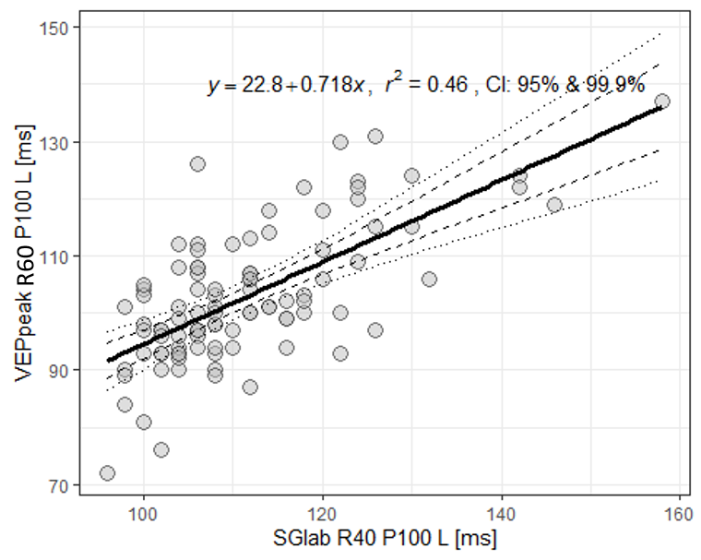

Bland-Altman plot
Concordance Correlation Coefficient: 0.5318709 [ 0.3954891 0.6453047 ]
Critical difference is 18.1201
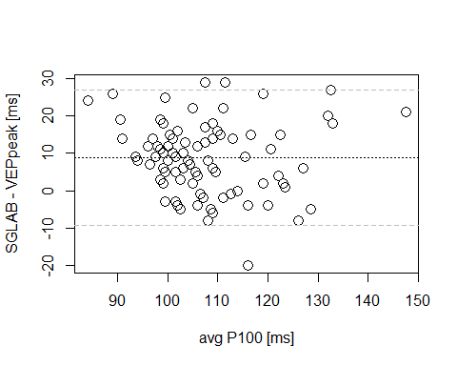

SGlab R20´vs. VEPpeak R15´ peak time

Paired test
Two tail tests Anderson-Darling test: normality = FALSE
SIGNIFICANT paired difference between groups, Wilcoxon p= 0.0001701087
Effect size and confidence limits, d = 0.56 [ 0.27 0.85 ]
Power of study with aforementioned effect, pwr = 0.97

Description
 | N | 25q | Median | 75q | Mean | SD | Min | Max | NaN
SGlab R20´ P100 L [ms] | 94 | 108 | 112 | 122 | 116.55 | 12.89 | 98 | 156 | 0
VEPpeak R15´ P100 L [ms] | 94 | 103 | 110 | 120 | 112.45 | 13.91 | 88 | 159 | 0
Diff. | 94 | -2 | 4 | 10 | 4.11 | 9.55 | -15 | 34 | 0

Correlation graph
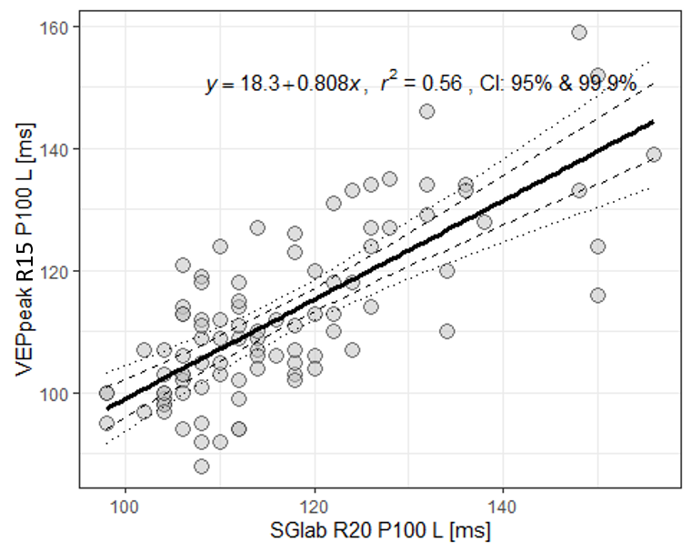

Bland-Altman plot
Concordance Correlation Coefficient: 0.7151121 [ 0.5958558 0.8035106 ]
Critical difference is 18.71701
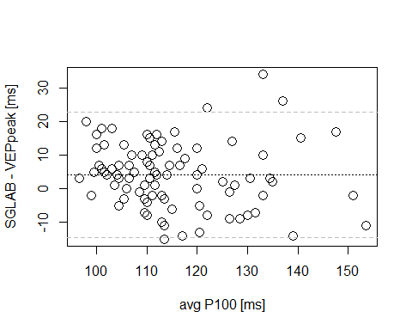

SGlab MO vs. VEPpeak MO peak time

Paired test
Two tail tests Anderson-Darling test: normality = TRUE
SIGNIFICANT paired difference between groups, ttest p= 0.002349777
Effect size and confidence limits, d = 0.44 [ 0.16 0.72 ]
Power of study with aforementioned effect, pwr = 0.87

Description
 | N | 25q | Median | 75q | Mean | SD | Min | Max | NaN
SGlab N160 L [ms] | 98 | 152.00 | 164.0 | 172.00 | 162.59 | 17.65 | 112 | 208 | 0
VEPpeak N160 L [ms] | 98 | 154.25 | 168.5 | 180.00 | 167.88 | 18.21 | 129 | 206 | 0
Diff. | 98 | -15.00 | -5.0 | 4.75 | -5.29 | 16.75 | -72 | 35 | 0

Correlation graph
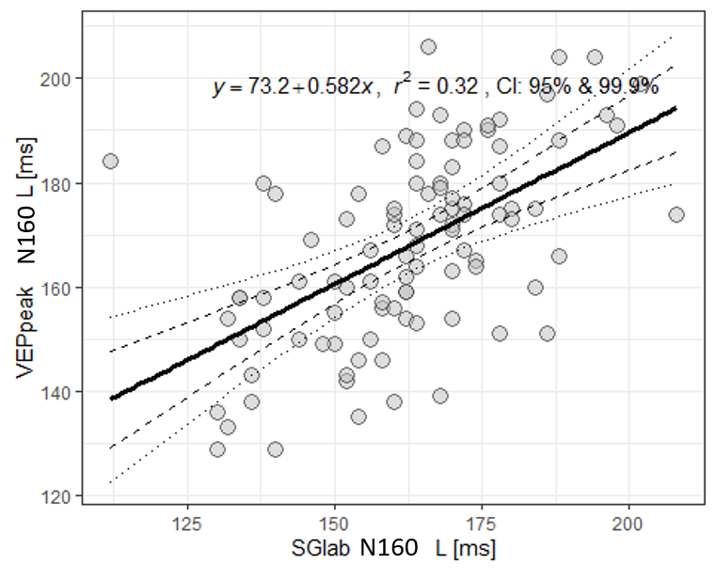

Bland-Altman plot
Concordance Correlation Coefficient: 0.5377402 [ 0.3410629 0.6893139 ]
Critical difference is 32.82483
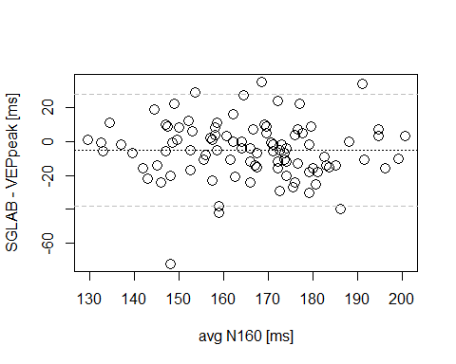

SGlab R40´ vs. VEPpeak R60´ amplitude

Paired test
Two tail tests Anderson-Darling test: normality = FALSE
SIGNIFICANT paired difference between groups, Wilcoxon p= 1.885157e-10
Effect size and confidence limits, d = 0.93 [ 0.64 1.22 ]
Power of study with aforementioned effect, pwr = 1

Description
 | N | 25q | Median | 75q | Mean | SD | Min | Max | NaN
SGlab R40´ P100 A [uV] | 104 | 6 | 9.0 | 13 | 9.84 | 5.65 | 0 | 26 | 0
VEPpeak R60´ P100 A [uV] | 104 | 4 | 6.5 | 10 | 7.39 | 5.20 | 0 | 25 | 0
Diff. | 104 | 1 | 2.0 | 4 | 2.44 | 3.49 | -10 | 12 | 0

Correlation graph
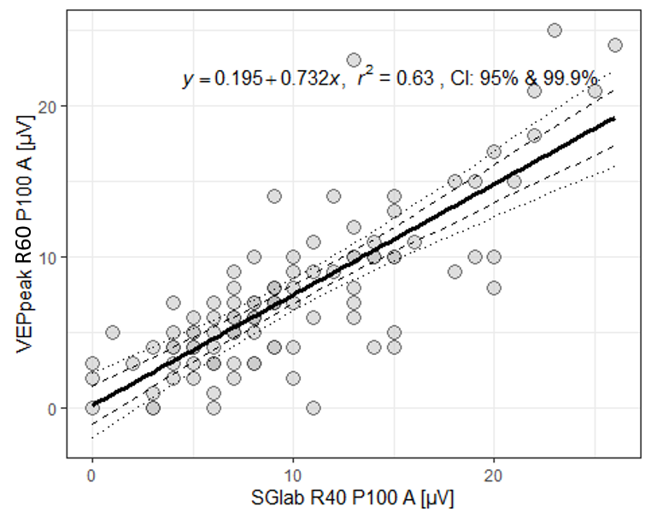

Bland-Altman plot
Concordance Correlation Coefficient: 0.7211457 [ 0.5916341 0.8143736 ]
Critical difference is 6.848856
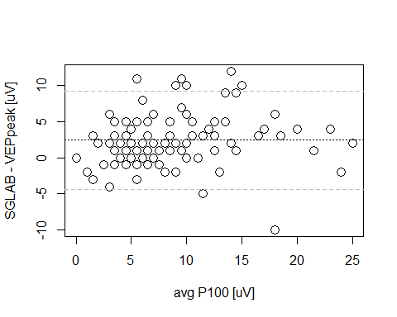

SGlab R20´ vs. VEPpeak R15´ amplitude

Paired test
Two tail tests Anderson-Darling test: normality = FALSE
SIGNIFICANT paired difference between groups, Wilcoxon p= 1.758405e-09
Effect size and confidence limits, d = 0.87 [ 0.59 1.16 ]
Power of study with aforementioned effect, pwr = 1

Description
 | N | 25q | Median | 75q | Mean | SD | Min | Max | NaN
SGlab R20´ P100 A [uV] | 104 | 5 | 9 | 13.25 | 9.80 | 6.42 | 0 | 28 | 0
VEPpeak R15´ P100 A [uV] | 104 | 4 | 6 | 11.00 | 7.15 | 4.84 | 0 | 24 | 0
Diff. | 104 | 0 | 2 | 5.00 | 2.64 | 3.78 | -4 | 13 | 0

Correlation graph
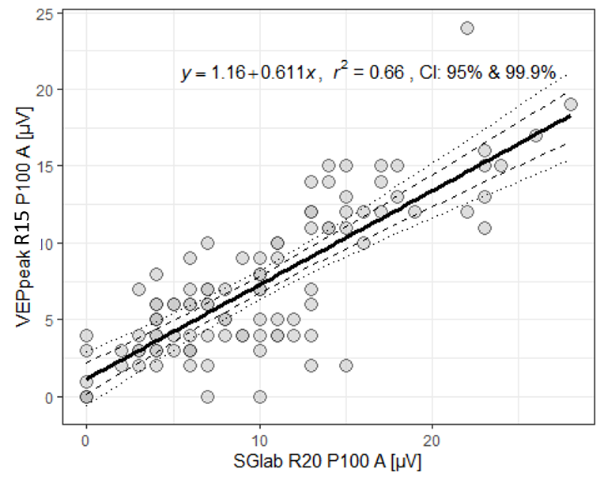

Bland-Altman plot
Concordance Correlation Coefficient: 0.7037117 [ 0.6082267 0.7791208 ]
Critical difference is 7.409131
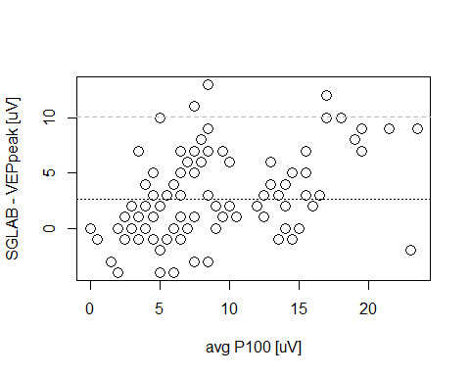

SGlab MO vs. VEPpeak MO amplitude

Paired test
Two tail tests Anderson-Darling test: normality = FALSE
SIGNIFICANT paired difference between groups, Wilcoxon p= 4.223358e-07
Effect size and confidence limits, d = 0.72 [ 0.44 1.01 ]
Power of study with aforementioned effect, pwr = 1

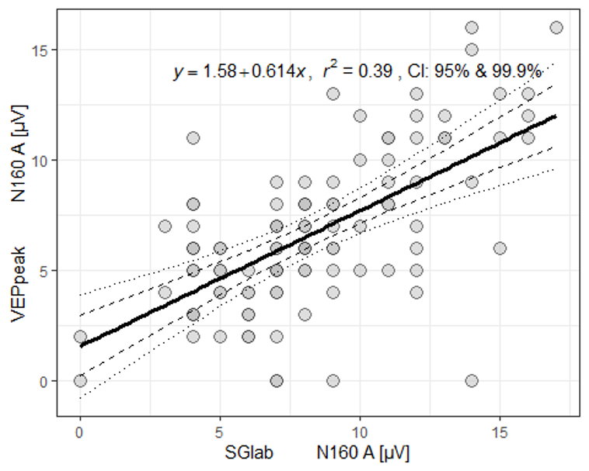
Description
 | N | 25q | Median | 75q | Mean | SD | Min | Max | NaN
SGlab N160 A [uV] | 104 | 6.00 | 8.0 | 11 | 8.34 | 3.60 | 0 | 17 | 0
VEPpeak N160 A [uV] | 104 | 4.75 | 6.0 | 9 | 6.69 | 3.54 | 0 | 16 | 0
Diff. | 104 | 0.00 | 1.5 | 3 | 1.64 | 3.09 | -7 | 14 | 0

Correlation graph

Bland-Altman plot
Concordance Correlation Coefficient: 0.5632186 [ 0.3753617 0.7066295 ]
Critical difference is 6.057577
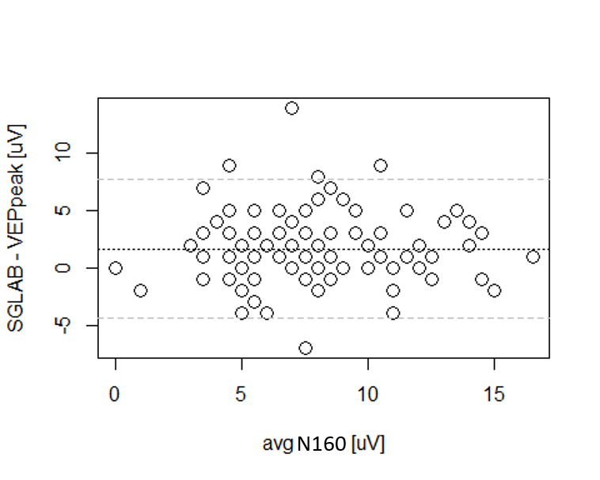

Supplementary material 4 (results of the pilot study in the group 5)

Pattern-reversal R60´ and motion-onset VEP latencies in patients with Multiple sclerosis
Right eye (RE) vs. Left eye (LE) – correlation signalizes bilateral optic nerve involvement
In both eyes the average group values of interpeak latencies are significantly prolonged, all 21 patients displayed pathological latency at least in one eye, some VEPs were not detectable (R15´ in 13 cases).

