Supplemental data

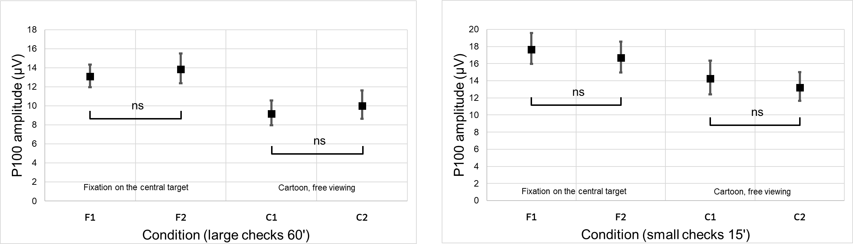

Figure S1. Test–retest comparison of log-transformed P100 amplitudes between blocks F (standard fixation) and C (free viewing La Linea) for 60′ (left) and 15′ (right) checks. No significant differences were observed, indicating good within-condition reliability.
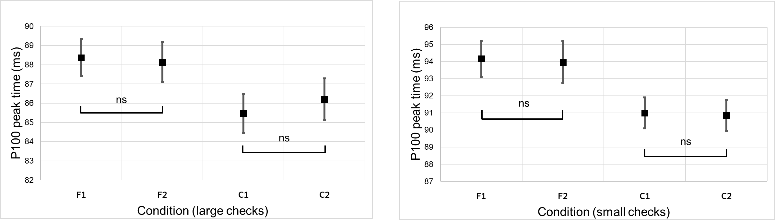

Figure S2. Test–retest comparison of P100 peak times between blocks F (standard fixation) and C (free viewing La Linea) for 60′ (left) and 15′ (right) checks. No significant differences were observed, indicating good within-condition reliability.
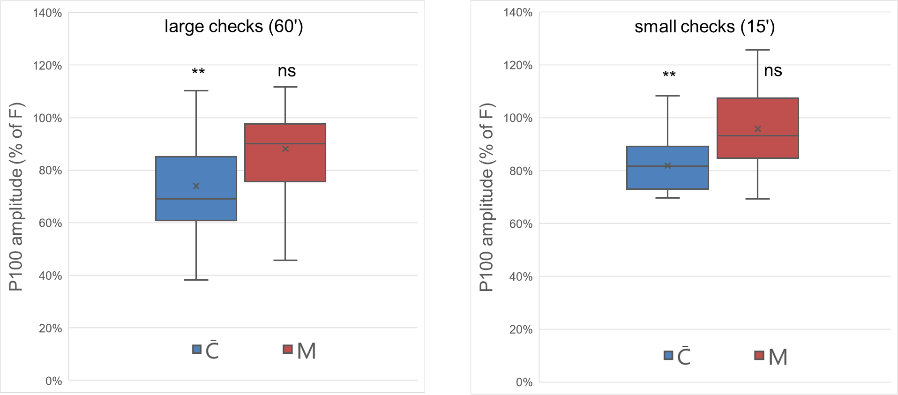

Figure S3. P100 amplitude (%) relative to the standard fixation condition (F = 100%) for the mixed condition (M) and free-viewing La Linea (C), shown for 60′ (left) and 15′ (right) checks. The box represents the interquartile range with the median indicated by the horizontal line, the cross represents the mean, and the whiskers indicate the full data range.

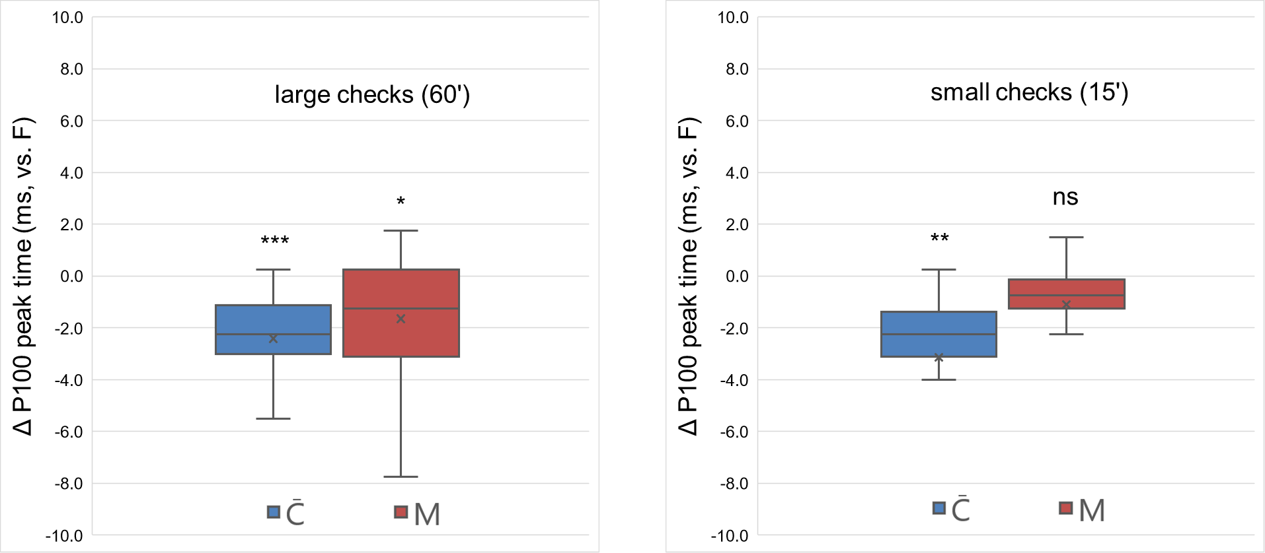

Figure S4. P100 peak time (ms) for 60′ (left) and 15′ (right) checks. Differences are shown between the standard fixation condition (F) and the mixed condition (M), and between F and free-viewing La Linea (C). The box represents the interquartile range with the median indicated by the horizontal line, the cross represents the mean, and the whiskers indicate the full data range.
