Article Title: Anti-ovarian cancer migration and toxicity characteristics of a platinum(IV) pro-drug with axial HDAC inhibitor ligands in zebrafish models
Journal Name: Investigational New Drugs
Author Names: Salma Begum, Scheldon D. Irvin, Carol K. Cox, Zhouyang Huang, Justin J. Wilson, Jerry D. Monroe, Yann Gibert
Corresponding author: Yann Gibert, Department of Cell and Molecular Biology, University of Mississippi Medical Center, 2500 State Street, Jackson, MS, 39216, email: ygibert@umc.edu
Supplemental Table
Table 1. IC₅₀ values for cisplatin and compound B in A2780 and A2780cis cell lines.
Treatment | IC₅₀ (µM)
Cisplatin (A2780) | 1.90 ± 0.91
Compound B (A2780) | 0.29 ± 0.31
Cisplatin (A2780cis) | 15.74 ± 0.23
Compound B (A2780cis) | 0.51 ± 0.12

Supplemental Figures
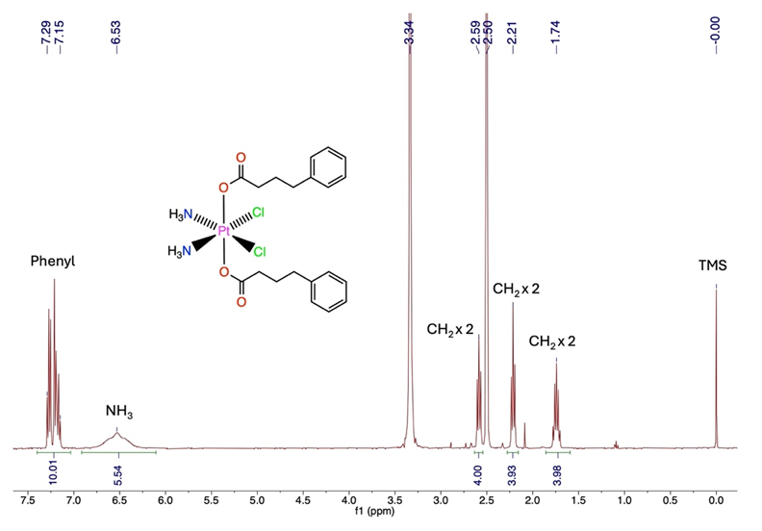
Fig. S1 ¹H NMR spectrum of cis,cis,trans-[Pt(NH₃)₂Cl₂(PBA₂)] in DMSO-d₆ (400 MHz, 25 °C)

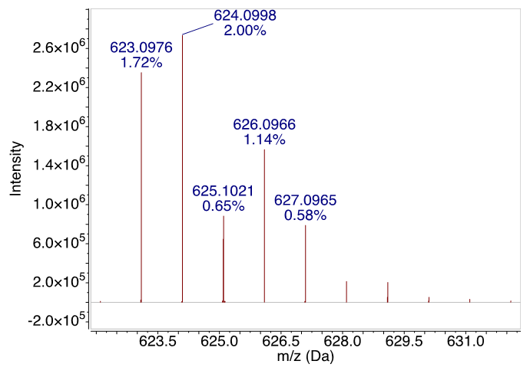
Fig. S2 HR-ESI-MS of cis,cis,trans-[Pt(NH₃)₂Cl₂(PBA₂)]

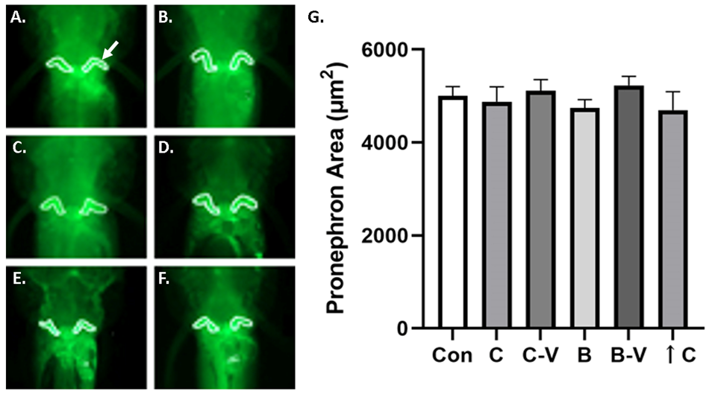

Fig. S3 Cisplatin and compound B do not alter pronephron area in wt1b:eGFP zebrafish A.-F. Representative images of control and experimental compound treated (A., 0.3% DMSO; B., 0.3 µM compound B; C., 0.9% NaCl; D., 2 µM cisplatin; E., E3 media; F., 100 µM cisplatin) wt1b:eGFP zebrafish embryos showing green fluorescent pronephrons with white tracing around the perimeter of the pronephron structures. G. Graph of pronephron area observed for control and experimental compound treated zebrafish embryos. Arrow in A. indicates pronephron with border tracing. Key: Con = E3 egg water media control; C = cisplatin; C-V = cisplatin 0.9% NaCl vehicle control; B = compound B; B-V = 0.3% DMSO compound B vehicle control; ↑C = 100 µM cisplatin overdose used as a positive control; p < 0.05.

