Supplementary Materials
Phase 1/2 open-label study of oral bacterial supplementation (EDP1503) plus pembrolizumab in participants with advanced or metastatic microsatellite-stable colorectal cancer, triple-negative breast cancer, and checkpoint inhibitor–relapsed tumors

Judy S Wang, Edward R Arrowsmith, J Thaddeus Beck, Jennifer Friedmann, Rahima Jamal, Duncan McHale, Humphrey Gardner, Michael J Chisamore, Susanna V Ulahannan

Table S1. Summary of treatment-emergent adverse events in participants who received 2 capsules BID or 4 capsules BID of EDP1503.
Event, n (%) | 2 capsules BID  n = 42 |  | 4 capsules BID  n = 27
Treatment-emergent adverse events | 42 (100.0) |  | 24 (88.9)
Grade ≥3 | 14 (33.3) |  | 14 (51.9)
Led to discontinuation of EDP1503 | 2 (4.8) |  | 2 (7.4)
Led to discontinuation of pembrolizumabª | 0 |  | 2 (8.0)
Led to interruption of EDP1503 | 7 (16.7) |  | 7 (25.9)
Led to interruption of pembrolizumabª | 4 (10.8) |  | 5 (20.0)
Led to death | 1 (2.4) |  | 0
Treatment-emergent adverse event in ≥10% of participants | Any | Grade ≥3 | Any | Grade ≥3
Fatigue | 14 (33.3) | 1 (2.4) | 8 (29.6) | 1 (3.7)
Nausea | 7 (16.7) | 0 | 13 (48.1) | 1 (3.7)
Vomiting | 10 (23.8) | 0 | 8 (29.6) | 0
Diarrhea | 9 (21.4) | 0 | 7 (25.9) | 3 (11.1)
Constipation | 12 (28.6) | 0 | 3 (11.1) | 0
Dyspnea | 7 (16.7) | 2 (4.8) | 6 (22.2) | 2 (7.4)
Abdominal distension | 7 (16.7) | 0 | 4 (14.8) | 0
Abdominal pain | 8 (19.0) | 1 (2.4) | 3 (11.1) | 0
Flatulence | 5 (11.9) | 0 | 6 (22.2) | 0
Decreased appetite | 5 (11.9) | 0 | 5 (18.5) | 0
Aspartate aminotransferase increased | 7 (16.7) | 2 (4.8) | 2 (7.4) | 1 (3.7)
Dehydration | 4 (9.5) | 0 | 5 (18.5) | 0
Anemia | 5 (11.9) | 3 (7.1) | 3 (11.1) | 3 (11.1)
Arthralgia | 5 (11.9) | 1 (2.4) | 3 (11.1) | 0
Alanine aminotransferase increased | 6 (14.3) | 2 (4.8) | 1 (3.7) | 0
Back pain | 4 (9.5) | 0 | 3 (11.1) | 0
Hypokalemia | 3 (7.1) | 1 (2.4) | 4 (14.8) | 1 (3.7)
Weight decreased | 2 (4.8) | 0 | 5 (18.5) | 1 (3.7)
ªPercentage based on total participants who received pembrolizumab; 5 participants receiving 2 capsules BID (4 in Cohort A and 1 in Cohort B) and 2 participants receiving 4 capsules BID (both from Cohort C) did not receive pembrolizumab.

Figure S1. Swimmer plots for time on treatment for (a) Cohort A, (b) Cohort B, and (c) Cohort C. The final date for each participant is the last dose date, not treatment exposure date.
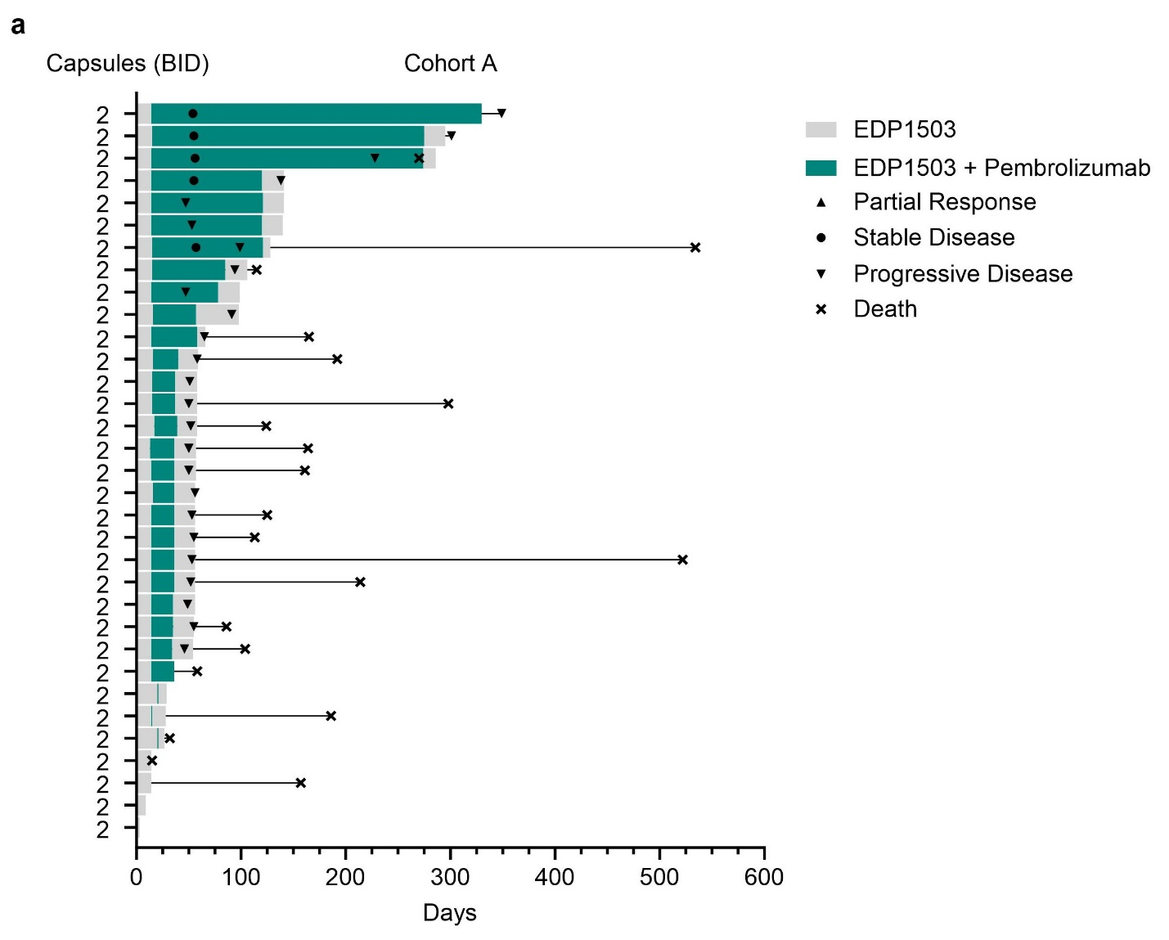
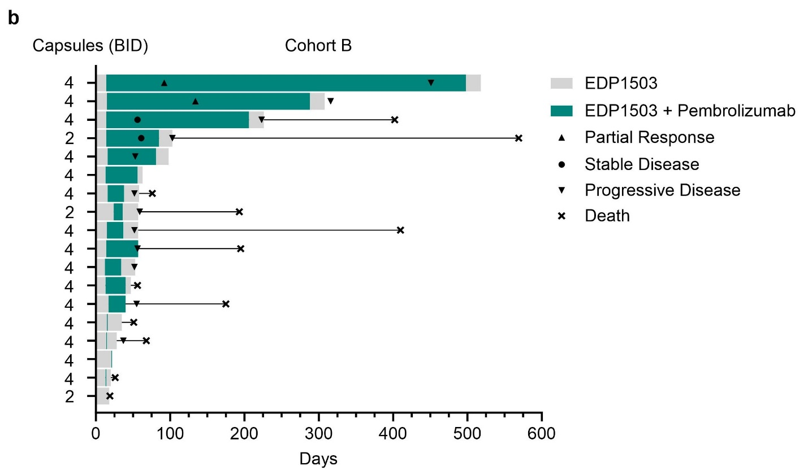

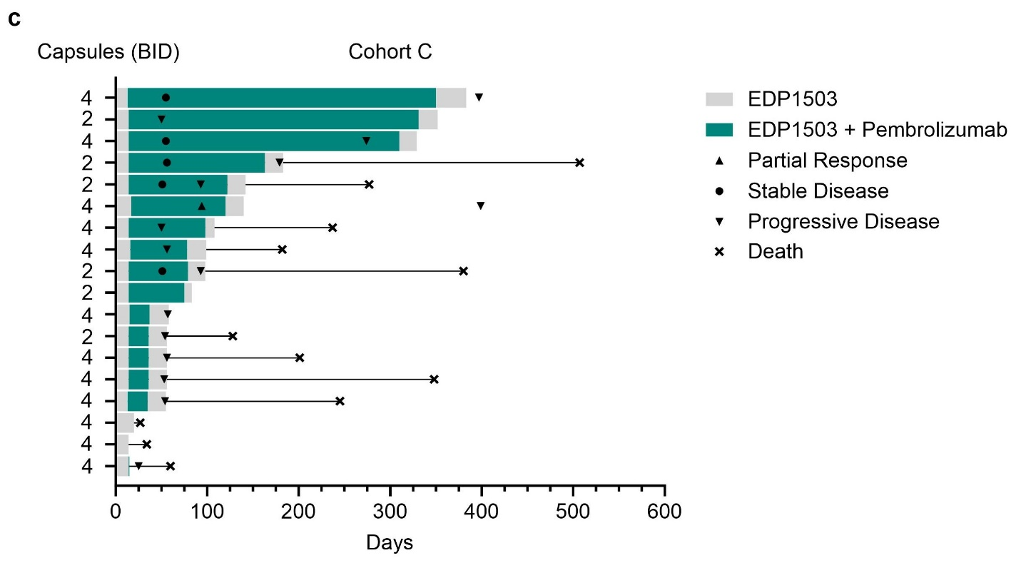

Figure S2. Waterfall plots for change from baseline tumor size for (a) 2 capsules BID versus 4 capsules BID and (b) Cohort B versus Cohort C.
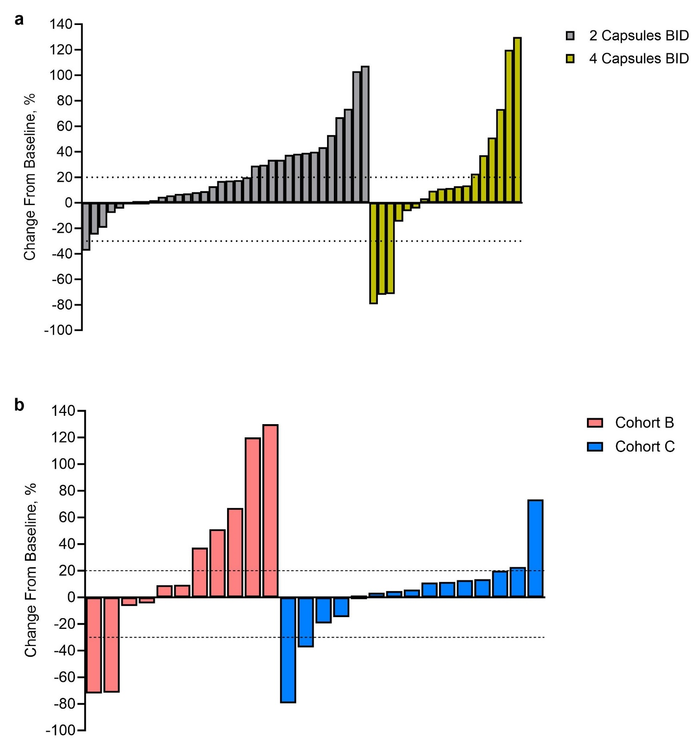

Figure S3. Changes in tumor samples between baseline and day 14 for (a) ratio of CD8+ T cells to Tregs and (b) percentage of activated CD8+ T cells. D, day; Tregs, regulatory T cells.
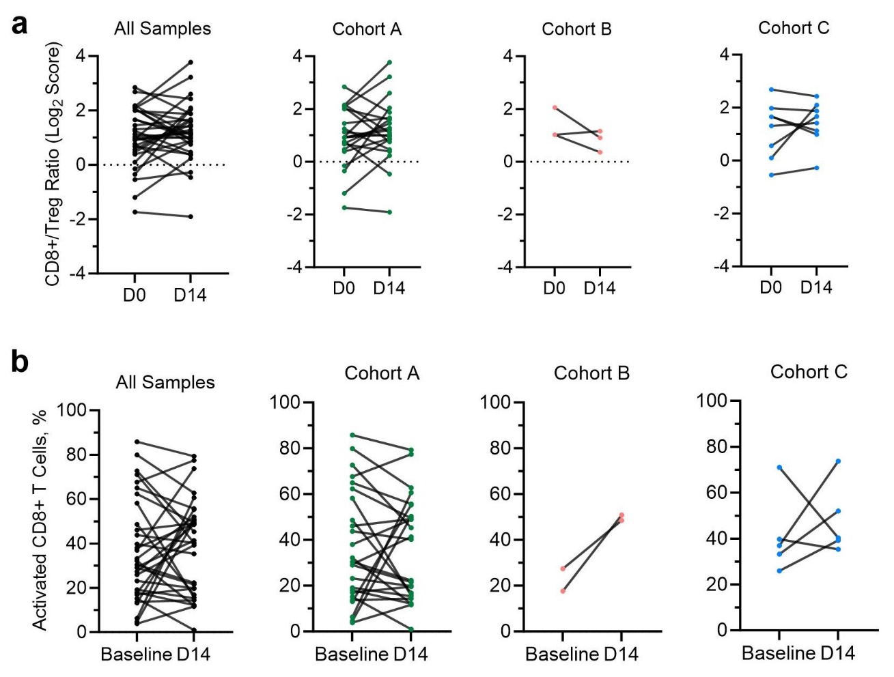

Figure S4. Changes in tumor inflammation signature gene expression. (a) Heatmap of participants and (b) score for immune cell markers by cohort.
