Supplemental material

Ad 3.1. Workshop

Table A.1. Timetable of the course of the workshop and the tasks

Phase | Time | Content
1 | 6 min | Welcoming the students and introducing the workshop leader in plenary. Division of learners according to BYOD and POOL.
2 | 4 min | Completion of the questionnaire on physics learning value and physics self-efficacy in individual work.
3 | 10 min | Introduction to the content of the workshop and motivation to engage with the content. The story of the workshop relates to the Driveman family, who would like to buy an electric car. As they are very environmentally conscious, they want to provide the energy to power the car with a solar system on the roof of their house. In the tasks of the workshop, the family analyzes the extent to which their own house can contribute to charging the electric car and is supported by the students.
4 | 15 min | Processing questionnaire on subject knowledge (pre) in individual work.
5 | 30 min | Installation of the apps (phyphox) for BYOD required for the workshop and issue of the smartphones for POOL. The students then work in groups on an initial experimental task to familiarize themselves with the typical experiments of the workshop. They are given a model house equipped with a solar cell. The voltage of the solar cell when illuminated with a lamp can be read out as a measure of the converted energy using the phyphox app. The students determined the roof pitch and the maximum illuminance. Following the experimental task, the students answer the item on cognitive load. Experiment instructions with the help of YouTube videos.
6 | 5 min | In groups, the learners determine a conversion factor experimentally and through further information on websites, which enables them to transfer the data of the model house to the values of a real house in order to be able to work on the overarching question with the following tasks.
7 | 5 min | Break.

Phase | Time | Content
8 | 20 min | Measuring the performance of solar cells with different cloud cover in groups on the model house. Experiment instructions with the help of YouTube videos. Following the experimental task, the students answer the item on cognitive load.
9 | 10 min | Measuring the performance of solar cells with direct and diffuse radiation in groups on the model house. Experiment instructions with the help of YouTube videos.
10 | 10 min | Processing of the questionnaire on concentration performance in individual work.
11 | 10 min | Continued measurement of the performance of solar cells with direct and diffuse radiation in groups on the model house. Experiment instructions with the help of YouTube videos. Following the experimental task, the students answer the item on cognitive load.
12 | 20 min | Break.
13 | 20 min | Measurement of the performance of solar cells over the course of the day (depending on the angle of incidence) in groups on the model house. Experiment instructions with the help of YouTube videos. Following the experimental task, the students answer the item on concentration performance.
14 | 20 min | Measurement of the performance of solar cells over the course of the year (depending on the angle of incidence) in groups on the model house. Experiment instructions with the help of YouTube videos. Following the experimental task, the students answer the item on concentration performance.
15 | 5 min | Break.
16 | 10 min | Exercises to determine the possible output of solar cells in complex situations with different cloud constellations, taking into account diffuse and direct radiation at different times of the day and year, based on the knowledge gained up to that point.
17 | 15 min | Processing of the questionnaire on subject knowledge (post) in individual work.

Phase | Time | Content
18 | 15 min | Answering open questions from the students and forecasting the output of the solar cells on the Driveman family’s house. Use of the apps padlet and Kahoot.
19 | 10 min | Farewell.

Figure A.1. Experiments to measure the performance of the solar cells on the model house

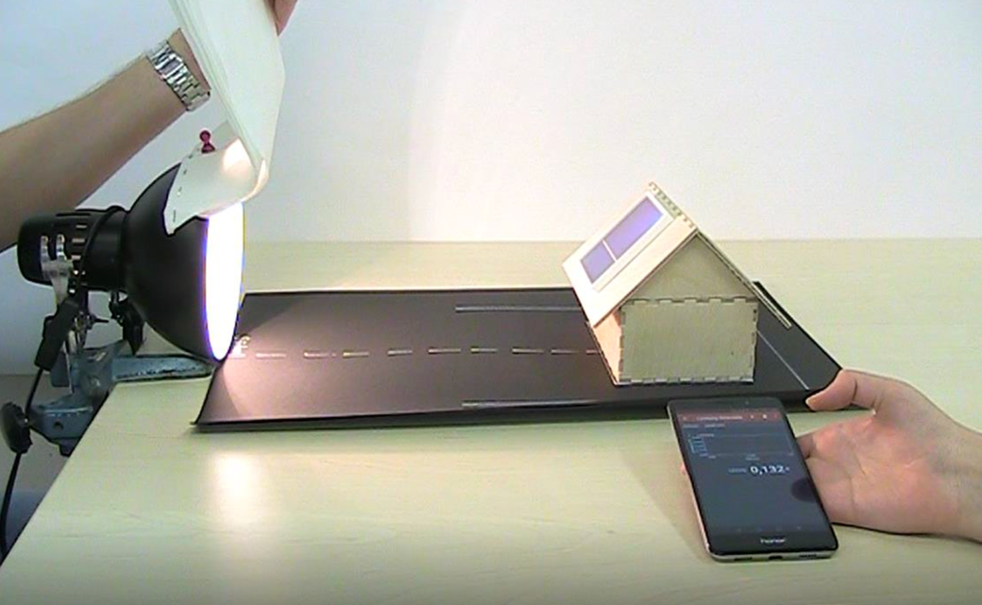

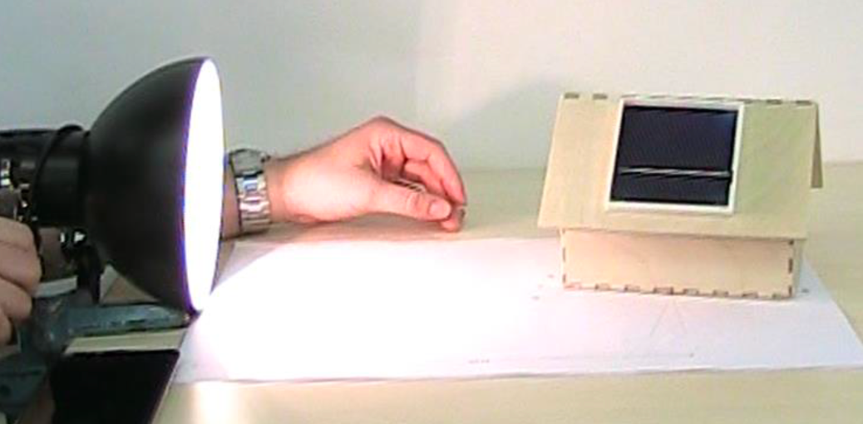

Ad 3.3. Data collection

Table A.2. Overview of the variables of the questionnaires with indication of items or referring to them by references

Variable | Reference | Item(s)
Gender | - | “How do you identify?”
Home language | - | “What language do you speak at home?”
Fear of missing out | Przybylski et al., 2013; German version from Reer, Tang, & Quandt, 2019 | See reference (identical)
Problematic smartphone use | van den Eijnden, Lemmens, & Valkenburg, 2016; German version from Reer, Küpper, & Quandt, 2020 | See reference (identical)
Physics learning value | SMTSL – Tuan, Chin, & Shieh, 2005 | See reference (replace “science” with “physics (lessons)”)
Physics self-efficacy | SMTSL – Tuan, Chin, & Shieh, 2005 | See reference (replace “science” with “physics (lessons)”)
General cognitive abilities | CFT 20-R – Weiß, 2019 | See reference (identical)
Subject knowledge | Self-development | See Table A.3.
Cognitive load | Kalyuga, Chandler, & Sweller, 1999 | “How easy or difficult was it for you to complete the task?”
Concentration performance | d2-R – Brickenkamp, Schmidt-Atzert, & Liepmann, 2010 | See reference (identical)

Table A.3. Items to assess subject knowledge (self-development)

No. | Item
1 | Sketch how the output of a solar cell changes over the course of a year.
 | 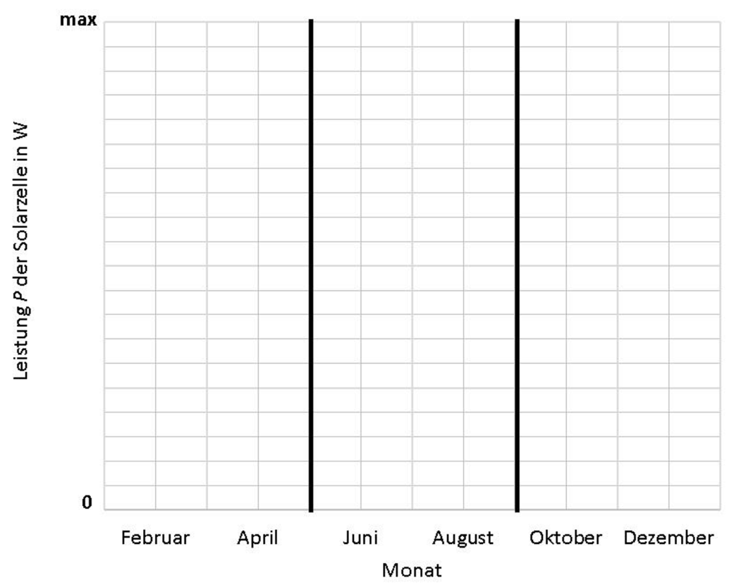
2 | When does the solar cell reach its maximum output?
- Between June and August.
- Between January and May.
- Between October and December.
- The output is always approximately the same.
3 | When does the solar cell reach its lowest output?
- The output is always roughly the same.
- Between February and April or October and December.
- Between November and February.
- Between September and November.

No. | Item
4 | Sketch how the output of a solar cell changes approximately when you hold more and more filters in front of the lamp.
 | 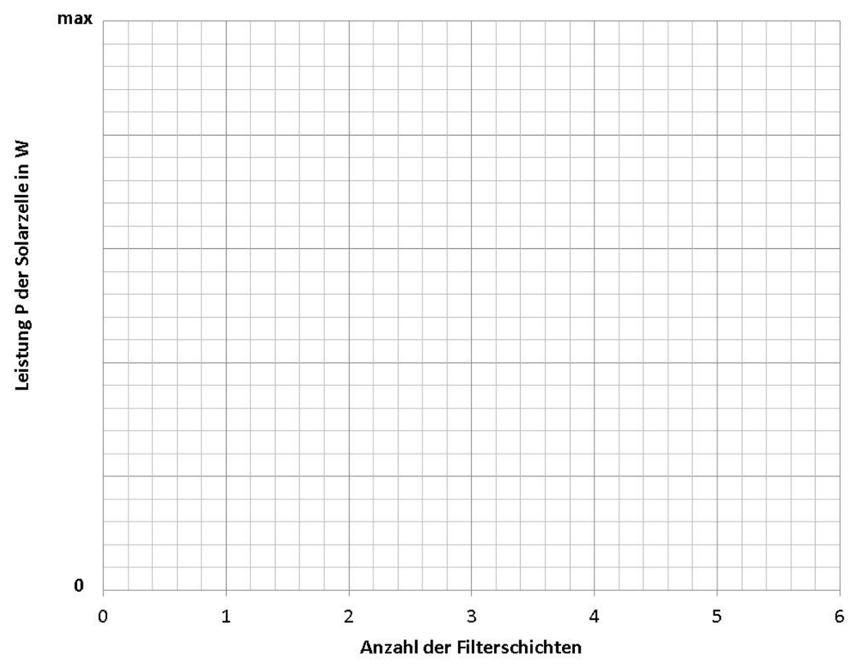
5 | Which of the following statements are not true?
- You can simulate both dark clouds and a cloudless sky with black cardboard.
- Clouds always reduce the output of the solar cell.
- White clouds in front of the sun reduce the output of the solar cell.
- Snow on the ground increases the output of the solar cell slightly.
6 | Mark which of the following statements applies to the measured performance.
- It does not matter how many filter foils are used, the performance is always the same.
- The fewer filter foils you use, the lower the output.
- The more filter foils you use, the higher the output.
- The output is at its highest with approximately three foils.

No. | Item
7 | Sketch how the output of a solar cell changes over the course of a day.
 | 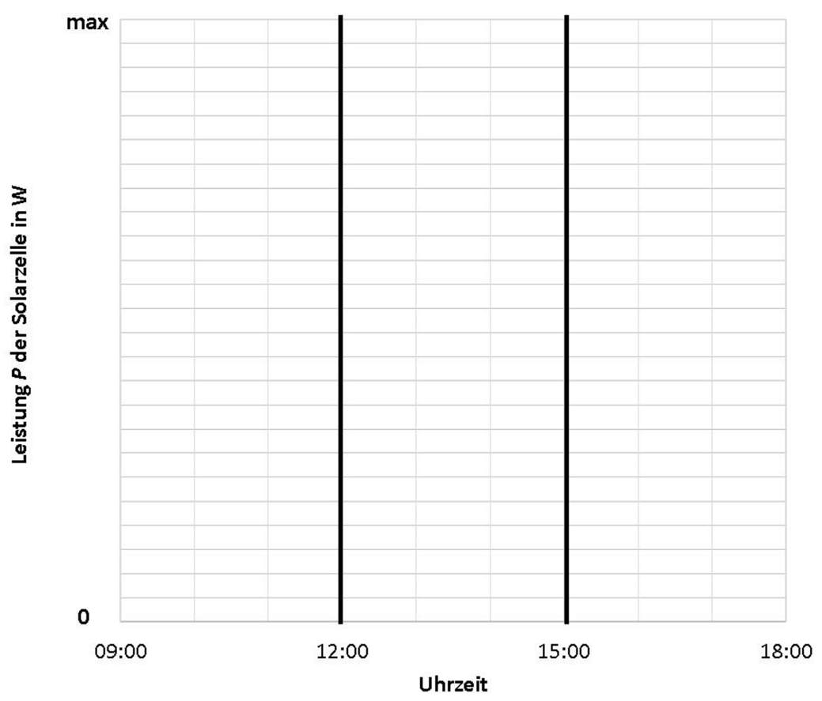
8 | When does the solar cell reach its maximum output?
- The service is always the same.
- Between 9:00 and 12:00.
- Between 12:00 and 15:00.
- Between 15:00 and 18:00.
9 | What is the unit of electrical power P?
- Newton (N)
- Joule (J)
- Watt (W)
- Ampere (A)
10 | What is the unit of illuminance I?
- Lux (lx)
- Lumen (lm)
- Watt (W)
- Candela (cd)

No. | Item
11 | On the underside of clouds, the light from the sun is mainly...
- … transmitted.
- … scattered.
- … absorbed.
- … reflected.
12 | How many types of clouds are usually distinguished?
- 3
- 7
- 10
- 14
13 | In which direction do we see the sun set in the evening?
- North
- South
- East
- West
14 | At what angle is the sun over Münster at midday in December?
- About 25°
- About 15°
- About 45°
- About 35°
15 | What percentage of the total energy requirement is currently covered by solar energy on an annual average?
- About 8 %
- About 16 %
- About 32 %
- About 50 %

Ad 4.2.1. RQ2: BYOD vs. POOL regarding subject knowledge development

Table A.4. Mixed measures ANCOVA results (dependent variable: subject knowledge development; within-subjects factor: measurement time points (1 to 2); between-subjects factor: mobile device access concept (BYOD, POOL); covariates: general cognitive abilities) for interaction term (within-subjects factor × between-subjects factor × covariates).

 |  | F(df₁, df₂) | p | η²
Gender | Female | F(1.00, 173.00) = 0.04 | .842 | .00
Gender | Male | F(1.00, 147.00) = 0.01 | .918 | .00
Socioeconomic status (SES) | Low | F(1.00, 30.00) = 0.29 | .597 | .01
Socioeconomic status (SES) | High | F(1.00, 293.00) = 0.01 | .946 | .00
Fear of missing out (FOMO) | Low | F(1.00, 74.00) = 0.03 | .875 | .00
Fear of missing out (FOMO) | High | F(1.00, 84.00) = 0.03 | .860 | .00
Problematic smartphone use (PSU) | Low | F(1.00, 89.00) = 0.09 | .765 | .00
Problematic smartphone use (PSU) | High | F(1.00, 53.00) = 0.07 | .798 | .00

Ad 4.2.2. RQ2: BYOD vs. POOL regarding cognitive load

Table A.5. Independent samples t-test results (dependent variable: cognitive load; group variable: mobile device access concept (BYOD, POOL)).

 |  | t(df) | p | Cohen’s d
Gender | Female | t(176.00) = 0.74 | .462 | .11
Gender | Male | t(150.00) = 1.33 | .185 | .22
Socioeconomic status (SES) | Low | t(31.00) = 1.73 | .094 | .62
Socioeconomic status (SES) | High | t(298.00) = 0.79 | .432 | .09
Fear of missing out (FOMO) | Low | t(76.00) = 2.19 | .032 | .50 | Pro POOL
Fear of missing out (FOMO) | High | t(72.56) = 0.18 | .860 | .04
Problematic smartphone use (PSU) | Low | t(85.99) = 1.38 | .173 | .28
Problematic smartphone use (PSU) | High | t(57.00) = 2.25 | .028 | .59 | Pro POOL

Table A.6. One-way ANCOVA results (dependent variable: cognitive load; between-subjects factor: mobile device access concept (BYOD, POOL); covariates: physics learning value, physics self-efficacy) for interaction term (between-subjects factor × covariates).

 |  | F(df₁, df₂) | p | η²
Gender | Female | F(1.00, 161.00) = 0.10 | .921 | .00
Gender | Male | F(1.00, 132.00) = 1.88 | .172 | .01
Socioeconomic status (SES) | Low | F(1.00, 26.00) = 5.51 | .027 | .18 | Pro POOL
Socioeconomic status (SES) | High | F(1.00, 270.00) = 0.03 | .861 | .00
Fear of missing out (FOMO) | Low | F(1.00, 67.00) = 3.53 | .064 | .05
Fear of missing out (FOMO) | High | F(1.00, 78.00) = 0.00 | .931 | .00
Problematic smartphone use (PSU) | Low | F(1.00, 78.00) = 1.12 | .293 | .01
Problematic smartphone use (PSU) | High | F(1.00, 51.00) = 3.51 | .067 | .06

Table A.7. Mixed measures ANCOVA results (dependent variable: cognitive load; within-subjects factor: measurement time points (1 to 5); between-subjects factor: mobile device access concept (BYOD, POOL); covariates: physics learning value, physics self-efficacy) for interaction term (within-subjects factor × between-subjects factor × covariates).

 |  | F(df₁, df₂) | p | η²
Gender | Female | F(8.00, 496.00) = 2.73 | .006 | .04 | Pro POOL
Gender | Male | F(7.01, 280.50) = 1.81 | .085 | .04
Socioeconomic status (SES) | Low | F(8.00, 56.00) = 3.11 | .006 | .31 | Pro POOL
Socioeconomic status (SES) | High | F(8.00, 727.23) = 1.21 | .295 | .01
Fear of missing out (FOMO) | Low | F(6.74, 138.24) = 1.22 | .298 | .06
Fear of missing out (FOMO) | High | F(8.00, 204.00) = 1.87 | .066 | .07
Problematic smartphone use (PSU) | Low | F(7.18, 183.17) = 2.03 | .052 | .07
Problematic smartphone use (PSU) | High | F(8.00, 112.00) = 1.07 | .387 | .07

Ad 4.2.3. RQ2: BYOD vs. POOL regarding concentration performance

Table A.8. Independent samples t-test results (dependent variable: concentration performance; group variable: mobile device access concept (BYOD, POOL).

 |  | t(df) | p | Cohen’s d
Gender | Female | t(177.00) = -0.49 | .625 | -.07
Gender | Male | t(143.00) = 0.30 | .764 | .05
Socioeconomic status (SES) | Low | t(30.00) = -1.95 | .061 | .72
Socioeconomic status (SES) | High | t(293.00) = 0.47 | .636 | .06
Fear of missing out (FOMO) | Low | t(73.00) = -0.39 | .699 | -.09
Fear of missing out (FOMO) | High | t(87.00) = -1.84 | .069 | -.39
Problematic smartphone use (PSU) | Low | t(89.00) = 0.50 | .617 | .11
Problematic smartphone use (PSU) | High | t(55.00) = 0.09 | .927 | .03

Table A.9. One-way ANCOVA results (dependent variable: concentration performance; between-subjects factor: mobile device access concept (BYOD, POOL); covariates: general cognitive abilities, physics learning value, physics self-efficacy) for interaction term (between-subjects factor × covariates).

 |  | F(df₁, df₂) | p | η²
Gender | Female | F(1.00, 161.00) = 0.36 | .548 | .00
Gender | Male | F(1.00, 125.00) = 0.22 | .638 | .00
Socioeconomic status (SES) | Low | F(1.00, 24.00) = 3.22 | .085 | .12
Socioeconomic status (SES) | High | F(1.00, 265.00) = 0.08 | .784 | .00
Fear of missing out (FOMO) | Low | F(1.00, 64.00) = 0.35 | .559 | .01
Fear of missing out (FOMO) | High | F(1.00, 77.00) = 4.90 | .030 | .06 | Pro POOL
Problematic smartphone use (PSU) | Low | F(1.00, 76.00) = 0.27 | .608 | .00
Problematic smartphone use (PSU) | High | F(1.00, 47.00) = 0.08 | .785 | .00

