ONLINE SUPPLEMENTARY MATERIAL

[Experimental Protocol]
(This protocol was translated back and forward into Chinese. The underlined instructions were only given to the subjects in the agglomeration bonus treatment.)

[This is the experimental protocol. Please precisely read out this protocol to each subject in the most similar way possible. In order to ensure that the subject thoroughly understands the rules, please remain patient and respond properly to the subject’s questions. Please be noted that the contents in brackets were meant to help the enumerator to implement the experiment and should NOT be read out to the subject.]

[1 Greetings and General Information]
Hello! I am a university student from Sichuan University. Today I would like to invite you to participate in a survey, which mainly includes the following two parts. The first part is a game about your forest management decisions. The second part is a questionnaire survey about your household information.
The results of our survey will be used for research only. Your personal information is strictly confidential. There are no right or wrong answers, as long as they reflect your real thoughts.
The whole survey will last about three hours. You will be paid as long as you complete the whole survey. However, we would not be able to pay you if you fail to complete the whole survey. Would you like to take part in our survey? [If ‘yes’, please continue with the following instructions; otherwise please record the reasons why the subject refuses to participate and contact your supervisor.]

Thanks a lot for agreeing to take part in our survey! We will pay you CNY 50 in cash immediately after you complete the whole survey.
In addition, you will also earn some money in the game, but the amount of your earnings depends on your decisions in the game. The money you earn in the game will not be paid to you today. Instead, we will make the payment tomorrow or one year later.
After finishing the whole survey, we will sign this IOU note [show the note to the subject], which says how much money we owe you and when we will pay you. This note has the signature and contact details of our supervisor. You are most welcome to contact our supervisor in case the payment fails to reach you in due course.
We will make the payment directly to your bank account or by postal order, if you are willing to give us your bank account or your postal address [show the deposit slip and postal order to the subject].
The money you earn in the game will be paid to you at an exchange rate of 1:200. For example, if you earn 20,000 in the game, we will actually pay you CNY 100; if you earn 10,000 in the game, we will actually pay you CNY 50.

Now we will start explaining the rules of the game. Please pay attention when we describe the rules. Please feel free to raise questions whenever needed.

[2 Auction Rules]
Now you have received two handouts. One of them is black and white [show the information sheet to the subject], which contains all the information that you need to participate in the game. The other one has colours [show the decision sheet to the subject], which is for you to write down your decisions in the game.
You will participate in the game together with seven other villagers from your village. You and the other seven villagers were randomly selected.

Assume each of you has a forest plot, the area of which is one mu. Throughout the game we will follow this assumption, which might be different from the actual situation of your forest lands. These forest plots are shown by this figure [show the information sheet to the subject].
These forest plots are different. Some of them only have one adjacent forest plot. For example, Plot A is only next to this plot [point at Plots A and B in turn on the forestland grid]. Plots D, E and H are also like this [point at Plots D, E and H in turn on the forestland grid]. [Pause and ensure that the subject fully understands before continuing.] The other forest plots have three adjacent forest plots. For example, Plot B is next to these three plots [point at Plots B, A, C and F in turn on the forestland grid]. Plots C, F and G are also like this [point at Plots C, F and G in turn on the forestland grid]. [Pause and ensure that the subject fully understands before continuing.]
In addition, there are different types of trees on these plots, which have different values if chopped down and sold [point at the values in the forestland features table].
Your forest plot is in one of the eight situations [show the forestland features table to the subject], but for now we do not know exactly which situation characterises your forest plot. The other seven villagers’ forest plots are characterised by the other seven situations that are different from yours. After finishing the whole survey, we will randomly decide the situation that characterises the forest plot of each player, by drawing lots without replacement.

Suppose your forest plot is like this [point at the first situation in the forestland features table]. You are planning to chop down the trees now and sell them for 10,000 the next day.
Now the government wants to select four players into an ecological conservation programme. If you are selected into the programme, you will be required to keep your trees standing for one year. In return, you will receive a compensation payment tomorrow. After one year, you can chop down your trees and sell them for 10,000 [point at the first situation in the forestland features table]. On this coloured sheet, please write down how much compensation you want to receive [point at the ‘compensation’ column of the forestland features table]. For example, suppose your forest plot is like this [point at the first situation in the forestland features table], which is next to one forest plot belonging to another villager and the trees are worth 10,000. If you think you would have to receive 200 tomorrow in compensation to make you willing to wait for one year to chop down and sell your trees, please write down 200 here [point at the ‘compensation’ column of the forestland features table]. This is to say, the value of your trees will not change after one year, and you are not responsible for tree care or maintenance during this year. You only need to consider, if you have to wait for one year to cut down and sell your trees, how much compensation you want to receive.
Since for now we do not know exactly which situation is assigned to your forest plot, please write down the amount of compensation you want to receive in each situation. You can revise your answers before submission. [Pause and ensure that the subject fully understands before continuing.]
After finishing the whole survey, we will invite you and the other seven villagers to draw lots to decide which situation characterises the forest plot of each player. The four players who ask for the lowest compensation will be selected into the conservation programme and receive the compensation they ask for. That is to say, if you ask for higher compensation, you are less likely to be selected and less likely to receive the compensation. If there is a tie, we will draw lots to select from those who ask for the same amount of compensation. Since each of the eight situations is equally likely to be assigned to your forest plot, please make thoughtful decisions on how much compensation you want to receive in each situation. For example, suppose after drawing lots we know that your forest plot is like this [point at the second situation in the forestland features table]. If you ask for 300 as compensation, and this happens to be one of the four lowest offers, you are then selected. You will receive the first payment tomorrow corresponding to the compensation you ask for. One year later, you will receive the second payment corresponding to the value of your trees. This means you are compensated for waiting for one year to cut down and sell your trees.
If you are not selected, you can cut down your trees and sell them for 10,000 tomorrow, and you will receive the corresponding payment tomorrow. [Pause and ensure that the subject fully understands before continuing.]
If your forest plot is selected, for each adjacent plot which is also selected, you and the owner of the adjacent plot will each receive an extra payment worth 100 in addition to the compensation you ask for. For example, suppose after drawing lots you know that Plot B is yours [point at Plot B on the forestland grid], which is in this situation [point at the sixth situation in the forestland features table]. If you ask for 300 as compensation, and this happens to be one of the four lowest offers, you are then selected. Meanwhile, your forest plot is next to three other villagers’ plots [point at Plots A, C and F on the forestland grid]. If one of the three villagers’ plots is selected, you will get an extra payment worth 100; if two of them are selected, you will get an extra payment worth 200; if all the three villagers’ plots are selected, you will get an extra payment worth 300. However, if your own forest plot is not selected, you cannot get the extra payment even if the adjacent plots are selected. [Pause and ensure that the subject fully understands before continuing.]

To sum up, your earnings from the game are only affected by these factors: the value of your trees, whether you will receive compensation and if so, how much it is, and the number of adjacent forest plots which will receive compensation.

At the end of the survey, we will invite you and the other seven villagers to draw lots to decide which situation characterises the forest plot of each player. After that, we will work out the results of the game. We will then write the results on this coloured sheet [show the decision sheet to the subject], and show you the results.
Finally, we will collect the coloured sheet. We will pay you CNY 50 in cash, sign the IOU note and pay you in due course the money you earn in the game.

Do you have any questions about the game? [Further explain the rules should there be any questions. Ensure that the subject fully understands before continuing.]

[3 Exercise]
Before we begin the game, let’s start with an exercise to see whether we have clearly explained the rules of the game. On the other side of the black-and-white sheet, there are a few statements about the rules of the game [point at the exercise table]. Please put a tick mark (√) next to a statement if you agree, or a cross mark (×) if you disagree. Your answers will not affect your earnings. Please let me know after you have finished writing your answers. We will go through these statements together [all the statements are true] and further discuss the rules of the game if needed. [Please record the amount of correct answers on the right side of the table. Further explain the rules should there be any wrong answers. Ensure that the subject fully understands before continuing.]

[4 Experiment]
We are now ready to begin the game. Your decisions now will affect your earnings. Please write down how much compensation you want [point at the ‘compensation’ column of the forestland features table]. Recall that each answer means that if your forest plot is in that situation, how much compensation you would have to receive tomorrow to make you willing to wait for one year to cut down and sell your trees. Please let me know after you have finished writing your answers.

Thank you for taking part in the game! Now we will start the questionnaire survey. Now your answers will not affect your earnings. At the end of the survey, we will invite you and the other seven villagers to draw lots to decide which situation characterises the forest plot of each player. After that, we will work out the results of the game, pay you CNY 50 in cash and sign the IOU note.

This information sheet contains all the information that you need to participate in the game.
Forestland grid:
 | A
 | B | C. | D
E | F | G
 |  | H

The situation of your forest plot could be:
Next to | 1 | forest plot of another villager | Value of trees: | 10,000
Next to | 1 | forest plot of another villager | Value of trees: | 15,000
Next to | 1 | forest plot of another villager | Value of trees: | 20,000
Next to | 1 | forest plot of another villager | Value of trees: | 25,000
Next to | 3 | forest plots of other villagers | Value of trees: | 10,000
Next to | 3 | forest plots of other villagers | Value of trees: | 15,000
Next to | 3 | forest plots of other villagers | Value of trees: | 20,000
Next to | 3 | forest plots of other villagers | Value of trees: | 25,000

We will draw lots later to see which situation characterises your forest plot.

Before we begin the game, let’s start with an exercise to see whether we have clearly explained the rules of the game.
Please put a tick mark (√) next to a statement if you agree, or a cross mark (×) if you disagree. Your answers will not affect your earnings.

 |  | Agree  (√) | Disagree  (×)
1) | I only have one forest plot in the game.
2) | In the game, my forest plot could be adjacent to one or three forest plots of other villagers.
3) | My earnings depend on the value of my trees, whether my forest plot is selected to receive compensation and whether the adjacent plot(s) is (are) selected to receive compensation.
4) | If I ask for lower compensation, I have a better chance of receiving the compensation.
5) | If my forest plot is selected to receive compensation, and an adjacent plot is also selected, I can get an extra payment.
6) | If I am selected to receive compensation, I will still get paid for the value of my trees, but I have to wait for one year.

Please write down how much compensation you want to receive. Recall that each answer means that if your forest plot is in that situation, how much compensation you would have to receive tomorrow to make you willing to wait for one year to cut down and sell your trees.
Situation of your forest plot |  |  |  |  | Compensation
Next to | 1 | forest plot of another villager | Value of trees: | 10,000
Next to | 1 | forest plot of another villager | Value of trees: | 15,000
Next to | 1 | forest plot of another villager | Value of trees: | 20,000
Next to | 1 | forest plot of another villager | Value of trees: | 25,000
Next to | 3 | forest plots of other villagers | Value of trees: | 10,000
Next to | 3 | forest plots of other villagers | Value of trees: | 15,000
Next to | 3 | forest plots of other villagers | Value of trees: | 20,000
Next to | 3 | forest plots of other villagers | Value of trees: | 25,000

For enumerator use only:
Date of payment  Selected or not |  |  |  | Tomorrow (Date: ________) |  |  |  |  |  | One year later (Date: ________)
Yes |  |  |  | Compensation + Agglomeration bonus: |  |  |  |  |  | Value of trees:
Yes |  |  |  | /200 = . |  |  |  |  |  | /200 = .
No |  |  |  | Value of trees:
No |  |  |  | /200 = .
Adjacent plot ID  Selected or not |  |  |  |  |  |  |  |  |  |  |  | Agglomeration bonus
Yes
No
 |  |  |  |  |  |  |  |  | Tomorrow  (Date: ________) |  |  |  | One year later  (Date: ________)
Do you believe we will make the payment at that time? |  |  |  |  |  |  |  |  | Yes |  | No |  | Yes | No
Do you think the other seven villagers believe we will make the payment at that time? |  |  |  |  |  |  |  |  | Yes |  | No |  | Yes | No

[Follow-up questions]
[Market experience]
1 | How did you decide the amount of compensation you asked for?
2 | Have you ever sold anything? (0 = No; 1 = Yes)
3 | Did the game remind you of selling things? (0 = No; 1 = Yes)
[Time preferences]
4 | Suppose you can choose one from the following two options: a) receiving CNY 100 tomorrow; b) receiving a certain amount of money after one year. How much money has to be offered to you in option b) to make it as good as option a)?
[Risk preferences]
5 | Suppose you can choose one from the following two options: a) receiving CNY 100 for sure; b) receiving a certain amount of money if we flip a coin and the heads side faces up. How much money has to be offered to you in option b) to make it as good as option a)?
[Environmental Awareness]
6 | Do you think forest conservation helps reduce natural disasters in your village, such as landslides, floods and sandstorms? (0 = No; 1 = Yes; 2 = Do not know)
7 | Do you think forest conservation helps reduce natural disasters in other regions, such as the downstream areas of Yangtze River? (0 = No; 1 = Yes; 2 = Do not know)
[Math]
8 | If you buy 8 TV sets for 500 each, how much do you have to pay in total?
9 | If 3 out of 10 people are female, what percentage is male?
10 | If the grain output is normally 800 kg per mu, but the output this year went down by 10% due to crop diseases, how much is the output this year?
11 | 12 + 15 = ?
12 | 35/5 = ?
13 | 13 – 7 = ?
14 | 12 × 4 = ?

[Picture games]
15 Which of these pictures does NOT belong?
1)  |  | 2) 
3) |  | 4) 
16 Among the four pictures in the right-hand column, which one should appear in the last cell of the left-hand column?
500  500  500  500 |  |  | 1)  500
500  500  500 |  |  | 2)  500  500
500  500 |  |  | 3)  500  500  500
? |  |  | 4)  500  500  500  500

17 How many differences can you spot between the two pictures (time limit: 5 minutes)?
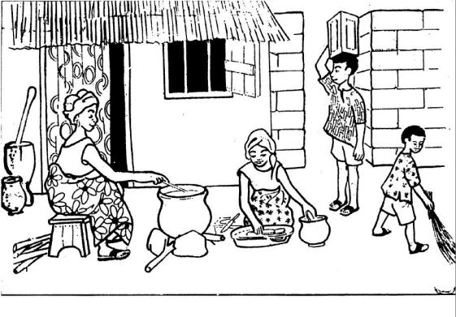
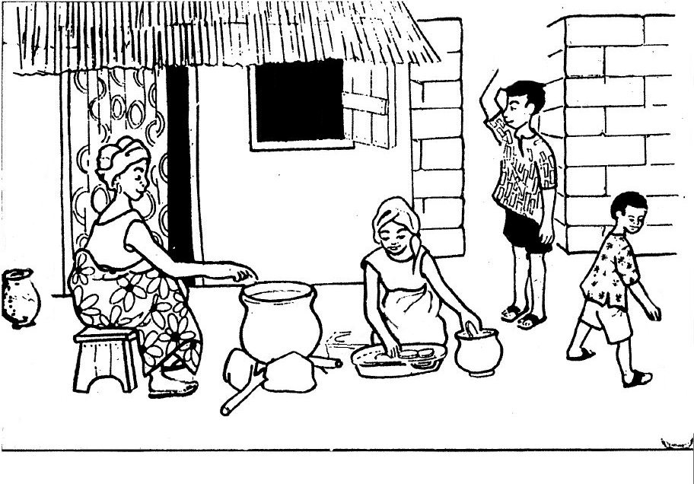
Note: Figures in boxes 15 to 17 above were adapted from the protocol used in Bulte, E. Kontoleon, A. List, J. Turley, T., & Voors, M. (2017). From personalized exchange towards anonymous trade: A field experiment on the workings of the invisible hand. Journal of Economic Behavior & Organization, 133, 313-330.

