SUPPLEMENTARY INFORMATION

Annexes
1 – Greenhouse emissions sources
2 – The crop productivity yields
3 – Additional discussion on yields and changes in land use
4 – Welfare impacts

Annex 1 – Greenhouse emissions sources
The energy and agricultural sectors are the first and second largest contributors to the global greenhouse (GHG) emissions. The shares of these two sectors in the global GHG emissions in 2012 were 72% and 11%, respectively (Supp. Fig. 1)(CAIT 2015). .
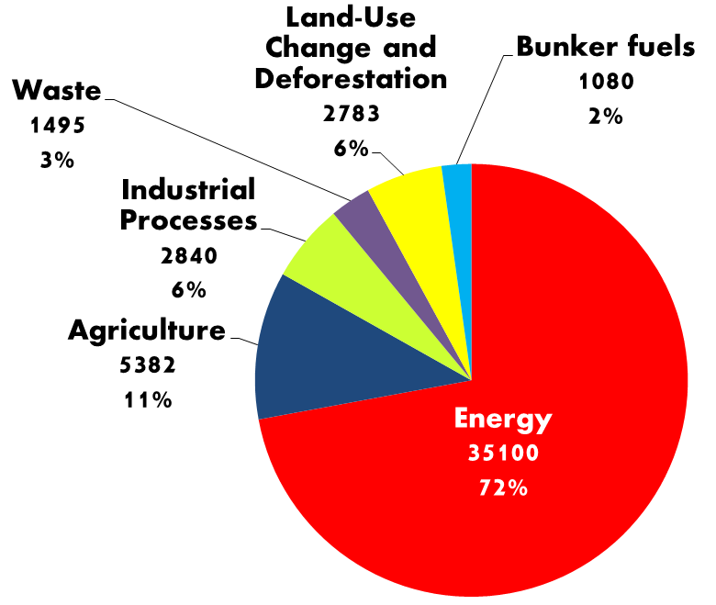
Supp. Figure 1. GHG emissions (in MtCO₂e) by sector in 2012
Source: CAIT, World Research Institute (2015), adapted by the authors
In terms of non-CO₂ gases (CH₄ and NH₃), agriculture was the largest emitter in the previous decade, being responsible for more than half of global non-CO₂ emissions. The most important sources were paddy rice (e.g. its land releases methane), ruminant sector and dairy farm (e.g. animals releases non-CO2 GHG emissions through livestock enteric fermentation)(Golub et al. 2010; US-EPA 2006). In particular, livestock represents 50% of the global agricultural GDP, making this sector an important source of GHGs(Herrero et al. 2016).

Annex 2 – The crop productivity yields
The original crop productivity values (in metric ton/ha) are collected for the period 2000-2099 through the online package developed by Agricultural Model Comparison and Improvement Project (AgMIP)(Villoria et al. 2016) at grid cell level (i.e. 0.5° $×$ 0.5° resolution). We collected information for eight different crops: maize, soybeans, millet, rice, rapeseed, sugarcane, sugar beets, and wheat by irrigation type (i.e. rainfed and irrigated). The data is then grouped by the AGMIP aggregation tool by crop, country, and AEZ for each irrigation type.
This procedure is followed for the crop yield shocks for both RCPs examined in this paper (RCP 4.5 and RCP 8.5) which are implemented in the Tax+CY, TS+CY and CYBAU scenarios. Overall, crop yields were expected to decrease over time due to climate change in both RCPs (Supp. Table 1 provides a summary of the yield shocks). In general the adverse effects are higher in the RCP 8.5. For the sugar sector, the changes are mixed, because this sector combines sugar cane (cultivated mainly in tropical regions) and sugar beet (cultivated in colder regions). The “other crops” category is the only sector which is not shocked.

The following steps are followed to calculate crop productivity shocks
1) We downloaded projected yields $Y_{cit}$ by c crop, at i grid cell level and time t, at the global scale for 2000-2100.
2) We calculated the average yields for the first ($Y_{cib}$) and last ($Y_{cie}$) 10 years by crop at the grid cell level at the global scale.
3) We then aggregated the crop yields ($Y_{czrb}$ and $Y_{czre}$) by region r and AEZ z. We used harvested areas as weights in the aggregation process.
4) We finally calculated the %change in yields $y_{zr}$ by region and AEZ using:
$$y_{zr}=(\frac{Y_{czre}}{Y_{czrb}}-1)×100$$

Supp. table 1.a Exogenous crop yields shocks (in %) for the Tax+CY and TS+CY scenarios (RCP4.5)
Region | Rice | Wheat | Sorghum | Other Coarse Grains | Soybeans | Palm | Rapeseed | Other Oilseeds | Sugar crops
USA | -14 | -14 | -11 | -14 | -16 | 0 | -12 | -16 | -9
European Union | -12 | -24 | -21 | -20 | -16 | 0 | -11 | -14 | -22
Brazil | -17 | -23 | -16 | -6 | -29 | -28 | -28 | -32 | 13
Canada | 0 | 15 | 0 | -15 | -24 | 0 | 1 | 5 | -22
Japan | -1 | -8 | 0 | -9 | -9 | 0 | 5 | -11 | 0
China | -7 | 1 | -10 | -10 | -12 | -8 | -1 | -9 | 23
India | -22 | -14 | -11 | -15 | -29 | 0 | -21 | -29 | -14
Central America | -30 | -18 | 14 | -1 | -21 | -24 | 0 | -25 | 17
South America | -11 | -7 | -7 | -4 | -18 | -25 | -16 | -19 | 16
East Asia | -20 | -14 | -9 | -8 | -17 | 0 | -9 | -17 | 13
Malaysia & Indonesia | -17 | 0 | 0 | -15 | -26 | -24 | 0 | -24 | -9
South East Asia | -23 | -28 | -16 | -16 | -34 | -29 | 0 | -34 | -6
South Asia | -23 | -13 | -6 | -8 | -14 | 0 | -18 | -19 | -14
Russia | 0 | -15 | -3 | -1 | -10 | 0 | -18 | -17 | -17
Other Central Europe | -13 | -10 | -16 | -15 | -21 | 0 | -17 | -21 | -21
Other European countries | 0 | -8 | 0 | 10 | 0 | 0 | -7 | -6 | -13
Middle East & North Africa | -11 | -10 | -6 | -10 | -16 | 0 | -23 | -19 | -1
Sub-Saharan Africa | -31 | -26 | -15 | -13 | -27 | -23 | -20 | -29 | 25
Oceania | -18 | -14 | -20 | -26 | -16 | -23 | -16 | -19 | 19
Supp. table 1.b Exogenous crop yield shocks (in %) implemented in the CYBAU scenario (RCP 8.5)
Region | Rice | Wheat | Sorghum | Other Coarse Grains | Soybeans | Palm | Rapeseed | Other Oilseeds | Sugar crops
USA | -33 | -22 | -5 | -19 | -27 | 0 | 0 | -21 | -33
European Union | -31 | -40 | -34 | -34 | -30 | 0 | -23 | -27 | -42
Brazil | -36 | -41 | -32 | -21 | -64 | -65 | -64 | -67 | 16
Canada | 0 | 15 | 0 | -26 | -45 | 0 | 10 | 12 | -65
Japan | -30 | -25 | 0 | -20 | -19 | 0 | -13 | -22 | -15
China | -25 | -8 | -7 | -11 | -28 | -22 | -15 | -24 | 9
India | -41 | -33 | -24 | -28 | -60 | 0 | -53 | -59 | -30
Central America | -39 | -29 | -2 | -16 | -49 | -60 | -1 | -56 | 2
South America | -30 | -14 | -25 | -11 | -51 | -59 | -62 | -51 | 33
East Asia | -39 | -34 | -12 | -11 | -27 | 0 | -27 | -28 | 21
Malaysia & Indonesia | -40 | 0 | 0 | -31 | -59 | -56 | 0 | -56 | -24
South East Asia | -37 | -51 | -19 | -32 | -57 | -64 | 0 | -64 | -17
South Asia | -43 | -30 | 5 | -3 | -35 | 0 | -54 | -42 | -34
Russia | -2 | -26 | -18 | -22 | -33 | 0 | -28 | -37 | -48
Other Central Europe | -28 | -21 | -31 | -28 | -41 | 0 | -30 | -40 | -41
Other European countries | 0 | -19 | 0 | -3 | -25 | 0 | -18 | -18 | -45
Middle East & North Africa | -26 | -23 | 42 | 35 | -27 | 0 | -41 | -34 | -11
Sub-Saharan Africa | -44 | -48 | -35 | -33 | -57 | -52 | -34 | -57 | 45
Oceania | -38 | -33 | -66 | -67 | -39 | -29 | -46 | -40 | 12
The crop yields are exogenous and implemented as shocks into the model. The agricultural productivities were obtained in the process described in Annex 3. The summary values presented were aggregated from [AEZ, crop and region] to [crop and region]. “Other crops” sector is not shown here (it was not shocked).

Annex 3 – Additional discussion on land use change and cropland rent
For the Tax-Only scenario, the proportion of land cover remains relatively constant in many regions (Supp. fig. 2) because there are no incentives in moving cropland and pasture land to forest. Therefore, area available for agriculture is relatively constant. In contrast, for the Tax-Subsidy scenario, the FCS subsidy intensifies competition for land which increases land rent everywhere (Supp. Table 2).
Under the presence of climate change, we exogenously impose the impacts of climate change on crops yields. In the Tax+CY scenario, the proportion of land cover remains relatively constant despite the negative crop yield shocks because the internal increases in cropland for many crop sectors are compensated with decreases of paddy rice land (due to its methane emissions) and “other crops” sector. Note that “other crops” sector was not shocked it can give up more land than the other crop categories with adverse yields. The impacts of the emission tax are reflected on noticeable increases in crop land rent. There is also substantial substitution of land with labor.
Since climate change negatively affects crops yields in many regions, it makes competition for land stronger. Therefore, the impact is worse for the TS+CY scenario due to two effects: (i) the competition for land with forestry driven by the sequestration subsidy (i.e., land use change) and (ii) the overall negative effects on crop yields.

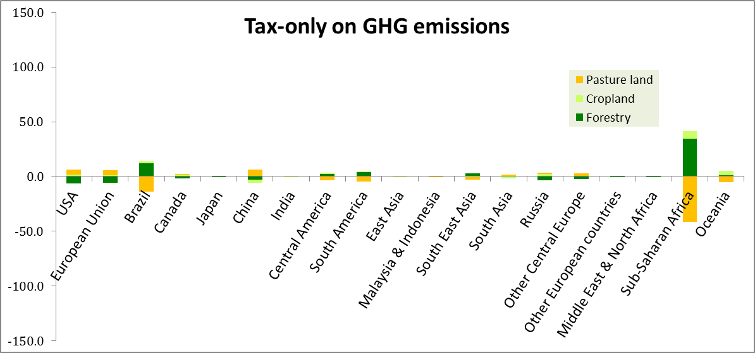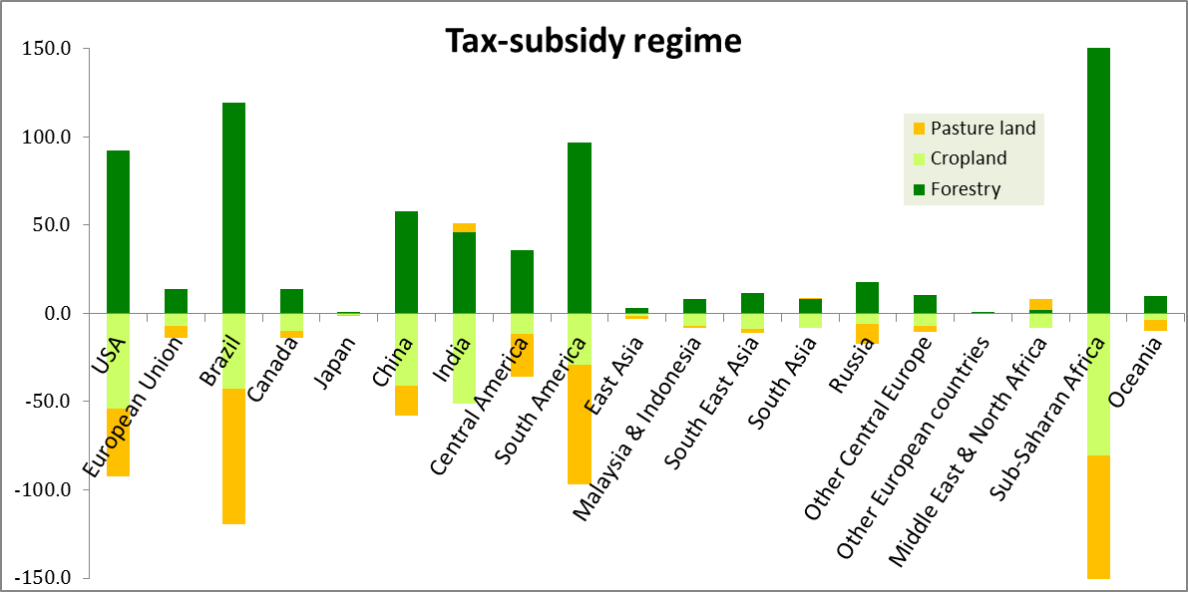
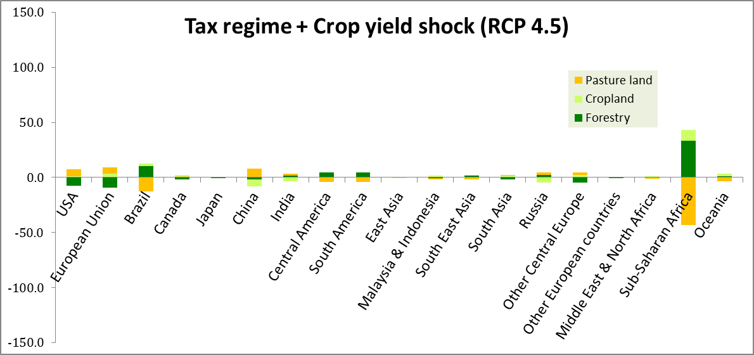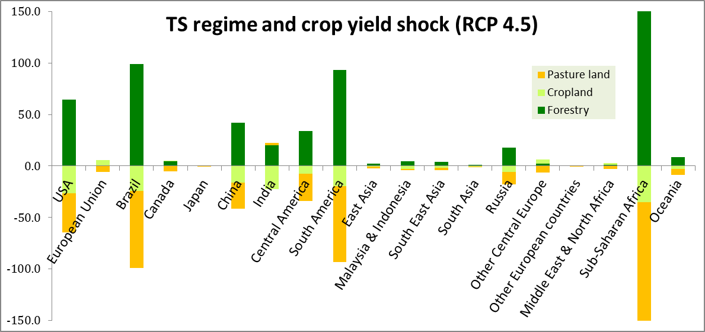
Supp. Fig. 2 Changes in land cover by type (in Mha)
Annex 4 – Welfare impacts
Table 2 shows an overall decline in the welfare (a measure of economic well-being in $ of equivalent variation [EV]) due to the 150$/tCO₂e tax for almost all of the countries. In this Tax-Only scenario United States, China and Middle East & North Africa suffer the highest losses (e.g. EV losses are higher than $100 billion) due partially to negative impacts from reallocating resources. The two least affected regions are Japan and the European Union due to favorable terms of trade (TOT) which eliminates the adverse impacts of other components of welfare (Supp. table 3a).
Implementing the 80 $/tCO₂e Tax-Subsidy regime drives a global welfare loss of about $457 billion (table 2), which is lower than the EV loss from applying the Tax-Only regime ($-760 billion). This is mostly attributed that revenue from FCS partially offset to the cost in reallocating resources in the Tax-Subsidy scenario (Supp. table 7b). Thus, this shows that FCS, under no presence of crop yield losses, seems to be a more cost effective alternative compared to the other options, which is consistent with the literature.
For both policy regimes, the addition of crop yield losses reduces welfare across the world, impacting negatively in the technological efficiency for most of the regions (Supp. tables 7c and 7d). Nevertheless, the impact is more dramatic in the TS+CY regime. This is because the adverse effects of climate change eliminate the advantage of FCS (e.g., there is less FCS in this scenario which drives down the FCS regional revenue). Thus, this suggests a significant underestimation of social welfare losses if the agricultural productivity variation is not included in the FCS modeling.
Supp. table 2a Welfare decomposition for the Tax-Only scenario (in $ millions of EV)
Region | Carbon Trading | Allocation Efficiency | Endowment Efficiency | Technical Efficiency | Terms of trade | Investment Saving | ΔEV
United States | 0 | -147,503 | -21 | 471 | 34,657 | -3,211 | -115,607
European Union | 0 | -57,549 | -68 | 1,516 | 57,740 | -2,368 | -729
Brazil | 0 | -18,706 | -23 | -55 | 2,730 | 799 | -15,255
Canada | 0 | -15,514 | -6 | 99 | 407 | -243 | -15,257
Japan | 0 | -16,442 | -1 | 326 | 27,909 | -3,393 | 8,400
China | 1 | -176,353 | -68 | -2,444 | -18,172 | 3,297 | -193,740
India | 0 | -34,721 | -32 | -181 | 3,213 | -315 | -32,037
Central America | 0 | -45,062 | -11 | 1 | -7,742 | -172 | -52,986
South America | 2 | -16,468 | -20 | -25 | -3,286 | 453 | -19,344
East Asia | 0 | -17,709 | -5 | 54 | 5,264 | -515 | -12,911
Malaysia & Indonesia | 0 | -13,702 | -7 | -13 | -1,892 | -584 | -16,198
South East Asia | 0 | -15,765 | -19 | -394 | 2,153 | -232 | -14,257
South Asia | 0 | -7,966 | -12 | -47 | -210 | -126 | -8,361
Russia | 0 | -43,414 | -14 | -330 | -23,186 | 6,405 | -60,539
Other Central Europe | 0 | -46,726 | -24 | 166 | 623 | -782 | -46,743
Other Europe | 0 | -2,255 | 0 | 72 | -6,282 | -1,006 | -9,471
Middle East & N. Africa | 0 | -38,362 | -9 | -51 | -66,731 | 2,151 | -103,002
Sub-Saharan Africa | 20 | -30,470 | -54 | -247 | -14,942 | 175 | -45,517
Oceania | -867 | -12,934 | -8 | 11 | 7,316 | -289 | -6,771
Global | -844 | -757,621 | -400 | -1,072 | -433 | 44 | -760,326

Supp. Table 2b Welfare decomposition for the Tax-Subsidy scenario (in $EV millions)
Region | Carbon Trading | Allocation Efficiency | Endowment Efficiency | Technical Efficiency | Terms of trade | Investment Saving | ΔEV
United States | 1 | -76,866 | -16 | -3,690 | 29,789 | -1,714 | -52,497
European Union | 0 | -22,133 | -57 | -2,720 | 37,221 | -1,415 | 10,897
Brazil | -87 | -13,164 | -20 | -678 | 3,815 | 625 | -9,509
Canada | 0 | -7,533 | -5 | -236 | 160 | -180 | -7,794
Japan | 0 | -9,297 | -1 | -1,621 | 17,065 | -2,305 | 3,841
China | 0 | -98,203 | -59 | -7,206 | -9,262 | 1,264 | -113,466
India | 0 | -27,650 | -30 | -4,602 | 2,735 | -291 | -29,839
Central America | 0 | -30,495 | -9 | -1,404 | -5,383 | -34 | -37,324
South America | 12 | -15,569 | -18 | -1,409 | -1,036 | 456 | -17,564
East Asia | 0 | -9,431 | -4 | -1,359 | 3,737 | -443 | -7,499
Malaysia & Indonesia | 0 | -8,532 | -6 | -1,993 | -912 | -269 | -11,713
South East Asia | 0 | -8,425 | -16 | -1,063 | 2,546 | -170 | -7,128
South Asia | 0 | -5,245 | -11 | -668 | -202 | -94 | -6,220
Russia | 0 | -18,316 | -11 | 335 | -18,359 | 4,263 | -32,088
Other Central Europe | 0 | -26,004 | -20 | -587 | 1,390 | -584 | -25,805
Other Europe | 0 | -1,265 | 0 | -1 | -6,166 | -534 | -7,966
Middle East & N. Africa | 0 | -19,114 | -7 | -467 | -52,819 | 1,504 | -70,903
Sub-Saharan Africa | -2 | -20,768 | -49 | -1,753 | -10,173 | 111 | -32,634
Oceania | 4 | -7,722 | -7 | 342 | 5,547 | -159 | -1,994
Global | -72 | -425,734 | -347 | -30,781 | -305 | 33 | -457,206

Supp. table 2c Welfare decomposition for the Tax+CY scenario (in $ millions of EV)
Region | Carbon Trading | Allocation Efficiency | Endowment Efficiency | Technical Efficiency | Terms of trade | Investment Saving | ΔEV
United States | -1 | -152,528 | -21 | -10,552 | 43,594 | -5,623 | -125,131
European Union | 0 | -64,265 | -69 | -34,109 | 52,448 | -3,443 | -49,437
Brazil | 0 | -18,813 | -23 | -704 | 6,137 | 491 | -12,911
Canada | 0 | -16,151 | -6 | -797 | 1,817 | -186 | -15,322
Japan | 0 | -17,883 | -1 | -1,751 | 25,880 | -3,233 | 3,013
China | 0 | -182,351 | -69 | 4,476 | -21,321 | 4,220 | -195,044
India | 0 | -39,423 | -34 | -32,313 | 2,868 | -425 | -69,327
Central America | 0 | -48,036 | -11 | -2,023 | -8,172 | -180 | -58,422
South America | -1 | -16,622 | -20 | -2,124 | 102 | 339 | -18,326
East Asia | 0 | -17,253 | -5 | -4,028 | 2,859 | 82 | -18,346
Malaysia & Indonesia | 0 | -14,760 | -8 | -5,734 | -1,431 | 4 | -21,928
South East Asia | 0 | -16,624 | -19 | -2,635 | 2,815 | -44 | -16,508
South Asia | 0 | -8,764 | -12 | -2,651 | -876 | -218 | -12,521
Russia | 0 | -45,686 | -14 | -4,112 | -24,817 | 7,225 | -67,404
Other Central Europe | 0 | -48,255 | -24 | -6,534 | 1,326 | -834 | -54,321
Other Europe | 0 | -2,565 | 0 | -243 | -7,049 | -771 | -10,629
Middle East & N. Africa | 0 | -41,015 | -10 | -5,499 | -71,346 | 2,695 | -115,174
Sub-Saharan Africa | -11 | -31,571 | -54 | -4,368 | -14,464 | 245 | -50,223
Oceania | -9 | -13,165 | -8 | -1,324 | 9,434 | -349 | -5,422
Global | -23 | -795,730 | -408 | -117,024 | -194 | -4 | -913,382

Supp. table 2d Welfare decomposition for the TS+CY scenario (in $ millions of EV)
Region | Carbon Trading | Allocation Efficiency | Endowment Efficiency | Technical Efficiency | Terms of trade | Investment Saving | ΔEV
United States | 0 | -98,976 | -18 | -52,889 | 71,531 | -14,944 | -95,295
European Union | 0 | -53,755 | -58 | -127,540 | 24,128 | -5,227 | -162,452
Brazil | 12 | -17,239 | -21 | -21,457 | 17,305 | 1,373 | -20,028
Canada | 0 | -10,083 | -5 | -6,841 | 5,574 | 53 | -11,301
Japan | 0 | -13,470 | -1 | -14,263 | 4,318 | -1,166 | -24,582
China | 0 | -129,254 | -65 | -43,354 | -21,787 | 5,564 | -188,896
India | 0 | -32,525 | -33 | -65,750 | 2,559 | -565 | -96,314
Central America | 0 | -50,814 | -10 | -21,387 | -13,170 | -76 | -85,458
South America | -116 | -20,023 | -19 | -20,732 | 8,752 | 836 | -31,302
East Asia | 0 | -11,391 | -5 | -8,333 | -7,211 | 2,119 | -24,821
Malaysia & Indonesia | 0 | -11,390 | -8 | -17,177 | -2,190 | 1,649 | -29,117
South East Asia | 0 | -11,617 | -19 | -8,865 | 5,963 | 564 | -13,974
South Asia | 0 | -6,373 | -12 | -10,578 | -2,034 | -497 | -19,493
Russia | 0 | -28,190 | -12 | -8,608 | -25,803 | 7,097 | -55,516
Other Central Europe | 0 | -31,786 | -22 | -22,337 | 9,189 | -939 | -45,895
Other Europe | 0 | -2,373 | 0 | -1,574 | -9,834 | 485 | -13,296
Middle East & N. Africa | 0 | -27,964 | -9 | -20,869 | -69,837 | 3,351 | -115,328
Sub-Saharan Africa | 12 | -26,326 | -52 | -33,423 | -10,955 | 614 | -70,130
Oceania | 9 | -9,714 | -7 | -8,388 | 14,569 | -515 | -4,046
Global | -84 | -593,262 | -377 | -514,365 | 1,067 | -225 | -1,107,245

REFERENCES
CAIT (2015) Climate Data Explorer. http://cait.wri.org.
Golub AA, Henderson BB, Hertel TW, Gerber PJ, Rose SK, Sohngen B (2010) Effects of the GHG Mitigation Policies on Livestock Sectors GTAP Working Paper No. 62
Herrero M et al. (2016) Greenhouse gas mitigation potentials in the livestock sector Nature Climate Change
US-EPA (2006) Global Emissions of Non-CO2 Greenhouse Gases: 1990–2020. Washington, DC
Villoria NB, Elliott J, Müller C, Shin J, Zhao L, Song C (2016) Rapid aggregation of global gridded crop model outputs to facilitate cross-disciplinary analysis of climate change impacts in agriculture Environmental Modelling & Software 75:193-201

