Online Appendix

- The survey used in this study (the discrete choice experiment part, English version)

Part 1
You will be given an introduction about air pollution in China and answer questions about how air pollution affects you and people around you
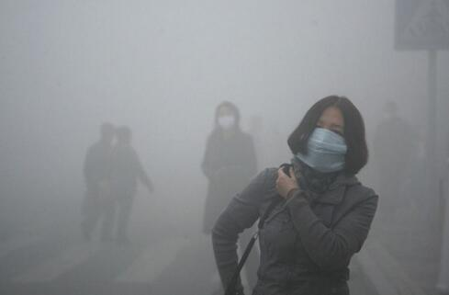

Introduction
In recent years, air pollution has become a commonly discussed issue in China. According to data from the World Health Organisation and the World Bank, over a million people in China die each year due to air pollution. The loss due to air pollution in China in 2013 was equal to 9.92% of its Gross domestic product.
There are mainly two ways in which air pollution may affect the wellbeing of people in your area:
- Health effect
Many substances in polluted air damage people’s health, particularly the invisible small particles (e.g., PM10 and PM2.5). Inhaling these particles increases the likelihood of heart and lung diseases. Scientists have shown that air pollution is one of the most important factors that contributes to lung cancer, stroke and cardiovascular diseases. According to the Greenpeace, about 1.6 million people died in China because of diseases triggered by air pollution in 2013. In addition, air pollution in China also causes 6.8 million hospital admissions each year.
- Visibility effect
Severe air pollution may also cause poor visibility, and thus slow down the traffic in rush hour, delay air flights and lead to more traffic accidents in your city. Additionally, poor visibility hinders emergency and rescue operations in your city.
Now, we would like to ask you some questions about your experience of the air pollution effects.
Question 1: How often do you hear people around you talking about the health and visibility effects of air pollution in China?
A: Often
B: Sometimes
C: Never
D: I don’t know
Question 2: How likely do you think it is that your health or that of your family will be affected by air pollution?
A: Very likely
B: Somewhat likely
C: Somewhat unlikely
D: Very unlikely
Question 3: Do you think you know enough about air pollution (for example, air pollutants, effects of air pollution and pollution-related policies) through social media or people around you ?
A: I know quite a lot
B: I have some knowledge about it
C: I know little about it
Question 4: Have you ever changed any of your daily activities to contribute to the reduction of air pollution? For example, have you tried to take public transport instead of driving your own car? or tried to use clean energy for home energy use?
A: Often
B: Sometimes
C: Never
D: I don’t know

Part 2
Please read the introduction and answer the questions about your opinion on air pollution. Please read the following text patiently as it helps you to better understand the context and express your opinions.
There are many sources of air pollution. In order to tackle this issue in Beijing, the local government has implemented relevant policies in recent years. The key actions include shutting down polluting factories that did not reach the environmental standards set by the central government, applying new technologies to the polluting industries, and developing renewable energy, such as wind, water and solar power.
Following the Air Pollution Prevention and Control Action Plan published by the State Council of China, there are some achievements on air quality management. Data from the local environmental protection bureau shows that in the last 5 years in Beijing, the level of air pollution has been reduced by one third, which meets the target set by the central government.
Now, a decision on air pollution actions need to be made for the next five years.
- What is the current situation?
If the implementation level remains unchanged as of now, the current budget of the local government will be spent on actions to ensure that the number of hospital admissions due to air pollution in Beijing will remain at 130,000 per year, and the number of low visibility days will remain at eight days per month.
- What governmental actions will be taken in the future?
The actions mainly focus on the health and visibility effects of air pollution. The government may take different types of actions to deal with these two different air pollution effects. Some actions can deal with the visibility effects and some other actions can deal with the health effects, so it is possible to have actions that alleviate health problems but aggravate visibility problems, or the other way around.
- When will the new policy outcomes be achieved?
The policy outcomes are expected to be achieved by the end of 2022
- Why should I pay or get compensation?
Now, we would like to know your preference on the actions and objectives for air pollution reduction. If you would like to see the situation improve in any of the effects, then you may need to pay extra to fund the additional activities needed. If you would be satisfied with lower health or visibility levels, then you may receive some of your money back, as fewer of the planned actions would have to be undertaken.

A bit of scientific knowledge
Why the effects of health and visibility are separable?
Scientists have proved that the health and visibility effects of air pollution are not necessarily related, because they have different sources. According to the reports from the United Nations and the Environmental Protection Agency of the United States, people’s health is affected by detrimental substances like ozone, nitrogen oxide (NOx), particulate matter (PM) and sulphur dioxide (SO2), but visibility is mainly affected by particulate matter.
- Health: Ozone, NOx, PM, SO2
- Visibility: PM
In our context, government will implement a combination of policies to alleviate air pollution problems, and due to the limited governmental budget, a policy combination cannot target all air pollutants at the same time.
The picture (figure 1) below provides a visual example.
In the example, after implementing a policy combination, visibility issue will be alleviated while health will be aggravated, if the government implements more policies (compared with the current level of actions) to reduce PM, and fewer policies to reduce other detrimental substances, in other words, ozone, NOx and SO2. Accordingly, you need to pay extra money for the improved visibility, but will receive some of your money back due to the deteriorated health issue.
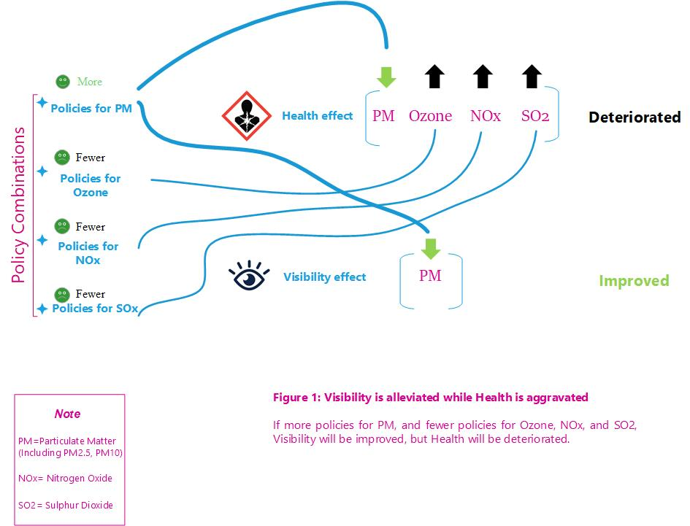

Similarly, visibility could be aggravated, but the health issue is alleviated, if the government implements more policies to reduce ozone, NOx and SO2, and fewer policies to reduce PM. Accordingly, you need to pay extra money for the improved health, but will receive some of your money back due to the deteriorated visibility issue.
[Question]: Now, do you understand that it is possible to have actions that alleviate the health problem but aggravate the visibility problem or the other way around?
- Yes, I understand
- No, I don’t understand, and would like to read the instruction again

How is the payment change achieved?
This payment change will be achieved through an increase or decrease in your monthly household electricity, gas and heating bill. The change in your bill will be organised by state owned electric power and gas companies (for example, State Grid Corporation of China and China Gas), and they will cooperate with the local government to achieve clean air plans.

[Please read the following text patiently as it helps you to better understand the context and express your opinions.]
In order to assist the government in making policies to tackle the air pollution issue, they need to hear your voice as a citizen in your city.
The tables below show the potential air pollution effects on people, after the governmental actions are implemented.
Four different characteristics are listed: health, chance of success, visibility and payment effects. Note that these effects have a range of possible levels.
Health effects: The effect of air pollution on health in your local area. This is represented by the number of hospital admissions per year due to air pollution. The man shape icon represents 100 thousand people who go to hospital due to air pollution related diseases in your area.

Health (number of hospital admissions per year)
150,000 hospital admissions per year

(20,000 or 15% more)

145,000 hospital admissions per year
( 15,000 or 11% more)

140,000 hospital admissions per year

(10,000 or 7.5% more)

130,000 hospital admissions per year  (no change)   | Current situation
120,000 hospital admissions per year

(10,000 or 7.5% less)

115,000 hospital admissions per year

(15,000 or 11% less)

110,000 hospital admissions per year

(20,000 or 15% less)

Chance of success:
The health effect of air pollution cannot be accurately predicted. Scientists have shown that the health effect is affected by wind, rain and extreme weather events, and it is very difficult to forecast these factors.
In our context, we use chance of success to describe the accuracy of the prediction. That means there is a chance that the health improvement or deterioration will occur, but also a chance that it will not occur and the health outcome will remain at the level under the current air pollution policies, which is 130,000 hospital admissions per year.
90%
The bar graph shows the chance that the health outcomes will be achieved.

For example, the picture above shows: there is a 90 out of 100 chance (shaded green) that the outcome will occur, and a 10 out of 100 chance (shaded grey) that the health outcome will not occur. In the case of not occurring, the health outcome will remain at the level under the current air pollution policies.

Chance of success
100%

(Only for the “current policies” option)
90%

50%

20%

An important reminder
The chance of success represents the likelihood that the stated health outcomes will occur.
For example, if the health outcome deteriorates (in other words, the number of hospital admissions increases), higher “chance of success” means that the deteriorated situation is more likely to happen.
if the health outcome improves (in other words, the number of hospital admissions decreases), higher “chance of success” means that the improved situation is more likely to happen.

Visibility effects: The number of bad visibility days per month in your local area. On a bad visibility day, visibility on traffic roads is less than 1.5 kilometres. The picture below compares a bad visibility day (left) to a good visibility day (right).
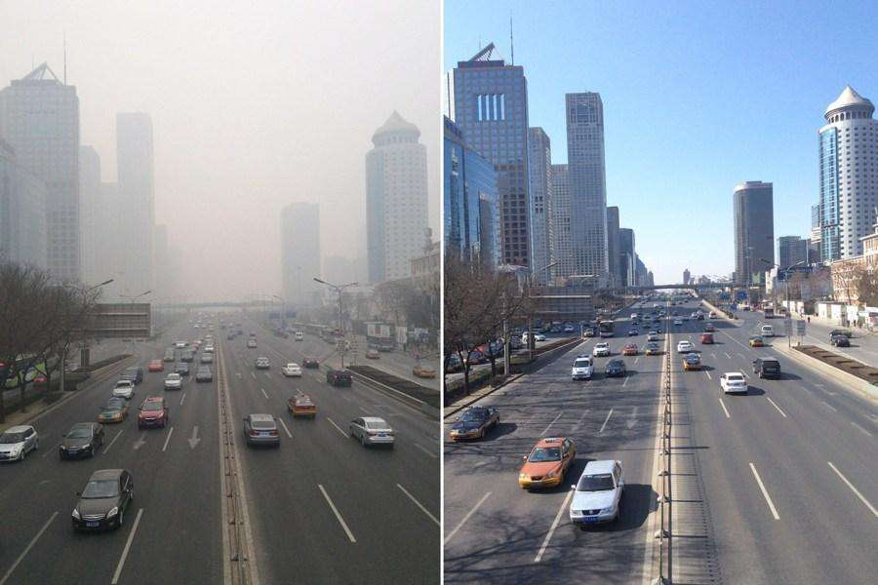

Bad visibility Good visibility
Visibility (number of bad visibility days per month)
12 days of bad visibility per month
(4 days more)

10 days of bad visibility per month
(2 days more)

8 days of bad visibility per month  (no change) | Current situation
6 days of bad visibility per month
(2 days less)

4 days of bad visibility per month
(4 days less)

Electricity, gas and heating bill: Your choices of different policies are accompanied by changes in your household monthly electricity, gas and heating bill. Your monthly bill will remain unchanged if you choose to maintain the current set of actions.
Electricity, gas and heating bill change per household per month (year)
500 RMB increase/month
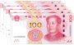
（6000 RMB increase/year）
200 RMB increase/month
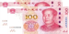
（2400 RMB increase/year ）
100 RMB increase/month
（1200 RMB increase/year ）
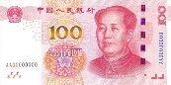

No change in bill | Current situation
100 RMB decrease/month
（1200 RMB decrease/year ）

300 RMB decrease/month
（3600 RMB decrease/year ）
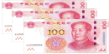

500 RMB decrease/month
（6000 RMB decrease/year ）

Note that if the amount of bill decrease exceeds your monthly electricity, gas and heating bill, it means that you don’t need to pay any bills and the exceeding amount will be transferred to your bank account.

Please note that the chance of success only affects the health effect of air pollution, not the visibility effect and the change in electricity, gas and heating bill.

- A bit of scientific knowledge
Why health effect of air pollution could be uncertain, and visibility effect is certain?
The relationship between health (especially long-term health) and air pollution, is still not well predictable. In addition, factors such as personal behaviour and habits, and working environment can also affect personal health, and sometimes the consequence of a health problem is triggered by a combination of many factors. Thus, the health outcomes are uncertain.
However, particulate matter is the main factor that affects visibility, and the visibility effect is much better predictable than the health effect. So the visibility outcomes are more certain than the health outcomes, and the policies tend to be effective in a short time.
Moreover, air pollutants related to the health effect is dependent on weather conditions, but visibility effect is less dependent on weather. For example, in a sunny day, ground level ozone will be much higher than that in a rainy or cloudy day, which causes adverse effect on human’s health. Thus, the health effect is more likely to be uncertain than the visibility effect, due to the unpredictable weather.
To sum up, in our context, the chance of success only affects the health effect of air pollution, not the visibility effect.

Question: Now, do you understand that the chance of success is only applied to health, while visibility and electricity, gas and heating bill are certain?
A Yes, I understand
B No, I don’t understand

[Please read the following text patiently as it helps you to better understand the context and express your opinions.]
Now, we will show you three different policies. We want to know which of these policies you prefer the most.
Policy A: If you choose this option, it means that there is a 90% chance that the number of hospital admissions in your city due to air pollution will be [150 thousand per year (20 thousand more (or 15% more) than the situation under the current implementation)]. Additionally, you accept 12 days of bad visibility per month instead of 8 days under the current implementation. Your monthly household electricity, gas and heating bill will reduce by 500 RMB (or 6,000 RMB annual reduction) for accepting this policy.

Attributes | Policy A
Health  (hospital admissions/year) | 150 thousand  hospital admission per year  (20 thousand more or 15% more)
Chance of Success | 90%
Visibility  (number of bad visibility days per month) | 12 days of bad visibility per month  (4 days more)
Cost per household per month (change in electricity, gas and heating bill) | 500 RMB per month bill decrease  （6000 RMB per year bill decrease）

Policy B: If you choose this option, it means that there is a 20% chance that the number of hospital admissions in your city due to air pollution will be [120 thousand per year (10 thousand less (or 7.5% less) than the situation under the current implementation)]. Additionally, you accept 10 days of bad visibility per month instead of 8 days under the current implementation. Your monthly household electricity, gas and heating bill will increase by 100 RMB (or 1,200 RMB annual increase) for this policy.
Attributes | Policy B
Health  (hospital admissions/year) | 120 thousand hospital admission per year  (10 thousand less or 7.5% less)
Chance of Success | 20%
Visibility  (number of bad visibility days per month) | 10 days  of bad visibility per month  (2 days more)
Cost per household per month (change in electricity, gas and heating bill) | 100 RMB per month bill increase  （1200 RMB per year bill increase ）

It is possible that you find the two policies not suitable for you, because you do not think you will benefit from them compared to the current set of actions. In that case, you may choose the current policies. This option would mean that you want to keep things as they are now.
Attributes | Current policies
Health  (hospital admissions/year) | 130 thousand hospital admission per year  (no change)
Chance of Success | 100%
Visibility  (number of bad visibility days per month) | 8 days  of bad visibility per month  (no change)
Cost per household per month (change in electricity, gas and heating bill) | No change in bill

Please be assured that there are no correct choices, we just want your opinions. Note that you may prefer other options not mentioned here to deal with air quality in your area.

Now, to understand how it works, let’s do a warm-up question. Please choose the option that you prefer the most.

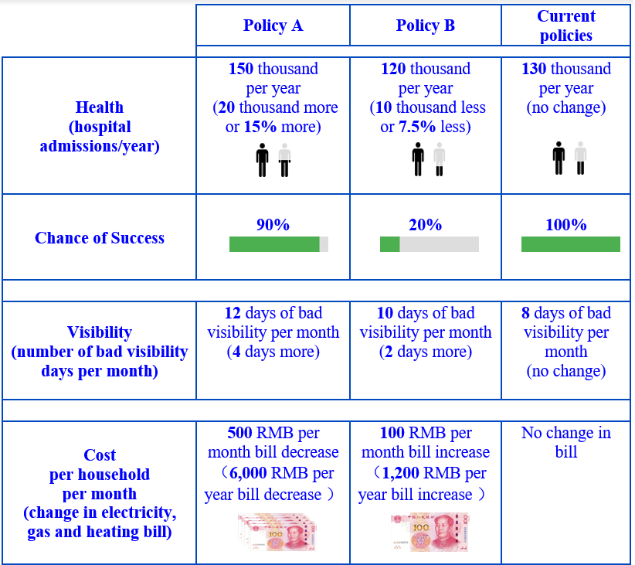

In the following questions, please select your most preferred policy among the three policies (Policy A, Policy B and Current policies) shown in each choice card. There are 10 questions like this. Each choice is a new situation, so please consider each new choice as independent from the previous choice you made.
Remember that although there may be someone else in your family who pays the bill for you, you need to make decisions as if you contribute to the payment too.
Please note that the chance of success only affects the health effects of air pollution, not the visibility effects and the change in electricity, gas and heating bill.
Keep in mind that if you decide to pay the extra money stated in the project you choose, the amount of money you may spend on other health and environmental programmes, and on the everyday products you buy, will be reduced. On the other hand, if you decide to accept the monetary compensation stated in the project you choose, the amount of money you may spend on other health and environmental programmes, and on the everyday products you buy, will be increased.
Question 1
Question 2
..
Question 10
Now we would like you to know more about the choices you have just made.

- Please indicate why you choose the current policies option? (multiple answers allowed)
A: My income is too low, so I cannot afford to pay more
B: I think air pollution is not an important issue in my area, so there is no need to pay
C: I don’t think that the policy will be effective enough to change the air quality
D: I don’t want the air quality to be deteriorated
E: I believe that citizens should not pay more for better air quality
F: other reasons, please specify: _______
- When making your choices, did you find a deterioration of health and/or visibility ever acceptable?
A: Yes
B: No
2.1. If no, please indicate why you think so?
A: I don’t want to sacrifice the environment, even if my gas, electricity and heating bill is reduced
B: other reasons, please specify: _______
- Do you think that the choices you just made were difficult or easy?
( “1” is very easy; “2” is a bit easy; “3” is normal; “4” is a bit difficult; “5” is very difficult)
4. Did you find yourself ignoring any elements when making choices? (multiple answers allowed)
A: I ignored the element “Health”
B: I ignored the element “Chance of success”
C: I ignored the element “Visibility”
D: I ignored the element “Electricity, gas and heating bill”
E: I considered all four elements (exclusive)
4.1. If you found yourself making choices only based on one or two elements, Why was this? (multiple answers allowed)
A: There were too many elements that need to be considered in decision making
B: I did not consider some elements because I don’t believe they can be achieved
C: I did not consider some elements because I don’t think they are important to me
D: Other reason, please specify______

