Supplementary Material

- Survey design

To design the final survey, three focus groups and two pilot surveys were conducted. The focus groups took place at the Nova SBE campus in Carcavelos (close to Lisbon) and one focus group was conducted in Sines, which is the largest city inside the study site. The focus groups happened in June and July 2019 and gathered between 8 to 10 people. The groups were diverse in terms of age, gender, and background. Each participant received an incentive of 10€ to participate. The goal of the focus groups was to assess the understanding of different groups of people about the concepts presented, the credibility of the scenarios and the design of the choice experiment. The script that was followed in the focus groups is presented in these supplementary materials.
The first pilot survey was conducted face-to-face by the market research company that conducted the final survey. This happened between the 8th and 31st of January 2020, in Lisbon and in two of the districts belonging to the study area (Setubal and Faro). 105 surveys were conducted in this phase. After this pilot survey, the questions and the choice experiment were simplified. The first pilot survey tested a choice experiment with 3 different levels of protection for each of the attributes (high protection, low protection, no protection). In the final version of the survey, the choice experiment was simplified, including only two levels of protection (protection, no protection). Likert-scales of several questions were also simplified (from 5 points to 3 points), to avoid participants’ exhaustion. The final survey was tested online to a diverse sample of 41 people. The data collected in both pilot surveys was not included in the final dataset.

- Survey materials

Participants were shown a video introducing the topic of oil spills, the study site and the valuation scenario. The video is available at the following link: https://www.youtube.com/watch?v=hRY9PhGD-5M
To understand the ecosystem services being valued, the following table was presented to participants, with a detailed explanation by those that were conducting the survey.

Figure 1 – Attribute table
Ecosystem Service (benefit) | Description | Level of protection
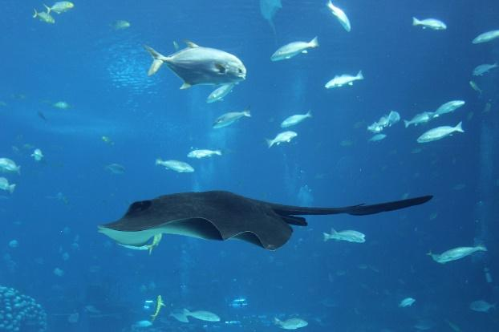  Biodiversity Conservation | The marine protected area of the Southwest Alentejo and Costa Vicentina is an area of high diversity of species and habitats (e.g., fish and dolphins). Oil spills can affect the survival of various marine organisms and their habitats. | Protects | No protection
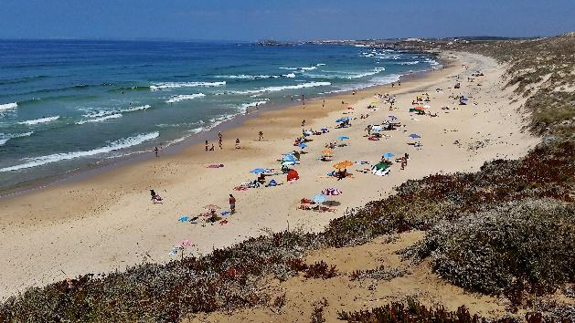  Beach use | There are several beaches across the study area, typically used for activities such as walking, hiking, and bathing. Oil spills result in a ban on the use of the beaches. | Protects | No protection
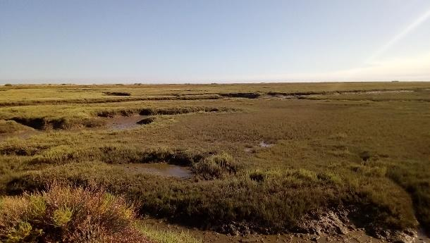  Coastal Protection | There are four marshlands across the study area. These vegetated areas provide natural barriers against flooding and sea storms. Oil spills affect the vegetation in these areas, reducing the coastal protection offered by marshlands. | Protects | No protection
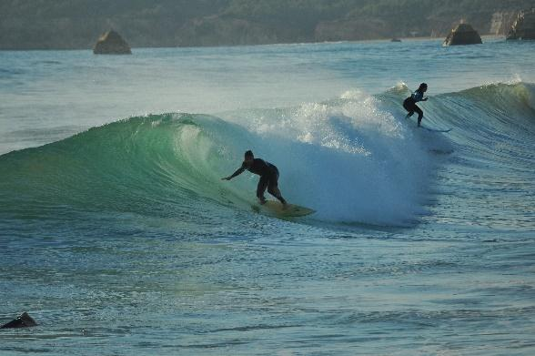  Surf | The study area is a prime surfing location for both beginners and experienced surfers. Oil spills may prevent surfing in the affected coastal areas. | Protects | No protection

- Data collection

The data collected for this study required a face-to-face survey to a representative sample of the Portuguese population. This work was done by a specialized market research company, Consulmark from 19th September 2020 and 22nd December 2020.
To target a representative sample of the Portuguese population, a participants’ quota was defined according to the main sociodemographic characteristics from the latest available census data (2011). The variables considered for the quota were: District of residence, age group, gender, and education. The respondents were targeted randomly at their homes, through a systematic random sampling, starting from a random selection of addresses, considering the quota defined.
The response rate was close to 37% and was calculated taking into account the number of people that were approached. The percentage of refusals was considerable, which can be explained by the fact that data collection occurred during the covid-19 pandemic. However, concerns on sampling error are low, since we have a large enough sample that is representative of the Portuguese population.

Abstract
In this study, we use a discrete choice experiment to elicit the willingness-to-pay (WTP) for preventing and mitigating the effects of oil spills on marine and coastal ecosystem services, along a particularly vulnerable coastal region of mainland Portugal. We used a split-sample design to analyze the differences between two payment vehicles (PV): a mandatory extra income tax and a voluntary contribution collected by a crowdfunding campaign with a provision point mechanism and a money-back guarantee. The difference between the two PVs is examined in a setting where the local population has a negative perception of the quality of institutions. We find that respondents are more willing to contribute when presented with the crowdfunding version. Also, regardless of the payment vehicle, respondents who express a mistrust in institutions are more likely to choose the status quo. These results suggest the potential of using crowdfunding to support ecosystem services’ conservation initiatives.

Mariel, Petr, David Hoyos, Jürgen Meyerhoff, Mikolaj Czajkowski, Thijs Dekker, Klaus Glenk, Jette Bredahl Jacobsen, et al. Environmental Valuation with Discrete Choice Experiments: Guidance on Design, Implementation and Data Analysis. SpringerBriefs in Economics. Cham: Springer International Publishing, 2021. https://doi.org/10.1007/978-3-030-62669-3.

