Supplementary Information for “Result-based vs. action-based payments: a systematic comparison”

Appendix A: Comparison of result-based and action based payments for α < a
Since the scheme benefit strictly monotonously increases with increasing proportion x_{max} of conserved land, it is sufficient to compare x_{max}^{(r)} and x_{max}^{(a)}, so that if one of the two is larger than the other, the cost-effectiveness and budget efficiency, respectively, exceeds that of the other. To start with the cost-effectiveness, I reformulate eq. (9) to

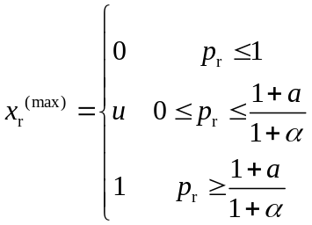 (A1)

with

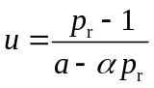. (A2)

The associated scheme cost equals

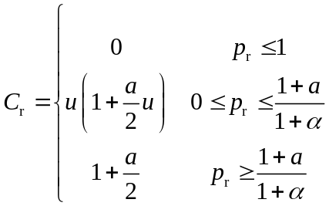. (A3)

Equating C_{r} = C_{a} as described in section 2.3, eqs. (15) and (4) yield

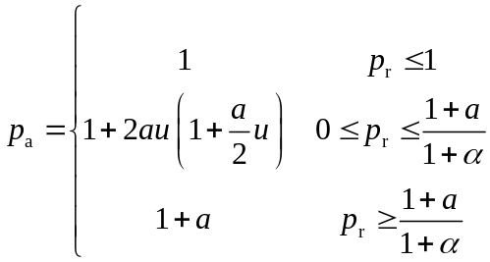 (A4)

and

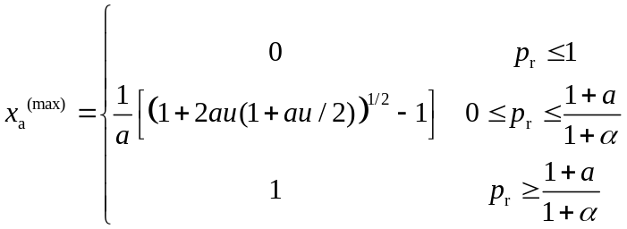. (A5)

The trivial first and third cases in eqs. (A1) and (A5) yield x_{a}^{(max)} = x_{r}^{(max)}. For the second case, eq. (A5) can be evaluated to

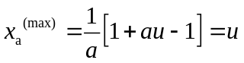, (A6)

which equals x_{r}^{(max)} of eq. (A1). Altogether x_{a}^{(max)} = x_{r}^{(max)} for all levels of p_{r}, so the two schemes are equally cost-effective. For the comparison of the budget efficiency, I obtain from eqs. (9) and (14)

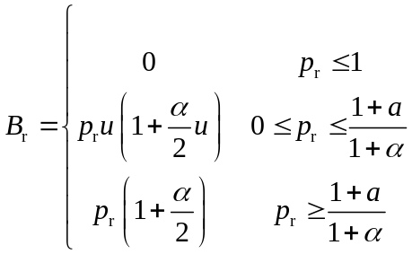. (A7)

Equating B_{r} = B_{a} analogously to above, eqs. (16) and (4) yield

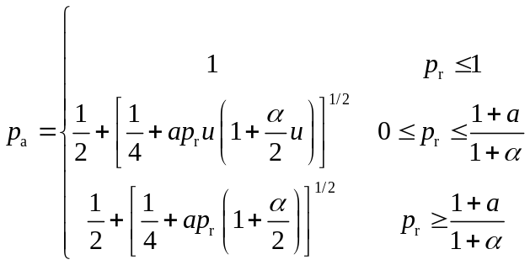 (A8)

and

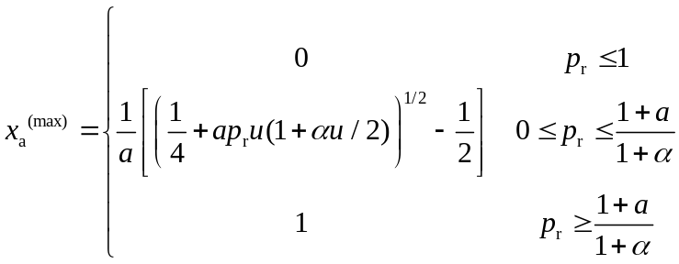. (A9)

Similar to above, the trivial first and third cases of eqs. (A1) and (A9) yield x_{a}^{(max)} = x_{r}^{(max)}. The second case requires comparing

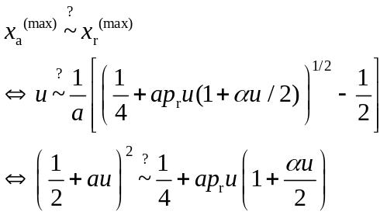, (A10)

where the left hand side of eq. (A10) represents x_{a}^{(max)} and the right hand side represents x_{r}^{(max)}. If and only if the left hand side of eq. (10) is smaller (larger) than the right hand side, x_{a}^{(max)} is smaller (larger) than x_{r}^{(max)}. Insertion of eq. (A2) into eq. (A10) and some slight rearrangement yields

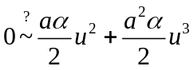. (A11)

For α > 0 the left hand side of eq. (A11) is smaller than the right hand side, so x_{a}^{(max)} < x_{r}^{(max)} and the action-based payment is less budget-efficient than the result-based payment. In contrast, for α < 0 the left hand side of eq. (A11) is larger than the right hand side, so x_{a}^{(max)} > x_{r}^{(max)} and the action-based payment is more budget-efficient than the result-based payment.

Appendix B: Additional result figures

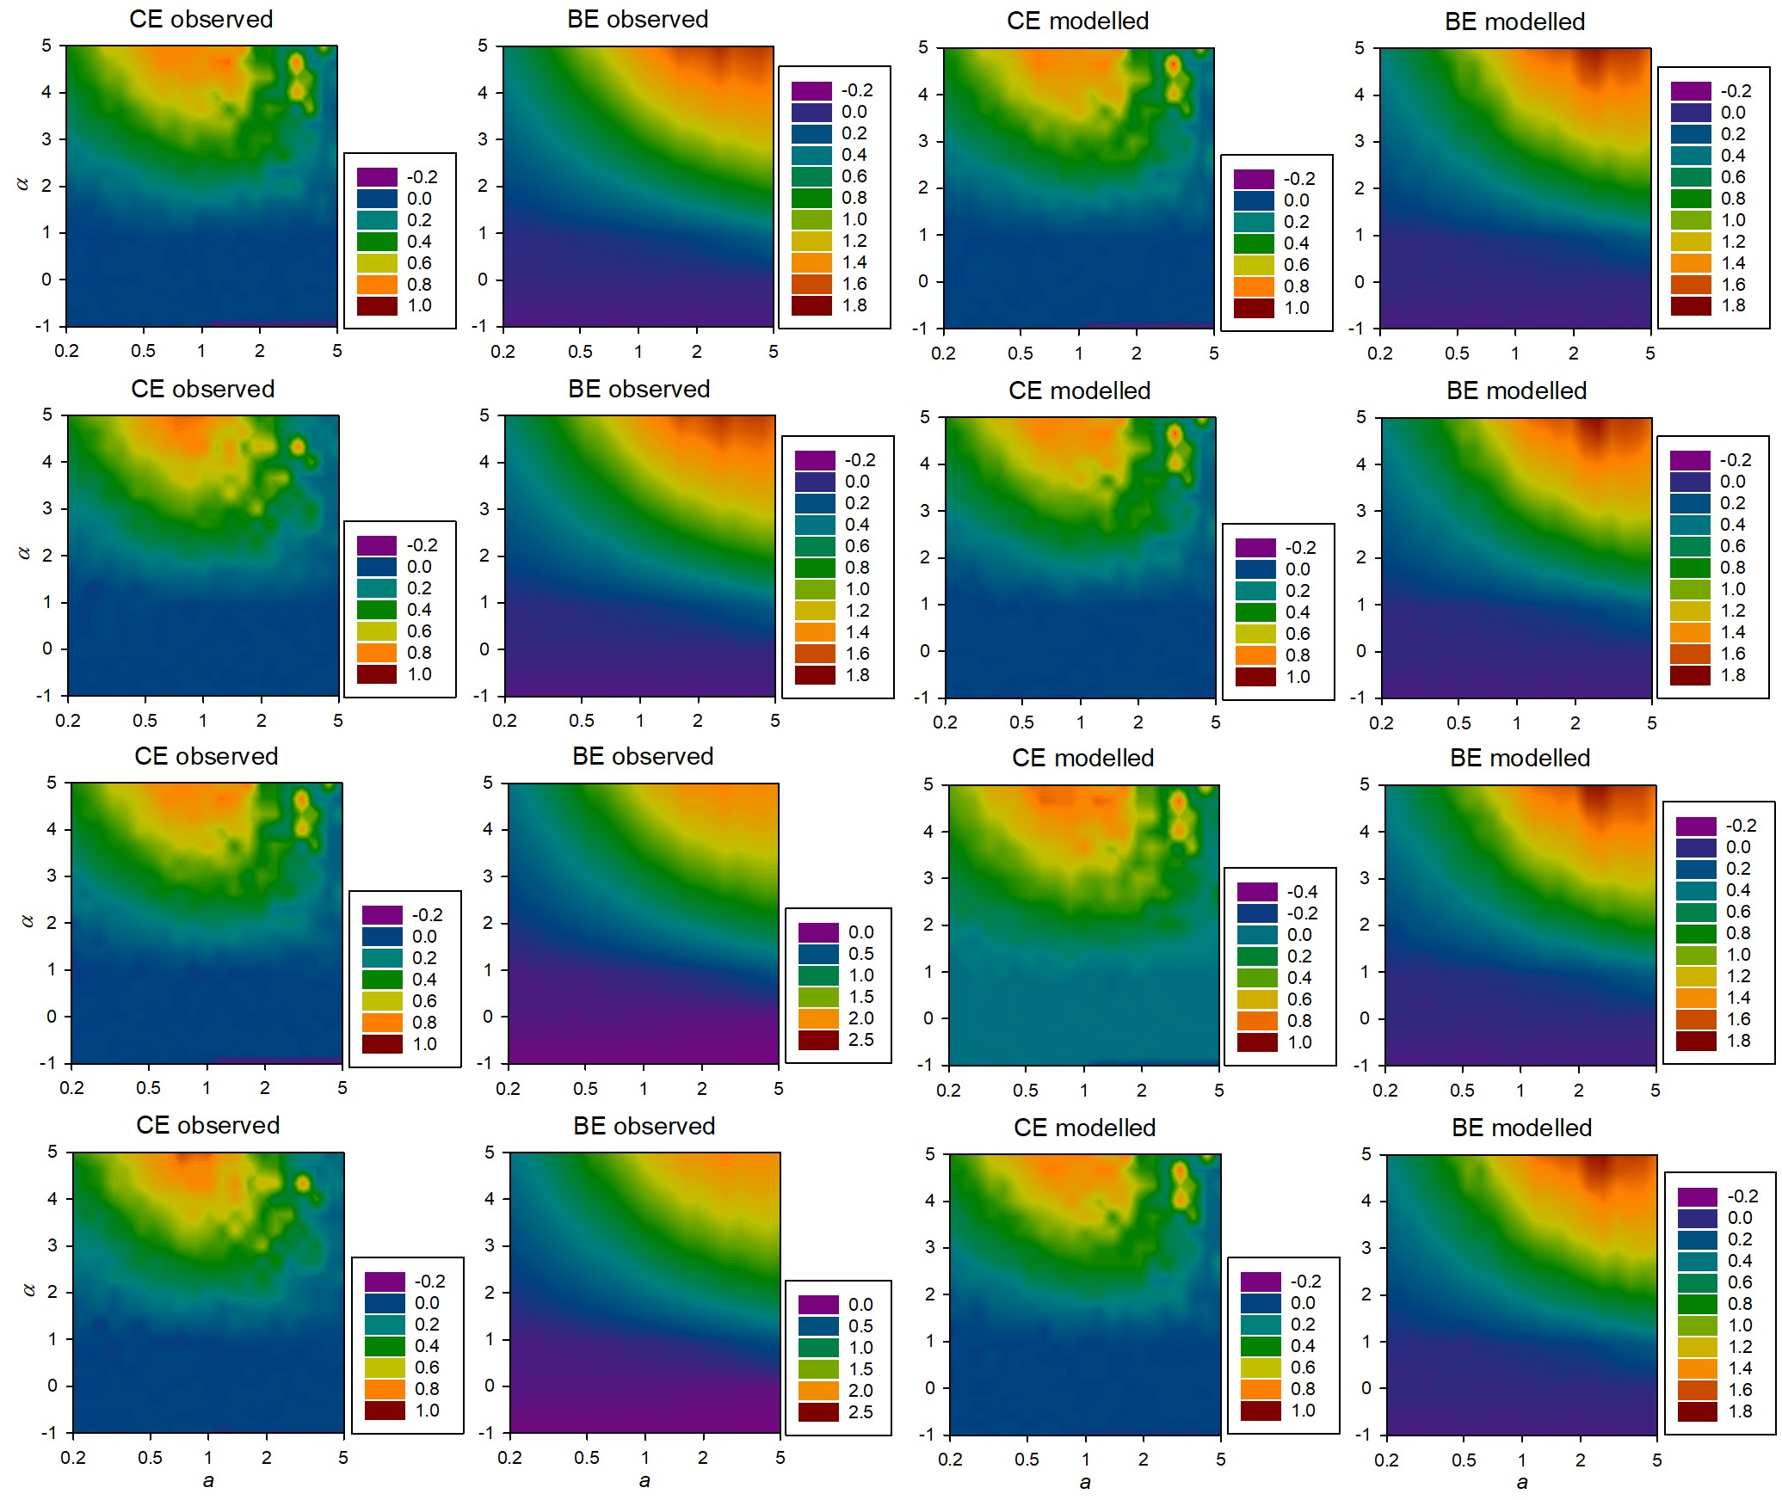
Figure B1: Cost-effectiveness (CE) and budget-efficiency (BE) gains (G, by colour) as functions of the marginal cost a (in log scale) and the marginal benefit α. Result-based payments may be paid for observed results or for modelled results. The vertical axis in each panel is defined as follows. Negative values represent α < 0; while positive values represent α/a, i.e. show a in units of α. Ecological uncertainty is absent: σ = 0. The four rows of panels represent scenarios S2–S5, i.e. correlated ecological uncertainty with magnitude σ = 1.2, and different farmers’ and regulator’s risk attitudes: first row: ρ = λ = 0; second row: ρ = 0.5, λ = 0; third row: ρ = 0, λ = 1; fourth row: ρ = 0.5, λ = 1.

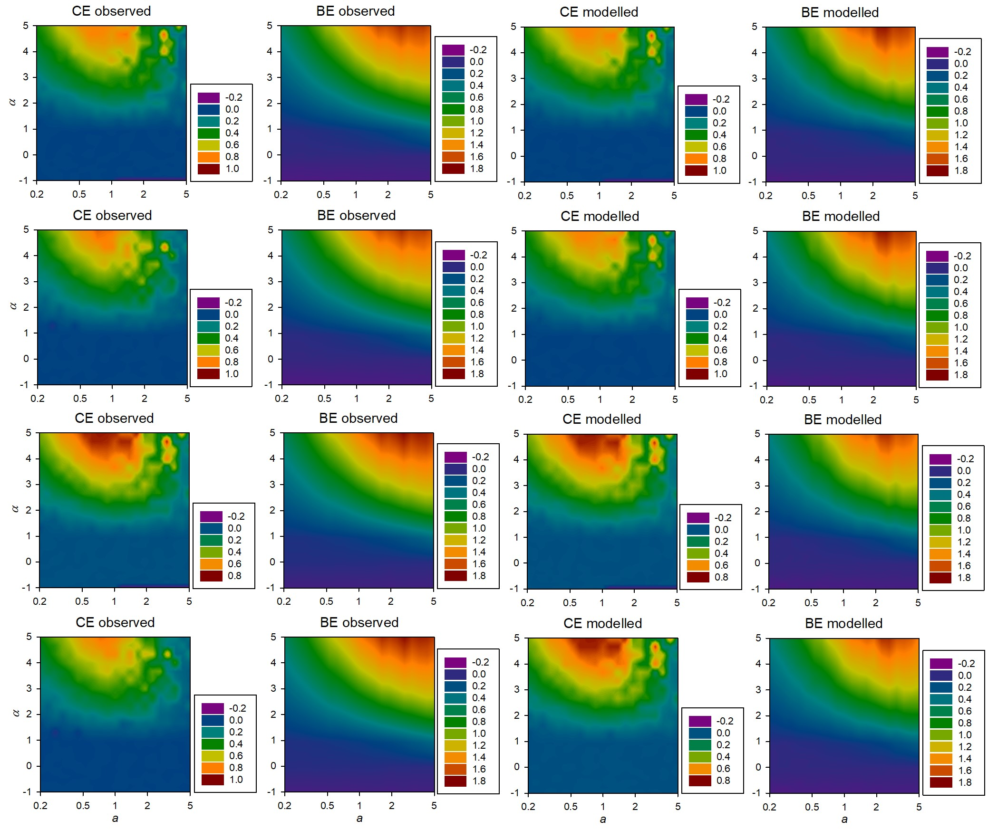
Figure B2: Cost-effectiveness (CE) and budget-efficiency (BE) gains (G, by colour) as functions of the marginal cost a (in log scale) and the marginal benefit α. Result-based payments may be paid for observed results or for modelled results. The vertical axis in each panel is defined as follows. Negative values represent α < 0; while positive values represent α/a, i.e. show a in units of α. Ecological uncertainty is absent: σ = 0. The four rows of panels represent scenarios S6–S9, i.e. uncorrelated ecological uncertainty with magnitude σ = 1.2, and different farmers’ and regulator’s risk attitudes: first row: ρ = λ = 0; second row: ρ = 0.5, λ = 0; third row: ρ = 0, λ = 1; fourth row: ρ = 0.5, λ = 1.

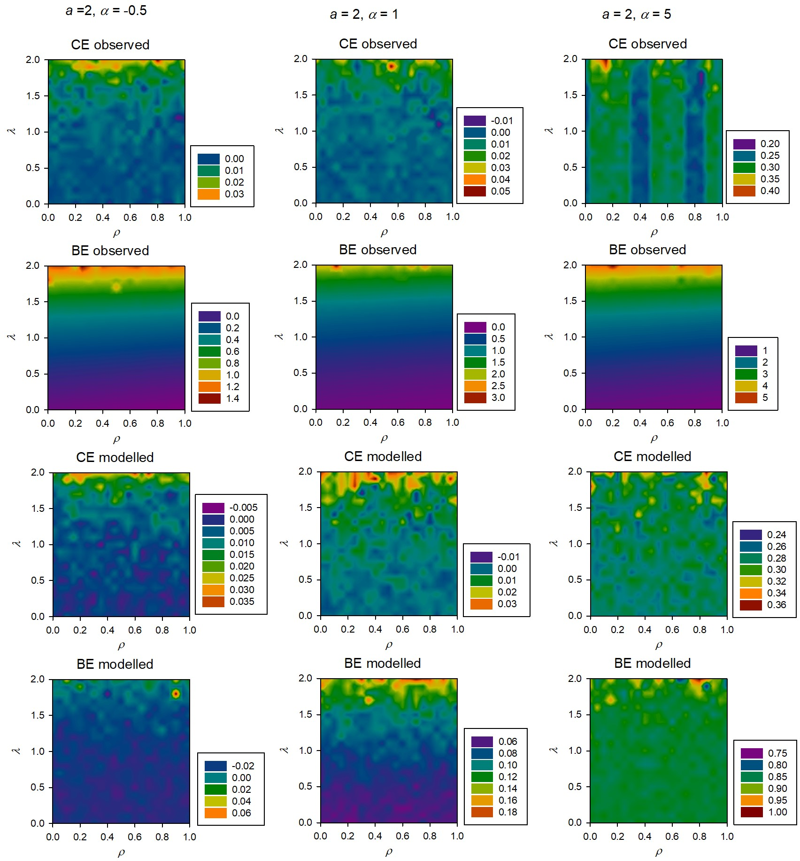

Figure B3: Cost-effectiveness (CE) and budget-efficiency (BE) gains G, by colour, as functions of the farmers’ risk attitude ρ and the regulator’s risk attitude λ. Result-based payments may be paid for observed results or for modelled results. The marginal cost equals a = 2. Ecological uncertainty is correlated and has a magnitude of σ = 1.2.

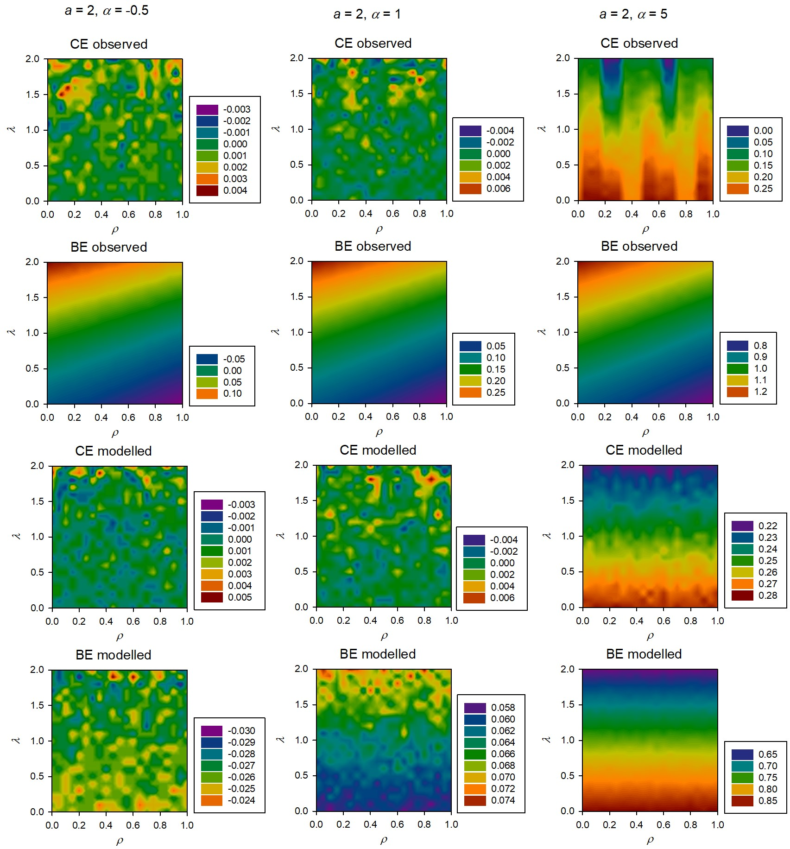

Figure B4: Cost-effectiveness (CE) and budget-efficiency (BE) gains G, by colour, as functions of the farmers’ risk attitude ρ and the regulator’s risk attitude λ. Result-based payments may be paid for observed results or for modelled results. The marginal cost equals a = 2. Ecological uncertainty is uncorrelated and has a magnitude of σ = 1.2.

