Supplementary Figures/Tables for Diversity of movement patterns of Longnose Gar tracked in coastal waters of western Lake Ontario– Croft-White et al.
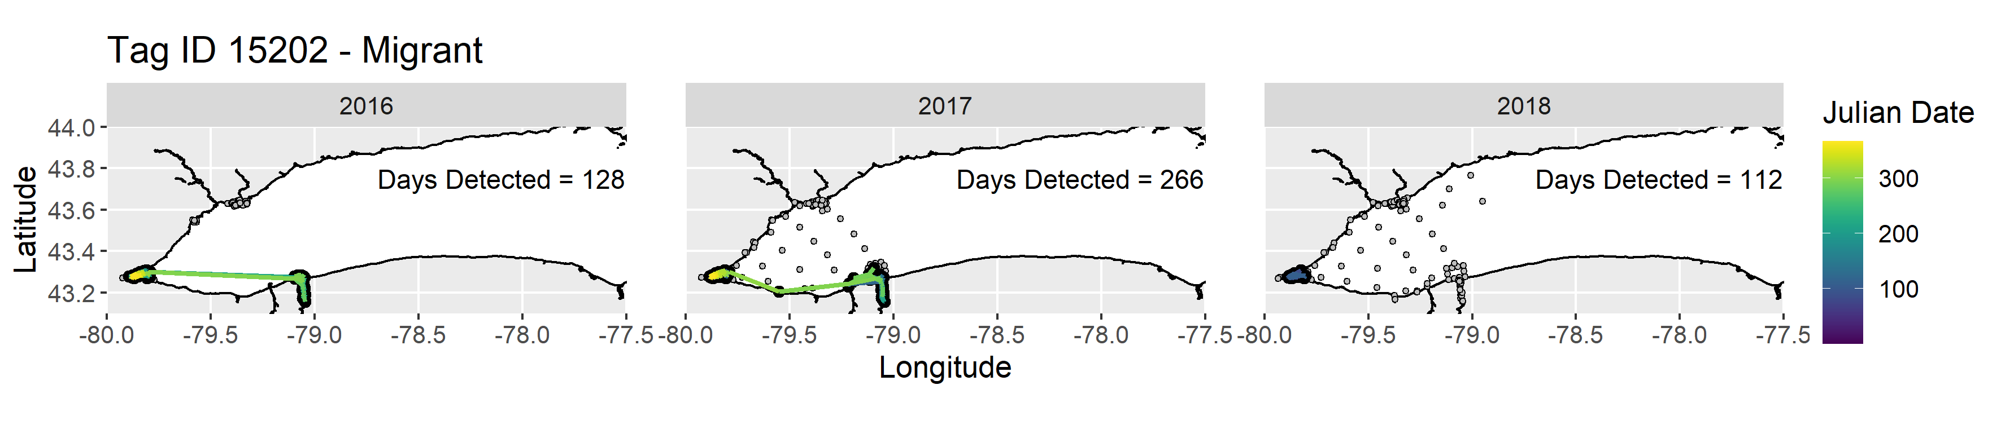
Figure 1A. Annual detections and coloured path based on Julian date of acoustically tagged Longnose Gar (Tag ID 15202) in western Lake Ontario. Receivers without detections are represented by grey circles.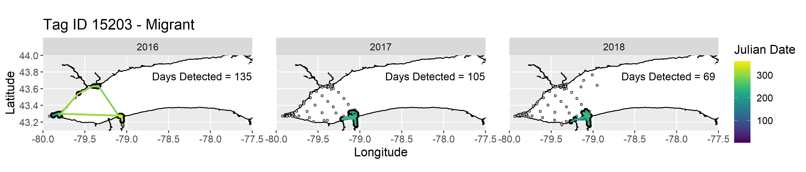
Figure 1B. Annual detections and coloured path based on Julian date of acoustically tagged Longnose Gar (Tag ID 15203) in western Lake Ontario. Receivers without detections are represented by grey circles.

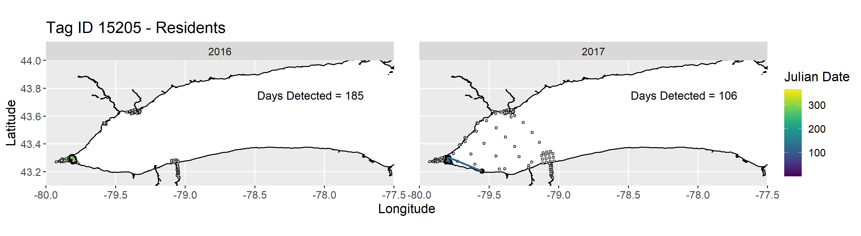
Figure 1C. Annual detections and coloured path based on Julian date of acoustically tagged Longnose Gar (Tag ID 15205) in western Lake Ontario. Receivers without detections are represented by grey circles.
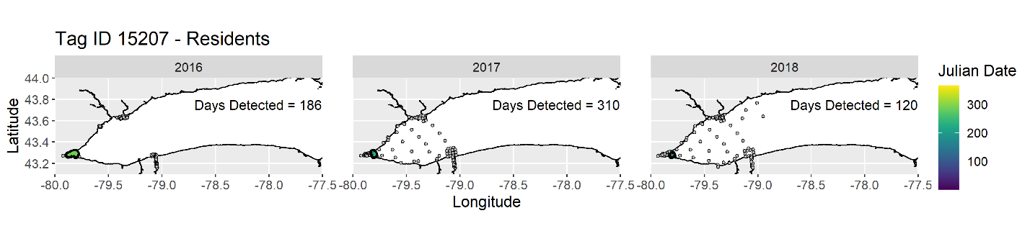
Figure 1D. Annual detections and coloured path based on Julian date of acoustically tagged Longnose Gar (Tag ID 15207) in western Lake Ontario. Receivers without detections are represented by grey circles.

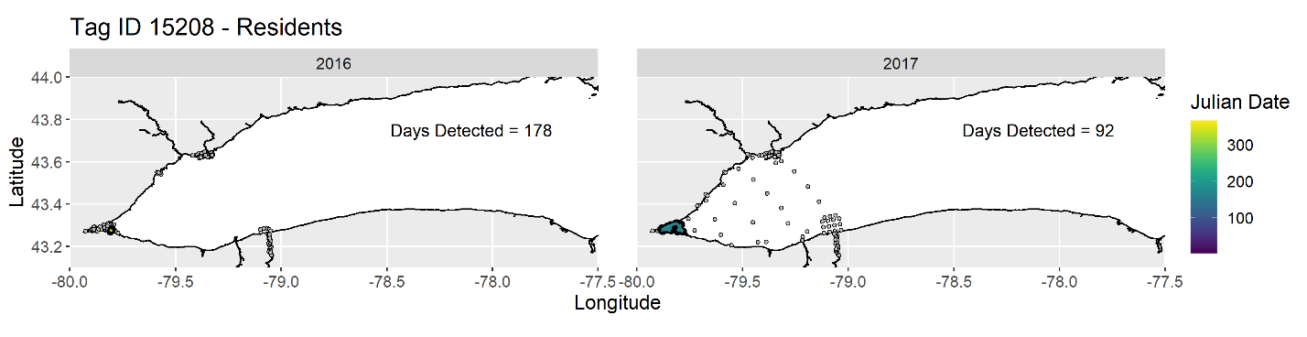
Figure 1E. Annual detections and coloured path based on Julian date of acoustically tagged Longnose Gar (Tag ID 15208) in western Lake Ontario. Receivers without detections are represented by grey circles.
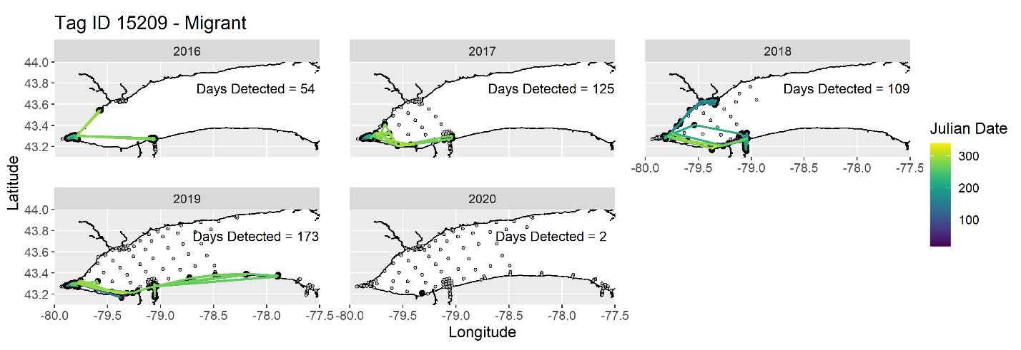
Figure 1F. Annual detections and coloured path based on Julian date of acoustically tagged Longnose Gar (Tag ID 15209) in western Lake Ontario. Receivers without detections are represented by grey circles.
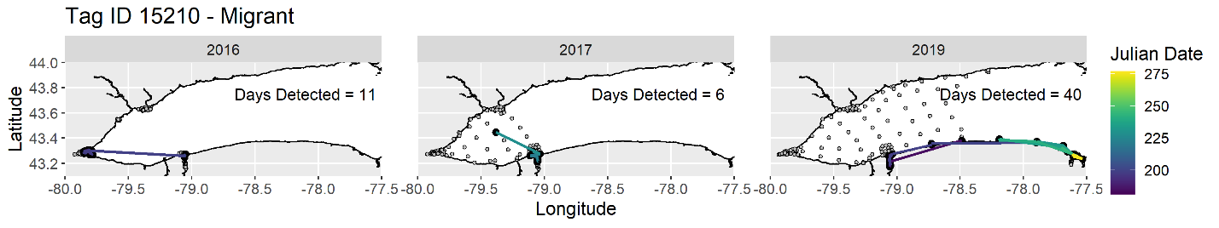
Figure 1G. Annual detections and coloured path based on Julian date of acoustically tagged Longnose Gar (Tag ID 15210) in western Lake Ontario. Receivers without detections are represented by grey circles.
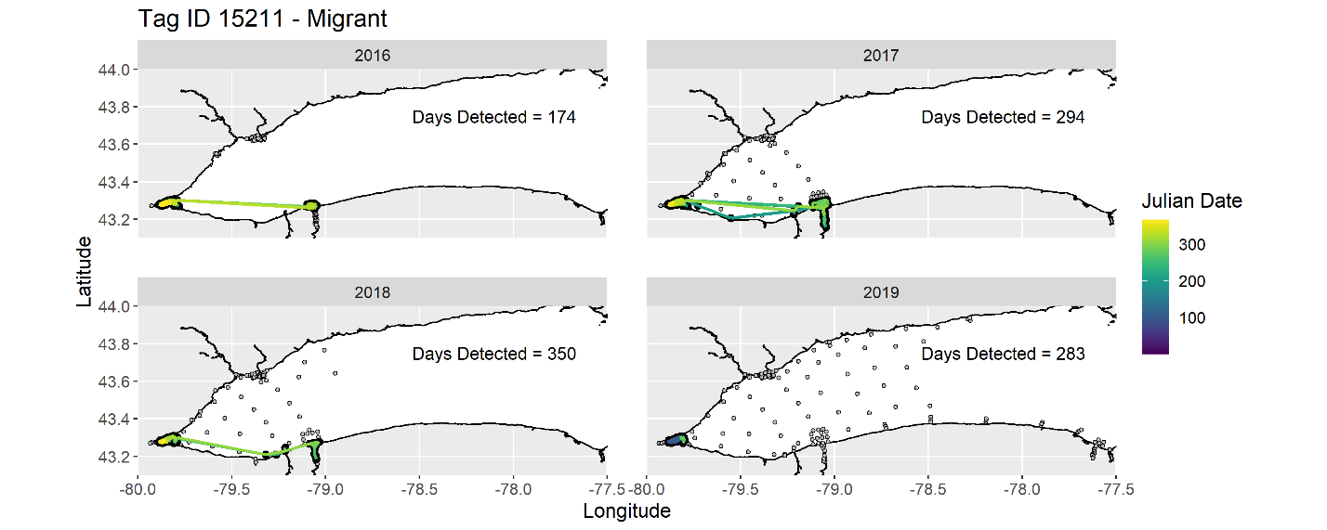
Figure 1H. Annual detections and coloured path based on Julian date of acoustically tagged Longnose Gar (Tag ID 15211) in western Lake Ontario. Receivers without detections are represented by grey circles.
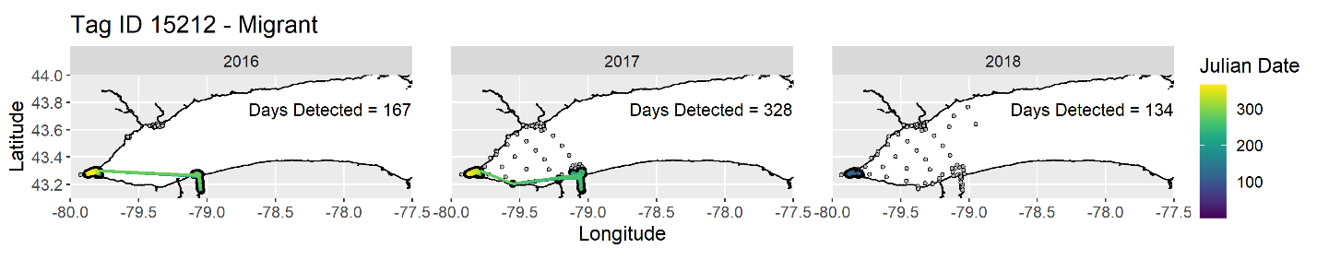
Figure 1I. Annual detections and coloured path based on Julian date of acoustically tagged Longnose Gar (Tag ID 15212) in western Lake Ontario. Receivers without detections are represented by grey circles.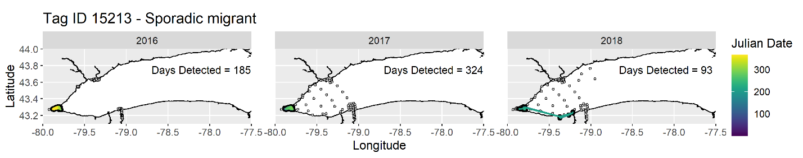
Figure 1J. Annual detections and coloured path based on Julian date of acoustically tagged Longnose Gar (Tag ID 15213) in western Lake Ontario. Receivers without detections are represented by grey circles.

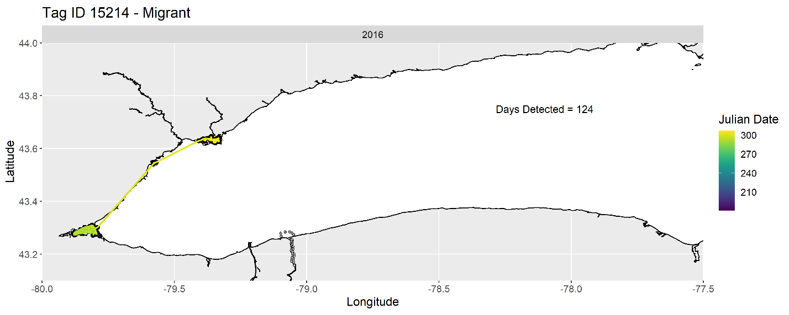
Figure 1K. Annual detections and coloured path based on Julian date of acoustically tagged Longnose Gar (Tag ID 15214) in western Lake Ontario. Receivers without detections are represented by grey circles.
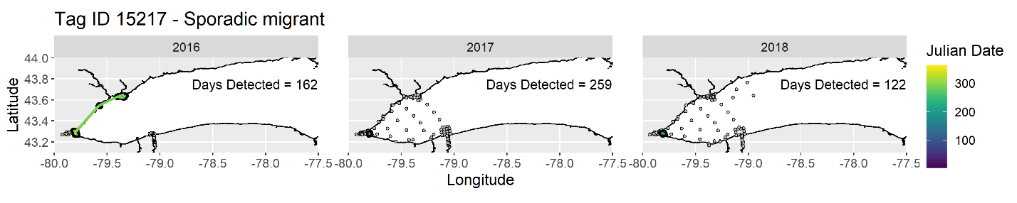
Figure 1L. Annual detections and coloured path based on Julian date of acoustically tagged Longnose Gar (Tag ID 15217) in western Lake Ontario. Receivers without detections are represented by grey circles.

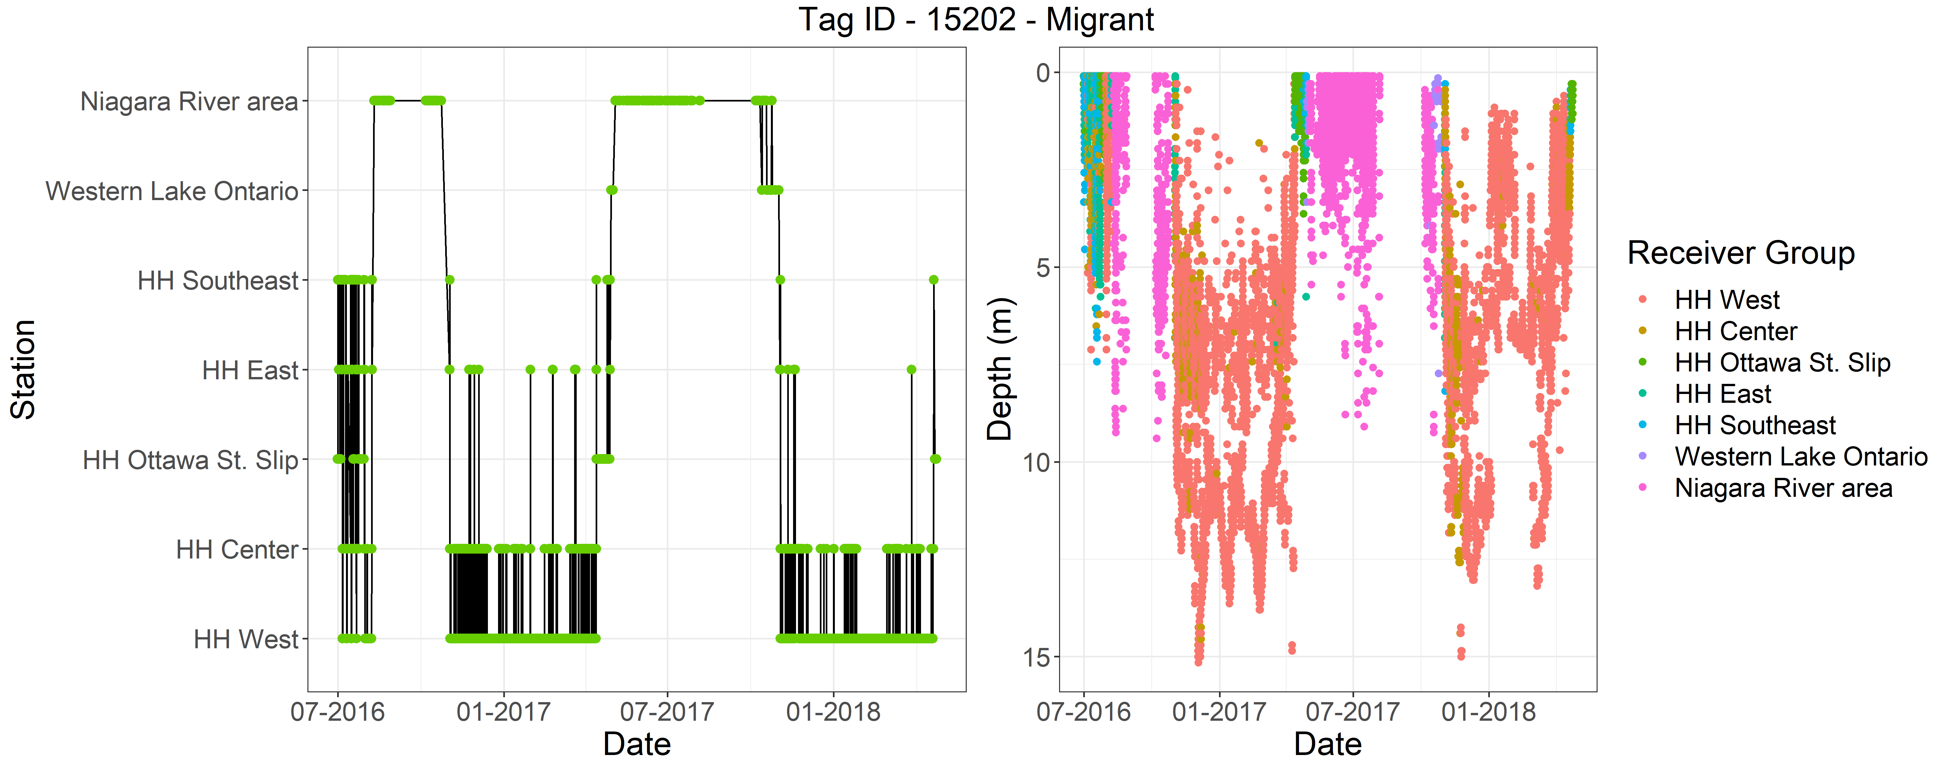
Figure 2A. Detections over time by general receiver location groupings (see Figures 3 and 4) and depth use of Longnose Gar ID 15202.
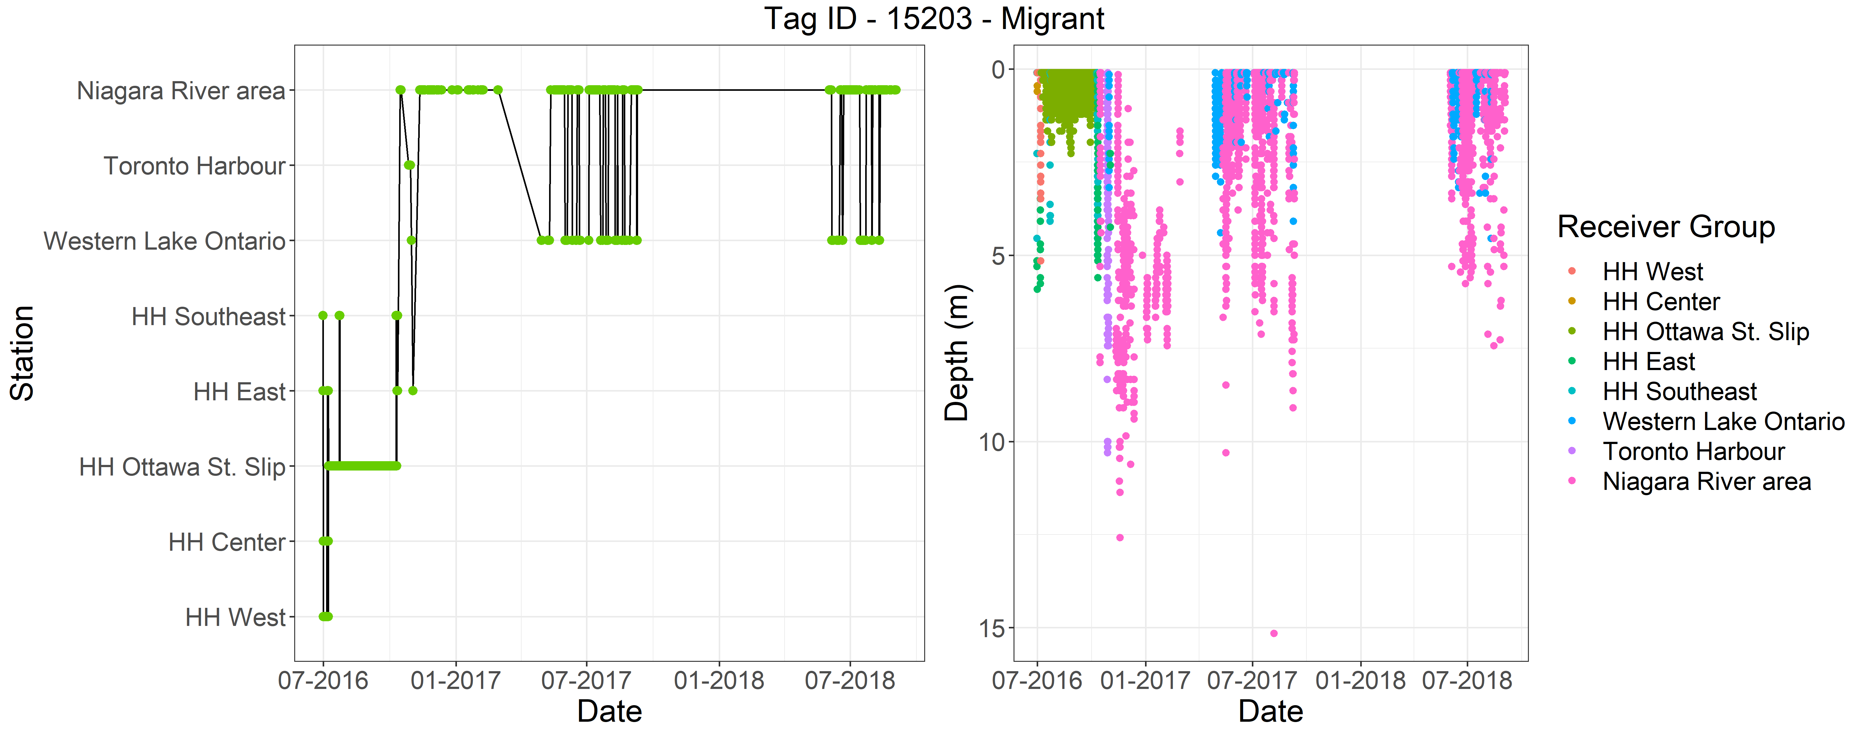
Figure 2B. Detections over time by general receiver location groupings (see Figures 3 and 4) and depth use of Longnose Gar ID 15203.
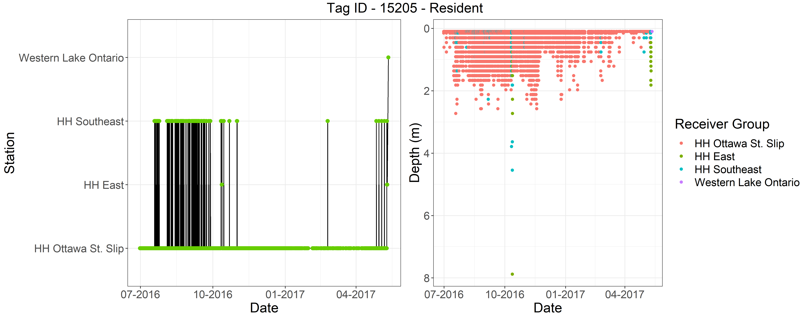
Figure 2C. Detections over time by general receiver location groupings (see Figures 3 and 4) and depth use of Longnose Gar ID 15205.

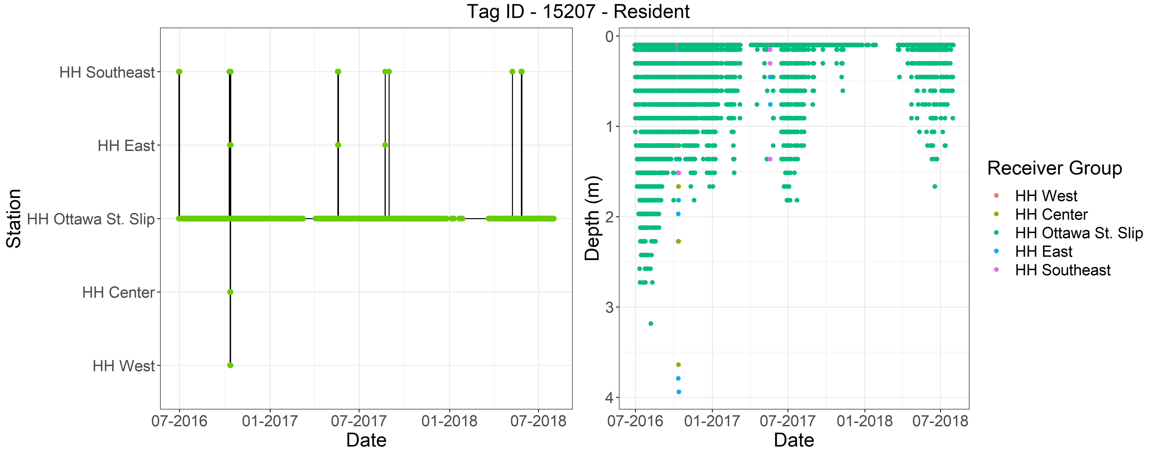
Figure 2D. Detections over time by general receiver location groupings (see Figures 3 and 4) and depth use of Longnose Gar ID 15207.
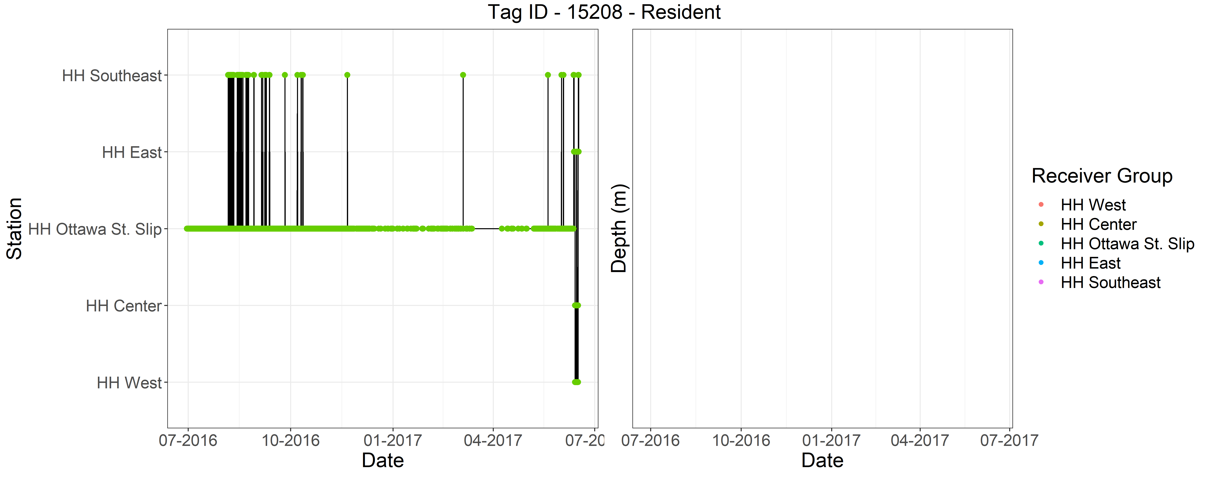
Figure 2E. Detections over time by general receiver location groupings (see Figures 3 and 4) and depth use of Longnose Gar ID 15208. Note – this tag had a malfunctioning depth sensor.

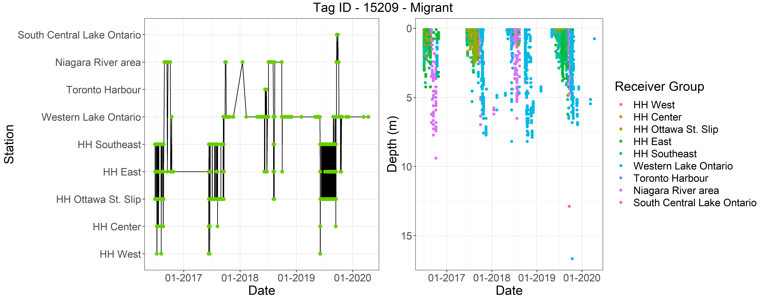
Figure 2F. Detections over time by general receiver location groupings (see Figures 3 and 4) and depth use of Longnose Gar ID 15209.
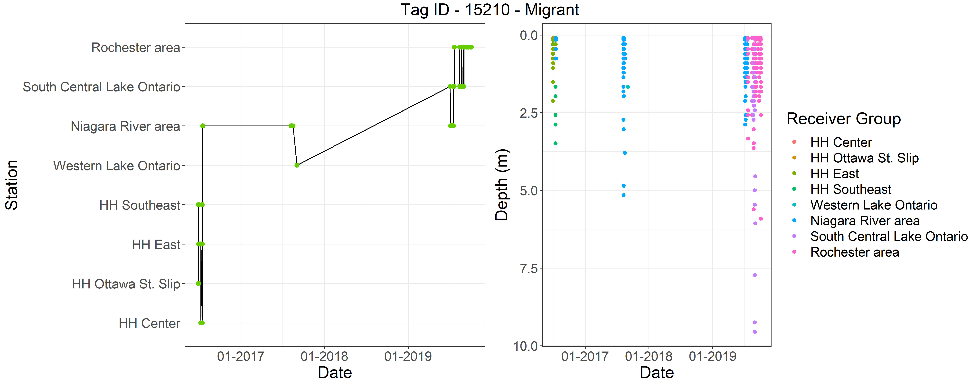
Figure 2G. Detections over time by general receiver location groupings (see Figures 3 and 4) and depth use of Longnose Gar ID 15210.
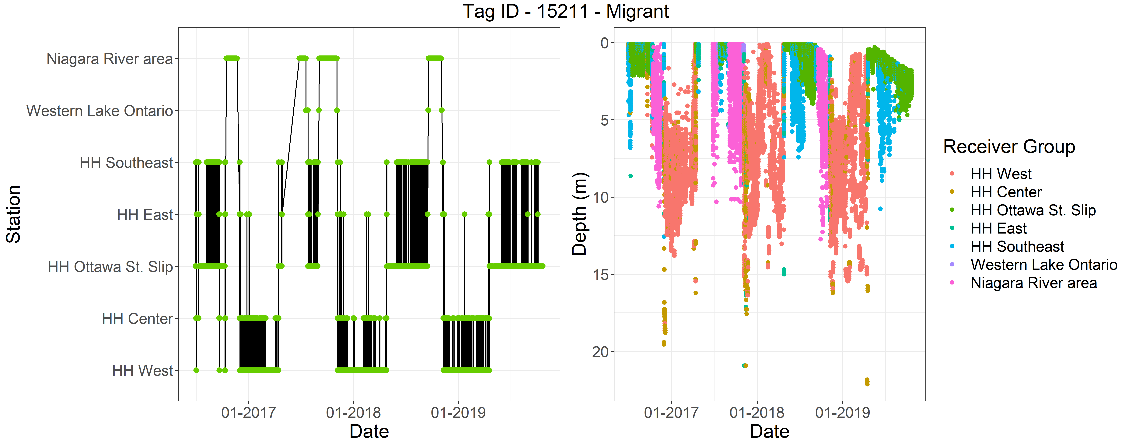
Figure 2H. Detections over time by general receiver location groupings (see Figures 3 and 4) and depth use of Longnose Gar ID 15211.
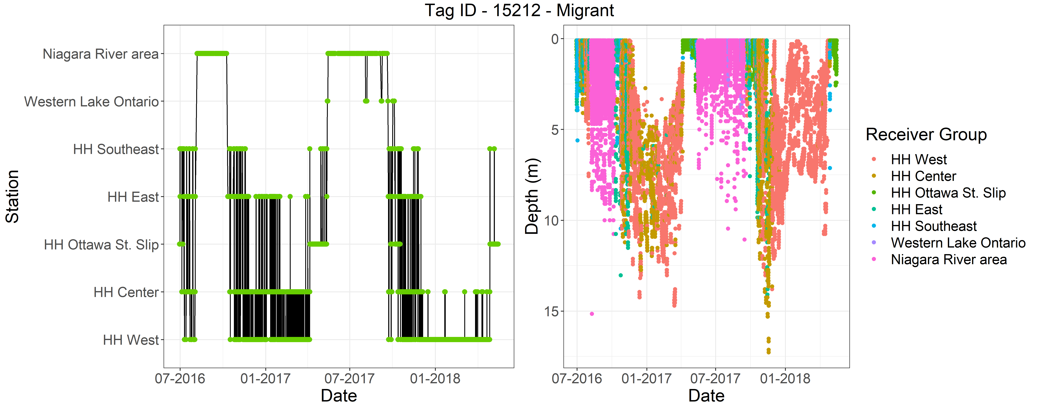
Figure 2I. Detections over time by general receiver location groupings (see Figures 3 and 4) and depth use of Longnose Gar ID 15212.
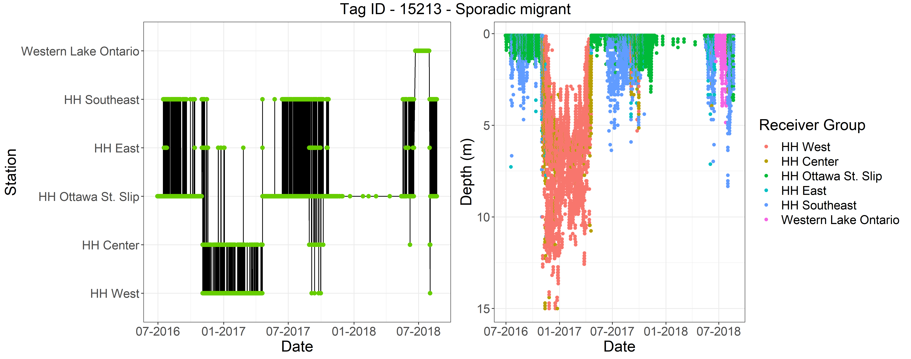
Figure 2J. Detections over time by general receiver location groupings (see Figures 3 and 4) and depth use of Longnose Gar ID 15213.
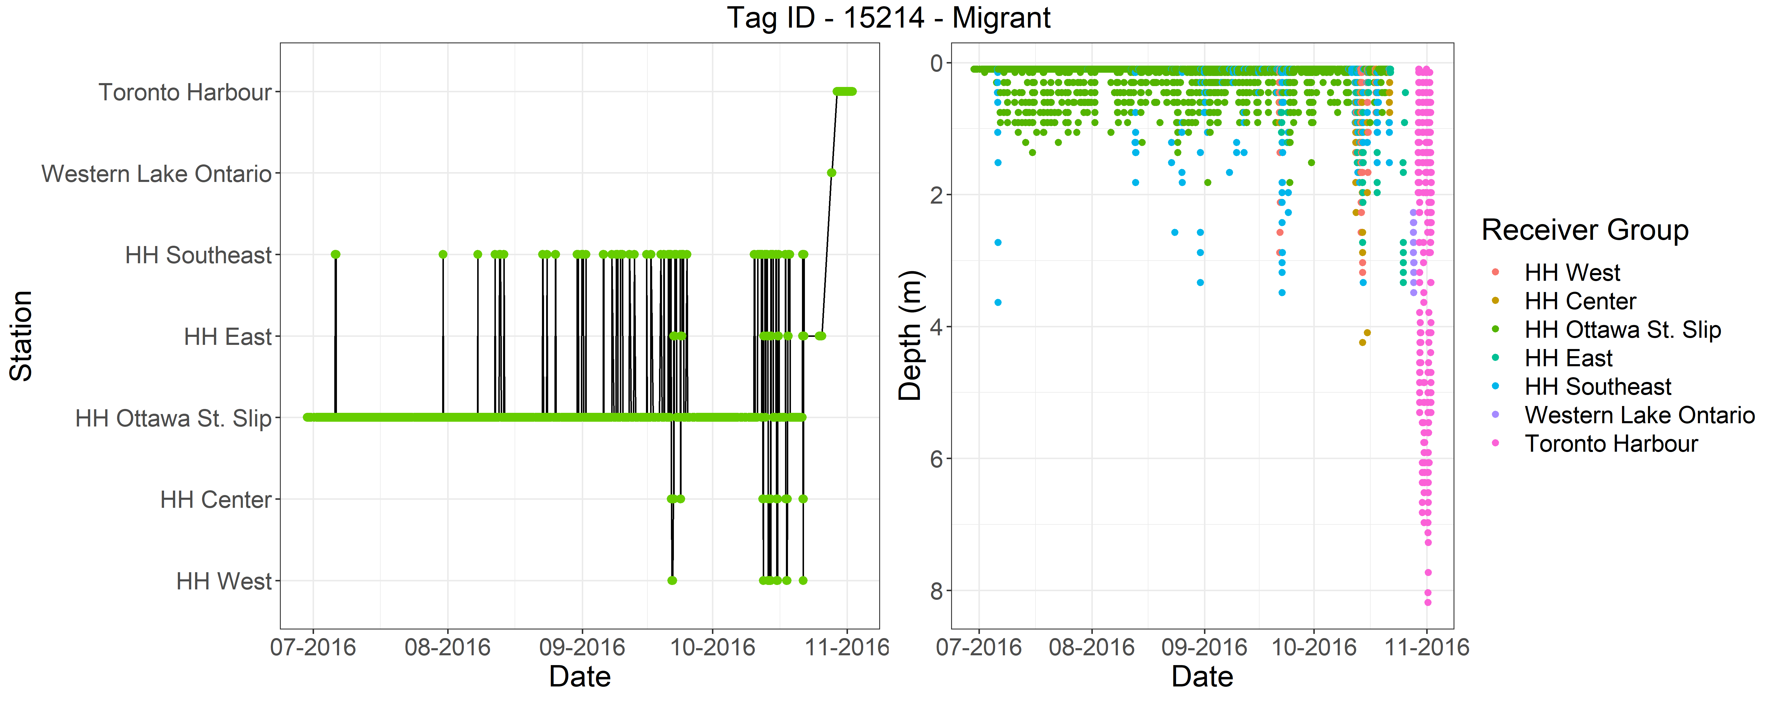
Figure 2K. Detections over time by general receiver location groupings (see Figures 3 and 4) and depth use of Longnose Gar ID 15214.
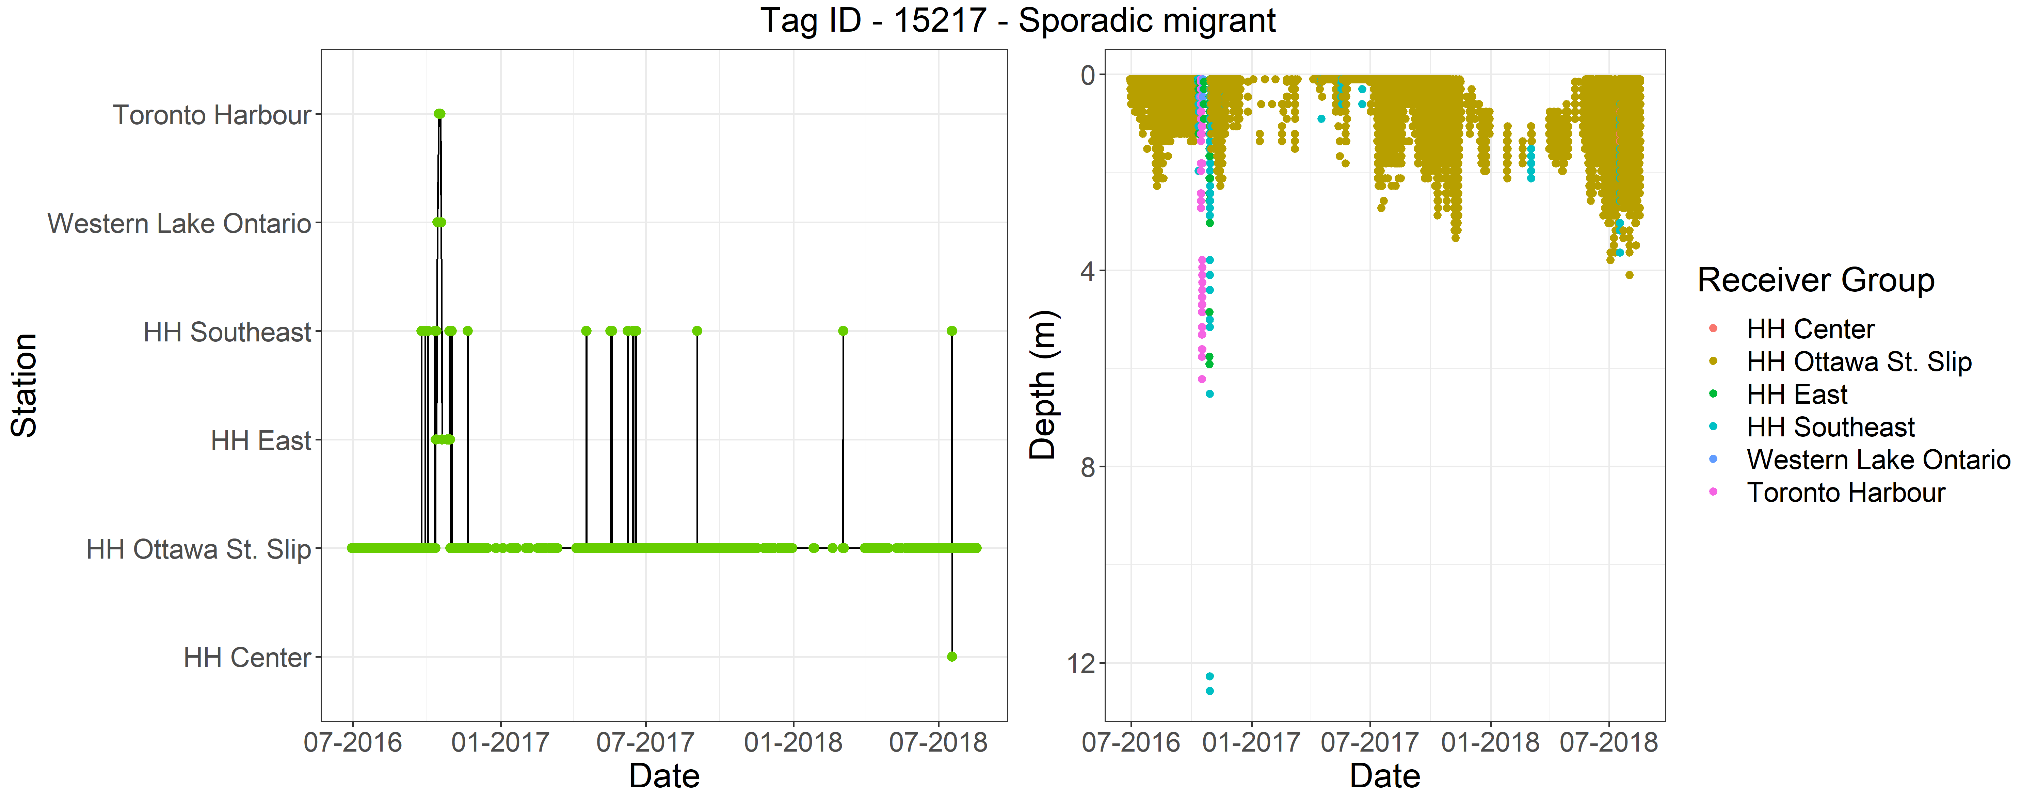
Figure 2L. Detections over time by general receiver location groupings (see Figures 3 and 4) and depth use of Longnose Gar ID 15217.

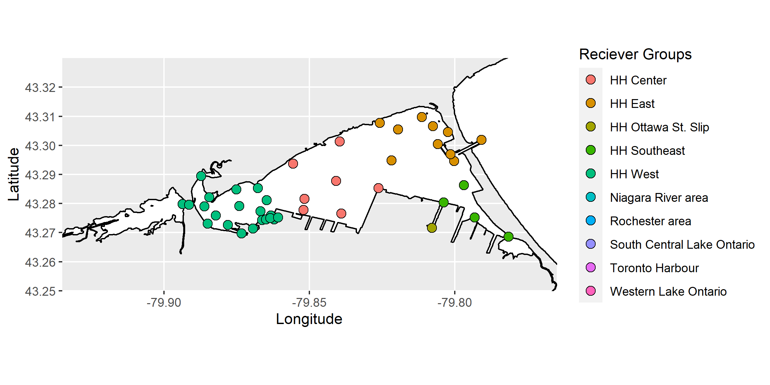
Figure 3. Receiver groups based on areas within Hamilton Harbour that Longnose Gar were detected on.
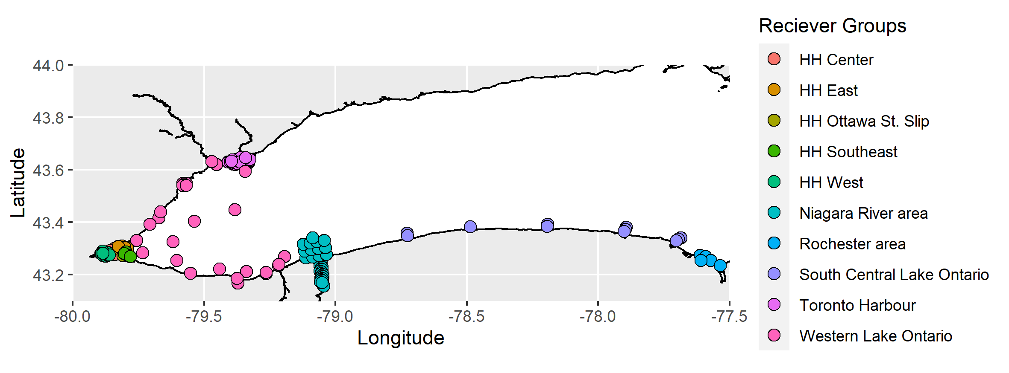
Figure 4. Receiver groups based on areas within western Lake Ontario that Longnose Gar were detected on.

