Table S1. Temperature selection ratios (w_{i}) and the associated standard errors (SEs) for temperature intervals available to white suckers in Turkey Lake across seasons. * denotes selection ratios > 1 (green bold text) or < 1 (red text) based on Bonferroni-corrected 95% confidence intervals (w_{i} ± z_{α/2I} SE where α = 0.05 and I is the number of temperature intervals), and zeros indicate available temperature intervals that were not used by the tagged white suckers.
Temperature (°C) | Temperature selection indices (SE)
Temperature (°C) | Winter 2021 | Spring 2022 | Summer 2022 | Fall 2022
Temperature (°C) | z_{0.0125} = 2.24 | z_{0.031} = 2.74 | z_{0.0023} = 2.84 | z_{0.0041} = 2.64
2.0 – 3.9 | 0.970 (0.02) | 0 (0)*
4.0 – 5.9 | 0.598 (0.23) | 0.36 (0.11)* | 0.01 (0.01)* | 0.03 (0.02)*
6.0 – 7.9 |  | 0.24 (0.05)* | 0.96 (0.32) | 1.03 (0.45)
8.0 – 9.9 |  | 0.38 (0.15)* | 3.49 (1.45) | 1.30 (0.22)
10.0 – 11.9 |  | 1.20 (0.33) | 4.76 (1.65) | 1.82 (0.07)*
12.0 – 13.9 |  | 2.27 (0.30)* | 4.27 (1.39) | 1.54 (0.19)*
14.0 – 15.9 |  | 2.01 (0.24)* | 2.98 (0.45)* | 1.68 (0.45)
16.0 – 17.9 |  | 1.62 (0.34) | 2.01 (0.41)
18.0 – 19.9 |  |  | 1.69 (0.43)
20.0 – 21.9 |  |  | 1.26 (0.42)
22.0 – 23.9 |  |  | 0.43 (0.23)

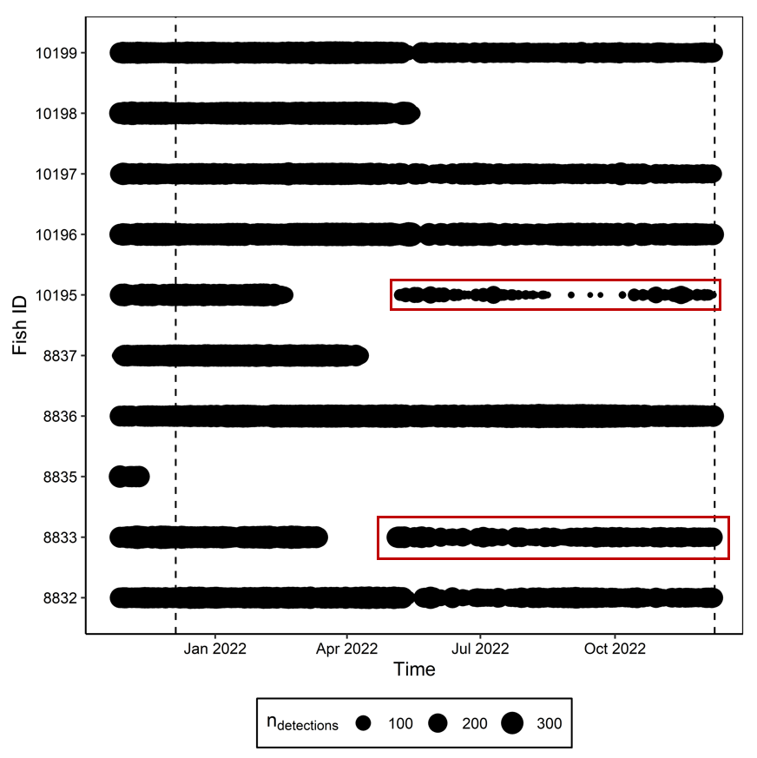
Fig. S1 - The number of spatial positions detected by the telemetry array in Turkey Lake per day for each tagged white sucker (n = 10). The dashed lines represent the start and end dates (December 5th, 2021 and December 8th, 2022, respectively) for the data used in the analysis in our study. The red rectangles denote spatial positions associated with periods of stationary horizontal and vertical space use. These data were omitted from analysis due to suspected mortality or tag failure.

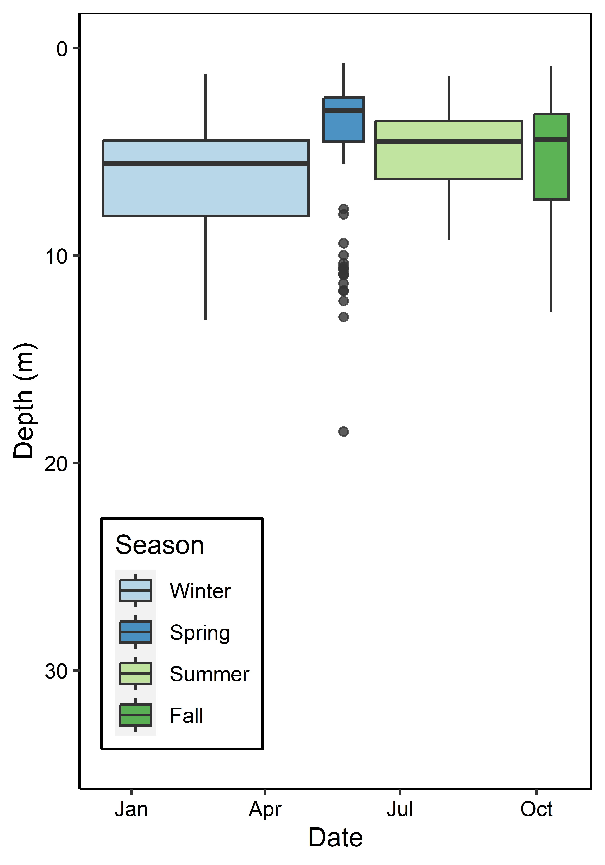
Fig. S2 - Boxplot of the daily depth occupancy of white suckers across seasons. Colour represents the different seasons; the box width is the season length. The middle horizontal line in each box is the median daily depth, and the interquartile range (IQR) is represented by the box from the first quartile (Q₁; bottom of each box) to the third quartile (Q₃; top of each box). The upper/lower whiskers extend to the highest and lowest values within 1.5 * IQR of Q₁ and Q₃.

Fig. S3 - Seasonal distributions of daily horizontal (A) and vertical (B) movement of white suckers in Turkey Lake standardized for the number of observations in each season.

