Supplementary Appendix to “Mapping Economic Growth and Employment in EU-Funded Research Projects: Trac(k)ing the SDG 8 Trajectory”
Kris BOUDT ^{1,2,3}, Yanick INGHELS ¹, André SPITHOVEN ^{1,4,5}
¹Department of Economics, Ghent University, Belgium
²Faculty of Social Sciences and Solvay Business School, Vrije Universiteit Brussel, Belgium
³School of Business and Economics, Vrije Universiteit Amsterdam, the Netherlands
⁴Monitoring and Evaluation Research and Innovation, Belgian Science Policy Office, Belgium
⁵ECOOM,Vrije Universiteit Brussel, Belgium
Abstract
In their paper " Mapping Economic Growth and Employment in EU-Funded Research Projects: Trac(k)ing the SDG 8 Trajectory", Boudt, Inghels and Spithoven (2024) propose a framework to evaluate the thematic prevalence of each of the 17 sustainable development goals (SDGs) in EU funded research projects. Such a global analysis allows them to compute the relative prevalence of SDG 8 by considering that some projects mention multiple SDGs. Their derived data and visualizations for the SDG prevalence in EU-funded research are made available through the web application https://sdgdashboard.streamlit.app/. In this supplementary appendix, we first describe the three main use cases of the SDG dashboard. We then present the results of a validation analysis of the methodology used to map the funded research projects to the SDGs. The supplementary appendix concludes with the list of stemmed keywords used for the SDG 8 mapping.
Keywords: Sustainable Development Goals, SDG 8, natural language processing, European Framework Programmes, research funding

Introduction
Boudt et al. (2024) enrich the CORDIS database with SDG labels they obtain based on a tractable pipeline of processing titles and abstracts of funded research projects. The derived data and interactive visualization are made available through the web application “SDG Dashboard” hosted at
https://sdgdashboard.streamlit.app/
Section 2 presents a user-friendly introduction to the SDG dashboard and its main use cases for studying SDG prevalence in EU-funded research. The examples focus on the research questions about SDG 8 presented in the main paper.
Section 3 presents the results of a validation analysis of the approach benchmarking the SDG classification method used against alternatives.
Section 4 concludes with the list of stemmed keywords used for the SDG 8 mapping.

Introduction to the SDG dashboard
Figure 1 shows the main page of the SDG dashboard. It has an SDG Navigator module for finding the thematically most relevant research projects per SDG and an SDG Monitor module for monitoring the SDG prevalence in EU-funded research.
The SDG Navigator enables researchers and policymakers to search the CORDIS database for specific Sustainable Development Goals (SDGs) and their targets. It utilizes the BM25 search algorithm by Robertson and Zaragoza (2009), enhanced by the dictionary-based term frequency approach developed by Borchardt et al. (2022) and Boudt et al. (2024). This combination provides a ranked list of ongoing or completed research projects funded by the European Framework Programmes, based on the relevant SDGs or targets.
The SDG Monitor offers in-depth visualizations and analyses of the findings by Boudt et al. (2024) for each SDG. Features include visualizing tables, downloading data, breaking down results for each SDG into specific targets, creating custom word clouds, and generating network graphs that illustrate the connections between different SDGs based on shared terminology. The dashboard is hosted at https://sdgdashboard.streamlit.app/
The SDG dashboard application, developed in Python, uses powerful libraries including matplotlib, networkx, numpy, pandas, Pillow, plotly, seaborn, streamlit, wordcloud, pyvis, streamlit-extras, and st-pages. Their detailed references are in the bibliography.

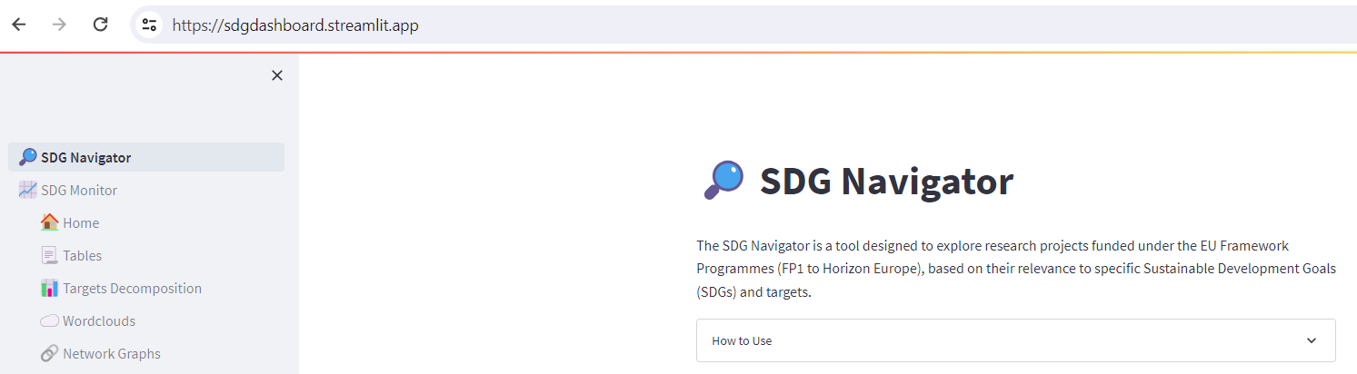
Figure 1 The SDG Dashboard home page. https://sdgdashboard.streamlit.app/

2.1. Use case 1: Finding the thematically most relevant research projects per SDG
The SDG Navigator is a tool for any scientist seeking information about which research projects have been funded per SDG. Utilizing the BM25 search algorithm, it acts as a search engine that displays the most relevant research projects, whether ongoing or finished, for a specific SDG, framework programme, and target.
In Figure 2, the Navigator shows the top research projects relevant to SDG 8 within Horizon Europe. By selecting the filter 'must include target' 8.5, it displays only those projects related to Full Employment and Decent Work. The tool provides detailed information, including the title, budget, coordinator, objective, and a link to the official entry in the CORDIS database and the associated SDGs.
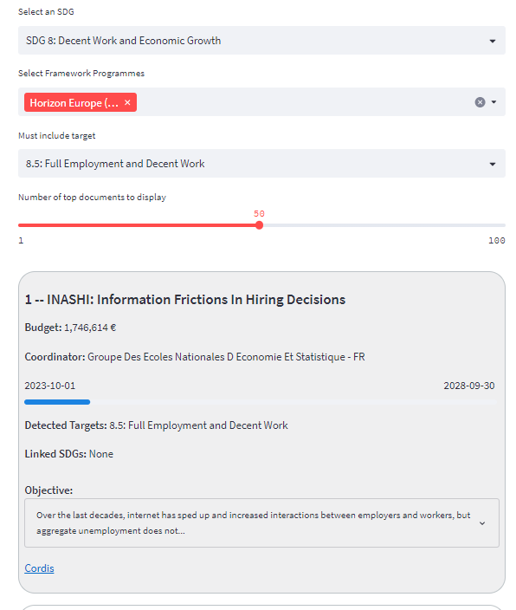
Figure 2 SDG Navigator example. This is a screenshot taken from the SDG Navigator on our dashboard. It shows the most relevant research project to target SDG 8's target 8.5 (full employment and decent work).
Boudt et al. (2024) explain that studying research projects offers more insights than studying publications. It highlights which institutions have been granted substantial funding to conduct groundbreaking research specifically aimed at solving an SDG. It also reveals the specific research objectives of these projects, enabling scientists to align or differentiate their research with state-of-the-art projects.

Use case 2: Explore the time-variation in popularity of SDG topics and targets
The SDG Monitor provides tables and interactive figures to show the trends in the relative prevalence of each SDG in the funded research projects. Tracing the historical prevalence of each SDG and its targets enables scientists to identify trends and understand their historical drivers. Tracking the current prevalence allows policymakers to assess whether their research funding policies align with their broader SDG policy objectives. In other words, it enables them to monitor policy consistency and adjust their strategies accordingly. Current research funding policy towards the SDGS meets their general SDG policy objectives; in other words, it allows them to track policy consistency and change their behaviour accordingly.
Figure 2 shows that the relative prevalence of SDG 8 takes the median position. It also shows the inequality since the 50% least prevalent SDG projects have jointly only between 15% and 25% prevalence. For the past 40 years, four SDGs (SDG 3, SDG 7, SDG 9, and SDG 13) attract half of the funding to SDG research projects. We refer to Boudt et al. (2024) for more discussion on interpreting this result.
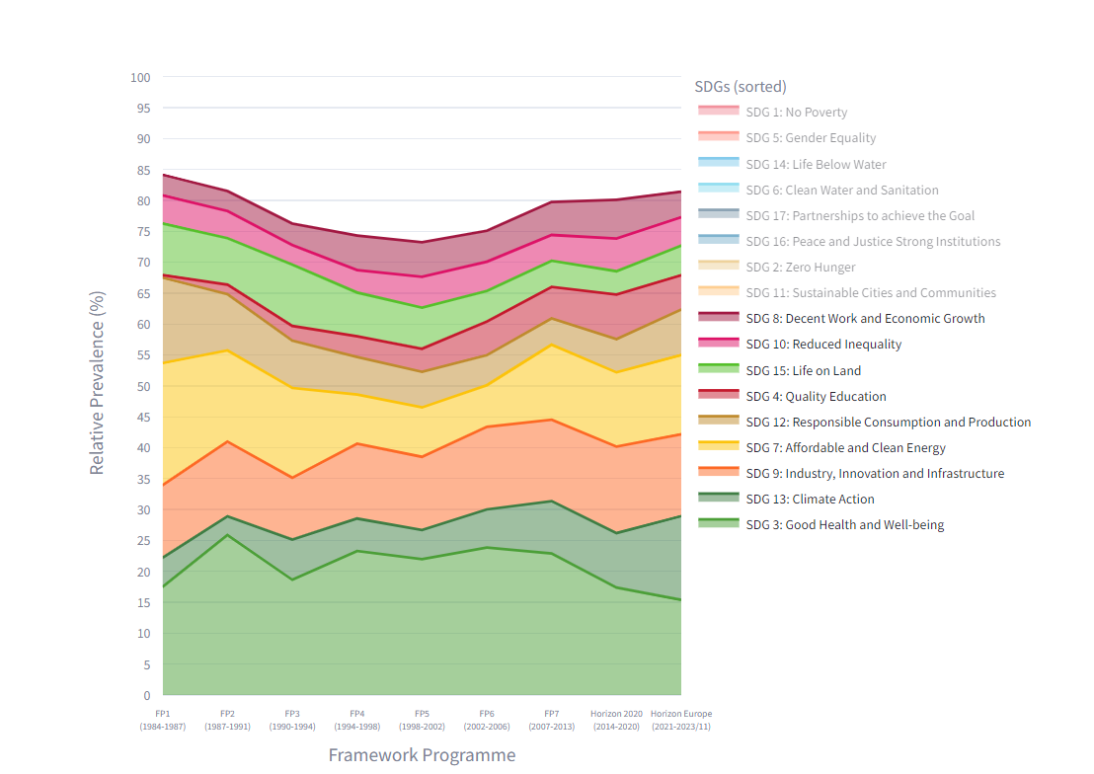
Figure 3 SDG Monitor on the relative prevalence of SDGs in EU-funded research projects
The SDG monitor also has a tool that identifies which specific targets within each SDG have received the most funding throughout the Framework Programmes. Figure 4 illustrates this in the context of SDG 8. We refer to Boudt et al. (2024) for more discussion on interpreting this result.

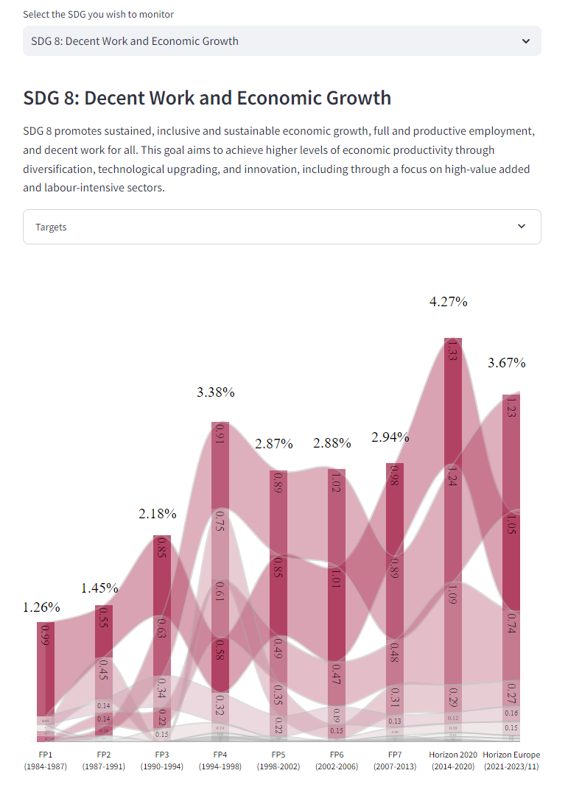
Figure 4 Target decomposition tool of the SDG Monitor. This figure shows the decomposition of the absolute prevalence for SDG 8 in its specific targets throughout the Framework Programmes.

Use case 3: Finding the interlinkages between SDGs in research projects
SDGs cannot be seen as isolated. Several projects are associated with multiple SDGs. Figure 5 illustrates the interlinkage in the case of SDG 8 and SDG 3. The common keywords between the SDGs are public health, mental health, research and development, research and innovation, climate change, and recycling. They are the connected linkages in the graph. Identifying this commonality can be helpful for policymakers to draft calls for a combination of SDG projects when they are coherent based on the analysis of linkages.
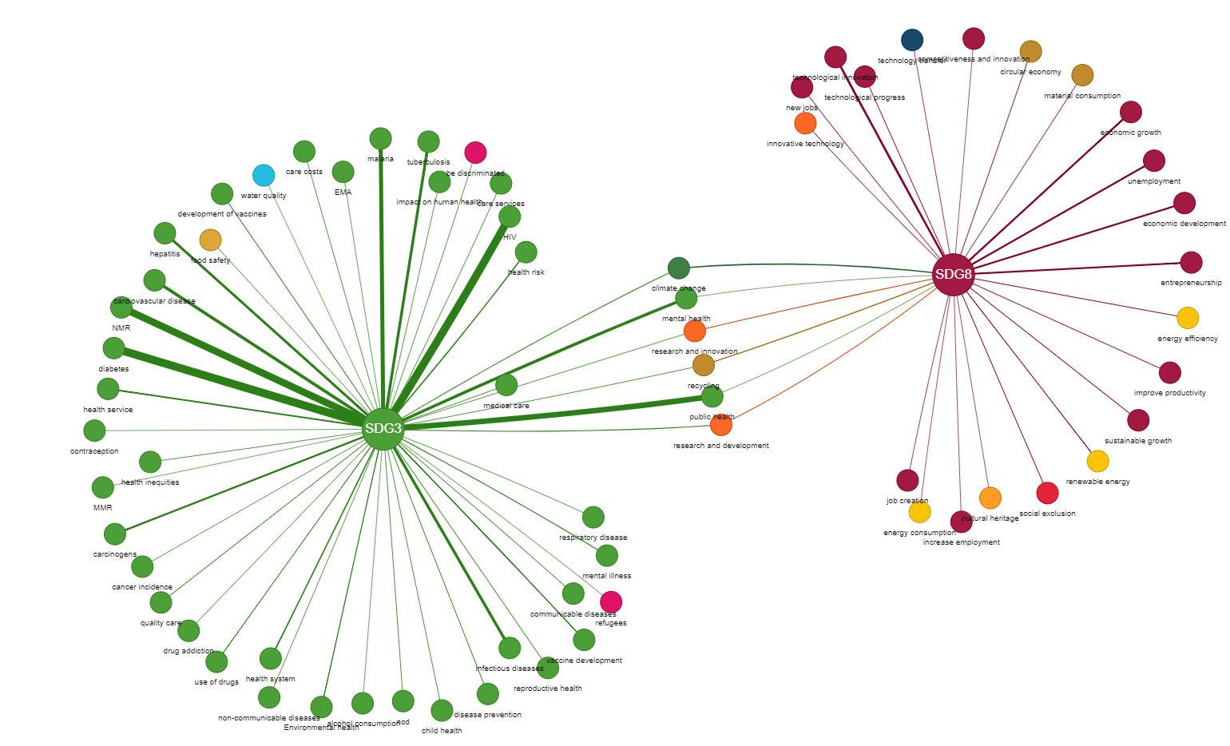
Figure 5 Network graph tool of the SDG Monitor. This figure shows the network graph demonstrating how SDG 8 and SDG 3 (Good Health and Well-Being) are linked based on co-occurrences.
  - Use case 4: Discovering the most frequently used words
To see which SDG-related words were most frequently used in each FP, our dashboard provides a word cloud generator that visualizes the most prominent words for a specific SDG for (a) specific FP(s). Figure 6 shows the word cloud for SDG 8 from FP1 until HE. It is generated from the mapping of SDG 8 in the research projects, showing the frequency of each word's detection in the abstract and title of the funded research projects. The most prominent terms identified are ‘technological innovation’, ‘unemployment’, ‘entrepreneurship’, ‘economic development’, and ‘economic growth’. The varied sizes of the words in the cloud demonstrate that no single keyword dominated our lexicon.
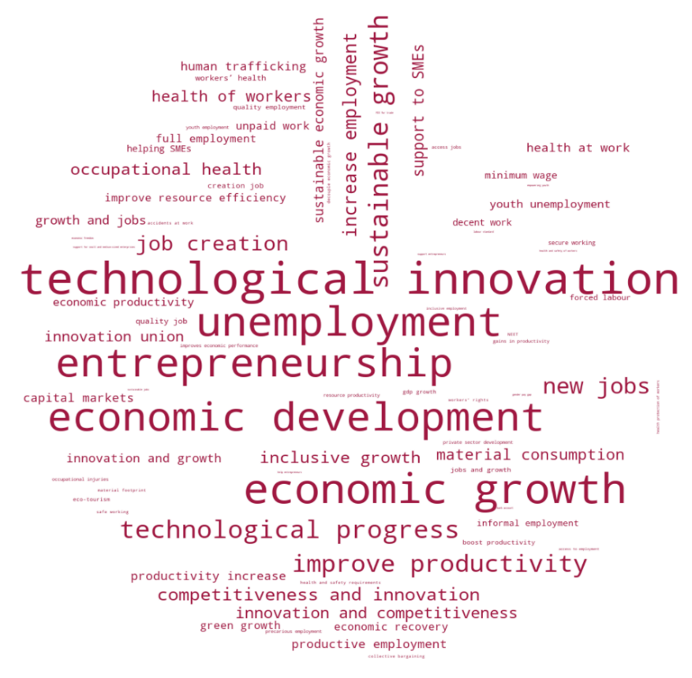
Figure 6 SDG 8 word cloud. The dimensions of each term in the word cloud signify their relative frequency compared to other terms within the SDG 8 lexicon.

Validation of the SDG classification approach used
Boudt et al. (2024) propose a tractable text-mining pipeline to extract insights on SDG prevalence from a large-scale analysis of the titles and abstracts of EU-funded research projects. In this section, we benchmark the SDG 8 classification outcomes against the outcomes from alternative implementations.
The most similar implementation to ours is the European Commission's SDG Mapper, which uses a keyword-based approach using the Borchardt et al. (2022) vocabulary. In Subsection 3.1, we list two drawbacks of the SDG Mapper: (i) opaqueness and evidence of wrong classifications and (ii) inefficiency in using their API.
In Subsection 3.2, we study the sensitivity of the SDG 8 classification to the choice of lexicon. We find a strong correlation, indicating the robustness of our results versus other choices of lexicons.
In Subsection 3.3, we compare the results obtained from machine learning models for SDG 8 classification. We show considerable disagreement between these models. Moreover, due to their black-box nature, the differences in classification are challenging to explain.
For these reasons, we recommend using a dictionary-based, fully tractable and explainable approach.
3.1. SDG Mapper
The European Commission's SDG Mapper is available at https://knowsdgs.jrc.ec.europa.eu/sdgmapper. Below are the drawbacks we identified when using this application.
3.1.1 Incidences of wrong classifications when using the SDG Mapper
The SDG Mapper of the European Commission needs to be more transparent in processing user text and detecting words from the Borchardt et al. (2022) vocabulary. As a result, users must identify the causes of false positives or false negatives themselves. Using SDG Mapper V1 used in June 2024, our analysis reveals that:
- The SDG Mapper does not detect keywords when they are mentioned between quotes (“” or ‘’):
For example, Project SIKB (The Development of Students’ Identities Knowledge Builders) specifically mentions contributing to this Innovation Union: “[…, making a vital contribution to the ‘Innovation Union’]”. Our transparent methodology correctly identifies the term “innovation union” in the project’s objective. However, submitting the text to the SDG Mapper fails to detect this term because it uses quotes. In other words, the mapper only works when first removing these.
- The SDG Mapper does not handle word variations well:
For example, the Mapper fails to recognize ‘socio-economic development’ as related to the term ‘economic development’ from the vocabulary of Borchardt et al. (2022). See project IC18970162 (Global change and subsistence management in Southern African resource variability, access and use in relation to rural livelihoods and welfare).
- The SDG Mapper does not remove commas (‘,’) in its preprocessing of the text:
The Mapper does not remove commas from the text during preprocessing, reducing the likelihood of detecting terms from the vocabulary of Borchardt et al. (2022).
For example, the Mapper fails to recognize ‘innovation, competitiveness, and growth’ as related to the term ‘innovation and competitiveness’ from the vocabulary of Borchardt et al. (2022). See project MICRO-DYN (The competitiveness of firms, regions and industries in the knowledge-based economy: What room for job-rich growth in Europe?).
3.1.2 Computational challenges of the SDG Mapper API
The Commission’s SDG Mapper includes an API enabling users to process large volumes of text quickly through their Python scripts. However, in practice, this API runs very slowly, taking approximately 4 seconds to process one research project of about 300 words. Extrapolating this to our dataset of abstracts and titles of 72,536 research projects means the total processing time would be around 82 hours, rendering the SDG Mapper practically unusable for large-scale text analysis. In contrast, our script completes the same task in approximately 15 minutes.
3.2. Alternative lexicons
To test the consistency of our lexicon with other SDG 8 lexicons, we chose three of the most popular SDG lexicons publicly available. First, we considered the Elsevier lexicon (Bedard-Vallee, 2023), a frequently updated list of keywords, used to query specific SDG publications within the Scopus database. Second, we chose the SDSN (2017) lexicon, a list of keywords compiled from several universities in Australia and New Zealand, each with internal lists of keywords to map SDGs to their research efforts or teaching. Third, we considered the lexicon from the University of Auckland (UoA) (Wang et al., 2023), who used the Elsevier -and SDSN lexicons to query their publications and global publications and develop an ML classification algorithm from which they extracted a list of keywords themselves.
It is important to note that these lexicons mainly focus on querying SDG publications. As research projects/proposals are written differently, we needed to remove specific keywords to maintain accuracy and avoid false positives.
3.3 Machine learning -and large language model-based approaches
An alternative approach to SDG classification is to rely on semantic embeddings as inputs for the classification task or to fine-tune these large language models (LLM), like BERT, for SDG classification (Vanderfeesten, 2022; La Fleur, 2023; Sadik, 2023).
Below, we discuss the advantages and disadvantages of these models for SDG classification, and then study their classification results.
3.3.1 Advantages of ML models
Machine-learning and LLM-based approaches offer several advantages compared to lexicon-based ones like ours. First, current LLMs are multilingual. This means that the semantic embeddings they compute remain consistent regardless of the underlying text (Zhou al., 2023). Second, these models account for the semantic context in which words are used. On the one hand, this means that they capture more variation than a lexicon-based approach. For example, the sentence "These economic policies will result in better productivity in the long run" clearly describes productivity increase without literally mentioning it. Although our lexicon-based approach will not be able to recognize this, these more advanced models will reduce the number of false negatives. On the other hand, it requires words to be used in a specific context, reducing the number of false positives (Minnaee et al., 2021). Third, heavy text-preprocessing steps are unnecessary as these models are trained on large amounts of text. The models use the information from entire sentences to create embeddings or perform classification (Minnaee et al., 2021).
3.3.2 Disadvantages of ML models
Regarding disadvantages, Machine learning and LLM based classification approaches are often held back by several major disadvantages. First, these advanced models require a large amount of accurately pre-labelled quality training data (Minnaee et al., 2021). As Boudt et al. (2024) mentioned, we are the first to map research projects to the SDGs, so no training data was available. Additionally, the detailed nature of our classification task (17 SDGs comprising 169 targets) makes gathering sufficient high-quality training data even more challenging. Conversely, our approach does not require any training data. Second, these models are often seen as ‘black box’, as they lack transparency in how they classify text and which rules they adopt, whereas our approach’s main advantage is its transparency. Third, fine-tuning or even using these models is computationally expensive and often requires a high-quality GPU (Sun et al., 2019). In contrast, our approach does not have such requirements and can run efficiently within 15 minutes.
3.4. Testing state-of-the-art SDG classification models and lexicons on our dataset
To validate our approach, we use the abovementioned alternative lexicons and our dataset to gauge their consistency with our approach, while including several state-of-the-art ML models. First, we chose SDG BERT, the most popular SDG classification model on Hugging Face, developed by Sadick (2023). This BERT model is fine-tuned on the oSDG Community Dataset, an open-source database containing publications, reports, and other texts, each divided into smaller paragraphs and labelled by volunteer experts (Pukelis et al., 2021). The model uses a SoftMax activation function to convert the classification logits into probabilities for each SDG, ensuring they sum up to one.
Second, we considered RoBERTa SDG, a recent and promising model developed by Nothnagel (2023). This model is based on the RoBERTa (Robustly optimized BERT approach) architecture, which offers improved performance over the original BERT model (Liu et al., 2019). Like SDG BERT, RoBERTa SDG is also fine-tuned using the oSDG Community Dataset and uses the SoftMax activation function to convert the logits into probabilities.
Third, we evaluated the SDGs Many BERTs model, developed by the Aurora alliance, a consortium of European universities aiming to address global societal challenges. Funded as a research project under Horizon 2020, Aurora created a dashboard to visualize the alliance's research contributions towards the SDGs. They constructed a training dataset of 1.4 million abstracts using custom-made SDG queries or search terms to fetch publications for each SDG. This dataset was used to fine-tune 17 BERT models, each dedicated to classifying publications into one SDG (Vanderfeesten et al, 2022). The use of 17 separate models resembles our approach (Boudt et al., 2024) and has the advantage of being able to classify projects under multiple SDGs or none.
For the classification of our 72,536 research projects, we employed the same binary approach as Boudt et al. (2024). Given that SDG BERT and RoBERTa SDG are multilabel classifiers utilizing a SoftMax activation function to convert logits into probabilities, we set a cutoff probability of 50%. For the Aurora model, we used a default cutoff probability of 95%.
Here, we present a macro-comparison of the results of this analysis. Figure 7 shows a correlation heatmap of the SDG 8 classification results from different algorithms and lexicons. This heatmap shows the similarities between the lexicons, state-of-the-art ML models and our approach (Boudt et al., 2024), and more importantly the substantial inconsistencies among the state-of-the-art models themselves. This latter discrepancy reveals the sensitivities or shortcomings of today’s more advanced models:
- Model used: Although both BERT SDG and RoBERTa SDG were fine-tuned on the oSDG training dataset, they produce widely different results.
- Training data used: Despite both BERT SDG and Aurora using the same underlying BERT model, they yield markedly different results due to being fine-tuned on different datasets.

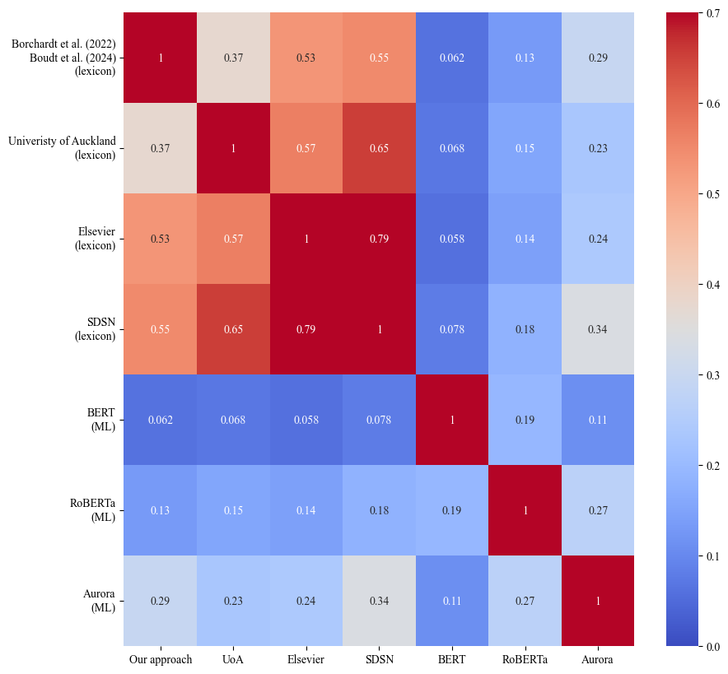
Figure 7 Correlation heatmap of SDG 8 classification methods. This heatmap illustrates the consistency between lexicon-based approaches, and the discrepancy between ML-based approaches for classifying SDG 8 in EU-funded research projects. The lexicon-based approaches include those from the University of Auckland, Elsevier, and the SDSN, as well as our own (using the Borchardt et al. (2022) lexicon). The ML models include SDG BERT (Sadick, 2023), SDG RoBERTa (Nothnagel, 2023), and the model developed by Aurora Universities Alliance (Vanderfeesten et al., 2022).

SDG 8 targets, indicators, and stemmed lexicon
Table 1 present the list of stemmed keywords used for SDG 8 classification.
Table 1 SDG 8 Targets, Indicators, and Stemmed Lexicon
 | Description | Indicators | Stemmed Lexicon
SDG 8 | Decent Work and Economic Growth |  | sustain develop goal 8, sdg 8, sustain econom growth, repair labour market, boost job growth, protect worker job, econom recoveri
8.1 | Sustain per capita economic growth in accordance with national circumstances and, in particular, at least 7 per cent gross domestic product growth per annum in the least developed countries | Annual growth rate of real GDP per capita | econom growth, econom develop, gdp growth, growth rate real gdp, growth rate gdp, gross domest product growth, gross ad valu, growth job, inclus growth, sustain growth, product sector growth
8.2 | Achieve higher levels of economic productivity through diversification, technological upgrading and innovation, including through a focus on high-value added and labour-intensive sectors | Annual growth rate of real GDP per employed person | econom productivity, technolog innov, innov union, technolog progress, innov growth, competit innov, innov competit, improv econom perform, gain productivity, boost productivity, improv productivity, productivity increas
8.3 | Promote development-oriented policies that support productive activities, decent job creation, entrepreneurship, creativity and innovation, and encourage the formalization and growth of micro-, small- and medium-sized enterprises, including through access to financial services | Proportion of informal employment in total employment, by sector and sex | job creation, creat qualiti job, entrepreneurship, support entrepreneur, support product activ, nonagriculture employ, increas employ, new job, financ enterprises, job growth, creation job, encourag enterprises innov, support small medium size enterprises, help sme, help small medium size enterprises, support sme, creativ job, sustain job, emerg industri job, job innov sector, access job, job rich recoveri, worker live extrem poverti, stimul busi environ, stimul invest climat, stimul busi climat, eas busi index, econom freedom, support micro small medium enterprises, support msme, privat sector organ promot, privat sector develop, support privat sme, privat sector advocaci, capit market, regulatori framework sme develop, help entrepreneur, creat busi climat, creat busi environ, creat invest climat, support innov sme, support innov enterprise, support innov small medium size
8.4 | Improve progressively, through 2030, global resource efficiency in consumption and production and endeavour to decouple economic growth from environmental degradation, in accordance with the 10-Year Framework of Programmes on Sustainable Consumption and Production, with developed countries taking the lead | 1. Material footprint, material footprint per capita, and material footprint per GDP  2. Domestic material consumption, domestic material consumption per capita, and domestic material consumption per GDP | decoupl econom growth, improv resourc effici, materi footprint, materi consumpt, resourc productivity, green growth, climat resili growth, econom growth decoupl resourc use, resourc effici consumpt product
Table 1 (continued)
 | Description | Indicators | Stemmed Lexicon
8.5 | By 2030, achieve full and productive employment and decent work for all women and men, including for young people and persons with disabilities, and equal pay for work of equal value | 1. Average hourly earnings of female and male employees, by occupation, age and persons with disabilities  2. Unemployment rate, by sex, age and persons with disabilities | full employ, product employ, decent work, unemploy, inclus employ, equal pay, high skill employ, help vulner return labour, qualiti employ, minimum wage, fair work condit, gender pay gap, gender balanc labour market, decent job, inclus job, qualiti job, job creation vulner, creation job opportun, decent labour, protect job, women particip labour forc, inform employ, underutil women labour forc, help women make steadi incom, vocat rehabilit, employ peopl disabl, recruit person disabl, decent employ, access employ, unpaid work, underutilis women labour forc, poor job search skill
8.6 | By 2020, substantially reduce the proportion of youth not in employment, education or training | Proportion of youth (aged 15-24 years) not in education, employment or training | unemploy among youth, youth employ, youth unemploy, youth train, youth work, job youth, young peopl employ, young peopl unemploy, help young peopl get work, young peopl age 15 29 employ educ train, educ insert labour market, neet, help 35 million young peopl year get train educ work, help young peopl get train educ work, young peopl employ educ train
8.7 | Take immediate and effective measures to eradicate forced labour, end modern slavery and human trafficking and secure the prohibition and elimination of the worst forms of child labour, including recruitment and use of child soldiers, and by 2025 end child labour in all its forms | Proportion and number of children aged 5-17 years engaged in child labour, by sex and age | forc labour, child labour, forc slaveri, human traffick, child soldier, child domest worker, protect children affect arm conflict, prevent recruit minor, recruit youth extremist group
8.8 | Protect labour rights and promote safe and secure working environments for all workers, including migrant workers, in particular women migrants, and those in precarious employment | 1. Fatal and non-fatal occupational injuries per 100,000 workers, by sex and migrant status  2. Level of national compliance with labour rights (freedom of association and collective bargaining) based on International Labour Organization (ILO) textual sources and national legislation, by sex and migrant status | labour right, safe work, secur work, precari employ, occup injuri, occup accid, accid work, collect bargain, labour union, employe rights, health safeti requir, health safeti worker, health protect worker, health safeti result workplac, health surveil worker, protect worker health, protect worker risk health, health requir work, health relat workstat, worker safeti health, health worker, safeti health worker, occup health, health safeti requir regard exposur worker risk, exposur worker risk, worker health, health exposed worker, protect all worker, health work, health protect work, health safeti condit work, protect health safeti worker, safeti requir workplac, protect labour, labour standard, improv labour condit, worker rights

Table 1 (continued)
 | Description | Indicators | Stemmed Lexicon
8.9 | By 2030, devise and implement policies to promote sustainable tourism that creates jobs and promotes local culture and products | Tourism direct GDP as a proportion of total GDP and in growth rate | impact sustain tourism, monitor sustain tourism, evalu sustain tourism, sustain tourism evalu, sustain tourism monitor, plan sustain tourism, eco tourism, cultur link tourism, agri tourism, green tourism, inclus tourism, respons tourism, respons ecotour, promot local cultur, promot local product,
8.10 | Strengthen the capacity of domestic financial institutions to encourage and expand access to banking, insurance and financial services for all | 1. (a) Number of commercial bank branches per 100,000 adults and (b) number of automated teller machines (ATMs) per 100,000 adults  2. Proportion of adults (15 years and older) with an account at a bank or other financial institution or with a mobile-money-service provider | access bank, access financial servic, access insur, commerci bank branch, number atm, autom teller machin, mobil money servic, bank account, financial inclus, access credit financial servic, financial servic provid, microfin, micro credit,
8.a | Increase Aid for Trade support for developing countries, in particular least developed countries, including through the Enhanced Integrated Framework for Trade-Related Technical Assistance to Least Developed Countries | Aid for Trade commitments and disbursements | aid trade, aid disbursement, trade relat technic assist, trade relat assist, trade relat direct foreign invest, fdi trade, trade polici develop support,
8.b | By 2020, develop and operationalize a global strategy for youth employment and implement the Global Jobs Pact of the International Labour Organization | Existence of a developed and operationalized national strategy for youth employment, as a distinct strategy or as part of a national employment strategy | strategi youth employ, polici youth employ, global job pact, youth employ strategi, increas profession abil youth, increas employ youth, youth unemploy rise, opportun youth enter labour market, enabl youth entrepreneurship, enhanc youth entrepreneurship, empow youth, reinforc youth particip, reinforc youth leadership, opportun youth employ, enhanc youth employ, creat opportun youth, creat incent entrepreneurship youth, creat incent innov youth, employ opportun youth, instrument fight youth unemploy, youth employ polici
Note: The words in bold are not stemmed to avoid false positives (see section 4.1 of Boudt et al. (2024))

References
Packages used:
Blackwood, Z. (2024). st-pages: Page management in Streamlit apps. https://github.com/blackary/st_pages
Clark, A. (2015). Pillow (PIL Fork) Documentation. readthedocs. Retrieved from https://buildmedia.readthedocs.org/media/pdf/pillow/latest/pillow.pdf
Hagberg, A. A., Schult, D. A., & Swart, P. J. (2008). Exploring network structure, dynamics, and function using NetworkX. Proceedings of the 7th Python in Science Conference (SciPy2008) (pp. 11-15).
Harris, C.R., Millman, K.J., van der Walt, S.J. et al. Array programming with NumPy. Nature 585, 357–362 (2020). https://doi.org/10.1038/s41586-020-2649-2
Hunter, J. D. (2007). Matplotlib: A 2D Graphics Environment. Computing in Science & Engineering, 9(3), 90-95. https://doi.org/10.1109/MCSE.2007.55
McKinney, W. (2010). Data structures for statistical computing in Python. In S. van der Walt & J. Millman (Eds.), Proceedings of the 9th Python in Science Conference (pp. 51-56). https://doi.org/10.25080/Majora-92bf1922-00a
Miribel, A. (2024). Streamlit-extras: Additional functionalities for Streamlit. https://github.com/arnaudmiribel/streamlit-extras
Mueller, A. C. (2023). Wordcloud (Version 1.9.1) [Computer software]. https://github.com/amueller/wordcloud
Perrone, G. (2018). Pyvis interactive network visualization. https://pyvis.readthedocs.io/en/latest/
Streamlit Inc. (2014). Streamlit: The fastest way to build data apps. https://streamlit.io
Waskom, M. L. (2021). Seaborn: Statistical data visualization. Journal of Open Source Software, 6(60), 3021. https://doi.org/10.21105/joss.03021
Other:
Bedard-Vallee, A., James, C., & Roberge, G. (2023). Elsevier 2023 Sustainable Development Goals (SDGs) Mapping [Data set]. Elsevier Data Repository, V1. https://doi.org/10.17632/y2zyy9vwzy.1
Boudt, K., Inghels, Y., & Spithoven, A. (2024). Trac(k)ing the trajectory: Mapping Sustainable Development Goal 8 in EU-funded research projects (No. 24/1084). Ghent University, Faculty of Economics and Business Administration.
Borchardt, S., Barbero Vignola, G., Buscaglia, D., Maroni, M. and Marelli, L., Mapping EU Policies with the 2030 Agenda and SDGs, EUR 31347 EN, Publications Office of the European Union, Luxembourg. https://doi.org/10.2760/87754
Devlin, J., Chang, M. W., Lee, K., & Toutanova, K. (2018). Bert: Pre-training of deep bidirectional transformers for language understanding. https://doi.org/10.48550/arXiv.1810.04805
La Fleur, M. (2023). Using large language models to help train machine learning SDG classifiers. UN DESA Working Paper No. 180. New York, NY: United Nations Department of Economic and Social Affairs.
Liu, Y., Ott, M., Goyal, N., Du, J., Joshi, M., Chen, D., ... & Stoyanov, V. (2019). Roberta: A robustly optimized bert pretraining approach. https://doi.org/10.48550/arXiv.1907.11692
Minaee, S., Kalchbrenner, N., Cambria, E., Nikzad, N., Chenaghlu, M., & Gao, J. (2021). Deep learning--based text classification: a comprehensive review. ACM Computing Surveys (CSUR), 54(3), 1-40. https://doi.org/10.48550/arXiv.2004.03705
Nothnagel, J. (2023). Roberta-base-finedtuned-sdg. Hugging Face. Retrieved June 8, 2024, from https://huggingface.co/jonas/roberta-base-finetuned-sdg
Pukelis, L., Puig, N. B., Skrynik, M., & Stanciauskas, V. (2020). OSDG -- Open-source approach to classify text data by UN Sustainable Development Goals (sdgs). https://doi.org/10.48550/arXiv.2005.14569
Robertson, S., & Zaragoza, H. (2009). The probabilistic relevance framework: BM25 and beyond. Foundations and Trends® in Information Retrieval, 3(4), 333-389. http:// doi.org/10.1561/1500000019
Sadick, A. M. (2023). SDG classification with BERT. https://huggingface.co/sadickam/sdg-classification-bert
Sun, C., Qiu, X., Xu, Y., & Huang, X. (2019). How to fine-tune BERT for text classification? In Chinese Computational Linguistics. CCL 2019. Lecture Notes in Computer Science (Vol. 11856). Springer, Cham. https://doi.org/10.1007/978-3-030-32381-3_16
Sustainable Development Solutions Network: Universities & SDGs (2017). Compiled keywords for SDG mapping [Excel spreadsheet]. SDSN Australia, New Zealand and Pacific. Retrieved June 3, 2024, from https://ap-unsdsn.org/wp-content/uploads/Compiled-Keywords-for-SDG-Mapping_Final_17-05-10-9.xlsx
Vanderfeesten, M., Jaworek, R., & Keßler, L. (2022). AI for mapping multi-lingual academic papers to the United Nations' Sustainable Development Goals (SDGs) (1.0). Zenodo. https://doi.org/10.5281/zenodo.6487606
Vaswani, A., Shazeer, N., Parmar, N., Uszkoreit, J., Jones, L., Gomez, A. N., ... & Polosukhin, I. (2017). Attention is all you need. Advances in neural information processing systems, 30. https://doi.org/10.48550/arXiv.1706.03762
Wang, W., Kang, W., & Mu, J. (2023). Mapping research to the Sustainable Development Goals (SDGs). https://doi.org/10.21203/rs.3.rs-2544385/v3
Zhou, C., Li, Q., Li, C., Yu, J., Liu, Y., Wang, G., ... & Sun, L. (2023). A comprehensive survey on pretrained foundation models: A history from bert to chatgpt. https://doi.org/10.48550/arXiv.2302.09419

The Innovation Union of the European Union is an initiative aimed at creating a Single Innovation Market to improve innovation, competition, and productivity. This initiative is included in the Borchardt et al. (2022) lexicon under target 8.2, which focuses on improving economic productivity.

