Supplementary Information

An evaluation of fish and invertebrate mercury concentrations in the Caribbean Region
Ecotoxicology

Authors: Linroy Christian^{1*}, Mark E.H. Burton, Azad Mohammed, Wendy Nelson, Tahlia Ali Shah, Laël Bertide-Josiah, Helen G. Yurek, David C. Evers
Corresponding Author: Linroy Christian^{1*}
¹Ministry of Foreign Affairs, Agriculture, Trade and Barbuda Affairs, St. John's, Antigua and Barbuda
*Linroy.Christian@ab.gov.ag

Fig. S1 Residuals vs predicted fish total mercury (THg) plot for the mixed effects model
Fig. S2 Actual vs predicted fish total mercury (THg) plot for the mixed effects model

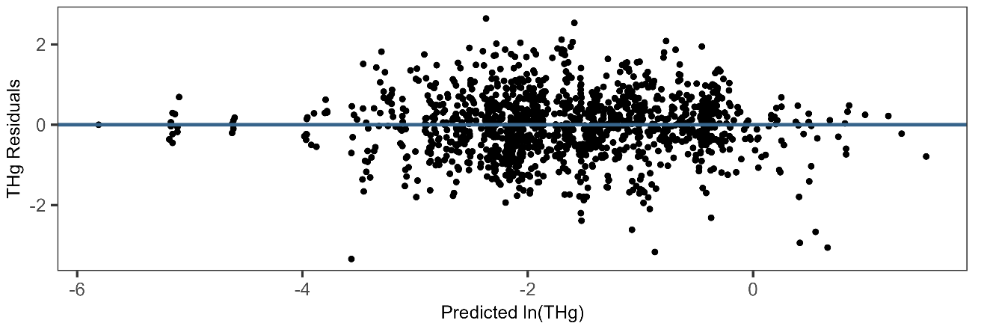
Fig. S1 Residuals vs predicted fish total mercury (THg) plot for the mixed effects model

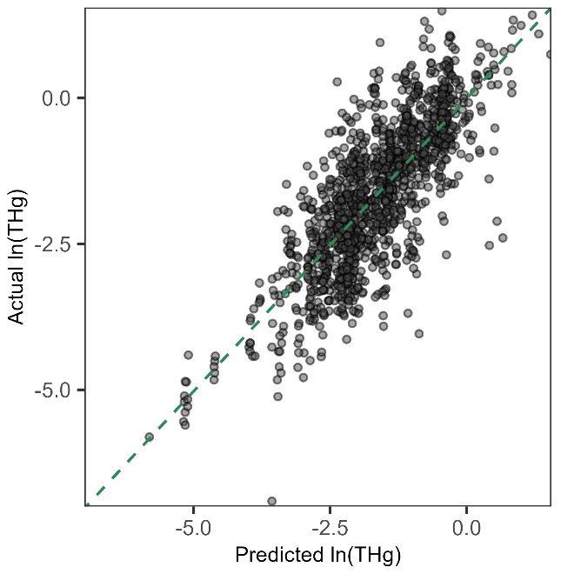
Fig. S2 Actual vs predicted fish total mercury (THg) plot for the mixed effects model

