Supplemental Table 1. Gene sequences included in the white sucker Catostomus commersonii liver codeSet.
Gene Symbol | Target sequence
ahr | AGTACTTTCAATGGGATGTAACCACTGGCACCATGTGTACAGAATAATTTTTGAAGGAAGTCTAGAGCTTCAGAGGTTCACAGATGTTCTGGATGAATAT
ar | CCGTGCAGACATGGGGTTGCATCGGGGCGCCGAATCAGGATGGAAATGCAGCGGTGCCGCTGAAGTTCTGTCACGCGAGTTGGGTTTGAGTCGTGACGCA
cat | TCACACGTTATTGCAAAGCCAAACTGTTTGAGCATGTGGGAAAAAGGACACCCATCGCTGTTCGCTTTTCCACTGTGGCTGGGGAGTCTGGGTCAGCAGA
ctnnβ1 | AGTATCCAGTGGAGGGACTGCCTGACTTGGGTCACGCTCAGGACCTGATGGACGGCTTGCCACCCACAGACTCAAATCAGCTGGCCTGGTTCGACACAGA
ef1a | AGTCAACCACCACTGGTCATCTGATCTACAGATACTGGACAAAGGGGAGCAGCAGCCGAGGAGTGATCTCTCAACACTGAAACCAATCAATCATGGGGAA
eif3d | CGGAGGTGGAAGCTTGGGGAAGATATTGACCTCATTGTTCGCTGCGAGCATGATGGAGTGATGACTGGAGCAAACGGAGAAGTGTCTTTCATCAACGTGA
erα | CTTTATGCATGCCTTCAGAGCATGTGCTGGTGTTACTTTTAGGTGCTGAGCCACCAGCTCTCTGCTCGCGACAGAAACAAAACCGCCCATACACCGAGAT
erβ | CAATGGAAACGAGGTTGTTACCGTGGCGTTAAGCCCAGAGGAACTAATAGCTCGCATCATAGATGCAGAGCCACCACAGATTTACCTTATGAAAGATATG
frt | GAAACTGATGAAGTTTCAGAACCAGAGGGGAGGGAAGATCTTTCTGCAGGATGTGAAAAAACCAGAGAAGGATGAGTGGGGAAGTGGTTTGGAAGCTCTT
gr | AAATGCTCGCAGAGATCATCAGCAACCAGTTACCAAAATTCAAAGCTGGGAGTGTCAAACCGCTACTCTTTCATCAGAAGTGAAGCTCCTCCCTGCAGCA
gst | AGGATGGTGACCTGGTCCTGTATCAGTCCAATACTATGTTAAGACATTTGGGTCGCAAACATGGTGCATATGGGAAAAATGACTCTGAGGCTTCTCTTAT
hsp70 | GACGATTGGAAATGCTGGGAAGAGCCAGATAATAACTAATTTTAAGAACACAGTTCACGGCTTTAAGAAGTTGCATGGTCGCACATTCGATGACCCTTAC
mt | TACACGAACAGTTAGTGCACTTGCAGGTGGCACCACAGTTGCAAGTTCCAGTCTTGGAGCAATCACAAGGATCCATTTTCCCTCAAAATATCCTTAAAGG
pcna | AAGATGCCTTCTGGTGAATTTGCCCGAATCTGCAGAGACCTGTCACAGATTGGTGACGCTGTCATGATTTCCTGTGCCAAAGATGGAGTGAAGTTCTCTG
pepck | GTTGGGGCCCGGTCCCTCTCCTCCATCCCCTCTTTGCCTCCATCTGTGGCTGAGTTTGTGTCAGGGGCCGCATCTGAGTGTAAACCTGCCAAAGTGCACT
ppar | CTTGATGACAGCGACCTTGCTCTGTTTGTGGCAACTGTCATACTGTGTGGAGATCGTCCTGGACTGATGAACGTGAAACAGGTAGAGCAGATCCAGGATG
rpl8 | CACAACCCTGAGACCAAAAAGTCCAGAGTTAAGCTTCCATCTGGATCCAAAAAGGTTGTCTCTTCCTCAAACAGAGCTGTAGTTGGTGTCGTTGCTGGTG
sod | CAAAATTCAGAGAGGCAGCATGGAACCAAAAAGGGCTGTTTGTGTGCTCAAAGGCACAGGGGAAGTGACCGGAACAGTCTATTTCGACCAAGCGGATGAC
tgfβ1 | GTTTGATGTGAAGAAGTCAATCACAGAATGGCTGCAAAGTTCAGAAGATGAAGTGAGTTTAGATTTGAGGTTATACTGTGGCTGTAAAACCGGCAAAGAC
tgfβr2 | ATTTGCATAGTGACCACACACCCTGTGGGAGGCCCAAAGTGCCCATCGTCCACCGAGATCTAAAGAGTTCCAACATACTGGTGAAGAATGATCTTTCCTG
tnf | GATTGCAGTCCTTTTCAGGCACAATCGGTTCAGTGATGAGGAGCTAAAGTTGGCTCAGACCTTCAAAAAGAAACTGCACCAGGGAGCCATGACAGCCATC
tp53 | TGAGGAAGAGAATCTAAAGAAGATTACTGGGGAGAAGTCTACTGGGACAAAGAGAAAACGTCAGCTTCAGGATCAGTTGAAAGAGCATCCTATACCTGAT
vtg | TATGCTGGTGACCGTTCCTCTGAGAACACTGATCCTGAAAGGCCTGCTGTGAGAACTGCTACTCCATTCCACAAGACCCTCTGTCTTGATGTCCCATACA
bc2 | CAATGGGAGATGAAGATGATGAAGAGGAGAGTGATGCTGTTGTATCTCAAGTTCTTGATGAGCTGGGTCTGACACTTTCTGATGAACTTTCAAACCTGCC
cxcl13 | AGCGCACATATTTACTGCTGGCAGCTGTTACAATCTGCTGCTTCACAAATCTGCTTGCTGTCTCAATGGAAGGCTTTACATCCAATAACAAGTGTCACTG
cyp1a1 | AATATTCTTGTGCTCTTGAGGAGCACGTCATCAAAGAGGGACTCTATCTGATAGAAAGATTACACACTGTCATGAAGGCTGATGGGAGCTTCGATCCTTT
ef1a | GCTGTGCTGATTGTTGCTGGTGGTGTTGGTGAGTTCGAGGCTGGTATCTCCAAGAACGGACAGACCCGTGAGCATGCCCTTCTGGCTTTTACATTGGGAG
erb2 | CCTGCTGATGCTGCTGTCACATATACGACACCTCAGCAACAAAGGTATTGAGCATCTGTCGAGCATGAAGAGAAAAAACGTGGTGCTTCTGTACGATCTT
erbB2 | CCCGGTCAGTGTGTGTCATGTGTCAATTACAAACGTGGGACCGAGTGTGTGGAGCAGTGTAATGTCCTACATGGGTCAGTACGGGAGTTTGTGGATGGTT
fasl | ATGGATACTGGCTTTGATACTCCTGTTGGTTTTTGCAGCCCTGGGACTGGGAGCCTACCAGATACTGAGGTTGCAGACTGAATTTGAAAGGCTGACACAG
ifit1 | ACATGTGATTAGATATGTGGGGAAATATATGCGGGTCTACGGGTCTTTAGATAGGTCCACTGCCCTGTTGAAAAGAGCATTGGAGGTTGCACCAAATTCA
ifn1 | AAGGACTATGATTGAGCAACGGGTGATGGTCTTTTTCTGGGGAGTATGTTTGTTGACTTCTGGATGGATGACATACGCCGATGCCAGCATCCCTGAAAAC
il8 | GATGAAGTTCACTGTAGCAGCTTTCACCATTCTGATCTGCATGACGCTACTGTCCACAACAGAAAGTAGATCCCTACAACAACTACGTTGCAACTGTATT
mt2 | ACCTGCAAGTGCACTAATTGTGCGTGTACAACCTGCAAGAAGAGTTGCTGCTCCTGCTGCCCATCCGGTTGCAGCAAGTGTGCTTCTGGCTGTGTATGTA
myc | GATGATAGCTGACAATACAGATAGCAGCTCGAATCGACACAATGCAAGTTATTTGCAGGATCTGAGCACTTCTGCATCAGAATGCATCGATCCTTCGGTG
pparg | CTACTCCGAAGAGAGCATCTACAGAGCACAAGAATCCCAAAATTCAATCAAACTTGAACCCGAGTCTCCTCCACAGTTTGCAGATAACAGCCTGTCATTT
tp53 | AGAAAAAGTGAGGAGAGCAACTTTAGAAAAGAGCAGGAGGCCAAAACCATGGGAAAGACCTCCTCTGCCACCAAACGAAGCTTTAAGGAGTCATCCTCAT
wshbv | CCGTCTTAAAGCCGTGTAAGCACGGAGAGCGAAAAGCAAAGGAAGAGTTTTGAATTGTTTGTAGCAAACAAACATAGAGTCAGATGCGAGTGCGCGACAG
wshbvp a | AACAGTTACGCTCCACAAAGAATTGCCTCTTTTACTGCCTTCAAGGACTTGGAAATACTTGCTGCCGGCCAGGTTTTGGCCAAAGGTGACCCATTGGTAT
wshbvp b | AGATCTTCCTCACGACTTTTTCCCTCTGCTTAAAGATCAGGTACAGTTCTCTAAGGACGTTATCAAGGAGTATAACGAACACCATTCTCAGAATAGACAC
wshbvs | CAACCTCGATGCACTTCAAAACGGACTGCCCGCTAACATGTACCGGATTTCGCTGGACCTTAGTGAGGCGTTCTATCATATTCCTTTGCATCCTGGCTCT

Supplemental Table 2. Posterior estimates of regression coefficients from Bayesian logistic regression models predicting liver and skin neoplasia presence in fish. Each row presents the posterior mean estimate (Value), 95% credible interval (Lower and Upper 95% CI), and the Probability of Direction (PD), which reflects the proportion of the posterior distribution that shares the same sign as the mean estimate. The intercept represents the expected log-odds of neoplasia when all predictors are zero; however, this is not always biologically meaningful for variables like length, age, and sex. Interpretation is more appropriately focused on the direction and magnitude of the predictor coefficients. Rows where the 95% CI does not include zero are bolded to identify significant effects.

Model | Tissue | Predictor | Value | Lower  95% CI | Upper  95% CI | PD
Combined | Liver | Intercept | -2.39 | -4.31 | 0.68 | 0.95
 |  | Sex:Male | 0.15 | -0.62 | 0.94 | 0.65
 |  | Age (years) | 0.30 | -0.03 | 0.63 | 0.96
 |  | Length (mm) | 0.71 | 0.21 | 1.25 | 1.00
Combined | Skin | Intercept | -1.48 | -3.39 | 0.97 | 0.93
 |  | Sex:Male | 0.81 | 0.37 | 1.24 | 1.00
 |  | Age (years) | 0.03 | -0.19 | 0.25 | 0.60
 |  | Length (mm) | 0.62 | 0.35 | 0.93 | 1.00
Sheboygan | Liver | Intercept | -1.92 | -5.39 | 2.58 | 0.85
 |  | Sex:Male | 0.00 | -0.93 | 0.96 | 0.51
 |  | Age (years) | 0.16 | -0.24 | 0.55 | 0.79
 |  | Length (mm) | 1.07 | 0.40 | 1.75 | 1.00
Sheboygan | Skin | Intercept | -1.16 | -3.97 | 2.19 | 0.83
 |  | Sex:Male | 0.99 | 0.51 | 1.50 | 1.00
 |  | Age (years) | -0.03 | -0.29 | 0.21 | 0.60
 |  | Length (mm) | 0.78 | 0.45 | 1.15 | 1.00
Green Bay | Liver | Intercept | -1.83 | -6.34 | 2.94 | 0.80
 |  | Sex:Male | 0.47 | -1.12 | 2.21 | 0.70
 |  | Age (years) | 0.67 | 0.05 | 1.27 | 0.98
 |  | Length (mm) | -0.10 | -0.97 | 0.71 | 0.59
Green Bay | Skin | Intercept | -0.93 | -5.51 | 3.20 | 0.69
 |  | Sex:Male | -0.09 | -1.17 | 1.08 | 0.58
 |  | Age (years) | 0.25 | -0.18 | 0.69 | 0.88
 |  | Length (mm) | 0.04 | -0.53 | 0.61 | 0.55

Supplemental Table 3. Hepatic transcript abundance (mean ± standard error) in white sucker Catostomus commersonii collected from the Green Bay Area of Concern in 2021.
Transcript |  | Females | Males
Androgen receptor | ar | 1,999 ± 102 | 1,914 ± 61
Estrogen receptor α | erα | 18,960 ± 866 | 12,081± 479
Estrogen receptor β | erβ | 835 ± 53 | 1,167 ± 61
Estrogen receptor β2 (Er-δ) | erβ2 | 45,797 ± 2785 | 28,205 ± 1158
Vitellogenin | vtg | 272,842 ± 18980 | 583 ± 174
Aryl hydrocarbon receptor | ahr | 236 ± 10 | 233 ± 12
Cytochrome P450 protein | cyp1a1 | 39,505 ± 3871 | 93,780 ± 5065
Metallothionein | mt | 129 ± 4 | 162 ± 3
Metallothionein 2 | mt2 | 111,908 ± 5185 | 109,255 ± 4000
Glutathionine S-transferase | gst | 48,082 ± 2109 | 73,242 ± 2441
Superoxide dismutase | sod | 13,403 ± 644 | 18,193 ± 537
Ferritin | frt | 289,413 ± 10540 | 429,420 ± 8412
Phosphoenolpyruvate carboxykinase | pepck | 32,293 ± 1994 | 39,759 ± 1245
Peroxisome proliferator-activated receptor | ppar | 68 ± 5 | 80 ± 6
Peroxisome proliferator-activated receptor γ | pparg | 2,840 ± 142 | 3,146 ± 103
Transforming growth factor β1 | tgfβ1 | 656 ± 20 | 799 ± 18
Transforming growth factor receptor type 2 | tgfβr2 | 571 ± 24 | 817 ± 29
Tumor necrosis factor | tnf | 80 ± 4 | 116 ± 8
Tumor protein p53 | tp53 | 372 ± 10 | 460 ± 11
Transcription family | myc | 328 ± 12 | 400 ± 15
B cell CLL/lymphoma 2 | bc2 | 9,544 ± 357 | 10,477 ± 252
HER2 family | erbB2 | 2,058 ± 92 | 2,016 ± 42
Proliferating cell nuclear Ag | pcna | 417 ± 14 | 511 ± 25
Protein associated with β-catenin | ctnnβ | 1,053 ± 37 | 1,358 ± 30
Glucocorticoid receptor | gr | 1,224 ± 34 | 1,391 ± 25
Heat shock protein 70 | hsp70 | 27 ± 4 | 43 ± 5
Transmembrane protein | fasl | 37 ± 4 | 57 ± 4
Interferon induced protein | ifit1 | 172 ± 16 | 223 ± 15
Interferon alpha | ifn1 | 32 ± 4 | 43 ± 5
Interleukin-8 | il8 | 1,509 ± 191 | 2,202 ± 234
C-X-C motif chemokine ligand 13 | cxcl13 | 212 ± 58 | 395 ± 64
White sucker hepatitis B virus | wshbv | 341 ± 57 | 607 ± 245
White sucker hepatitis B virus protein a | wshbvp a | 31,139 ± 21,638 | 45,961 ± 24,602
White sucker hepatitis B virus protein b | wshbvp b | 21,533 ± 14,697 | 41,146 ± 20,837
White sucker hepatitis B virus s | wshbvs | 20,885 ± 13,964 | 51,381 ± 25,808

Supplemental Table 4. Hepatic transcript abundance (mean ± standard error) in white sucker Catostomus commersonii liver tissue collected from the Sheboygan Area of Concern in 2021.
Transcript |  | Females | Males
Androgen receptor | ar | 1,280 ± 64 | 1,393 ± 56
Estrogen receptor α | erα | 6,496 ± 239 | 5,763 ± 239
Estrogen receptor β | erβ | 2,281 ± 130 | 2,184 ± 123
Estrogen receptor β2 (Er-δ) | erβ2 | 6.326 ± 237 | 6,555 ± 314
Vitellogenin | vtg | 71,607 ± 8,822 | 2,450 ± 943
Aryl hydrocarbon receptor | ahr | 235 ± 13 | 236 ± 16
Cytochrome P450 protein | cyp1a1 | 60,998 ± 3,232 | 87,620 ± 4,081
Metallothionein | mt | 73 ± 2 | 116 ± 5
Metallothionein 2 | mt2 | 68,831 ± 3,192 | 116,554 ± 6,876
Glutathionine S-transferase | gst | 96,314 ± 5,088 | 137,906 ± 5,975
Superoxide dismutase | sod | 11,417 ± 397 | 24,343 ± 1,306
Ferritin | frt | 175,373 ± 5,172 | 288,349 ± 9,495
Phosphoenolpyruvate carboxykinase | pepck | 6,300 ± 303 | 9,796 ± 395
Peroxisome proliferator-activated receptor | ppar | 47 ± 4 | 43 ± 2
Peroxisome proliferator-activated receptor γ | pparg | 3,179 ± 102 | 3,701 ± 161
Transforming growth factor β1 | tgfβ1 | 392 ± 11 | 507 ± 17
Transforming growth factor receptor type 2 | tgfβr2 | 527 ± 25 | 684 ± 30
Tumor necrosis factor | tnf | 96 ± 6 | 110 ± 7
Tumor protein p53 | tp53 | 236 ± 6 | 1,436 ± 77
Transcription family | myc | 451 ± 23 | 536 ± 28
B cell CLL/lymphoma 2 | bc2 | 3,238 ± 89 | 5,116 ± 241
HER2 family | erbB2 | 1,378 ± 39 | 1,744 ± 58
Proliferating cell nuclear antigen | pcna | 525 ± 37 | 635 ± 28
Protein associated with β-catenin | ctnnβ | 574 ± 26 | 771 ± 39
Glucocorticoid receptor | gr | 859 ± 21 | 1,149 ± 37
Heat shock protein 70 | hsp70 | 35 ± 3 | 35 ± 3
Transmembrane protein | fasl | 52 ± 6 | 46 ± 4
Interferon induced protein | ifit1 | 158 ± 10 | 201 ± 16
Interferon alpha | ifn1 | 49 ± 6 | 41 ± 4
Interleukin-8 | il8 | 2,873 ± 170 | 3,493 ± 333
C-X-C motif chemokine ligand 13 | cxcl13 | 873 ± 136 | 876 ± 237
White sucker hepatitis B virus | wshbv | 1,694 ± 946 | 478 ± 189
White sucker hepatitis B virus protein a | wshbvp a | 105,041 ± 23,901 | 36,116 ± 16,700
White sucker hepatitis B virus protein b | wshbvp b | 67,768 ± 15,647 | 17,604 ± 7,197
White sucker hepatitis B virus protein vs | wshbvs | 82,851 ± 19,296 | 20,801 ± 8,716

Supplemental Figure 1. Posterior mean odds ratios (OR) with 40% and 80% credible intervals for predictor variables from Bayesian logistic regression models of neoplasia presence in liver (left) and skin (right) for A) Combined model, B) Sheboygan AOC, and C) Green Bay AOC. Predictors include standardized age (zage), length (zlength), and sex (sexM; male relative to female). In the liver neoplasia model, longer fish (OR = 2.10) show a strong positive association with neoplasia risk, while age (OR = 1.38) and male sex (OR = 1.26) have weaker, more uncertain effects. In the skin neoplasia model, both length (OR = 1.89) and male sex (OR = 2.30) are strongly associated with increased odds of neoplasia, whereas age (OR = 1.03) shows no meaningful effect. Credible intervals that do not overlap the vertical reference line at OR = 1 indicate stronger evidence for an association. The 40% and 80% Bayesian credible intervals represent ranges where the true parameter values likely fall, given the data and model. The numeric value is the Bayesian Point Estimate (BPE) mean, or the average value of the posterior distribution.

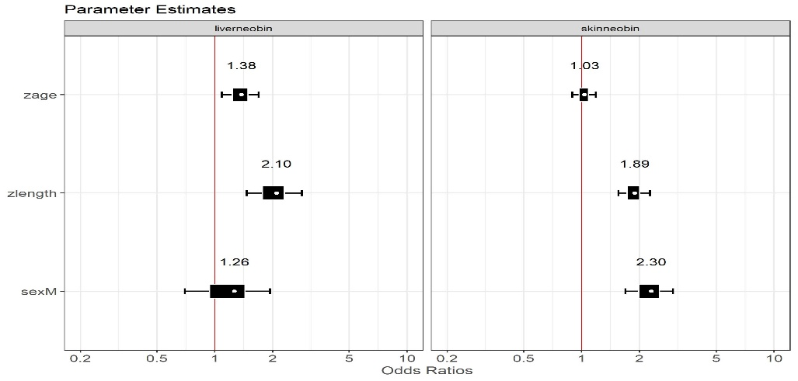
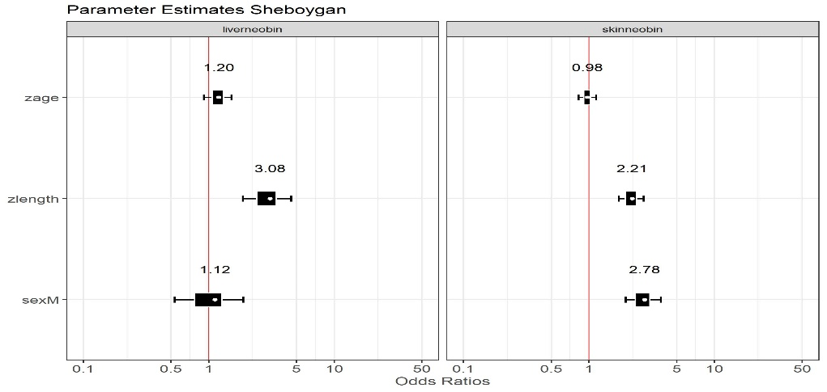
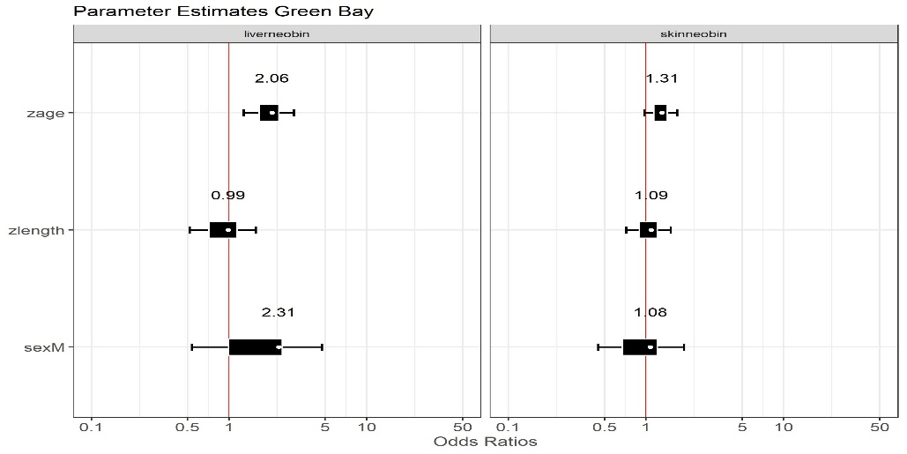
A
B.
C.
Supplemental Figure 2. Posterior mean and 95% credible intervals for site-level random effects (A) and year-level random effects (B) from Bayesian logistic regression models of neoplasia presence in skin (left panels) and liver (right panels). Random effects are plotted on the log-odds scale and represent the deviation of each group (site or year) from the overall model intercept, after accounting for fixed effects (e.g., sex, length, age). Points near zero suggest little deviation from the overall mean neoplasia risk, while values above or below zero indicate relatively higher or lower risk, respectively.

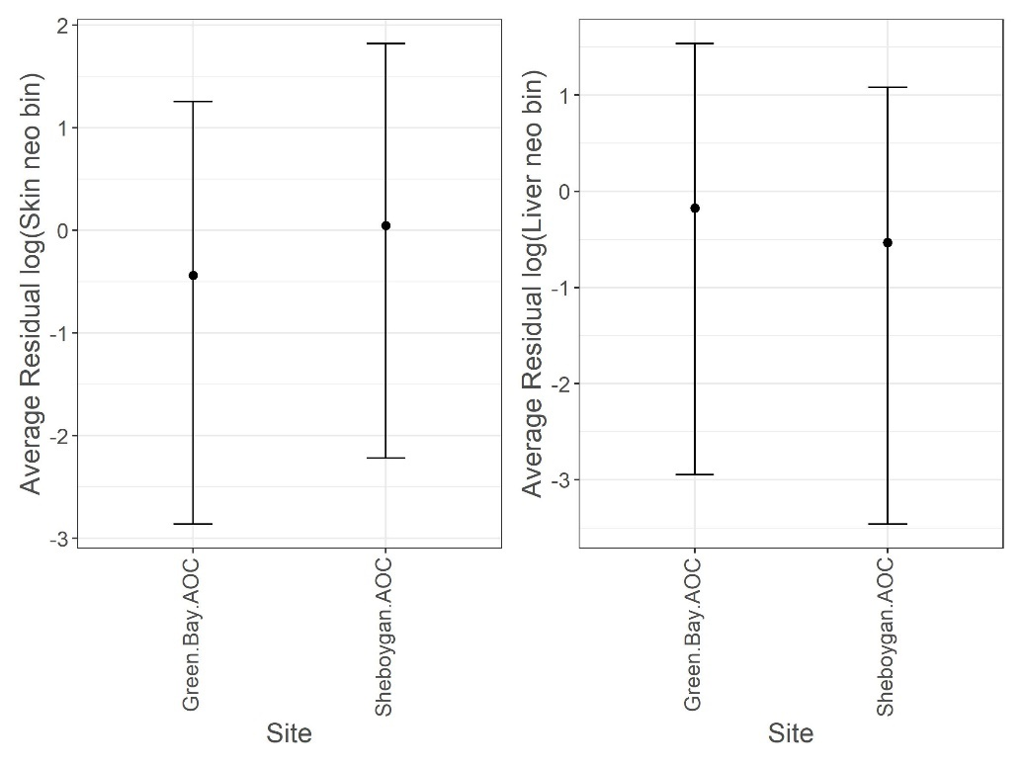
A
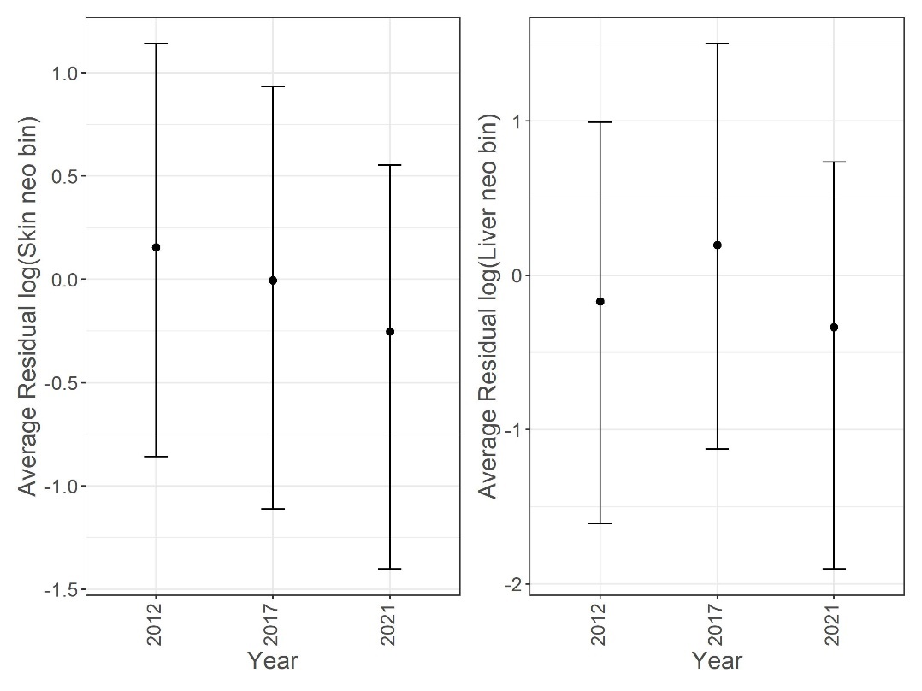
B

