Online Supplement:
How strongly is personality associated with burnout among teachers? A meta-analysis.

Table S1
Literature Search on Web of Science and PsycInfo
Database | Search term and operator |  | Search in
Web of Science |  | Preschool Teacher* OR Teacher* OR High School Teacher* OR Special Education Teacher* OR Elementary School Teacher* OR Vocational Education Teacher* OR Junior High School Teacher* OR Middle School Teacher* OR Kindergarten Teacher* OR kindergarten Teacher* OR Primary Teacher* OR Secondary Teacher* NOT College Teacher* NOT Preservice Teacher* NOT Student Teacher* | Topic
Web of Science | and | Burnout OR Occupational Stress OR Depersonali?ation OR Personal Accomplishment OR Emotional Exhaustion OR Cynicism OR Exhaustion | Topic
Web of Science | and | Big Five OR Personality OR Five Factor Personality Model OR Conscientiousness OR Neuroticism OR Agreeableness OR Extraversion OR Openness OR Emotional Stability | Topic
Web of Science | not | Qualitative Method*NEAR/1 | Topic
Web of Science | not | Arabic OR Chinese OR Japanese OR Korean OR Russian | Language
Web of Science | not | Biographical-Item OR Book Review OR Editorial Material OR Letter OR Meeting Abstract OR Review | Document Type
PsycInfo |  | exp Preschool Teachers/ or exp Teachers/ or exp High School Teachers/ or exp Special Education Teachers/ or exp Elementary School Teachers/ or exp Vocational Education Teachers/ or exp Junior High School Teachers/ or exp Middle School Teachers/ or Kindergarten Teachers.mp. or Kindergarden Teachers.mp. or Primary teacher.mp. or Secondary teacher.mp.
PsycInfo | and | Burnout.mp. or exp Occupational Stress/ or exp Depersonalization/ or Personal Accomplishment.mp. or exp Emotional Exhaustion/ or exp Cynicism/
PsycInfo | and | exp Conscientiousness/ or exp Five Factor Personality Model/ or exp Neuroticism/ or exp Agreeableness/ or exp Extraversion/ or exp Openness to Experience/ or Openness.mp. or Big Five.mp. or exp Personality/ or exp Emotional Stability/
PsycInfo | not | exp Qualitative Methods/
Note. The asterisk (*) represents any group of characters, including no character; “Topic” in the searches on Web of Science summarizes the search in titles, abstracts, and keywords; exp = expands the results of terms entered and includes more specific related topics.

Figure S1
Funnel plots for burnout dimensions and personality traits
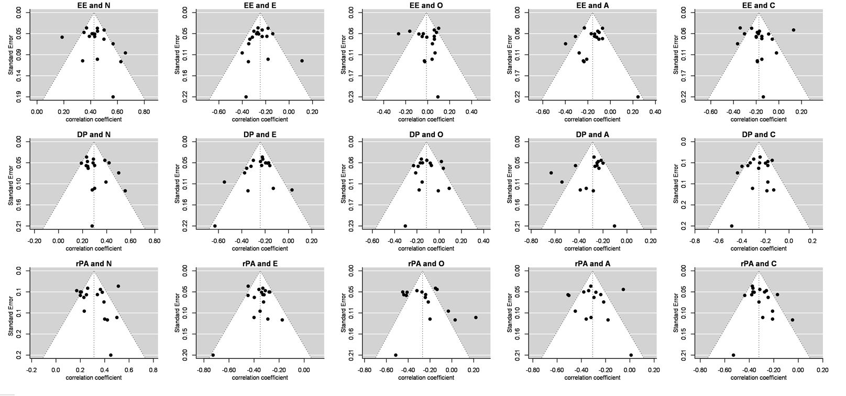
Note. EE: emotional exhaustion, DP: depersonalization, rPA: reduced personal accomplishment, N: neuroticism, E: extraversion, O: openness to experience, A: agreeableness, C: conscientiousness.

