SUPPLEMENTAL MATERIAL

The impasse on gender differences in intelligence: A meta-analysis on WISC batteries

CHC AREA: g factor (full-scale IQ)
Figure S1
Forest plot of all effects aggregated by sample, for g factor/FSIQ. Error bars represent 95% CIs. Larger dots indicate higher precision (i.e., smaller standard errors). The diamond below represents the overall meta-analytic mean effect (its width represents the 95% CI).
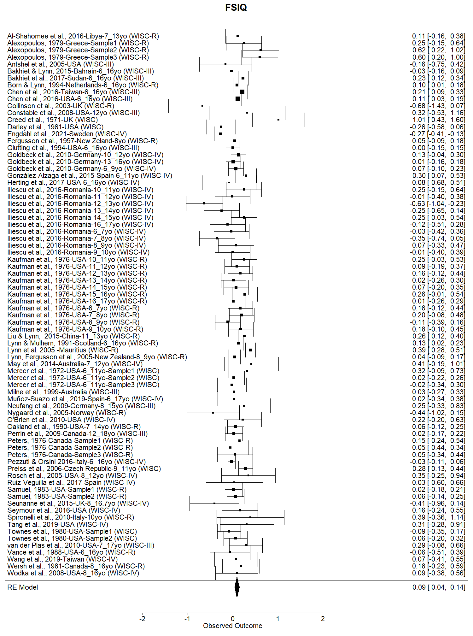

Figure S2
Funnel plot of all effects (aggregated by sample) for g factor/FSIQ, graphically clustered by study with PET-PEESE meta-regression method applied (dot with 95% CI at SE = 0 indicate the estimate bias-free effect).
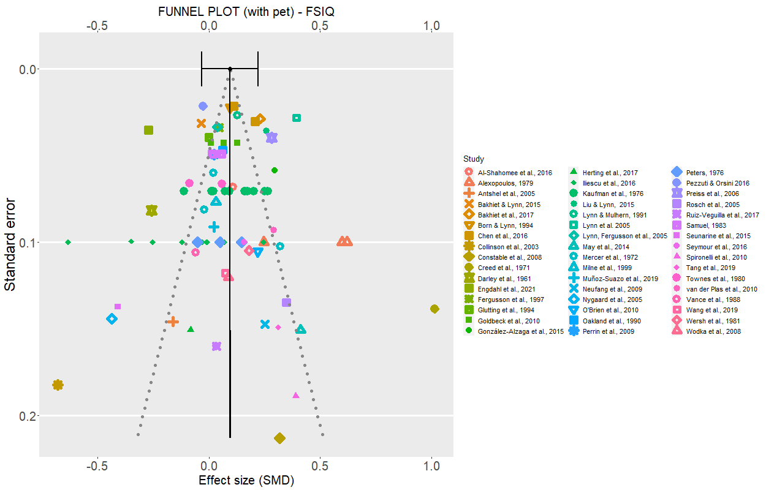

Figure S3
Leave-one-out sensitivity analysis for g factor/FSIQ. The plot shows how the estimated mean meta-analytic effect varies with each individual study being removed one at a time. Shaded area represents the variation of the 95% CI of the meta-analytic estimate.
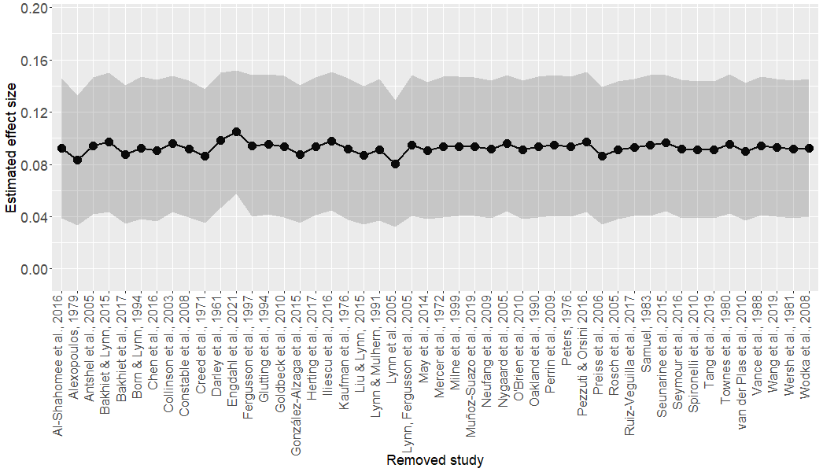

CHC AREA: fluid reasoning (gF)

Figure S4
Forest plot of all effects aggregated by sample, for fluid reasoning (gF). Error bars represent 95% CIs. Larger dots indicate higher precision (i.e., smaller standard errors). The diamond below represents the overall meta-analytic mean effect (its width represents the 95% CI).
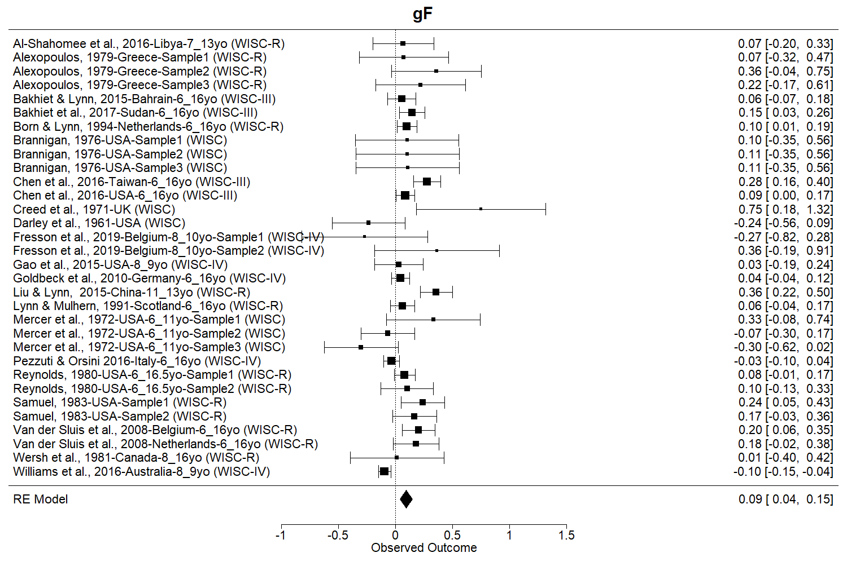

Figure S5
Funnel plot of all effects (aggregated by sample) for fluid reasoning (gF), graphically clustered by study with PET-PEESE meta-regression method applied (dot with 95% CI at SE = 0 indicate the estimate bias-free effect).
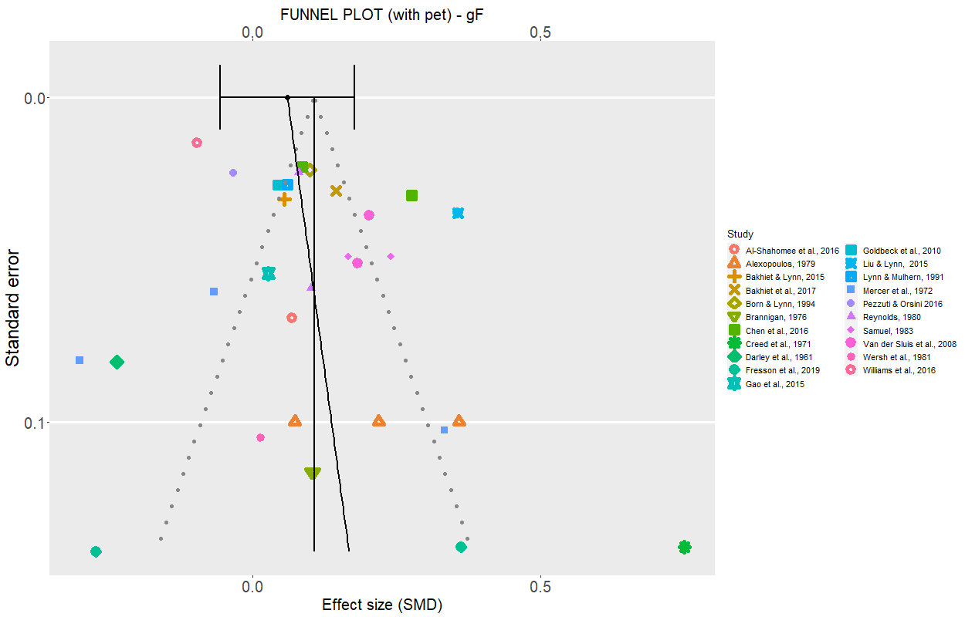

Figure S6
Leave-one-out sensitivity analysis for fluid reasoning (gF). The plot shows how the estimated mean meta-analytic effect varies with each individual study being removed one at a time. Shaded area represents the variation of the 95% CI of the meta-analytic estimate.
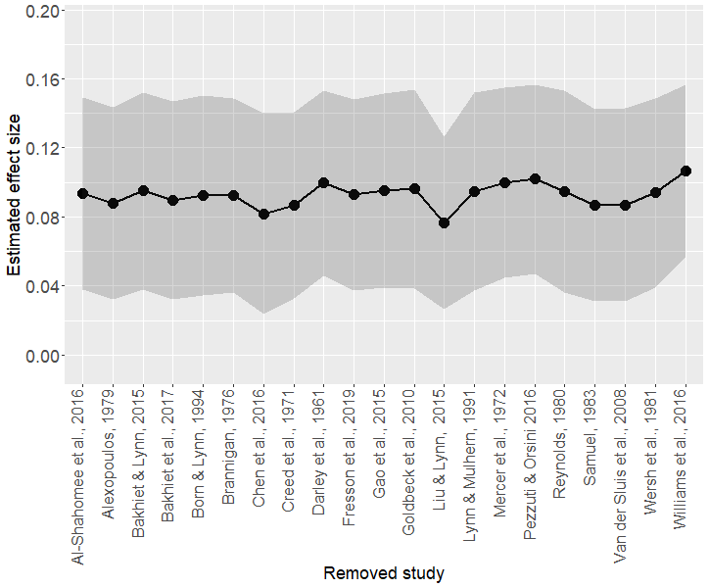

CHC AREA: visual spatial factor (gV)

Figure S7
Forest plot of all effects aggregated by sample, for visual spatial factor (gV). Error bars represent 95% CIs. Larger dots indicate higher precision (i.e., smaller standard errors). The diamond below represents the overall meta-analytic mean effect (its width represents the 95% CI).
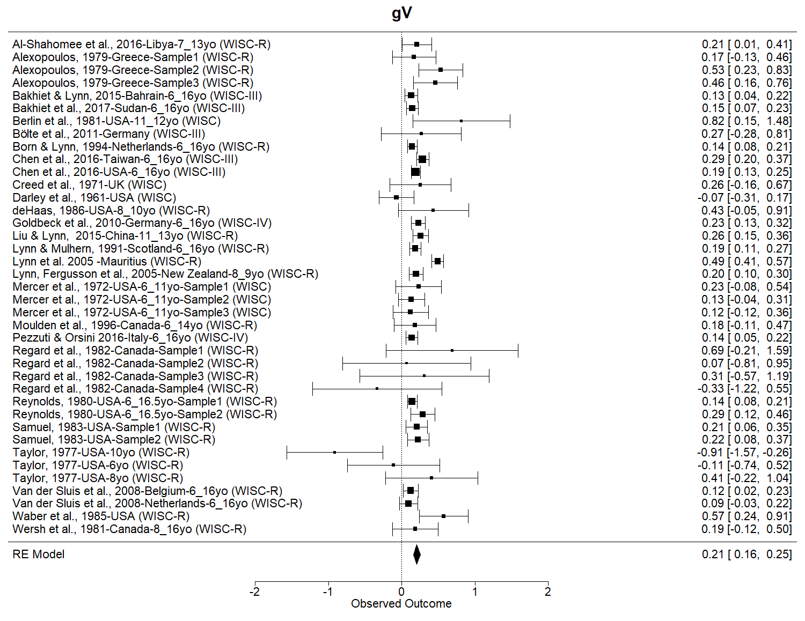

Figure S8
Funnel plot of all effects (aggregated by sample) for visual spatial factor (gV), graphically clustered by study with PET-PEESE meta-regression method applied (dot with 95% CI at SE = 0 indicate the estimate bias-free effect).
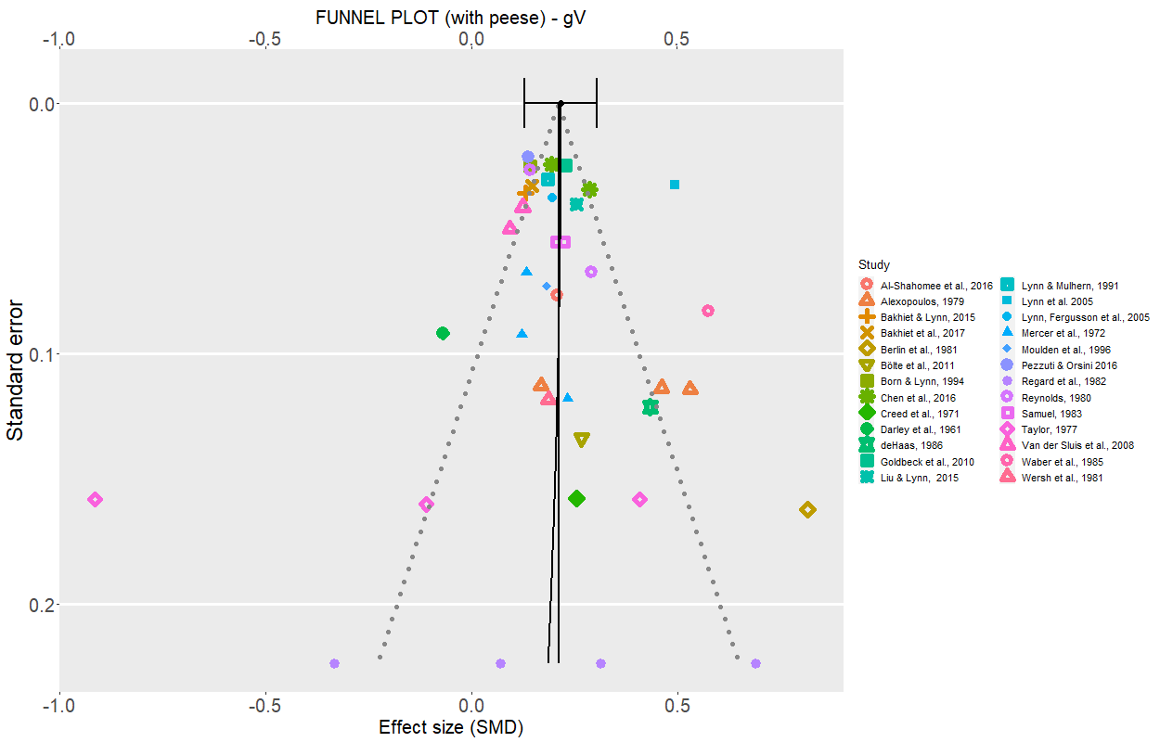

Figure S9
Leave-one-out sensitivity analysis for visual spatial factor (gV). The plot shows how the estimated mean meta-analytic effect varies with each individual study being removed one at a time. Shaded area represents the variation of the 95% CI of the meta-analytic estimate.
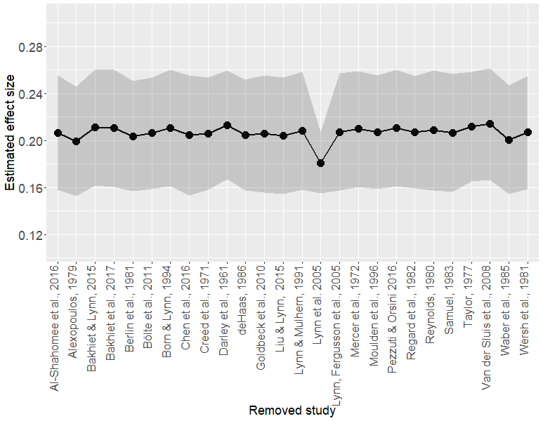

CHC AREA: crystallized intelligence (gC)

Figure S10
Forest plot of all effects aggregated by sample, for crystallized intelligence (gC). Error bars represent 95% CIs. Larger dots indicate higher precision (i.e., smaller standard errors). The diamond below represents the overall meta-analytic mean effect (its width represents the 95% CI).
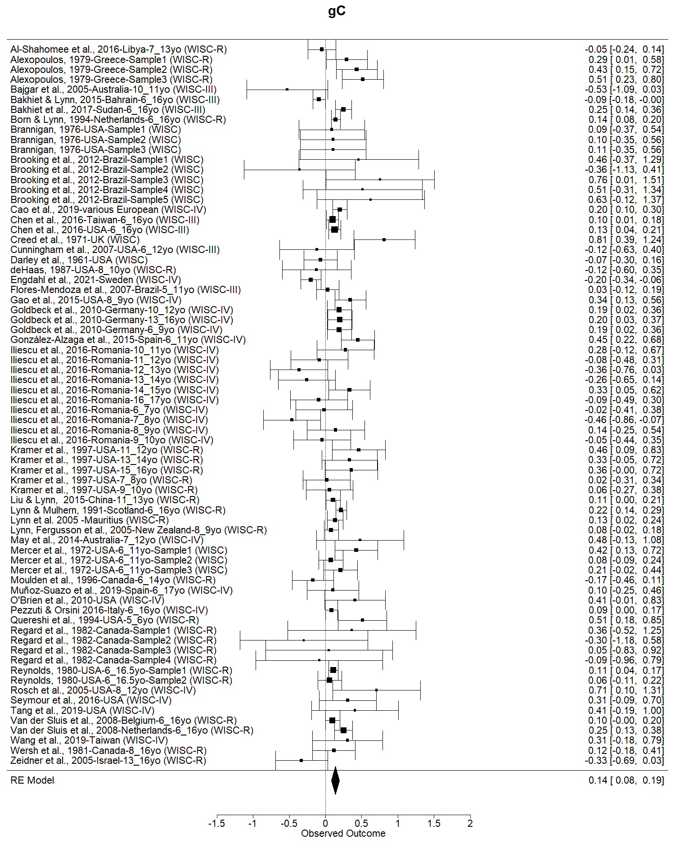

Figure S11
Funnel plot of all effects (aggregated by sample) for crystallized intelligence (gC), graphically clustered by study with PET-PEESE meta-regression method applied (dot with 95% CI at SE = 0 indicate the estimate bias-free effect).
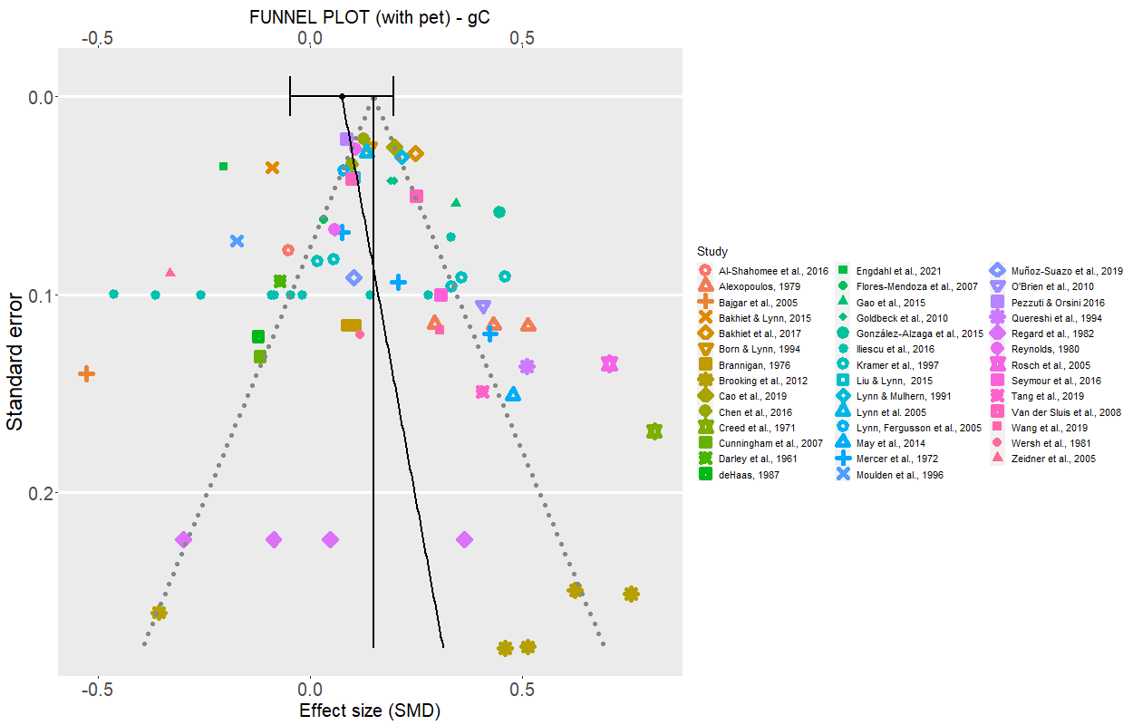

Figure S12
Leave-one-out sensitivity analysis for crystallized intelligence (gC). The plot shows how the estimated mean meta-analytic effect varies with each individual study being removed one at a time. Shaded area represents the variation of the 95% CI of the meta-analytic estimate.
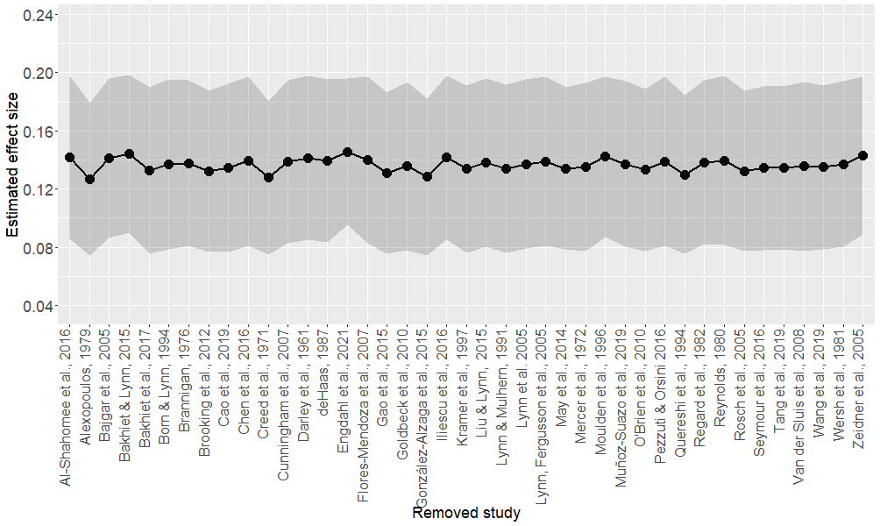

CHC AREA: short-term memory (gSM)

Figure S13
Forest plot of all effects aggregated by sample, for short-term memory (gSM). Error bars represent 95% CIs. Larger dots indicate higher precision (i.e., smaller standard errors). The diamond below represents the overall meta-analytic mean effect (its width represents the 95% CI).
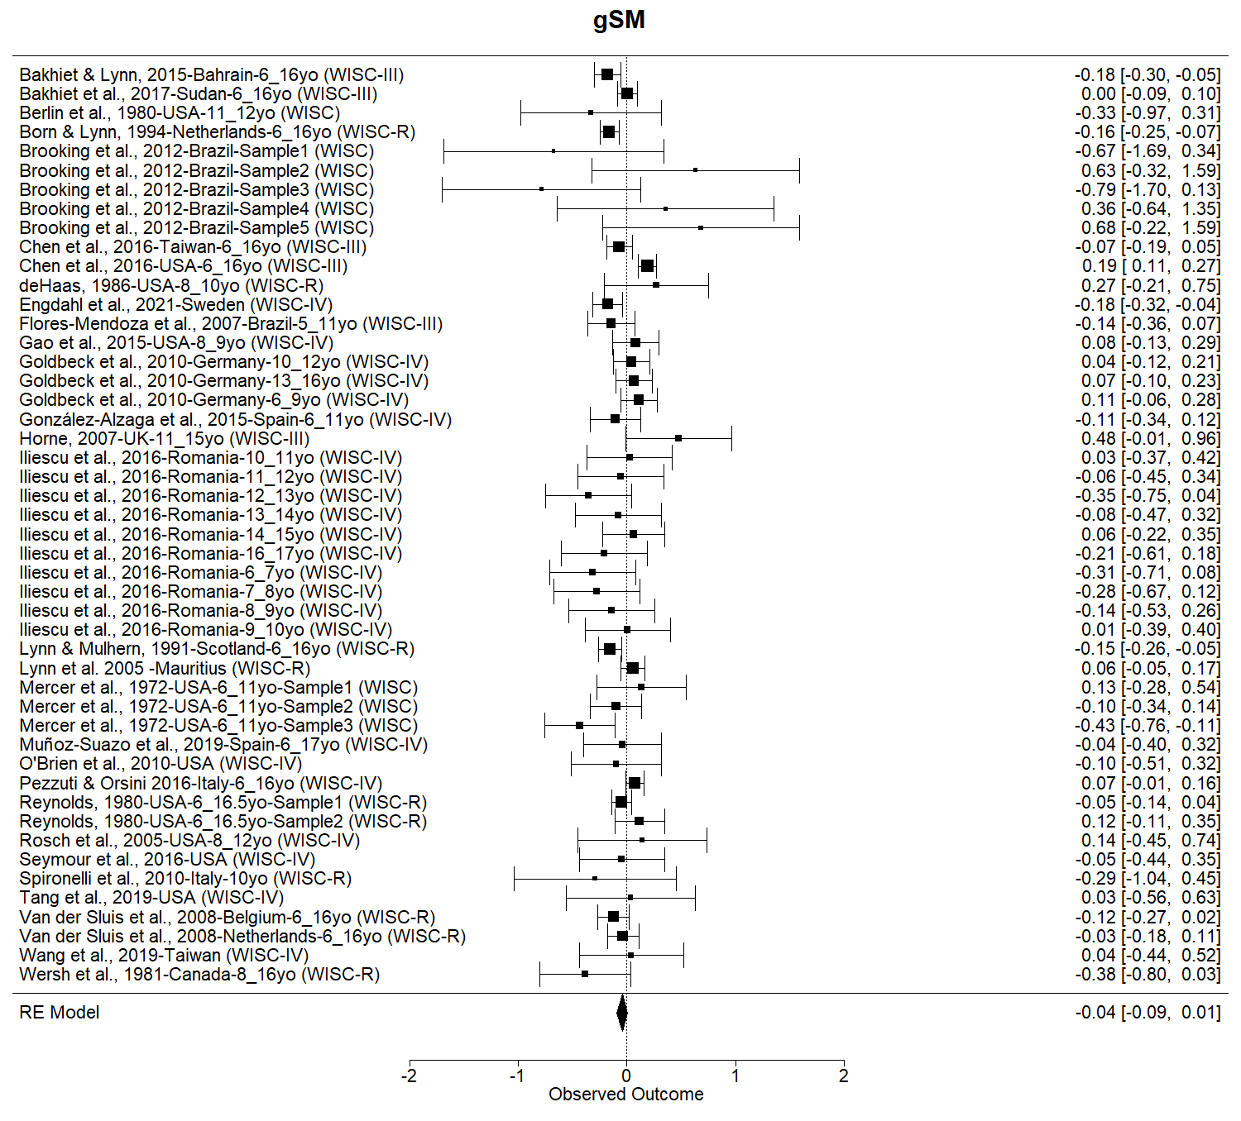

Figure S14
Funnel plot of all effects (aggregated by sample) for short-term memory (gSM), graphically clustered by study with PET-PEESE meta-regression method applied (dot with 95% CI at SE = 0 indicate the estimate bias-free effect).
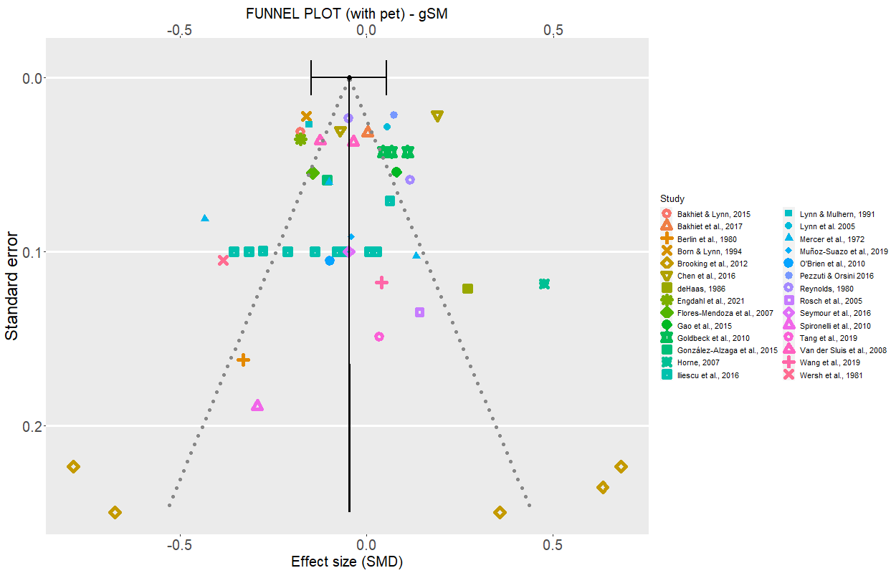

Figure S15
Leave-one-out sensitivity analysis for short-term memory (gSM). The plot shows how the estimated mean meta-analytic effect varies with each individual study being removed one at a time. Shaded area represents the variation of the 95% CI of the meta-analytic estimate.
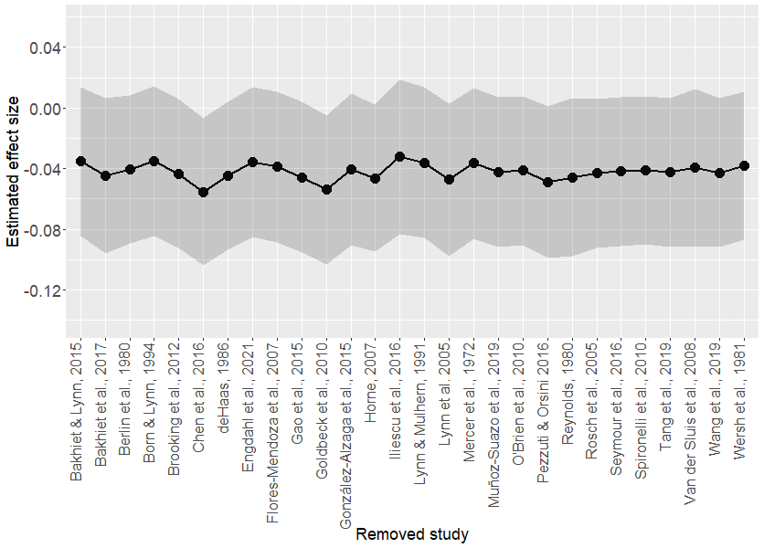

CHC AREA: speed of processing (gS)

Figure S16
Forest plot of all effects aggregated by sample, for speed of processing (gS). Error bars represent 95% CIs. Larger dots indicate higher precision (i.e., smaller standard errors). The diamond below represents the overall meta-analytic mean effect (its width represents the 95% CI).
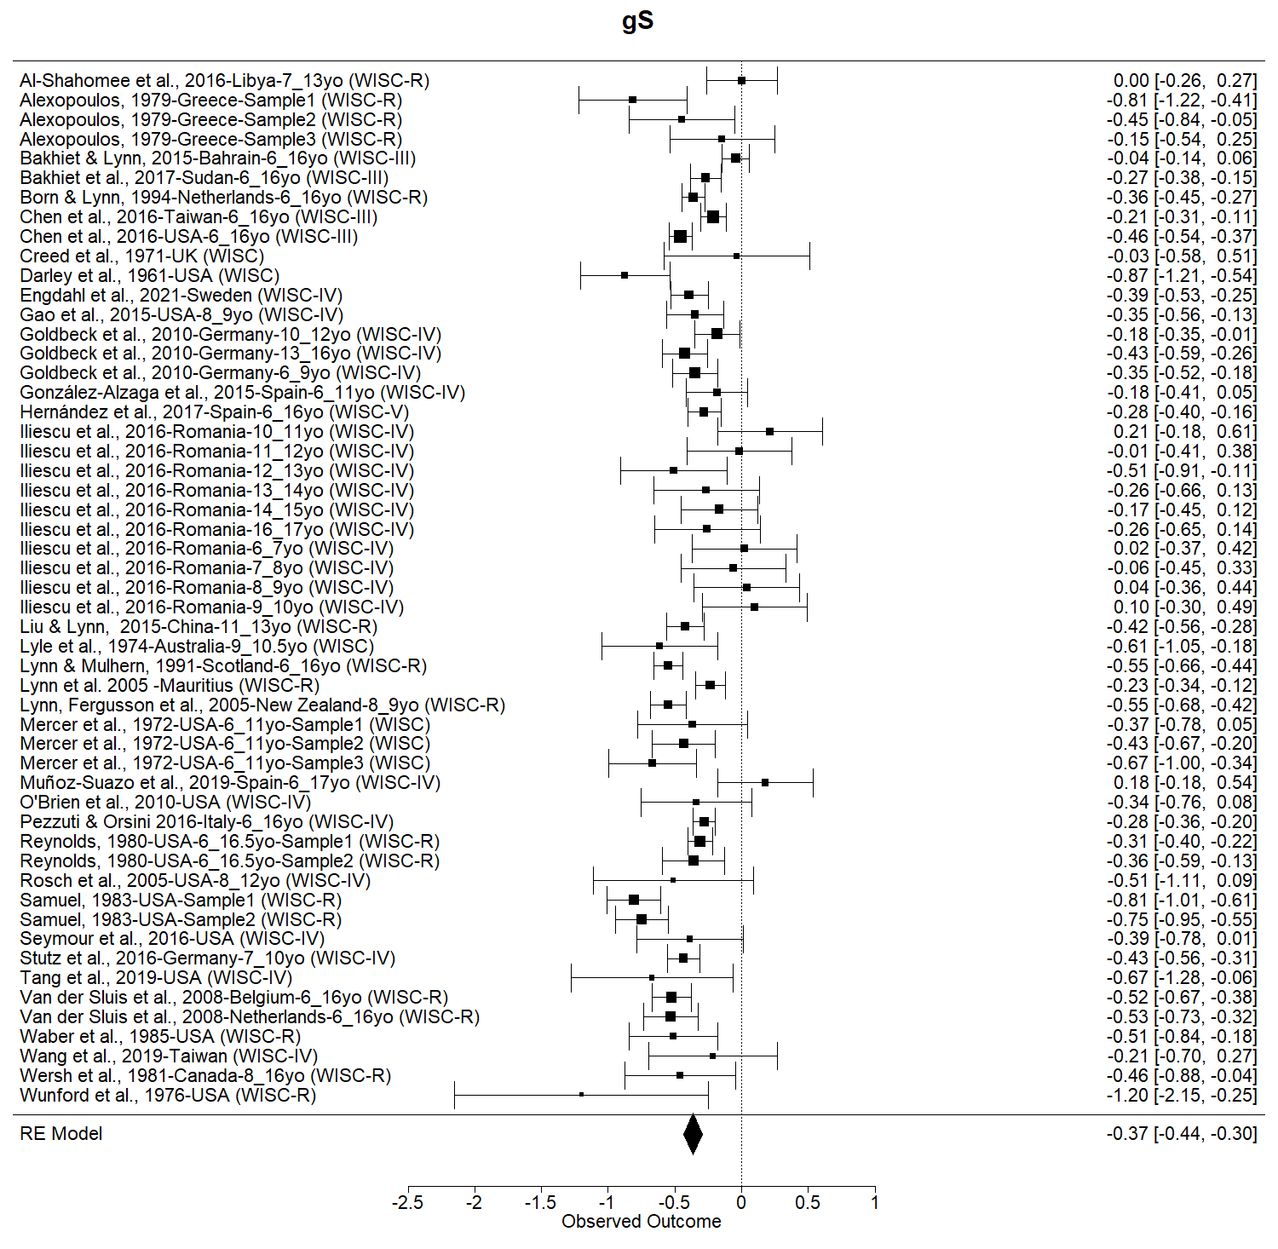

Figure S17
Funnel plot of all effects (aggregated by sample) for speed of processing (gS), graphically clustered by study with PET-PEESE meta-regression method applied (dot with 95% CI at SE = 0 indicate the estimate bias-free effect).
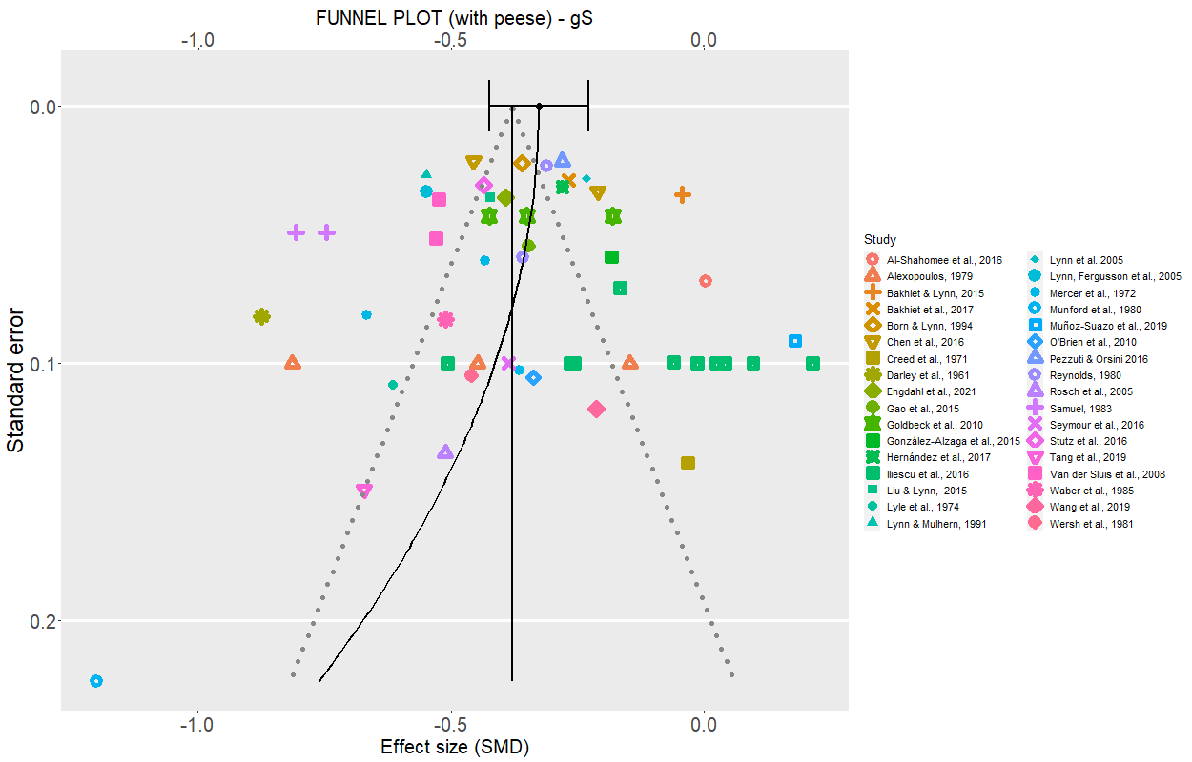

Figure S18
Leave-one-out sensitivity analysis for speed of processing (gS). The plot shows how the estimated mean meta-analytic effect varies with each individual study being removed one at a time. Shaded area represents the variation of the 95% CI of the meta-analytic estimate.
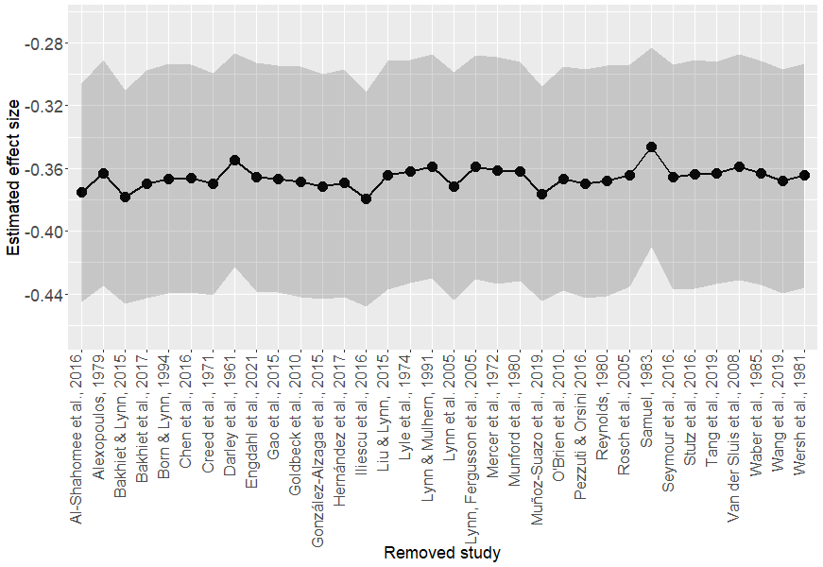

Table S1. Codebook Variable Definitions and Coding scheme (selected variables example only)

Term | Definitions
Study | Include the reference for each included study (e.g., Mercer et al., 1972).
Sample ID | Contain the reference of each study divided for sub-samples (e.g., Mercer et al., 1972 - Sample1; Mercer et al., 1972 - Sample1).
Country [Block Continent] | Include the information of the Country [and correspondent Continent] where data were collected.
Battery [Battery regrouped] | Specify the Battery edition (e.g., WISC; WISC-R; WISC-III; WISC-IV; WISC-V).  The grouping variable identifies the editions as follows:  WISC 1-2 when WISC and WISC-R;  WISC-345 when WISC-III; WISC-IV; WISC-V.
Task | Name of each sub-test of the WISC batteries. When not all sub-tests were listed, main Indexes were coded instead (e.g., Verbal IQ; Performance IQ; FISQ; VCI; PRI; WMI; PSI)
CHC | Include the correspondence with the CHC factorial model (e.g., gC; gQ; gV; gF; gS; gSM).
Male– Female [N/M/SD] | Number of participants, means and standard deviations for each sub-test or index reported were coded with reference to male and female participants.
Age Range | Age range of the overall sample was reported.

References
Alexopoulos, D. (1979) ‘Revision and standardization of the Wechsler intelligence scale for children - revised (WISC-R) for the age range 1 3 — 1 5 years in Greece.’
Al-Shahomee, A.A., Abdalla, S.E.G., &Lynn, R. (2016). Sex differences on the WISC-R in Libya. Mankind Quarterly, 57(1), pp. 91–94. doi:10.46469/mq.2016.57.1.12.
Antshel, K. M., AbdulSabur, N., Roizen, N., Fremont, W., & Kates, W. R. (2005). Sex differences in cognitive functioning in velocardiofacial syndrome (VCFS). Developmental Neuropsychology, 28(3), 849–869. https://doi.org/10.1207/s15326942dn2803_6.
Bajgar, J., Ciarrochi, J., Lane, R., & Deane, F. P. (2005). Development of the Levels of Emotional Awareness Scale for Children (LEAS-C). British Journal of Developmental Psychology, 23(4), 569–586. https://doi.org/10.1348/026151005X35417
Bakhiet, S. F., Albursan, I. S., Al Qudah, M. F., Abduljabbar, A. S., Aljomaa, S. S., Toto, H. S. A., & Lynn, R. (2017). Sex differences on the WISC-III among children in Sudan and the United States. Journal of Biosocial Science, 49(6), 792–797. https://doi.org/10.1017/S0021932016000432
Bakhiet, S. F. A., & Lynn, R. (2015). Sex differences on the Wechsler intelligence scale for children-III in Bahrain and the United States. Psychological Reports, 117(3), 794–798. https://doi.org/10.2466/03.17.PR0.117c26z9
Berlin, D. F., & Languis, M. L. (1980). Age and sex differences in measures of brain lateralization. Perceptual and Motor Skills, 50(3), 959–967. https://doi.org/10.2466/pms.1980.50.3.959
Berlin, D.F. & Languis, M.L. (1981). Hemispheric correlates of the rod-and-frame test field dependence / independence was originally conceived by H. A. Witkin and his associates (1962) as a measure of spatial perception. The current definition of field dependence / independence has, (1974), pp. 35–41.
Bölte, S., Duketis, E., Poustka, F., & Holtmann, M. (2011). Sex differences in cognitive domains and their clinical correlates in higher-functioning autism spectrum disorders. Autism, 15(4), 497–511. https://doi.org/10.1177/1362361310391116
Born, M. P., & Lynn, R. (1994). Sex Differences on the Dutch WISC-R: A comparison with the USA and Scotland. Educational Psychology, 14(2), 249–254. https://doi.org/10.1080/0144341940140208
Brannigan, G. G. (1976). Children’s social desirability response tendencies and Wechsler comprehension and picture arrangement performance. Psychological Reports, 38(3_suppl), 1194–1194. https://doi.org/10.2466/pr0.1976.38.3c.1194
Brooking, L., Uehara, E., Charchat-Fichman, H., & Landeira-Fernandez, J. (2012). Memory performance in Brazilian school-age children. Psychology and Neuroscience, 5(2), 165–173. https://doi.org/10.3922/j.psns.2012.2.06
Cao, Z., Bennett, M., Orr, C., Icke, I., Banaschewski, T., Barker, G. J., Bokde, A. L. W., Bromberg, U., Büchel, C., Quinlan, E. B., Desrivières, S., Flor, H., Frouin, V., Garavan, H., Gowland, P., Heinz, A., Ittermann, B., Martinot, J. L., Nees, F., … Whelan, R. (2019). Mapping adolescent reward anticipation, receipt, and prediction error during the monetary incentive delay task. Human Brain Mapping, 40(1), 262–283. https://doi.org/10.1002/hbm.24370
Chen, H.-Y., Lynn, R., & Cheng, H. (2016). Sex differences on the WISC-III in Taiwan and the United States. Mankind Quarterly, 57(1), 66–71. https://doi.org/10.46469/mq.2016.57.1.7
Collinson, S. L., Mackay, C. E., James, A. C., Quested, D. J., Phillips, T., Roberts, N., & Crow, T. J. (2003). Brain volume, asymmetry and intellectual impairment in relation to sex in early-onset schizophrenia. British Journal of Psychiatry, 183(AUG.), 114–120. https://doi.org/10.1192/bjp.183.2.114
Constable, R. T., Ment, L. R., Vohr, B. R., Kesler, S. R., Fulbright, R. K., Lacadie, C., Delancy, S., Katz, K. H., Schneider, K. C., Schafer, R. J., Makuch, R. W., & Reiss, A. R. (2008). Prematurely born children demonstrate white matter microstructural differences at 12 years of age, relative to term control subjects: An investigation of group and gender effects. Pediatrics, 121(2), 306–316. https://doi.org/10.1542/peds.2007-0414
Creed, C. D., & Robinson, W. P. (1971). Intelligence test scores in the evaluation of a “use of language-programme” for infant school children. Research in Education, 6(1), 1–11. https://doi.org/10.1177/003452377100600101
Cunningham, S. D., Thomas, P. D., & Warschausky, S. (2007). Gender differences in peer relations of children with neurodevelopmental conditions. Rehabilitation Psychology, 52(3), 331–337. https://doi.org/10.1037/0090-5550.52.3.331
Darley, F. L., & Winitz, H. (1961). Comparison of male and female kindergarten children on the WISC. Journal of Genetic Psychology, 99(1), 41–49. https://doi.org/10.1080/00221325.1961.10534389
deHaas, P. A. (1986). Attention styles and peer relationships of hyperactive and normal boys and girls. Journal of Abnormal Child Psychology, 14(3), 457–467. https://doi.org/10.1007/BF00915438
Engdahl, E., Svensson, K., Lin, P. I. D., Alavian-Ghavanini, A., Lindh, C., Rüegg, J., & Bornehag, C. G. (2021). DNA methylation at GRIN2B partially mediates the association between prenatal bisphenol F exposure and cognitive functions in 7-year-old children in the SELMA study. Environment International, 156(April). https://doi.org/10.1016/j.envint.2021.106617
Fergusson, D. M., & Horwood, L. J. (1997). Gender differences in educational achievement in a New Zealand birth cohort. New Zealand Journal of Educational Studies, 32(1), 83–96.
Flores-Mendoza, C. E., Mansur-Alves, M., Lelé, Á. J., & Bandeira, D. R. (2007). Inexistência de diferenças de sexo no fator g (inteligência geral) e nas habilidades específicas em crianças de duas capitais brasileiras. Psicologia: Reflexão e Crítica, 20(3), 499–506. https://doi.org/10.1590/s0102-79722007000300018
Fresson, M., Meulemans, T., Dardenne, B., & Geurten, M. (2019). Overdiagnosis of ADHD in boys: Stereotype impact on neuropsychological assessment. Applied Neuropsychology: Child, 8(3), 231–245. https://doi.org/10.1080/21622965.2018.1430576
Gao, Y., Borlam, D., & Zhang, W. (2015). The association between heart rate reactivity and fluid intelligence in children. Biological Psychology, 107, 69–75. https://doi.org/10.1016/j.biopsycho.2015.03.006
Ghaffari, J., Abbaskhanian, A., Jalili, M., & Yazdani Charati, J. (2014). IQ score of children with persistent or perennial allergic rhinitis: A comparison with healthy children. Iranian Journal of Child Neurology, 8(3), 44–48. https://doi.org/10.22037/ijcn.v8i3.5198
Glutting, J. J., Oakland, T., & Konold, T. R. (1994). Criterion-related bias with the guide to the assessment of test-session behavior for the WISC-III and WIAT: Possible race/ethnicity, gender, and SES effects. Journal of School Psychology, 32(4), 355–369. https://doi.org/10.1016/0022-4405(94)90033-7
Goldbeck, L., Daseking, M., Hellwig-Brida, S., Waldmann, H. C., & Petermann, F. (2010). Sex differences on the German Wechsler Intelligence Test for Children (WISC-IV). Journal of Individual Differences, 31(1), 22–28. https://doi.org/10.1027/1614-0001/a000003
González-Alzaga, B., Hernández, A. F., Rodríguez-Barranco, M., Gómez, I., Aguilar-Garduño, C., López-Flores, I., Parrón, T., & Lacasaña, M. (2015). Pre- and postnatal exposures to pesticides and neurodevelopmental effects in children living in agricultural communities from South-Eastern Spain. Environment International, 85, 229–237. https://doi.org/10.1016/j.envint.2015.09.019
Hernández, A., Aguilar, C., Paradell, È., Muñoz, M. R., Vannier, L. C., & Vallar, F. (2017). El efecto de las variables demográficas en la evaluación de la aptitud cognitiva. Psicothema, 29(4), 469–474. https://doi.org/10.7334/psicothema2017.33
Herting, M. M., Kim, R., Uban, K. A., Kan, E., Binley, A., & Sowell, E. R. (2017). Longitudinal changes in pubertal maturation and white matter microstructure. Psychoneuroendocrinology, 81, 70–79. https://doi.org/10.1016/j.psyneuen.2017.03.017
Horne, J. (2007). Gender differences in computerised and conventional educational tests. Journal of Computer Assisted Learning, 23(1), 47–55. https://doi.org/10.1111/j.1365-2729.2007.00198.x
Iliescu, D., Ilie, A., Ispas, D., Dobrean, A., & Clinciu, A. I. (2016). Sex differences in intelligence: A multi-measure approach using nationally representative samples from Romania. Intelligence, 58, 54–61. https://doi.org/10.1016/j.intell.2016.06.007
Jensen, A. R., & Reynolds, C. R. (1983). Sex differences on the WISC-R. Personality and Individual Differences, 4(2), 223–226. https://doi.org/10.1016/0191-8869(83)90029-6
Kaufman, A. S., & Doppelt, J. E. (1976). Analysis of WISC-R standardization data in terms of the stratification variables. Child Development, 47(1), 165–171. https://doi.org/10.2307/1128295.
Kramer, J. H., Kaplan, E., Delis, D. C., O’Donnell, L., & Prifitera, A. (1997). Developmental sex differences in verbal learning. Neuropsychology, 11(4), 577–584. https://doi.org/10.1037/0894-4105.11.4.577
Liu, J., & Lynn, R. (2015). Chinese sex differences in intelligence: Some new evidence. Personality and Individual Differences, 75, 90–93. https://doi.org/10.1016/j.paid.2014.11.002
Lyle, J. G., & Johnson, E. G. (1974). Analysis of WISC coding: 5. Prediction of coding performance. Perceptual and Motor Skills, 39(1), 111–114. https://doi.org/10.2466/pms.1974.39.1.111
Lynn, R., & Mulhern, G. (1991). A comparison of sex differences on the Scottish and American standardisation samples of the WISC-R. Personality and Individual Differences, 12(11), 1179–1182. https://doi.org/10.1016/0191-8869(91)90082-M
Lynn, R., Fergusson, D. M., & Horwood, L. J. (2005). Sex differences on the WISC-R in New Zealand. Personality and Individual Differences, 39(1), 103–114. https://doi.org/10.1016/j.paid.2004.12.009
Lynn, R., Raine, A., Venables, P. H., Mednick, S. A., & Irwing, P. (2005). Sex differences on the WISC-R in Mauritius. Intelligence, 33(5), 527–533. https://doi.org/10.1016/j.intell.2005.05.001
May, T., Cornish, K., & Rinehart, N. (2014). Does gender matter? A one year follow-up of autistic, attention and anxiety symptoms in high-functioning children with autism spectrum disorder. Journal of Autism and Developmental Disorders, 44(5), 1077–1086. https://doi.org/10.1007/s10803-013-1964-y
Mercer, J. R., & Smith, J. M. (1972). Subtest estimates of the WISC full scale IQ’s for children. Vital and Health Statistics. Ser. 1: Programs and Collection Procedures, 2(47), 1–42.
Milne, L. C., & Greenway, P. (1999). Do high scores on the adolescent-school problems and immaturity scales of the MMPI-A have implications for cognitive performance as measured by the WISC-III? Psychology in the Schools, 36(3), 199–203. https://doi.org/10.1002/(SICI)1520-6807(199905)36:3<199::AID-PITS3>3.0.CO;2-K
Moulden, J. A., & Persinger, M. A. (1996). Visuospatial/vocabulary differences in boys and girls and a potential age-dependent drift in vocabulary proficiency. Perceptual and Motor Skills, 84(2), 472–474. https://doi.org/10.2466/pms.1996.82.2.472
Munford, P. R., & Munoz, A. (1980). A comparison of the WISC and WISC-R on Hispanic children. Journal of Clinical Psychology, 36(2), 452–458. https://doi.org/10.1002/jclp.6120360211
Muñoz-Suazo, M. D., Navarro-Muñoz, J., Díaz-Román, A., Porcel-Gálvez, A. M., & Gil-García, E. (2019). Sex differences in neuropsychological functioning among children with attention-deficit/hyperactivity disorder. Psychiatry Research, 278(January), 289–293. https://doi.org/10.1016/j.psychres.2019.06.028
Neufang, S., Specht, K., Hausmann, M., Güntürkün, O., Herpertz-Dahlmann, B., Fink, G. R., & Konrad, K. (2009). Sex differences and the impact of steroid hormones on the developing human brain. Cerebral Cortex, 19(2), 464–473. https://doi.org/10.1093/cercor/bhn100
Nygaard, E., Moe, V., Slinning, K., & Walhovd, K. B. (2015). Longitudinal cognitive development of children born to mothers with opioid and polysubstance use. Pediatric Research, 78(3), 330–335. https://doi.org/10.1038/pr.2015.95
O’Brien, J. W., Dowell, L. R., Mostofsky, S. H., Denckla, M. B., & Mahone, E. M. (2010). Neuropsychological profile of executive function in girls with attention-deficit/hyperactivity disorder. Archives of Clinical Neuropsychology, 25(7), 656–670. https://doi.org/10.1093/arclin/acq050
Oakland, T., & Glutting, J. J. (1990). Examiner observations of children’s WISC-R test-related behaviors: Possible socioeconomic status, race, and gender effects. Psychological Assessment, 2(1), 86–90. https://doi.org/10.1037/1040-3590.2.1.86
Perrin, J. S., Leonard, G., Perron, M., Pike, G. B., Pitiot, A., Richer, L., Veillette, S., Pausova, Z., & Paus, T. (2009). Sex differences in the growth of white matter during adolescence. NeuroImage, 45(4), 1055–1066. https://doi.org/10.1016/j.neuroimage.2009.01.023
Peters, H. D. (1976). The validity of the Wechsler Intelligence Scale for children, revised. Canadian Journal of Behavioural Science, 8(4), 414–417. https://doi.org/10.1037/h0081967
Pezzuti, L., & Orsini, A. (2016). Are there sex differences in the Wechsler Intelligence Scale for Children - Forth Edition? Learning and Individual Differences, 45, 307–312. https://doi.org/10.1016/j.lindif.2015.12.024
Preiss, M., & Fráňová, L. (2006). Depressive symptoms, academic achievement, and intelligence. Studia Psychologica, 48(1), 57–67.
Quereshi, M. Y., & Seitz, R. (1994). Gender differences on the WPPSI, the WISC-R, and the WPPSI-R. Current Psychology, 13(2), 117–123. https://doi.org/10.1007/BF02686795
Rosch, K. S., & Mostofsky, S. H. (2016). Increased delay discounting on a novel real-time task among girls, but not boys, with ADHD. Journal of the International Neuropsychological Society, 22(1), 12–23. https://doi.org/10.1017/S1355617715001071
Regard, M., Strauss, E., & Knapp, P. (1982). Children’s production on verbal and non-verbal fluency tasks. Perceptual and Motor Skills, 55(3 Pt 1), 839–844. https://doi.org/10.2466/pms.1982.55.3.839
Reynolds, C. R. (1980). Differential construct validity of intelligence as popularly measured: Correlations of age with raw scores on the WISC-R for Blacks Whites, males, and females. Intelligence, 4(4), 371–379. https://doi.org/10.1016/0160-2896(80)90030-6
Ruiz-Veguilla, M., Moreno-Granados, J., Salcedo-Marin, M. D., Barrigon, M. L., Blanco-Morales, M. J., Igunza, E., Cañabate, A., Garcia, M. D., Guijarro, T., Diaz-Atienza, F., & Ferrin, M. (2017). Sex-specific cognitive abnormalities in early-onset psychosis. Revista Brasileira de Psiquiatria, 39(1), 28–35. https://doi.org/10.1590/1516-4446-2015-1807
Samuel, W. (1983). Sex differences in spatial ability reflected in performance on IQ subtests by black or white examinees. Personality and Individual Differences, 4(2), 219–221. https://doi.org/10.1016/0191-8869(83)90028-4
Seunarine, K. K., Clayden, J. D., Jentschke, S., Muñoz, M., Cooper, J. M., Chadwick, M. J., Banks, T., Vargha-Khadem, F., & Clark, C. A. (2016). Sexual dimorphism in white matter developmental trajectories using tract-based spatial statistics. Brain Connectivity, 6(1), 37–47. https://doi.org/10.1089/brain.2015.0340
Seymour, K. E., Mostofsky, S. H., & Rosch, K. S. (2016). Cognitive load differentially impacts response control in girls and boys with ADHD. Journal of Abnormal Child Psychology, 44(1), 141–154. https://doi.org/10.1007/s10802-015-9976-z
Spironelli, C., Penolazzi, B., & Angrilli, A. (2010). Gender differences in reading in school-aged children: An early ERP study. Developmental Neuropsychology, 35(4), 357–375. https://doi.org/10.1080/87565641.2010.480913
Stutz, F., Schaffner, E., & Schiefele, U. (2016). Relations among reading motivation, reading amount, and reading comprehension in the early elementary grades. Learning and Individual Differences, 45, 101–113. https://doi.org/10.1016/j.lindif.2015.11.022
Taji, W., Mandell, B., & Liu, J. (2019). China’s urban-rural childhood cognitive divide: evidence from a longitudinal cohort study after a 6-year follow up. Intelligence, 73(January), 1–7. https://doi.org/10.1016/j.intell.2019.01.002
Tang, X., Seymour, K. E., Crocetti, D., Miller, M. I., Mostofsky, S. H., & Rosch, K. S. (2019). Response control correlates of anomalous basal ganglia morphology in boys, but not girls, with attention-deficit/hyperactivity disorder. Behavioural Brain Research, 367(November 2018), 117–127. https://doi.org/10.1016/j.bbr.2019.03.036
Taylor, L. J. (1977). Sex and psychological differentiation. Psychological Reports, 41(1), 192–194. https://doi.org/10.2466/pr0.1977.41.1.192.
Townes, B. D., Trupin, E. W., Martin, D. C., & Goldstein, D. (1980). Neuropsychological correlates of academic success among elementary school children. Journal of Consulting and Clinical Psychology, 48(6), 675–684. https://doi.org/10.1037/0022-006X.48.6.675
van der Plas, E. A. A., Boes, A. D., Wemmie, J. A., Tranel, D., & Nopoulos, P. (2010). Amygdala volume correlates positively with fearfulness in normal healthy girls. Social Cognitive and Affective Neuroscience, 5(4), 424–431. https://doi.org/10.1093/scan/nsq009
van der Sluis, S., Derom, C., Thiery, E., Bartels, M., Polderman, T. J. C., Verhulst, F. C., Jacobs, N., van Gestel, S., de Geus, E. J. C., Dolan, C. V., Boomsma, D. I., & Posthuma, D. (2008). Sex differences on the WISC-R in Belgium and The Netherlands. Intelligence, 36(1), 48–67. https://doi.org/10.1016/j.intell.2007.01.003
Vance, B., Hankins, N., & Brown, W. (1988). Ethnic and sex differences on the test of Nonverbal intelligence, quick test of intelligence, and Wechsler intelligence scale for children-revised. Journal of Clinical Psychology, 44(2), 261–265. https://doi.org/10.1002/1097-4679(198803)44:2<261::AID-JCLP2270440228>3.0.CO;2-4
Waber, D. P., Mann, M. B., Merola, J., & Moylan, P. M. (1985). Physical Maturation Rate and Cognitive Performance in Early Adolescence. A Longitudinal Examination. Developmental Psychology, 21(4), 666–681. https://doi.org/10.1037/0012-1649.21.4.666
Wang, L.-J., Lee, S.-Y., Chou, M.-C., Lee, M.-J., & Chou, W.-J. (2019). Dehydroepiandrosterone sulfate, free testosterone, and sex hormone-binding globulin on susceptibility to attention-deficit/hyperactivity disorder. Psychoneuroendocrinology, 103(January), 212–218. https://doi.org/10.1016/j.psyneuen.2019.01.025
Wersh, J., & Briere, J. (1981). WISC-R subtest variability in normal Canadian children and its relationship to sex, age, and IQ. Canadian Journal of Behavioural Science, 13(1), 76–86. https://doi.org/10.1037/h0081112
Wilbourn, M. P., Gottfried, A. W., & Kee, D. W. (2011). Consistency of hand-preference across the early years: long-term relationship to verbal intelligence and reading achievement in girls. Developmental Psychology, 47(4), 931–942. https://doi.org/10.1037/a0023834
Williams, K. E., White, S. L. J., & MacDonald, A. (2016). Early mathematics achievement of boys and girls: Do differences in early self-regulation pathways explain later achievement? Learning and Individual Differences, 51, 199–209. https://doi.org/10.1016/j.lindif.2016.09.006
Wodka, E. L., Loftis, C., Mostofsky, S. H., Prahme, C., Larson, J. C. G., Denckla, M. B., & Mahone, E. M. (2008). Prediction of ADHD in boys and girls using the D-KEFS. Archives of Clinical Neuropsychology, 23(3), 283–293. https://doi.org/10.1016/j.acn.2007.12.004
Zeidner, M., Shani-Zinovich, I., Matthews, G., & Roberts, R. D. (2005). Assessing emotional intelligence in gifted and non-gifted high school students: Outcomes depend on the measure. Intelligence, 33(4), 369–391. https://doi.org/10.1016/j.intell.2005.03.001

