Supplementary Material
Beames et al., 2023, Educational Psychology Review

Appendix A: Search Strategy Example

PsycINFO:
((((MJMAINSUBJECT.EXACT.EXPLODE("Teachers"))) OR noft(school teacher*) OR noft(teacher*) OR noft(teacher trainee) OR noft(pre-service teacher*) OR noft(educator)) AND (noft(treat*) OR noft(interven*) OR noft(program*) OR noft(train*) OR (noft(("support group" OR "support groups"))) OR noft("professional development")) AND ((MAINSUBJECT.EXACT("Mental Disorders") OR MJMAINSUBJECT.EXACT("Mental Health") OR noft("mental health") OR (noft("mental disorder") OR noft("mental disorders")) OR noft(anxi*) OR noft(mood) OR noft(depress*) OR noft(trauma*) OR noft(sleep) OR noft(insomnia) OR noft(stress) OR noft(distress*) OR noft(burn?out) OR noft(exhaust*) OR noft(well-being) OR noft(wellbeing) OR noft("life satisfaction") OR noft("quality of life"))))

Appendix B: Figures
Fig S1
PRISMA Flow Diagram

Forest Plots: Randomised Controlled Trials

Fig S2
Forest Plot for Anxiety
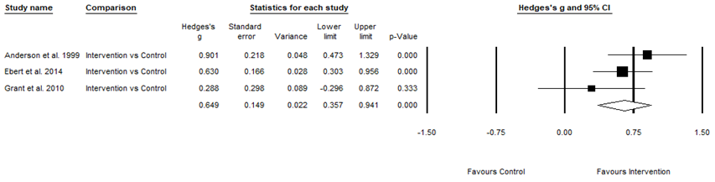

Fig S3
Forest Plot for Depression
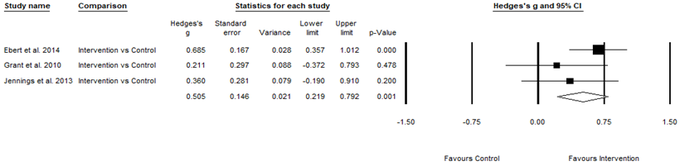

Fig S4
Forest Plot for Stress
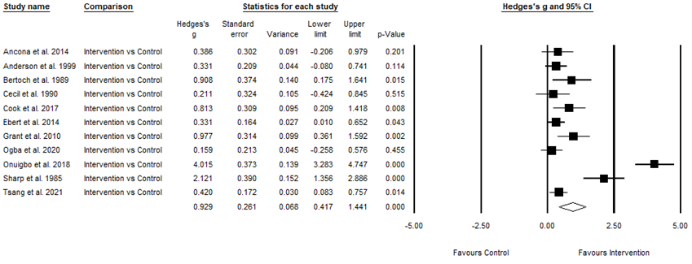

Fig S5
Forest Plot for Psychological Distress
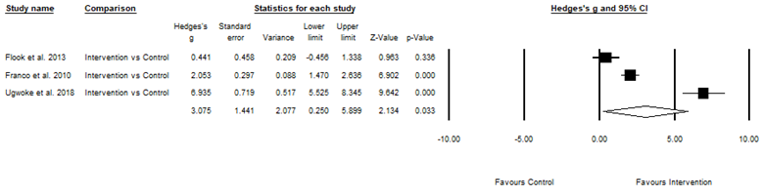

Fig S6
Forest Plot for Burnout
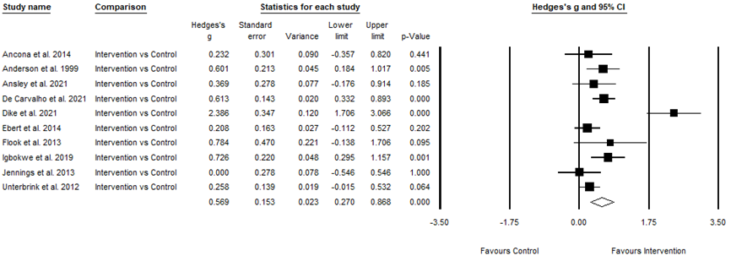

Fig S7
Forest Plot for Wellbeing
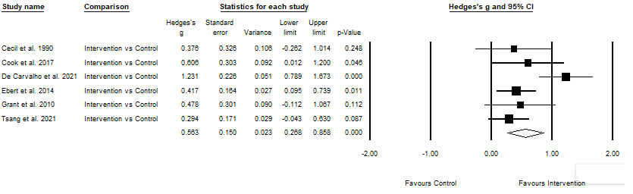

Forest Plots: Non-Randomised Controlled Trials
Fig S8
Forest Plot for Anxiety
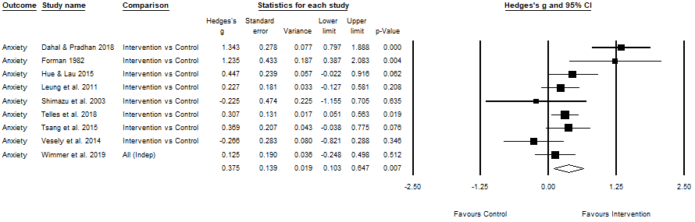

Fig S9
Forest Plot for Depression
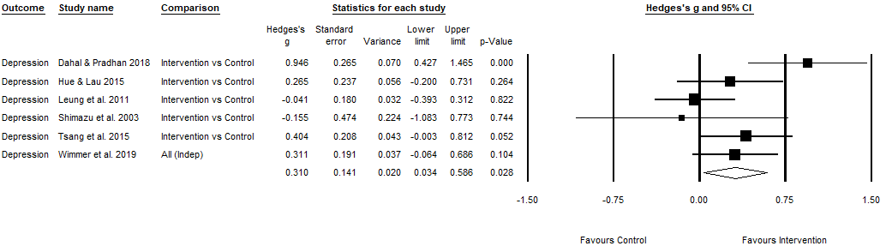

Fig S10
Forest Plot for Stress
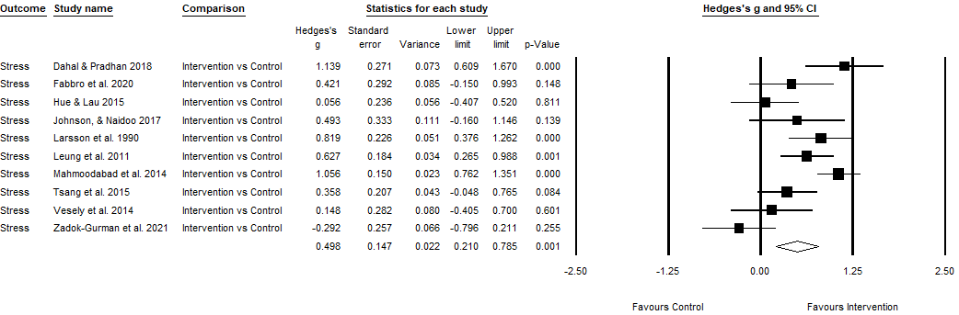

Fig S11
Forest Plot for Burnout
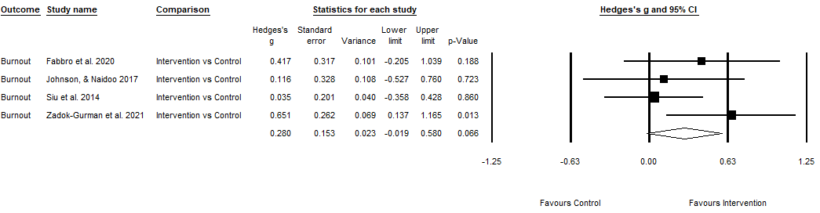

Fig S12
Forest Plot for Wellbeing
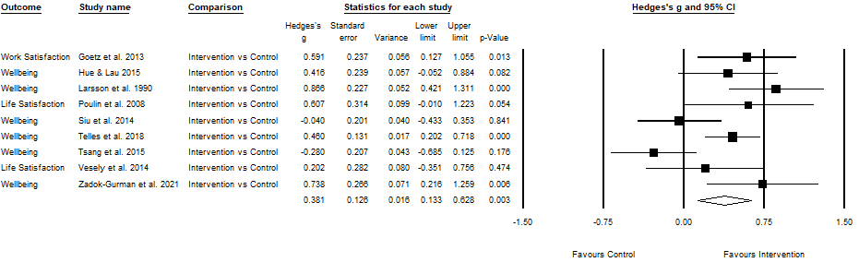

Fig S13
Forest Plot for Somatisation
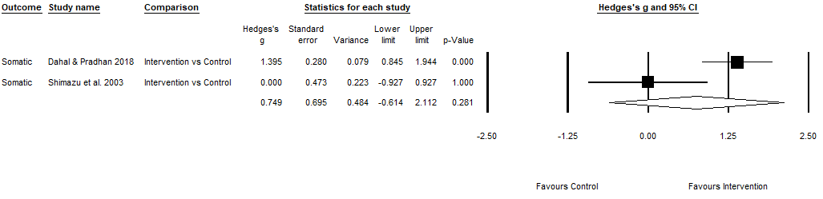

Appendix C: Tables
Table S1
Characteristics of Randomised Controlled Trials Included in the Review
Study | Country | Population | N | Mean Age | Attrition | Control/Comparison | Program | Theoretical Approach | Program Content | Program Sessions
Ancona et al. 2014* | USA | Elementary & Middle teachers | 47 | NR | 16.00 | NI | Holistic Life Foundation Yoga & Mindfulness Curriculum | Mindfulness and/or relaxation | Yoga & Mindfulness practices to train awareness and attention, including breathing, visualisation, yoga postures, guided mindful reflection | 3-weeks, six 45-min sessions
Anderson et al. 1999* | USA | Elementary, Middle, & Secondary teachers (incl Special Education) | 91 | NR | 0.00 | WL | Standardised Meditation Program | Mindfulness and/or relaxation | Simple mantra meditation, including progressive muscle relaxation, breathing practice, discussion of experiences | 5-weeks, five 1.5-hr sessions delivered weekly plus 1-hr booster session 1-month later
Ansley et al. 2021* | USA | Pre-service,  Elementary, & Secondary teachers | 59 | NR | 6.90 | NI | Online Stress Intervention | Stress management skills | Online stress program including response activation and cognitive restructuring, self-care, mindfulness, relaxation, relationships at work, routines and stress, de-escalation | 4-weeks, eight 30-min sessions delivered twice per week
Au et al. 2016 | Hong Kong | Elementary Secondary, & Special Education teachers | 60 | NR | 13.33 | Comparison | Stress Management Program | Cognitive-behavioural skills | Cognitive-behavioural principles including psychoeducation, identification of work stress, cognitive restructuring | 8-weeks, eight 90-min sessions delivered weekly
Benn et al. 2012ª | USA | Special Education teachers & parents | 70 | 45.30 | 34.29 | WL | SMART-in-Education Program | Stress management skills | Stress management and relaxation techniques, based on MBSR plus emotion regulation, forgiveness, kindness, and compassion | 12-weeks, eight 3-hr sessions
Berger et al. 2016ª | NZ | Secondary teachers, counsellors, administrators, & psychologists | 69 | 44.57 | 2.86 | Comparison | ERASE-Stress New Zealand Program | Other | Coping skills and resilience strategies to deal with traumatic stress, including psychoeducation, mindfulness, body-oriented exercises, art-therapy, narrative techniques | 3 full day workshops
Bertoch et al. 1989* | USA | Middle and Secondary teachers | 30 | 38.10 | NR | NI | Stress Management Program | Stress management skills | Psychoeducation, assertiveness training, relaxation and breathing strategies, meditation, self-care | Twelve 2-hr sessions
Biglan et al. 2013ª | USA | Pre-school teachers, assistants, & affiliated family consultants | 28 | NR | 0.00 | WL | ACT Workshops | ACT | Sleep education, including physiological & behavioural characteristics, mechanisms of regulation, sleep hygiene | 8-weeks, four 4-hr sessions delivered fortnightly
Castillo-Gualda et al. 2017ª | Spain | Early Childhood, Elementary & Secondary teachers, managers | 54 | 35.98 | 0.00 | NI | RULER Program | Socio-emotional, relationship and/or interpersonal skills | Socio-emotional learning program focused on emotional intelligence skills | 12-weeks, eight 3-hr sessions
Cecil et al. 1990^{*,b} | USA | Elementary & Middle teachers | 54 | NR | NR | NI | Stress Inoculation Training | Cognitive-behavioural skills | Cognitive-behavioural principles, including psychoeducation, relaxation training, cognitive restructuring | 6-weeks, six 90-min sessions delivered weekly
Chan 2013 | Hong Kong | Teachers (type not specified) | 81 | 33.73 | 2.44 | Comparison | Gratitude Intervention | Other | “Count-your-blessings” activity, involving keeping weekly logs of good things or events | 8-weeks
Cheek et al. 2003 | USA | Elementary teachers | 51 | NR | NR | Comparison | Stress Inoculation training | Cognitive-behavioural skills | Cognitive-behavioural principles, including psychoeducation, relaxation training, cognitive restructuring | 6-weeks
Cook et al. 2017* | USA | Middle & Secondary teachers | 44 | NR | NR | AC | ACHIEVER Resilience Curriculum | Other | Wellbeing promoting intervention based on positive psychology, cognitive-behavioural principles, and ACT | 5-weeks, five 2.5-hr sessions delivered weekly
Cooley et al. 1996^{a, b} | USA | Elementary, Secondary, & Middle Special Education teachers & related services providers | 37 | NR | NR | WL | Stress Management Workshops | Cognitive-behavioural skills | Cognitive-behavioural principles to develop situational, physiological, & cognitive coping skills | 5-weeks, five 2-hr workshops delivered weekly
De Carvalho et al. 2021* | Portugal | Elementary teachers | 228 | 43.67 | 8.95 | WL | Mindfulness-Based Program | Mindfulness and/or relaxation | Mindfulness-based program that aims to promote teache’s' social-emotional competencies. Three components: mindfulness practices to reduce stress, emotional self-regulation, and caring practices | 10-weeks, ten 2.5-hour sessions delivered weekly
Dike et al. 2021* | Nigeria | Special Education teachers | 58 | 31.95 | 0.00 | WL | Y-CBT Program | Cognitive-behavioural skills | CBT strategies were blended with after-session Yoga exercises. Based on ABCDE group therapeutic modelIncl | 12-weeks, twelve 2-hour sessions delivered weekly
Ebert et al. 2014* | Germany | Teachers (type not specified) | 150 | 47.10 | 18.67 | WL | Internet-Based Problem-Solving Training | Cognitive-behavioural skills | Cognitive-behavioural principles, including problem-solving, behavioural activation, coping with rumination | 5 weeks, one self-guided lesson weekly
Figl-Hertlein et al. 2014 | Austria | Secondary teachers | 151 | NR | 39.53 | Comparison | Individualised Physiotherapy Directed Occupational Health Program (tailored for teachers) | Stress management skills | Ergonomic and stress management training, including psychoeducation, relaxation strategies, rest and sleep patterns, behavioural activation, body awareness | 5-months, six 30-min sessions
Flook et al. 2013* | USA | Elementary teachers | 18 | 43.06 | NR | WL | Modified MBSR (adapted for teachers) | Mindfulness and/or relaxation | Psychoeducation and practices including body scan, sitting meditation, walking meditation, loving-kindness meditation, choiceless awareness, yoga | 8-weeks, eight 2.5-hr sessions + 1 day mindfulness immersion
Franco et al. 2010* | Spain | Secondary teachers | 68 | 40.20 | NR | AC | Flow Meditation Program | Mindfulness and/or relaxation | Based on ACT, including learning and practicing flow meditation, allowing and accepting thoughts, sensations and feelings, body-scan, metaphors, mindfulness (breathing) | 10-weeks, ten 90-min sessions
Grant et al. 2010* | Australia | Secondary teachers | 44 | 43.21 | NR | WL | Developmental Coaching | Cognitive-behavioural skills | Cognitive-behavioural solution-focused approach to coaching on goal attainment, stress, and workplace wellbeing and resilience | 20-weeks, ten sessions delivered every 1-2 weeks
Harris et al. 2016ª | USA | Middle teachers & other support staff | 64 | 43.00 | 0.00 | WL | CALM Program for Educators | Mindfulness and/or relaxation | Yoga and mindfulness practices to promote social-emotional competences, stress management, and wellbeing | 16-weeks, sixty-four 20-min sessions delivered 4 days per week
Hwang et al. 2019ª | Australia | Elementary, Secondary, & Special Education teachers (including non-teaching roles) | 185 | 43.02 | 35.29 | NI | Reconnected | Mindfulness and/or relaxation | MBI, including range of experiential, physical and everyday exercises e.g., mindful yoga, walking, eating and breathing | 8-weeks, eight 90-min sessions
Igbokwe et al. 2019* | Nigeria | Pre-service teachers | 96 | 20.72 | 4.17 | NI + Whatsapp group | REBT | REBT | Cognitive, behavioural, and emotive techniques to consciously change irrational thoughts and beliefs, including reframing, distraction, acceptance, rewards | 10-weeks, ten 80-min sessions delivered twice per week
Jeffcoat et al. 2012ª | USA | Early Education, Elementary, & Secondary teachers, administrators, counsellors, & other staff | 236 | NR | 24.79 | WL | ACT self-help book | ACT | Reading self-help book, Get out of your mind and into your life, plus quizzes | 8-weeks, self-guided
Jennings et al. 2011 | USA | Pre-service teachers | 43 | 32 | 14.29 | WL | CARE | Mindfulness and/or relaxation | Mindfulness-based professional development program, including emotion skills instruction, mindful awareness, stress reduction practices, caring and listening practices | 6-weeks, four day-long sessions over with intersession phone coaching
Jennings et al. 2013* | USA | Early Education, Elementary, Middle, & Secondary teachers | 53 | 36 | 7.41 | WL | CARE | Mindfulness and/or relaxation | Mindfulness-based professional development program, including emotion skills instruction, mindful awareness, stress reduction practices, caring and listening practices | 4-6 weeks, four day-long sessions with intersession phone coaching, plus booster session 2-months later
Jennings et al. 2017; 2019 follow up data | USA | Elementary teachers | 224 | NR | 7.00 | WL | CARE | Mindfulness and/or relaxation | Mindfulness-based professional development program, including emotion skills instruction, mindful awareness, stress reduction practices, caring and listening practices | 4-months, five 6-hr training days, plus intersession phone coaching
Kaspereen et al. 2012ª | USA | Secondary teachers, assistants, receptionists, & coaches | 54 | 40.65 | 0.00 | NI | Structured Relaxation Training customised for teachers | Mindfulness and/or relaxation | Meditation, deep breathing, relaxing music | 4-weeks, four 30-45 min sessions
Kemeny et al. 2012 | USA | Teachers (type not specified) | 82 | 41.05 | 7.32 | WL | Contemplative/ Emotion Training | Combination | Secular meditation component including concentration, mindfulness, and directive practices (empathy, compassion); emotional component, including recognising and understanding emotions | 8-weeks, eight all-day/evening sessions (42-hrs total)
Mihić et al. 2020ª | Croatia | Elementary teachers, counsellors, administrators, & cooks | 54 | 42.55 | 16.70 | WL | CARE for teachers | Mindfulness and/or relaxation | Mindfulness-based professional development program, including emotion skills instruction, mindful awareness, stress reduction practices, caring and listening practices | 3-months, five 6-hr sessions, plus booster session 1-month later
Montero-Marin et al. 2021 | England | Secondary teachers | 206 | 18.10 | 38.80 | NI | Instructor-Led Mindfulness Program | Mindfulness and/or relaxation | Introductory skills-based program using mindfulness-based cognitive for improving wellbeing. | 8 weeks, eight 1.5-hour weekly sessions
Nwabuko et al. 2019 | Nigeria | Elementary teachers | 86 | NR | NR | NI | REAEI | REBT | Cognitive-behavioural principles, including cognitive restructuring and relaxation, plus relaxation | 16-weeks, 32 2-hr sessions
Ogba et al. 2020* | Nigeria | Special Education teachers | 87 | 32.17 | 2.33 | NI | REOHC | REBT | Counselling aimed to counter irrational beliefs, with cognitive, behavioural, and emotive techniques | 12-weeks, 12 1-2 hr sessions delivered weekly
Onuigbo et al. 2018* | Nigeria | Elementary Special Education teachers | 86 | 39.38 | 0.00 | NI | REBT | REBT | Cognitive, behavioural, and emotive techniques to dispute irrational beliefs, including cognitive reframing, rational emotive imagery, relaxation, systematic desensitisation | 12-weeks, 24 90-min sessions delivered twice per week
Pozo-Rico et al. 2020 | Spain | Elementary teachers | 141 | 38.40 | NR | NI | REBT | REBT | Cognitive, behavioural, and emotive techniques to dispute irrational beliefs, including cognitive reframing, rational emotive imagery, relaxation, systematic desensitisation | 12-weeks, 24 90-min sessions delivered twice per week
Rao et al. 2017* | India | Elementary teachers | 60 | 41.50 | 0.00 | NI | MSRT | Mindfulness and/or relaxation | Mindfulness-based, yogic relaxation technique | 4-weeks, 30-min sessions each day, five times per week
Roeser et al. 2013 | Canada, USA | Elementary & Secondary teachers | 113 | 46.90 | 10.00 | WL | MT | Mindfulness and/or relaxation | Mindfulness-based, including 5 activities that increase compassion and mindfulness by directing and sustaining attention intentionally and nonjudgmentally on present-moment experiences | 8-weeks, 11 sessions delivered over 36-hours
Schloss et al. 1983 | USA | Special Education teachers & associates | 14 | 30 | NR | Comparison | Relaxation Training and Systematic Desensitisation | Stress management skills | Progressive muscle relaxation and gradual exposure to provoking events | 3-months, 32 sessions delivered three times per week
Schoeps et al. 2019ª | Spain | Early Childhood, Kindergarten, Elementary, & Secondary teachers & counsellors | 340 | 42.64 | NR | NI | Emotional Skills Training | Socio-emotional, relationship and/or interpersonal skills | Emotional abilities and skills to develop perception, expression, understanding, and management of emotions | 3-months, seven 2-hr sessions
Sharp et al. 1985*^{,b} | USA | Elementary, Middle, & Secondary teachers | 40 | NR | NR | NI | Stress Inoculation Training adapted for Teachers | Cognitive-behavioural skills | Psychoeducation, skill acquisition including relaxation and rational restructuring, and rehearsal | 4-weeks, eight 2-hr sessions, delivered twice per week
Sottimano et al. 2018^{b} | Italy | Pre-school teachers | 318 | 48.30 | 21.59 | NI | Multilevel Approach developed for pre-school teachers | Other | Three approaches including individual psychological counselling, group worksite support intervention (e.g., focusing on group dynamics, relationships with colleagues) and redefinition of work environment, space and furniture | Three 60-min counselling sessions, three 120-min worksite intervention groups, three meetings with architect to redefine workspace
Tsang et al. 2021*  (teacher subsample reported here) | Hong Kong | Elementary, & Secondary, Special Education teachers | 186 | 29.55 | 2.15 | WL | MBSR  MBCT | Mindfulness and/or relaxation | Based on core elements of MBSR, MBCT and Mindfulness | 8-weeks, eight 1.5-hour weekly sessions.
Tunnecliffe et al. 1986^{b} | Australia | Elementary teachers | 14 | NR | NR | WL | Relaxation Training | Mindfulness and/or relaxation | Stress psychoeducation and relaxation training | 5-weeks, five 1.5-2-hr sessions delivered weekly
Ugwoke et al. 2018* | Nigeria | Special Education teachers | 54 | 36.67 | 0.00 | WL | RESM | REBT | Behavioural, cognitive, and emotive techniques, including cognitive restructuring, goal-setting, relaxation, motivational interviewing, desensitisation, and imagery | 12-weeks, 20 90-min sessions
Unterbrink et al. 2021* | Germany | Secondary teachers | 337 | 46.95 | 34.50 | WL | Professional Relationships Intervention | Socio-emotional, relationship and/or interpersonal skills | Stress psychoeducation, relaxation training, authenticity and role identification, relationships, and social support | 10-months, 10 90-min sessions
Wu et al. 2006* | China | Middle teachers | 961 | 50.50 | NR | Control (type NR) | Organisational and Individual Level Stress Management | Stress management skills | Organisational-level strategies to modify/diminish sources of stress at work, including redesigning tasks or flexible working, and individual stress management skills including psychoeducation, relaxation techniques, cognitive coping skills, and work/lifestyle modification skills | Lectures presented twice per month for the first half of the year, then once per month for the remainder
Zolnierczyk-Zreda 2005* | Poland | Teachers (type not specified) | 59 | 41.80 | 3.33 | NI | Stress Management Workshop | Stress management skills | Cognitive-behavioural methods of overcoming workload (e.g., time management and priority setting skills), enhancing mastery (e.g., developing positive meaning of work), relationships (e.g., interpersonal and communication skills) | 2-days, 6-hrs per day
Note. * – Studies included in the meta-analysis; ª = includes samples other than teachers, including counsellors/psychologists, administrative staff, principals, parents, affiliated family consultants, managers, learning support etc. N, mean ages, and dropout reported in Table 1 for these studies include the whole sample; ^{b} = These studies included more than one intervention group. Only the relevant intervention was selected for inclusion in this review and meta-analysis, which is reported in Table 1 (see “Program” column). The total sample sizes reported for these studies only include the relevant intervention and the control group/s. The mean ages and dropout reported in Table 1 for these studies only include the relevant groups if they were reported. N – Total number of participants randomly allocated to groups. Mean Age – Mean age of the allocated sample at baseline, unless otherwise specified. Attrition – Number of participants lost to drop out in the intervention group only, measured after the final follow up measurement time point. Control group – NI=no intervention control, WL=wait-list control, AC=active control. Program – ACT=Acceptance and Commitment Therapy; RULER=Recognising, Understanding, Labelling, Expressing, and Regulating Emotion; Y-CBT=Yoga Complemented Cognitive Behavioural Therapy; CBT=Cognitive Behavioural Therapy; MBSR=Mindfulness-Based Stress Reduction; CALM=Community Approach to Learning Mindfully; MBI=Mindfulness-Based Intervention; REBT=Rational Emotive Behaviour Therapy; CARE=Cultivating Awareness and Resilience in Education; REAEI=Rational-Emotive Adult Education Intervention Programme; REOHC=Rational Emotive Occupational Health Coaching; MSRT=Mind Sound Resonance Technique; MT=Mindfulness Training; RESM=Rational-Emotive Stress Management. NR=information not reported.

Table S2
Summary of Effect Sizes of Randomised Controlled Trials Included in the Review
Study | Outcome Domain/s | Outcome Measure/s | Effect Size Comparison and Source | Effect Size (Hedges’s g or Cohen’s d)
Ancona et al. 2014* | Mental health (stress)  Burnout | TSI  MBI-ES-EE | Program vs NI control at post. Computed from raw data. | g=0.39  g=0.23
Anderson et al. 1999* | Mental health (stress)  Mental health (anxiety)  Burnout | TSI  STAI-S  MBI-EE | Program vs WL control at post (T2) and 9-week follow-up (T3). Computed from raw data. | T2: g=0.33; T3: g=0.90  T2: g=0.90; T3: g=1.40  T2: g=0.60; T3: g=0.76
Ansley et al. 2021* | Burnout | MBI-ES-EE | Program vs NI control at post. Computed from raw data | g=0.37
Au et al. 2016 | Mental health (stress)  Wellbeing | PSS  PWBI-A | Program vs comparison at post (T2) and 4-week follow-up (T3). Computed from raw data. | T2: g=0.52; T3: g=0.06  T2: g=0.14; T3: g=-0.23
Benn et al. 2012 | Mental health (anxiety)  Mental health (depression)  Mental health (stress)  Affect (positive)  Affect (negative) | STAI-S  CES-D  PSS  PANAS-N  PANAS-P | Program vs WL control at post (T2) and 2-month follow-up (T3). Computed from raw data | T2: g=0.44; T3: g=0.61  T2: g=0.38; T3: g=0.49  T2: g=0.33; T3: g=0.74  T2: g=0.39; T3: g=0.88  T2: g=0.03; T3: g=0.37
Berger et al. 2016ª | Mental health (post-traumatic stress)  Burnout  Resilience | PCL-C  ProQOL-burnout  CDRS | Program vs comparison at post (T2) and 8-month follow-up (T3). Computed from raw data. | T2: g=0.22; T3: g=1.22  T2: g=1.25; T3: g=0.77  T2: g=0.30; T3: g=0.43
Bertoch et al. 1989* | Mental health (stress) | OSI | Program vs NI control at post. Computed from raw data. | g=0.91
Biglan et al. 2013 | Mental Health (stress) | ITS | Relevant data not available. Cannot compute. | N/A
Castillo-Gualda et al. 2017 | Burnout | MBI-EE | Program vs NI control at post. Computed from raw data. | g=0.13
Cecil et al. 1990* | Mental health (stress)  Wellbeing (job satisfaction) | TSI-EM  JSSS-JS | Program vs NI control at post. Computed from raw data. | T2: g=0.21; T3: g=-0.12  T2: g=0.38; T3: g=-0.06
Chan 2013 | Wellbeing (life satisfaction)  Affect (positive)  Affect (negative) | SWLS  PANAS-P  PANAS-N | Program vs comparison at post. Computed from raw data. | g=0.40  g=0.33  g=0.51
Cheek et al. 2003 | Burnout | MBI-ES-EE | Program vs comparison at post. Computed from raw data. | g=0.09
Cook et al. 2017* | Mental health (stress)  Wellbeing (work satisfaction) | PSS  SWS | Program vs AC at post. Computed from raw data. | g=0.81  g=0.61
Cooley et al. 1996 | Burnout  Wellbeing (job satisfaction) | MBI-EE  MSQ-20 | Relevant data not available. Cannot compute. | N/A
De Carvalho et al. 2021* | Burnout  Wellbeing | MBI-ES-EE  MHC-SF | Program vs WL control at post. Computed from raw data. | g=0.61  g=1.23
Dike et al. 2021* | Burnout | MBI-ES-EE | Program vs WL control at post (T2) and 12-week follow-up (T2). Computed from raw data. | T2: g=2.39; T3: g=2.19
Ebert et al. 2014* | Mental health (anxiety/worry)  Mental health (depression)  Mental health (stress)  Wellbeing  Burnout | PSWQ  CES-D  PSQ  SF-12 MCS  MBI-EE | Program vs WL control at post (T2), 3-month (T3), and 6-month (T4) follow-up. Extracted from text. | T2: d=0.63; T3: d=0.62; T4: d=0.54  T2: d=0.59; T3: d=0.37; T4: d=0.38  T2: d=0.36; T3: d=0.28; T4: d=0.36  T2: d=0.40; T3: d=0.35; T4: d=0.27  T2: d=0.24; T3: d=0.54; T4: d=0.38
Figl-Hertlein et al. 2014 | Wellbeing | SF-36 MCS | Relevant data not available. Cannot compute. | N/A
Flook et al. 2013* | Mental health (distress)  Burnout | SC 90-R  MBI-ES- EE | Program vs WL control at post. Computed from raw data. | g=0.44  g=0.78
Franco et al. 2010* | Mental health (distress) | SC 90-R | Program vs AC at post. Computed from raw data. | g=2.05
Grant et al. 2010* | Mental health (anxiety)  Mental health (depression)  Mental health (stress)  Wellbeing  Resilience | DASS-A  DASS-D  DASS-S  WWBI  CHS | Program vs WL control at post. Computed from raw data. | g=0.29  g=0.21  g=0.98  g=0.48  g=0.46
Harris et al. 2016 | Mental health (stress)  Mental health (sleep)  Burnout  Affect (positive)  Affect (negative) | PSS  SRIS  MBI-ES  PANAS-P  PANAS-N | Program vs WL control at post. Computed from raw data. | g=0.19  g=0.09  g=0.08  g=0.14  g=0.06
Hwang et al. 2019 | Mental health (stress)  Mental health (sleep) | PSS  PSQI | Program vs NI control at post (T2) and 6-week (T3) follow-up. Computed from raw data. | T1: g=0.42; T2: g=0.45  T1: g=0.31; T2: g= .29
Igbokwe et al. 2019* | Burnout | OLBI-S-E | Program vs NI + whatsapp group at post (T2) and 3-month (T3) follow-up. Computed from raw data. | T1: g=0.73; T2: g= 0.73
Jeffcoat et al. 2012 | Mental health (distress) | GHQ-12 | Program vs WL control from baseline to 10-week follow-up. Extracted from text. | d=0.73
Jennings et al. 2011 | Mental health (depression)  Affect (positive)  Affect (negative) | CES-D  PANAS-P  PANAS-N | Covariance-adjusted post-program mean comparisons for program vs WL control. Extracted from text. | d=0.09  d=0.11  d=0.43
Jennings et al. 2013* | Mental health (depression)  Burnout  Affect (positive)  Affect (negative) | CES-D  MBI-ES-EE  PANAS-P  PANAS-N | Program vs WL control at post. Computed from raw data. | g=0.36  g=0.00  g=0.21  g=0.23
Jennings et al. 2017 | Mental health (anxiety)  Mental health (depression)  Mental health (stress)  Mental health (sleep)  Burnout  Affect (positive)  Affect (negative) | GAD-7  PHQ-8  PSS  PROMIS-SDQ  MBI-ES-EE  PANAS-P  PANAS-N | Relevant data not available. Cannot compute. | N/A
Jennings et al. 2019 (follow up data to 2017) | Mental health (anxiety)  Mental health (depression)  Mental health (stress)  Mental health (sleep)  Burnout  Affect (positive)  Affect (negative) | GAD-7  PHQ-8  PSS  PROMIS-SDQ  MBI-ES-EE  PANAS-P  PANAS-N | Relevant data not available. Cannot compute. | N/A
Kaspereen et al. 2012 | Mental health (stress)  Wellbeing (life satisfaction) | PSS  SWLS | Program vs NI control at post. Computed from raw scores. | g=1.20  g=0.67
Kemeny et al. 2012 | Mental health (depression)  Affect (positive)  Affect (negative) | BDI  PANAS-P  PANAS-N | Unadjusted mean comparison for program vs WL control at post (T2) and 5-month follow-up (T3). Extracted from text. PANAS effect sizes not reported in text. | T2: d=.81; T3: d=.90
Mihić et al. 2020 | Burnout | MBI-EE | Program vs WL control at post (T2) and 2-month follow-up (T3). Computed from raw scores. | T2: g=0.13; T3: g=0.38
Montero-Marin et al. 2021 | Mental health (anxiety)  Mental health (depression)  Mental health (stress)  Burnout  Wellbeing | GAD-7  PHQ-9  PSS  MBI-ES  WEMWBS | Program vs NI control at post. Computed from raw scores. | g=0.47  g=0.37  g=0.58  g=0.23  g=0.49
Nwabuko et al. 2019 | Burnout | TBI | Relevant data not available. Cannot compute. | N/A
Ogba et al. 2020* | Mental health (stress) | OSI | Program vs NI control at post (T2) and 3-month follow-up (T3). Computed from raw data. | T2: g=0.16; T3: g=0.75
Onuigbo et al. 2018* | Mental health (stress) | TSQ | Program vs NI control at post (T2) and 4-month follow-up (T3). Computed from raw data. | T2: g=4.02; T3: g=5.35
Pozo-Rico et al. 2020 | Mental health (stress)  Burnout | PSS  MBI | Relevant data not available. Cannot compute. | N/A
Rao et al. 2017* | Mental health (anxiety)  Mental health (stress)  Mental health (distress)  Mental health (sleep)  Fatigue | STAI-S  PSS  GHQ-12  PSQI  PFS | Program vs NI control at post. Computed from raw data. | g=2.70  g=4.94  g=1.07  g=2.16  g=0.76
Roeser et al. 2013 | Mental health (anxiety)  Mental health (depression)  Burnout | STAI-S  BDI  MBI | Mean comparison for program vs control at post (T2) and 3-month follow-up (T3). Extracted from text. | T2: d=-0.71; T3: d=-1.10  T2: d=-1.06; T3: d=-1.56  T2: d=-0.76; T3: d=-0.68
Schloss et al. 1983 | Mental health (anxiety) | STAI | Relevant data not available. Cannot compute. | N/A
Schoeps et al. 2019 | Mental health (anxiety)  Mental health (depression)  Mental health (stress)  Burnout  Wellbeing (life satisfaction) | DASS-A  DASS-D  DASS-S  SBI-PE  SWLS | Mean comparison for program vs control at post (T2) and 6-month follow-up (T3). Extracted from text. | T2: d=-0.09; T3; d=-0.22  T2: d=-0.17; T3; d=-0.04  T2: d=-0.06; T3; d=-0.17  T2: d=-0.43; T3; d=-0.75  T2: d=-0.52; T3; d=-0.21
Sharp et al. 1985* | Mental health (anxiety) | STAI-S | Program vs NI control at post (T2) and 1-month follow-up (T3). Computed from raw data. | T2: d=2.12; T3: d=2.18
Sottimano et al. 2018 | Burnout | SBI-PE | Relevant data not available. Cannot compute. | N/A
Tsang et al. 2021* | Mental health (stress)  Wellbeing (life satisfaction)  Affect (positive)  Affect (negative)  Insomnia | PSS  SWLS  PANAS-P  PANAS-N  ISI | Program vs WL control at post (T2) and 2-month follow-up (T3). Computed from raw data. | T2: g=0.42; T3: g=0.57  T2: g=0.29; T3: g=0.58  T2: g=0.50; T3: g=0.55  T2: g=0.44; T3: g=0.67  T2: g=0.64; T3: g=0.35
Tunnecliffe et al. 1986^{b} | Mental health (stress) | TOSQ | Relevant data not available. Cannot compute. | N/A
Ugwoke et al. 2018* | Mental health (distress)  Burnout | PED  TBS-EE | Program vs WL control at post. Computed from raw data. | g=6.94  g=9.44
Unterbrink et al. 2021* | Burnout | MBI-EE | Program vs WL control at post. Computed from raw data. | g=0.26
Wu et al. 2006* | Mental health (stress) | OSI-R-PS | Program vs control at post. Computed from raw data. | g=0.04
Zolnierczyk-Zreda 2005* | Burnout | MBI-EE | Program vs NI at post. Computed from raw data. | g=0.22
Note. * – Studies included in the meta-analysis. Control group – WL=wait-list control; NI=no intervention control (including treatment as usual); AMC=attention matched control. Outcome Measures – MBI-EE=Maslach Burnout Inventory – Emotional Exhaustion Subscale; TSI=Teacher Stress Inventory; PSS=Perceived Stress Scale; PWBI-A=Personal Well Being Index – Adult; STAI-S=State-Trait Anxiety Inventory – State Subscale; CES-D=Center for Epidemiological Studies Depression Scale; PANAS-P=Positive and Negative Affect Scale – Positive; PANAS-N=Positive and Negative Affect – Negative; SBI-PE=Spanish Burnout Inventory – Psychological Exhaustion Subscale; PCL-C=Posttraumatic Check List S, ProQOL=Professional Quality of Life Scale; CDRS=Connor-Davidson Resilience Scale; OSI=Occupational Stress Inventory; JSS=Job Satisfaction Scale; ITS=Index of Teaching Stress; TSI-EM=Teacher Stress Inventory – Emotional Manifestations; JSSS-JS=Job Stress in the School Setting – Job Satisfaction; SWLS=Satisfaction with Life Scale; SWS=Satisfaction with Work Scale; MSQ-20=Minnesota Satisfaction Questionnaire – 20 items; SF-36 MCS=Short Form 36 Health Survey – Mental Health Component Score; SF-12 MCS=Short Form 12 Health Survey – Mental Health Component Score; PSWQ=Penn State Worry Questionnaire; SC 90-R=Symptom Checklist 90-R; MBI-ES=Maslach Burnout Inventory – Educator Survey; MBI-ES-EE=Maslach Burnout Inventory – Educator Survey – Emotional Exhaustion Subscale; DASS-D=Depression Anxiety Stress Scale – Depression Subscale; DASS-A=Depression Anxiety Stress Scale – Anxiety Subscale; DASS-S=Depression Anxiety Stress Scale – Stress Subscale; WWBI=Workplace Well-Being Index; CHS=Cognitive Hardiness Scale; SRIS=Sleep-Related Impairment Scale; PSQI=Pittsburgh Sleep Quality Index; OLBI-S-E=Oldenburg Burnout Inventory for Students – Exhaustion Subscale; PHQ-8=Patient Health Questionnaire 8-item Depression Scale; GAD-7=Generalised Anxiety Disorder 7-item Scale; PROMIS-SDQ=PROMIS Sleep Disorder Questionnaire; WEMWBS=The Warwick-Edinburgh Mental Well-being Scale – 14 items; TBI=Teachers’ Burnout Inventory; OSI=Occupational Stress Index; TSQ=Teacher Stress Questionnaire; GHQ-12=General Health Questionnaire; PFS=Piper Fatigue Scale; BDI=Beck Depression Inventory; SBI-PE=Spanish Burnout Inventory – Psychological Exhaustion Subscale; TOSQ=Teacher Occupational Stress Factor Questionnaire; TBS-E=Teacher Burnout Scale – Exhaustion Subscale; PED=Profile of Emotional Distress; TBS-EE=Teacher Burnout Scale – Emotional Exhaustion; OSI-R-PS=Occupational Stress Index – Revised – Personal Strain Subscale; ISI=Insomnia Severity Index. Effect Size Comparison and Source – Hedges’s g was computed from raw data extracted from results of primary papers, otherwise Cohen’s d was extracted from primary papers when reported. Effect Size (Hedges’s g or Cohen’s d) – Positive effect sizes favour the program over the control.

Table S3
Characteristics of Non-Randomised Controlled Trials Included in the Review
Study | Country | Population | N | Mean Age | Attrition | Control/ Comparison | Program | Theoretical Approach | Program Content | Program Sessions
Berkovich-Ohana et al. 2020 | Israel | Elementary teachers | 39 | NR | 40 | Comparison | MBI | Mindfulness and/or relaxation | Applied mindful pedagogy for educators, including psychoeducation, experiential & mindful practices (e.g., body scan, monitoring experiences) | 3-months, ten sessions delivered over 30-hrs
Beshai et al. 2015ª | England | Secondary teachers & staff with direct contact with students | 108 | NR | 17.59 | WL | b. Foundations Course | Mindfulness and/or relaxation | Based on MBSR + MBCT | 8-weeks, nine 75-min sessions delivered fortnightly
Carroll et al. 2021 | Australia | Elementary & Secondary teachers | 83 | 45.28 | 7.14 | Comparison | MBSR | Mindfulness and/or relaxation | Guided progressive mindfulness meditation practices, body awareness training and gentle yoga | 8-weeks, 2.5-hr sessions delivered weekly (plus a full day retreat in weeks 5 or 6)
Castillo-Gualda et al. 2019ª | Spain | Kindergarten, Elementary & Secondary teachers & counsellors | 59 | 41.12 | 0.00 | NI | RULER | Socio-emotional, relationship, and/or interpersonal skills | SEL, including emotional awareness, vocabulary, expression, & regulation | 12-weeks, eight 3-hr sessions
Cheng et al. 2021 | China | Kindergarten teachers | 70 | 30.96 | 0.00 | NR | Mindfulness Training Program | Mindfulness and/or relaxation | Based on MBSR + MBCT | 4-weeks, four 1.5-hr sessions delivered weekly
Cicotto et al. 2014* | Italy | Elementary teachers | 126 | 45.00 | 0.00 | NI | Psychosocial Training | Socio-emotional, relationship, and/or interpersonal skills | Work-related stress & coping strategies, group dynamics, communication, problem-solving, decision-making | 16-weeks, 4 3-hr modules, flexible delivery frequency
Dahal & Pradhan 2018* | India | Secondary teachers | 62 | 37.42 | 0.00 | WL | Cyclic Meditation | Mindfulness and/or relaxation | Meditation practice including prayer, relaxation, centering, sitting asanas | 4-weeks, twenty .5-hr sessions delivered daily
de Souza et al. 2016* | Brazil | Elementary & Secondary teachers | 84 | 45.50 | 55.17 | WL | Sleep Education Program | Other | Sleep education, including physiological & behavioural characteristics, mechanisms of regulation, sleep hygiene | 8-weeks, four 4-hr sessions delivered fortnightly
Dicke et al. 2015*^{,b} | Germany | Pre-service teachers | 61 | NR | 42.86 | WL | Stress Management Training | Stress management skills | Based on German AGIL Training, including Psychoeducation, stress & time management strategies, PMR | Two 8-hr sessions
Dyer et al. 2020ª | USA | Education professionals (teachers, counsellors, technology specialists, & librarians) | 31 | 47.50 | 22.22 | WL | RISE program | Mindfulness and/or relaxation | Psychoeducation, guided meditation & relaxation, focusing techniques | 3-day residential program, 5-hrs daily
Fabbro et al. 2020* | Italy | Kindergarten, Elementary & Middle teachers | 39 | 50.81 | 0.00 | WL | MOM | Mindfulness and/or relaxation | Psychoeducation, mindfulness meditation techniques including mindful breathing, body scan, observation of states of mind | 8-weeks, eight 1.5-hr sessions delivered weekly
Figueiredo-Ferraz et al. 2013 | Spain | Elementary teachers | 37 | 46.12 | 0.00 | NI | CBT | Cognitive-behavioural skills | Psychoeducation, cognitive restructuring, physiological and relaxation techniques (e.g., deep breathing, visualisation), emotion regulation techniques | Four 3-4 hr sessions delivered over 4-months
Forman 1982* | USA | Secondary teachers | 30 | NR | 33.33 | WL | CB-SMP | Cognitive-behavioural skills | Based on stress inoculation, including psychoeducation, relaxation, cognitive restructuring | 6-weeks, six 3-hr sessions delivered weekly
Frank et al. 2015ª | USA | Secondary teachers, counsellors, principals, nurses, librarians | 36 | 40.72 | NR | WL | MBSR | Mindfulness and/or relaxation | Mindfulness meditation, including body scan & awareness | 8-weeks, eight 2-hr sessions delivered weekly
Friedman et al. 1983 | USA | Elementary & Secondary teachers | 85 | 35.00 | NR | NR | Stress Management | Cognitive-behavioural skills | Cognitive coping skills & relaxation skills for stress | 5-weeks, two to five 2-hr sessions, either delivered weekly or self-directed
Goetz et al. 2013* | Germany | Teachers (type not specified) | 95 | 47.40 | 17.64 | NI | AFA Breathing Therapy | Mindfulness and/or relaxation | Holistic approach with focus on perception of breathing, including listening to breath, experiencing the body during movement & relaxation, continuous mindfulness | 11 sessions delivered weekly
Gouda et al., 2016 | Germany | Secondary teachers | 29 | 45.90 | 0.00 | WL | MBSR | Mindfulness and/or relaxation | Psychoeducation & mindfulness meditation, including body scan & awareness | 8-weeks, eight 2-hr sessions delivered weekly
Hall et al., 1997 | NR | Pre-service teachers | 84ª | NR | 2.38ª | NI | Human Relations Training | Socio-emotional, relationship, and/or interpersonal skills | Interpersonal skills development, counselling skills, Rogerian style process group | 2-year course (five consecutive 10-week terms), 3-hrs delivered weekly
Hue & Lau 2015* | Hong Kong | Pre-service teachers | 135 | 22.32 | 11.56 | NR | MBI | Mindfulness and/or relaxation | Based on MBSR | 6-weeks, six 2.5-hr sessions delivered weekly, plus 1-day retreat (7-hrs)
Johnson & Naidoo 2013* | South Africa | Elementary & Secondary teachers | 57 | NR | 10.00 | NI | Transpersonal Psychology Workshops | Other | Emotion-oriented intervention, including mindfulness, visualisation | 6 days, six sessions delivered daily
Johnson & Naidoo 2017*^{, b} | South Africa | Secondary teachers | 26 | 46 | 0.00 | NI | Transpersonal Psychology Workshops | Other | Emotion-oriented intervention, including mindfulness, visualisation | 10-weeks, ten 1.5-hr sessions delivered weekly
Larsson et al. 1990* | Sweden | Secondary teachers | 118 | 42.33 | 34.12 | NI | Stress Control Programme | Stress management skills | Cognitive-behavioural strategies, including psychoeducation & relaxation exercises | Five to eight 1-3 hr sessions, delivered in 2-3-week intervals
Leung et al. 2011* | China | Secondary teachers | 161 | NR | NR | WL | Brief CB-SMP | Cognitive-behavioural skills | Psychoeducation, cognitive-behavioural therapy principles including thought identification and restructuring, pleasurable activities, & relaxation | 1 session
Luong et al. 2019* | Germany | Secondary teachers | 96 | 45.16 | 8.00 | WL | MBSR | Mindfulness and/or relaxation | Mindfulness meditation, including body scan & awareness | 8-weeks, eight 2-hr sessions delivered weekly
Mahmoodabad et al. 2014* | Iran | Elementary teachers | 200 | 41.65 | NR | NI | Transactional Model Based Teaching Program | Socio-emotional, relationship, and/or interpersonal skills | Cognitive-behavioural strategies, including psychoeducation, coping strategies, self-efficacy, time management, social relationships, physical stress management | Eight 1-1.5 hr sessions
Miyahara et al., 2017 | Japan | Pre-service teachers | 60 | NR | 33.33 | Comparison | Sitting Meditation | Mindfulness and/or relaxation | Based on guided mindfulness meditation | One 35-min session
Munday et al., 1995 | USA | Pre-service teachers | 35 | NR | NR | NI | Stress Management Training | Stress management skills | Cognitive-behavioural strategies, including psychoeducation, breathing techniques, stretching, cognitive skills, PMR, relaxation, mental quieting | 2-weeks, four sessions (5hr in total), delivered twice per week
Poulin et al. 2008* | USA | Pre-service teachers | 44 | 26.35 | 0.00 | NI | MBWE | Mindfulness and/or relaxation | Based on MBSR, with health and wellness promotion component | 8-weeks
Schnaider-Levi et al. 2020* | Israel | Secondary teachers | 60 | 46.40 | NR | NI | IBSR | Cognitive-behavioural skills | Cognitive reframing program, including thought identification & challenging, guided reflection | 12-weeks, 12 4.5hr sessions delivered weekly (3.5hr group & 1hr individual)
Shimazu et al. 2003* | Japan | Elementary & Secondary teachers | 24 | 44.40 | 33.33 | WL | Stress Management Program | Stress management skills | Combined cognitive behavioural training & relaxation training, including psychoeducation, PMR, coping strategies to manage classroom stressors | Five 2-hr sessions, delivered in 2-4 week intervals
Siu et al 2014* | Hong Kong | Elementary & Secondary teachers | 100 | 38.58 | 0.00 | Control (type NR) | Stress Management Program | Stress management skills | Psychoeducation, & skills drawn from cognitive behavioural therapy, emotion regulation, positive psychology, & conflict management (e.g., relaxation, mindfulness, effective communication, & recovery) | 2.5 days, 7-hrs per day
Song et al. 2020ª | China | Elementary, Middle, Secondary, College, University teachers | 161 | 38.50 | 0.00 | WL | Mindfulness Training | Mindfulness and/or relaxation | Adapted from MBSR, including psychoeducation, sitting meditation, mindful eating, body scan | 4 days, 8hrs per day
Telles et al. 2018* | India | Elementary teachers | 236 | 41.90 | 0.00 | NI | Residential Yoga Program | Mindfulness and/or relaxation | Physical postures & exercises, breathing techniques, chanting, guided relaxation | 15 days, 6hrs per day
Thephilah et al., 2020 | India | Secondary teachers | 28 | NR | NR | Control (type NR) | Autogenic Relaxation Training | Mindfulness and/or relaxation | Relaxation training, including psychoeducation | 6-weeks, six 2-hr sessions, delivered weekly
Todd et al., 2019 | United Kingdom | Elementary & Secondary teachers | 44 | 41.25 | 66.67 | Comparison | MBSR | Mindfulness and/or relaxation | Mindfulness meditation, including body scan & awareness | 8-weeks, eight 2-hr sessions delivered weekly
Tsang et al. 2015* | Hong Kong | Elementary teachers | 93 | 38.43 | 21.28 | WL | Stress Management Program | Cognitive-behavioural skills | Based on CBT & CAM, including cognitive restructuring, self-management, relaxation, mindfulness, aromatherapy, acupressure | 6-weeks, six 2-hr sessions
Vesely et al. 2014* | Canada | Pre-service teachers | 49 | 26.50 | 0.00 | NI | Managing Occupational Stress through the Development of EI | Socio-emotional, relationship, and/or interpersonal skills | Based on Swinburne EI Model, including emotional self-awareness & expression, reasoning, self-management, management of others, self-control | 5-weeks, five 1.5-hr sessions, delivered weekly
Wimmer et al. 2019*^{, b} | Germany | Pre-service teachers | 154 | NR | 7.84 | NI + AMC | MBSR | Combination | Mindfulness meditation, including body scan & awareness, including ACT and Dialectical Behaviour Therapy | 12-weeks, eight 1.5-hr sessions, delivered twice per week
Winzelberg & Luskin 1999 | USA | Pre-service teachers | 21 | 24.50 | NR | WL | RISE Program | Mindfulness and/or relaxation | Psychoeducation, guided meditation & relaxation, focusing techniques | 4-weeks, four 45-min sessions, delivered weekly
Zadok-Gurman et al. 2021* | Israel | Teachers (type not specified) | 67 | 45.00 | 8.57 | NI | IBSR | Combination | Based on principles and skills of observation, self-exploration, cognitive reframing, and empowerment. | 20-weeks, ten 2.5-hr biweekly group meetings and biweekly 1.5-hr individual sessions
Note. * = Studies included in the meta-analysis; ª = includes samples other than teachers, including counsellors/psychologists, administrative staff, principals, parents, affiliated family consultants, managers, learning support etc. N, mean ages, and dropout reported in Table 3 for these studies include the whole sample; ^{b} = These studies included more than one intervention group. Only the relevant intervention was selected for inclusion in this review and meta-analysis, which is reported in Table 3 (see “Program” column). The total sample sizes reported for these studies only include the relevant intervention and the control group/s. The mean ages and dropout reported in Table 3 for these studies only include the relevant groups if they were reported. N – Total number of participants allocated to groups. Mean Age – Mean age of the allocated sample at baseline, unless otherwise specified. Attrition – Number of participants lost to drop out in the intervention group only, measured after the final follow up measurement time point. Control group – WL=wait-list control; NI=no intervention control (including treatment as usual); AMC=attention matched control. Program Content – MBI=Mindfulness-Based Intervention; MBSR=Mindfulness-Based Stress Reduction; MBWE=Mindfulness-Based Wellness Education; MBCT=Mindfulness-Based Cognitive Therapy; RULER=Recognising, Understanding, Labelling, Expressing, and Regulating Emotion; MOM=Mindfulness-Oriented Meditation; CBT=Cognitive Behavioural Therapy; SEL=Socio-Emotional Learning; PMR=Progressive Muscle Relaxation; CB-SMP=Cognitive Behavioural Stress Management Program; IBSR=Inquiry-Based Stress Reduction; CAM=Complementary and Alternative Medicine; EI=Emotional Intelligence. NR=information not reported.

Table S4
Summary of Effect Sizes of Non-Randomised Controlled Trials Included in the Review
Study | Outcome Domain/s | Outcome Measure/s | Effect Size Comparison and Source | Effect Size (Hedges’s g)
Berkovich-Ohana et al. 2020 | Mental health (stress) | PSS | Program vs Comparison at post. Computed from raw data. | g=8.07
Beshai et al. 2015 | Mental health (stress)  Wellbeing | PSS  WEMWBS | Program vs WL control at post. Computed from raw data. | g=1.34  g=1.34
Carroll et al. 2021 | Mental health (anxiety)  Mental health (depression)  Mental health (stress)  Burnout | DASS-A  DASS-D  PSS  CBI | Program vs comparison at post (T2) and 5-month follow-up (T3). Computed from raw data. | T2: g=0.14; T3: g=-0.23  T2: g=0.05; T3: g=-0.08  T2: g=0.00; T3: g=0.13  T2: g=0.02; T3: g=-0.01
Castillo-Gualda et al. 2019 | Burnout | MBI-ES-EE | Program vs NI control at post. Computed from raw data. | g=-0.07
Cheng et al. 2021 | Mental health (anxiety)  Mental health (depression)  Mental health (stress)  Burnout | DASS-A  DASS-D  DASS-S  MBI-EE | Program vs comparison/control (not reported) at post. Computed from raw data. | g=0.53  g=0.59  g=0.37  g=0.29
Cicotto et al. 2014* | Wellbeing | BOJSM | Program vs NI control at post. Computed from raw data. | g=0.04
Dahal & Pradhan 2018* | Mental health (anxiety)  Mental health (depression)  Mental health (stress)  Mental health (somatisation) | GHQ-AI  GHQ-D  PSS  GHQ-SS | Program vs WL control at post. Computed from raw data. | g=1.34  g=0.95  g=1.14  g=1.40
de Souza et al. 2016* | Mental health (sleep) | PSQI | Program vs WL control at post. Computed from raw data. | g=0.03
Dicke et al. 2015* | Mental health (sleep)  Burnout | QSS  MBI-ES-EE | Program vs WL control at post (T2) and 10 to 12-month follow-up (T3). Computed from raw data. | T2: g=1.06; T3: g=0.26  T2: g=0.34; T3: g=0.33
Dyer et al. 2020ª | Mental health (stress)  Burnout  Wellbeing (life satisfaction)  Affect (positive)  Affect (negative)  Resilience | PSS  MBI-EE  SWLS  PANAS-P  PANAS-N  RS | Program vs WL control at post (T2) and 2-month follow-up (T3). Computed from raw data. | T2: g=0.57; T3: g=1.26  T2: g=-0.29; T3: g=0.09  T2: g=0.64; T3: g=0.77  T2: g=-0.87; T3: g=0.64  T2: g=0.82; T3: g=1.17  T2: g=0.05; T3: g=0.61
Fabbro et al. 2020* | Mental health (stress)  Burnout | TSI  MBI-ES-EE | Program vs WL control at post. Computed from raw data. | g=0.42  g=0.42
Figueiredo-Ferraz et al. 2013 | Burnout | SBI-PE | Relevant data not available. Cannot compute. | N/A
Forman 1982* | Mental health (anxiety) | STAI-S | Program vs WL control at post. Computed from raw data. | g=1.24
Frank et al. 2015 | Mental health (anxiety)  Mental health (depression)  Mental health (somatisation)  Mental health (sleep)  Burnout | BSI-A  BSI-D  BSI-S  PSQI  MBI-ES-EE | Program vs WL control at post. Computed from raw data. | g=0.19  g=0.35  g=0.29  g=2.09  g=0.02
Friedman et al. 1983 | Mental health (anxiety)  Mental health (sleep) | STAI-S  SSS | Relevant data not available. Cannot compute. | N/A
Goetz et al. 2013* | Wellbeing | AVEM-SW | Program vs NI control at post (T2) and 3-month follow-up. Computed from raw data. | T2: g=0.59; T3: g=0.00
Gouda et al., 2016 | Mental health (anxiety)  Mental health (depression)  Mental health (stress) | HADS-A  HADS-D  PSQ | Program vs WL control at post. Computed from raw data. | g=0.38  g=0.29  g=-0.61
Hall et al., 1997 | Burnout | MBI-EE | Program vs NI control at post. Computed from raw data. | g=0.65
Hue & Lau 2015* | Mental health (anxiety)  Mental health (depression)  Mental health (stress)  Wellbeing | DASS-A  DASS-D  PSS  WHO-5 | Program vs control (type not reported) at post. Computed from raw data. | g=0.45  g=0.27  g=0.06  g=0.42
Johnson & Naidoo 2013* | Mental health (anxiety)  Burnout | BAI  CBI-WS | Program vs NI control at post. Computed from raw data. | g=0.56  g=0.04
Johnson & Naidoo 2017* | Mental health (stress)  Burnout | PSS  CBI-WS | Program vs NI control at post. Computed from raw data. | g=0.49  g=0.12
Larsson et al. 1990* | Mental health (stress)  Wellbeing | SP-ESR  SP-GW | Program vs NI control at post. Computed from raw data. | g=0.82  g=0.87
Leung et al. 2011* | Mental health (anxiety)  Mental health (depression)  Mental health (stress) | DASS-A  DASS-D  DASS-S | Program vs WL control at post. Computed from raw data. | g=0.23  g=-0.04  g=0.63
Luong et al. 2019* | Mental health (anxiety)  Mental health (depression)  Mental health (stress) | HADS-A  HADS-D  PSQ | Program vs WL control at post. Computed from raw data. | g=0.28  g=-0.07  g=0.31
Mahmoodabad et al. 2014* | Mental health (stress) | PSS | Program vs NI control at post (T2) and 1-month follow-up (T3). Computed from raw data. | T2: g=1.06; T3: g=2.51
Miyahara et al., 2017 | Mental health (stress) | SRS | Program vs comparison at post. Computed from raw data. | g=0.48
Munday et al., 1995 | Mental health (anxiety) | STAI-S | Relevant data not available. Cannot compute. | N/A
Poulin et al. 2008* | Mental health (psychological distress)  Wellbeing (satisfaction with life) | K10  SWLS | Program vs NI control at post. Computed from raw data. | g=0.62  g=0.61
Schnaider-Levi et al. 2020* | Mental health (anxiety)  Mental health (depression)  Mental health (stress)  Burnout  Affect (positive)  Affect (negative) | DASS-A  DASS-D  PSS  MBI-EE  PANAS-P  PANAS-N | Program vs NI control at post. Computed from raw data. | g=-0.21  g=-0.15  g=0.40  g=0.81  g=0.03  g=0.15
Shimazu et al. 2003* | Mental health (anxiety)  Mental health (depression)  Mental health (stress)  Fatigue | BJSQ-A  BJSQ-D  BJSQ-SSR  BJSQ-F | Program vs WL control at post. Computed from raw data. | g=-0.23  g=-0.15  g=0.00  g=0.40
Siu et al 2014* | Burnout  Wellbeing | MBI-EE  ASSET-PW | Program vs control (type not reported) at post. Computed from raw data. | g=0.04  g=-0.04
Song et al. 2020 | Mental health (stress)  Affect (positive)  Affect (negative) | Chinese PSS  PANAS-P  PANAS-N | Program vs WL control at post. Computed from raw data. | g=0.32  g=0.15  g=0.47
Telles et al. 2018* | Mental health (anxiety)  Wellbeing | STAI-S  WEMWBS | Program vs NI control at post. Computed from raw data. | g=0.31  g=0.46
Thephilah et al., 2020 | Mental health (stress)  Burnout  Fatigue | TSI-EM  MBI-EE  TSI-FM | Relevant data not available. Cannot compute. | N/A
Todd et al., 2019 | Mental health (anxiety)  Mental health (depression)  Mental health (stress) | HADS-A  HADS-D  PSS | Program vs comparison at baseline (T1), post (T2), and 3-month follow-up (T3). | T1: g=-0.39; T2: g=-0.55; T3: g=-0.14  T1: g=-0.60; T2: g=-0.36; T3: g=0.12  T1: g=-0.31; T2: g=-0.18; T3: g=-0.07
Tsang et al. 2015* | Mental health (anxiety)  Mental health (depression)  Mental health (stress)  Wellbeing | DASS-A  DASS-D  DASS-S  OSI-MWS | Program vs WL control at post (T2) and 1-month follow-up (T3). Computed from raw data. | T2: g=0.37; T3: g=0.24  T2: g=0.40; T3: g=0.11  T2: g=0.36; T3: g=0.57  T2: g=-0.28; T3: g=-0.38
Vesely et al. 2014* | Mental health (anxiety)  Mental health (stress)  Wellbeing (life satisfaction)  Resilience | OASIS  PSS  SWLS  RSCA-A-R | Program vs NI control at post. Computed from raw data. | g=-0.27  g=0.15  g=0.20  g=-0.10
Wimmer et al. 2019* | Mental health (anxiety)  Mental health (depression)  Affect (positive)  Affect (negative) | HADS-A  HADS-D  PANAS-P  PANAS-N | Program vs NI (program vs AMC) at post. Computed from raw data. | g=0.19 (g=0.06)  g=0.38 (g=0.25)  g=0.25 (g=0.10)  g=0.25 (g=0.00)
Winzelberg & Luskin 1999 | Mental health (anxiety)  Mental health (stress) | STAI-S  TSI | Relevant data not available. Cannot compute. | N/A
Zadok-Gurman et al. 2021* | Mental health (stress)  Burnout  Wellbeing  Affect (positive)  Affect (negative)  Resilience | PSS  MBI-EE  PERMA  PANAS-P  PANAS-N  BRS | Program vs NI control at post. Computed from raw data. | g=-0.29  g=0.65  g=0.74  g=0.74  g=0.12  g=0.58
Note. *=Studies included in the meta-analysis. Control group – WL=wait-list control; NI=no intervention control (including treatment as usual); AMC=attention matched control. Outcome Measures – PSS=Perceived Stress Scale; WEMWBS=Warwick-Edinburgh Mental Well-Being Scale; MBI-ES-EE=Maslach Burnout Inventory – Educator Survey – Emotional Exhaustion Subscale; MBI-EE=Maslach Burnout Inventory – Emotional Exhaustion Subscale; BOJSM=Brief Overall Job Satisfaction Measure; GHQ-SS=General Health Questionnaire – Somatic Symptoms Subscale; GHQ-AI=General Health Questionnaire – Anxiety and Insomnia Subscale; GHQ-D=General Health Questionnaire – Depression Subscale; PSQI=Pittsburgh Sleep Quality Index; QSS=Quality of Sleep Scale; K10=Kessler 10 Psychological Distress Scale; SWLS=Satisfaction with Life Scale; PANAS-P=Positive and Negative Affect Scale – Positive; PANAS-N=Positive and Negative Affect – Negative; RS=Resilience Scale; TSI=Teacher Stress Inventory; STAI-S=State-Trait Anxiety Inventory – State Subscale; BSI-D=Brief Stress Inventory – Depression Subscale; BSI-A=Brief Stress Inventory – Anxiety Subscale; BSI-S=Brief Stress Inventory – Somatisation Subscale; SSS=Subjective Stress Scale; AVEM-SW=Work-Related Behaviour and Experience Patterns – Satisfaction with Work; PSQ=Perceived Stress Questionnaire; HADS-D=Hospital Anxiety and Depression Scale – Depression Subscale; HADS-A=Hospital Anxiety and Depression Scale – Anxiety Subscale; WHO-5=World Health Organisation-Five Well-Being Index; CBI-WS=Copenhagen Burnout Inventory – Work Subscale; BAI=Beck Anxiety Inventory; SP-ESR=Stress Profile – Emotional Stress Reactions Subscale; SP-GW=Stress Profile – General Wellbeing Subscale; DASS-D=Depression Anxiety Stress Scale – Depression Subscale; DASS-A=Depression Anxiety Stress Scale – Anxiety Subscale; DASS-S=Depression Anxiety Stress Scale – Stress Subscale; SRS=Stress Response Scale; BJSQ-D=Brief Job Stress Questionnaires – Depression Subscale; BJSQ-A=Brief Job Stress Questionnaires – Anxiety Subscale; BJSQ-SSR=Brief Job Stress Questionnaires – Somatic Stress Response Subscale; BJSQ-F=Brief Job Stress Questionnaires – Fatigue Subscale; ASSET-PW=An Organisational Stress Screening Tool – Psychological Well-being Scale; TSI-EM=Teacher Stress Inventory – Emotional Manifestations Subscale; TSI-FM=Teacher Stress Inventory – Fatigue Manifestations; OSI-MWS=Occupational Stress Indicator – Mental Wellbeing Scale; OASIS=Overall Anxiety Severity and Impairment Scale; RSCA-A-R=Resiliency Scale for Children and Adolescence – Adult Version Revised – Emotional Reactivity Subscale; PERMA=Positive Emotion, Engagement, Relationships, Meaning, and Accomplishment scale; BRS=Brief Resilience Scale. Effect Size Comparison and Source – Hedges’s g was computed from raw data extracted from results of primary papers. Effect Size (Hedges’s g) – Positive effect sizes favour the program over the control.

Table S5
ROB-II Judgments for each Domain
Authors | Randomisation | Deviation | Missing | Outcome | Reporting | Overall
Ancona et al. 2014 | High | SC | Low | SC | SC | High
Anderson et al. 1999 | SC | Low | Low | SC | SC | SC
Ansley et al. 2021 | SC | Low | High | SC | SC | High
Au et al. 2016 | SC | High | SC | SC | SC | High
Benn et al. 2012 | SC | Low | High | SC | SC | High
Berger et al. 2016 | Low | SC | Low | SC | SC | SC
Bertoch et al. 1989 | SC | SC | SC | SC | SC | SC
Biglan et al. 2013 | SC | Low | Low | SC | SC | SC
Castillo-Gualda et al. 2017 | SC | Low | Low | SC | SC | SC
Cecil et al. 1990 | SC | Low | SC | SC | High | High
Chan et al. 2013 | SC | Low | Low | Low | SC | SC
Cheek et al. 2003 | SC | Low | High | Low | High | High
Cook et al et al. 2017 | SC | Low | High | SC | SC | High
Cooley et al. 1996 | SC | Low | High | SC | High | High
De Carvalho et al. 2021 | Low | Low | Low | SC | SC | SC
Dike et al. 2021 | Low | Low | Low | SC | SC | SC
Ebert et al. 2014 | SC | Low | Low | SC | Low | SC
Figl-Hertlein et al. 2014 | High | SC | High | SC | SC | High
Flook et al. 2013 | SC | Low | High | SC | SC | High
Franco et al. 2010 | SC | Low | High | SC | SC | High
Grant et al. 2010 | SC | Low | High | SC | SC | High
Harris et al. 2016 | High | Low | Low | SC | SC | High
Hwang et al. 2019 | High | Low | High | High | SC | High
Igbokwe et al. 2019 | SC | SC | Low | SC | SC | SC
Jeffcoat et al. 2012 | Low | Low | Low | SC | SC | SC
Jennings et al. 2011 | SC | SC | Low | SC | SC | SC
Jennings et al. 2013 | SC | SC | Low | SC | SC | SC
Jennings et al. 2017 | Low | SC | Low | SC | SC | SC
Jennings et al. 2019 | Low | SC | Low | SC | SC | SC
Kaspereen et al. 2012 | Low | SC | SC | SC | SC | SC
Kemeny et al. 2012 | SC | Low | Low | SC | SC | SC
Mihić et al. 2020 | SC | Low | Low | SC | SC | SC
Montero-Marin et al. 2021 | SC | Low | Low | SC | SC | SC
Nwabuko et al. 2019 | Low | SC | High | SC | SC | High
Ogba et al 2020 | Low | Low | Low | SC | SC | SC
Onuigbo et al. 2018 | Low | SC | Low | SC | SC | SC
Pozo-Rico et al. 2021 | SC | High | High | SC | SC | High
Rao et al. 2017 | Low | SC | Low | SC | SC | SC
Roeser et al. 2013 | High | SC | Low | High | SC | High
Schloss et al. 1983 | SC | SC | High | SC | SC | High
Schoeps et al. 2019 | High | SC | High | SC | SC | High
Sharp et al. 1985 | High | SC | High | SC | SC | High
Sottimano et al. 2018 | SC | Low | Low | SC | SC | SC
Tunnecliffe et al. 1986 | High | SC | High | SC | SC | High
Tsang et al. 2021 | SC | Low | Low | SC | SC | SC
Ugwoke et al. 2018 | Low | Low | Low | SC | Low | SC
Unterbrink et al 2012 | Low | High | High | SC | SC | High
Wu et al. 2006 | SC | SC | High | SC | SC | High
Zolnierczyk-Zreda et al. 2005 | SC | SC | Low | SC | SC | SC
Note. SC=some concerns.

Table S6
ROBINS-I Risk of Bias Judgments for each Domain
Authors | Confounding | Selection | Deviation | Missing | Outcomes | Reporting | Overall
Berkovich-Ohana et al. 2020 | Serious | Low | Low | NI | Serious | Serious | Serious
Beshai et al. 2015 | Moderate | Low | Low | Serious | Serious | Low | Serious
Carroll et al. 2021 | Moderate | Low | Low | Low | Serious | Low | Serious
Castillo-Gualda et al. 2019 | Moderate | Low | Low | Low | Serious | Serious | Serious
Cicotto et al. 2014 | Serious | Low | Low | Low | Serious | Serious | Serious
Cheng et al. 2021 | Serious | Low | Low | Low | Serious | Low | Serious
Dahal & Pradhan 2018 | Moderate | Low | Low | NI | Serious | Low | Serious
de Souza et al. 2016 | Serious | Low | Low | Serious | Serious | Serious | Serious
Dicke et al. 2015 | Moderate | Low | Low | Low | Serious | Low | Serious
Dyer et al. 2020 | Serious | Low | Low | Serious | Low | Serious | Serious
Fabbro et al. 2020 | Serious | Low | Low | Low | Serious | Low | Serious
Figueiredo-Ferraz et al. 2013 | Critical | Low | Low | Low | Serious | Low | Critical
Forman 1982 | Serious | Low | Low | Serious | Serious | Moderate | Serious
Frank et al., 2015 | Moderate | Low | Low | NI | Serious | Low | Serious
Friedman et al., 1983 | Moderate | Low | Low | NI | Serious | Serious | Serious
Goetz et al. 2013 | Moderate | Low | Low | Serious | Serious | Low | Serious
Gouda et al., 2016 | Moderate | Low | Low | Low | Serious | Low | Serious
Hall et al., 1997 | Serious | Low | Low | Low | Serious | Serious | Serious
Hue & Lau 2015 | Moderate | Low | Low | Serious | Serious | Low | Serious
Johnson & Naidoo 2017 | Moderate | Low | Low | Low | Serious | Low | Serious
Johnson & Naidoo 2013 | Moderate | Low | Low | Low | Serious | Serious | Serious
Larsson et al. 1990 | Serious | Low | Low | Serious | Serious | Serious | Serious
Leung et al. 2011 | Moderate | Low | Low | Critical | Serious | Serious | Critical
Luong et al. 2019 | Moderate | Low | Low | Low | Serious | Low | Serious
Mahmoodabad et al. 2014 | Moderate | Low | Low | NI | Serious | Serious | Serious
Miyahara et al., 2017 | Serious | Low | Low | Low | Serious | Low | Serious
Munday et al., 1995 | Serious | Low | Low | NI | Serious | Serious | Serious
Poulin et al. 2008 | Critical | Low | Low | Low | Serious | Low | Critical
Schnaider-Levi et al. 2020 | Moderate | Low | Low | NI | Serious | Low | Serious
Shimazu et al. 2003 | Serious | Low | Low | Serious | Serious | Low | Serious
Siu et al 2014 | Critical | Low | Low | Low | Serious | Serious | Critical
Song et al. 2020 | Serious | Low | Low | NI | Serious | Serious | Serious
Telles et al. 2018 | Serious | Low | Low | Low | Serious | Serious | Serious
Thephilah et al., 2020 | Serious | Low | Low | NI | Serious | Critical | Critical
Todd et al., 2019 | Serious | Low | Low | Serious | Serious | Low | Serious
Tsang et al. 2015 | Moderate | Low | Low | Low | Serious | Low | Serious
Vesely et al. 2014 | Serious | Low | Low | Low | Serious | Serious | Serious
Wimmer et al. 2019 | Moderate | Low | Low | Serious | Serious | Low | Serious
Winzelberg & Luskin 1999 | Serious | Low | Low | Moderate | Serious | Serious | Serious
Zadok-Gurman et al. 2021 | Moderate | Low | Low | Moderate | Serious | Low | Serious
Note. NI=no information.

Table S7
RCT Meta-Analytic Results at Post-Intervention and Short-Term Follow-Up
Primary Outcomes | Hedges’s g | k | p | CI_{lower} | CI_{upper}
Post-Intervention
Depression | 0.51 | 3 | .001* | 0.22 | 0.79
Anxiety | 0.65 | 3 | <.001* | 0.36 | 0.94
Stress | 0.93 | 11 | .001* | 0.42 | 1.44
Psychological distress | 3.08 | 3 | .033 | 0.25 | 5.90
Burnout | 0.57 | 10 | <.001* | 0.27 | 0.87
Wellbeing | 0.56 | 6 | <.001* | 0.27 | 0.86
Short Term Follow-Up
Anxiety | 1.48 | 3 | 0.01 | 0.31 | 2.65
Stress | 1.79 | 8 | .001* | 0.87 | 2.71
Sleep | 1.24 | 2 | .17 | -0.53 | 3.01
Burnout | 0.82 | 5 | .002* | 0.30 | 1.33
Wellbeing | 0.33 | 3 | .04 | 0.02 | 0.64
Secondary Outcomes
Post-Intervention
Positive Affect | 0.42 | 2 | .004* | 0.13 | 0.71
Negative Affect | 0.38 | 2 | .009 | 0.01 | 0.67
Note. *Significant at the conservative threshold of p<.008.

Table S8
RCT Heterogeneity Statistics for the Primary Analyses at Post-Intervention
 | Heterogeneity Statistics
 | Q | df | p | I² | CI_{lower} | CI_{upper}
Primary Outcomes
Depression | 2.38 | 2 | .31 | 15.81 | 0.00 | 97.18
Anxiety | 2.81 | 2 | .25 | 28.83 | 0.00 | 97.61
Stress | 113.01 | 10 | <.001 | 91.15 | 86.19 | 94.33
Psychological distress | 58.31 | 2 | <.001 | 96.57 | 92.88 | 98.35
Burnout | 42.16 | 9 | <.001 | 78.65 | 61.17 | 88.26
Wellbeing | 12.34 | 5 | .03 | 59.49 | 0.36 | 83.52
Secondary Outcomes
Positive Affect | 0.82 | 1 | .37 | 0.00 | - | -
Negative Affect | 0.41 | 1 | .52 | 0.00 | - | -
Note. Confidence interval estimates cannot be calculated when df<2.

Table S9
nRCT Meta-Analytic Results at Post-Intervention and Short-Term Follow-Up
Primary Outcomes | Hedges’s g | k | p | CI_{lower} | CI_{upper}
Post-Intervention
Depression | 0.31 | 6 | .03 | 0.03 | 0.59
Anxiety | 0.38 | 9 | 0.007* | 0.10 | 0.65
Stress | 0.50 | 10 | <.001* | 0.21 | 0.79
Burnout | 0.28 | 4 | .07 | -0.19 | 0.58
Wellbeing | 0.38 | 9 | .003* | 0.13 | 0.63
Somatisation | 0.75 | 2 | .28 | -0.61 | 2.11
Short Term Follow-Up
Depression | 0.02 | 2 | .88 | -0.27 | 0.31
Anxiety | 0.33 | 3 | .01 | 0.08 | 0.58
Stress | 1.14 | 3 | .12 | -0.28 | 2.54
Burnout | 0.14 | 2 | .51 | -0.28 | 0.57
Wellbeing | -0.11 | 3 | .40 | -0.38 | 0.15
Secondary Outcomes
Post-Intervention
Positive Affect | 0.43 | 2 | .13 | -0.13 | 0.98
Negative Affect | 0.12 | 2 | .44 | -0.18 | 0.42
Resilience | 0.25 | 2 | .46 | -0.42 | 0.92
Note. *Significant at the conservative threshold of p<.008.

Table S10
nRCT Heterogeneity Statistics for the Primary Analyses at Post-Intervention
 | Heterogeneity Statistics
 | Q | df | p | I² | CI_{lower} | CI_{upper}
Primary Outcomes
Depression | 10.71 | 5 | .06 | 53.33 | 0.00 | 81.34
Anxiety | 25.23 | 8 | .001 | 68.29 | 32.35 | 84.20
Stress | 35.77 | 9 | <.001 | 74.84 | 53.05 | 86.52
Burnout | 3.92 | 3 | .27 | 23.40 | 0.00 | 87.93
Wellbeing | 22.06 | 8 | .003 | 65.32 | 29.36 | 82.96
Somatisation | 6.44 | 1 | .01 | 84.47 | - | -
Secondary Outcomes
Positive Affect | 3.04 | 1 | .08 | 67.09 | - | -
Negative Affect | 0.00 | 1 | .99 | 0.00 | - | -
Resilience | 3.12 | 1 | .08 | 67.97 | - | -
Note. Confidence interval estimates cannot be calculated when df<2.

