Multi-level meta-analysis of physical activity interventions during childhood
Department of Psychological Sciences
Birkbeck, University of London
Fotini Vasilopoulos^{1,2}, Holly Jeffrey³, Yanwen Wu³, & Iroise Dumontheil^{1,2}

¹ Centre for Brain and Cognitive Development, Department of Psychological Sciences, Birkbeck, University of London, London, UK
² Centre for Educational Neuroscience, University of London, London, UK
³ University of Cambridge
Journal: Educational Psychology Review

Supplementary Figures
Figure S1. Risk of bias for each study
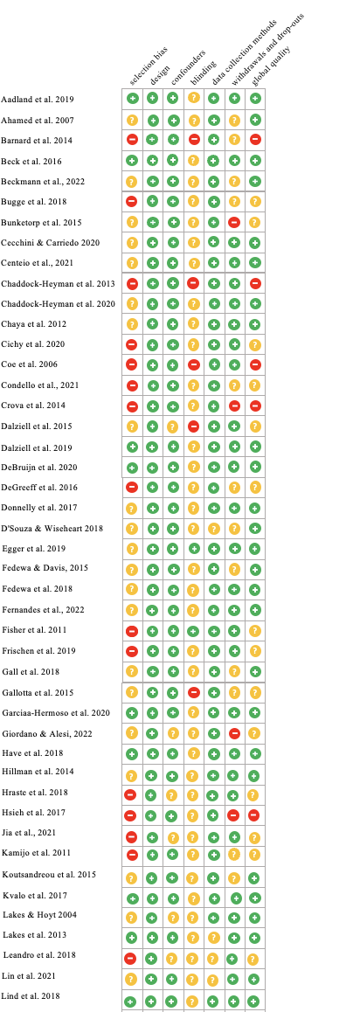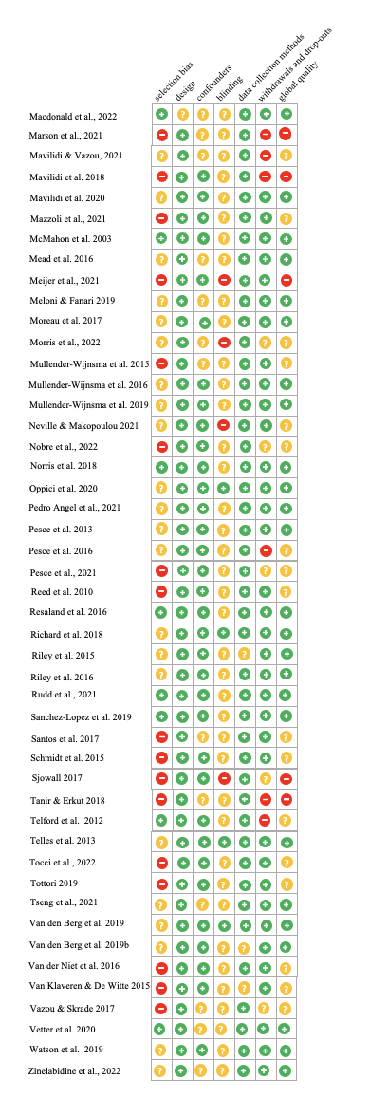

Figure S2. Forest plots of the effect sizes of physical activity interventions on (a) attention and (b) cognitive flexibility.

a.
b.

Figure S3. Forest plot of the effect sizes of physical activity interventions on inhibitory control.

Figure S4. Forest plot of the effect sizes of physical activity interventions on planning.

Figure S5. Forest plot of the effect sizes of physical activity interventions on mathematics.

Figure S6. Forest plot of the effect sizes of physical activity interventions on language.

Figure S7. Cook’s distance identification of outliers for (a) language, (b) maths, (c) all academic achievement, (d) on-task behaviour, (e) creativity, and (f) all executive function outcomes.

- b.
Cook's distance
Cook's distance
c. d.
Cook's distance
Cook's distance
e. f.

Cook's distance
Cook's distance

Figure S7. Cook’s distance identification of outliers for (a) attention, (b) cognitive flexibility, (c) fluid intelligence, (d) inhibitory control, (e) planning, and (f) working memory outcomes.

- b.

Cook's distance
Cook's distance
c. d.
Cook's distance
Cook's distance
e. f.
Cook's distance
Cook's distance

Figure S8. Doi plots for (a) language, (b) maths, (c) all academic achievement, (d) on-task behaviour, (e) creativity, and (f) all executive function outcomes. ES: effect size; LFK: Luis Furuya-Kanamori.

- b.
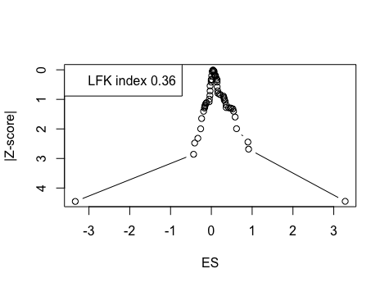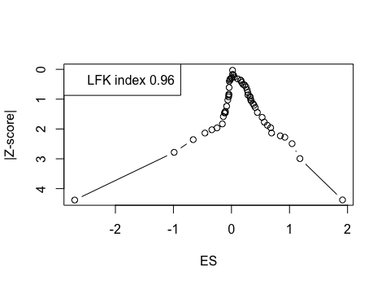
c. d.
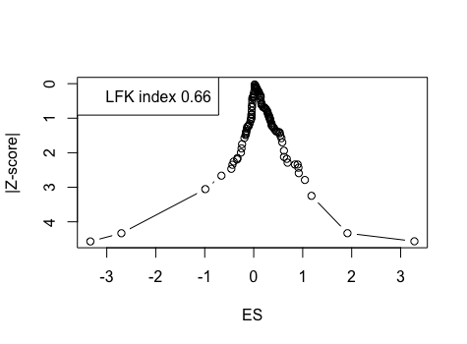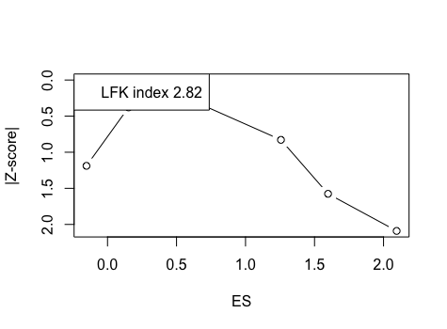
e. f.
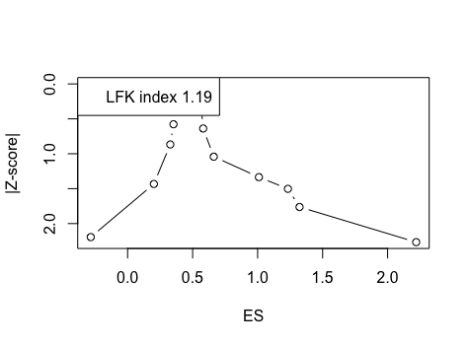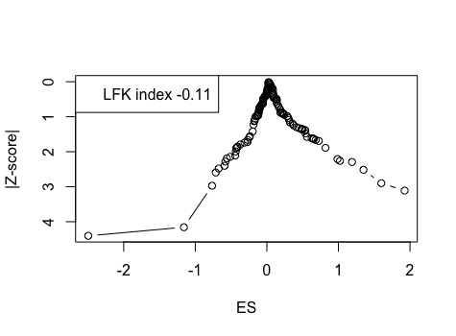

Figure S8. Doi plots for (a) attention, (b) cognitive flexibility, (c) fluid intelligence, (d) inhibitory control, (e) planning, and (f) working memory outcomes. ES: effect size; LFK: Luis Furuya-Kanamori.

- b.
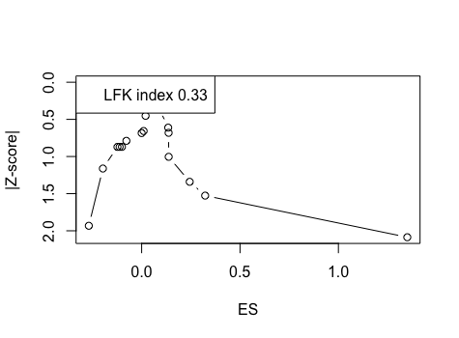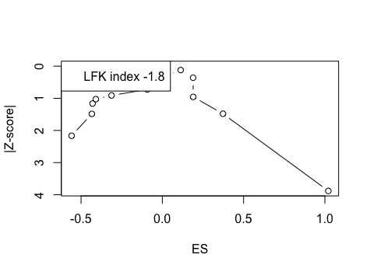
c. d.
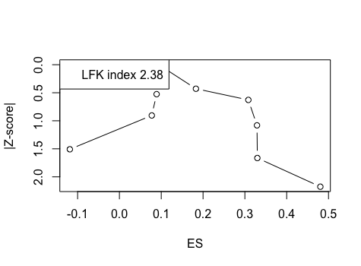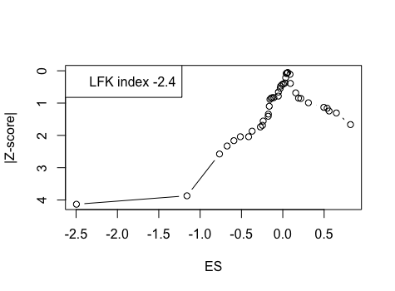
e. f.

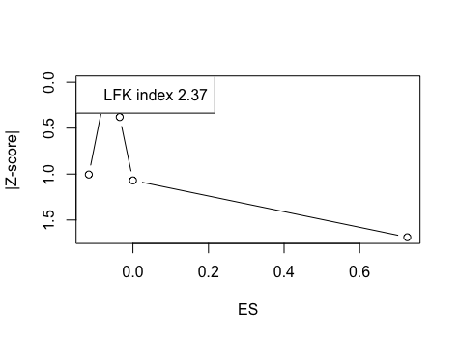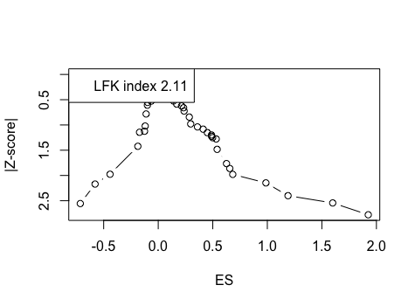

Supplementary Tables
Table S1. Complete search strategy
Pubmed | (danc*[tiab] OR gymnas*[tiab] OR physical*[tiab] OR active[tiab] OR activity[tiab] OR PE[tiab] OR sport[tiab] OR fitness[tiab] OR exercis*[tiab] OR creativity [tiab] OR creative [tiab] OR theat*[tiab])AND (class*[tiab] OR school[tiab]) AND child*[tiab] AND (train*[tiab] OR practice[tiab] OR curriculum[tiab] OR intervention[tiab] OR teach*[tiab] OR instruct*[tiab] OR class[tiab] OR trial[tiab])AND (acad*[tiab] OR achiev*[tiab] OR attain*[tiab] OR math*[tiab] OR numeracy[tiab] OR literacy[tiab] OR reading[tiab] OR cognit*[tiab] OR “executive function”[tiab] OR attention*[tiab] OR inhibit*[tiab] OR flexibility [tiab] OR switch*[tiab] OR shift*[tiab] OR plan*[tiab] OR “working memory” [tiab] OR updating[tiab]) NOT (ADHD[tiab] OR autis*[tiab] OR obes*[tiab])
ERIC  BEI | ((danc* OR gymnas* OR physical* OR active OR activity OR PE OR sport OR fitness OR exercis* OR creativity OR creative OR theat*)AND (class* OR school) AND child* AND (train* OR practice OR curriculum OR intervention OR teach* OR instruct* OR class OR trial)AND (acad* OR achiev* OR attain* OR math* OR numeracy OR literacy OR reading OR cognit* OR “executive function” OR attention* OR inhibit* OR flexibility OR switch* OR shift* OR plan* OR “working memory” OR updating) NOT (ADHD OR autis* OR obes*)) OR AB=((danc* OR gymnas* OR physical* OR active OR activity OR PE OR sport OR fitness OR exercis* OR creativity OR creative OR theat*)AND (class* OR school) AND child* AND (train* OR practice OR curriculum OR intervention OR teach* OR instruct* OR class OR trial)AND (acad* OR achiev* OR attain* OR math* OR numeracy OR literacy OR reading OR cognit* OR “executive function” OR attention* OR inhibit* OR flexibility OR switch* OR shift* OR plan* OR “working memory” OR updating) NOT (ADHD OR autis* OR obes*))
AEI | ((danc* OR gymnas* OR physical* OR active OR activity OR PE OR sport OR fitness OR exercis* OR creativity OR creative OR theat*)AND (class* OR school) AND child* AND (train* OR practice OR curriculum OR intervention OR teach* OR instruct* OR class OR trial)AND (acad* OR achiev* OR attain* OR math* OR numeracy OR literacy OR reading OR cognit* OR “executive function” OR attention* OR inhibit* OR flexibility OR switch* OR shift* OR plan* OR “working memory” OR updating) NOT (ADHD OR autis* OR obes*)) OR ABSTRACT((danc* OR gymnas* OR physical* OR active OR activity OR PE OR sport OR fitness OR exercis* OR creativity OR creative OR theat*)AND (class* OR school) AND child* AND (train* OR practice OR curriculum OR intervention OR teach* OR instruct* OR class OR trial)AND (acad* OR achiev* OR attain* OR math* OR numeracy OR literacy OR reading OR cognit* OR “executive function” OR attention* OR inhibit* OR flexibility OR switch* OR shift* OR plan* OR “working memory” OR updating) NOT (ADHD OR autis* OR obes*))
ASSIA | ((danc* OR gymnas* OR physical* OR active OR activity OR PE OR sport OR fitness OR exercis* OR creativity OR creative OR theat*)AND (class* OR school) AND child* AND (train* OR practice OR curriculum OR intervention OR teach* OR instruct* OR class OR trial)AND (acad* OR achiev* OR attain* OR math* OR numeracy OR literacy OR reading OR cognit* OR “executive function” OR attention* OR inhibit* OR flexibility OR switch* OR shift* OR plan* OR “working memory” OR updating) NOT (ADHD OR autis* OR obes*)) OR ABSTRACT((danc* OR gymnas* OR physical* OR active OR activity OR PE OR sport OR fitness OR exercis* OR creativity OR creative OR theat*)AND (class* OR school) AND child* AND (train* OR practice OR curriculum OR intervention OR teach* OR instruct* OR class OR trial)AND (acad* OR achiev* OR attain* OR math* OR numeracy OR literacy OR reading OR cognit* OR “executive function” OR attention* OR inhibit* OR flexibility OR switch* OR shift* OR plan* OR “working memory” OR updating) NOT (ADHD OR autis* OR obes*))
WOS | ((danc* OR gymnas* OR physical* OR active OR activity OR PE OR sport OR fitness OR exercis* OR creativity OR creative OR theat*)AND (class* OR school) AND child* AND (train* OR practice OR curriculum OR intervention OR teach* OR instruct* OR class OR trial)AND (acad* OR achiev* OR attain* OR math* OR numeracy OR literacy OR reading OR cognit* OR “executive function” OR attention* OR inhibit* OR flexibility OR switch* OR shift* OR plan* OR “working memory” OR updating) NOT (ADHD OR autis* OR obes*)) OR AB=((danc* OR gymnas* OR physical* OR active OR activity OR PE OR sport OR fitness OR exercis* OR creativity OR creative OR theat*)AND (class* OR school) AND child* AND (train* OR practice OR curriculum OR intervention OR teach* OR instruct* OR class OR trial)AND (acad* OR achiev* OR attain* OR math* OR numeracy OR literacy OR reading OR cognit* OR “executive function” OR attention* OR inhibit* OR flexibility OR switch* OR shift* OR plan* OR “working memory” OR updating) NOT (ADHD OR autis* OR obes*))
Psychinfo | (danc*[tiab] OR gymnas*[tiab] OR physical*[tiab] OR active[tiab] OR activity[tiab] OR PE[tiab] OR sport[tiab] OR fitness[tiab] OR exercis*[tiab] OR creativity [tiab] OR creative [tiab] OR theat*[tiab])AND (class*[tiab] OR school[tiab]) AND child*[tiab] AND (train*[tiab] OR practice[tiab] OR curriculum[tiab] OR intervention[tiab] OR teach*[tiab] OR instruct*[tiab] OR class[tiab] OR trial[tiab])AND (acad*[tiab] OR achiev*[tiab] OR attain*[tiab] OR math*[tiab] OR numeracy[tiab] OR literacy[tiab] OR reading[tiab] OR cognit*[tiab] OR “executive function”[tiab] OR attention*[tiab] OR inhibit*[tiab] OR flexibility [tiab] OR switch*[tiab] OR shift*[tiab] OR plan*[tiab] OR “working memory” [tiab] OR updating[tiab]) NOT (ADHD[tiab] OR autis*[tiab] OR obes*[tiab])

Table S2. Study characteristics.
Study | n | M age | % Female | Physical activity intervention | Duration (weeks) | Freq. (per week) | Intensity | Session duration (min) | Teacher qualification | Control group(s) | Outcomes | Instrument
Aadland et al. 2019 | 1202 | 10.2 | - | Active Smarter Kids  (PA with academic instruction) | 20 | 3 | MVPA | 30 | Classroom teacher (LQ) | PE | Language  Maths | Standardised national test
Ahamed et al. 2007 | 287 | 10.2 | 50.2% | AS! BC (PA break from academic instruction) | 50 | 5 | MPA | 15 | Classroom teacher (LQ) | PE | AA composite | Canadian Achievement Test (CAT-3)
Barnard et al. 2014 | 149 | 7.4 | 53.0% | Integrated PA (PA with academic instruction) | 8 | 3 | LPA | 30 | Not reported (LQ) | 1. Intensive PA 2. Passive | Language  Maths | ESSI Reading  ESSI Spelling  Vassi Mathematical Skills
Beck et al. 2016 | 165 | 7.5 | 46.7% | Gross Motor Math  (PA with academic instruction) | 6 | 3 | LMPA | 60 | Classroom teacher (LQ) | 1. Fine Motor Math (not PA) 2. Academic Instruction | Inhibitory control  Maths  Working memory | Eriksen Flanker Task  Standardised test  CANTAB: Spatial Span subset
Beckmann et al. 2022 | 481 | 8.1 | 49.0% | KazKidz | 12 | 2 | Cannot tell |  | HQ | Placebo | Inhibitory control  Language  Maths | Eriksen Flanker Task  School Performance Test
Bugge et al. 2018 | 1181 | 8.4 | 53.3% | PE Boost | 234 | 4 | cannot tell | 45 | PE teachers (HQ) | PE | Language  Maths | Danish National Test System
Bunketorp et al. 2015 | 545 | - | 46.4% | School-in-Motion: different sports and games with or without use of equipment | 8 | 2 | MVPA | 30 | Experienced exercise instructor (HQ) | PE | Language  Maths | Standardised national test
Cecchini & Carriedo 2020 | 46 | 6.4 | 58.7% | math-PE integrated teaching | 3 | 5 | MVPA | 60 | PE teachers (HQ) | PE | Maths | Standardised test
Chaddock-Heyman et al. 2013 | 23 | 8.9 | 56.5% | Fitness Improves Thinking in Kids (FIT Kids) (Aerobic) | 30 | 5 | MVPA | 120 | University staff (HQ) | Passive | Inhibitory control | Eriksen Flanker Task
Chaddock-Heyman et al. 2020 | 150 | 8.5 | 54.3% | Fitness Improves Thinking in Kids (FIT Kids) (Aerobic) | 30 | 5 | MVPA | 120 | University staff (HQ) | Passive | Fluid intelligence  Language  Maths | Kaufman Test of Educational Achievement  WJ III: Concept Formation, Planning, Verbal Comprehension, Visual Auditory Learning
Chaya et al. 2012 | 193 | 7.7 | 49.7% | Yoga | 12 | 6 | LPA | 45 | Experienced yoga teacher (HQ) | PA - passive stretching and aerobic exercises (running and group games) | Fluid intelligence  Language  Maths | Malinas Intelligence Scale for Indian Children (MISIC). Indian adaptation of the WISC-II.
Cichy et al. 2020 | 47 | 7 | 44.7% | PE with Eduball | 39 | 2 | cannot tell | 45 | Classroom teacher (LQ) | PE | Maths | Standardised national test
Coe et al. 2006 | 214 | 11.5 | 49.0% | PE | 20 | 5 | cannot tell | 55 | Not reported (LQ) | Alternative exploratory class (i.e., arts and computer classes) | AA composite | Standardised national test
Condello et al. 2021 | 181 | 10.7 | 50.0% | Games-based Multisport |  | 1 | Cannot tell |  | HQ | PE | Inhibitory control  Working memory | Random Number Generation Task
Crova et al. 2014 | 70 | 9.6 | 50.0% | Tennis skill-based training | 21 | 1 | MVPA | 120 | PE teachers (HQ) | PE | Inhibitory control  Working memory | Random Number Generation Task
D'Souza & Wiseheart 2018 | 75 | 7.8 | 58.7% | Dance: Creative Movement | 3 | 5 | MPA | 120 | Experienced dance teacher (HQ) | 1. Music  2. Passive | Cognitive flexibility  Fluid intelligence  Inhibitory control  Language  Working memory | Color-shape switch task  Digit Span Backward  Eriksen Flanker Task  K-BIT (Kaufman brief Intelligence Test) matrices  PPVT (Peabody Picture Vocabulary Test)  Quantity Identity Task  Self Ordering Point Task  Stroop Colour Test
Dalziell et al. 2015 | 46 | 9.5 | 52.2% | Better Movers and Thinkers (BMT)  Enriched PA programme | 16 | 2 | cannot tell | 60 | PE teachers (HQ) | PE | Fluid intelligence  Language Working memory | The Lucid Assessment System for Schools: phonological composite, reading composite, reasoning, spelling, visual spatial memory subtest.
Dalziell et al. 2019 | 150 | 10.5 | cannot tell | Better Movers and Thinkers (BMT)  Enriched PA programme | 16 | 2 | cannot tell | 60 | PE teachers (HQ) | PE | EF composite | Cognitive Assessment System
DeBruijn et al. 2020 | 891 | 9.2 | 51.2% | Aerobic intervention | 14 | 4 | MVPA | 30 | PE teachers (HQ) | 1. Cognitively engaging activity  2. PE | Language  Maths | Standardised tests
DeGreeff et al. 2016 | 499 | 8.1 | 54.7% | F&V (PA with academic instruction) | 44 | 3 | MVPA | 20 | Classroom teacher (LQ) | Passive | Cognitive flexibility  Inhibitory control  Working memory | Digit Span Backward  Stroop Colour Test  Visual Span Backward  Wisconsin Card Sorting Test
Donnelly et al. 2017 | 584 | 8.1 | 51.4% | Physical Activity Across the Curriculum (PAAC) | 117 | 10 | MVPA | 10 | Classroom teacher (LQ) | Passive | Language  Maths | Wechsler Individual Achievement Test-Third Edition
Egger et al. 2019 | 142 | 7.9 | 54.9% | PA breaks (high cognitive engagement, high physical exertion)  (PA break from academic instruction) | 20 | 10 | MVPA | 10 | Classroom teacher (LQ) | 1. Aerobic group  2. Cognitive group (low physical exertion) | cognitive flexibility  Inhibitory control  Language  Maths  Working memory | Backwards Colour Recall task  Eriksen Flanker Task  Hamburger Schreib-Probe: Spelling  Heidelberger Rechentest: Maths  Salzburger Lesescreening: Reading
Fedewa & Davis, 2015 | 460 | grade 3 -5 | cannot tell | Classroom-based physical activity breaks | 25 | 20 | MPA | 5 | Classroom teacher (LQ) | Passive | Fluid intelligence  Language  Maths | Standard Progressive Matrices  National standardised tests
Fedewa et al. 2018 | 460 | grade 3 -5 | 51.0% | Academic-based movement breaks | 36 | 10 | LPA | 10 | Video (HQ) | Aerobic-only movement breaks | Language  Maths | FastBridge: Standardised tests
Fisher et al. 2011 | 64 | 6.1 | 55.0% | Aerobic PE curriculum | 10 | 2 | MVPA | 60 | Researchers, PE and Classroom teachers (HQ) | PE | Attention  Fluid intelligence  Planning  Working memory | CANTAB: attention and working memory subset  CAS: planning and simulteanous scale subset
Frischen et al. 2019 | 76 | 5.7 | 60.1% | Yoga | 20 | 3 | LPA | 20 | Researchers (HQ) | 1. Rhythm training  2. Pitch training | Cognitive flexibility  Inhibitory control  Working memory | Corsi Block Test  Dimensional Change Card Sort  Matrix Span Test  NEPSY-II "statue" subtest
Fernandes et al. 2022 | 47 | 10.5 | 50.0% | Capoeira |  | 3 | Cannot tell | 60 | HQ | Passive | Working memory  Inhibitory control  Maths  Language | WISC IV Digit span backward  WISC IV Letter number sequencing
Gall et al. 2018 | 663 | 9.2 | 51.0% | Moving to Music | 20 | 1 | MPA | 45 | Classroom teacher and Researchers (HQ) | PE | Attention  AA composite | d2 Test of Attention  End of year results
Gallotta et al. 2015 | 230 | 9.5 | cannot tell | Coordinative PA | 20 | 2 | MVPA | 60 | Classroom teacher (LQ) | 1. Traditional PA  2. Passive | Attention | d2 Test of Attention
Garcia­a-Hermoso et al. 2020 | 170 | 10.1 | 43.5% | Active Start (PE boost) | 8 | 5 | MVPA | 30 | Sport Science Graduate (LQ) | PE | Attention  Language  Maths | d2 Test of Attention  End of year results
Giordano & Alesi 2022 | 75 | 5.7 | 48.0% | Enriched programme |  | 3 | Cannot tell | 10 | HQ | Free play  Passive | Inhibitory control | Stroop Test  Head Shoulders Knees Toes
Have et al. 2018 | 505 | 7.2 | 50.5% | Active Math (PA with academic instruction) | 30 | 6 | MVPA | 45 | Classroom teacher (LQ) | Academic instruction | Inhibitory control  Maths | Eriksen Flanker Task  Standardised test
Hillman et al. 2014 | 221 | 8.8 | 46.2% | Fitness Improves Thinking in Kids (FIT Kids)  (Aerobic) | 30 | 5 | MVPA | 120 | University staff (HQ) | Passive | Cognitive flexibility  Inhibitory control | Color-shape switch task  Eriksen Flanker Task
Hraste et al. 2018 | 36 | 10.4 | cannot tell | Integrated lessons of mathematics/geometry and PA | 4 | 4 | LMPA | 45 | Classroom teacher (LQ) | Academic instruction | AA composite | National standardised test
Hsieh et al. 2017 | 44 | 8.6 | 47.7% | Gymnastics | 8 | 2 | MPA | 90 | PE teachers (HQ) | Passive | Working memory | Delayed matching-to-sample test
Jia et al. 2021 | 40 | 6.1 | 50.0% | Diverse exercise |  | 3 | MPA |  | HQ | Aerobic | Language  Maths | Wechsler Individual Achievement Test-Third Edition
Kamijo et al. 2011 | 36 | 9.0 | 52.8% | After-School PA Intervention (aerobic) | 30 | 5 | MVPA | 120 | University staff (HQ) | Passive | Working memory | Sternberg task
Koutsandreou et al. 2015 | 71 | 9.4 | 54.9% | Cardiovascular Fitness Training | 10 | 3 | MVPA | 45 | Experienced exercise instructor (HQ) | 1. Motor skills training  2. Academic instruction | Working memory | Letter Digit Span
Kvalo et al. 2017 | 449 | 9.5 | 48.7% | Active School (PA with academic instruction) | 38 | 2 | MPA | 45 | Classroom teacher (LQ) | PE | Inhibitory control  Working memory | Backward digit span task  Stroop Golden interference effect
Lakes & Hoyt 2004 | 193 | cannot tell | 51.3% | Taekwondo | 12 | 2 | MVPA | 45 | Experienced martial arts instructor (HQ) | PE | Maths  On-task behaviour  Working memory | Cognitive subscale of Response to Challenge Scale  WISC III-FD Arithmetic and Digit Span
Lakes et al. 2013 | 59 | 12.2 | 52.0% | Taekwondo | 36 | 2 | VPA | 45 | Experienced martial arts instructor (HQ) | PE | EF composite  Inhibitory control | The Hearts & Flowers test
Leandro et al. 2018 | 117 | 7.5 | 43.6% | Creative dance & mathematics  (PA with academic instruction) | 5 | 1 | MPA | 60 | Classroom teacher (LQ) | Academic instruction | Maths | Standardised test
Lin et al. 2021 | 50 | 8.6 | 48.0% | Gymnastics | 8 | 2 | MPA | 90 | PE teachers (HQ) | Passive | Working memory | Spatial working memory delayed-matching test
Lind et al. 2018 | 931 | 11.9 | 51.0% | Football | 11 | 2 | MVPA | 45 | Classroom teacher (LQ) | PE | Working memory | Cogstate® Brief Battery: one back (OBK)
Marson et al. 2021 | 30 | 8.5 | 30.0% | Quadrato Motor Training (QMT) |  | 4 | Cannot tell |  | HQ | One Minute Meditation | Creativity | Alternative Uses Test
Mavilidi et al. 2018 | 55 | 10.3 | 47.3% | Thinking While Moving in English (TWM-E)  (PA with academic instruction) | 4 | 3 | MPA | 40 | Researchers, PE teacher (HQ) | Passive | Inhibitory control  Language  On-task behaviour  Working memory | Eriksen Flanker Task  Grammar and Punctuation test  Momentary time sampling  n-back task  National standardised test
Mavilidi et al. 2020 | 283 | 9.8 | 48.4% | Thinking While Moving in English (TWM-E)  (PA with academic instruction) | 6 | 3 | MPA | 40 | Classroom teacher (LQ) | Passive | Language  On-task behaviour | National standardised test  Momentary time sampling
Mavilidi & Vazou 2021 | 560 | 10 | 51.0% | Move for thought |  | 3 | Cannot tell |  | HQ | Academic | Maths | Academic Achievement Test
Mazzoli et al. 2021 | 141 | 7.7 | 46.1% | Cognitively engaging Active Breaks |  | 4 | Cannot tell |  | HQ | Academic instruction | Attention  Inhibitory control  Working memory | Go No/Go  List sorting working memory test (NIH Toolbox)
McMahon et al. 2003 | 721 | 6.5 | cannot tell | Basic Reading Through Dance (PA with academic instruction) | 10 | 2 | MPA | 40 | Experienced dance teacher (HQ) | Passive | Language | PhonoGraphix Standardised Tests
Mead et al. 2016 | 81 | 11.5 | 51.9% | Activity breaks from academic instruction | 40 | 5 | MVPA | 10 | Classroom teacher (LQ) | 1. Stability Balls  2. Passive | Maths | National standardised test  Measure of academic progress test
Meijer et al. 2021 | 650 | 9.17 | 50.6% | Cognitively engaging | 14 | 4 | MVPA |  | HQ | Passive | Attention  Working memory  Inhibitory control | Attention Network Task  WISC III-FD Digit span  Stop and Signal Task
Meloni & Fanari 2019 | 85 | 9.3 | 51.8% | Basketball | 30 | 1 | MVPA | 60 | Not reported (LQ) | Chess | Language  Maths | Standard Progressive Battery  Studying test
Morris et al. 2022 | 97 | 9.6 | 52.6% | Maths on the move |  | 1 | MVPA |  | HQ | Academic | Maths
Moreau et al. 2017 | 318 | 9.9 | 61.3% | HIT (High Intensity Training) | 6 | 5 | VPA | 10 | Video (HQ) | Sedentary Games | Inhibitory control  Working memory | Backward digit span task  Stroop Test  Eriksen Flanker Task
Mullender-Wijnsma et al. 2015 | 228 | 8.1 | 46.5% | F&V (PA with academic instruction) | 21 | 3 | MVPA | 10 | Classroom teacher (LQ) | Passive | Language  Maths | One-Minute Test - Reading  Speed Test Arithmetic
Mullender-Wijnsma et al. 2016 | 499 | 8.1 | 45.2% | F&V (PA with academic instruction) | 44 | 3 | MVPA | 20 | Classroom teacher (LQ) | Passive | Language  Maths | One-Minute Test - Reading  Speed Test Arithmetic  Child Academic Monitoring System - Maths & Spelling
Mullender-Wijnsma et al. 2019 | 499 | 8.1 | 54.7% | F&V (PA with academic instruction) | 44 | 3 | MVPA | 20 | Classroom teacher (LQ) | Passive | Language  Maths | One-Minute Test - Reading  Speed Test Arithmetic  Child Academic Monitoring System - Maths & Spelling
Nobre et al. 2022 | 211 |  | 50.0% | Mastery climate |  | 3 | Cannot tell |  | HQ | Traditional PA | Maths  Language
Neville & Makopoulou 2021 | 40 | 7.4 | 50.0% | Dance-based PE | 6 | 1 | MPA | 50 | PE Graduate (LQ) | PE | Creativity | Guilford's (1967) Alternative Uses task
Norris et al. 2018 | 219 | 8.6 | 49.3% | Virtual Traveller | 6 | 3 | MVPA | 10 | Classroom teacher (LQ) | Passive | On-task behaviour | Observing Teachers and Pupils in Classrooms (OPTIC) tool
Oppici et al. 2020 | 80 | 8.8 | 61.0% | Dance (high cognitive) | 7 | 2 | MPA | 60 | Experienced dance teacher (HQ) | 1. Dance (low cognitive)  2. PE | Cognitive flexibility  Inhibitory control  Working memory | Dimensional Change Card Sort  Eriksen Flanker Task  List sorting working memory test (NIH Toolbox)
Pesce et al. 2013 | 250 | 6.9 | 49.2% | Cognitively Enriched Specialist Led PA | 20 | 1 | Cannot tell | 60 | PE teachers (HQ) | 1. Specialist Led PE  2. PE | Attention  Planning | CAS: attention and planning sub-scale
Pesce et al. 2016 | 460 | 7.5 | 50.0% | Enriched PE (high cognitive) | 24 | 1 | Cannot tell | 60 | PE teachers (HQ) | PE | Attention  Inhibitory control  Working memory | CAS: attention sub-scale  Random Number Generation Task
Pesce et al. 2021 | 116 | 8.8 | 53.0% | Self control programme |  | 1 | Cannot tell |  | PE teachers (HQ) | PE | Inhibitory control  Attention
Reed et al. 2010 | 155 | 10 | 43.2% | PA fundamental skills in Core Curriculum  (PA with academic instruction) | 12 | 3 | MPA | 30 | Researchers and Classroom teachers (HQ) | Academic instruction | Fluid intelligence | Standard Progressive Matrices
Resaland et al. 2016 | 1202 | 10.2 | cannot tell | Active Smarter Kids  (PA with academic instruction) | 28 | 3 | MVPA | 30 | Classroom teacher (LQ) | PE | Language  Maths | National standardised tests
Richard et al. 2018 | 173 | 9.6 | cannot tell | Creative Exercise Program | 10 | 1 | MPA | 30 | PE teachers (HQ) | Conventional Exercise Program | Creativity | Bertsch test motor creativity  Runco Creative Assessment Battery
Riley et al. 2015 | 54 | 10.5 | 48.2% | EASY Minds  (PA with academic instruction) | 6 | 3 | MVPA | 60 | Classroom teacher (LQ) | Academic instruction | On-task behaviour | Momentary time sampling
Riley et al. 2016 | 240 | 11.1 | 40.7% | EASY Minds  (PA with academic instruction) | 6 | 3 | MPA | 60 | Classroom teacher (LQ) | Passive | Maths  On-task behaviour | Momentary time sampling  Standardised test
Rudd et al. 2021 | 55 | 6.6 | 47.0% | Creative dance | 10 | 2 | Cannot tell | 60 | HQ | Choreography dance | Cognitive flexibility  Inhibitory control  Working memory | Dimensional Change Card Sort  Eriksen Flanker Task  List sorting working memory test (NIH Toolbox)
Sanchez-Lopez et al. 2019 | 1608 | 5.8 | 56.3% | MOVI-KIDS (recreational non-competitive physical activity) | 26 | 3 | MVPA | 60 | Experienced exercise instructor (HQ) | PE | Fluid intelligence  Maths | Battery of general and Differential Aptitudes - logic reasoning and numerical factor subsets
Santos et al. 2017 | 50 | 9.2 | cannot tell | Skills4Genius | 20 | 3 | MVPA | 60 | PE teachers (HQ) | PE (Additional) | Creativity | Creativity Behavior Assessment in Team Sports  Torrance Test of Creative Thinking
Schmidt et al. 2015 | 181 | 11.4 | 54.9% | Team Games | 6 | 2 | MVPA | 45 | PE teachers (HQ) | 1. Aerobic Exercise  2. PE | Cognitive flexibility  Inhibitory control  Working memory | Eriksen Flanker task  n-back task with pictures of fruits
Sjowall 2017 | 470 | 9.5 | 48.5% | PE Boost | 78 | 5 | VPA | 60 | Activity leader (LQ) | PE | Maths  Working memory | Arithmetic test  Follow instructions task  Odd One Out task
Tanir & Erkut 2018 | 56 | 9.2 | 50.0% | Rhythmic Basketball | 6 | 2 | MVPA | 60 | PE teachers (HQ) | Basketball | Inhibitory control | Stroop Colour Test
Telford et al. 2012 | 620 | 7.5 | 48.8% | Specialist Taught PA | 75 | 2 | MVPA | 45 | PE teachers (HQ) | PE | Language  Maths | National standardised tests
Telles et al. 2013 | 98 | 10.5 | 38.7% | Yoga | 12 | 5 | LPA | 45 | Experienced yoga teacher (HQ) | PA (Additional) | Inhibitory control | Stroop Colour Test
Tocci et al. 2022 | 95 | 7.7 | 50.0% | Specialist led enriched programme |  | 1 | Cannot tell |  | Specialist teacher (HQ) |  | Creativity  Inhibitory control  Working memory | Bertsch test motor creativity  Random Number Generation Task
Tottori 2019 | 58 | 10.2 | 42.3% | HIT (High Intensity Training) | 4 | 3 | MVPA | 10 | University staff (HQ) | Passive | Planning  Working memory | Digit Span Backward (WISC)  Tower of Hanoi (5 disk) time
Tseng et al. 2021 | 55 | 11.3 | 51.0% | FIFA11 |  | 5 | Cannot tell |  | HQ | Passive | Attention | Attention Scale
Van den Berg et al. 2019 | 512 | 10.9 | 46.5% | Just Dance | 9 | 5 | MVPA | 10 | Video (HQ) | Academic instruction | Attention  Inhibitory control | Attention Network  d2 Test of Attention  Stroop Colour test
Van den Berg et al. 2019b | 323 | 11 | 48.0% | Juggling with Maths | 5 | 4 | LPA | 5 | Video (HQ) | Academic instruction | Maths | Multiplication tables test
Van der Niet et al. 2016 | 112 | 8.8 | 50.0% | PA Boost (aerobic and cognitive enriched) | 22 | 2 | MVPA | 30 | PE teachers (HQ) | Passive | Cognitive flexibility  Inhibitory control  Working memory | Digit Span Test from Weschler Memory Scale  Golden Stroop Colour Test  Tower of London  Trail-Making Test  Visual Memory Span test from Wechler Memory Scale
Van Klaveren & De Witte 2015 | 178 | 10.5 | 36.0% | Football | 10 | 1 | MVPA | 180 | Experienced exercise instructor (HQ) | Passive | Language  Maths | Test construction by CITO  National standardised test
Vazou & Skrade 2017 | 284 | 10.0 | 46.5% | Move for Thought  (PA with academic instruction) | 8 | 3 | MPA | 10 | Classroom teacher (LQ) | Academic instruction | Maths | National standardised test
Vetter et al. 2020 | 170 | 8.4 | 52.0% | Playground | 6 | 3 | MVPA | 30 | Classroom teacher (LQ) | Academic instruction | Maths | NAPLAN test  Teacher-designed multiplication-tables test
Watson et al. 2019 | 341 | 9.1 | 52.8% | ACTI-BREAK: a variety of elements including: drama, games, following instructions, and technology | 6 | 15 | MPA | 5 | Classroom teacher (LQ) | Academic instruction | Language  Maths  On-task behaviour | Wheldall Assessment of Reading Passages Test  Westwood One Minute Tests of Basic Number Facts  Adaptation from the Direct Behaviour Rating Scale
Zinelabidine et al. 2022 | 44 | 10.3 | 49.0% | Aerobic dance |  | 2 | MVPA |  | HQ | Passive | Cognitive flexibility  Inhibitory control  Working memory | Trail-making test  Stroop Test  Digit Recall Test

Table S3. GRADE evidence profile
Outcome | Study design | Risk of bias | Inconsistency | Indirectness | Imprecision | Publication bias | Certainty of evidence
Executive functions | RCT | seriousª | serious^{b} | serious^{c} | not serious | unlikely
Attention | RCT | seriousª | serious^{b} | serious^{c} | not serious | unlikely
Cognitive flexibility | RCT | seriousª | serious^{b} | not serious | not serious | likely
Inhibitory control | RCT | seriousª | serious^{b} | serious^{c} | not serious | unlikely
Planning | RCT | seriousª | not serious | serious^{c} | not serious | likely
Working memory | RCT | seriousª | serious^{b} | serious^{c} | not serious | likely
Academic achievement | RCT | not serious | serious^{b} | not serious | not serious | unlikely
Language | RCT | not serious | serious^{b} | not serious | not serious | unlikely
Maths | RCT | not serious | serious^{b} | not serious | not serious | likely
On-task behaviour | RCT | not serious | serious^{b} | not serious | serious^{d} | likely
Fluid intelligence | RCT | not serious | not serious | not serious | not serious | likely
Creativity | RCT | seriousª | not serious | serious^{c} | not serious | likely
Note: RCT: Randomised Control Trial; ª inadequate blinding of participants; ^{b} high value of I²; ^{c} school not representative of population; ^{d} wide confidence intervals.
Certainty of evidence (GRADE):
High certainty The true effect is close to that of the estimate of the effect.
Moderate certainty The true effect is likely to be close to the estimate of the effect, but there is a possibility that it is substantially different.
Low certainty The true effect may be substantially different from the estimate of the effect.
Very low certainty The true effect is likely to be substantially different from the estimate of effect.
Table S4. Moderator analyses for executive functions.
 |  |  |  |  |  |  |  |  |  |  |  | Heterogeneity
Continuous moderator | Level | Effect size (n) |  | B |  | 95% CI |  | p |  |  |  | I²  ^{level 3} | I²  ^{level 2} | Q
Mean age | 5 – 12 years | 127 |  | -0.08 |  | -1.42 – 1.27 |  | 0.91 |  |  |  | 87.1% | 0.0% | 625.9
Publication bias | -2.4 – 2.4 | 127 |  | 0.02 |  | -0.01 – 0.05 |  | 0.10 |  |  |  | 76.7% | 15.3% | 834.3
Categorical moderator | Level | Effect size (n) |  | g |  | 95% CI |  | p |  |  |  | I²  ^{level 3} | I²  ^{level 2} | Q
Frequency | 1/week | 16 |  | 0.07 |  | -0.10 – 0.24 |  | 0.41 |  |  |  | 81.0% | 12.0% | 833.5
 | 2/week | 39 |  | 0.14 |  | -0.29 – 0.58 |  | 0.51
 | 3/week | 25 |  | 0.11 |  | -0.23 – 0.45 |  | 0.51
 | >3/week | 47 |  | 0.06 |  | -0.04 – 0.16 |  | 0.26
Intervention duration | ≤ 6 weeks | 25 |  | 0.18 |  | -0.06 – 0.41 |  | 0.14 |  |  |  | 80.3% | 12.4% | 835.8
 | 7 – 10 weeks | 37 |  | 0.27 |  | -0.10 – 0.64 |  | 0.14
 | 11 – 24 weeks | 49 |  | -0.05 |  | -0.36 – 0.27 |  | 0.76
 | ≥ 25 weeks | 16 |  | 0.03 |  | -0.06 – 0.12 |  | 0.50
Intensity | Cannot tell | 34 |  | -0.27 |  | -0.83 – 0.30 |  | 0.33 |  |  |  | 78.5% | 13.5% | 744.6
 | LPA | 5 |  | -0.27 |  | -0.93 – 0.39 |  | 0.32
 | MPA | 25 |  | 0.21 |  | -0.19 – 0.61 |  | 0.29
 | MVPA | 63 |  | 0.21 |  | 0.07 – 0.34 |  | 0.01
Session duration | < 20 min | 25 |  | 0.05 |  | -0.30 – 0.39 |  | 0.78 |  |  |  | 80.7% | 12.2% | 839.4
 | 20 – 44 min | 27 |  | 0.04 |  | -0.08 – 0.16 |  | 0.53
 | 45 – 60 min | 59 |  | 0.06 |  | -0.17 – 0.30 |  | 0.58
 | > 60 min | 16 |  | 0.38 |  | -0.15 – 0.92 |  | 0.14
Teacher qualification | Low | 23 |  | 0.09 |  | -0.07 – 0.25 |  | 0.24 |  |  |  | 79.9% | 12.7% | 841.8
 | High | 104 |  | 0.10 |  | -0.10 – 0.43 |  | 0.29
Activity type | Aerobic | 33 |  | 0.16 |  | 0.03 – 0.28 |  | 0.02 |  |  |  | 75.1% | 16.0% | 741.5
 | PE interventions | 6 |  | -0.64 |  | -2.24 – 0.87 |  | 0.31
 | Dance | 21 |  | 0.13 |  | -0.32 – 0.58 |  | 0.56
 | Enriched PA programme | 35 |  | 0.12 |  | -0.11 – 0.35 |  | 0.28
 | Holistic movement | 5 |  | -0.27 |  | -0.93 – 0.39 |  | 0.32
 | PA with academic instruction | 13 |  | 0.02 |  | -0.01 – 0.13 |  | 0.62
 | Sport | 14 |  | 0.33 |  | -0.04 – 0.70 |  | 0.08
Quality | Weak | 19 |  | 0.24 |  | -0.26 – 0.75 |  | 0.34 |  |  |  | 80.0% | 12.6% | 838.4
 | Moderate | 48 |  | 0.10 |  | -0.18 – 0.36 |  | 0.51
 | Strong | 60 |  | -0.06 |  | -0.41 – 0.29 |  | 0.75
LPA: low physical activity, LMPA: low to moderate physical activity, MPA: moderate physical activity, MVPA: moderate to vigorous physical activity, PA: physical activity, PE: physical exercise, VPA: vigorous physical activity
Table S5. Moderator analysis for academic achievement.
 |  |  |  |  |  |  | Heterogeneity
Continuous moderator | Level | Effect size (n) | B | 95% CI | p |  | I²  ^{level 3} | I²  ^{level 2} | Q
Mean age | 5 – 12 years | 114 | 0.06 | -1.43 – 1.55 | 0.93 |  | 86.3% | 11.6% | 1290.7
Publication bias | -1.8 – 0.33 | 114 | 0.07 | -0.17 – 0.30 | 0.61 |  | 77.7% | 19.2% | 1914.1
Categorical moderator | Level | Effect size (n) | g | 95% CI | p |  | I²  ^{level 3} | I²  ^{level 2} | Q
Frequency | 1/week | 6 | 0.04 | -0.88 – 0.96 | 0.91 |  | 78.3% | 18.8% | 1852.9
 | 2/week | 16 | -0.05 | -1.13 – 1.02 | 0.91
 | 3/week | 47 | 0.28 | 0.07 – 0.50 | 0.01
 | >3/week | 45 | 0.08 | -0.07 – 0.23 | 0.29
Intervention duration | ≤ 6 weeks | 15 | 0.22 | -0.03 – 0.48 | 0.08 |  | 78.4% | 18.7% | 1749.2
 | 7 – 10 weeks | 22 | 0.36 | 0.11 – 0.60 | 0.01
 | 11 – 24 weeks | 41 | -0.02 | -0.63 – 0.60 | 0.96
 | ≥ 25 weeks | 36 | 0.08 | -0.07 – 0.23 | 0.28
Intensity | Cannot tell | 21 | 0.06 | -0.95 – 1.10 | 0.90 |  | 79.7% | 17.5% | 1769.9
 | LPA | 13 | -0.07 | -0.21 – 0.06 | 0.28
 | LMPA | 2 | 0.26 | -1.56 – 2.09 | 0.32
 | MPA | 17 | 0.26 | 0.04 – 0.48 | 0.03
 | MVPA | 61 | 0.16 | 0.01 – 0.30 | 0.03
Session duration | < 20 min | 30 | 0.04 | -0.10 – 0.18 | 0.58 |  | 78.3% | 18.8% | 1770.0
 | 20 – 44 min | 42 | 0.27 | 0.12 – 0.42 | < 0.01
 | 45 – 60 min | 33 | 0.06 | -0.37 – 0.48 | 0.80
 | > 60 min | 9 | 0.41 | -0.80 – 1.61 | 0.45
Teacher qualification | Low | 55 | 0.16 | 0.02 – 0.30 | 0.03 |  | 78.4% | 18.6% | 1913.0
 | High | 59 | 0.12 | -0.20 – 0.43 | 0.47
Activity type | Aerobic | 23 | 0.05 | -0.16 – 0.26 | 0.64 |  | 77.5% | 19.5% | 1807.4
 | PE interventions | 11 | -0.22 | -0.20 – 0.43 | 0.70
 | Enriched PA programme | 18 | 0.10 | 0.02 – 0.17 | 0.01
 | Holistic movement | 5 | -0.09 | -0.32 – 0.14 | 0.29
 | PA with academic instruction | 47 | 0.31 | 0.10 – 0.51 | < 0.01
 | Sports | 10 | 0.03 | -0.41 – 0.47 | 0.88
Quality | Weak | 8 | -0.14 | -0.74 – 0.48 | 0.66 |  | 77.3% | 19.6% | 1898.5
 | Moderate | 28 | 0.25 | -0.05 – 0.54 | 0.35
 | Strong | 78 | -0.14 | -0.46 – 0.17 | 0.10
Note: LPA: low physical activity, LMPA: low to moderate physical activity, MPA: moderate physical activity, MVPA: moderate to vigorous physical activity, PA: physical activity, PE: physical exercise, VPA: vigorous physical activity

Table S6. Moderator analyses for creativity.
 |  |  |  |  |  |  | Heterogeneity
Continuous moderator | Level | Effect size (n) | B | 95% CI | p |  | I²  ^{level 3} | I²  ^{level 2} | Q
Mean age | 5-12 | 14 | 0.27 | -0.34 – 0.89 | 0.35 |  | 78.7% | 2.1% | 33.4
Categorical moderator | Level | Effect size (n) | g | 95% CI | p |  | I²  ^{level 3} | I²  ^{level 2} | Q
Frequency | 1/week | 9 | 0.47 | 0.31 – 0.62 | < 0.01 |  | 64.3% | 3.3% | 25.1
 | 3/week | 5 | 1.15 | -0.39 – 2.70 | 0.11
Intervention duration | ≤ 6 weeks | 4 | 0.56 | 0.51 – 1.63 | 0.20 |  | 79.1% | 1.7% | 34.3
 | 11 – 24 weeks | 8 | 1.06 | -0.38 – 2.51 | 0.13
Session duration | 45 – 60 min | 9 | 0.84 | -0.14 – 1.18 | 0.08 |  | 82.0% | 1.6% | 34.6
Note: Sample sizes in each category were insufficient to investigate moderator effects for publication bias, study quality, activity type, intensity, teacher qualification and some categories of intervention duration and session duration.

Table S7. Moderator analyses for fluid intelligence.
 |  |  |  |  |  |  | Heterogeneity
Continuous moderator | Level | Effect size (n) | B | 95% CI | p |  | I²  ^{level 3} | I²  ^{level 2} | Q
Mean age | 5 –12 years | 9 | 0.31 | -1.82 – 2.44 | 0.32 |  | 3.6% | 2.0% | 1.0
Categorical moderator | Level | Effect size (n) | g | 95% CI | p |  | I²  ^{level 3} | I²  ^{level 2} | Q
Frequency | >3/week | 5 | 0.06 | -0.12 – 0.23 | 0.43 |  | 0.0% | 0.0% | 2.0
Intervention duration | 11 – 24 weeks | 4 | 0.18 | -0.29 – 0.65 | 0.30 |  | 35.8% | 0.0% | 7.6
 | ≥ 25 weeks | 4 | 0.16 | -0.17 – 0.48 | 0.17
Session duration | 45 – 60 min | 5 | 0.21 | -0.13 – 0.56 | 0.16 |  | 44.9% | 0.0% | 7.0
Note: Sample sizes in each category were insufficient to assess moderator effects for publication bias, study quality, activity type, intensity, teacher qualification and some categories in frequency and duration.

