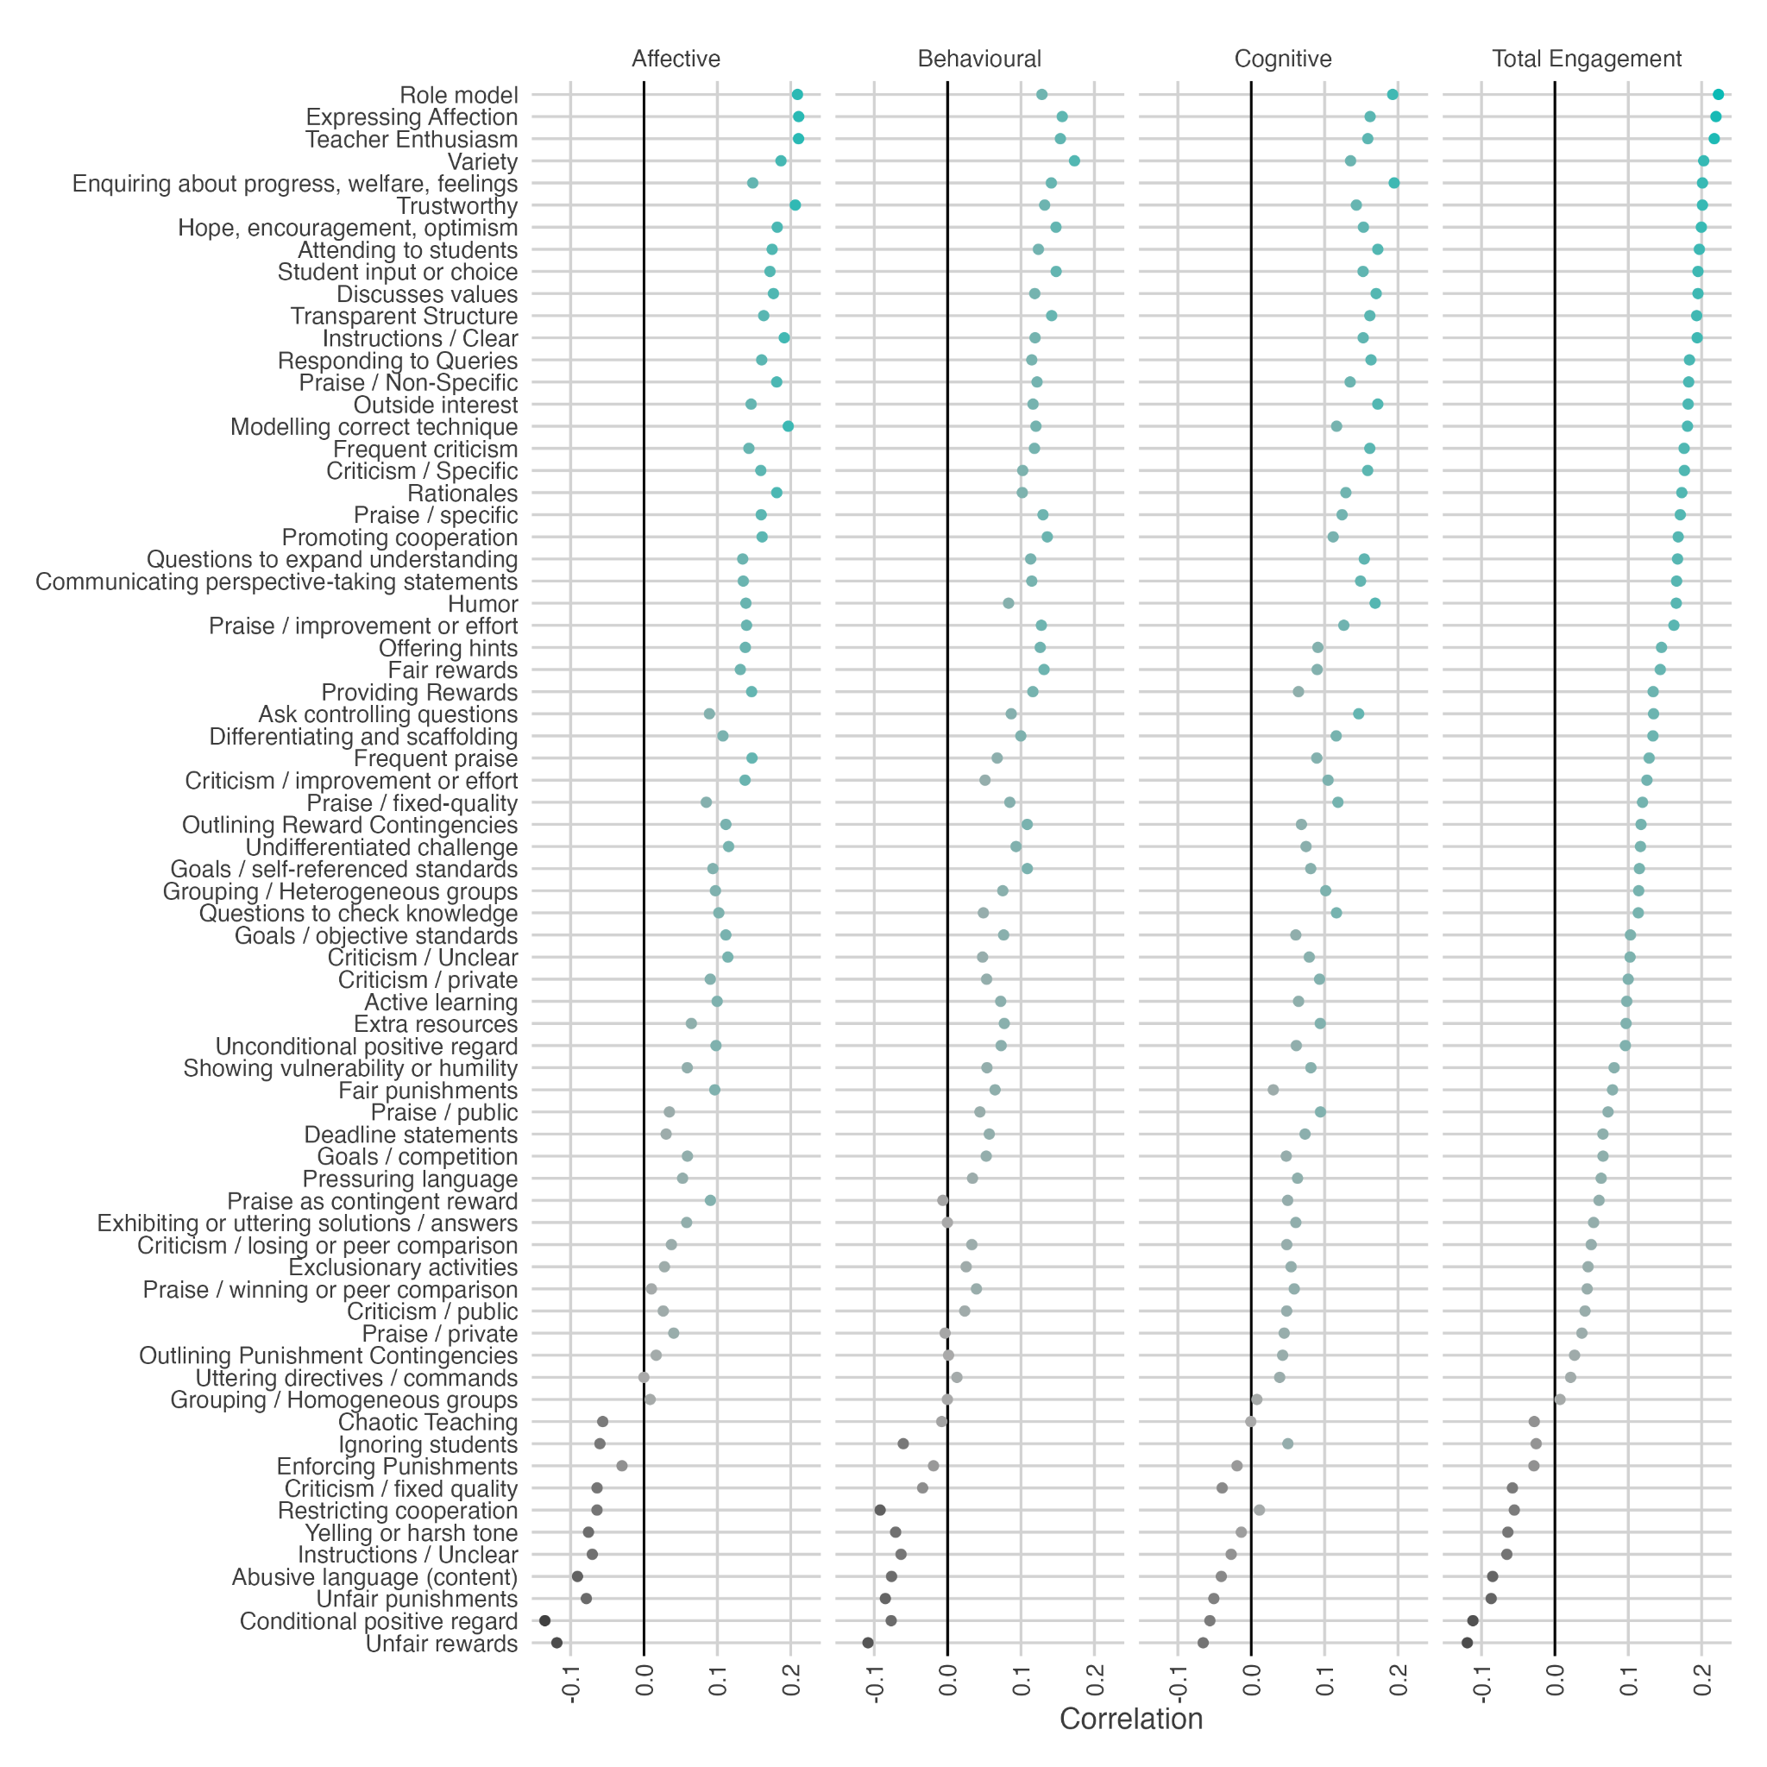
Supplementary Figure 1
Correlations Between Mid-Year Reports of Teacher Behaviour and Change in Engagement

