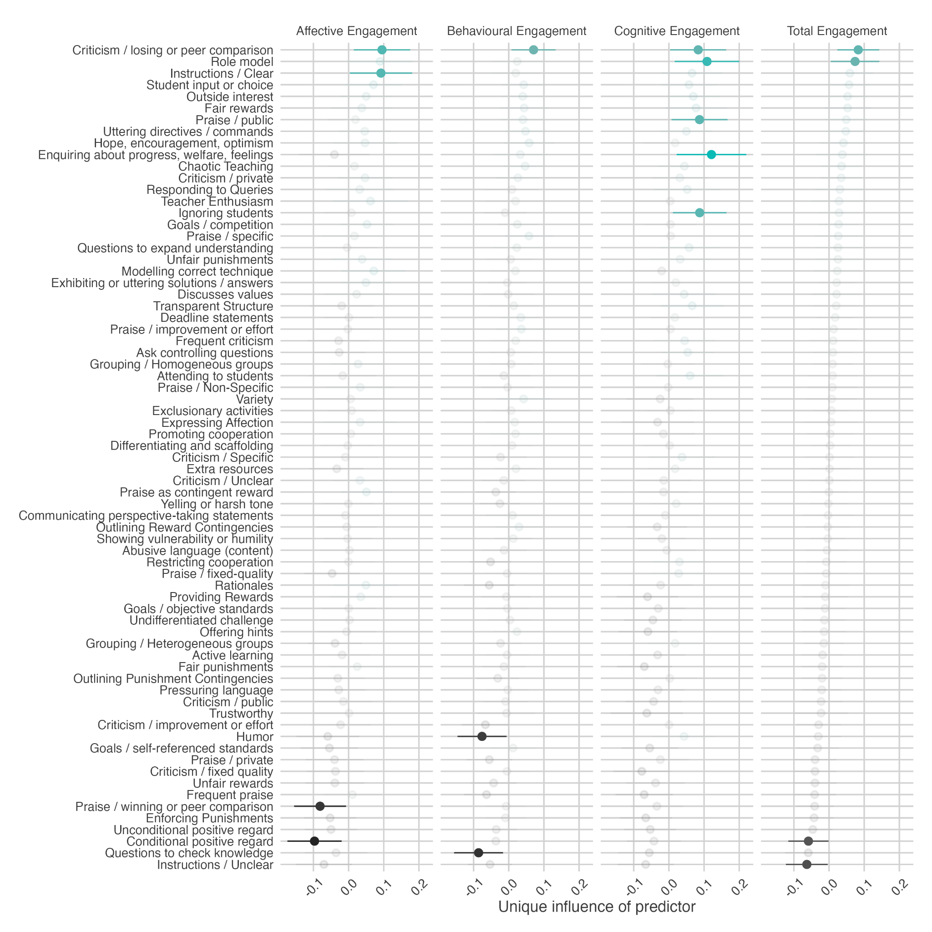
Supplementary Figure 2
Beta-Values for Ordinary Linear Regression Predicting Change in Engagement, with 95% Confidence Intervals

Note: coefficients in light grey were included in the model but not statistically significant

