SUPPLEMENTARY INFORMATION
The Associations Between Discrete Emotions and Political Learning: A Cross-Disciplinary Systematic Review and Meta-Analysis

Content
Appendix A Search Strategy 3
Appendix B Coding Scheme 10
Appendix C Coding 31
Appendix D Risk of Bias Quality Assessment 34
Appendix E Study Description 36
Appendix F Forest Plots 47
Appendix G Results of the Analysis of Variance Components 57
Appendix H Additional Analysis 59
H1. Bayesian Regularized Meta-Analysis 59
H2. Moderator Analysis for Learning Category 61
Appendix I Funnel Plots 63

Appendix A Search Strategy
This chapter describes the search strategy planned for the systematic review and meta-analysis on the associations between discrete emotions and political learning. It was developed before pre-registration and includes literature search within databases, citations, conference proceedings, bibliography and consultation of authors. Search strings were pre-tested in various databases. The search was conducted in winter 2020/2021. Any updates during the research process deviating from the initially planned search are documented here.

- Literature Search within Databases
The literature search was conducted in the databases PsycInfo, IBSS, ERIC, ProQuest Dissertation and Thesis, ProQuest Education and Politics collection using two different English and one German search term.

  - Search terms
Search terms are based on emotions and terms used in prior literature, i.e. in scales on achievement emotions (Pekrun et al., 2011) and epistemic emotions (Pekrun et al., 2017) and the literature on emotions in politics (reviews on emotions and politics: Groenendyk, 2011; Marcus & MacKuen, 1993; studies on political learning: Park, 2015; Valentino et al., 2008). Additionally, we added relevant controlled vocabulary from the thesauri of ProQuest and PsycInfo (controlled vocabulary for “emotions”, “learning”, “politics”, and “civic education”). We combined these terms for the following English and German search strings.

Search String for PsycInfo (Search within titles and abstracts, no other restrictions)
No. | Search String
A1 | (Emotion* OR affective OR "negative affect" OR  anxiety OR fear OR enthusiasm OR anger OR pride OR hope OR shame OR hopelessness OR sadness OR curiosity OR surprise OR enjoyment OR confusion OR frustration OR boredom OR worry OR satisfaction OR disgust OR happiness OR  anxious OR fearful OR enthusiastic OR angry OR proud OR hopeful OR hopeless OR sad OR curious OR surprised OR enjoyed OR confused OR frustrated OR bored OR worried OR satisfied OR disgusted OR happy OR afraid OR uneasy OR  apathy OR grief OR hate OR loneliness OR sympathy OR rage OR hostility OR agitation OR antipathy OR dislike OR disappointment OR distress OR doubt OR embarrassment OR euphoria OR gratitude OR guilt OR regret OR suspicion OR  apathetic OR lonely OR sympathetic OR hostile OR antipathetic OR disappointed OR embarrassed OR euphoric OR grateful OR guilty OR suspicious)
A2 | ("political learning" OR "civic learning" OR "citizenship education" OR "information seeking" OR "information acquisition" OR "attention to politics" OR "political discussions" OR "political knowledge" OR "learn about politic*" OR "learn about civic*" OR "search for information" OR "discuss politic*" OR "discussion of politic*" OR "seek information")
A3 | A1 ADJ10 A2
A4 | Politic*
A5 | A3 AND A4

Search String for IBSS, ERIC, ProQuest Dissertation and Thesis, ProQuest Education and Politics collection (Search within titles and abstracts, no other restrictions)
No. | Search String
B1 | (Emotion* OR affective OR "negative affect" OR  anxiety OR fear OR enthusiasm OR anger OR pride OR hope OR shame OR hopelessness OR sadness OR curiosity OR surprise OR enjoyment OR confusion OR frustration OR boredom OR worry OR satisfaction OR disgust OR happiness OR  anxious OR fearful OR enthusiastic OR angry OR proud OR hopeful OR hopeless OR sad OR curious OR surprised OR enjoyed OR confused OR frustrated OR bored OR worried OR satisfied OR disgusted OR happy OR afraid OR uneasy OR  apathy OR grief OR hate OR loneliness OR sympathy OR rage OR hostility OR agitation OR antipathy OR dislike OR disappointment OR distress OR doubt OR embarrassment OR euphoria OR gratitude OR guilt OR regret OR suspicion OR  apathetic OR lonely OR sympathetic OR hostile OR antipathetic OR disappointed OR embarrassed OR euphoric OR grateful OR guilty OR suspicious)
B2 | ("political learning" OR "civic learning" OR "citizenship education" OR "information seeking" OR "information acquisition" OR "attention to politics" OR "political discussions" OR "political knowledge" OR "learn about politic*" OR "learn about civic*" OR "search for information" OR "discuss politic*" OR "discussion of politic*" OR "seek information")
B3 | B1 NEAR/10 B2
B4 | Politic*
B5 | B3 AND B4

Search Term for PsycInfo, IBSS, ERIC, ProQuest Dissertation and Thesis, ProQuest Education and Politics collection (Search within titles and abstracts, no other restrictions)
No. | Search String
C1 | (Emotionen OR Affekt OR Gefuehle OR  Angst OR Furcht OR Enthusiasmus OR Aerger OR Stolz OR Hoffnung OR Scham OR Hoffnungslosigkeit OR Traurigkeit OR Neugierde OR Ueberraschung OR Spass OR Verwirrung OR Frust OR Langeweile OR Sorge OR Zufriedenheit OR Ekel OR Freude OR Furcht OR  Aengstlich OR furchterregt OR enthusiastisch OR veraergert OR hoffnungsvoll OR hoffnungslos OR traurig OR neugierig OR ueberrascht OR lustig OR freudig OR verwirrt OR frustriert OR gelangweilt OR besorgt OR zufrieden OR ekelhaft OR gluecklich OR unwohl OR  Apathie OR Trauer OR Hass OR Einsamkeit OR Mitleid OR Wut OR Feindseligkeit OR Aufregung OR Abneigung OR Enttaeuschung OR Stress OR Zweifel OR Scham OR Euphorie OR Dankbarkeit OR Schuld OR Bedauern OR  Apathisch OR wuetend OR feindselig OR einsam OR aufgeregt OR abgeneigt OR enttaeuscht OR gestresst OR zweifeln OR schaemen OR euphorisch OR dankbar OR schuldig)
C2 | (Lernen OR Wissen OR Informationssuche OR Aufmerksamkeit OR Diskussionen OR Politikunterricht OR "Politische Bildung")
C3 | C1 AND C2
C4 | (Politik OR politisch)
C5 | C3 AND C4

- Citation Search
  - Citation Search (backwards)
Papers cited by reviews (Brader & Marcus, 2013; Groenendyk, 2011) which specifically address the research question were included in the meta-analysis.
  - Citation Index (forwards): via web of knowledge, Scopus and Google Scholar
A central theory for emotions and political learning often cited in political science is the Theory of Affective Intelligence (Marcus et al., 2000). Although the theory mainly focuses on political judgement, it also makes important predictions on concepts like information seeking and learning (Brader, 2011). Therefore, we expected a large number of papers on the topic to refer to this theory, even if they use a different perspective (e.g., appraisal theories, as for example in Huddy et al., 2007). Google scholar results show 2,037 citations of the book. The results were filtered again by using the search term on learning and the remaining articles were screened for inclusion and exclusion criteria. Additionally, the citation index of papers directly referring to political learning were analyzed:
- Marcus, G. E., & MacKuen, M. B. (1993). Anxiety, enthusiasm, and the vote: The emotional underpinnings of learning and involvement during presidential campaigns. American Political Science Review, 87(3), 672–685.
- Nadeau, R., Niemi, R. G., & Amato, T. (1995). Emotions, Issue Importance, and Political Learning. American Journal of Political Science, 39(3), 558. https://doi.org/10.2307/2111644
- Valentino, N. A., Hutchings, V. L., Banks, A. J., & Davis, A. K. (2008). Is a Worried Citizen a Good Citizen? Emotions, Political Information Seeking, and Learning via the Internet. Political Psychology, 29(2), 247–273. https://doi.org/10.1111/j.1467-9221.2008.00625.x

- Author Search/Consultation
There are some researchers at the University of Vienna working in the field of political psychology and political communication, and more specific also emotions. As a starting point, we contacted them whether they know important (non-published) works on the topic or researchers working on it.

- Conference Proceedings
Some conference papers and proceedings might already be found when searching the databases. Additionally, we searched in conference proceedings of the following conferences:
- Annual Meeting of the International Society of Political Psychology
- APSA (American Political Science Association)
- EARLI (European Association for Research on Learning and Instruction)
- ICA (International Communication Association)
- AERA (American Educational Research Association, added during revision in 2023)
- GEBF (Society for Empirical Educational Research, added during revision in 2023)
- GPJE (Society for Civic Education Didactics and Civic Youth and Adult Education, added during revision in 2023)

- Bibliography
Further, we screened for publications in bibliographies of researchers who published frequently on the topic, for example, George Marcus, Eric Groenendyk.
  - Hand-searching of key-journals
- Political Psychology
- Journal of Social and Political Psychology
- Cognition and Emotion
- Political Communication
- Journal of Affective Science (special issue on emotions in Socio-Political contexts planned for mid 2021)

References
Brader, T. (2011). The political relevance of emotions: “Reassessing” revisited. Political Psychology, 32(2), 337–346. https://doi.org/10.1111/j.1467-9221.2010.00803.x
Brader, T., & Marcus, G. E. (2013). Emotion and political psychology. In L. Huddy, D. O. Sears, & J. S. Levy (Eds.), The Oxford Handbook of Political Psychology (pp. 156–204). Oxford University Press.
Groenendyk, E. (2011). Current emotion research in political science: How emotions help democracy overcome its collective action problem. Emotion Review, 3(4), 455–463. https://doi.org/10.1177/1754073911410746
Huddy, L., Feldman, S., & Cassese, E. (2007). On the distinct political effects of anxiety and anger. In W. R. Neuman (Ed.), The Affect Effect: Dynamics of Emotion in Political Thinking and Behavior (pp. 202–230). University of Chicago Press;
Marcus, G. E., & MacKuen, M. B. (1993). Anxiety, enthusiasm, and the vote: The emotional underpinnings of learning and involvement during presidential campaigns. American Political Science Review, 87(3), 672–685.
Marcus, G. E., Neuman, W. R., & MacKuen, M. (2000). Affective intelligence and political judgment. University of Chicago Press.
Park, C. S. (2015). Applying “negativity bias” to twitter: Negative news on twitter, emotions, and political learning. Journal of Information Technology & Politics, 12(4), 342–359. https://doi.org/10.1080/19331681.2015.1100225
Pekrun, R., Goetz, T., Frenzel, A. C., Barchfeld, P., & Perry, R. P. (2011). Measuring emotions in students’ learning and performance: The Achievement Emotions Questionnaire (AEQ). Contemporary Educational Psychology, 36(1), 36–48. https://doi.org/10.1016/j.cedpsych.2010.10.002
Pekrun, R., Vogl, E., Muis, K. R., & Sinatra, G. M. (2017). Measuring emotions during epistemic activities: The Epistemically-Related Emotion Scales. Cognition and Emotion, 31(6), 1268–1276. https://doi.org/10.1080/02699931.2016.1204989
Valentino, N. A., Hutchings, V. L., Banks, A. J., & Davis, A. K. (2008). Is a worried citizen a good citizen? Emotions, political information seeking, and learning via the internet. Political Psychology, 29(2), 247–273. https://doi.org/10.1111/j.1467-9221.2008.00625.x

Appendix B Coding Scheme
Coding was done on three different levels:
- Article Level: Meta-Data and Theory
- Study Level
- Effect-Size Level
We used excel files with makros which assist in multiplicating the entries for each subsequent level. After finishing one level, rows are multiplicated automatically to the next tab by clicking on “Multiply Entries”. Afterwards, the next level is coded.
Exclusion of Studies: If during the coding process additional exclusion criteria are met by the study, there is still the possibility to exclude it when coding the first level. Only studies where the column “Eligible?” is “YES” will be multiplicated.
The File is organized according to the three steps of coding, and the levels are separated in the different sheets of the file. The grey-coloured sheets are used for the drop-down menus and makros and mustn’t be edited. The background colours of the cells indicate how they need to be processed:
- Variables which need to be coded do not have a background colour. Cells with grey colour include formulas based on a column coded before. The formulas are used to automatically code the variable, but if they remain empty, they need to be coded manually.
- Green-coloured cells are those where the initial information on the article is inserted (Meta-level), or where the Makros copy the information from the meta-level according to the number of studies/effect sizes in an article.
- ID columns are coloured in the colour of the sheet (meta-level, study-level, effect-size-level). They include formulas which automatically calculate the ID for the specific level.
- Columns for comments are in bright yellow-orange colour. Here is place for every question or note taken during coding the specific level.

- Coding Scheme
In this section, all variables are described.
  - Meta-Data and Theory
V | Name | Type | Description | Coding
1 | coderID | Categorical | CoderID by initials, e.g. EG
2 | ID | Numeric | Individual ID per article/book/chapter/dissertation | Automatically
3 | authors | String | As stated in the reference | Automatically
4 | title | String | As stated in the reference | Automatically
5 | year | Numeric | Indicates the year when the study was published, taken from reference. | Automatically
6 | abstract | String |  | Automatically
7 | publication | Categorical | Type of publication  To find out whether a journal is peer reviewed, you can look it up in ulrichsweb | - Peer-reviewed Journal Article  - Journal Article  - Book chapter  - Book (monograph)  - Conference Paper  - Dissertation /thesis  - Published (other)  - Unpublished (other)
8 | focus | Dummy | Is the main focus of the study on the relation between (discrete) emotions and learning? | 1 – yes  0 - no
9 | aim | String | Aim of the study as stated in the article (purpose: use in qualitative synthesis, Systematic Review)
10 | theory | String | Theoretical approach of the study authors (e.g., appraisal theories, affective intelligence theory)
11 | n_studies | Numeric | Number of relevant studies included in the article/book/chapter/dissertation  - Variable 13 – 35 will be coded for each relevant study  Examples: (1) An article reports results of three different experiments conducted; (2) A study analyses two different datasets
12 | ELIGIBLE? | Categorical | All studies are already checked for eligibility criteria. If it still turns out that it is not eligible due to variables coded on this level, insert it here. If you would exclude it on a subsequent level, insert it there in the comment section. | YES  NO  UNCLEAR
13 | Discipline | Categorical | The discipline was coded retroactively the main coding process. It was based on the affiliation of the first author. If not indicated on the publication, coding is based on the CV or public profile of the first author. If a person has two equal affiliations in two different disciplines, a combination is coded. Categories were established along coding. | - Political science  - Communication science  - Psychology  - Political and Communication Science  - Social Science

  - Study Characteristics
V | Name | Type | Description | Coding
13 | studyID | String | combines ID with individual number per study; pattern: ID_Study-ID | Automatically from N_Studies
14 | primary | Dummy | Indicates whether study uses primary (1) or secondary data analysis (0) | 1 – Yes  0 - No
15 | datasource | Categorical | [if Primary = 0]: Data used in the study; new categories might be added | - ANES  - NAES  - Afrobarometer  - …
16 | datasource_y | Numeric | Year when data was collected; if more than one year is reported, use the year when data collection started; use “n.r.” if not reported
17 | datasource_wave | String | [if Primary = 0]: indicate wave used in the study (if applicable). If several waves are used, report wave used for effect size measure; if different waves are used for measures of emotion and learning, report both of them (“emotion: X, learning: Y”); if not applicable, use “n.a.” (inserted automatically if primary = 0)
18 | design | Categorical | General Study-Design, taken from the methods section. | - Cross-sectional  - Longitudinal  - Experimental  - other
19 | targetpop | Categorical | What was the target population of the study?  Revision: The electorate is coded as (1) adults. | - Adults  - College/university students  - Adolescents / high school students  - Other  - Not specified
20 | country | Categorical | Country, where the study was conducted. If the study is based on multiple countries, use the category “mixed”.  If country code is chosen with the form, assure that your active cell is on the right place to insert the code! | Choose from list of country-codes (click on button “code”; you can then search for the country by name)
21 | sampling | Categorical | Sampling strategy used in the study  Example: Code (1) Random if random digital dialling is used as a strategy to recruit participants  Revision: Online sampling service added as category (for e.g., Mechanical Turk, Qualtrics Samples) | - Random sample  - Stratified sample  - Clustered sample  - Online Sampling Service  - Snowball sample  - Convenience sample  (99) not mentioned
22 | samplesize | Numeric | Number of participants included in the sample, as reported in the methods-section.
23 | response | Dummy | Does the study report the response rate? Use “n.a.” if not applicable | 1 – Yes  0 - No
24 | exclusion | Dummy | Does the study report information about excluding participants? | 1 – Yes  0 - No
25 | missings | Dummy | Does the study report information about missing values? | 1 – Yes  0 - No
26 | rem_details | string | e.g., for response rate: percentage of responses of the initial sample; percentage of missing values for missings; number of excluded participants; if not reported, insert “n.r.”
27 | allocation | Categorical | [if Design = (3) Experimental]  How were participants allocated to the experimental conditions? For non-experimental designs, “n.a.” is used. | - Random  - Quasi-experimental  - Non-random
28 | age_m | Numeric | Mean age of the sample taken from the sample description.
29 | age_sd | Numeric | Standard deviation of the sample age taken from the sample description
30 | p_female | Numeric | Percentage of female participants in the sample taken from the sample description. If not reported, use “n.r.”
31 | p_male | Numeric | Percentage of male participants in the sample taken from the sample description. If not reported, use “n.r.”
32 | measure_e | Categorical | Kind of measurement of emotions, taken from the methods section.  If two measures are used (e.g. induced and additionally self-reported), choose (4) multiple | - Self-reported  - Physiological  - Induced  - Multiple  - other
33 | trait | Dummy | Indicates whether trait (1) or state (0) measure is used for emotion. Note that physiological or induced emotions (-> measure_e) are always state. | - Trait  - State
34 | Objectfocus_inf | Dummy | Object focus of the emotion measured – taken from the operationalization of emotions.  Are emotions related to an overall topic, or specific aspects of political information (e.g., incongruent information) which trigger the emotion? Use “YES” if it is focused on political information, and “NO” if it is not. | - YES  - NO
35 | objectfocus_top | Categorical | Object focus of the emotion measured – taken from the operationalization of emotions.  Note that non-political focus is an exclusion criterion NO EFFECT-SIZES NEED TO BE CODED (just leave n_emotions and n_learning blank). | - Political leaders/ candidates  - Policy issue  - Election & campaign  - General political situation  - Political event  - Other  - Non-political
37 | n_emotions | Numeric | How many discrete emotions are analysed in the study?
38 | n_learning | Numeric | How many learning-related measures are used in the study?

  - Effect-Sizes
V | Name | Type | Description | Coding
 | effectsizeID | String | combines Study-ID with individual number per effect size; pattern: ID_Study-ID_EffectSize-ID | Automatically from N_Emotions & N_Learning
 | emotions_str |  | How is the emotion named in the study?
 | emotion | Categorical | Which emotion is used for this effect size? | Chose emotion from emotion list
 | positive | Dummy | Is it a positive – meaning pleasant, comfortable or negative, unpleasant emotion?  (see definitions in Table 6.1) | - Positive  - Negative
 | activation | Dummy | Is it physiologically activating or deactivating?  (see definitions in Table 6.1) | - Activating  - deactivating
 | emotion_cat | Categorical | Which Category does the emotion belong to? Positive Activating, Negative Activating, Positive Deactivating or Negative Deactivating Emotion? | Automatically; 4 categories, combined by v16 & v17
 | items_e | Numeric | Number of items used to measure this emotion; if emotions are induced or measured physiologically, indicate “n.a.”
 | bidimensional | Dummy | Is a unidimensional (e.g. how anxious do you feel) or bi-dimensional scale used (e.g. from relaxed to excited, where would you place yourself?) | - Uni-dimensional  - Bi-dimensional
 | min_e | Numeric | The mimimum of the response scale used to measure emotions; use “n.a.” if no self-report measure was used
 | max_e | Numeric | The maximum of the response scale used to measure emotions; use “n.a.” if no self-report measure was used (see measure_e)
 | mean_e | Numeric | The mean of the emotion as reported in the descriptive statistics; if not applicable, use “n.a.”; if not reported, use “n.r.”
 | sd_e | numeric | The standard deviation of the emotion as reported in the descriptive statistics; if not applicable, use “n.a.”; if not reported, use “n.r.”
 | reliability_e_c | Categorical | Reliability of Emotions-Scale: Type of Coefficient (if reported);  Choose (6) not reported if no measure is reported, and (7) not applicable if type of measurement would not allow a reliability measure | (1) Cronbach’s Alpha  (2) McDonald’s Omega  (3) Test-Test-correlation  (4) Kappa  (5) Krippendorff’s Alpha  (6) other  (7) n. r.  (8) n. a.
 | reliability_e | Numeric | Reliability Coefficient of the Emotions-Scale – Magnitude of the reliability
 | learning | String | Which learning-related measure was used? Type how it is named in the primary study; if it limited to specific kind of information (see learning_limits_d), describe it here
 | learning_c | Categorical | Which learning-related measure was used? For detailed definition, see list of working definition (Table 6.2). | (1) Attention to politics /Media Use  - Information seeking  - information acquisition  - Discussions  - political knowledge
 | learning_limits_d | Dummy | Is learning general on politics/the object focus of the emotions or specific kind of politics (e.g., information in line with one’s attitudes / counter-attitudinal); if it includes limits, describe it in the string-variable (learning) | - YES (limited)  - NO
 | measure_l | Categorical | Kind of measurement of learning, taken from the methods section.  Examples: behavioural measures are e.g., clicks on news articles; recall tasks would be a test/assessment | - self-report  - behavioral  - test/assessment  - other
 | items_l | Numeric | Number of items used to measure learning; if not applicable, insert “n.a.”
 | min_l | Numeric | The minimum of the response scale used to measure learning; “n.a.” if no self-report measure was used (this is coded automatically, based on the category chosen for measure_l)
 | max_l | Numeric | The maximum of the response scale used to measure learning; “n.a.” if no self-report measure was used (this is coded automatically, based on the category chosen for measure_l)
 | mean_l | Numeric | The mean of learning reported in the descriptive statistics; if not applicable, use “n.a.”; if not reported, use “n.r.”
 | sd_l | Numeric | The standard deviation of learning as reported in the descriptive statistics; if not applicable, use “n.a.”; if not reported, use “n.r.”
 | reliability_l_c | Categorical | Reliability of the learning-scale: Type of coefficient (if reported) | (1) Cronbach’s Alpha  (2) test-test-correlation  (3) Kappa  other  (3) n. r.  (4) n. a.
 | reliability_l | Numeric | Reliability of the learning-scale – Magnitude of the reliability
 | n | Numeric | Sample size of the (sub-)sample which is used for the measure, if it deviates from before mentioned sample size.  If it is not reported, insert “n.r.”
 | es_design | Categorical | Study design on which the effect size is based. E.g., if the study generally has an experimental design, but the effect size is taken from two measures at the baseline, use “cross-sectional”; if the independent variable is affected by the manipulation, use “experimental”; In longitudinal studies, use “cross-sectional” if a relationship-measure is available from the first time point. | - Cross-sectional  - Longitudinal  - Experimental  - other
 | calc_method | Categorical | Is the effect size based on calculating and effect size based on a relationship (e.g., Pearson’s R, taken from a Regression) or on comparison of means (e.g. t-test, ANOVA)? This question is decisive for which of the following variables need to be coded; those not dedicated to the respective method will automatically include “n.a.” | - relationship  - means
 | measure | Categorical | Type of measure used for the relationship;  Note that (6) will be excluded for quantitative synthesis | - correlation (unspecified)  - Pearson’s R  - Spearman’s ρ  - Kendall’s τ  - Latent correlation  - Bivariate Regression Coefficient  - Standardized Beta  - Partial Correlation  - Unstandardized Beta  - Odds Ratio from Logistic Regression
 | direction | Categorical | Is there a direction implied by the statistical model? Use “none” for bivariate correlations, and 2 or 3 for regressions depending on the predictors and outcomes used in the study | - None  - Emotions to learning  - Learning to emotions
 | controls | Numeric | [if 29 == Standardized Beta, Partial Correlation or unstandardized Beta]: Number of control variables included; otherwise use “n.a.”; If other emotions are included in the same model, mention them in the model_comment;
 | effect_size | Numeric | Size of the effect size (correlational); if a different effect size is used, insert “n.a.”
 | effect_size_se | Numeric | Standard error of the effect size.
 | p-value_c_exact | Numeric | What was the exact p-value? Insert with as many digits as reported; if it is reported only verbal (e.g. “significant relationship”) or stars, use “n.r.” und indicate the corresponding category in “p-value_c_cat”
 | p-value_c_cat | Categorical | This variable is automatically calculated from the variable “p-value_c_exact”, unsless “n.r.” is chosen; then chose the corresponding category via drop-down menu; use “n.s.” for “not significant” if no significance level is reported, but stated in the text that the effect is not significant | - below 0.001  - below 0.01  - below 0.05  - below 0.1  (5) above 0.1  (6) n.s.  (7) n.r.  (8) n.a.
 | model_comments | String | Indicate any special model features, e.g., moderator terms or mediation; other emotions as controls,…  Please do not leave this blank, but include “none” if you do not have any comment on the model.
 | m_emg | Numeric | For experimental designs: Mean of learning within the emotion (experimental) group
 | sd_emg | Numeric | For experimental designs: SD of learning within the emotion (experimental) group
 | n_emg | Numeric | For experimental designs: number of participants within the emotion (experimental) group
 | controlgroup | String | Type of control group (e.g. no-emotion induced, relaxation, …) – describe it shortly
 | m_cg | Numeric | For experimental designs: Mean of learning within the control group
 | sd_cg | Numeric | For experimental designs: SD of learning within the control group
 | n_cg | Numeric | For experimental designs: number of participants within the control group
 | statistic | Categorical | For experimental designs: which test-statistic is reported? | - t  - F  - χ²
 | df | Numeric | Degrees of freedom reported in the test statistic
 | value | Numeric | t-/F-/ χ²-value
 | Comments
 | Contact_address | String | url of published data or e-mail of author contacted (anonymized to “mail@” in published data)
 | contacted | Date | Date of contact
 | measure_contacted | Categorical | Type of measure received through author consultation / using published data
 | effect_size_contacted | Numeric | Effect size received through author consultation / using published data
 | p-value_contacted | Numeric | p-value received through author consultation / using published data
 | N_contacted | Numeric | Number of observations in calculation received through author consultation / using published data
 | dir_diff_c | Categorical | Direction of the effect received through author consultation / using published data (if using t-test): 1 = higher in emotion group, -1 = higher in control group
 | dataID | Categorical | Mirrors studyID, unless same data is used in two studies -> one ID

- Missing Values
For missing values, two different categories are used:
- “n.a.”: not applicable – for variables which can’t be coded due to specific dependencies (e.g. allocation in a non-experimental design)
- “n.r.”: not reported – for variables which can’t be coded due to missing information in the original study

- Working Definitions
  - Emotions
Emotion | Category | Definition
positive | Positive-activating | Only used if effect sizes are not reported on discrete emotion level, but can be differentiated as either positive-activating or positive-deactivating (concerned only to activating emotions in the included studies).
negative | Negative-activating | Only used if effect sizes are not reported on discrete emotion level, but can be differentiated as either negative-activating or negative-deactivating (concerned only to activating emotions in the included studies).
anger | Negative-activating | Outcome or activity emotion (Pekrun & Stephens, 2012), high in arousal (Russel, 1980)
anxiety | Negative-activating | Prospective outcome emotion (Pekrun & Stephens, 2012); includes fear and fright
fear | Negative-activating | Being afraid is rated high in distress (Russel, 1980) – activating; can be grouped with anxiety
boredom | Negative-deactivating | Activity emotion (Pekrun & Stephens, 2012)
curiosity | Positive-activating | Positive, though valence might vary regarding the emotion-eliciting event (Pekrun & Loderer, 2020)
disgust | Negative-activating | Same place in circumplex structure as fear, anger, and embarrassment (Russel & Feldman Barrett, 1999)
enjoyment | Positive-activating | Activity emotion (Pekrun & Stephens, 2012); includes “happy”
enthusiasm | Positive-activating | “blend of pleasure and arousal” (Russel & Feldman Barrett, 1999, p. 811)
frustration | Negative-activating | Can be both, activating or deactivating (Pekrun & Loderer, 2020) – depending whether it is more directed towards anger or disappointment; activity and epistemic emotion
surprise | positive-activating | Can be either positive or negative (Pekrun & Loderer, 2020)
confusion | Negative-activating | (Pekrun & Loderer, 2020)
hope | Positive-activating | Retrospective outcome emotions (Pekrun & Stephens, 2012)
hopelessness | Negative-deactivating | Prospective outcome emotion, attributed to stable cause (Pekrun & Stephens, 2012)
Pride | Positive-activating | Retrospective outcome emotions
Sadness | Negative-deactivating | Pekrun & Stephens (2012); deactivating retrospective outcome emotion (Pekrun et al., 2023)
Shame | Negative-activating | Retrospective emotion (Pekrun, 2018; Pekrun & Loderer, 2020)
Aversion | Negative-activating | Differentiation of anger: not an approach-emotion
Hatred | Negative-activating | Social emotion (Pekrun & Loderer, 2020)
Compassion | Positive-activating
Guilt | Negative-deactivating | Pekrun et al. (2023)
Content | Positive-deactivating | Pekrun & Stephens (2012); Russel (1980)

  - Learning Categories
Learning | Definition
Attention to politics | Media use (for example number of days one is exposed to television, radio, internet or newspapers), and media use specific to politics, e.g., debate viewing or election campaigns
Information Seeking | Behavioural: often measured by process tracing methods, e.g., mock websites; information seeking is often operationalized as the number of clicks, or time spent on websites
Discussions | Political discussions, often measured by the frequency and different items focusing on several social groups – e.g., family, friends, at work;
Knowledge | Issue knowledge (often measured by multiple items asking where to place two opposing candidates, and by comparing their placements – that the “left” candidate is placed left to the other), classical knowledge tests (e.g., multiple choice questions about the political system, candidates, parties, …)
Learning (= Knowledge Gain in the final publication) | Change/gain in knowledge, either by adjusting for prior knowledge or by measuring information acquisition – knowledge of new information which was presented directly in the study or experiment

Appendix C Coding
The following table shows the agreement rates and Krippendorf’s α and how we handled disagreement of coded variables. Note that variables which assessed the effect size from studies comparing means were excluded from this table as this applied to none of the double-coded sample.
Table C1
Reliability and processing of disagreement for coded variables
Variable | N (%) | AR | Kripp. α | Comment
Publication level (N = 8)
publication | 8 | 100 | 1.00
focus | 8 | 37 | -0.190 | not relevant, dropped
Study level (N = 9)
datasource_y | 8 | 75 | 0.995
design | 8 | 100 | 1.000
targetpop | 8 | 25 | -0.023 | focus on actual sample, electorate and
 |  |  |  | adults combined to one group - revised
country | 8 | 87 | 0.717
sampling | 8 | 62 | 0.262
samplesize | 8 | 87 | 0.951
allocation | 8 | 75 | 0.524 | disagreement due to coding not reported
age_m | 8 | 75 | 1.000
age_sd | 8 | 87 | 1.000
p_female | 8 | 87 | 0.960
p_male | 8 | 62 | 1.000
measure_e | 8 | 75 | 0.423 | disagreement from coding ‘multiple’ - re-
 |  |  |  | vised

Table C1
(continued)
Variable | N (%) | AR | Kripp. α | Comment
trait | 8 | 75 | -0.071 | revised with clearer rules
object_focus | 8 | 50 | 0.318 | revised with clearer rules
Effect-size level (N = 49)
emotion_str | 36 | 100 | 1.000
items_e | 36 | 94 | 1.000
bidimensional | 36 | 100 |  | only bidemimensional measures included
min_e | 36 | 86 | 0.878
max_e | 36 | 92 | 1.000
mean_e | 36 | 81 | 0.934
sd_e | 36 | 81 | 0.992
reliability_e_c | 36 | 94 | 0.884
reliability_e | 36 | 81 | 0.498 | mixed up numbers and rows - revised
learning_c | 36 | 83 | 0.738 | disagreement between ‘information acqui-
 |  |  |  | sition’ and ‘knowledge’ - combined to one
 |  |  |  | category
Learning_limits_d | 36 | 14 | -0.732 | different rules applied, resolved by discus-
 |  |  |  | sion
measure_l | 36 | 100 | 1.000
items_l | 36 | 92 | 0.908
min_l | 36 | 100 | 1.000
max_l | 36 | 100 | 1.000
mean_l | 36 | 44 | 1.000
sd_l | 36 | 44 | 1.000
reliability_l_c | 36 | 100 | 1.000

Table C1
(continued)
Variable | N (%) | AR | Kripp. α | Comment
reliability_l | 36 | 100 | 1.000
n | 36 | 25 | 0.811 | wrong formula used, range coded - revised
 |  |  |  | with lower bound
es_design | 36 | 25 | -0.578 | different rules applied, resolved by discus-
 |  |  |  | sion
calc_method | 36 | 100
measure | 36 | 42 | 0.047 | disagreement from ‘Pearson’s R’ versus
 |  |  |  | ‘Correlation (unspecified)’ and ‘Bivariate
 |  |  |  | Regression Coefficient’ and ‘Unstandard-
 |  |  |  | ized Beta’
direction | 36 | 89 | 0.743
controls | 32 | 94 | 0.942
effect_size | 36 | 92 | 1.000
effect_size_se | 36 | 89 | 1.000
p-value_c_exact | 36 | 97 | 1.000
p-value_c_at | 36 | 92 | 0.900
Note. AR = Agreement rate, N (%) is the number of entries used to calculate the agreement rate (missing values are deleted listwise).

Appendix D Risk of Bias Quality Assessment
We used the following rules for classifying coded variables into high and low risk of bias:
- Bias due to sampling:
  - low risk: Random sample, clustered sample, online sampling service, stratified sample
  - high risk: convenience sample, snowball sample
- Bias due to response rate: values of 75% and higher are coded as low risk (based on the MERSQI-scale, where full points are allocated in line with this threshold; Reed et al., 2008), values below are coded as high risk
- Bias due to missings: if reported percentage of missing values is below 5%, risk of bias is coded as low risk (Graham, 2008)
- Bias due to measurement error: according to general recommendations on reliability of scale measures (see for example, Moosbrugger & Kelava, 2012, p. 683), values above .7 are coded as low risk

Figure D1
Risk of Bias Assessment
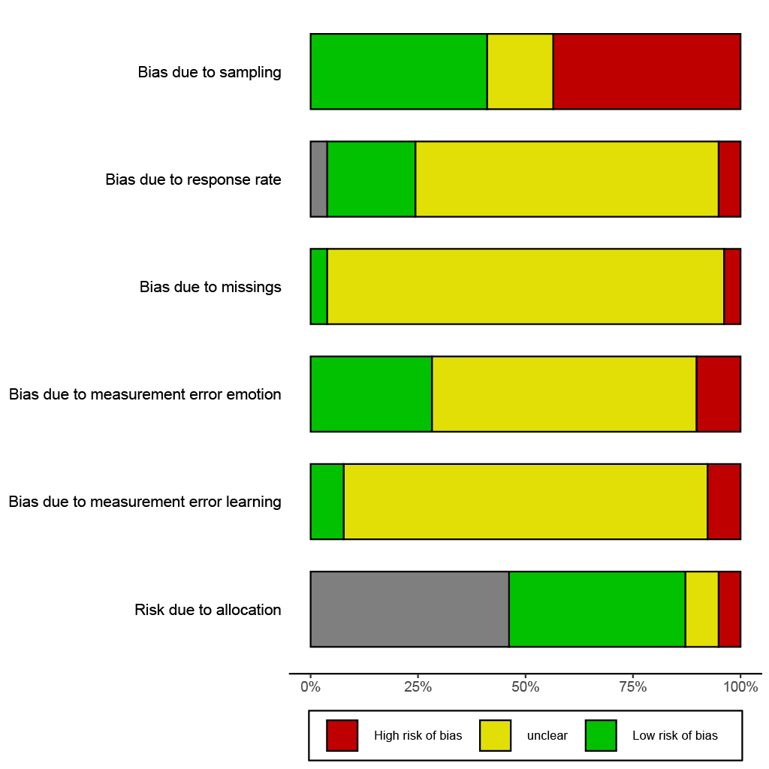
Note. For detailed coding description, please consult the supporting information. Studies where an assessment of the risk of bias was not applicable to the respective categories are displayed in gray.

Appendix E Study Description

Table E1
Summary of included studies
Study | Publication Type | Aim | Sample | Emotion | Learning
Zweigenhaft (1986) | p.r. Article | explore the relations between nuclear knowledge and anxiety about a nuclear war, expectations and attitudes | N = 1115, other, multiple | anxiety | Knowledge
Boehnke (1989) | p.r. Article | how adolescents experience nuclear threat and how it affects various (psycho-social and health-related) outcomes | N = 3499, adolescents / high school students, Germany | anxiety | Knowledge
Marcus (1993) | p.r. Article | aim to incorporate emotions (anxiety and enthusiasm) into information-processing models of citizens during elections | N = n.r., adults, USA | enthusiasm, anxiety | Learning, Attention to politics
Nadeau (1995) | p.r. Article | analyze the effect of anxiety on learning, test its mediation through issue importance and a moderation with hope | N = n.r., adolescents / high school students, Canada | anxiety, hope | Knowledge
Lee (2000) | Diss. / Thesis | examine how cognitive appraisals of candidates produce discrete emotions (fear, anger, happiness, pride) and how these relate to political learning, participation and attitudes towards candidates | N = 517, adults, USA | anger, hope, anxiety, pride | Knowledge
Marcus (2000) | Book | set up a two-system theory of emotional functioning in the context of elections, in order to explain political behavior, party identification, symbolic politics, and negative campaigning | N = 10682, adults, USA | anxiety, enthusiasm | Attention to politics, Knowledge
Chaffee (2001), study 1 | p.r. Article | attention to counter-attitudinal messages | N = 430, adults, USA | curiosity | Attention to politics
Chaffee (2001), study 2 | p.r. Article | attention to counter-attitudinal messages | N = 417, adolescents / high school students, USA | curiosity | Attention to politics
Hullett (2003) | p.r. Article | analyze effects of voters' emotions on attitudes, involvement, and learning of candidates statement at a debate | N = 81, not specified, USA | anger, anxiety, enthusiasm | Attention to politics, Learning
Wolak (2003) | Conf. paper | analyze what elicits emotions in politics (political issues, different news constructions) | N = 341, college/university students, USA | anxiety, enthusiasm, aversion | Information Seeking
Brader (2006) | Book | show through emotions the motivational and persuasive power of campaign ads | N = 286, adults, USA | anxiety, enthusiasm | Attention to politics, Learning, Information Seeking
Hutchings (2006) | Book Chapter | analyze how group cues in a campaign elicit emotion which in turn affect candidate evaluation and learning in a campaign | N = 198, adults, USA | anxiety | Knowledge
Capelos (2007), study 1 | Conf. paper | test AIT in the context of Dutch parliamentary democracy - influence of heuristics vs preferences on party evaluation | N = 244, adults, Netherlands | anxiety | Attention to politics, Knowledge
Capelos (2007), study 2 | Conf. paper | test AIT in the context of Dutch parliamentary democracy - influence of heuristics vs preferences on party evaluation | N = 3178, adults, Netherlands | anxiety | Discussions, Attention to politics
Gadarian (2007) | Conf. paper | experiment in the context of immigration: effects of anxiety on information seeking, differentiate between threatening and non-threatening news | N = 52, college/university students, USA | enthusiasm, anxiety | Information Seeking, Learning
Huddy (2007) | Book Chapter | show distinct effects of anxiety and anger on political beliefs and actions | N = 1071, adults, USA | anger, anxiety | Discussions, Information Seeking
Redlawsk (2007) | Book Chapter | investigate how initial feelings toward a candidate influence evaluation of information; how emotional reactions to the information influence learning; in a dynamic process tracing environment | N = 117, college/university students, USA | anger, anxiety, enthusiasm | Information Seeking, Knowledge
Surawski (2007) | Diss. / Thesis | analyze effects of threat on preferences for information | N = 302, college/university students, USA | anxiety | Information Seeking
Brader (2008) | p.r. Article | analyze how group cues on immigration issues affect opinions and action, mediated through emotions | N = 354, adults, USA | anxiety | Information Seeking
Valentino (2008), study 1 | p.r. Article | analyze whether emotions (anxiety and anger) mediate effects of threat on information seeking | N = 408, adults, USA | anger, anxiety, enthusiasm | Attention to politics, Information Seeking
Valentino (2008), study 2 | p.r. Article | analyze whether emotions (anxiety and anger) mediate effects of threat on information seeking | N = 101, adults, USA | anxiety, anger, enthusiasm, disgust | Information Seeking
Williams (2008) | Diss. / Thesis | analyze effects of anxiety on information seeking and voting by replicating studies by Marcus et al. | N = n.r., adults, USA | anxiety, enthusiasm | Knowledge
Civettini (2009) | p.r. Article | experimental study on whether anxiety influences information remembered at the time of voting in a dynamic process tracing environment | N = 189, adults, USA | enthusiasm, anxiety, anger | Learning
McClain (2009) | p.r. Article | test a predictive model on effect of enthusiasm and anxiety on behavioral and information seeking outcomes regarding stem cell research, an issue salient in the 2008 elections | N = 100, college/university students, USA | enthusiasm, anxiety, anger | Information Seeking, Discussions
Valentino (2009) | p.r. Article | aim to explain what explains biased versus balanced information seeking | N = 305, adults, USA | anger, anxiety | Information Seeking, Knowledge
Albertson (2010) | Conf. paper | testing how anxiety affects trust and learning about health issues | N = 156, college/university students, | anxiety | Information Seeking, Learning
MacKuen (2010) | Conf. paper | aim to compare effects of personality traits and emotions on political attention, steadfastness of views and inclination towards compromise using a survey experiment | N = 1545, adults, USA | enthusiasm, aversion, anxiety | Information Seeking
MacKuen (2010) | p.r. Article | aim to analyze the effect of emotions on the type of citizenship practiced (loyal partisan solidarity versus open-minded deliberation) | N = 2015, college/university students, USA | anxiety, enthusiasm, aversion | Information Seeking
Schoen (2010) | p.r. Article | Analyzes the relations between anxiety related to the economic crisis and decision making during elections in Germany 2009 | N = 2173, adults, Germany | anxiety | Attention to politics, Discussions
Landreville (2011) | p.r. Article | analyzes how political entertainment film and negative emotions are related to discussion intent of the film | N = 302, college/university students, USA | anger, disgust, sadness, guilt, anxiety | Discussions
MacKuen (2011), study 1 | Conf. paper | experimental panel design to investigate effects of news stories on emotional responses and information seeking over time | N = 1026, adults, USA | anxiety, aversion, enthusiasm | Attention to politics, Information Seeking
MacKuen (2011), study 2 | Conf. paper | experimental panel design to investigate effects of news stories on emotional responses and information seeking over time | N = 1047, adults, USA | anxiety, aversion, enthusiasm | Attention to politics, Information Seeking
Sirin (2011) | p.r. Article | aim to explore effects of political information and anger on participant's cognitive processing and policy preferences | N = 188, college/university students, USA | anger | Information Seeking
Valenzuela (2011), study 1 | Diss. / Thesis | aims to understand the process how emotions enable people to learn about public affairs | N = 2586, adults, USA | positive-activating, negative-activating | Attention to politics, Discussions, Knowledge
Valenzuela (2011), study 2 | Diss. / Thesis | aims to understand the process how emotions enable people to learn about public affairs | N = 415, adults, USA | negative-activating | Attention to politics, Discussions, Knowledge
Ryan (2012), study 1 | p.r. Article | analyze effects of evoked anger on information seeking | N = n.r., adults, USA | anxiety, anger | Information Seeking
Ryan (2012), study 2 | p.r. Article | analyze effects of evoked anger on information seeking | N = n.r., adults, USA | anxiety, anger | Information Seeking
Ryan (2012), study 3 | p.r. Article | analyze effects of evoked anger on information seeking | N = n.r., adults, USA | anger | Information Seeking
Schemer (2012) | p.r. Article | analyze reinforcing spirals of affective responses towards asylum seekers (anxiety and anger) on attention to political advertisements in a campaign on the issues of asylum | N = 1725, adults, Switzerland | negative-activating | Attention to politics
Weber (2013) | p.r. Article | analyze effects of discrete emotions (anger, sadness, fear and enthusiasm in emotional adds) on political participation | N = 656, not specified, USA | anger, sadness, anxiety, enthusiasm | Attention to politics, Discussions
Cohen-Chen (2014) | p.r. Article | hypothesize opposite effects of hope and fear on information processing in the context of peace for the Israeli-Palestinian conflict | N = 222, other, Israel | hope, anxiety, compassion, hatred | Information Seeking
Han (2014) | Diss. / Thesis | examination of the role of bias-induced emotions (anxiety and anger) in partisan information seeking and the role of anger expression and issues novelty in partisan emotional responses | N = 243, college/university students, USA | anger, anxiety | Information Seeking
Obermaier (2014) | Article | analyze effects of induced emotions (anger, anxiety and enthusiasm) on participation, and information seeking | N = 249, college/university students, Germany | enthusiasm, anxiety, anger | Information Seeking
Albertson (2015) | Book | analyze how anxiety affects information processing/focus on threatening information on the issue of migration | N = 384, adults, USA | anxiety | Information Seeking, Learning
Chadwick (2015) | p.r. Article | use factorial survey design to analyze appraisals of hope (importance, goal congruence, future expectations and possibility of climate protection) and persuasive outcomes | N = 245, college/university students, | hope | Attention to politics
Park (2015) | p.r. Article | investigate the effect of negative twitter news on participants emotions, cognitive and behavioral responses | N = 420, other, South Korea | anger, anxiety, disgust | Information Seeking, Learning
Valenzuela (2015), study 1 | p.r. Article | analyze relations between emotions (pride and anger) and discussions with people with different opinions | N = 1737, adults, Chile | pride, anger | Discussions
Valenzuela (2015), study 2 | p.r. Article | analyze relations between emotions (pride and anger) and discussions with people with different opinions | N = 1457, adults, USA | pride, anger | Discussions
Valenzuela (2015), study 3 | p.r. Article | analyze relations between emotions (pride and anger) and discussions with people with different opinions | N = 999, adults, Switzerland | pride, anger | Discussions
Wang (2015) | p.r. Article | analyze reactions to a public health crisis - surprise as initial emotional reactions on information seeking and vaccination behavior | N = 205, college/university students, USA | surprise | Information Seeking
Calfano (2016) | p.r. Article | AIT outside the partisan context: analyze the effect of anxiety on information seeking and validating sought information | N = 330, adults, USA | anxiety | Information Seeking
Cheung-Blunden (2016) | p.r. Article | analyze the effect of anxiety during cyber attacks on information processing/memory | N = 130, college/university students, USA | anxiety, anger | Knowledge
Kim (2016) | p.r. Article | analyze in an experimental design how induced anger and information provided influences participation in a debate and post-deliberation outcomes | N = 237, college/university students, | anger | Discussions, Knowledge
Ditonto (2017) | Article | test implications of various theories in a dynamic process tracing environment - what motivates to switch from System 1 to System 2 processing | N = 473, not specified, USA | enthusiasm, anger, anxiety | Information Seeking, Learning
Martin (2017) | p.r. Article | use an experiment to test how aspects of news coverage and participants' emotions and cognitions shape attitudes and behavioral intentions about health care | N = 1056, adults, USA | hope, anger, anxiety, pride | Information Seeking, Attention to politics
Song (2017) | p.r. Article | analyzes the role of fear, anger, and enthusiasm in selective approach and avoidance of partisan news | N = 5914, adults, USA | anxiety, anger, enthusiasm | Attention to politics
Taylor (2017) | p.r. Article | aim to analyze effects of extreme television media on political knowledge and affect | N = 686, college/university students, USA | Negative-activating | Knowledge
Sokhey (2017) | Conf. paper | analyze how emotions experienced in the 2016 presidential campaign relate to political discussions | N = n.r., adults, USA | enthusiasm, aversion, anxiety, shame | Discussions
Choi (2018) | Diss. / Thesis | analyze the difference between appraisals of discrete positive emotions and (pos. and neg.) emotions' effects on information seeking and participation | N = 387, adults, USA | enthusiasm, pride, hope, anger, anxiety, disgust | Information Seeking
Clifford (2018), study 1 | p.r. Article | compare effects of disgust and anxiety on learning in an experimental setting about an outbreak of a disease | N = 1000, adults, USA | disgust, anxiety | Knowledge, Information Seeking, Discussions
Clifford (2018), study 2 | p.r. Article | compare effects of disgust and anxiety on learning in an experimental setting about an outbreak of a disease | N = 748, college/university students, USA | disgust | Knowledge, Information Seeking, Discussions
Erisen (2018) | Book Chapter | test the role of emotions in learning about politics, information seeking, and extending one's political knowledge in the context of the Syrian crisis and ISIS threat in Turkey | N = 233, not specified, Turkey | anxiety, anger, enthusiasm | Discussions, Attention to politics, Information Seeking
Kahlor (2018) | p.r. Article | analyze the role of perceived risk, related emotions in information seeking intent (also separately for liberals and conservatives) during the 2016 presidential elections | N = 520, adults, USA | anxiety, anger, sadness, enjoyment, hope | Information Seeking, Knowledge
Lee (2018) | p.r. Article | investigate how debates influence emotional responses (anger, fear and enthusiasm) and how these are related to cognitive elaboration and tolerance | N = 407, other, South Korea | anger, anxiety, enthusiasm | Discussions
Vasilopoulos (2018) | p.r. Article | Analyze effects of fear stemming from a terrorist attack on information seeking and participation | N = 1524, adults, France | anxiety, anger | Information Seeking
Söderström (2018) | p.r. Article | analyze how affective response to political violence is related to cognition (political knowledge) | N = 27713, adults, multiple | anxiety | Knowledge, Discussions
Hmielowski (2019) | p.r. Article | test the effect of hopelessness and anxiety on information seeking in the context of water quality | N = 2015, not specified, USA | anxiety, hopelessness | Information Seeking
Hoewe (2019) | p.r. Article | analyze the relations between anger, anxiety, enthusiasm, and hopefulness and post-election information seeking / sharing behaviors | N = 263, college/university students, USA | anger, anxiety, enthusiasm, hope | Information Seeking
Lamprianou (2019) | p.r. Article | experimental analysis of effects of emotions (anger and shame) on political behavior (information seeking and political activism); in interaction with political sophistication | N = 217, college/university students, multiple | anger, shame | Information Seeking
Lee (2019), study 1 | p.r. Article | experimental study to investigate effects of tone of messages (positive vs negative) and emotions on learning (wish for more information) about a presidential candidate | N = 718, college/university students, USA | positive-activating, negative-activating | Information Seeking
Lee (2019), study 2 | p.r. Article | experimental study to investigate effects of tone of messages (positive vs negative) and emotions on learning (wish for more Information) about a presidential candidate | N = 703, college/university students, USA | positive-activating, negative-activating | Information Seeking
So (2019) | p.r. Article | experimental study to analyze effects of threat on information seeking | N = 927, college/university students, USA | anxiety | Information Seeking
Wollebæk (2019) | p.r. Article | investigate the role of fear and anger on online information seeking and debating | N = 10000, adults, Norway | anxiety, anger | Discussions, Information Seeking
Chung (2020) | Conf. paper | analyze whether emotions mediate the relation between media use and political efficacy | N = 1365, college/university students, Hong Kong | enjoyment, hope, anger, anxiety, sadness | Attention to politics, Discussions
Otto (2020) | p.r. Article | use experience sampling to investigate the relation between emotions and attention towards news | N = 78, adults, Germany | anger, content, anxiety, enjoyment | Attention to politics
Tian (2020) | p.r. Article | analyze the role of cynicism for emotions and information seeking - emotions considered as mediators | N = 800, adults, USA | anxiety, anger, enthusiasm | Information Seeking
Miles (2021), study 1 | p.r. Article | analyze effects of compulsory voting on participation and learning | N = 109, college/university students, USA | anger, worry, sadness, frustration, anxiety | Learning
Miles (2021), study 2 | p.r. Article | analyze effects of compulsory voting on participation and learning | N = 138, college/university students, USA | anger, worry, sadness, frustration, anxiety | Learning
Note. The ‘Sample’-column reports sample size, target population and country where the study was conducted. p.r. article = peer reviewed Article; Diss. = Dissertation; n.r. = not reported. AIT = Affective Intelligence Theory.

Appendix F Forest Plots

Figure F1
Effect Sizes of the Associations Between Positive-Activating Emotions and Learning in Cross-Sectional Studies
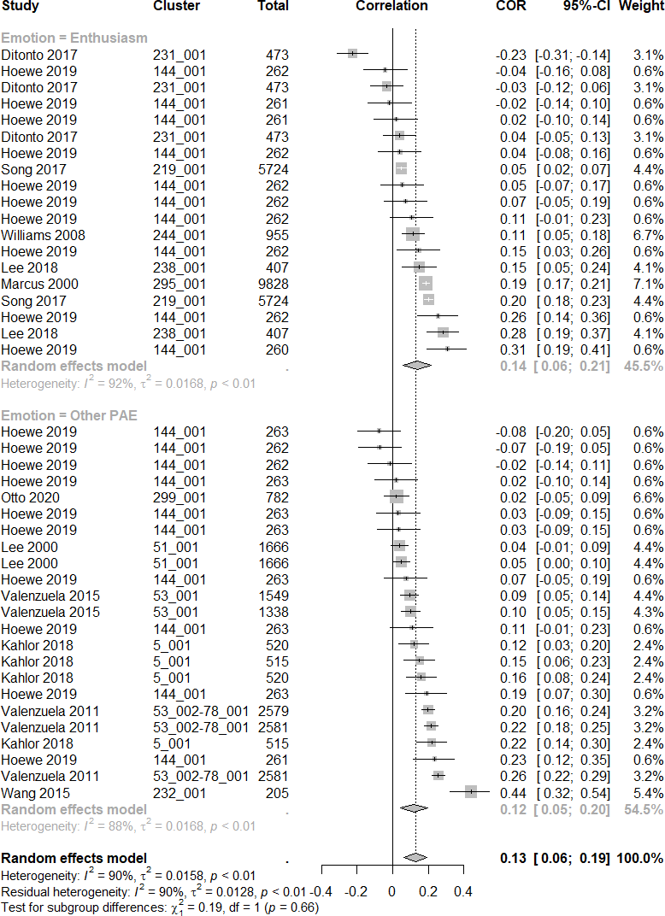
Note. Discrepancies of subgroup overall effects between the figure and text are due to differences in the sum of weights.

Figure F2a
Effect Sizes of the Associations Between Negative-Activating Emotions and Learning in Cross-Sectional Studies, first part
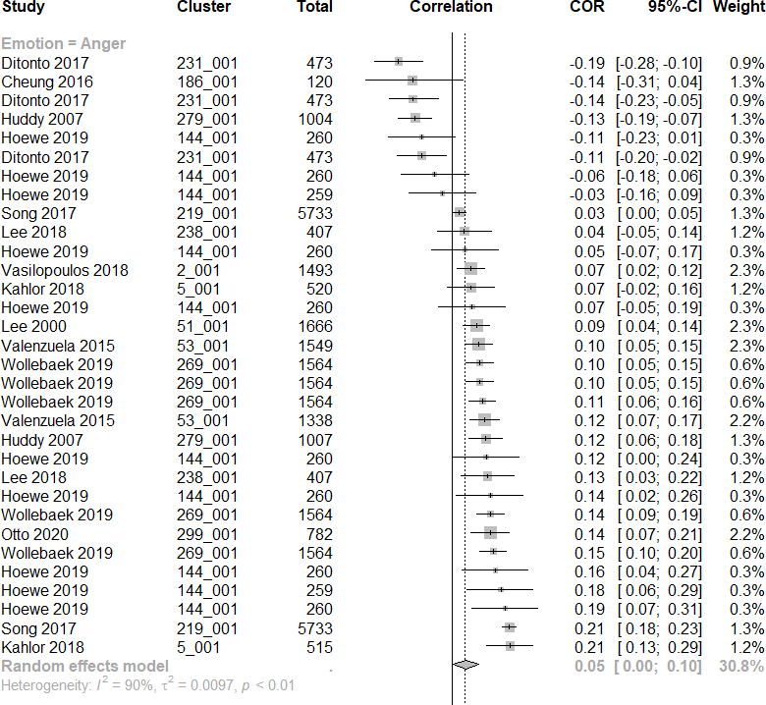
Note. Discrepancies of subgroup overall effects between the figure and text are due to differences in the sum of weights.

Figure F2b
Effect Sizes of the Associations Between Negative-Activating Emotions and Learning in Cross-Sectional Studies, second part
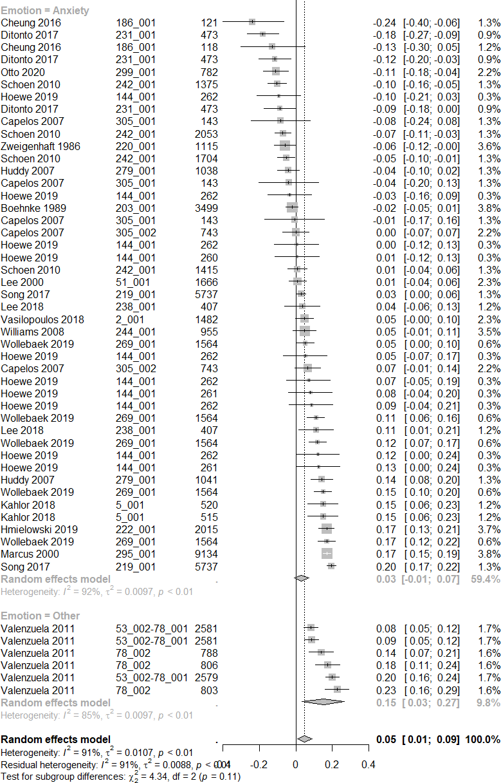
Figure F3
Effect Sizes of the Associations Between Negative-Deactivating Emotions and Learning in Cross-Sectional Studies 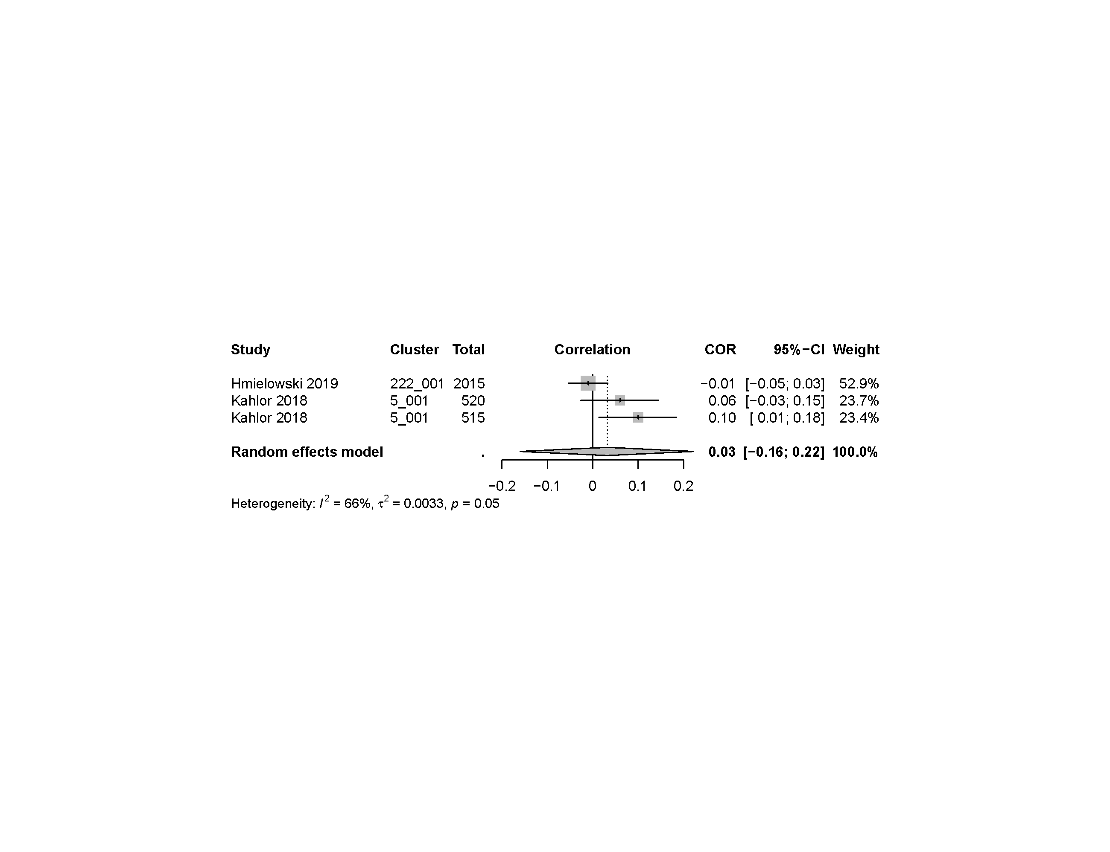

Figure F4
Effect Sizes of the Associations Between Positive-Activating Emotions and Learning in Experimental Studies
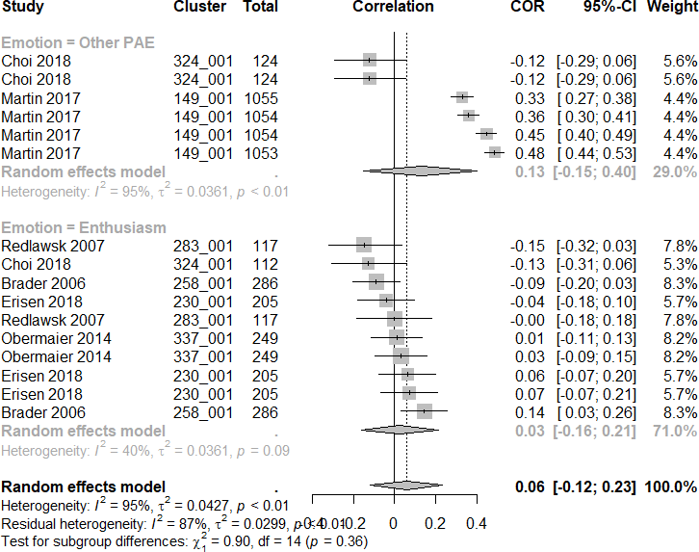
Note. Discrepancies of subgroup overall effects between the figure and text are due to differences in the sum of weights.

Figure F5a
Effect Sizes of the Association Between Negative-Activating Emotions and Learning in Experimental Studies, first part
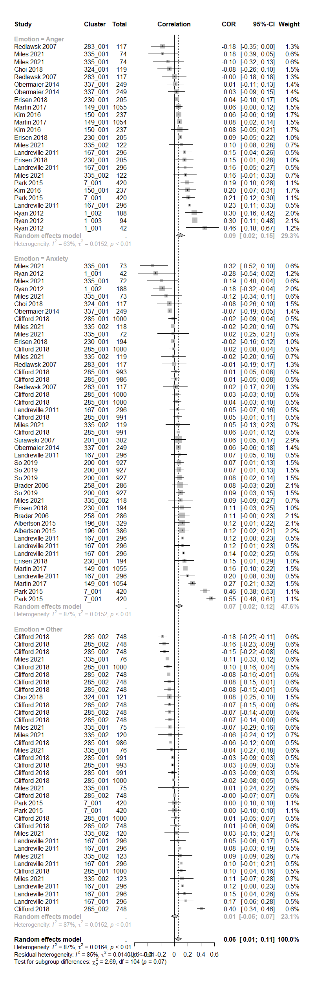
Note. Discrepancies of subgroup overall effects between the figure and text are due to differences in the sum of weights.

Figure F5b
Effect Sizes of the Association Between Negative-Activating Emotions and Learning in Experimental Studies, second part
Figure F5c
Effect Sizes of the Association Between Negative-Activating Emotions and Learning in Experimental Studies, third part

Figure F6
Effect Sizes of the Association Between Negative-Activating Emotions and Learning in Experimental Studies 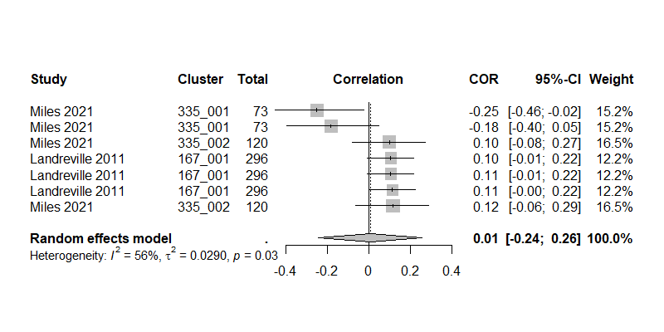

Appendix G Results of the Analysis of Variance Components
Table G1
Log-Likelihood tests for heterogeneity of effect sizes within and between studies (cross-sectional designs)
Model | Variance | df | AIC | BIC | AICc | logLik | LRT | p
PAE | variances estimated | 3 | -55.020 | -49.879 | -54.372 | 30.510
 | within fixed | 2 | 29.827 | 33.254 | 30.143 | -12.914 | 86.848 | <.001
 | between fixed | 2 | -50.508 | -47.081 | -50.192 | 27.254 | 6.512 | .011
Enthusiasm | variances estimated | 3 | -16.943 | -14.272 | -15.229 | 11.472
 | within fixed | 2 | 68.567 | 70.348 | 69.367 | -32.283 | 87.510 | .000
 | between fixed | 2 | -17.847 | -16.067 | -17.047 | 10.924 | 1.096 | .295
NAE | variances estimated | 3 | -153.830 | -146.610 | -153.523 | 79.915
 | within fixed | 2 | 77.486 | 82.300 | 77.638 | -36.743 | 233.316 | <.001
 | between fixed | 2 | -126.248 | -121.434 | -126.096 | 65.124 | 29.583 | <.001
Anxiety | variances estimated | 3 | -80.269 | -74.916 | -79.669 | 43.134
 | within fixed | 2 | 8.829 | 12.397 | 9.122 | -2.415 | 91.098 | <.001
 | between fixed | 2 | -70.050 | -66.481 | -69.757 | 37.025 | 12.219 | <.001
Anger | variances estimated | 3 | -45.398 | -41.096 | -44.509 | 25.699
 | within fixed | 2 | 68.681 | 71.549 | 69.109 | -32.340 | 116.079 | <.001
 | between fixed | 2 | -43.577 | -40.709 | -43.148 | 23.788 | 3.821 | .051
NDE | variances estimated | 3 | -0.369 | -4.290 | 23.631 | 3.185
 | within fixed | 2 | -2.369 | -4.983 | 9.631 | 3.185 | 0.000 | 1.00
 | between fixed | 2 | -1.663 | -4.277 | 10.337 | 2.832 | 0.706 | .401
Note. PAE = Positive activating emotions, NAE = negative activating emotions, NDE = negative deactivating emotions;

Table G2
Log-Likelihood tests for heterogeneity of effect sizes within and between studies (experimental designs)
Model | Variance | df | AIC | BIC | AICc | logLik | LRT | p
PAE | variances estimated | 3 | -11.118 | -8.994 | -8.936 | 8.559
 | within fixed | 2 | 2.964 | 4.380 | 3.964 | 0.518 | 16.082 | <.001
 | between fixed | 2 | 2.154 | 3.570 | 3.154 | 0.923 | 15.272 | <.001
Enthusiasm | variances estimated | 3 | -11.237 | -10.646 | -6.437 | 8.619
 | within fixed | 2 | -11.653 | -11.258 | -9.653 | 7.826 | 1.585 | .208
 | between fixed | 2 | -13.237 | -12.843 | -11.237 | 8.619 | 0.000 | 1.00
NAE | variances estimated | 3 | -125.873 | -117.883 | -125.638 | 65.937
 | within fixed | 2 | 105.236 | 110.563 | 105.352 | -50.618 | 233.109 | <.001
 | between fixed | 2 | -106.128 | -100.801 | -106.012 | 55.064 | 21.745 | <.001
Anxiety | variances estimated | 3 | -75.530 | -70.177 | -74.930 | 40.765
 | within fixed | 2 | -77.177 | -73.609 | -76.885 | 40.589 | 0.352 | .553
 | between fixed | 2 | -34.744 | -31.176 | -34.452 | 19.372 | 42.785 | <.001
Anger | variances estimated | 3 | -32.860 | -29.326 | -31.660 | 19.430
 | within fixed | 2 | -34.860 | -32.504 | -34.289 | 19.430 | 0.000 | 1.00
 | between fixed | 2 | -24.711 | -22.355 | -24.140 | 14.356 | 10.149 | .001
NDE | variances estimated | 3 | -6.220 | -6.844 | 5.780 | 6.110
 | within fixed | 2 | -8.220 | -8.636 | -4.220 | 6.110 | 0.000 | 1.00
 | between fixed | 2 | -1.963 | -2.379 | 2.037 | 2.982 | 6.257 | .012
Note. PAE = Positive activating emotions, NAE = negative activating emotions, NDE = negative deactivating emotions;

Appendix H Additional Analysis

H1. Bayesian Regularized Meta-Analysis
Table H1
Results from Moderator Analysis using Bayesian Regularized Meta-Analysis (BRMA)
Predictor |  |  | Effect [95% CI]
 | Cross-sectional Designs |  |  |  | Experimental Designs
 | Positive-activating Emotions | Negative-activating Emotions |  | Positive-activating Emotions |  | Negative-activating Emotions
Intercept | 0.081 [-0.13, 0.244] | -0.012 [-0.145, 0.091] |  | -0.086 [-0.543, 0.304] |  | 0.055 [-0.052, 0.148]
Sample size | 0 [0, 0] | 0 [0, 0] |  | 0 [0, 0.001] |  | 0 [0, 0]
Country
Germany | -0.02 [-0.199, 0.113] | -0.015 [-0.093, 0.028] |  | - |  | -
France |  | 0.01 [-0.068, 0.122]
Korea | 0.016 [-0.081, 0.16] | 0.002 [-0.067, 0.079] |  | - |  | 0.018 [-0.029, 0.162]
Netherlands | - | -0.007 [-0.085, 0.05] |  | - |  | -
Norway | - | 0.004 [-0.043, 0.064] |  | - |  | -
Turkey | - | - |  | -0.012 [-0.268, 0.197] |  | 0.001 [-0.055, 0.06]
USA | 0 [-0.077, 0.079] | 0.005 [-0.023, 0.048] |  | 0.022 [-0.125, 0.267] |  | -0.003 [-0.05, 0.03]
Multiple | - | -0.014 [-0.144, 0.083] |  | - |  | -
Discipline
Political Science | -0.004 [-0.083, 0.068] | -0.021 [-0.097, 0.014] |  | 0.003 [-0.149, 0.17] |  | -0.005 [-0.056, 0.017]
Psychology | - | -0.032 [-0.156, 0.025] |  | - |  | 0.005 [-0.098, 0.13]
Social Science | - | 0.005 [-0.043, 0.068] |  | - |  | -
Published | 0 [-0.07, 0.069] | -0.003 [-0.048, 0.036] |  | 0.039 [-0.157, 0.369] |  | 0.01 [-0.039, 0.106]
Sampling
Random sample | 0.005 [-0.042, 0.071] | 0.004 [-0.026, 0.046] |  | - |  | 0.007 [-0.062, 0.116]
Not mentioned | -0.003 [-0.096, 0.089] | -0.003 [-0.059, 0.047] |  | 0 [-0.252, 0.251] |  | -0.004 [-0.078, 0.049]
Online sampling service | - | - |  | 0.008 [-0.154, 0.192] |  | 0 [-0.042, 0.04]
Other | - | 0.006 [-0.046, 0.077] |  | - |  | -0.002 [-0.049, 0.032]
Snowball sample | - | -0.015 [-0.126, 0.054] |  | - |  | -
Stratiefied sample | 0.006 [-0.07, 0.103] | 0.003 [-0.044, 0.056] |  | - |  | -
Target Population
Adults | - | 0.007 [-0.022, 0.056] |  | - |  | -
College/university students | -0.003 [-0.066, 0.049] | -0.006 [-0.057, 0.027] |  | -0.015 [-0.236, 0.144] |  | -0.006 [-0.057, 0.016]
Not specified | - | -0.027 [-0.208, 0.062] |  | -0.003 [-0.065, 0.051] |  | -0.008 [-0.24, 0.206]
Other | 0.017 [-0.077, 0.16] | -0.003 [-0.071, 0.057] |  | - |  | 0.019 [-0.029, 0.165]
Emotion
Anxiety | - | -0.006 [-0.035, 0.013] |  | - |  | 0.002 [-0.017, 0.029]
Disgust | - | - |  | - |  | -0.014 [-0.082, 0.011]
Enthusiasm | 0.003 [-0.035, 0.049] | - |  | - |  | -
Frustration | - | - |  | - |  | 0.003 [-0.051, 0.069]
Guilt | - | - |  | - |  | -0.006 [-0.082, 0.046]
Hope | -0.01 [-0.07, 0.025] | - |  | -0.007 [-0.1, 0.086] |  | -
Negative |  | 0.017 [-0.029, 0.101]
Positive | 0.026 [-0.047, 0.16] | - |  | - |  | -
Pride | -0.012 [-0.111, 0.05] | - |  | 0.015 [-0.065, 0.117] |  | -
Surprise | 0.093 [-0.071, 0.442] | - |  | - |  | -
Worry | - | - |  | - |  | -0.003 [-0.068, 0.048]
Trait | 0.008 [-0.067, 0.107] | 0.039 [-0.016, 0.15] |  | -0.011 [-0.262, 0.189] |  | 0.001 [-0.041, 0.049]
Emotion Measure
Multiple | - | - |  | -0.018 [-0.291, 0.177] |  | -0.006 [-0.087, 0.047]
Other |  | 0.004 [-0.086, 0.104]
Self-reported | 0.028 [-0.063, 0.204] | 0.019 [-0.029, 0.123] |  | 0.02 [-0.12, 0.236] |  | 0.002 [-0.022, 0.039]
Object Focus
General political situation | - | 0.004 [-0.044, 0.065] |  | - |  | -
Other | -0.021 [-0.21, 0.103] | -0.004 [-0.067, 0.047] |  | - |  | -0.002 [-0.039, 0.025]
Policy issue | 0.098 [-0.067, 0.447] | -0.007 [-0.073, 0.039] |  | 0.015 [-0.128, 0.218] |  | -0.001 [-0.034, 0.024]
Political candidates | 0.001 [-0.057, 0.061] | 0.007 [-0.024, 0.056] |  | -0.002 [-0.253, 0.249] |  | -0.008 [-0.1, 0.05]
Political event | - | -0.014 [-0.11, 0.039] |  | - |  | -
Learning Measure
self-report | 0.008 [-0.044, 0.087] | 0.012 [-0.02, 0.076] |  | 0.06 [-0.075, 0.339] |  | 0.002 [-0.021, 0.033]
test/assessment | -0.012 [-0.098, 0.04] | -0.008 [-0.063, 0.025] |  | -0.033 [-0.264, 0.128] |  | -0.002 [-0.031, 0.02]
Learning Category
Discussions | 0.002 [-0.065, 0.076] | 0.015 [-0.014, 0.068] |  | 0.038 [-0.083, 0.214] |  | 0.004 [-0.022, 0.048]
Information Seeking | -0.001 [-0.058, 0.049] | -0.001 [-0.03, 0.028] |  | 0.075 [-0.016, 0.176] |  | 0.001 [-0.021, 0.027]
Knowledge | 0.009 [-0.039, 0.083] | 0.007 [-0.024, 0.065] |  | -0.001 [-0.261, 0.249] |  | -0.002 [-0.035, 0.026]
Learning | -0.102 [-0.346, 0.03] | -0.031 [-0.149, 0.035] |  | -0.054 [-0.319, 0.133] |  | 0 [-0.031, 0.032]
Learning limited | -0.007 [-0.097, 0.057] | 0.011 [-0.02, 0.072] |  | -0.001 [-0.252, 0.253] |  | -0.004 [-0.077, 0.051]
τ²_{between} | 0.007 [0, 0.029]* | 0.004 [0, 0.012]* |  | 0.082 [0, 0.383]* |  | 0.008 [0.001, 0.021]*
τ²_{within} | 0.006 [0.002, 0.013]* | 0.004 [0.002, 0.006]* |  | 0.003 [0, 0.017]* |  | 0.01 [0.007, 0.015]*
Note. * 95% credible interval excludes zero. Reference categories: ¹ Chile in the models for cross-sectional designs, Germany in the models for experimental designs; ² communication science; ³ Convenience sample; ⁴ adolescents / high school students; ⁵ enjoyment / enthusiasm in models for positive-activating emotions; anger in models for negative-activating emotions; ⁶ other in cross-sectional designs, induced in experimental designs; ⁷ election & campaign; ⁸ behavioral; ⁹ attention to politics;

H2. Moderator Analysis for Learning Category
Additionally to our exploratory moderator analysis, we conducted a moderator analysis testing whether effect sizes differ depending on the type of learning. For this analysis, we recoded the five outcome variables to a dummy variable differentiating between cognitive (knowledge and knowledge gain) and behavioral processes (attention to politics, information seeking, discussions).

Table H2
Moderator Analysis for Learning Category
Model | Predictor | k | N | Estimate | SE | T | P | CI
Cross-Sectional Designs
Positive activating emotions | Intercept | 12 | 42 | 0,14 | 0,04 | 3.804 (40) | .000 | [0.067, 0.22]
 | Learning |  |  | -0,04 | 0,05 | -0.89 (40) | .379 | [-0.14, 0.055]
Enthusiasm | Intercept | 6 | 19 | 0,14 | 0,06 | 2.373 (17) | .030 | [0.015, 0.256]
 | Learning |  |  | -0,10 | 0,09 | -1.14 (17) | .270 | [-0.287, 0.086]
Negative activating emotions | Intercept | 22 | 83 | 0,06 | 0,02 | 2.611 (81) | .011 | [0.014, 0.102]
 | Learning |  |  | -0,03 | 0,03 | -0.964 (81) | .338 | [-0.087, 0.03]
Anxiety | Intercept | 19 | 45 | 0,04 | 0,03 | 1.476 (43) | .147 | [-0.014, 0.091]
 | Learning |  |  | -0,03 | 0,04 | -0.892 (43) | .378 | [-0.113, 0.044]
Anger | Intercept | 12 | 32 | 0,07 | 0,03 | 2.315 (30) | .028 | [0.008, 0.127]
 | Learning |  |  | -0,03 | 0,06 | -0.562 (30) | .578 | [-0.156, 0.088]
Negative deactivating emotions | Intercept | 2 | 3 | 0,01 | 0,03 | 0.441 (1) | .735 | [-0.411, 0.44]
 | Learning |  |  | 0,08 | 0,06 | 1.245 (1) | .431 | [-0.706, 0.86]
Experimental Designs
Positive activating emotions | Intercept | 6 | 16 | 0,11 | 0,08 | 1.295 (14) | .216 | [-0.072, 0.29]
 | Learning |  |  | -0,22 | 0,10 | -2.091 (14) | .055 | [-0.441, 0.006]
Enthusiasm | Intercept | 5 | 10 | 0,04 | 0,03 | 1.28 (8) | .236 | [-0.028, 0.1]
 | Learning |  |  | -0,12 | 0,05 | -2.158 (8) | .063 | [-0.244, 0.008]
Negative activating emotions | Intercept | 19 | 104 | 0,07 | 0,03 | 2.503 (102) | .014 | [0.014, 0.117]
 | Learning |  |  | -0,01 | 0,03 | -0.428 (102) | .670 | [-0.073, 0.047]
Anxiety | Intercept | 16 | 45 | 0,06 | 0,05 | 1.254 (43) | .217 | [-0.035, 0.15]
 | Learning |  |  | -0,01 | 0,02 | -0.33 (43) | .743 | [-0.051, 0.037]
Anger | Intercept | 13 | 25 | 0,10 | 0,04 | 2.431 (23) | .023 | [0.016, 0.194]
 | Learning |  |  | 0,02 | 0,05 | 0.367 (23) | .717 | [-0.079, 0.113]
Negative deactivating emotions | Intercept | 3 | 10 | 0,10 | 0,22 | 0.432 (8) | .677 | [-0.415, 0.607]
 | Learning |  |  | -0,15 | 0,28 | -0.536 (8) | .606 | [-0.784, 0.488]
Note. Learning is a dummy variable, in which cognitive outcomes variables (knowledge, knowledge gain) are coded as 1 and behavioral outcome variables (attention to politics, information seeking, discussions) are coded as 0.

Appendix I Funnel Plots
Figure I1
Funnel Plots of Studies with Cross-Sectional Designs
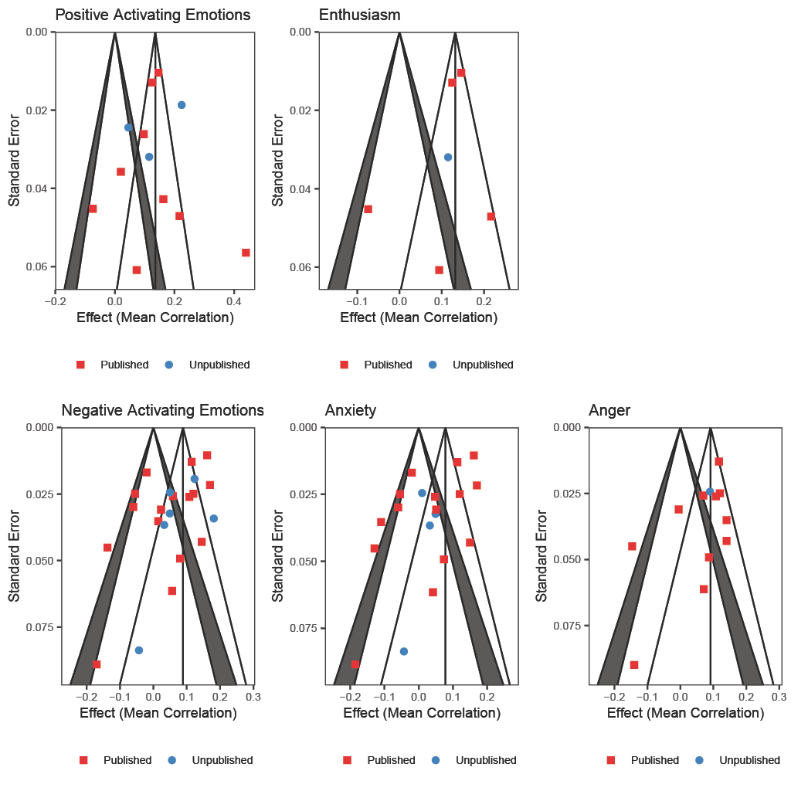

Figure I2
Funnel Plots of Studies with Experimental Designs
