Supplementary Material 2 – Funnel Plot

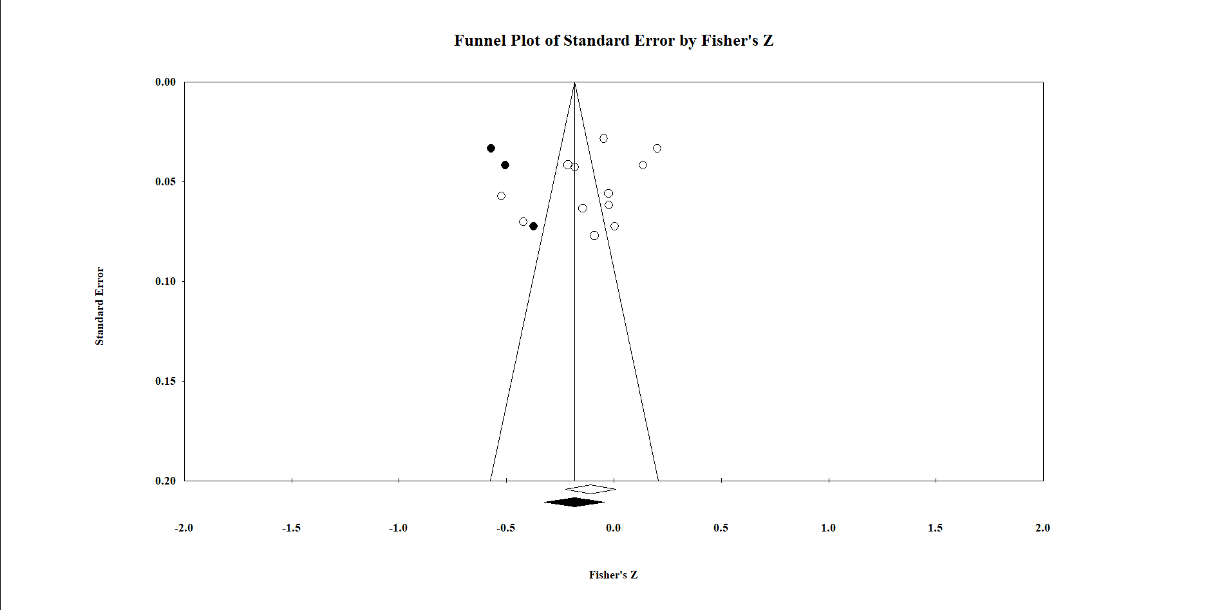
Fig. 1. Funnel plot of the studies adjusted to the left of mean in the trim and fill analysis for the relationship between academic burnout and adaptive emotion regulation strategies. The solid marks indicate adjusted studies and overall effect.

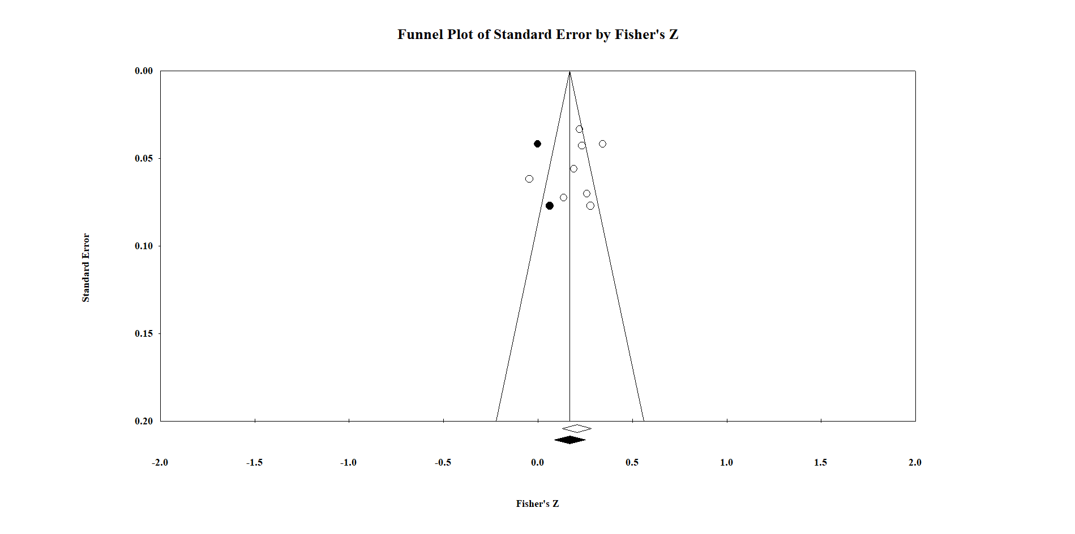
Fig. 2. Funnel plot of the studies adjusted to the left of mean in the trim and fill analysis for the relationship between academic burnout and emotion regulation difficulties. The solid marks indicate adjusted studies and overall effect.

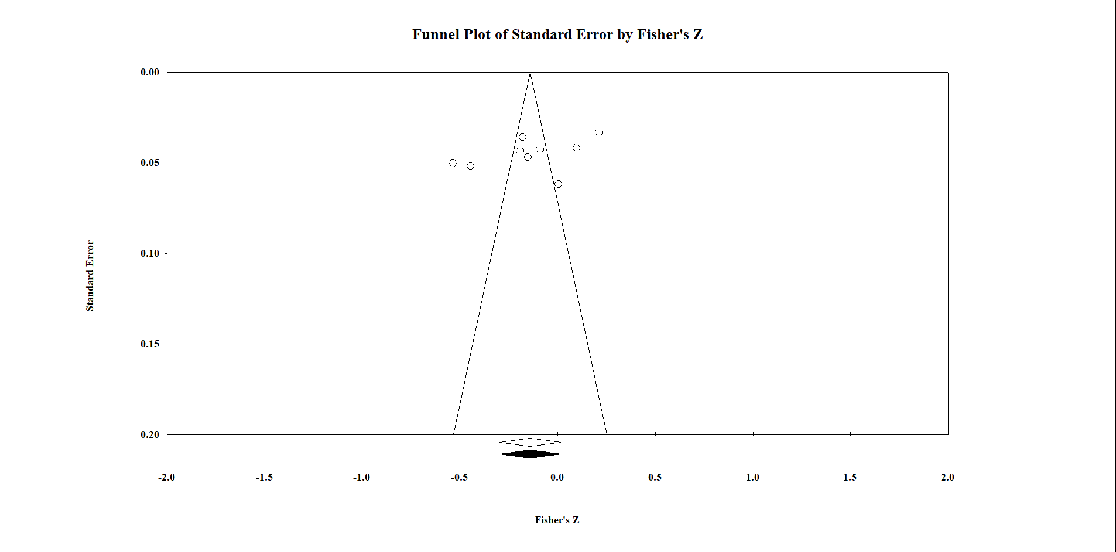
Fig. 3. Funnel plot of the studies included in the trim and fill analysis for the relationship between cynicism and adaptive emotion regulation strategies. The solid marks indicate the overall effect.

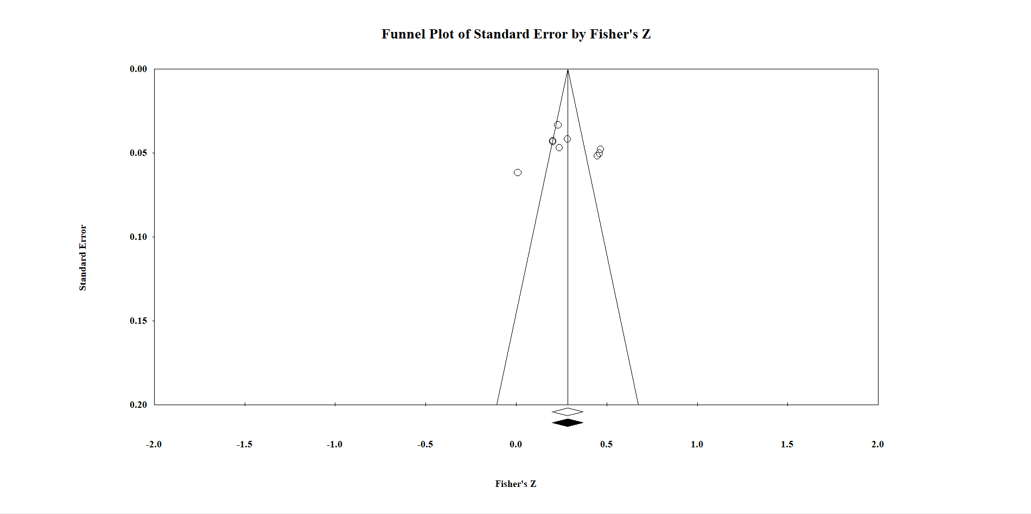
Fig. 4. Funnel plot of the studies included in the trim and fill analysis for the relationship between cynicism and emotion regulation difficulties. The solid marks indicate the overall effect.

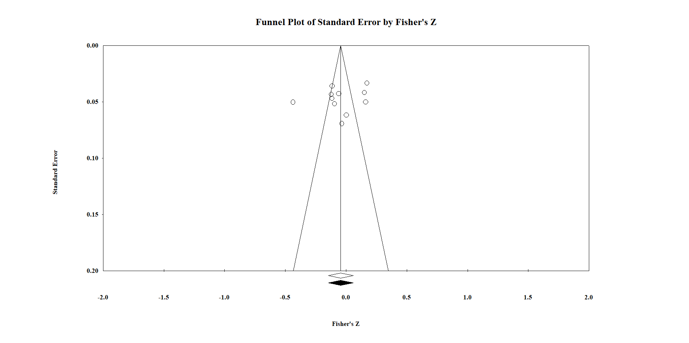

Fig. 5. Funnel plot of the studies included in the trim and fill analysis for the relationship between emotional exhaustion and adaptive emotion regulation strategies. The solid marks indicate the overall effect.
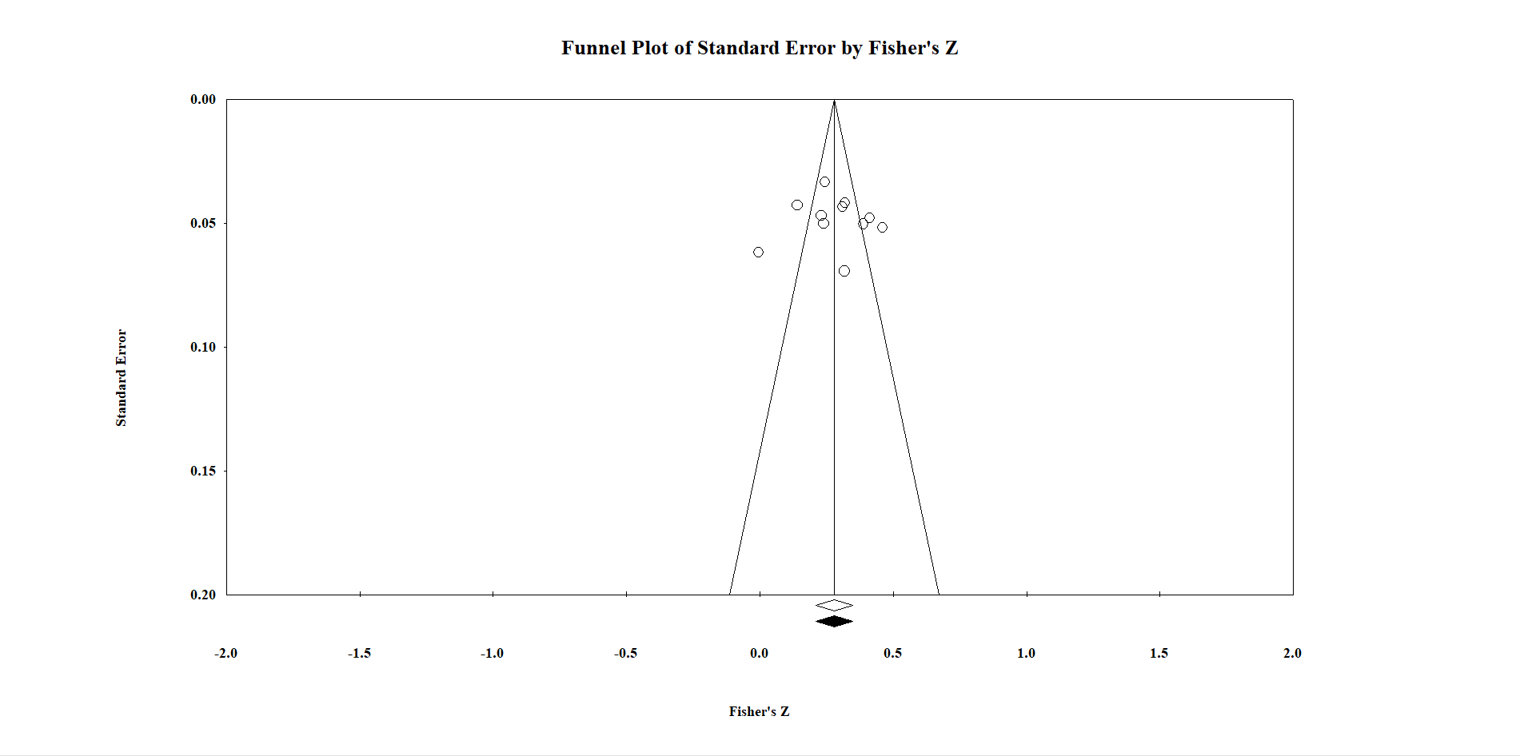
Fig. 6. Funnel plot of the studies included in the trim and fill analysis for the relationship between emotional exhaustion and emotion regulation difficulties. The solid marks indicate the overall effect.

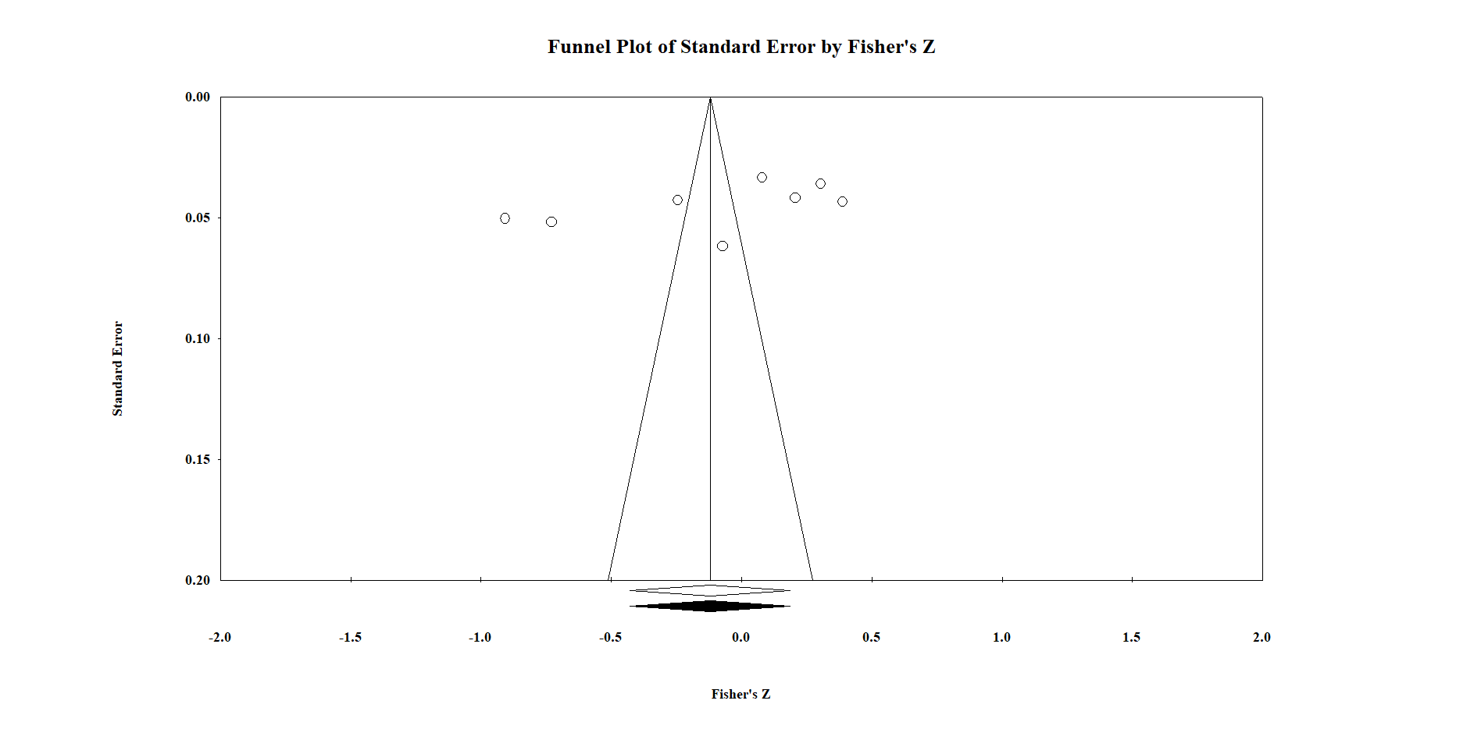
Fig. 7. Funnel plot of the studies included in the trim and fill analysis for the relationship between lack of efficacy and adaptive emotion regulation strategies. The solid marks indicate the overall effect.

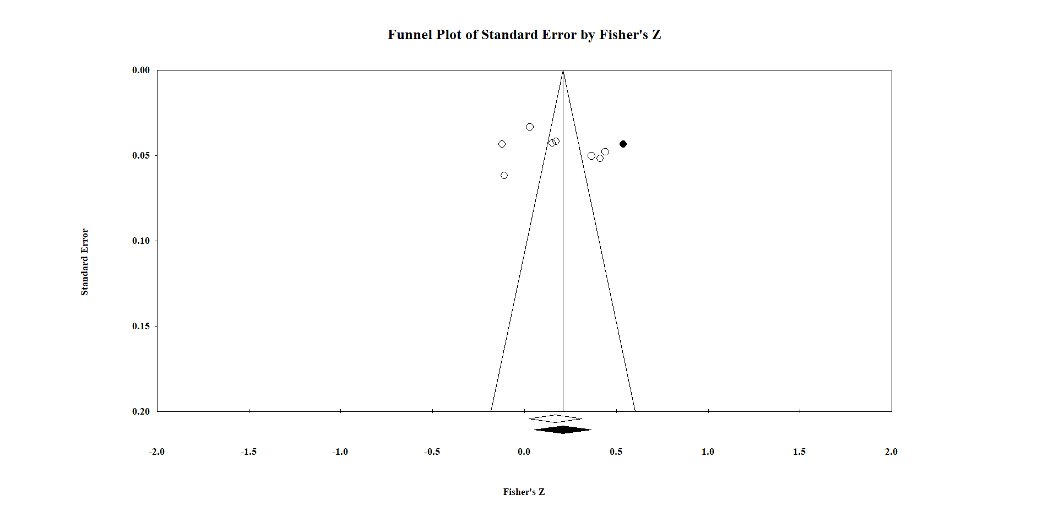
Fig. 8. Funnel plot of the studies adjusted to the right of mean in the trim and fill analysis for the relationship between lack of efficacy and emotion regulation difficulties. The solid marks indicate adjusted studies and overall effect.

