Table S1
Database Search Term Query Based on Focus, Population, and Setting
Focus | “reading” AND (“meta-analysis” OR “review” OR “practice guide” OR “report”)
 | AND
Population | (“language minority” OR “language-minority” OR “English language learners” OR “English-language learners” OR “ELLs” OR “English learner” OR “English-learner” OR “EL” OR “limited English proficient” OR “limited-English proficient” OR “LEP” OR “second language learners” OR “second-language learners” OR “English as a second language” OR “ESL” OR “English language development” OR “ELD” OR “emergent bilingual” OR “bilingual” OR “bilingual learners” OR “multilingual” OR “multilingual learners” OR “ML” OR “linguistic minority” OR “linguistic minorities” OR “immigrants” OR “limited English-speaking” OR “limited English speaking” OR “non-English speaking”)
 | AND
Setting | (“K” OR “kindergarten” OR “1st grade” OR “grade 1” OR “first grade” OR “2nd grade” OR “grade 2” OR “second grade” OR “3rd grade” OR “grade 3” OR “third grade” OR “4th grade” OR “grade 4” OR “fourth grade” OR “5th grade” OR “grade 5” OR “fifth grade” OR “elementary” OR “primary”)

Table S2
Significant Effect Sizes on L1 (Spanish) Vocabulary by Program and Studies
Studies | Participants | Format and Setting | Duration and Dosage | Delivery | Measures | ES
Descubriendo La Lectura
Escamilla (1994) | Gr 1  Spanish  at risk for RD | one-on-one  pull-out | 12–16 weeks  30 min per day | Descubriendo la Lectura teachers | writing vocabulary | NR
Vocabulary Enhanced Systematic and Explicit Teaching Routines (VE-SETR)
Cena et al. (2013) | Gr 1  Spanish | TBP | 8 weeks  5 days per week  15 min per day | — | TBP group  DOK-S definitionsª  DOK-S usageª  DOK-S totalª | 0.20  0.10  0.17
Note. DOK-S = Depth of Knowledge Spanish Vocabulary; ES = effect size; L1 = first language; NR = not reported; RD = reading difficulties or reading disability; TBP = Transitional Bilingual Program.
ªResearcher-developed measure.

Table S3
Significant Effect Sizes on English Oral Language by Program and Studies
Studies | Participants | Format and Setting | Duration and Dosage | Delivery | Measures | ES
Corrective Reading/Reading Mastery
Gunn et al. (2000) | RM: Gr K–2  CR: Gr 3–4  Spanish  at-risk/with RD | small group  - 2–3 students  - homogenous  one-on-one  - as needed  pull-out | 15 months  5 days per week  25–30 min per day | researcher-hired instructional assistants/ paraeducators | reading vocabulary | NR
Gunn et al. (2005) | RM: Gr 1–2  CR: Gr 3–4  Spanish  at risk/with RD | small group | 6–7 months in the  first year  full academic year in the second year  3 days per week  30 min per day | researcher-hired instructional assistants | vocabulary | 0.28
Direct Instruction (DI)
Becker and Gersten (1982) | Gr K–3  Spanish | — | — | — | MAT Word Knowledge | 0.11ª
Project English Language and Literacy Acquisition (ELLA)
Tong et al. (2011) | Gr K–2  Spanish  included struggling readers | enhanced TBP  K: 70/30 SP/ENG  Gr 1: 60/40 SP/ENG  Gr 2: 50/50 SP/ENG  Tier I  all content instruction in SP until Grade 2 spring Tier II  K and Gr 1: small group intervention  Tier III  small group intensive intervention | 3 years  5 days per week  Intervention  K: 75 mins  Gr 1: 90 mins | Tiers I and II  classroom teachers  Tier III  highly-trained paraprofessionals | WLPB-R Oral Language | 0.48
Wilson Reading
Wanzek and Roberts (2012) | Gr 4  Spanish  included MLs with LD | small group  - 2–3 students | 28 weeks  2–3 days per week  30 min per day | certified teachers hired by research team | WJ III Listening Comprehension | 0.93ª
Note. CR = Corrective Reading; ENG = English; ES = effect size; LD = learning disabilities; MAT = English Metropolitan Achievement Test; NR = not reported; RD = reading difficulties or reading disability; RM = Reading Mastery; SP = Spanish; TBP = Transitional Bilingual Program; WJ III = Woodcock Johnson; WLPB-R = Woodcock Language Proficiency Battery–Revised.
ªCalculated by systematic review(s).

Table S4
Significant Effect Sizes on English Phonological Awareness Measures by Program and Studies
Studies | Participants | Format and Setting | Duration and Dosage | Delivery | Measures | ES
Project English Language and Literacy Acquisition (ELLA)
Tong et al. (2008) | Gr K–2  Spanish  included struggling readers | enhanced TBP  K: 70/30 SP/ENG  Gr 1: 60/40 SP/ENG  Gr 2: 50/50 SP/ENG  Tier I  all content instruction in SP until Grade 2 spring Tier II  K and Gr 1: small group intervention  Tier III  small group intensive intervention | 3 years  5 days per week  Intervention  K: 75 mins  Gr 1: 90 mins | Tiers I and II  classroom teachers  Tier III  highly-trained paraprofessionals | CTOPP Blending Phonemes  CTOPP Segmenting Phonemes | 0.44  0.71
Ladders to Literacy
O’Connor et al. (2010) | K  Spanish  at risk for LD | small group  - 2–3 students  homogenous | 36 weeks  3 days per week  15 mins per day | paraprofessionals | DIBELS PSF | 0.91ª
Lectura Proactiva
Vaughn, Cirino et al. (2006) | Gr 1  Spanish  at risk for RD | small group  - 3–5 students  homogenous | 32 weeks  5 days per week  50 min per day | bilingual teachers | CTOPP PA Composite  (Elision, Blending Words, Blending Nonwords, Segmenting Words, and Sound Matching) | 0.54
Peer Assisted Learning Strategies in Reading for Kindergarten (K-PALS)
McMaster et al. (2008) | K  heterogenous | dyads  - higher reader: lower reader  whole class  two-way bilingual classroom | 18 weeks  4 days per week  20–30 days per week | teacher | segmentation  blending | 1.00ª/  1.02ª
Proactive Reading
Vaughn, Cirino et al. (2006) | Gr 1  Spanish  at risk for RD | small group  - 3–5 students  homogenous | 32 weeks  5 days per week  50 min per day | bilingual teachers | CTOPP PA Composite  (Elision, Blending Words, Blending Nonwords, Segmenting Words, and Sound Matching) | 0.38
Vaughn, Mathes et al. (2006) | Gr 1  Spanish  at risk for RD | small group  - 3–5 students  homogenous | 32 weeks  5 days per week  40–50 min per day | bilingual teachers | CTOPP phonemic/phonological awareness | 1.08/  1.24ª
Read Well
Santoro et al. (2006) | Gr 2  Spanish  included an ML with an LD | one-on-one  pull-out | 21 weeks  3 days per week  30 min per day | special education teacher and two graduate students | DIBELS PSF | PND_{I} = 80.00%ª, PND_{M} = 100.00%ª
Sound Partners
Vadasy and Sanders (2010) | K  heterogenous  at risk for RD | one-on-one | 18 weeks  4 days per week  30 min per day | paraeducators | CTOPP | 0.93ª
Note. CTOPP = Comprehensive Test of Phonological Processing; DIBELS = Dynamic Indicators of Basic Early Literacy Skills; ENG = English; ES = effect size; LD = learning disabilities; PA = phonological awareness; PND_{I} = % of PND Intervention versus Baseline; PND_{M} = % of PND Maintenance versus Baseline; PSF = Phoneme Segmentation Fluency; RD = reading difficulties or reading disability; SP = Spanish.
ªCalculated by systematic review(s).

Table S5
Significant Effect Sizes on L1 (Spanish) Decoding Measures by Program and Studies
Studies | Participants | Format and Setting | Duration and Dosage | Delivery | Measures | ES
Descubriendo La Lectura
Escamilla (1994) | Gr 1  Spanish  at risk for RD | one-on-one  pull-out | 12–16 weeks  30 min per day | Descubriendo la Lectura teachers | Spanish word reading | NR
Lectura Proactiva
Vaughn, Cirino et al. (2006) | Gr 1  Spanish  at risk for RD | small group  - 3–5 students  homogenous | 32 weeks  5 days per week  50 min per day | bilingual teachers | WLPB-RS LWID | 0.60ª
Vaughn, Linan-Thompson et al. (2006) | Gr 1  Spanish  at risk for RD | small group  - 3–5 students  homogenous  enhanced bilingual program | 32 weeks  5 days per week  50 min per day | bilingual teachers | WLPB-RS WA | 0.85/  0.91ª
Proactive Reading
Vaughn, Mathes et al. (2006) | Gr 1  Spanish  at risk for RD | small group  - 3–5 students  homogenous | 32 weeks  5 days per week  40–50 min per day | bilingual teachers | Spanish nonsense word reading | 0.87
Note. ES = effect size; L1 = first language; LWID = Letter-Word Identification; NR = not reported by the review(s); RD = reading difficulties or reading disability; WA = Word Attack; WLPB-RS = Woodcock Language Proficiency Battery–Revised Spanish Form.
ªCalculated by systematic review(s).
Table S6
Significant Effect Sizes on English Decoding Measures by Program and Studies
Studies | Participants | Format and Setting | Duration and Dosage | Delivery | Measures | ES
Corrective Reading/Reading Mastery
Gunn et al. (2000) | RM: Gr K–2  CR: Gr 3–4  Spanish  at-risk/with RD | small group  - 2–3 students  - homogenous  one-on-one  - as needed  pull-out | 4–5 months and  15 months  5 days per week  25–30 min per day | researcher-hired instructional assistants/ paraeducators | After 4 to 5 months  WJ III WA  After 15 months  WJ III WA | NR  0.52ª
Gunn et al. (2005) | RM: Gr 1–2  CR: Gr 3–4  Spanish  at risk/with RD | small group | 6–7 months in the first year  full academic year in the second year  3 days per week  30 min per day | researcher-hired instructional assistants | After intervention  reading nonsense words  Two years after  reading nonsense words | 0.38  0.25
Peer-Assisted Learning Strategies (PALS)
Calhoon et al. (2007) | Gr 1  heterogenous (Spanish majority) | dyads  - higher reader: lower reader  whole class  50/50 two-way bilingual immersion program | 20 weeks  3 days per week  30–35 min per day | tutors | nonsense word fluency | 0.75ª
Proactive Reading
Vaughn, Cirino et al. (2006) | Gr 1  Spanish  at risk for RD | small group  - 3–5 students  homogenous | 32 weeks  5 days per week  50 min per day | bilingual teachers | WA | 0.42
Vaughn, Mathes et al. (2006) | Gr 1  Spanish  at risk for RD | small group  - 3–5 students  homogenous | 32 weeks  5 days per week  40–50 min per day | bilingual teachers | WA | 1.09ª
Read Naturally
Denton (2000) | Gr 2–5  Spanish | small group  - 2–4 students  one-on-one | 8 weeks  3 days per week  40 min per day | undergraduate students with a special education major | word reading | NR
Read Well
Denton et al. (2004) | Gr 2–5  Spanish  at risk for LD  word-level reading difficulties | small group  - 2–4 students  homogenous  one-on-one | 10 weeks  3 days per week  40 min per day | undergraduate students with education majors | WRMT-R WA | 0.46ª
Santoro et al. (2006) | Gr 2  Spanish  included an ML with an LD | one-on-one  pull-out | 21 weeks  3 days per week  30 min per day | special education teacher and two graduate students | DIBELS NWF | PND_{I} = 100.00%ª  PND_{M} = 100.00%ª
Success for All (SFA)
Slavin and Madden (1998): Arizona Evaluation | Gr 1  Spanish | large group  - 15 students  homogenous  in-class  one-on-one  (as needed)  pull-out | 36 weeks  5 days per week  90 min per day  36 weeks  —  20 min per day | Spanish-English bilingual teachers | WA | NR
Slavin and Madden (1998): Fairhill Evaluation | Gr 1–3  Spanish | large group  - 15 students  homogenous  in-class  one-on-one  (as needed)  pull-out | 72 weeks  5 days per week  90 min per day  72 weeks  —  20 min per day | classroom teachers and ESL teachers | Woodcock-  Johnson WA | NR
Ross et al. (1998) | Gr 1  Spanish | whole-school  whole-class  one-on-one  (as needed)  pull-out | 1 year  —  —  —  —  — | classroom teachers | English Woodcock LWID  English Woodcock  WA | 0.51ª  0.83ª
Chambers et al., (2004) | Gr K–1  Spanish | whole-school  whole-class  one-on-one  (as needed)  pull-out | 1 year  —  —  —  —  — | classroom teachers | English Woodcock LWID  English Woodcock WA | 0.40/  0.41ª  0.36ª
Sound Partners
Vadasy and Sanders (2010) | K  heterogenous  at risk for RD | one-on-one | 18 weeks  4 days per week  30 min per day | paraeducators | WRMT LWID and WA | 0.61ª
Wilson Reading
Wanzek and Roberts (2012) | Gr 4  Spanish  included MLs with LD | small group  - 2–3 students | 28 weeks  2–3 days per week  30 min per day | certified teachers hired by research team | WJ III WA | 1.09ª
Note. DIBELS = Dynamic Indicators of Basic Early Literacy Skills; ES = effect size; ESL = English as a second language; LD = learning disabilities; LWID = Letter-Word Identification; NR = not reported by the review(s); NWF = Nonsense Word Fluency; PND_{I} = % of PND Intervention versus Baseline; PND_{M} = % of PND Maintenance versus Baseline; RD = reading difficulties or reading disability; WA = Word Attack; WJ III = Woodcock Johnson; WRMT/WRMT-R = Woodcock Reading Mastery Tests.
ªCalculated by systematic review(s).

Table S7
Significant Effect Sizes on English Oral Reading Fluency Measures by Program and Studies
Studies | Participants | Format and Setting | Duration and Dosage | Delivery | Measures | ES
Corrective Reading/Reading Mastery
Gunn et al. (2005) | RM: Gr 1–2  CR: Gr 3–4  Spanish  at risk/with RD | small group | 6–7 months in the first year  full academic year in the second year  3 days per week  30 min per day | researcher-hired instructional assistants | oral reading fluency | 0.24
Project English Language and Literacy Acquisition (ELLA)
Tong et al. (2008) | K–2  Spanish  included struggling readers | enhanced TBP  K: 70/30 SP/ENG  Gr 1: 60/40 SP/ENG  Gr 2: 50/50 SP/ENG  Tier I  all content instruction in SP until Grade 2 spring Tier II  K and Gr 1: small group intervention  Tier III  small group intensive intervention | 3 years  5 days per week  Intervention  K: 75 mins  Gr 1: 90 mins | Tiers I and II  classroom teachers  Tier III  highly-trained paraprofessionals | DIBELS ORF | > .40
Peer-Assisted Learning Strategies (PALS)
Sáenz (2002) | Gr 3–6  Spanish  with LD | — | 15 weeks | teachers | Words Correct | 0.17ª
Sáenz et al. (2005) | Gr 3–6  Spanish  included MLs with LD | dyads  higher reader: lower reader  whole class  transitional bilingual classroom | 15 weeks  3 days per week  35 mins per day | teachers | CRAB number of words read correctly | NR
Read Well
Santoro et al. (2006) | Gr 2  Spanish  included an ML with an LD | one-on-one  pull-out | 21 weeks  3 days per week  30 min per day | special education teacher and two graduate students | Correct words per minute (ORF) | PND_{I} = 63.64%^{ac}  PND_{M} = 100.00%^{ac}
Sound Partners
Vadasy and Sanders (2010) | K  heterogenous  at risk for RD | one-on-one | 18 weeks  4 days per week  30 min per day | paraeducators | Passage reading fluency^{b} | 0.90ª
Note. CRAB = The Comprehensive Reading Assessment Battery; DIBELS = Dynamic Indicators of Basic Early Literacy Skills; ENG = English; ES = effect size; LD = learning disabilities; NR = not reported by the review(s); ORF = Oral Reading Fluency; PND_{I} = % of PND Intervention versus Baseline; PND_{M} = % of PND Maintenance versus Baseline; RD = reading difficulties or reading disability; SP = Spanish; TBP = Transitional Bilingual Program.
ªCalculated by systematic review(s). ^{b}Researcher-developed measure. ^{c}For MLs with LD.

Table S8
Significant Effect Sizes on L1 (Spanish) Reading Comprehension Measures by Program and Studies
Studies | Participants | Format and Setting | Duration and Dosage | Delivery | Measures | ES
Lectura Proactiva
Vaughn, Linan-Thompson et al. (2006) | Gr 1  Spanish  at risk for RD | small group  - 3–5 students  homogenous  enhanced bilingual program | 32 weeks  5 days per week  50 min per day | bilingual teachers | WLPB-RS Passage comprehension | 0.55/  0.88ª
Proactive Reading
Vaughn, Mathes et al. (2006) | Gr 1  Spanish  at risk for RD | small group  - 3–5 students  homogenous | 32 weeks  5 days per week  40–50 min per day | bilingual teachers | WLPB-RS Passage comprehension | 0.81
Read Naturally
De La Colina et al. (2001) | Gr 1–2  Spanish  at risk | one-on-one  in-class  Spanish-English bilingual classrooms | 8, 10, and 12 weeks  3 days per week  45 min per day | classroom teachers | Spanish comprehension | NR
Note. ES = effect size; LD = learning disabilities; L1 = first language; NR = not reported by the review(s); RD = reading difficulties or reading disability;
WLPB-RS = Woodcock Language Proficiency Battery–Revised Spanish Form.
ªCalculated by systematic review(s).

Table S9
Significant Effect Sizes on English Reading Comprehension Measures by Program and Studies
Studies | Participants | Format and Setting | Duration and Dosage | Delivery | Measures | ES
Corrective Reading/Reading Mastery
Gunn et al. (2000) | RM: Gr K–2  CR: Gr 3–4  Spanish  at-risk/with RD | small group  - 2–3 students  - homogenous  one-on-one  - as needed  pull-out | 15 months  5 days per week  25–30 min per day | researcher-hired instructional assistants/ paraeducators | passage comprehension | NR
Gunn et al. (2005) | RM: Gr 1–2  CR: Gr 3–4  Spanish  at risk/with RD | small group | 6–7 months in the  first year  full academic year in the second year  3 days per week  30 min per day | researcher-hired instructional assistants | after intervention  comprehension | 0.29
HELPS Fluency Program (HELPS)
Begeny et al. (2012) | Gr 2  Spanish  at risk for LD | one-on-one | 20–28 weeks  2–3 days per week  10 mins per day | lead researcher/  graduate and undergraduate students | GORT Comprehension | 1.00ª
Peer-Assisted Learning Strategies (PALS)
Saenz (2002) | Gr 3–6  Spanish  with LD | — | 15 weeks | teachers | Questions Correct  Maze Choice | 0.76ª  0.16ª
Saenz et al. (2005) | Gr 3–6  Spanish  included MLs with LD | dyads  - higher reader:  - lower reader  whole class  transitional bilingual classroom | 15 weeks  3 days per week  35 mins per day | teachers | CRAB maze choices correct  CRAB multiple-choice questions | NR  NR  /2.67ª
Proactive Reading
Vaughn, Mathes et al. (2006) | Gr 1  Spanish  at risk for RD | small group  - 3–5 students  homogenous | 32 weeks  5 days per week  40–50 min per day | bilingual teachers | WLPB-R Passage Comprehension | 1.08ª  /0.83ª
Success for All (SFA)
Ross et al. (1998) | Gr 1  Spanish | whole-school  whole-class  one-on-one  (as needed)  pull-out | 1 year  —  —  —  —  — | classroom teachers | English Woodcock Passage Comprehension | 0.41ª
Chambers et al. (2004) | Gr K–1  Spanish | whole-school  whole-class  one-on-one  (as needed)  pull-out | 1 year  —  —  —  —  — | classroom teachers | English Woodcock Passage Comprehension | 0.21ª
 |  |  | Sound Partners
Vadasy and Sanders (2010) | K  heterogenous  at risk for RD | one-on-one | 18 weeks  4 days per week  30 min per day | paraeducators | WRMT Passage Comprehension | 0.47ª
Note. CRAB = The Comprehensive Reading Assessment Battery; ES = effect size; GORT = Gray Oral Reading Test; LD = learning disabilities; MLs = multilingual learners; NR = not reported by systematic review(s); RD = reading difficulties or reading disability; WLPB-R = Woodcock Language Proficiency Battery–Revised; WRMT = Woodcock Reading Mastery Tests.
ªCalculated by systematic review(s).
Figure S1
PRISMA Flow Diagram for Systematic Review
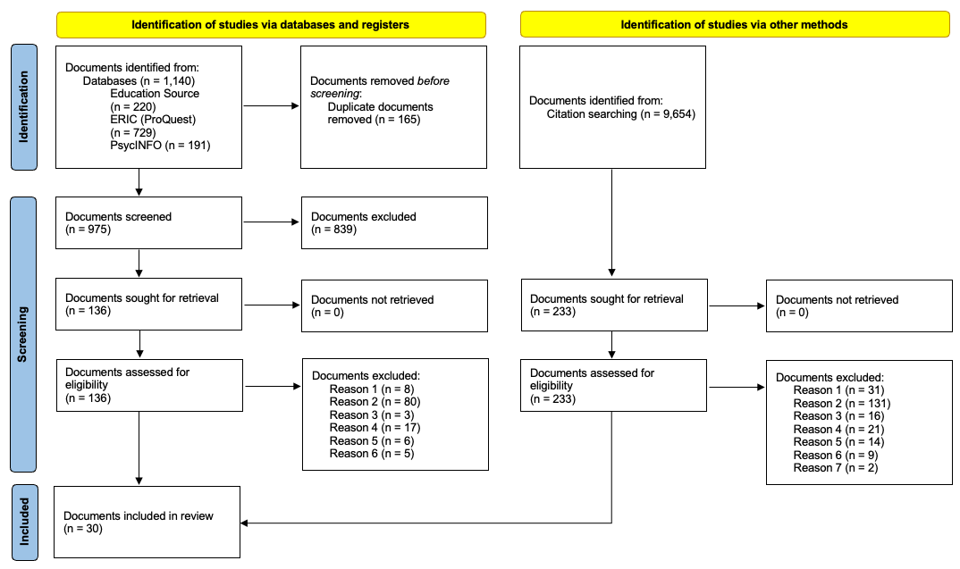
Note. Adapted from Page et al. (2021); Reason 1 = Not a review of research; Reason 2 = Does not explicitly state how documents were identified and retrieved; Reason 3 = Review of reviews; Reason 4 = Not U.S. or K-5 focused (50% or more); Reason 5 = Not multilingual learner (ML) focused and/or include results disaggregated for MLs; Reason 6 = Not reading focused and/or does not include reading comprehension has an outcome measures. Reason 7 = Documents, excluding journal articles and commissioned reports, that were not updates to commissioned reports
Figure S2
Percentage of Systematic Reviews by Grade Level
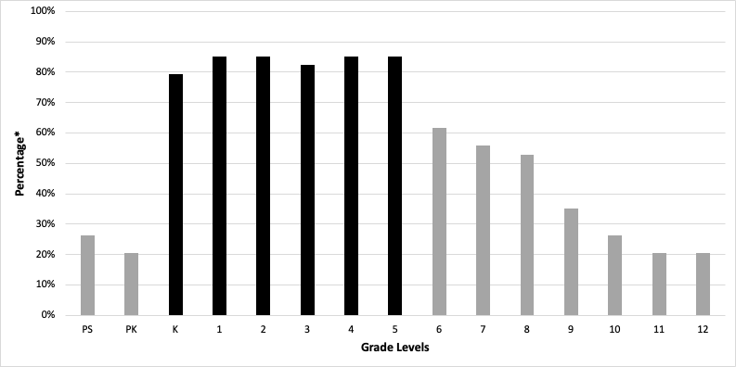
Note. *Percentages do not add up because multiple grade levels were included in all reviews.
PK = pre-kindergarten; PS = preschool; solid bars = included grade levels
Figure S3
Evidence-based reading components for K-5 MLs mapped onto the SVR and the Reading Rope
