Title: Task Characteristics Associated with Mathematical Word Problem-Solving Performance Among Elementary School-Aged Children: A Systematic Review and Meta-Analysis
Supplementary material 2
Forest plots for each investigated task characteristic
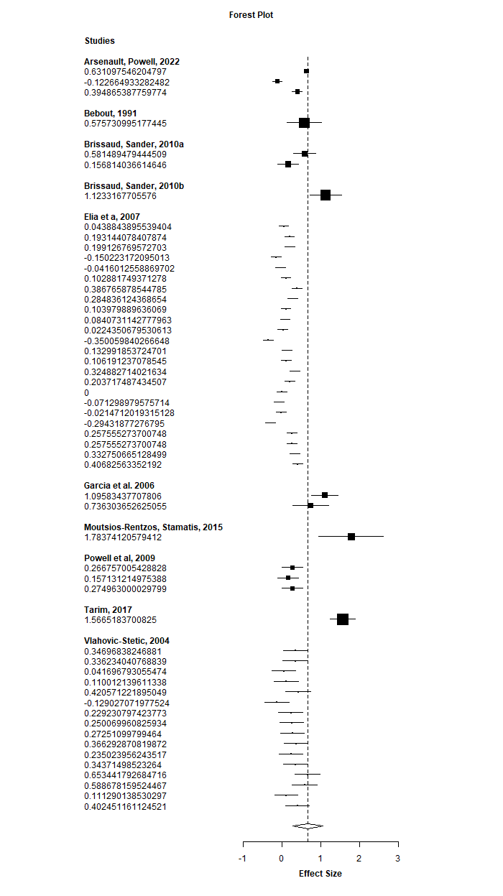
Position of the unknown: First-second
Position of the unknown: First-third

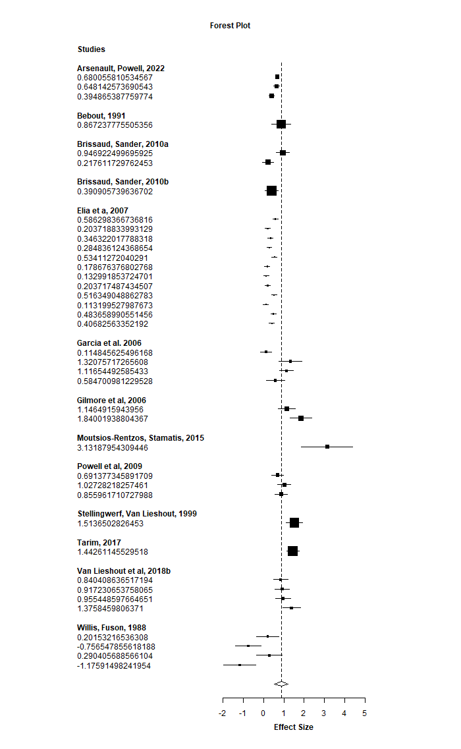
Position of the unknown: Third-second
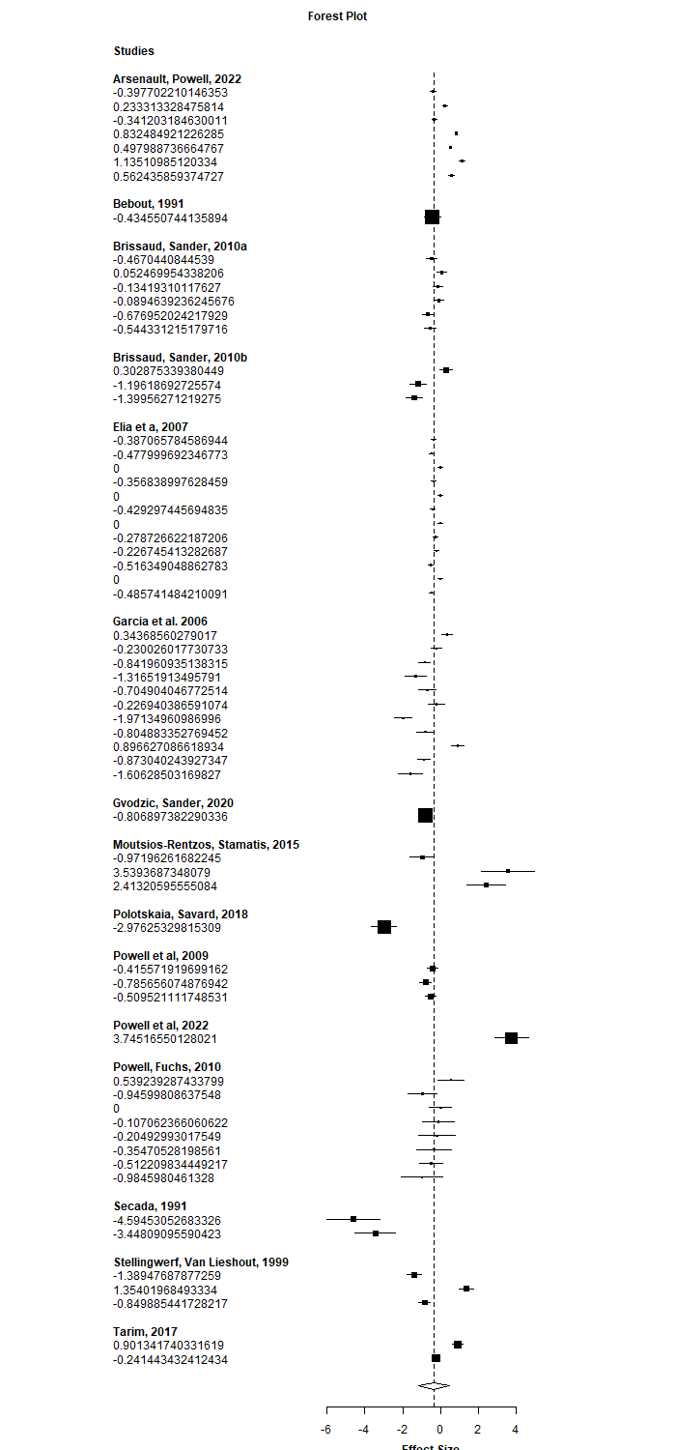
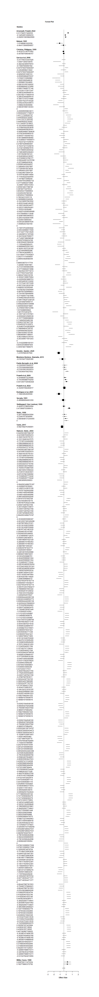
Schematic structure: Change-Difference

Schematic structure: Change-Total

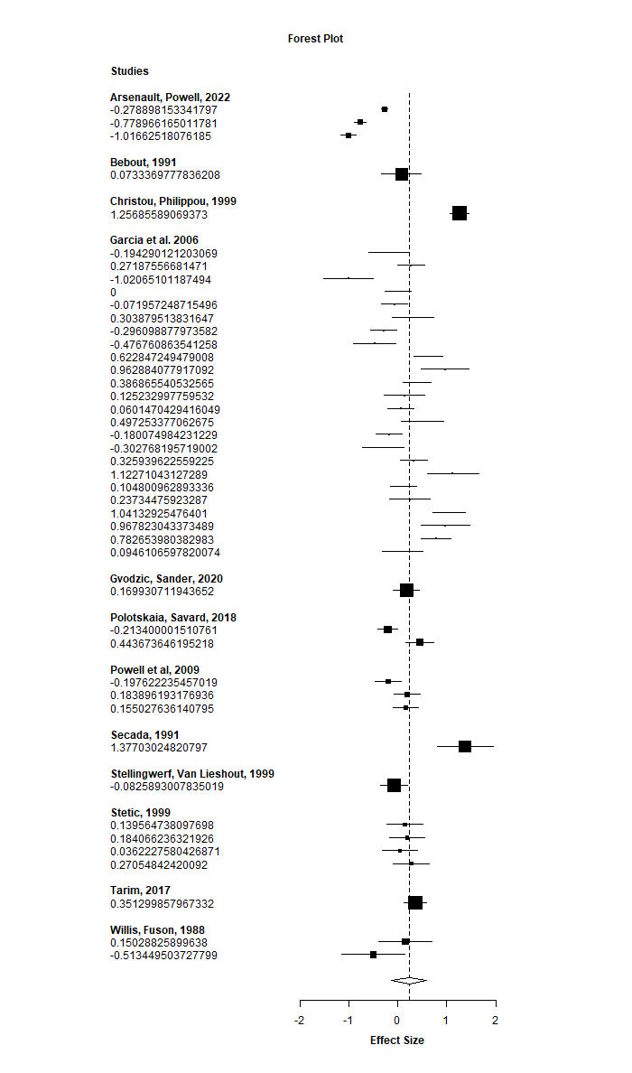

Schematic structure: Difference-Total
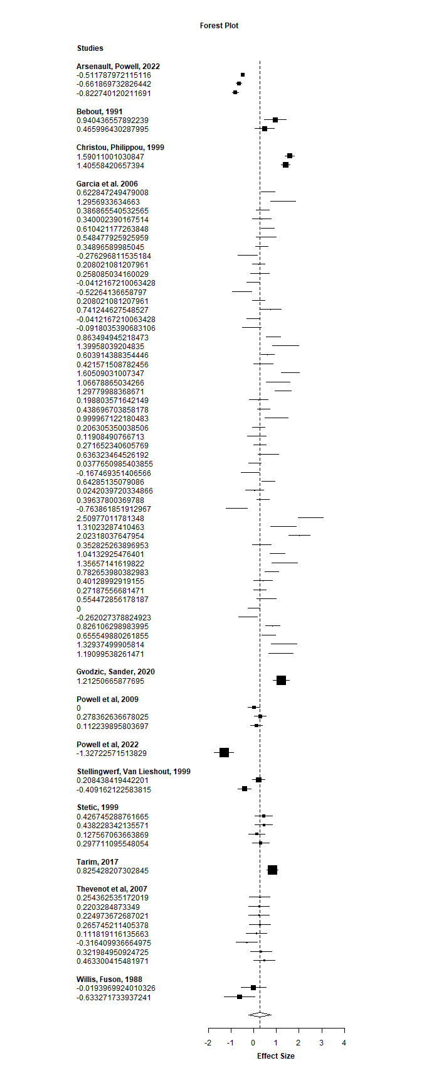

Familiarity: Standard-Familiar or personalized
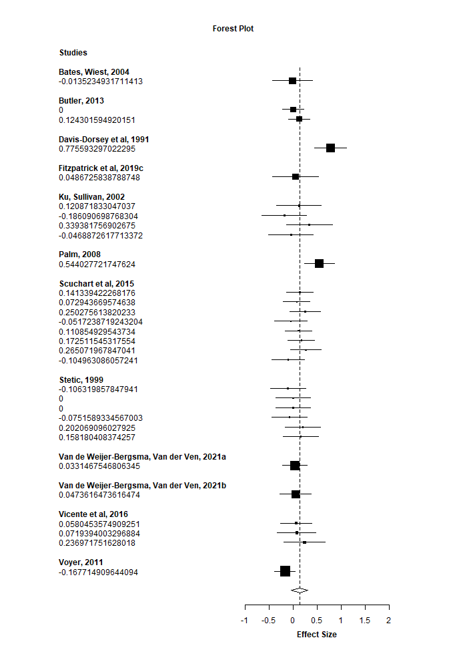

Irrelevant information: No irrelevant information-Irrelevant information
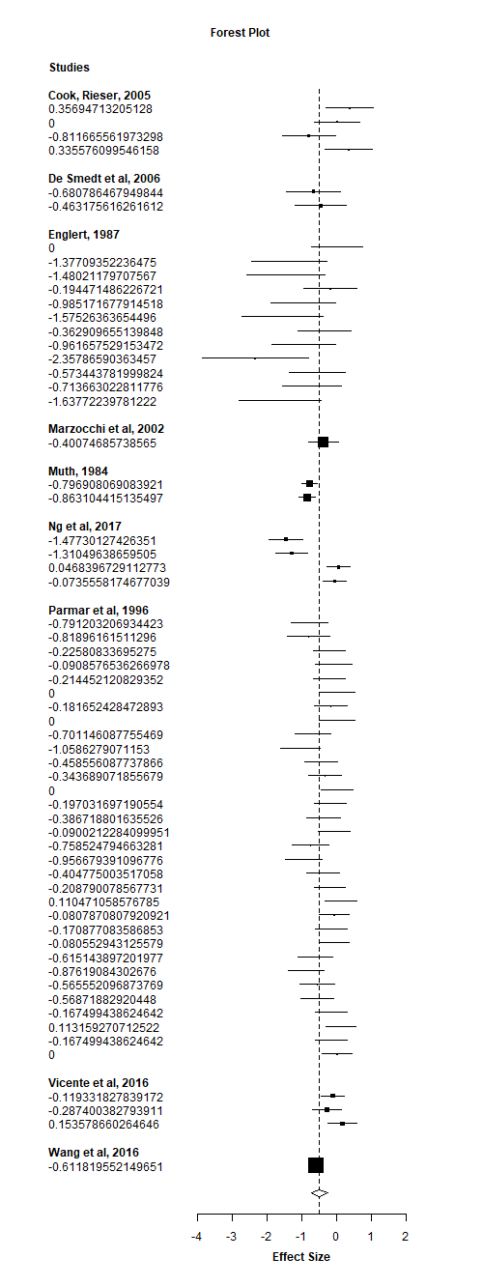

Realistic considerations: Standard-Realistic


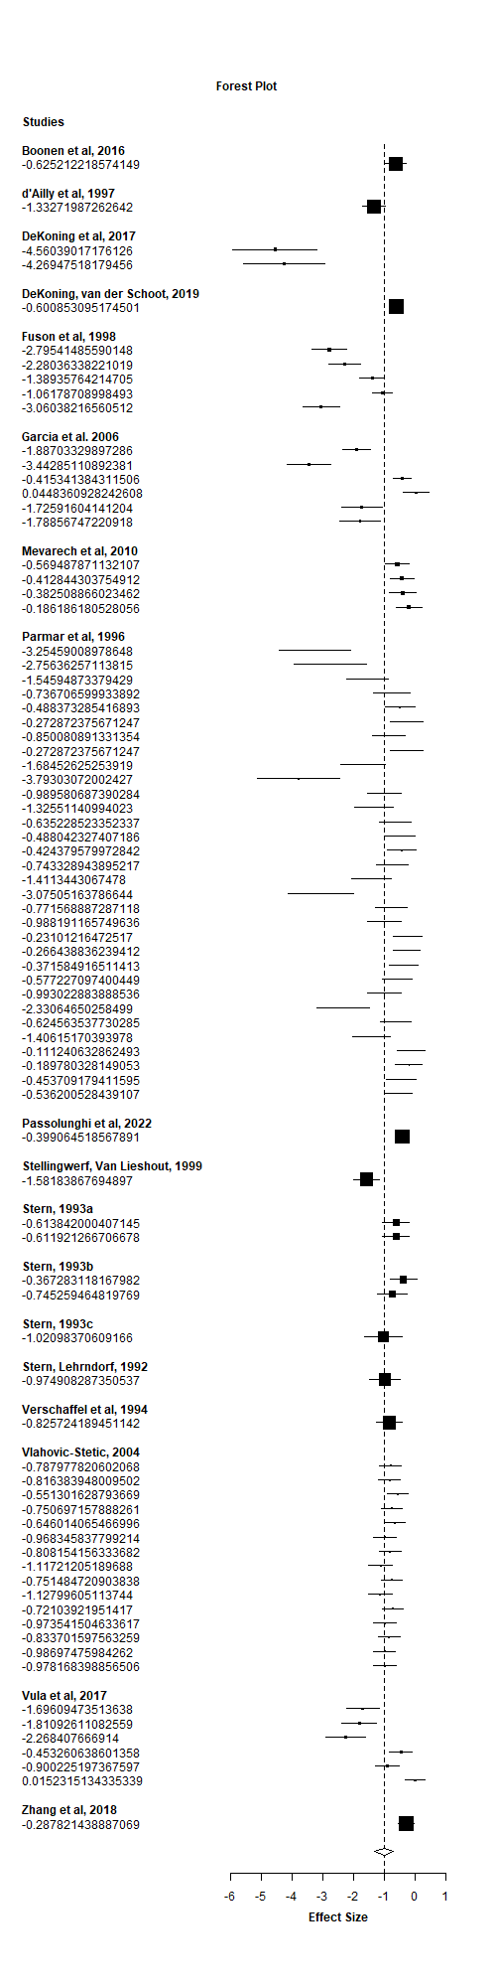
Consistency: Consistent-Inconsistent

Required operation: Additive-multiplicative
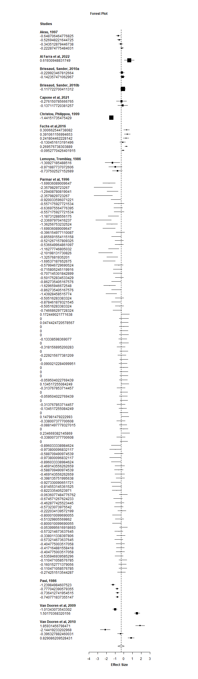

Number of operations: Single-step-Multi-step
