Supplementary Analyses
Experiment 1
The Effect of Domain on Generalization
To examine whether results differed across domains, we conducted an additional mixed-effects ANOVA including domain (language vs. mathematics) as a factor. The results of main effects and interactions for variability conditions and learning strategy were identical to those observed in the model that did not include domain as a factor. There was a significant main effect of learning strategy, F(1, 74) = 6.59, p = .012, η²ₚ = .08, indicating higher performance for retrieval practice than for worked examples. The main effect of variability condition was not significant, F(1, 74) = 2.92, p = .092, η²ₚ = .04, nor was the main effect of domain, F(1, 74) = 1.09, p = .299, η²ₚ = .01. None of the interactions involving learning strategies were significant, including the variability × learning strategy interaction, F(1, 74) = 0.15, p = .700, η²ₚ = .002, the learning strategy × domain interaction, F(1, 74) = 0.85, p = .361, η²ₚ = .01, the variability × domain interaction, F(1, 74) = 3.59, p = .062, η²ₚ = .05, and the three-way interaction, F(1, 74) = 0.85, p = .359, η²ₚ = .01.

Learning Time
We predicted that retrieval practice would require more time than worked examples and that learning would be slower in the varied items condition compared to the repeated items condition. To test these predictions, we analyzed participants’ total learning time, including time spent during the initial study phase (4 examples) and the learning session (50 items). We used a similar analytic approach to that used for the final test. The mixed-effects ANOVA revealed that participants who practiced with varied items and those who practiced with repeated items spent a similar amount of time learning, F(1,76) = 0.36, p = .550, η_{p}² = .005. However, participants who practiced using retrieval practice spent more time learning than those who studied using worked examples, F(1,76) = 35.40, p < .001, η_{p}² = .32, as illustrated in Figure S1.
Figure S1
Participants’ Total Learning Time In Experiment 1
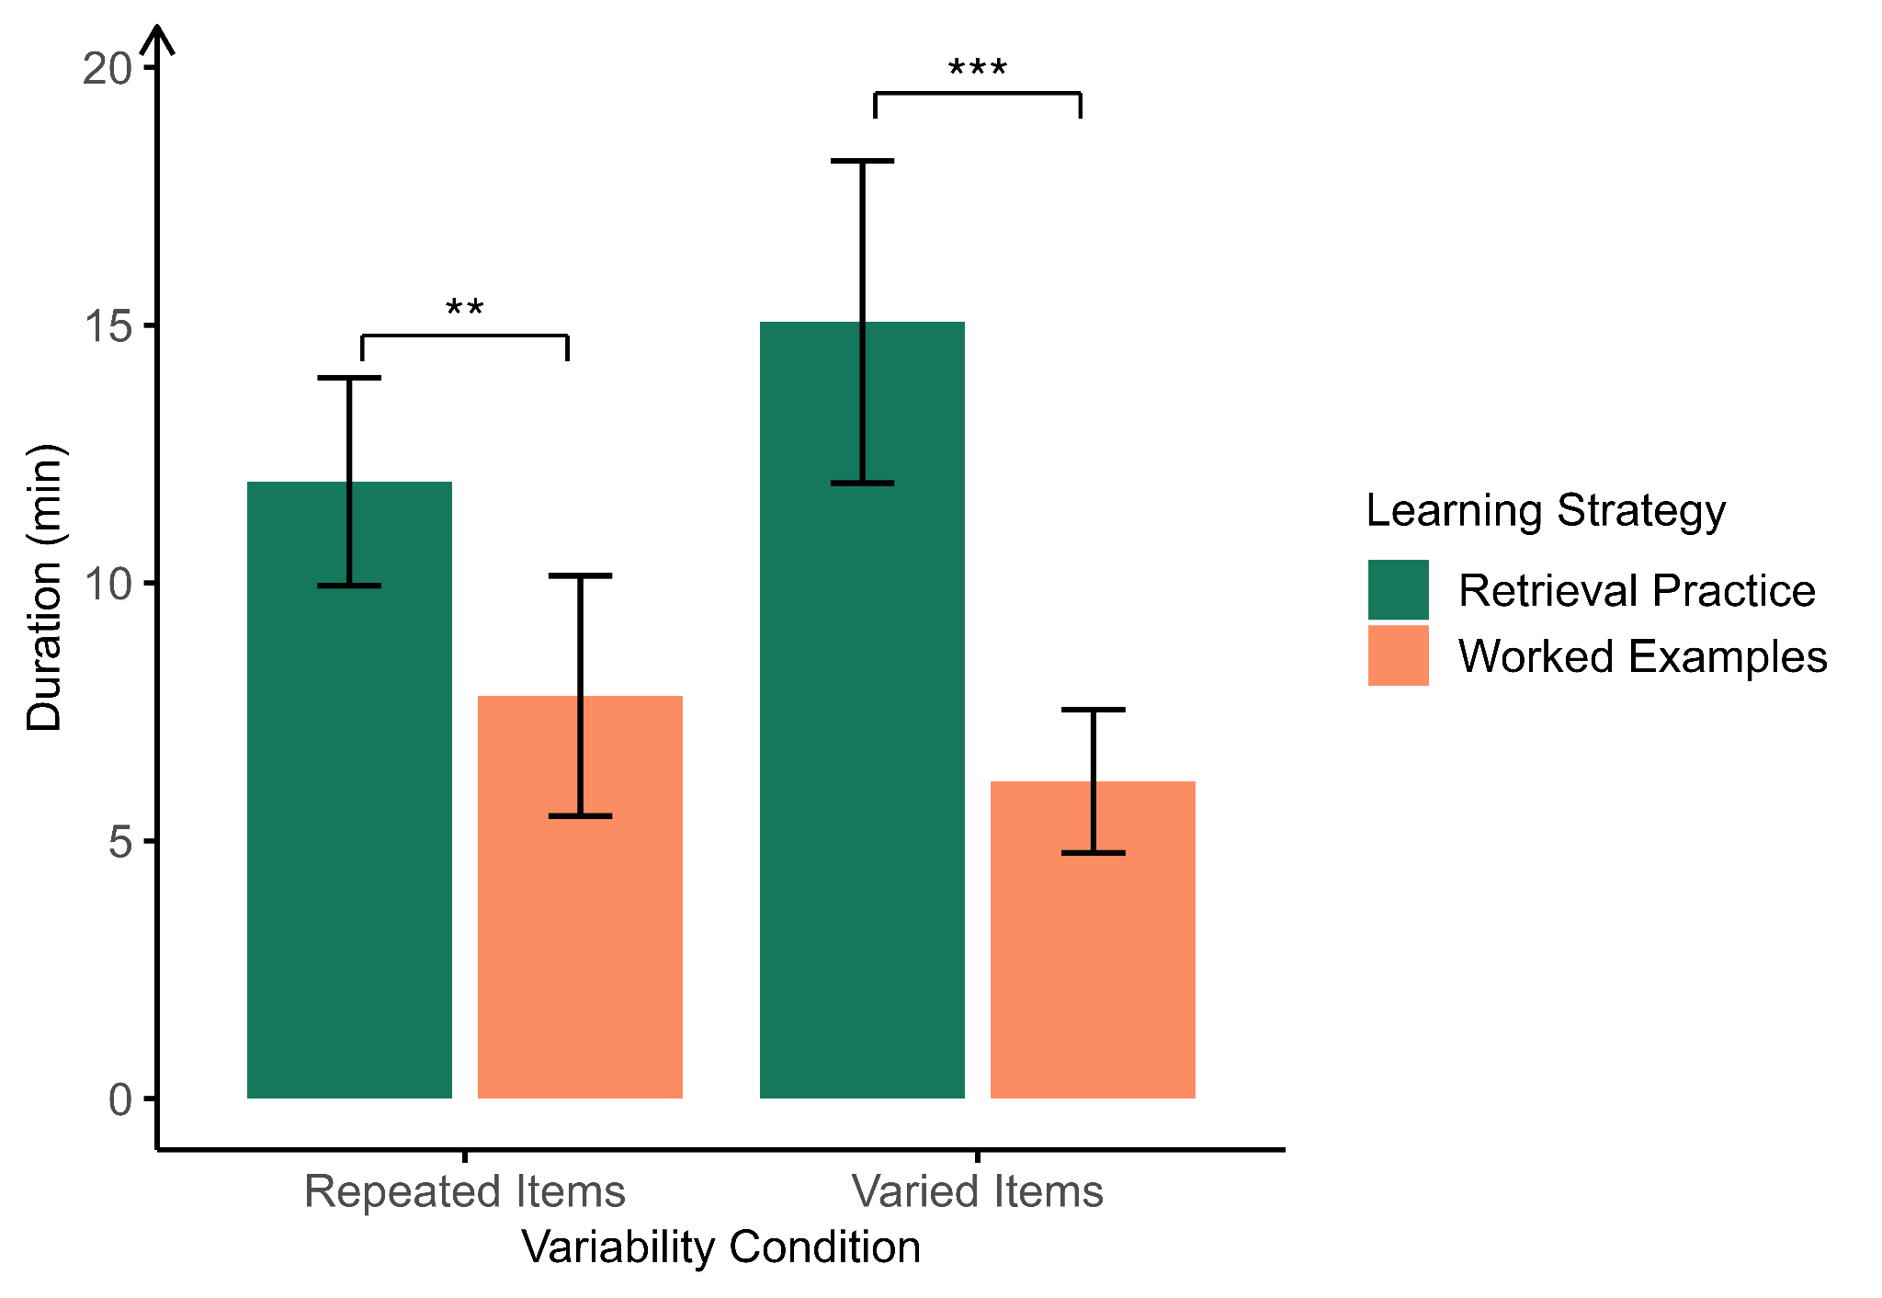
Note. Error bars show ± 2SEM.

There was also a significant interaction between variability and learning strategy, F(1,76) = 4.69, p = .034, η_{p}² =.06. To further investigate this interaction, we conducted a post hoc simple effects analysis using the emmeans function in the emmeans package (Lenth, 2023). We compared the learning time between learning strategies within each variability condition. In the repeated items group, participants spent significantly more time when practicing using retrieval practice (M = 11.96, SE = 1.15) than studying worked examples (M = 7.81, SE = 1.15), t(76) = 4.15, p = .009. Similarly, in the varied items group, participants also spent more time when doing retrieval practice (M = 15.06, SE = 1.15) than studying worked examples (M = 6.16, SE = 1.15), t(76) = 8.90, p < .001. However, participants who learned with varied items showed a larger time cost for retrieval practice over worked examples (about 4.75 minutes more) than participants who learned with repeated items, t(76) = –2.17, p = .034. These results suggest that although retrieval practice was more effective than worked examples, it required more learning time. Introducing variability did not enhance generalization performance but did increase learning time, particularly in the retrieval practice condition.
Learning Accuracy During Retrieval Practice
We also predicted that learning would be less accurate in the varied items condition compared to the repeated items condition. To test this prediction, we examined participants’ trial-by-trial accuracy during the learning session for the retrieval practice condition, as accuracy data were not available for the worked examples condition. Each practice item was scored as correct (1) or incorrect (0). Each rule was practiced on 10 items. We conducted a mixed-effects logistic regression using the glmer function from the lme4 package (Bates et al., 2015), with variability (reference: repeated) and trial number (centered so that 0 represented the first trial) as fixed effects, along with their interaction. The model included random intercepts and random slopes for trial number for both participants and concepts to account for individual differences in baseline performance and learning rate, as well as differences across rules. The results indicated that the varied items group (M = 0.51, SD = 0.33) started with significantly lower accuracy than the repeated items group (M = 0.63, SD = 0.28), b = −0.67, SE = 0.32, z = −2.09, p = .037. Participants’ accuracy increased significantly as the number of learning trials increased, b = 0.34, SE = 0.05, z = 6.26, p < .001. The significant interaction between variability and trial number, b = −0.21, SE = 0.06, z = −3.55, p <.001, indicated that the varied items group improved at a slower rate than the repeated items group. The model-predicted accuracy across trials (i.e., the learning curve) is shown in Figure S2.

Figure S2
Learning Curves for Retrieval Practice in Experiment 1
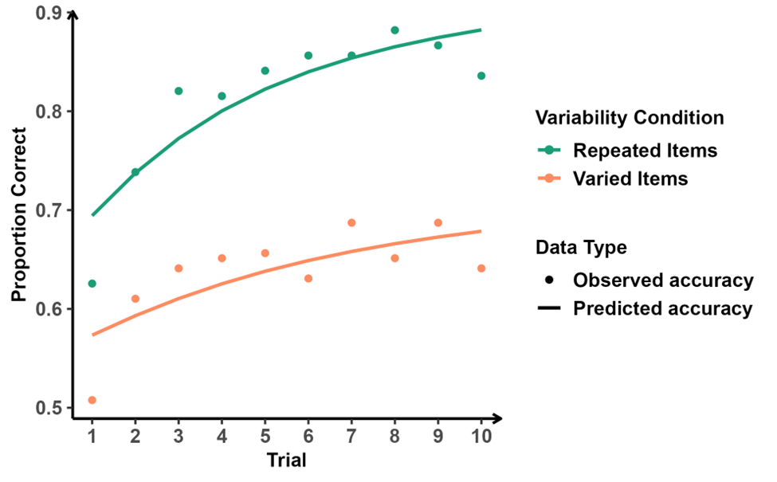
Note. The learning curve was plotted based on predictions from the mixed-effects model: Accuracy ~ trial*variability + (trial | rule)+(trial|prolific_id).

Experiment 2

The Effect of Domain on Generalization
Similar to Experiment 1, we did a mixed-effects ANOVA including variability condition, learning strategy, and domain (language vs. mathematics) as fixed effects and participants as a random effect. The results of main effects and interactions for variability conditions and learning strategy were identical to those observed in the model that did not include domain as a factor. There was a significant main effect of learning strategy, F(1, 70) = 8.26, p = .005, η²ₚ = .11, such that participants who studied worked examples performed better on the final test than those who engaged in retrieval practice. The main effect of variability condition was not significant, F(1, 70) = 1.02, p = .317, η²ₚ = .01. The interaction between variability condition and learning strategy was significant, F(1, 70) = 4.08, p = .047, η²ₚ = .06, indicating that the relative effectiveness of retrieval practice and worked examples differed depending on whether learners studied repeated or varied items. Follow-up simple effects analyses were conducted to examine this interaction. In the repeated-items condition, participants who studied worked examples performed significantly better on the final test than those who engaged in retrieval practice, t(70) = −4.09, p < .001. In contrast, in the varied-items condition, there was no significant difference between retrieval practice and worked examples, t(70) = −0.53, p = .596.

Learning Time
Similar to Experiment 1, we also examined the effects of variability and learning strategy on the learning time. The model included random intercepts for participant ID, but a singularity warning was detected. Therefore, we removed this random effect and used the aov function to perform the ANOVA. The results revealed no significant difference in learning time between repeated item group and varied item group, F(1,72) = 3.69, p = .059, η_{p}² = .05. However, participants spent more time on learning in the retrieval practice condition than in the worked examples condition, F(1,72) = 17.51, p < .001, η_{p}² = .20. The interaction between variability and learning strategy was also significant, F(1,72) = 4.69, p = .034, η_{p}² =.06, as shown in Figure S3.
Figure S3
Participants’ Total Learning Time in Experiment 2
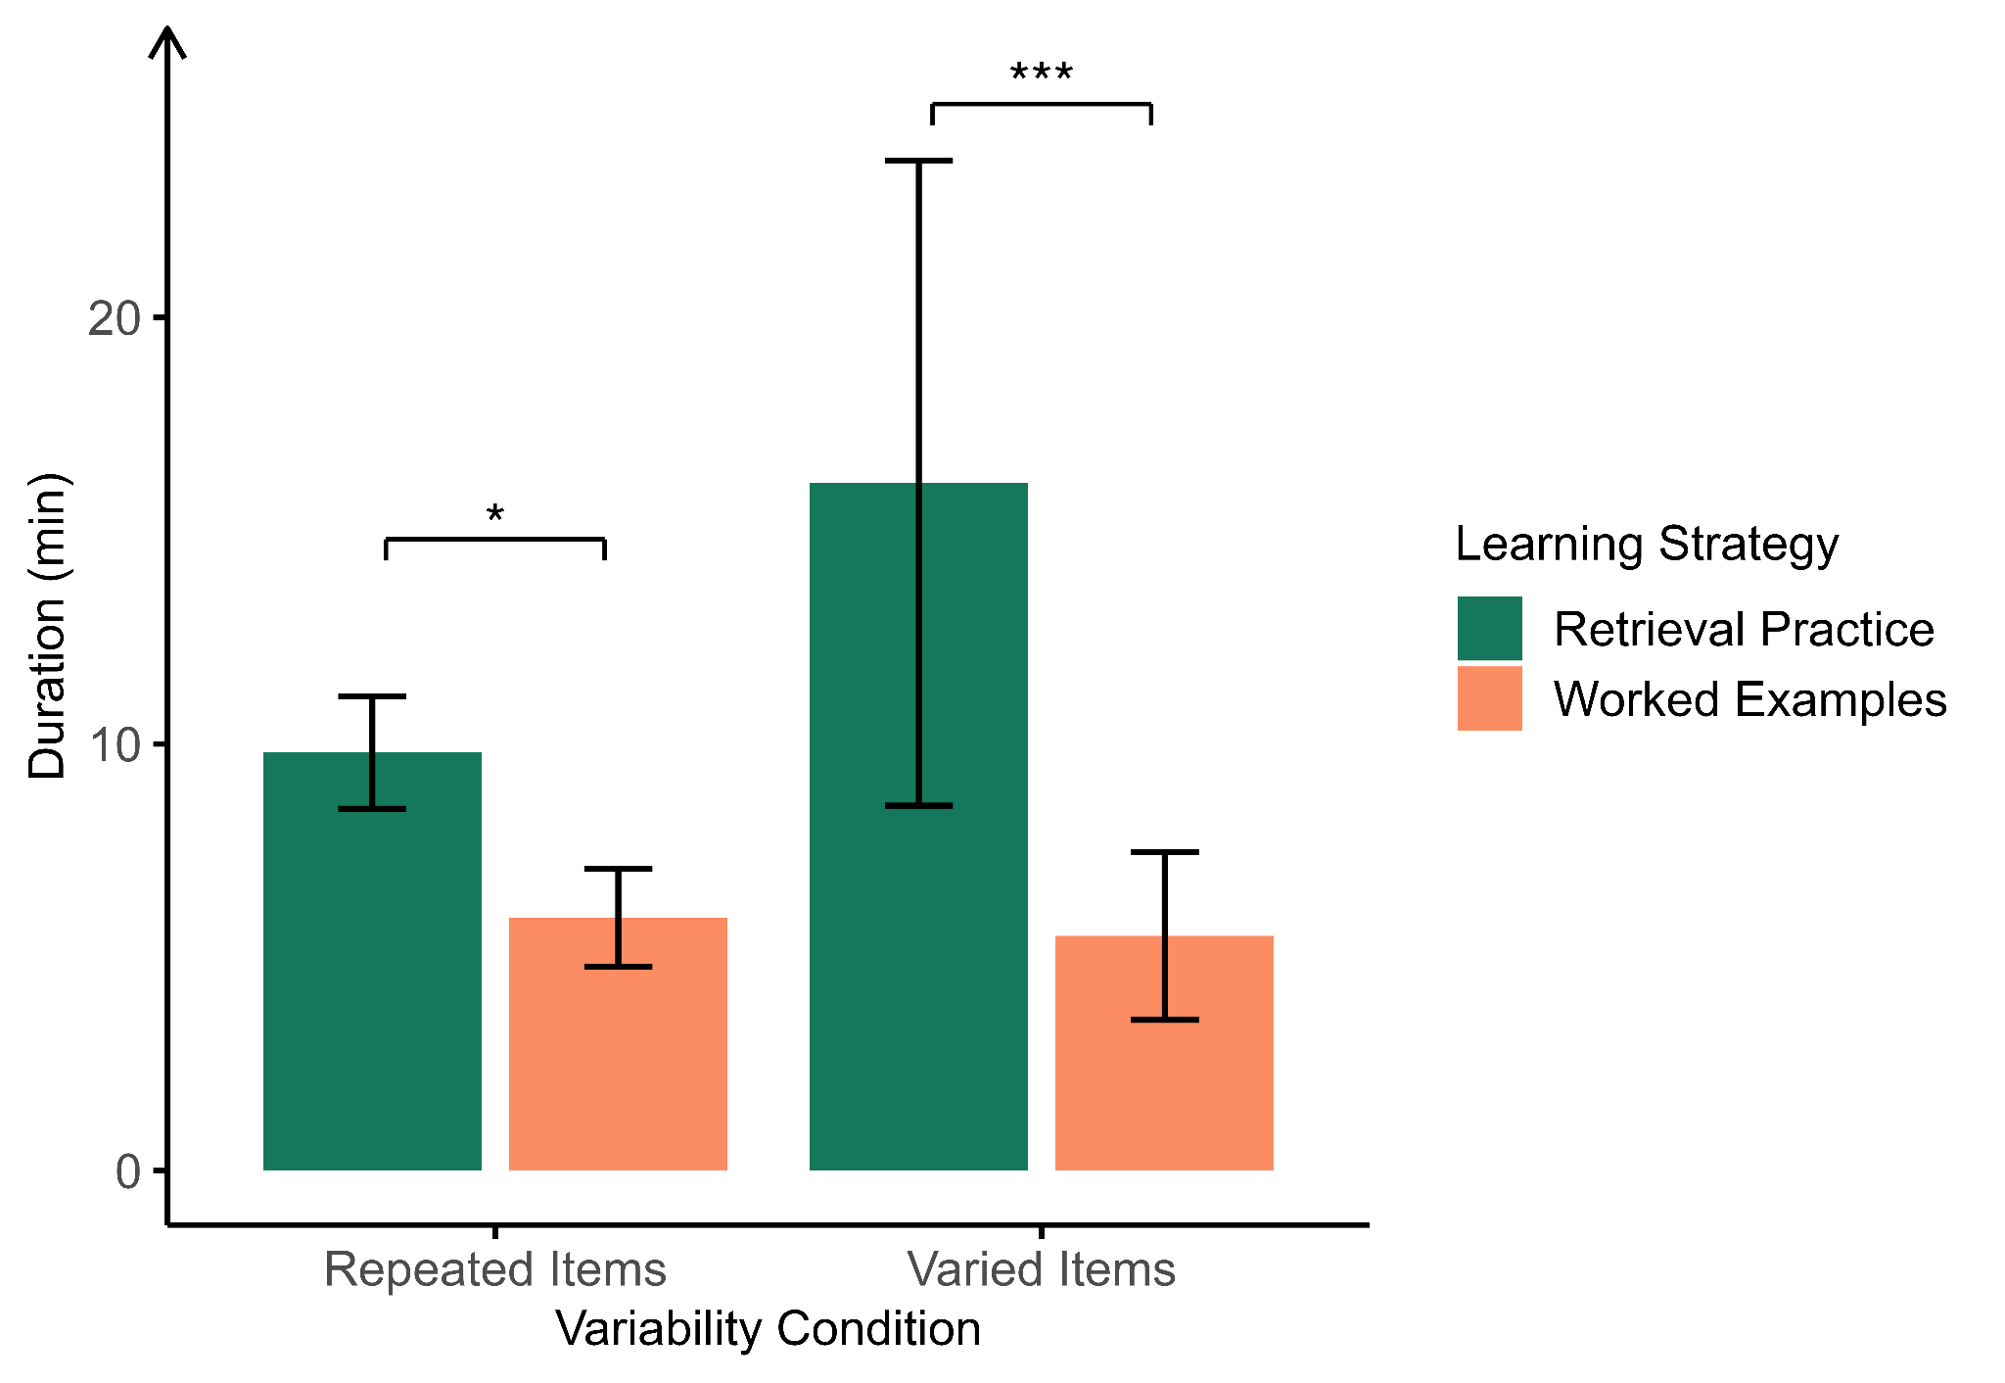
Note. Error bars show ± 2SEM.
To further investigate this interaction, we conducted a post hoc simple effects analysis. We compared the difference between learning strategies within each variability condition. In the repeated items group, participants spent significantly more time in the retrieval practice condition (M = 9.36, SE = 1.41) than in the worked examples condition (M = 5.49, SE = 1.41), t(72) = 2.09, p = .04. Similarly, in the varied items group, participants also spent more time in retrieval practice condition (M = 15.68, SE = 1.64) than in worked examples condition (M = 5.06, SE = 64), t(72) = 4.22, p < .001. However, the additional learning time in the retrieval practice condition compared to the worked examples condition was approximately 6.75 minutes greater in the varied items group than in the repeated items group, t(72) = –2.16, p = .034. The results were identical to those observed in Experiment 1.

Learning Accuracy During Retrieval Practice
Participants’ accuracy during the learning session was available only for the retrieval practice condition. Therefore, we analyzed trial-by-trial accuracy in this condition using a mixed-effects logistic regression, with variability (reference: repeated) and trial number (centered so that 0 represented the first trial) as fixed effects, along with their interaction. The model included random intercepts and random slopes for trial number for both participants and concepts to account for individual differences in baseline performance and learning rate, as well as differences across rules. The model was fit using the glmer function from the lme4 package (Bates et al., 2015) with a binomial logit link. The results indicated no significant difference in initial performance between the repeated items (M = 0.31, SD = 0.20) and varied items groups (M = 0.39, SD = 0.23), b = 0.16, SE = 0.20, z = 0.77, p = .439. Trial number was a significant positive predictor of accuracy, b = 0.48, SE = 0.05, z = 9.26, p < .001, indicating substantial learning across trials. Importantly, the interaction between variability and trial number was significant, b = −0.31, SE = 0.07, z = −4.36, p < .001, showing that the varied items group’s learning rate was significantly slower than that of the repeated items group. The learning curves are shown in Figure S4.
Figure S4
Learning Curves for Retrieval Practice in Experiment 2
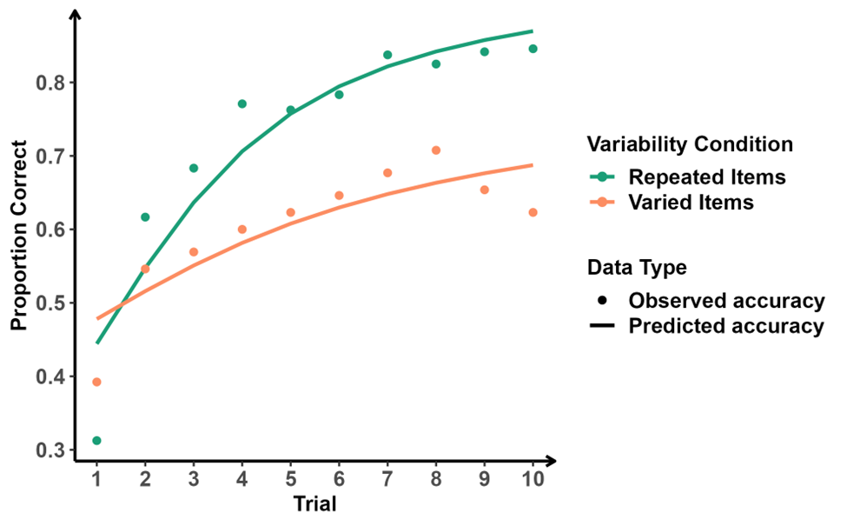
Note. The learning curve was plotted based on predictions from the mixed-effects model: Accuracy ~ trial*variability + (trial | rule)+(trial|prolific_id).

