Supplementary Materials

Broad Category Coding Manual
Creating the Search Strings is combination of
- relevant STEM disciplines,
- education-related specifiers,
- publication types,
- publication years.
STEM disciplines
STEM, STEAM, STREAM, STEMM, iSTEM, SMET, pSTEM, science, technology, engineering, mathematics, math, maths, biology, chemistry, physics, computer.
Education-related Specifiers
Strings entered in ERIC and à potential results for outcomes
For all other platforms, only the asterisk (*) was used
- teach[*3] à teacher, teachers, teaching
- learn[*3] à learner, learners, learning
- instruct[*4] à instruction, instructions, (instructive)
- educat[*4] à educate, educates, educator, educators, education, educations, educative
- studen[*2] à student, students
- studying
- interventio[*2] à intervention, interventions
- progra[*4] à program, programs, programme, programmes, (programmer)
- projec[*2] à project, projects
- classroo[*2] à classroom, classrooms
- cours[*2] à course, courses
- clas[*3] à class, classes, (classy)
- subjec[*2] à subject, subjects
- literac[*3] à literacy, literacies
- knowledge
- skil[*2] à skill, skills
- competenc[*3] à competence, competency, competences, competencies
- proficienc[*3] à proficiency, proficiencies
- identit[*3] à identity, identities
- curriculum
- curricula
- curricular
- achievemen[*2] à achievement, achievements
- performanc[*2] à performance, performances
- assess[*5] à assessment, assessments, (assessing, assesses, assessed, assessor, assessors)
- evaluat[*4] à evaluate, evaluating, evaluation, evaluations
Publication types
Scoping review, systematic review, research synthesis, synthesis of research, research overview, literature review, literature overview, literature synthesis, research summary, meta-analysis
Inclusion (== 1):
- Second-order analysis (e.g., systematic review, literature review, scoping review, meta-analysis, research overview, etc.)
- Investigates aspects of STEM education or individual subdisciplines such as science, technology, engineering, mathematics, computer science, physics, biology, medical science, health science, etc.
- Published between Jan 01, 2000 and Oct 31, 2023
Exclusion (==0):
- No second-order analysis (e.g., systematic review, literature review, scoping review, meta-analysis, research overview, etc.)
- Does not investigate aspects of STEM education or individual subdisciplines such as science, technology, engineering, mathematics, computer science, physics, biology, physics, medical science, health science, etc.
- Not published between Jan 01, 2000 and Oct 31, 2023
No abstract available (== abstract):
The title sounds promising and relevant for the project, but no abstract is available for more detailed information (à abstract should be added manually if available)
Category coding
Yes (==1) /No (==0) /empty coding: if one category isn’t mentioned or not related to the paper, we just leave it empty and don’t put anything at all
Publication type – authors’ wording
Fill in the information according to the authors’ wording (e.g., meta-analysis, systematic review, scoping review, etc.). If different terms are used, proceed as follows: XXX
STEM domain:
science, technology, engineering, mathematics, biology, chemistry, physics, computer science, pharmacy, medical science, STEM, STEMM, STEAM, STREAM (Robot), STREAM (Religion), other, STEM + non-STEM
Code as “1” every category or discipline that is mentioned in the abstract (or title). In cases where a specific area of a subject is mentioned, e.g. astronomy, which is part of physics, code “1” for the subject (physics in this case) and specify the area in the column “other”.
If STEM is mentioned, only fill in “STEM” – and not the individual subdisciplines, i.e., S, T, E and M.
Similarly, if “stem, technology, engineering and mathematics” are used without the acronym STEM, we only code for STEM unless there is a clear emphasis on the respective subdisciplines.
If an explanation of the acronym is provided, e.g. STEM (science, technology, engineering, and mathematics), only code for STEM!
If not only STEM domains are mentioned (e.g. maths and language skills), fill in “1” into the respective STEM domain + the last column that is called “STEM + non-STEM”.
STREAM (Robotics): refers to uses of the acronym in which R denotes robotics
STREAM (Relegion): refers to uses of the acronym in which R denotes religion
Multiple codings are possible here, i.e. if two (or more) acronyms are mentioned, e.g. STEM & STEAM, add 1 to both columns
Intervention – 1/empty
Code 1 if the paper is concerned with studies that used interventions to see a pre-post effect on e.g., learning outcomes, educational experiences, or the overall development of students.
For example: There is a problem or a specific status and the intervention tries to change that (code 1 if there is a problem described and an intervention is developed for that problem or it’s a review of interventions for that problem). That is, if the paper reviews something that has been tested or done (X) to see if it has an effect on something like a certain outcome (Y) (that aspect X should be the same in all research reviewed in the paper). Impact or effectiveness of one method on the outcome of one group. Comparisons may be possible too.
Keywords: outcome, intervention, control group, non-sth group vs. Sth-group, experiment(al), semi-experiment(al).

Forest Plot of Model-Specific and Model-Averaged Hedges’ g Estimates From the RoBMA-PSMA
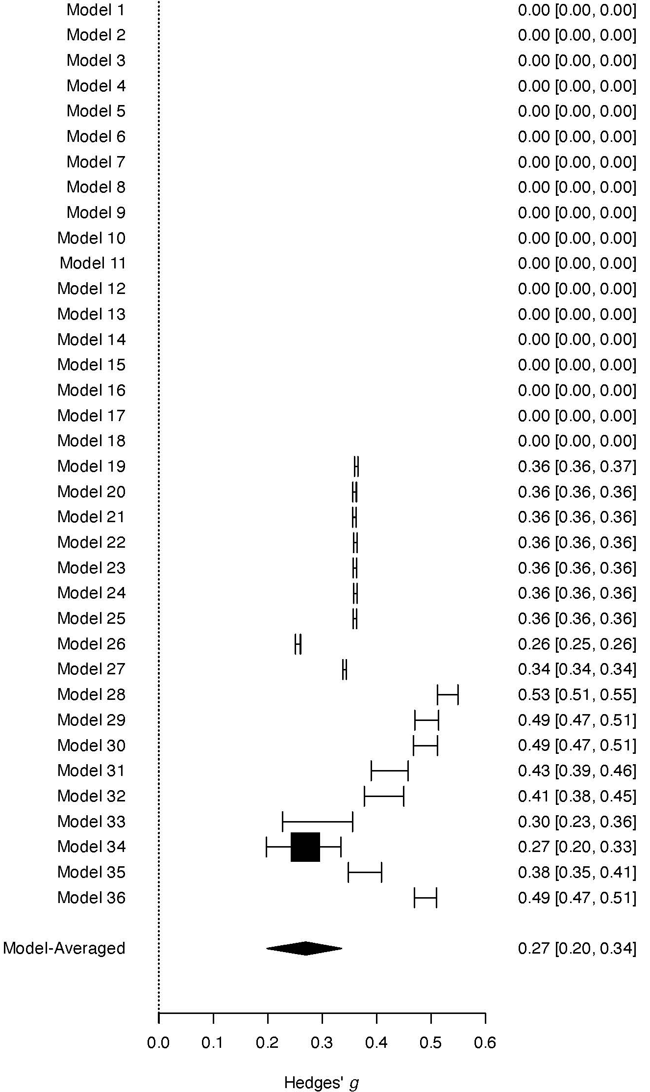

Forest Plot of Model-Specific and Model-Averaged Hedges’ g Estimates From the RoBMA-Regression
