Appendix A. Supplementary data

Material and methods
Detailed predictors descriptions
The topographic data were obtained as an image from the SRTM database (Jarvis et al. 2008). Four topographic metrics were used, namely elevation (mean altitude in the square), aspect (0°/360° means that the slope faces the North, 90° – the East, 180° – the South, and 270° – the West), roughness (largest inter-cell difference of a central pixel and its surrounding cell), and slope (the average slope in the square expressed as percentage).
The WorldClim database (www.worldclim.org, Hijmans et al. 2005) delivered climate layers with spatial resolution of 1 km². Six climatic variables were obtained for each grid square, i.e. Annual Mean Temperature (AMT), Mean Temperature of the Warmest Quarter (MTWAQ), Mean Temperature of the Coldest Quarter (MTCQ), Annual Precipitation (AP), Precipitation of the Warmest Quarter (PWAQ), and Precipitation of the Coldest Quarter (PCQ).
Habitat types were derived from three sources: (1) The Corine Land Cover database (based on remote sensing with basic spatial units of 100 m x 100 m, https://land.copernicus.eu/pan-european/corine-land-cover), created in 1986–1996, 2000, 2003 and 2006 from the Landsat TM; (2) Images of lights at night used as the level of human density (LIGHT). This dataset comes from remote sensing data, and lights on the night map include cities, towns, and other sites with persistent lighting. This kind of data is highly correlated with industrial activities (Small et al. 2005; Doll et al. 2007); and (3) types of the forest cover from the Joint Research Centre (http://forest.jrc.ec.europa.eu/), which is a dataset of 25 meter resolution covering two types of forest, viz. coniferous and deciduous.
As the level of green vegetation, the normalised differences vegetation index (NDVI) from the SPOT dataset (http://free.vgt.vito.be/) was applied. The NDVI is expressed as a mean monthly value (from March to June) calculated from three measurements taken every ten days.
Then, landscape configuration metrics included (1) the buffer zone expressed in percentage and defined as the area within 100 m from the outside edge of the patch; (2) the core also presented in percentage and defined as the area without the 100 m buffer zone from the patch’s edge; and (3) the patch shape index expressed as a mean patch perimeter in each grid cell divided by the minimum perimeter possible for the maximal patch. Thus, the index equals 1 when the patch is square and increases without limit until the patch shape becomes more irregular.

Table S4. GAM models for the Great Grey Shrike (Ď_{GGS}) and Great Spotted Woodpecker (Ď_{DM}) density, as well as Bird Species Richness (BSR) and Functional Species Richness (FRic). Particular models differing in numbers of predictors, linearized or included predictors as a polynomial spline. (s) reflect spline, while (L) – linear. The most parsimonious model given in bold
Model | Predictor | logLink | AIC | Δ AIC | weight
Ď_{GGS}
GGS1 | Null | 2.724 | -1.4 | 270.11 | 0
GGS2 | s(URB-BCFOR)+L(MEAD-CFIELD)+ s(NDVI.APR)+s(ROUGHNESS)+s(SHAPE.DFOR) | 184.75 | -271.6 | 0 | 0.994
GGS3 | s(NDVI.APR)+s(MEAD-CFIELD)+s(PREC)+s(URB-BCFOR) +s(ROUGHNESS) +s(SHAPE.DFOR)+s(SHAPE.MFOR)+s(SHAPE.MEADOWS) | 172.41 | -259.7 | 11.88 | 0.003
GGS4 | s(NDVI.MAR)+s(NDVI.APR)+s(MEAD-CFIELD)+s(PREC)+s(URB-BCFOR) +L(ROUGHNESS) +s(SHAPE.DFOR)+s(SHAPE.MFOR)+s(SHAPE.MEADOWS) | 171.30 | -258.9 | 12.65 | 0.002
GGS5 | s(NDVI.MAR)+s(MEAD-CFIELD)+s(PREC)+s(URB-BCFOR) +L(ROUGHNESS) +s(SHAPE.  DFOR)+s(SHAPE.MEADOWS)+s(NDVI.APR) | 171.30 | -258.9 | 12.65 | 0.002
Ď_{GSW}
GSW1 | null | -1131.77 | 2267.6 | 1657.6 | 0
GSW 2 | s(CFIELD-CCFOR)+s(NDVI.MAR)+s(CDFOR- CFIELD)+s(MFOR-CBFIELD) +s(ROUGHNESS) | -280.06 | 609.9 | 0 | 0.540
GSW 3 | s(CFIELD-CCFOR)+s(CDFOR- CFIELD)+s(MFOR-CBFIELD) +s(NDVI.APR)+s(ROUGHNESS) | -281.16 | 610.6 | 0.69 | 0.254
GSW 4 | s(CFIELD-CCFOR)+s(CDFOR- CFIELD)+s(MFOR-CBFIELD) | -285.45 | 612.2 | 2.36 | 0.110
GSW 5 | s(CFIELD-CCFOR)+s(CDFOR- CFIELD)+s(MFOR-CBFIELD) | -285.46 | 612.3 | 2.44 | 0.053
GSW 6 | s(CFIELD-CCFOR) | -277.14 | 612.8 | 2.91 | 0.042
BSR
BSR1 | null | -4228.16 | 8660.3 | 175.51 | 0
BSR2 | s(MFIELD-CCFOR)+ s(CFIELD-CCFOR)+s(PEAT)+s(ROUGHNESS)+S(CFIELD-BBUSHE) | -4112.06 | 8284.8 | 0 | 0.998
BSR3 | L(MFIELD - CCFOR)+L(PEAT)+L(CFIELD-CCFOR)+L(ROUGHNESS)+L(CFIELD-BBUSHE) | -4128.04 | 8302.40 | 17.59 | 0.001
BSR4 | s(MFIELD - CCFOR)+s(PEAT)+s(CFIELD-CCFOR)+s( ROUGHNESS)+S(CFIELD-BBUSHE) | -4128.04 | 8302.41 | 17.60 | 0.001
FRic
FRIC1 | null | 1055.40 | -2106.8 | 220.25 | 0
FRIC2 | L(CFIELD-CCFOR)+L(MFIELD- CCFOR)+ L(MFOR-CBFIELD)+L(TEMP)+L(NDVI.APR)+ L(PEAT) | 1195.26 | -2327.1 | 0 | 0.849
FRIC3 | s(CFIELD-CCFOR)+s(TEMP)+s(NDVI.MAY)+s(MFIELD- CCFOR)+s(PEAT)+L(MFOR-CBFIELD)+s(ALTITUDE) | 1185.83 | -2321.4 | 5.65 | 0.052
FRIC4 | s(CFIELD-CCFOR)+s(BFIELD- CCFOR)+s(PEAT)+s(ROUGHNESS) | 1185.84 | -2321.5 | 5.66 | 0.049
FRIC5 | s(CFIELD-CCFOR)+s(BFIELD- CCFOR)+s(PEAT) | 1185.84 | -2321.6 | 5.67 | 0.048

Table S5. Predictors including in the best supported Generalised additive models and Random forests. Bold indicate model with the best predictive accuracy
Species/richness | GAM |  |  |  | RF
Species/richness | Predictor | F | P | RI | Predictor | MSE_{OOB}
Great Grey Shrike  (Ď_{GGS}) | URB-BCFOR | 2.871 | 0.004 | 1 | URB-BCFOR | 20.49
Great Grey Shrike  (Ď_{GGS}) | MEAD-CFIELD | 4.159 | 0.041 | 1 | ROUGHNES | 19.45
Great Grey Shrike  (Ď_{GGS}) | NDVI.APR | 1.937 | 0.049 | 1 | NDVI.MAR | 17.84
Great Grey Shrike  (Ď_{GGS}) | ROUGHNES | 4.159 | 0.041 | 1 | PREC | 17.69
Great Grey Shrike  (Ď_{GGS}) | SHAPE.DFOR | 2.082 | 0.037 | 1 | MFIELD-CCFOR | 15.10
Great Grey Shrike  (Ď_{GGS}) |  |  |  |  | MEAD-CFIELD | 15.07
Great Grey Shrike  (Ď_{GGS}) |  |  |  |  | NDVI.APR | 14.00
Great Spotted Woodpecker (Ď_{GSW}) | CFIELD-CCFOR | 9.53 | <0.0001 | 1 | CFIELD-CCFOR | 61.98
Great Spotted Woodpecker (Ď_{GSW}) | NDVI.MAR | 0.83 | 0.008 | 0.540 | NDVI.MAR | 47.84
Great Spotted Woodpecker (Ď_{GSW}) | CDFOR-CFIELD | 1.15 | 0.0005 | 0.958 | MFOR-CBFIELD | 44.29
Great Spotted Woodpecker (Ď_{GSW}) | MFOR-CBFIELD | 3.69 | <0.0001 | 0.540 | CDFOR- CFIELD | 26.38
Great Spotted Woodpecker (Ď_{GSW}) | ROUGHNESS | 1.336 | 0.001 | 0.794 | ROUGHNESS | 24.10
Great Spotted Woodpecker (Ď_{GSW}) |  |  |  |  | NDVI.APR | 23.79
Great Spotted Woodpecker (Ď_{GSW}) |  |  |  |  | SHAPE.CFOR | 23.47
Great Spotted Woodpecker (Ď_{GSW}) |  |  |  |  | PREC | 22.57
Bird species richness (BSR) | MFIELD - CCFOR | 7.53 | <0.001 | 1 | MFIELD- CCFOR | 40.19
Bird species richness (BSR) | CFIELD-CCFOR | 7.23 | <0.001 | 1 | CFIELD-CCFOR | 27.81
Bird species richness (BSR) | PEAT | 7.23 | <0.001 | 1 | TEMP | 22.14
Bird species richness (BSR) | ROUGHNESS | 3.05 | 0.002 | 1 | CFIELD-BBUSHE | 17.15
Bird species richness (BSR) | CFIELD-BBUSHE | 6.63 | 0.010 | 1 | ROUGHNESS | 11.41
Bird species richness (BSR) |  |  |  |  | ASPECT | 10.07
Bird species richness (BSR) |  |  |  |  | SHAPE.AFIELDS | 9.45
Functional species richness (FRic) | CFIELD-CCFOR | 1.58 | 0.001 | 1 | MFIELD- CCFOR | 23.01
Functional species richness (FRic) | MFIELD- CCFOR | 9.35 | <0.0001 | 0.901 | SHAPE.AFIELDS | 21.11
Functional species richness (FRic) | MFOR-CBFIELD | 0.98 | 0.01 | 0.849 | CFIELD-CCFOR | 19.07
Functional species richness (FRic) | TEMP | 1.84 | <0.0001 | 0.849 | TEMP | 18.98
Functional species richness (FRic) | NDVI.APR | 1.86 | 0.002 | 0.849 | CFIELD-BBUSHE | 18.04
Functional species richness (FRic) | PEAT | 2.43 | 0.001 | 1 | MEAD-CFIELD | 17.22
Functional species richness (FRic) |  |  |  |  | ROUGHNESS | 16.99
Functional species richness (FRic) |  |  |  |  | ALTITUDE | 10.17
Functional species richness (FRic) |  |  |  |  | NDVI.MAR | 9.9

Table S6. Full and selected models in Random Forest Approach
 | Full model |  |  |  | Selected model
 | RMSE | OOB | R² | r | # predictors | RMSE | OOB | R² | r
GGS | 0.37 | 0.59 | 0.61 | 0.91 | 7 | 0.24 | 0.44 | 0.69 | 0.95
GSW | 0.59 | 0.41 | 51 | 0.62 | 8 | 0.53 | 0.36 | 0.55 | 0.59
TSR | 0.80 | 0.86 | 0.22 | 0.52 | 7 | 0.77 | 0.70 | 0.25 | 0.53
FRic | 0.65 | 0.38 | 0.67 | 0.82 | 9 | 0.56 | 0.30 | 0.77 | 0.97

Fig. S1. GAM fit for Great Grey Shrike (Ď_{GGS}) density. y-axis – (s) fitted function with estimated degrees of freedom in parenthesis. The shaded areas represent standard errors of the estimate curves.
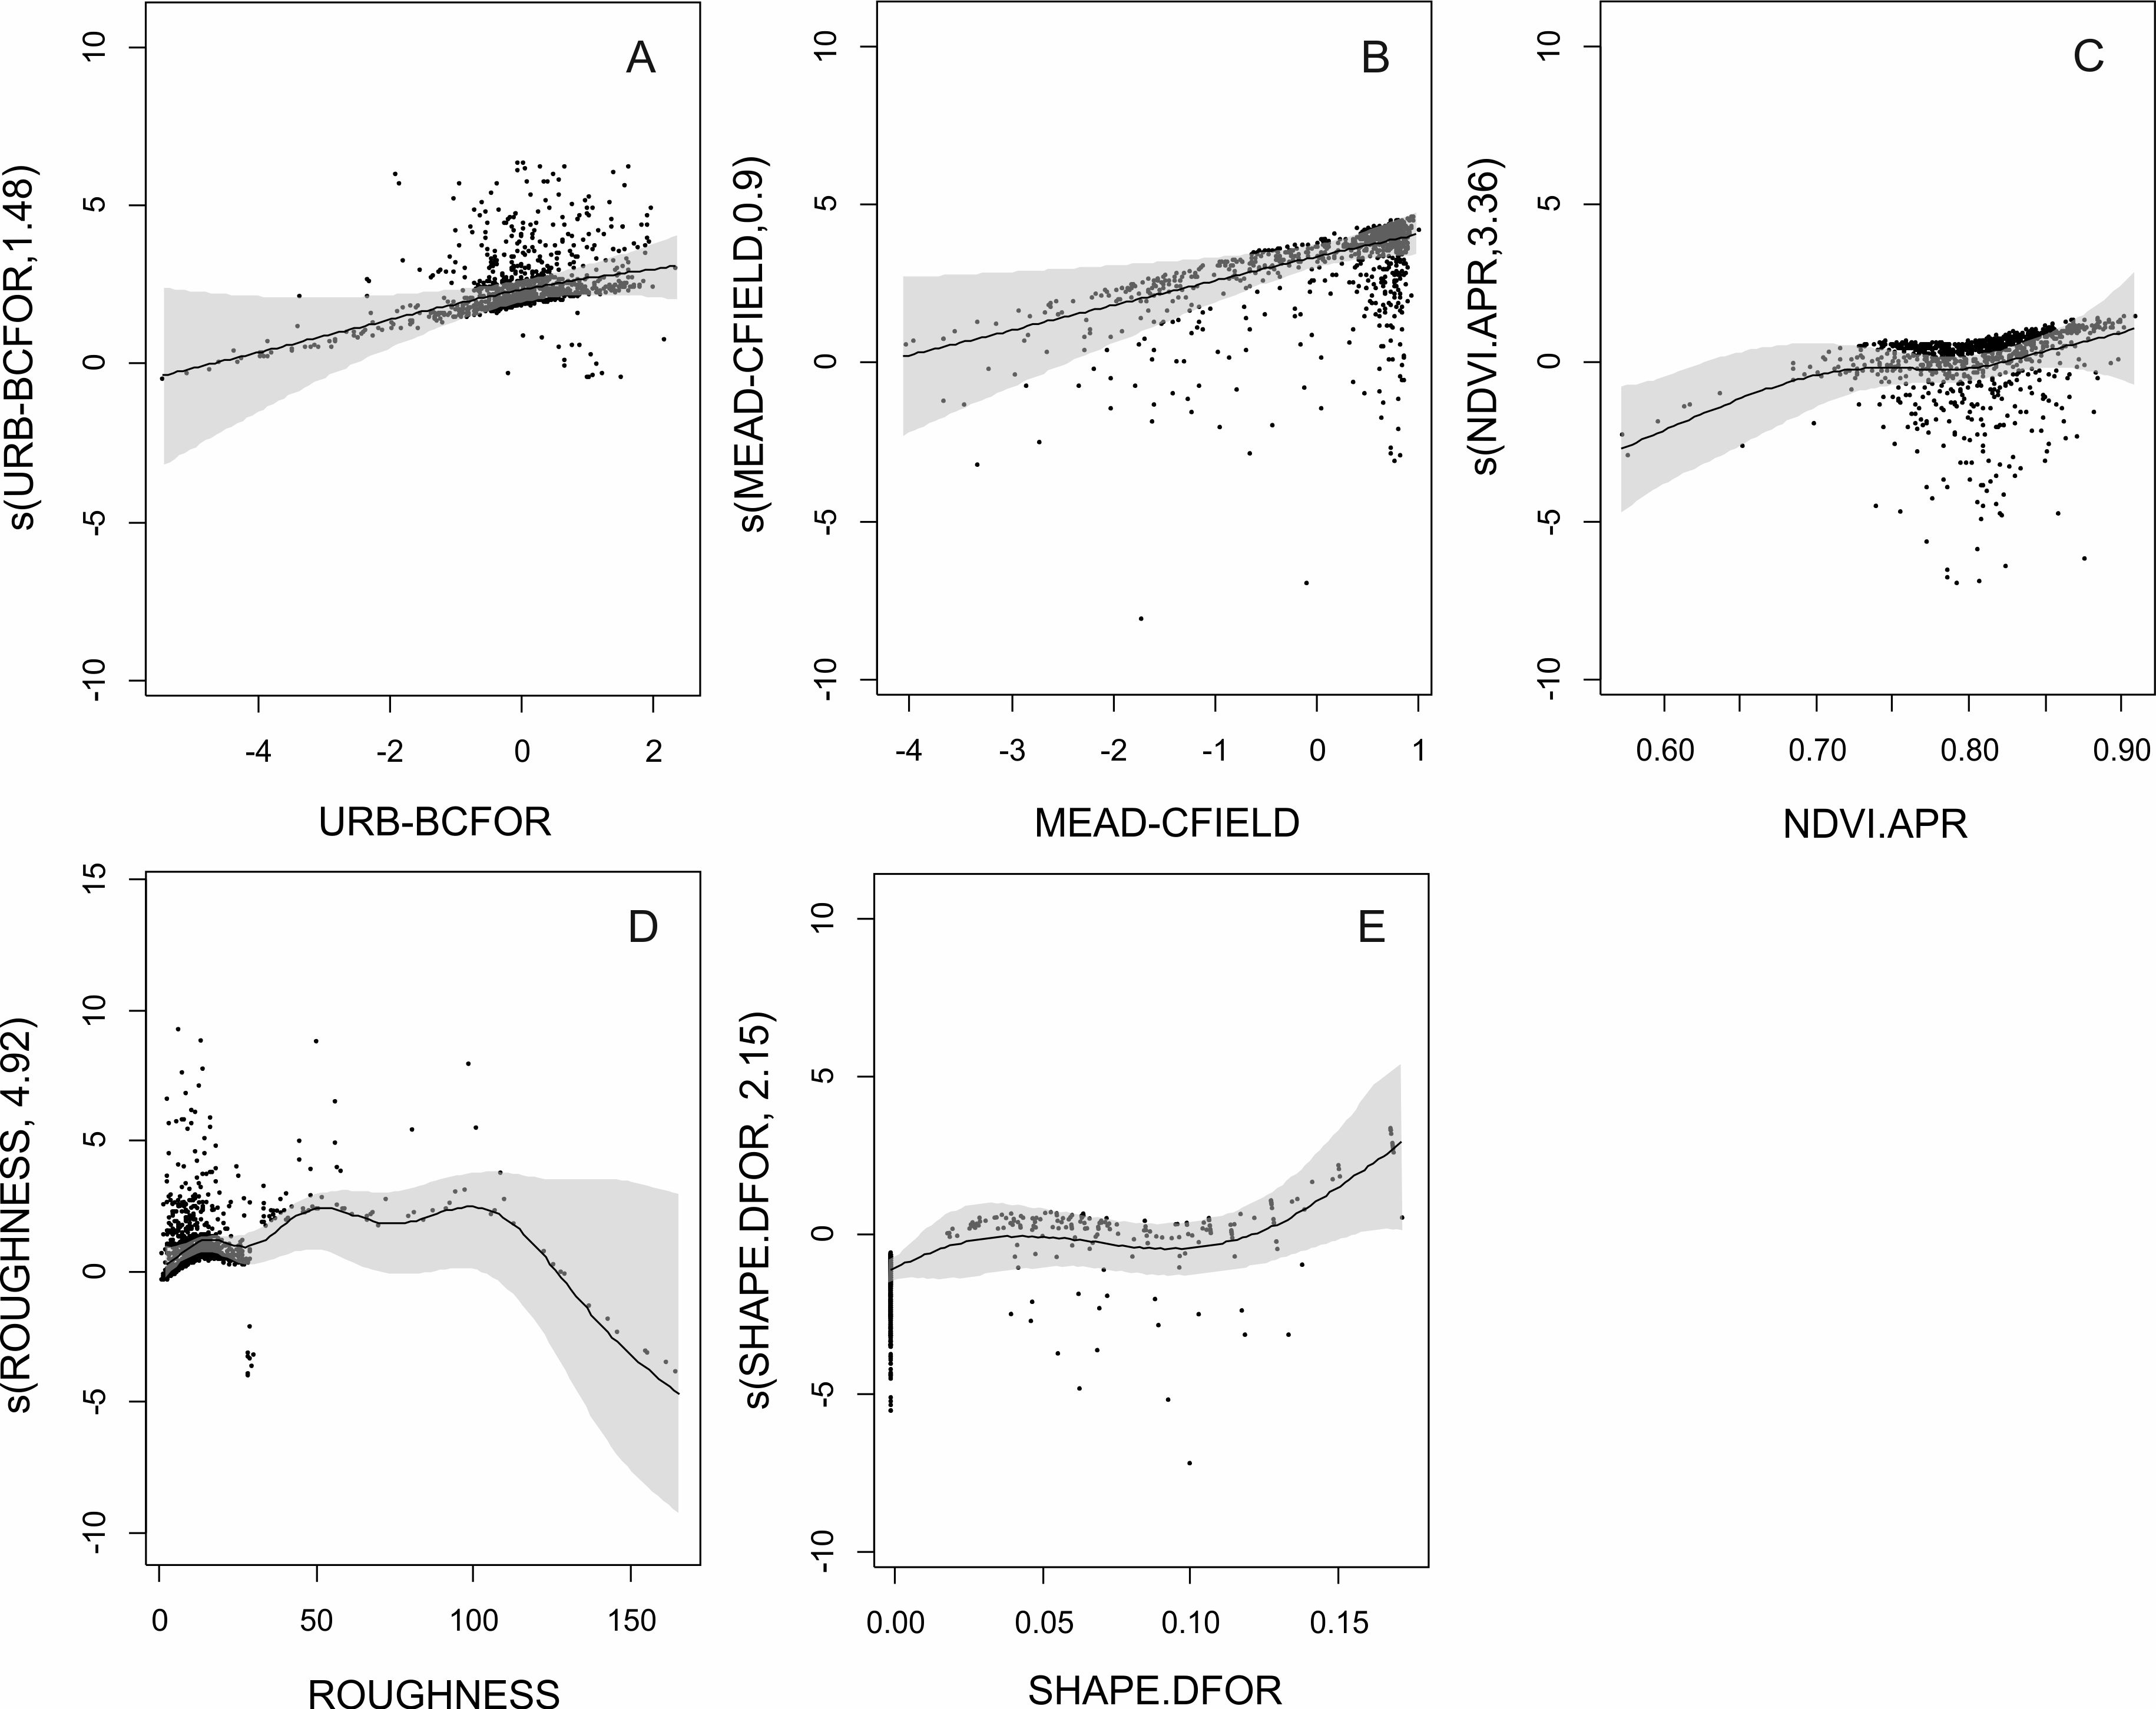

Fig. S2. Partial dependences plot used for interpretation of relationships between predictors and Hayne estimator of Great Grey Shrike density
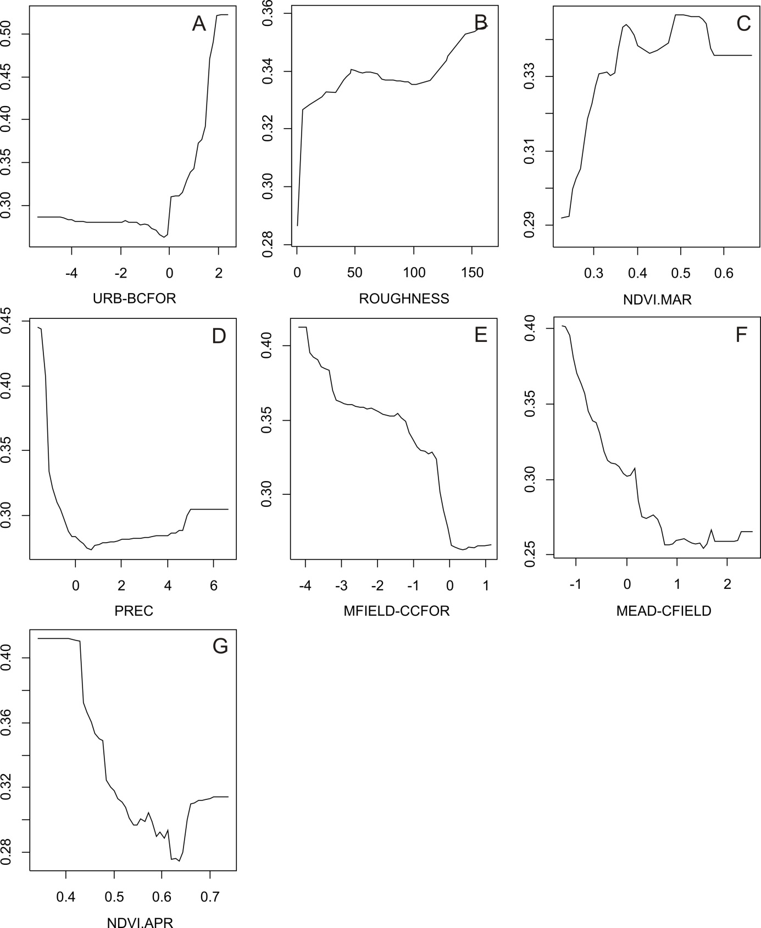

Fig. S3. GAM fit for Great Spotted Woodpecker (Ď_{GSW}) density. y-axis – (s) fitted function with estimated degrees of freedom in parenthesis. The shaded areas represent standard errors of the estimate curves.

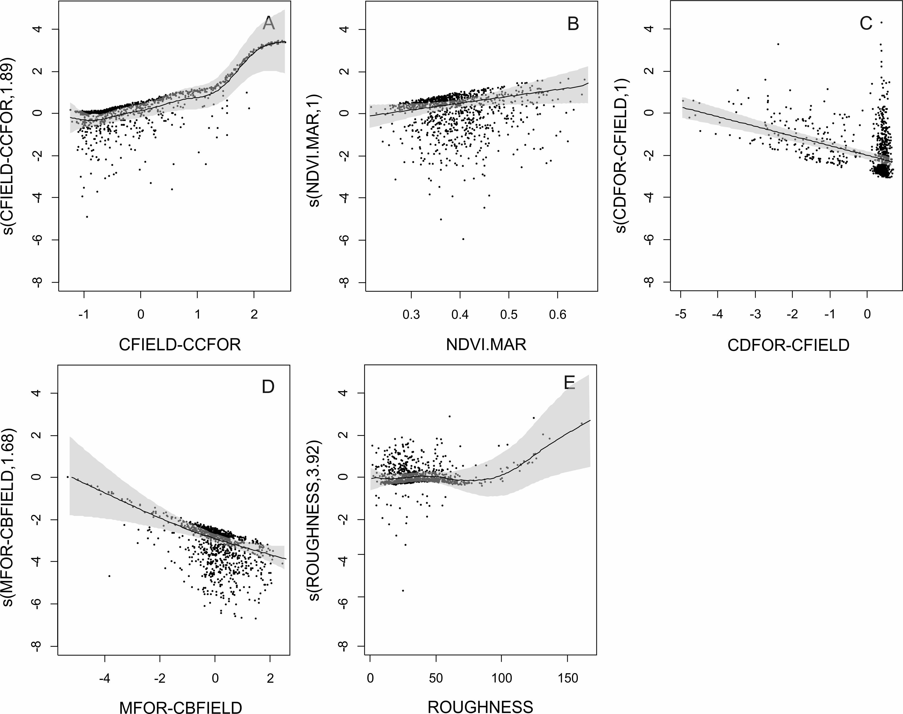

Fig. S4. Partial dependences plot used for interpretation of relationships between predictors and Great Spotted Woodpecker (Ď_{GSW}) density
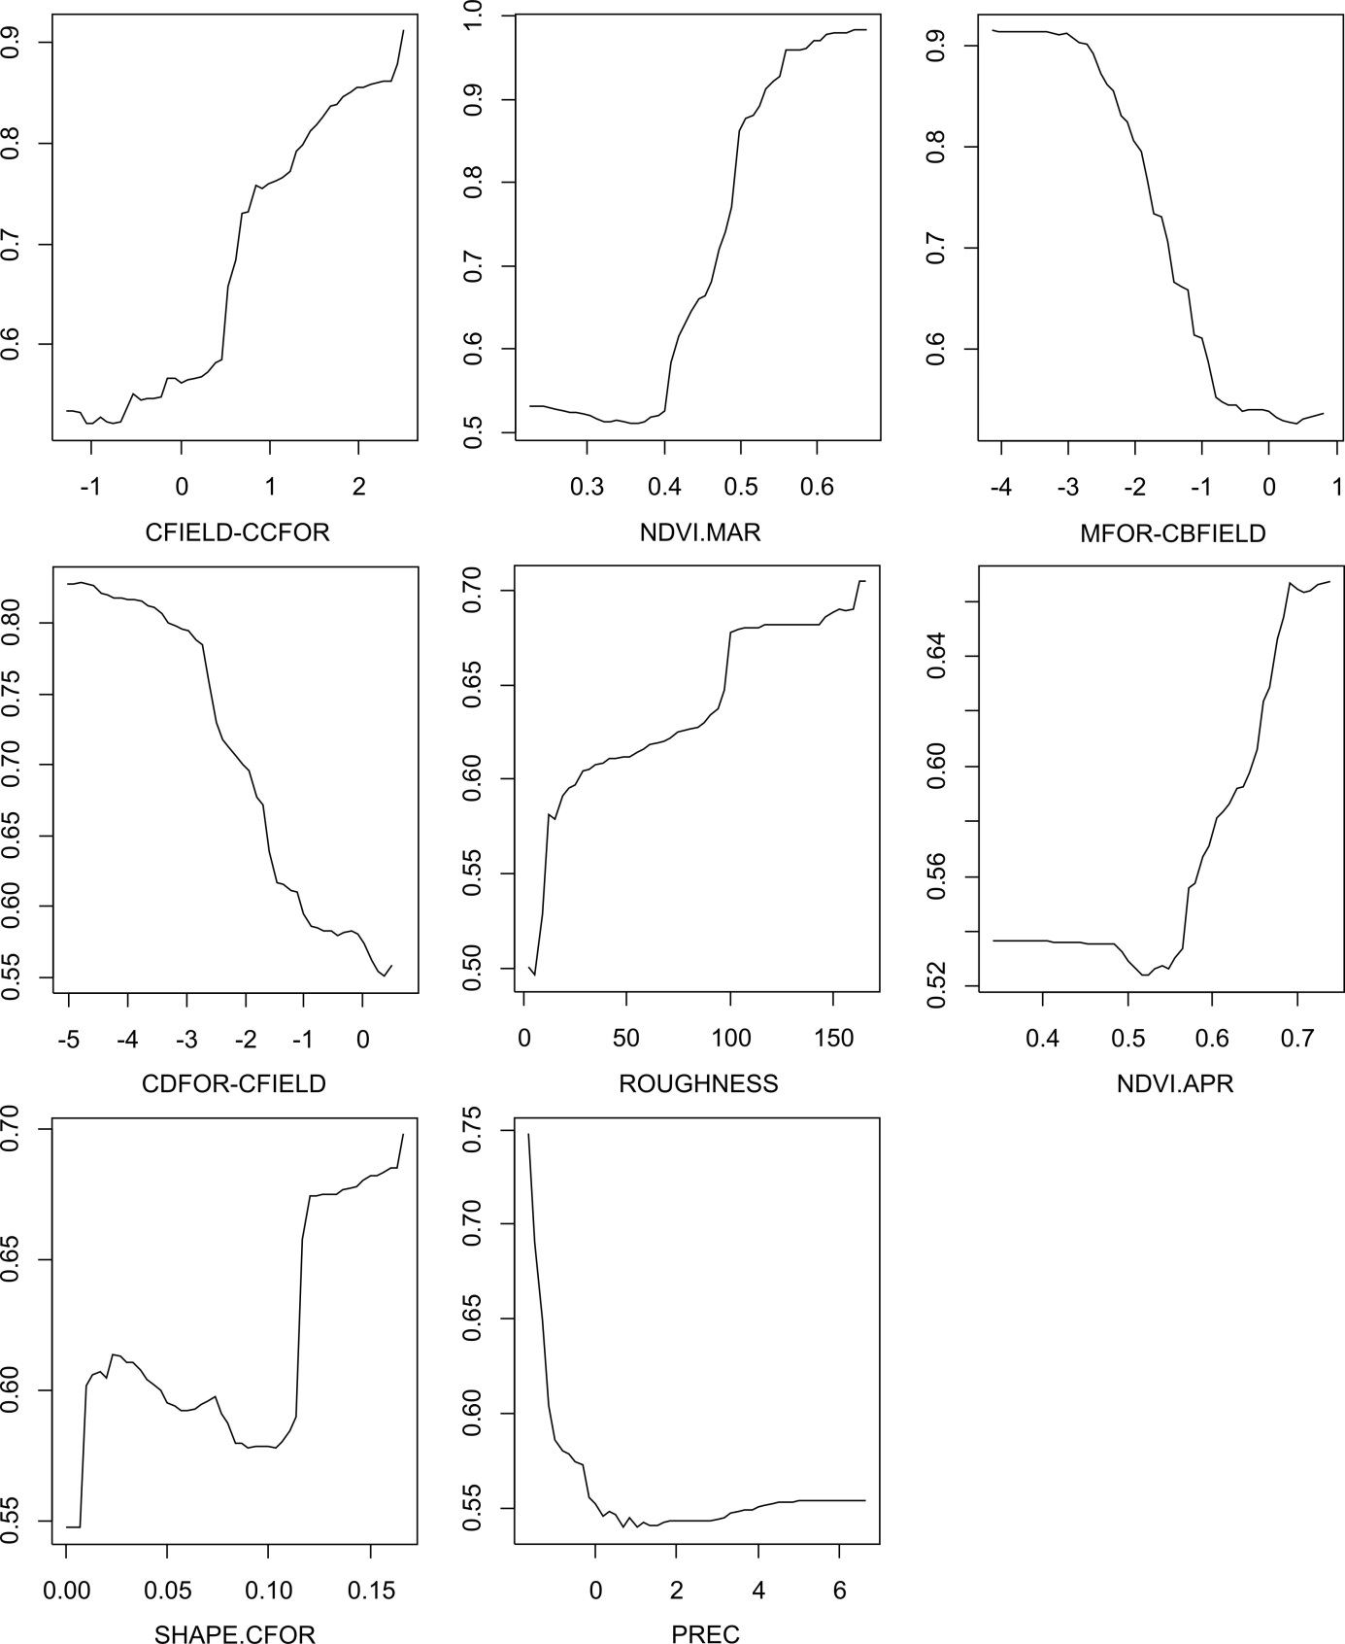

Fig. S5. GAM fit for Bird species richness (BSR) density. y-axis – (s) fitted function with estimated degrees of freedom in parenthesis. The shaded areas represent standard errors of the estimate curves.
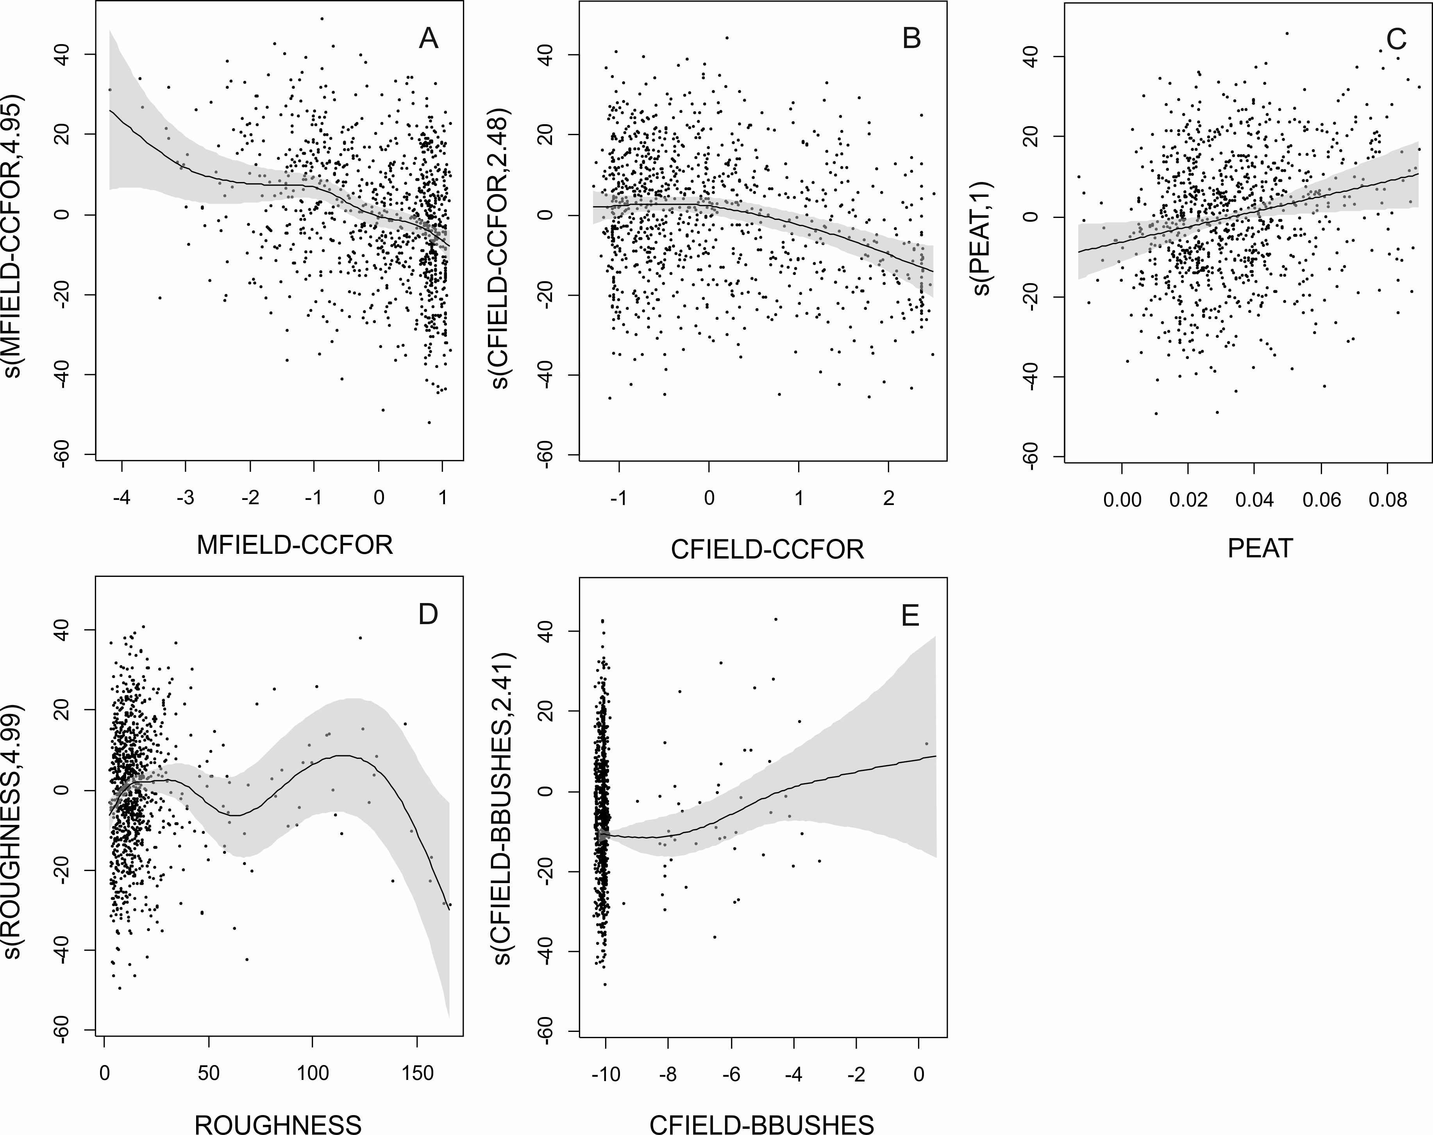

Fig. S6. Partial dependences plot used for interpretation of relationships between predictors and bird species richness (BSR)
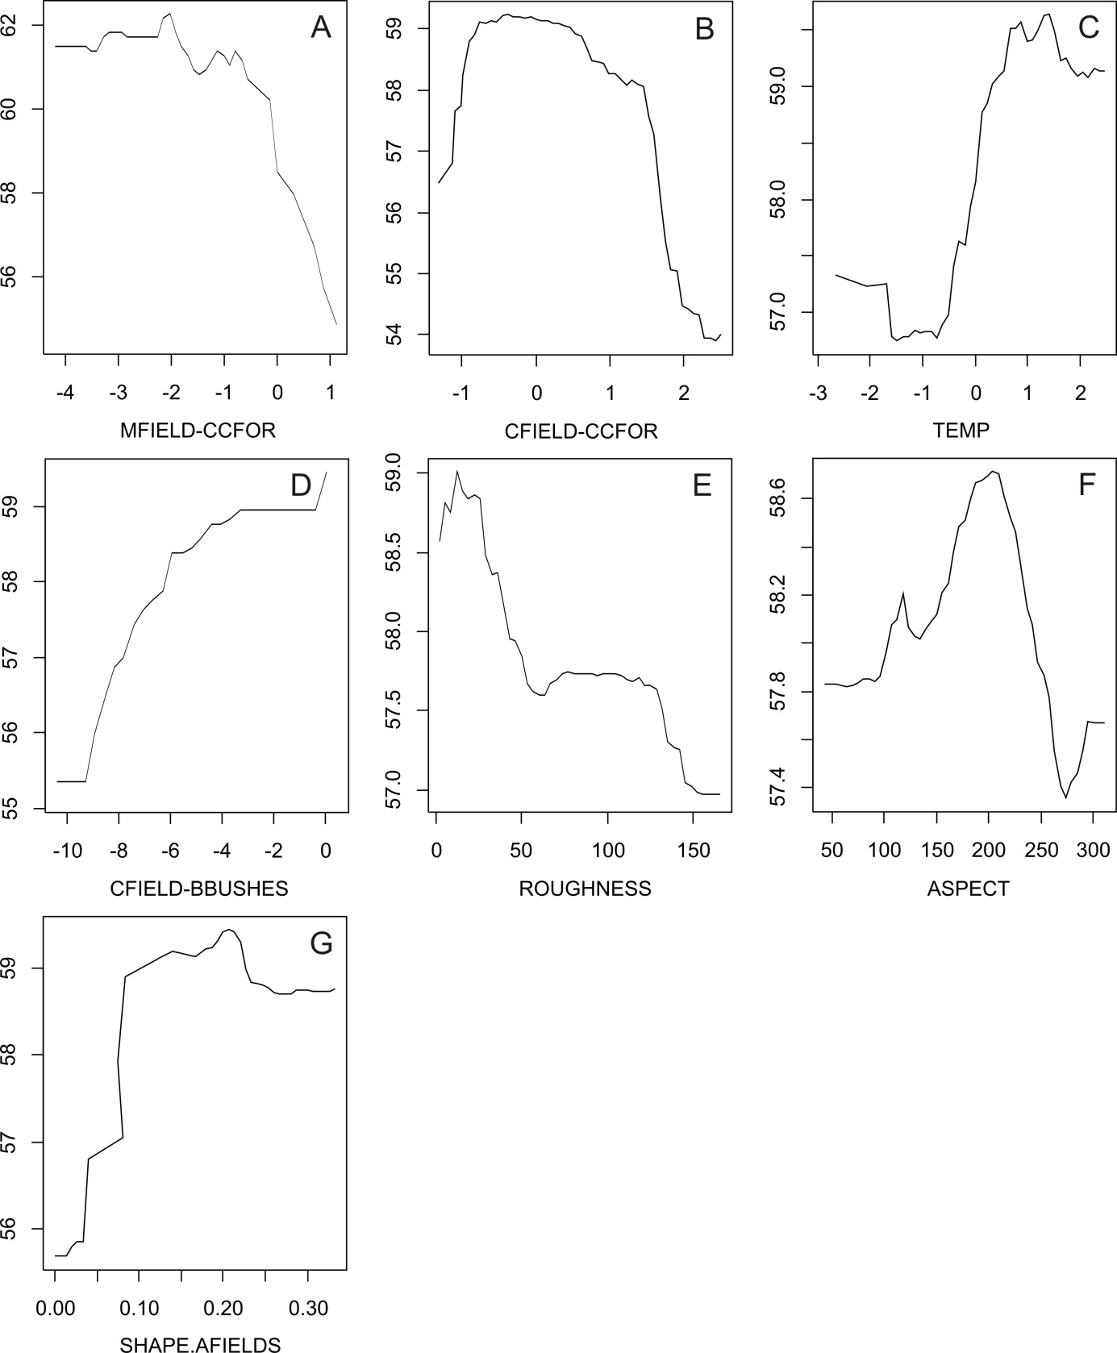

Fig. S7. GAM fit for Functional species richness density. y-axis – (s) fitted function with estimated degrees of freedom in parenthesis. The shaded areas represent standard errors of the estimate curves.
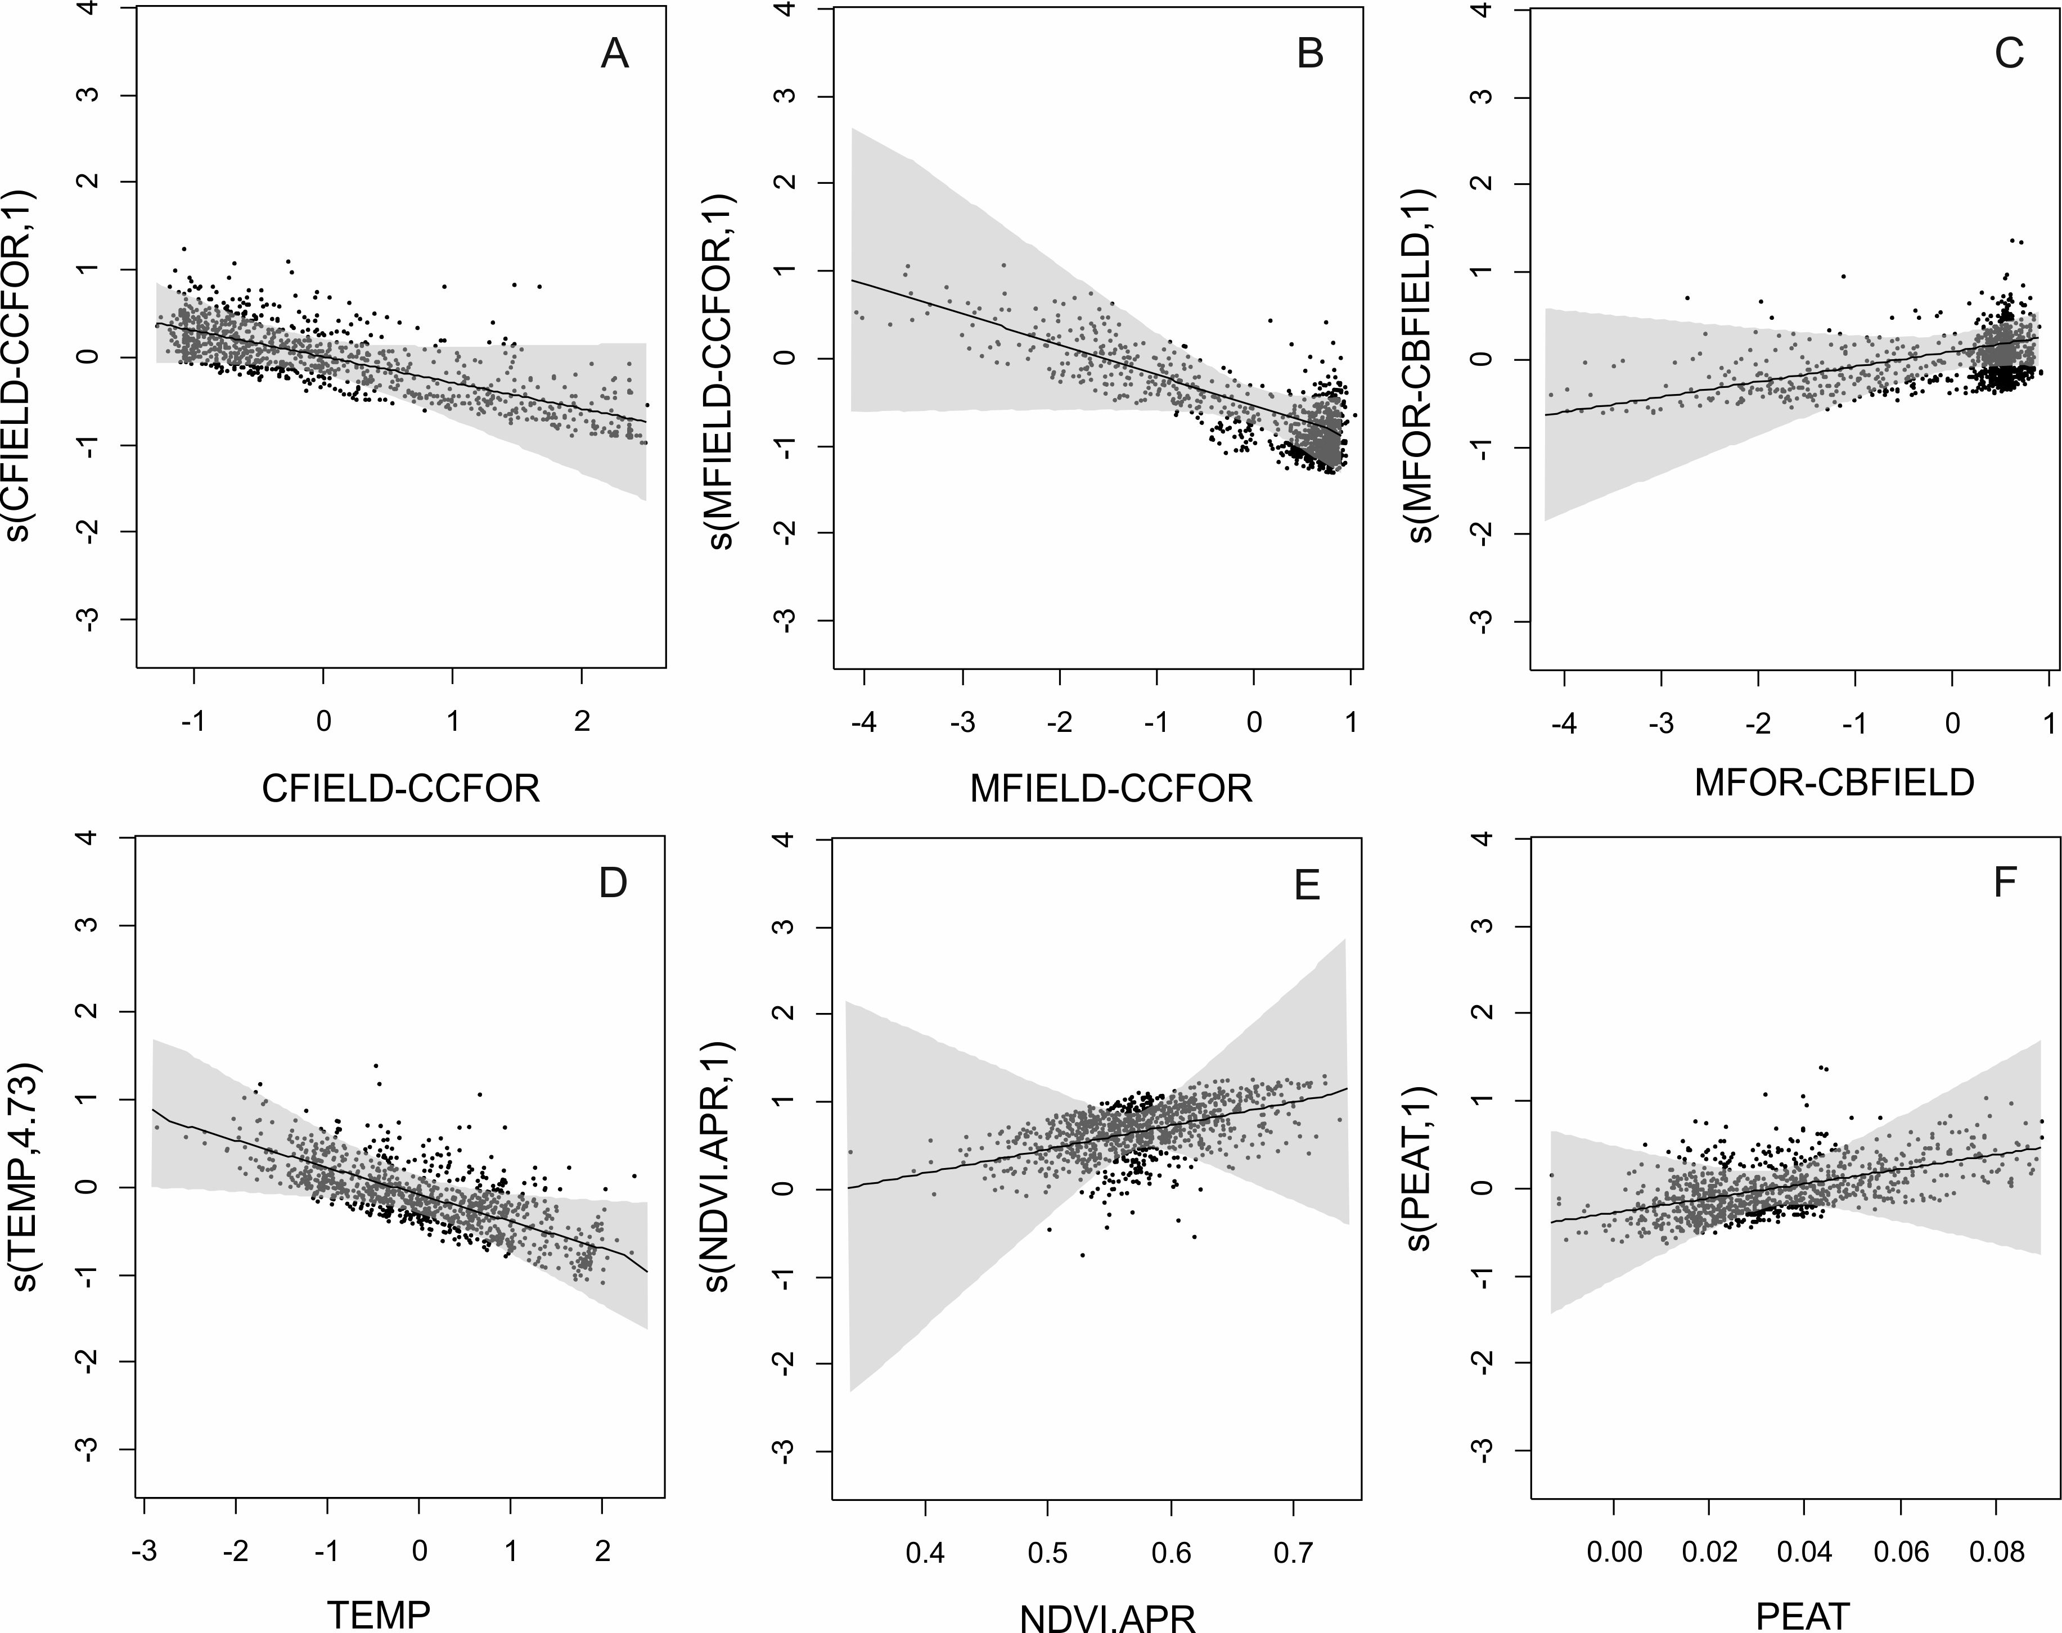

Fig. S8. Partial dependences plot used for interpretation of relationships between predictors and functional species richness (FRic)
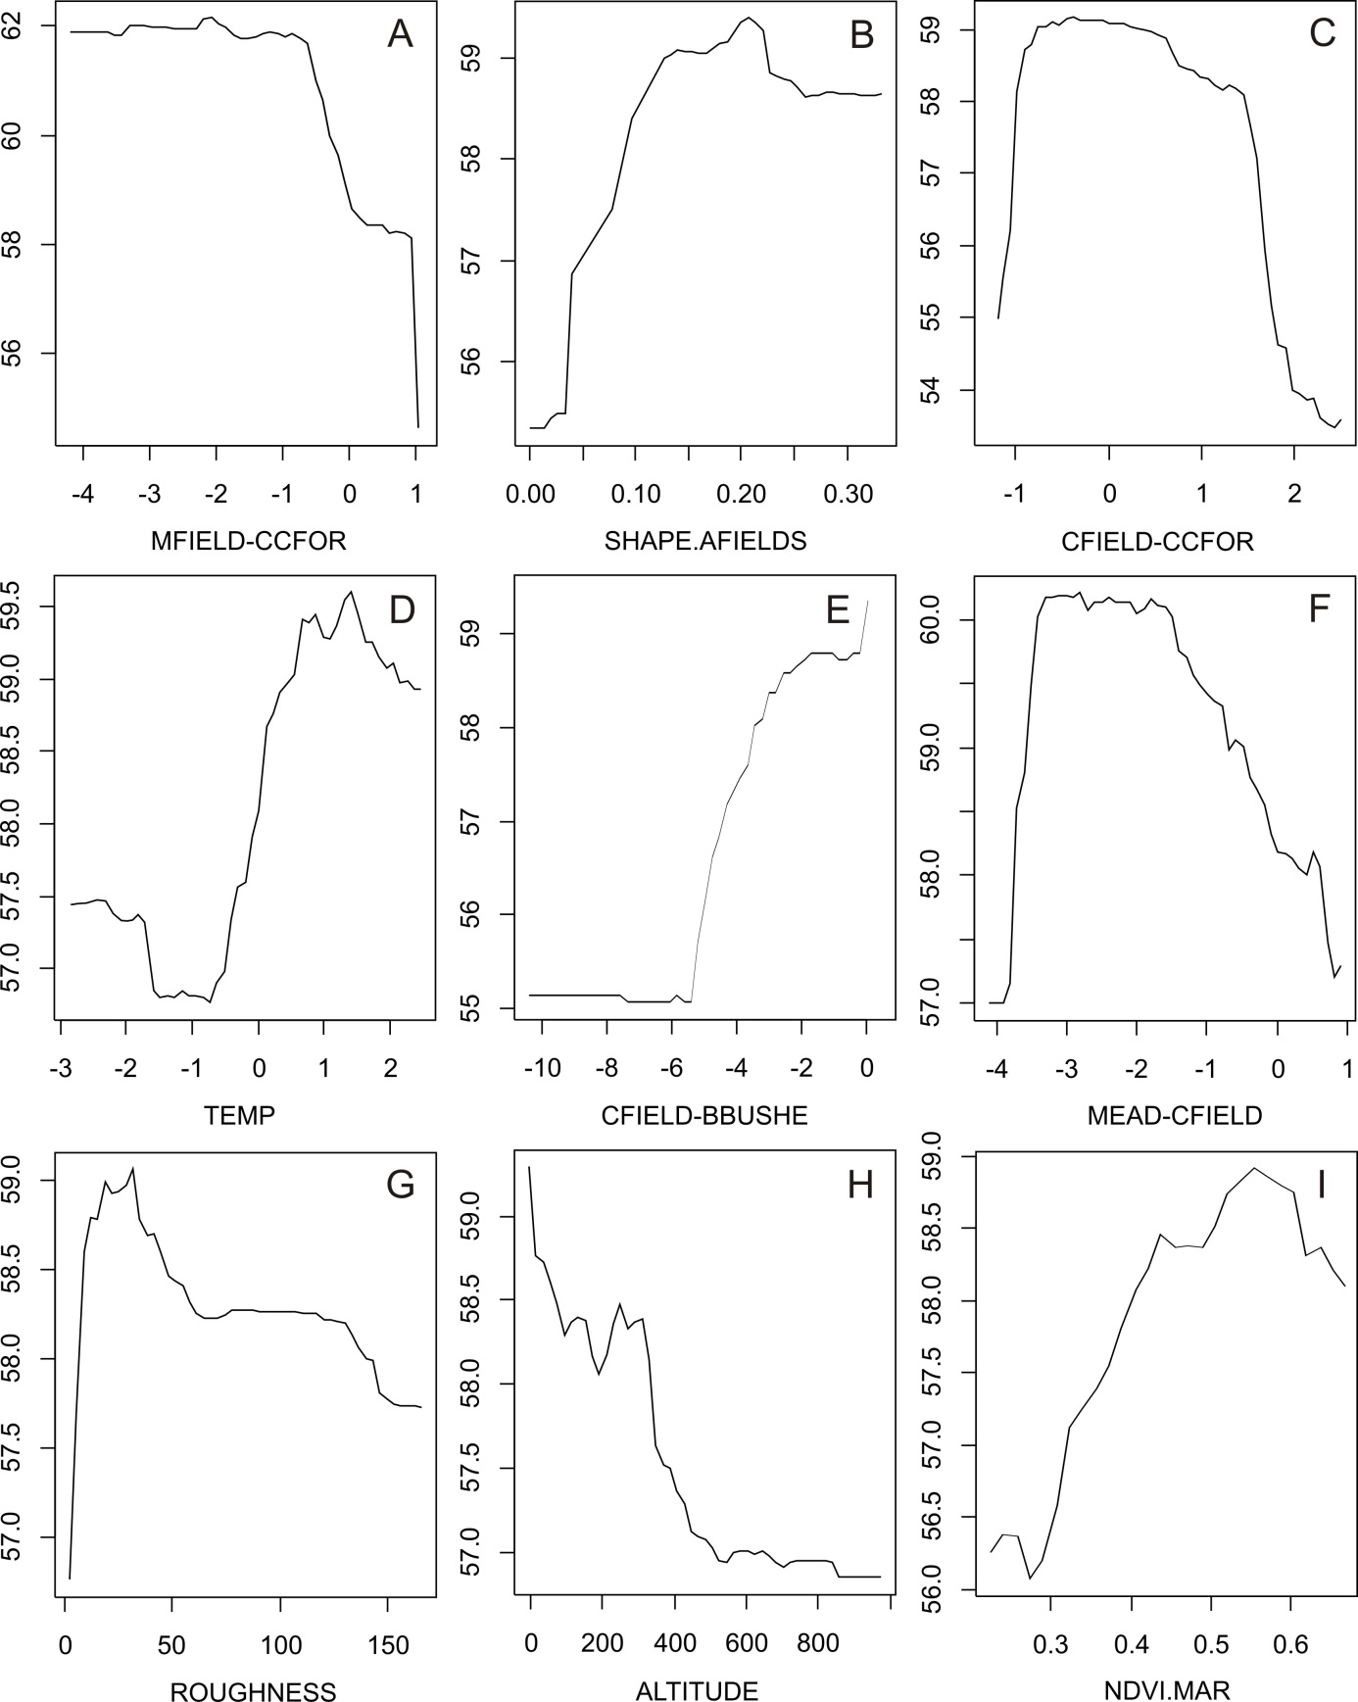

References
Doll CNH, Muller J -P, Morley JG (2007) Mapping regional economic activity from night-time light satellite imagery. Ecol Economics 57:75–92
Hijmans RJ, Cameron SE, Parra JL, Jones PG, Jarvis A (2005) Very high resolution interpolated climate surfaces for global land areas. Int J Climatology 25:1965–1978
Jarvis A, Reuter HI, Nelson A, Guevara E (2008) Hole-filled SRTM for the globe Version 4, available from the CGIAR-CSI SRTM 90m Database (http://srtm.csi.cgiar.org).
Small C, Pozzi F, Elvidge CD (2005) Spatial analysis of global urban extent from DMSP-OLS nighttime lights. Remote Sensing Environment 96: 277–291

