Supplementary Information
Polycyclic aromatic hydrocarbons (PAHs) in soils of an industrial area in semi-arid Uzbekistan: spatial distribution, relationship with trace metals, and risk assessment
Benjamin A. Musa Bandowe^{a*}, Nosir Shukurov^{b,c}, Sophia Leimer^{d}, Michael Kersten^{c}, Yosef Steinberger^{e}, Wolfgang Wilcke^{d}

ª Multiphase Chemistry Department, Max-Planck Institute for Chemistry, Hahn-Meitner-Weg 1, 55128 Mainz, Germany.
^{b} Institute of Geology and Geophysics, State committee of the Republic of Uzbekistan for Geology and Mineral Resources, Olimlar street 49, Tashkent 100041, Uzbekistan.
^{c} Geosciences Institute, Johannes Gutenberg-University, 55099 Mainz, Germany.
^{d} Institute of Geography and Geoecology, Karlsruhe Institute of Technology (KIT), Reinhard-Baumeister-Platz 1, 76131 Karlsruhe, Germany.
^{e} The Mina and Everard Goodman Faculty of Life Sciences, Bar-Ilan University, Ramat-Gan 52900, Israel.
*Corresponding author: Benjamin A. Musa Bandowe (E-mail: benjamin.bandowe@mpic.de; Tel.: + 49 6131 305 7061).

Supplementary Information contains Tables S1-S4 and Figures S1-S5.

Table S1 Mean recoveries of the target PAHs in the certified reference soil material (ERM-CC013a-Polycyclic aromatic hydrocarbons in soil) during the period in which the analyses of the Almalyk soil samples were analyzed.
 | Certified value or indicative values | Uncertainty | Mean of recovery [%]
PAHs | mass fraction (ng/g) | ± in ng/g
Naphthalene | 2400 | 500 | 114
Acenaphthyleneª | 770 |  | 82
Acenaphtheneª | 750 |  | 94
Fluorene | 1140 | 110 | 101
Phenanthrene | 12000 | 600 | 106
Anthracene | 1410 | 220 | 144
Fluoranthene | 12900 | 700 | 46
Pyrene | 9600 | 300 | 108
Benzo[a]anthracene | 5600 | 500 | 119
Chrysene^{b} | 5300 | 800 | 72
Benzo[b+k]fluoranthene^{c} | 10400 | 1400 | 115
Benzo[a]pyrene | 4900 | 700 | 85
Indeno[1,2,3-cd]pyrene | 5200 | 1000 | 75
Dibenzo[a,h]anthraceneª | 1100 |  | 106
Benzo[g,h,i]perylene | 4600 | 500 | 94
a: indicative values (not certified)
b: values from our laboratory measurement is the sum of Chrysene and Tripheylene
c: values from our laboratory measurement is the sum of Benzo[b+j+k]fluoranthene

Table S2 Data transformations to approximate normal distribution. For variables marked with an asterisk, only an approximate normal distribution was reached by transformation.

 | Transformation for 0-10 cm | Transformation for 10-20 cm
Total Zn (mg/kg) | -1/x | -1/x
Total Cu (mg/kg) | log(x) | log(x)
Total Pb (mg/kg) | log(x) | -1/x
Total Cd (mg/kg) | -1/x | -1/(x+1)
Total Cr (mg/kg) | log(x) | log(x)
Total Ni (mg/kg) | none | none
C_{org} (mg/g) | none | -1/x
Total soluble nitrogen (mg/l) | none | none
Soil moisture (%) | none | log(x)
pH | none* | none*
Electrical conductivity (mS/g) | log(x) | log(x)*
Naphthalene (ng/g) | log(x) | log(x)
2-Methylnaphthalene (ng/g) | log(x) | log(x)
1-Methylnaphthalene (ng/g) | log(x) | log(x)
Biphenyl (ng/g) | log(x) | log(x)
1,3-Dimethylnaphthalene (ng/g) | log(x) | log(x)
Acenaphthene (ng/g) | log(x+1) | log(x+1)
Fluorene (ng/g) | log(x) | log(x)
Phenanthrene (ng/g) | log(x) | log(x)
Anthracene (ng/g) | log(x) | log(x)
4,5-Methylenephenanthrene (ng/g) | -1/(x+1) | excluded
1-Methylphenanthrene (ng/g) | excluded | log(x+1)
Fluoranthene (ng/g) | -1/x | -1/x
Pyrene (ng/g) | -1/x | log(x)*
Benzo[a]anthracene (ng/g) | log(x) | -1/(x+1)
Chrysene+Triphenylene (ng/g) | -1/x | -1/(x+1)
Benzo[b+j+k]fluoranthene (ng/g) | log(x) | log(x)*
Benzo[e]pyrene (ng/g) | -1/(x+1) | log(x)
Indeno[1,2,3-cd]pyrene (ng/g) | -1/(x+1) | -1/(x+1)
Coronene (ng/g) | excluded | log(x+1)
Σ 29PAHs (ng/g) | -1/x | log(x)
Σ21 Parent-PAHs (ng/g) | -1/x* | -1/x
ΣUS-EPA PAHs (ng/g) | -1/x | -1/x
ΣLMW-PAHs (ng/g) | log(x) | log(x)
ΣHMW-PAHs (ng/g) | log(x) | log(x)*
Σ2+3 ring PAHs (ng/g) | log(x) | log(x)
Σ4 ring PAHs (ng/g) | -1/x | log(x)*
Table S2 Continued
Σ5 ring PAHs (ng/g) | log(x) | log(x)*
Σ6+7-ring PAHs (ng/g) | log(x+1) | log(x+1)
Σalkyl-Naphthalene (ng/g) | log(x) | log(x)
Retene (ng/g) | -1/x | -1/x
ΣAlkyl-Phenanthrene (ng/g) | log(x+1) | log(x+1)

Table S3 Topsoil/subsoil concentration ratios (CR) of individual and sums of PAHs.
CR (0-10 cm/10-20 cm)
Study site |  |  | L1 | L2 | L3 | L4 | L5 | L6 | L7 | L8 | L9 | L10 | L11
Naphthalene |  |  | 1.07 | 1.22 | 1.80 | 1.27 | 0.65 | 0.27 | 0.67 | 0.86 | 1.02 | 8.67 | 1.24
2-Methylnaphthalene |  |  | 0.65 | 1.29 | 2.65 | 1.49 | 0.66 | 0.29 | 0.86 | 1.09 | 0.88 | 6.61 | 1.22
1-Methylnaphthalene |  |  | 1.19 | 1.07 | 1.49 | 1.51 | 0.74 | 0.33 | 0.54 | 0.69 | 1.84 | 6.14 | 1.92
Biphenyl |  |  | 1.04 | 3.19 | 0.87 | 2.20 | 0.62 | 0.26 | 2.52 | 3.12 | 0.24 | 6.15 | 0.61
1,3-Dimethylnaphthalene |  |  | 0.79 | 0.98 | 0.60 | 1.17 | 0.92 | 0.49 | 0.77 | 1.64 | 0.89 | 3.45 | 1.06
Acenaphthylene |  |  | 0.99 |  | 0.00 |  |  | 0.08
Acenaphthene |  |  | 0.91 |  |  | 1.62 | 0.99 | 0.33 |  | 1.69 | 0.00 | 2.31 | 0.81
Fluorene |  |  | 1.69 | 2.23 | 1.80 | 1.01 | 1.04 | 0.62 | 1.33 | 1.64 | 0.67 | 1.34 | 0.53
Phenanthrene |  |  | 1.13 | 0.80 | 0.84 | 1.60 | 1.06 | 0.09 | 0.93 | 1.99 | 1.35 | 1.80 | 1.35
Anthracene |  |  | 2.89 | 0.85 | 0.13 | 17.21 | 0.46 | 0.31 | 0.96 | 1.75 | 0.54 | 1.60 | 3.36
4H-Cyclopenta[d,e,f]phenanthrene |  |  | 2.62 |  |  |  | 0.95 |  |  | 0.00 | 0.84 | 1.12 | 0.82
1-Methylphenanthrene |  |  | 1.02 |  | 0.00 | 1.57 | 0.97 | 0.00 |  |  | 0.88 | 1.30 | 1.09
3,6-Dimethylphenanthrene |  |  | 0.91
Fluoranthene |  |  | 1.61 | 1.52 | 0.58 | 1.36 | 1.18 | 0.08 | 1.42 | 1.46 | 0.91 | 1.63 | 0.99
Pyrene |  |  | 1.59 | 1.46 | 0.80 | 0.86 | 1.24 | 0.08 | 1.43 | 1.16 | 0.89 | 3.04 | 0.46
Retene |  |  | 0.66 | 1.21 | 0.57 | 1.44 | 0.86 | 0.20 | 1.49 | 2.24 | 0.84 | 0.99 | 0.99
Benzo[a]anthracene |  |  | 1.12 | 4.63 | 1.29 | 0.19 | 0.61 | 0.06 | 2.16 | 2.39 | 0.33 | 3.41 | 0.16
Chrysene + Triphenylene |  |  | 1.40 | 2.37 | 1.23 | 0.42 | 1.60 | 0.13 | 1.25 | 1.09 | 1.09 | 2.32 | 0.32
Benzo[b+j+k]fluoranthenes |  |  | 1.31 | 5.08 | 2.54 | 0.39 | 1.64 | 0.08 | 1.11 | 1.49 | 0.55 | 5.60 | 0.21
Benzo[e]pyrene |  |  | 1.12 | 5.45 | 1.40 | 0.09 | 1.65 | 0.07 | 1.55 | 1.41 | 0.55 | 0.00 | 0.11
Benzo[a]pyrene |  |  | 1.33 |  |  | 0.15 | 1.85 | 0.05 |  |  | 0.00 | 0.00 | 0.00
Perylene |  |  | 1.43 |  |  | 0.31 | 2.05 | 0.05 |  |  |  |  | 0.00
Indeno [1,2,3-cd] pyrene |  |  | 1.34 |  |  | 0.12 | 2.76 | 0.02 | 2.18 | 0.70 | 0.71 | 3.51 | 0.08
Dibenzo[ah]anthracene |  |  | 1.34 |  |  |  |  | 0.00 |  |  |  |  | 0.00
Benzo[ghi]perylene |  |  | 1.24 |  |  | 0.00 | 1.53 | 0.14 |  |  |  |  | 0.00
Coronene |  |  | 1.61 |  |  | 0.00 | 1.43 | 0.05 | 1.46 | 0.94 | 0.00 |  | 0.00
∑29 PAHs |  |  | 1.22 | 1.56 | 0.82 | 1.13 | 0.90 | 0.10 | 1.17 | 1.65 | 0.93 | 2.74 | 0.85
Σ21 Parent PAHs |  |  | 1.33 | 1.73 | 0.83 | 1.02 | 0.99 | 0.09 | 1.23 | 1.64 | 0.92 | 2.52 | 0.73
ΣUS EPA PAHs |  |  | 1.33 | 1.62 | 0.82 | 1.20 | 0.96 | 0.09 | 1.22 | 1.67 | 0.95 | 2.53 | 0.82
ΣLMW-PAHs |  |  | 1.30 | 1.01 | 0.75 | 1.84 | 0.87 | 0.15 | 0.93 | 1.72 | 1.09 | 2.48 | 1.36
ΣHMW-PAHs |  |  | 1.33 | 3.89 | 1.06 | 0.29 | 1.36 | 0.07 | 1.62 | 1.55 | 0.63 | 2.77 | 0.21
Table S4 Results of Pearson correlations between log K_{OW} values and the respective log concentration ratios (CR).
Concentration ratio (CR) | p | r
Log L1 (10-20 cm/0-10 cm) | 0.568 | -0.12
Log L1 (0-10 cm/10-20 cm) | 0.568 | 0.12
Log L2 (10-20 cm/0-10 cm) | 0.045 | -0.52
Log L2 (0-10 cm/10-20 cm) | 0.045 | 0.52
Log L3 (10-20 cm/0-10 cm) | 0.882 | 0.04
Log L3 (0-10 cm/10-20 cm) | 0.882 | -0.04
Log L4 (10-20 cm/0-10 cm) | 0.001 | 0.69
Log L4 (0-10 cm/10-20 cm) | 0.001 | -0.69
Log L5 (10-20 cm/0-10 cm) | <0.001 | -0.72
Log L5 (0-10 cm/10-20 cm) | <0.001 | 0.72
Log L6 (10-20 cm/0-10 cm) | <0.001 | 0.69
Log L6 (0-10 cm/10-20 cm) | <0.001 | -0.69
Log L7 (10-20 cm/0-10 cm) | 0.027 | -0.53
Log L7 (0-10 cm/10-20 cm) | 0.027 | 0.53
Log L8 (10-20 cm/0-10 cm) | 0.671 | 0.11
Log L8 (0-10 cm/10-20 cm) | 0.671 | -0.11
Log L9 (10-20 cm/0-10 cm) | 0.431 | 0.20
Log L9 (0-10 cm/10-20 cm) | 0.431 | -0.20
Log L10 (10-20 cm/0-10 cm) | 0.194 | 0.32
Log L10 (0-10 cm/10-20 cm) | 0.194 | -0.32
Log L11 (10-20 cm/0-10 cm) | 0.001 | 0.71
Log L11 (0-10 cm/10-20 cm) | 0.001 | -0.71

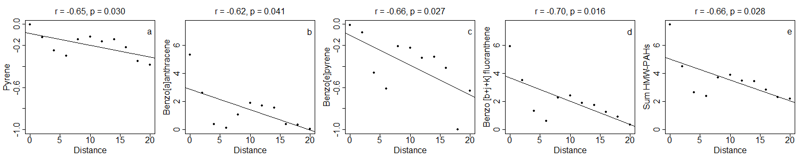

Fig. S1 Relationships between distance from the Almalyk Cu smelter [km] and concentrations of PAHs [ng g⁻¹].

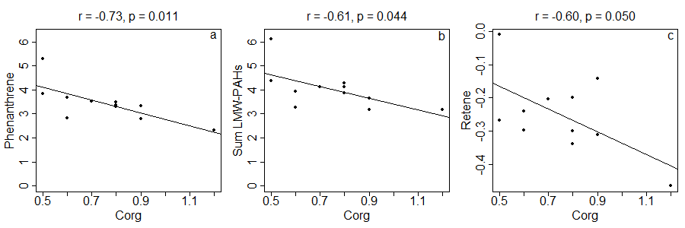

Fig. S2 Relationships between concentration of soil organic C [Corg, mg g⁻¹] and PAHs [ng g⁻¹].

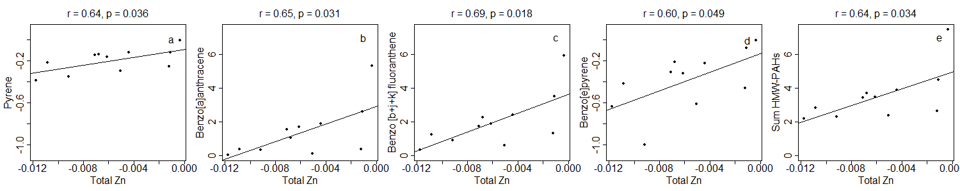

Fig. S3 Relationships between concentration of Zn [µg g⁻¹] and PAHs [ng g⁻¹].

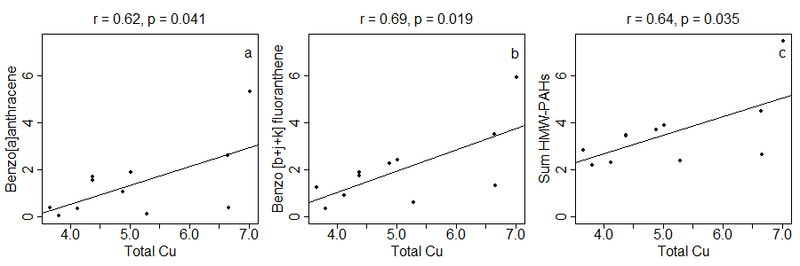
Fig. S4 Relationships between concentration of Cu [µg g⁻¹] and PAHs [ng g⁻¹].

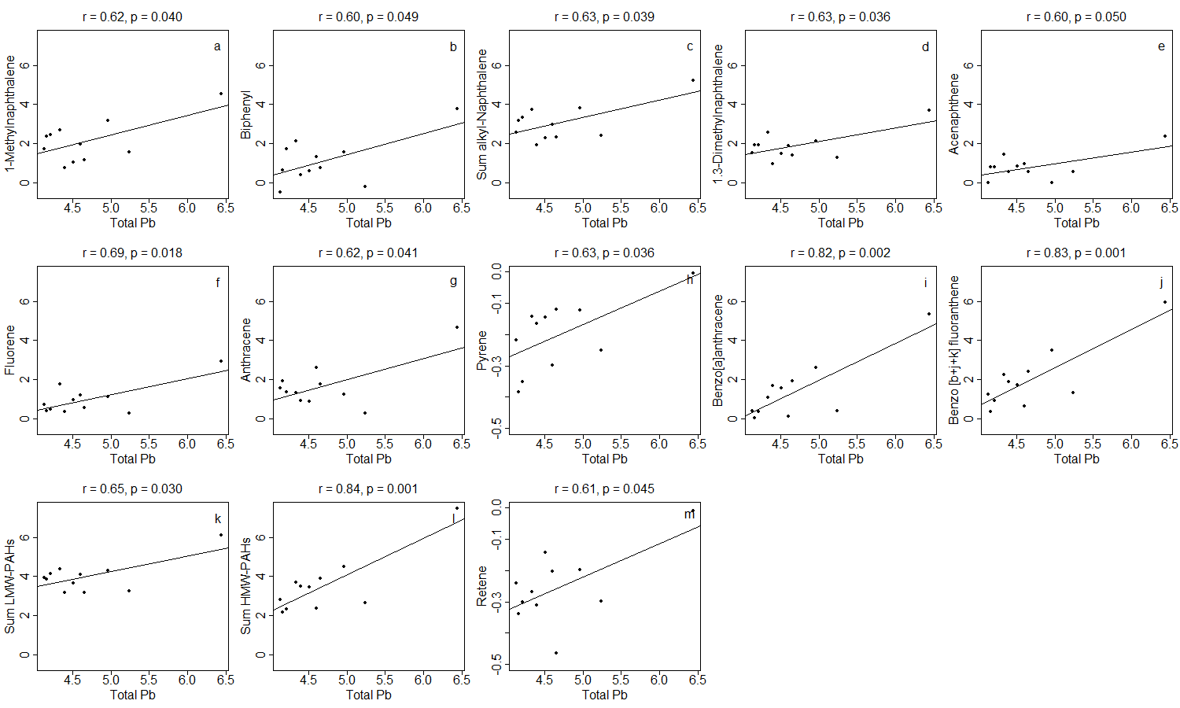
Fig. S5a Relationships between concentrations of Pb [µg g⁻¹] and PAHs [ng g⁻¹].

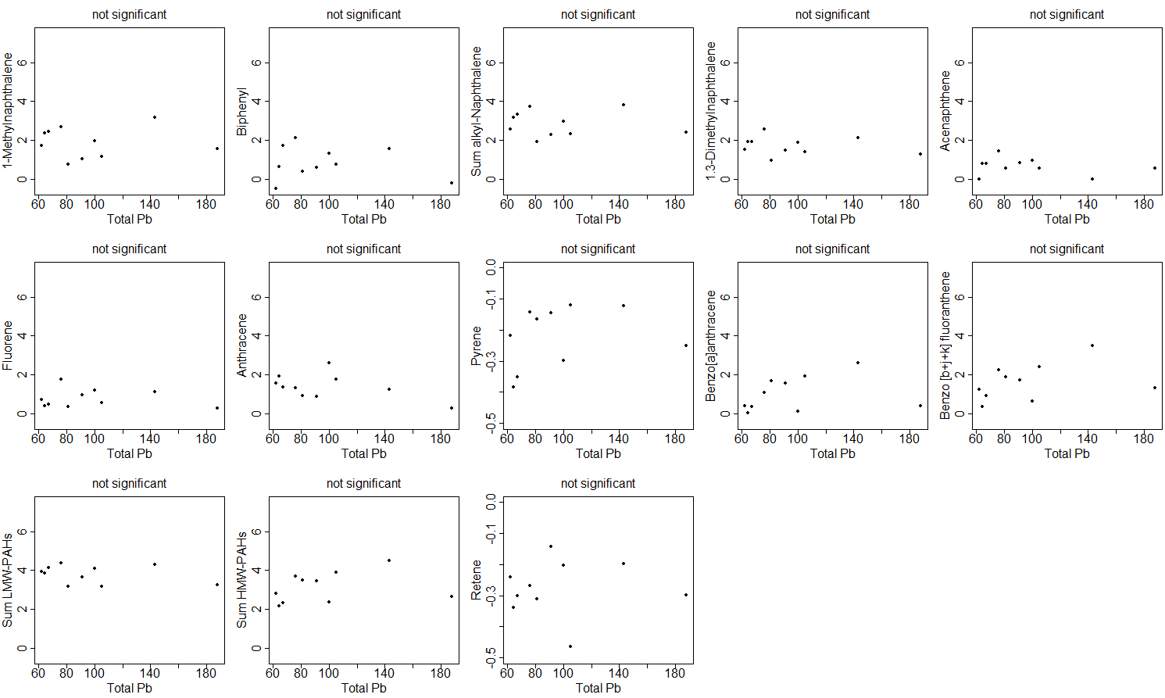
Fig. S5b Relationships between concentrations of Pb [µg g⁻¹] and PAHs [ng g⁻¹]. With outlier in Pb concentration removed.

