Supplementary Information

Degradation of four pesticides in five urban landscape soils: Human and environmental health risk assessment

Islam Md Meftaul • Kadiyala Venkateswarlu • Prasath Annamalai • Aney Parven • Mallavarapu Megharaj*

I. M. Meftaul • P. Annamalai • A. Parven • M. Megharaj
Global Centre for Environmental Remediation (GCER), College of Engineering, Science and Environment, The University of Newcastle, Callaghan, NSW 2308, Australia
I. M. Meftaul • A. Parven
Department of Agricultural Chemistry, Sher‒e‒Bangla Agricultural University, Dhaka‒1207, Bangladesh
K. Venkateswarlu
Formerly Department of Microbiology, Sri Krishnadevaraya University, Anantapuramu 515003, India
M. Megharaj
Cooperative Research Centre for Contamination Assessment and Remediation of the Environment (CRC CARE), The University of Newcastle, Callaghan, NSW 2308
*Address for correspondence:
Mallavarapu Megharaj
Global Centre for Environmental Remediation (GCER)
College of Engineering, Science and Environment
The University of Newcastle, ATC Building
University Drive, Callaghan, NSW 2308, Australia
Mobile: +61 411126857; orcid.org/0000‒0002‒6230‒518X
E‒mail: megh.mallavarapu@newcastle.edu.au

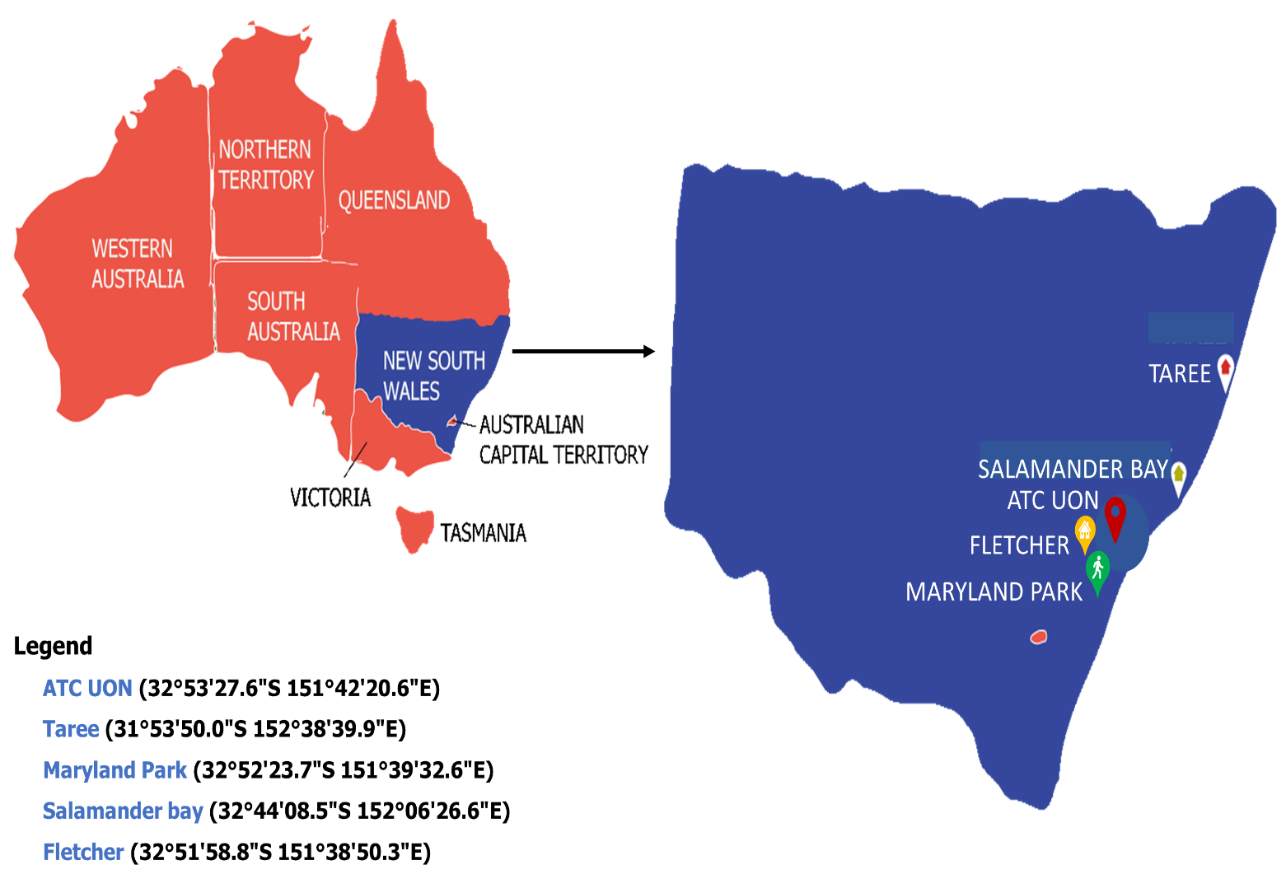

Fig. S1 Map showing different sampling locations in New South Wales, Australia.

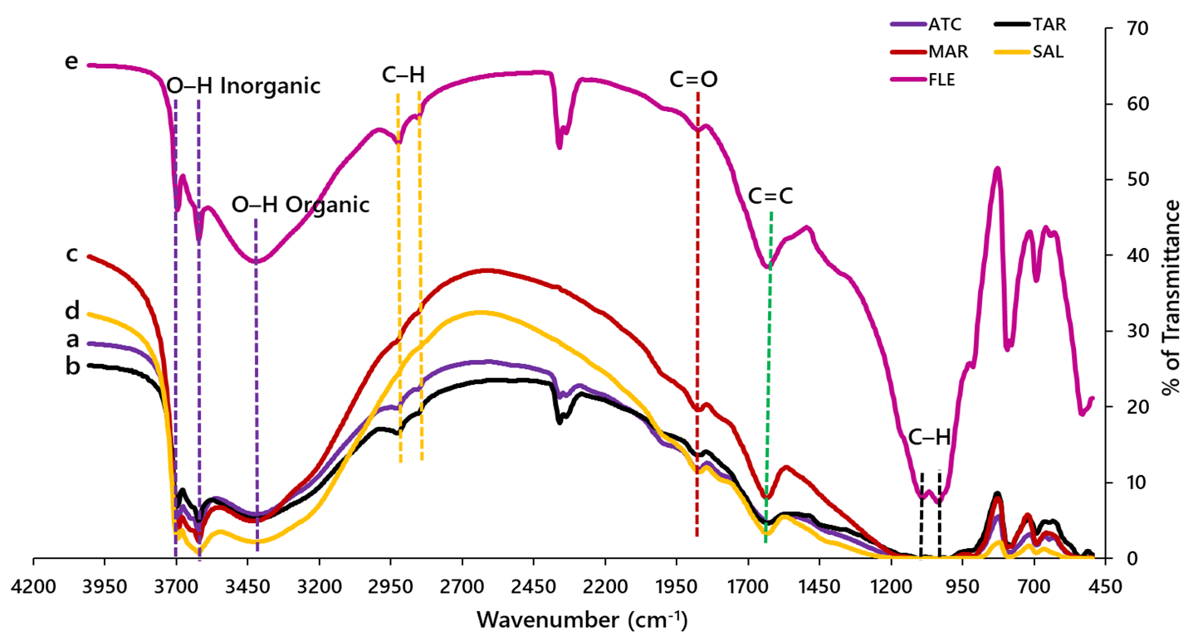

Fig. S2 Fourier‒transform infrared (FTIR) spectra indicating the functional groups present in the selected urban soils.

Table S1 Physicochemical properties of five soils collected from the urban landscapes.
Soil ID | Location | OCª (%) | Fe^{b}  (%) | Al^{b}  (%) | Sand (%) | Silt (%) | Clay (%) | pH^{c}  (in Milli‒Q water) |  | Textural  class | Major mineral compound
ATC | Lawn | 7.66 ±0.01 | 1.10±0.09 | 0.73±0.11 | 51.30 | 41.20 | 7.50 | 5.8±0.03 |  | Loam | Quartz, Orthoclase, Albite, Hyalophane
FLE | Home garden | 1.29 ±0.02 | 0.03±0.67 | 0.01±0.99 | 63.80 | 23.80 | 12.40 | 6.6±0.03 |  | Sandy loam | Quartz, Oligoclase, Albite, Sodalite
SAL | Home garden | 0.25 ±0.16 | 1.42±0.02 | 0.65±0.15 | 97.60 | 1.20 | 1.20 | 6.1±0.02 |  | Sand | Quartz, Dolomite, Zeolite LC‒3, Palladium
TAR | Home garden | 2.02 ±0.01 | 1.19±0.03 | 0.92±0.11 | 33.80 | 55 | 11.20 | 7.5±0.03 |  | Silt loam | Quartz, Sinnerite, Ice Ic, Sylvine, Bernalite, Albite
MAR | Park | 0.21 ±0.10 | 2.15±0.03 | 0.73±0.18 | 76.30 | 16.20 | 7.50 | 8.0±0.01 |  | Loamy sand | Quartz, Albite, Zeolite, Sodalite

ªAnalyzed in LECO analyser (LECO Corporation, USA). ^{b}Analyzed in ICP‒OES (Perkin Elmer Pvt Ltd, Singapore) after microwave digestion (MARS 6™, USA). ^{c}Determined in a pH meter (Horiba Scientific, UK). ATC = University of Newcastle; FLE = Fletcher; SAL = Salamander Bay; TAR = Taree; MAR = Maryland.

Table S2 Concentration of pesticide residue in the soil after 50% degradation (C_{s}), coefficient of organic carbon (K_{oc}), coefficient of determination (R²) and estimated average non-dietary chronic daily intake (CDI), in terms of mg kg⁻¹ day⁻¹, via ingestion (CDI_{i}), dermal (CDI_{d}) and inhalation (CDI_{ih}) pathways of four pesticides for adults and children in five urban landscape soils.
Pesticide | Soil ID | C_{s}  (mg kg^{‒1}) | K_{OC}  (L g⁻¹) | R² | Adults |  |  | Children
 |  |  |  |  | CDI_{i} | CDI_{d} | CDI_{ih} | CDI_{i} | CDI_{d} | CDI_{ih}
Glyphosate | ATC | 2.13 | 901.78 | 0.938 | 1.40×10^{‒6} | 7.30×10^{‒7} | 1.81×10^{‒10} | 7.27×10^{‒7} | 1.98×10^{‒7} | 9.36×10^{‒11}
Glyphosate | TAR | 2.33 | 110.57 | 0.960 | 1.54×10^{‒6} | 8.00×10^{‒7} | 1.98×10^{‒10} | 7.97×10^{‒7} | 2.17×10^{‒7} | 1.02×10^{‒10}
Glyphosate | MAR | 1.90 | 1066.05 | 0.982 | 1.25×10^{‒6} | 6.52×10^{‒7} | 1.61×10^{‒10} | 6.49×10^{‒7} | 1.77×10^{‒7} | 8.36×10^{‒11}
Glyphosate | SAL | 2.42 | 1240.34 | 0.908 | 1.60×10^{‒6} | 8.32×10^{‒7} | 2.06×10^{‒10} | 8.28×10^{‒7} | 2.26×10^{‒7} | 1.06×10^{‒10}
Glyphosate | FLE | 2.13 | 180.27 | 0.948 | 1.40×10^{‒6} | 7.30×10^{‒7} | 1.81×10^{‒10} | 7.27×10^{‒7} | 1.98×10^{‒7} | 9.36×10^{‒11}
2,4‒D | ATC | 2.43 | 39.57 | 0.871 | 1.60×10^{‒6} | 8.35×10^{‒7} | 2.07×10^{‒10} | 8.31×10^{‒7} | 2.27×10^{‒7} | 1.07×10^{‒10}
2,4‒D | TAR | 2.12 | 192.57 | 0.881 | 1.40×10^{‒6} | 7.27×10^{‒7} | 1.80×10^{‒10} | 7.24×10^{‒7} | 1.97×10^{‒7} | 9.32×10^{‒11}
2,4‒D | MAR | 2.36 | 1870.37 | 0.960 | 1.56×10^{‒6} | 8.11×10^{‒7} | 2.01×10^{‒10} | 8.08×10^{‒7} | 2.20×10^{‒7} | 1.03×10^{‒10}
2,4‒D | SAL | 2.26 | 1181.56 | 0.971 | 1.49×10^{‒6} | 7.77×10^{‒7} | 1.92×10^{‒10} | 7.74×10^{‒7} | 2.11×10^{‒7} | 9.96×10^{‒11}
2,4‒D | FLE | 2.44 | 188.26 | 0.921 | 1.61×10^{‒6} | 8.40×10^{‒7} | 2.08×10^{‒10} | 8.36×10^{‒7} | 2.28×10^{‒7} | 1.07×10^{‒10}
Chlorothalonil | ATC | 2.36 | 77.67 | 0.907 | 1.56×10^{‒6} | 8.11×10^{‒7} | 2.01×10^{‒10} | 8.07×10^{‒7} | 2.20×10^{‒7} | 1.03×10^{‒10}
Chlorothalonil | TAR | 2.33 | 373.72 | 0.901 | 1.54×10^{‒6} | 7.99×10^{‒7} | 1.98×10^{‒10} | 7.96×10^{‒7} | 2.17×10^{‒7} | 1.02×10^{‒10}
Chlorothalonil | MAR | 1.33 | 567.06 | 0.960 | 8.82×10^{‒7} | 4.58×10^{‒7} | 1.13×10^{‒10} | 4.56×10^{‒7} | 1.24×10^{‒7} | 5.87×10^{‒11}
Chlorothalonil | SAL | 2.22 | 546.16 | 0.960 | 1.46×10^{‒6} | 7.62×10^{‒7} | 1.89×10^{‒10} | 7.59×10^{‒7} | 2.07×10^{‒7} | 9.76×10^{‒11}
Chlorothalonil | FLE | 1.87 | 133.40 | 0.921 | 1.23×10^{‒6} | 6.42×10^{‒7} | 1.59×10^{‒10} | 6.39×10^{‒7} | 1.74×10^{‒7} | 8.23×10^{‒11}
Dimethoate | ATC | 2.23 | 41.85 | 0.971 | 1.47×10^{‒6} | 7.66×10^{‒7} | 1.90×10^{‒10} | 7.63×10^{‒7} | 2.08×10^{‒7} | 9.82×10^{‒11}
Dimethoate | TAR | 1.95 | 202.78 | 0.977 | 1.29×10^{‒6} | 6.70×10^{‒7} | 1.66×10^{‒10} | 6.68×10^{‒7} | 1.82×10^{‒7} | 8.59×10^{‒11}
Dimethoate | MAR | 2.45 | 116.26 | 0.973 | 1.62×10^{‒6} | 8.42×10^{‒7} | 2.08×10^{‒10} | 8.38×10^{‒7} | 2.29×10^{‒7} | 1.07×10^{‒10}
Dimethoate | SAL | 2.29 | 779.63 | 0.843 | 1.51×10^{‒6} | 7.86×10^{‒7} | 1.95×10^{‒10} | 7.83×10^{‒7} | 2.13×10^{‒7} | 1.00×10^{‒10}
Dimethoate | FLE | 2.49 | 234.05 | 0.950 | 1.65×10^{‒6} | 8.58×10^{‒7} | 2.13×10^{‒10} | 8.55×10^{‒7} | 2.33×10^{‒7} | 1.10×10^{‒10}

Table S3 Hazard index (HI) values for human adults and children via ingestion (HI_{i}), dermal (HI_{d}), and inhalation (HI_{ih}) pathways based on the sum of HQ of individual pesticides in five urban landscape soils.

Soil ID | Adults |  |  | Children
Soil ID | HI_{i} | HI_{d} | HI_{ih} | HI_{i} | HI_{d} | HI_{ih}
ATC | 7.66×10^{–3} | 3.97×10^{–3} | 9.86×10^{–7} | 3.96×10^{–3} | 1.08×10^{–3} | 5.09×10^{–7}
TAR | 6.72×10^{–3} | 3.48×10^{–3} | 8.65×10^{–7} | 3.47×10^{–3} | 9.48×10^{–4} | 4.47×10^{–7}
MAR | 8.34×10^{–3} | 4.32×10^{–3} | 1.07×10^{–6} | 4.31×10^{–3} | 1.17×10^{–3} | 5.54×10^{–7}
SAL | 7.84×10^{–3} | 4.06×10^{–3} | 1.00×10^{–6} | 4.05×10^{–3} | 1.10×10^{–3} | 5.21×10^{–7}
FLE | 8.53×10^{–3} | 4.42×10^{–3} | 1.09×10^{–6} | 4.41×10^{–3} | 1.20×10^{–3} | 5.67×10^{–7}

