Identifying the spatial pattern and driving factors of nitrate in groundwater using a novel framework of interpretable stacking ensemble learning
Xuan Li^{a,b}, Guohua Liangª, Lei Wang^{b}*, Yuesuo Yang^{c}, Yuanyin Li^{b,e}, Zhongguo Li^{d}, Bin Heª, Guoli Wangª.

ª School of Hydraulic Engineering, Dalian University of Technology, Dalian, 116024, China.
^{b} British Geological Survey, Keyworth, Nottingham, NG12 5GG, UK.
^{c} Key Laboratory of Groundwater Resources and Environment, Jilin University, Ministry of Education, Changchun, 130021, China.
^{d} Liaoning Water Affairs Service Center, Shenyang, 110003, China.
^{e} Department of Geography, Durham University, Durham, DH1 3LE, UK.

Corresponding author: L.Wang (lelei@bgs.ac.uk)

Appendix A. Supplementary data

Table S1
Summary of predictor variables.
Variable | Description | Source
Topography
DEM | Land surface elevation, m | (Wang & Burke, 2017)
SLOPE | Average slope, degree | Derived from DEM
Climate
RAINFALL | Average precipitation, 2012- 2021, mm/a | (Met Office et al., 2018)
PET | Average potential evapotranspiration, 2012- 2021, mm/a | (Met Office et al., 2018)
Hydrology
BFI | Baseflow index | (Boorman et al., 1995)
RECHARGE | Average recharge for the period 1961-2011, mm/d | (Wang & Burke, 2017)
Land use
WOOD | Percentage of woodland in a 500m radius circular buffer, % | (Morton et al., 2014)
ARABLE | Percentage of arable land in the buffer, % | (Morton et al., 2014)
GRASS | Percentage of grassland in the buffer, % | (Morton et al., 2014)
BUILTUP | Percentage of built-up areas in the buffer, % | (Morton et al., 2014)
Soil property
S_SAND | Sand content, % | (Ballabio et al., 2016)
S_SILT | Silt content, % | (Ballabio et al., 2016)
S_CLAY | Clay content, % | (Ballabio et al., 2016)
S_COARSE | Coarse fragments, % | (Ballabio et al., 2016)
S_CN | Carbon to nitrogen ratio | (Ballabio et al., 2016)
S_C | Organic carbon content of soils, g/kg | (Ballabio et al., 2016)
S_N | Organic nitrogen content of soils, g/kg | (Ballabio et al., 2016)
S_AWC | Available water capacity | (Ballabio et al., 2016)
Geology
SF_THICK | Superficial thickness, m | (BGS, 2020)
Hydrogeology
AQ_THICK | Aquifer thickness, m | (Wang & Burke, 2017)
USZ_THICK | Unsaturated zone thickness, m | (Wang & Burke, 2017)
T | Transmissivity, m²/day | (Wang & Burke, 2017)
K | Average horizontal hydraulic conductivity, m/d | (Wang & Burke, 2017)
Others
FERTILISER | Average annual nitrogen fertiliser application rate, kg/km² | (Osório et al., 2019)
RESIDENTS | UK gridded population, 2011 | (Reis et al., 2017)

Table S2
Optimal hyperparameters of the machine learning models, gradient boosting decision tree (GBDT), extreme gradient boosting (XGB), random forest (RF), extremely randomized trees (ET), and k-nearest neighbors (KNN) in level 0, and the meta-model, KNN, in level 1.
Model |  | Hyperparameters
Base models | GBDT | n_estimators=185, learning_rate=0.03, max_depth=11, min_samples_leaf=13, subsample=1.0
Base models | XGB | n_estimators=359, learning_rate=0.35, max_depth=13, min_child_weight=13, gamma=0.03, colsample_bytree =0.53, subsample=0.74, reg_lambda=5.84, reg_alpha=1.46
Base models | RF | n_estimators=114, max_depth=18, min_samples_leaf=3, min_samples_split=5, max_features=20
Base models | ET | criterion=‘mse’, n_estimators=157, min_samples_leaf=1, min_samples_split=6, max_depth=8
Base models | KNN | weights=’distance’, n_neighbors=6
Meta-model | KNN | weights=’distance’, n_neighbors=14

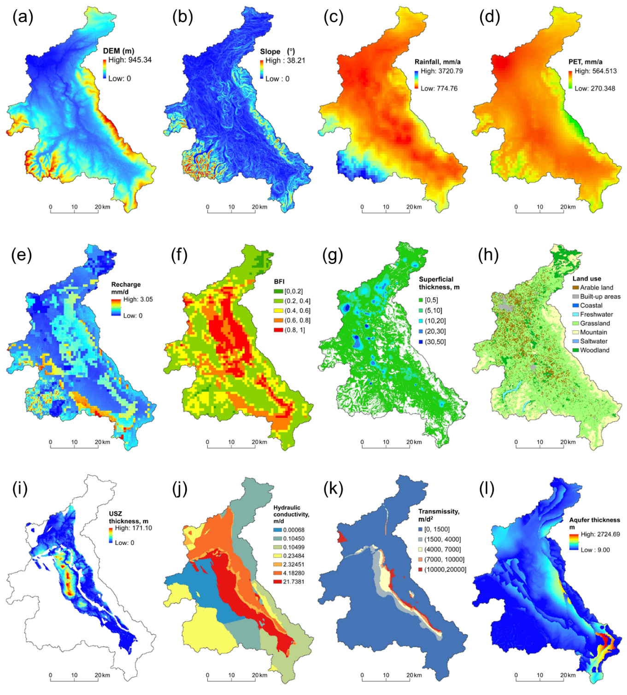
Fig. S1. Environmental variables in the Eden Valley.

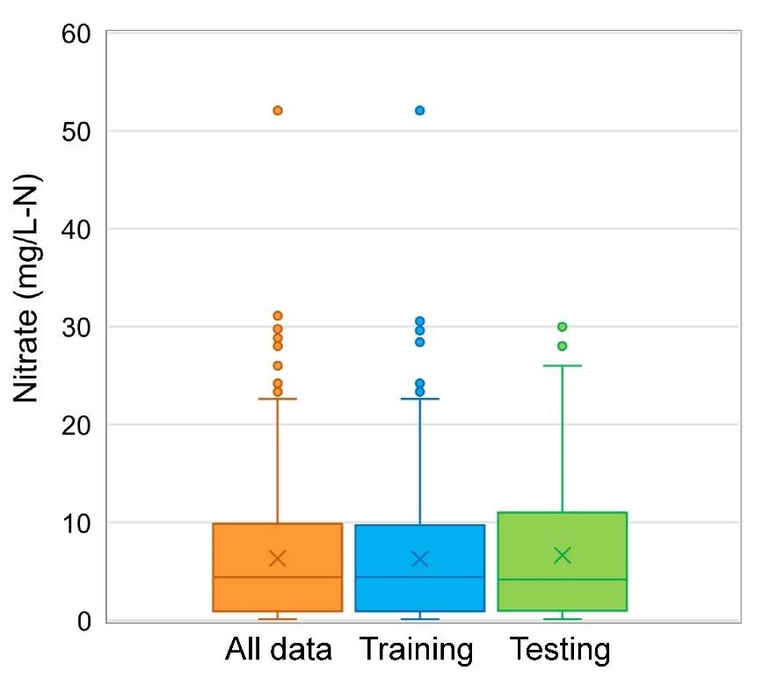
Fig. S2. The boxplot of groundwater nitrate concentrations for all data, training data, and testing data.

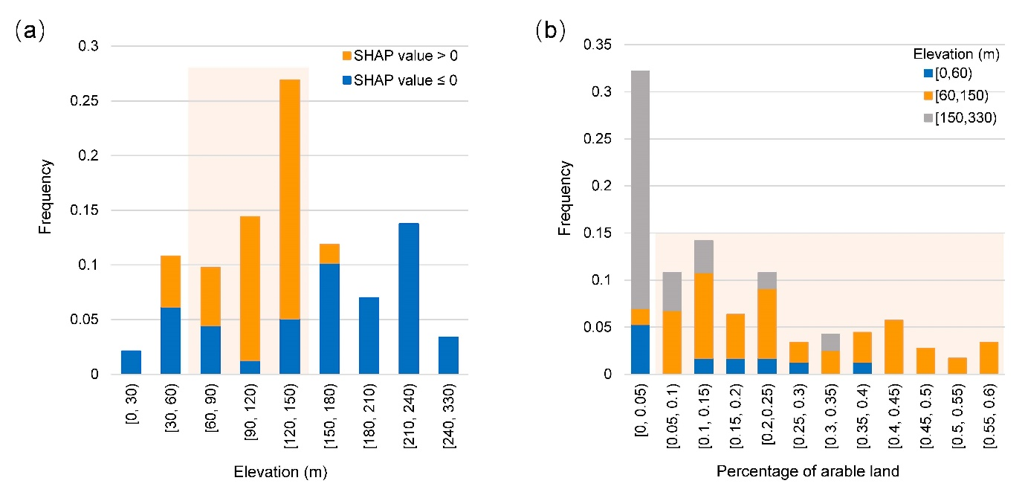
Fig. S3. The frequency distribution histograms of (a) the elevation and (b) the percentage of arable land at different elevations.

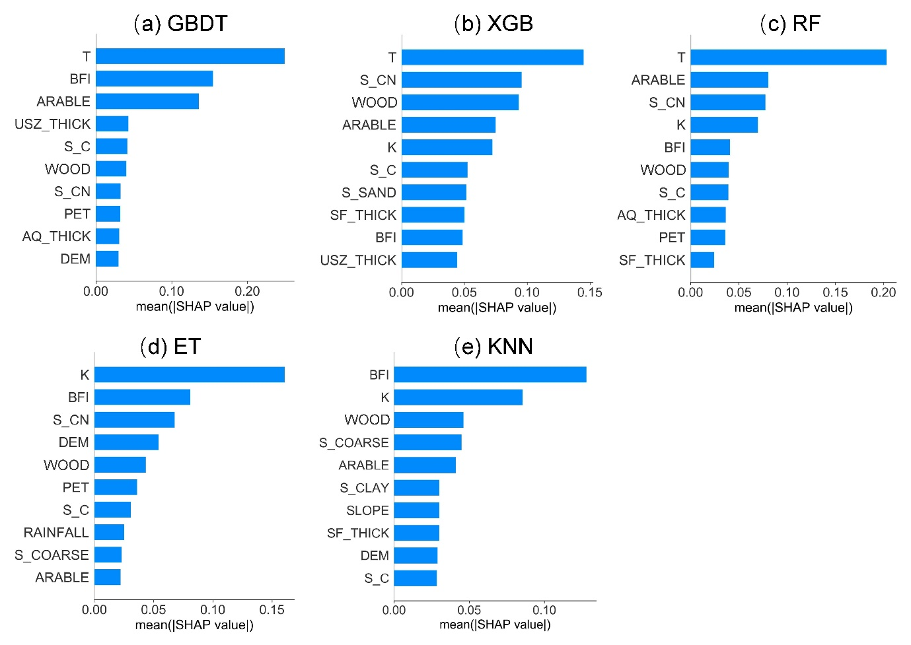
Fig. S4. Average absolute value of SHAP values of the top ten most important variables in the base models, including (a) gradient boosting decision tree (GBDT), (b) extreme gradient boosting (XGB), (c) random forest (RF), (d) extremely randomized trees (ET), and (e) k-nearest neighbors (KNN).
References:
Ballabio, C., Panagos, P., & Monatanarella, L. (2016). Mapping topsoil physical properties at European scale using the LUCAS database. Geoderma, 261, 110-123. https://doi.org/10.1016/j.geoderma.2015.07.006.
BGS. (2020). BGS geology 50k (DigMapGB-50). British Geological Survey. https://www.bgs.ac.uk/datasets/bgs-geology-50k-digmapgb/.
Boorman, D. B., Hollis, J. M., & Lilly, A. (1995). Hydrology of soil types: a hydrologically based classification of the soils of the United Kingdom (Report No. 126). Institute of Hydrology. https://nora.nerc.ac.uk/id/eprint/7369/1/IH_126.pdf.
Met Office, Hollis, D., McCarthy, M., Kendon, M., Legg, T., & Simpson, I. (2018). HadUK-Grid gridded and regional average climate observations for the UK. Centre for Environmental Data Analysis. 2023-08-04. http://catalogue.ceda.ac.uk/uuid/4dc8450d889a491ebb20e724debe2dfb.
Morton, R. D., Rowland, C. S., Wood, C. M., Meek, L., Marston, C. G., & Smith, G. M. (2014). Land cover map 2007 (25m raster, GB) v1.2. NERC Environmental Information Data Centre. https://doi.org/10.5285/a1f88807-4826-44bc-994d-a902da5119c2.
Osório, B., Redhead, J. W., Jarvis, S. G., May, L., & Pywell, R. F. (2019). CEH Land Cover plus: Fertilisers 2010-2015 (England). NERC Environmental Information Data Centre. https://doi.org/10.5285/15f415db-e87b-4ab5-a2fb-37a78e7bf051.
Reis, S., Liska, T., Steinle, S., Carnell, E., Leaver, D., Roberts, E., Vieno, M., Beck, R., & Dragosits, U. (2017). UK gridded population 2011 based on census 2011 and land cover map 2015. NERC Environmental Information Data Centre. https://doi.org/10.5285/0995e94d-6d42-40c1-8ed4-5090d82471e1.
Wang, L., & Burke, S. P. (2017). A catchment-scale method to simulating the impact of historical nitrate loading from agricultural land on the nitrate-concentration trends in the sandstone aquifers in the Eden Valley, UK. Science of The Total Environment, 579, 133-148. https://doi.org/10.1016/j.scitotenv.2016.10.235.

