Supplementary Information
Increased human health risks at a legacy mine site: copper and lead bioaccessibility of oxidized tailings
Sean McHale^{a*}
Heather E. Jamiesonª
Amy E. Cleaver^{b}
Philippa Huntsman^{b}
ªQueen’s University, Department of Geological Sciences and Geological Engineering, Kingston, K7L 3N6, Canada
^{b}CanmetMINING, Natural Resources Canada, Ottawa, K1A 0G1, Canada
*Corresponding author
E-mail address: 19stm3@queensu.ca

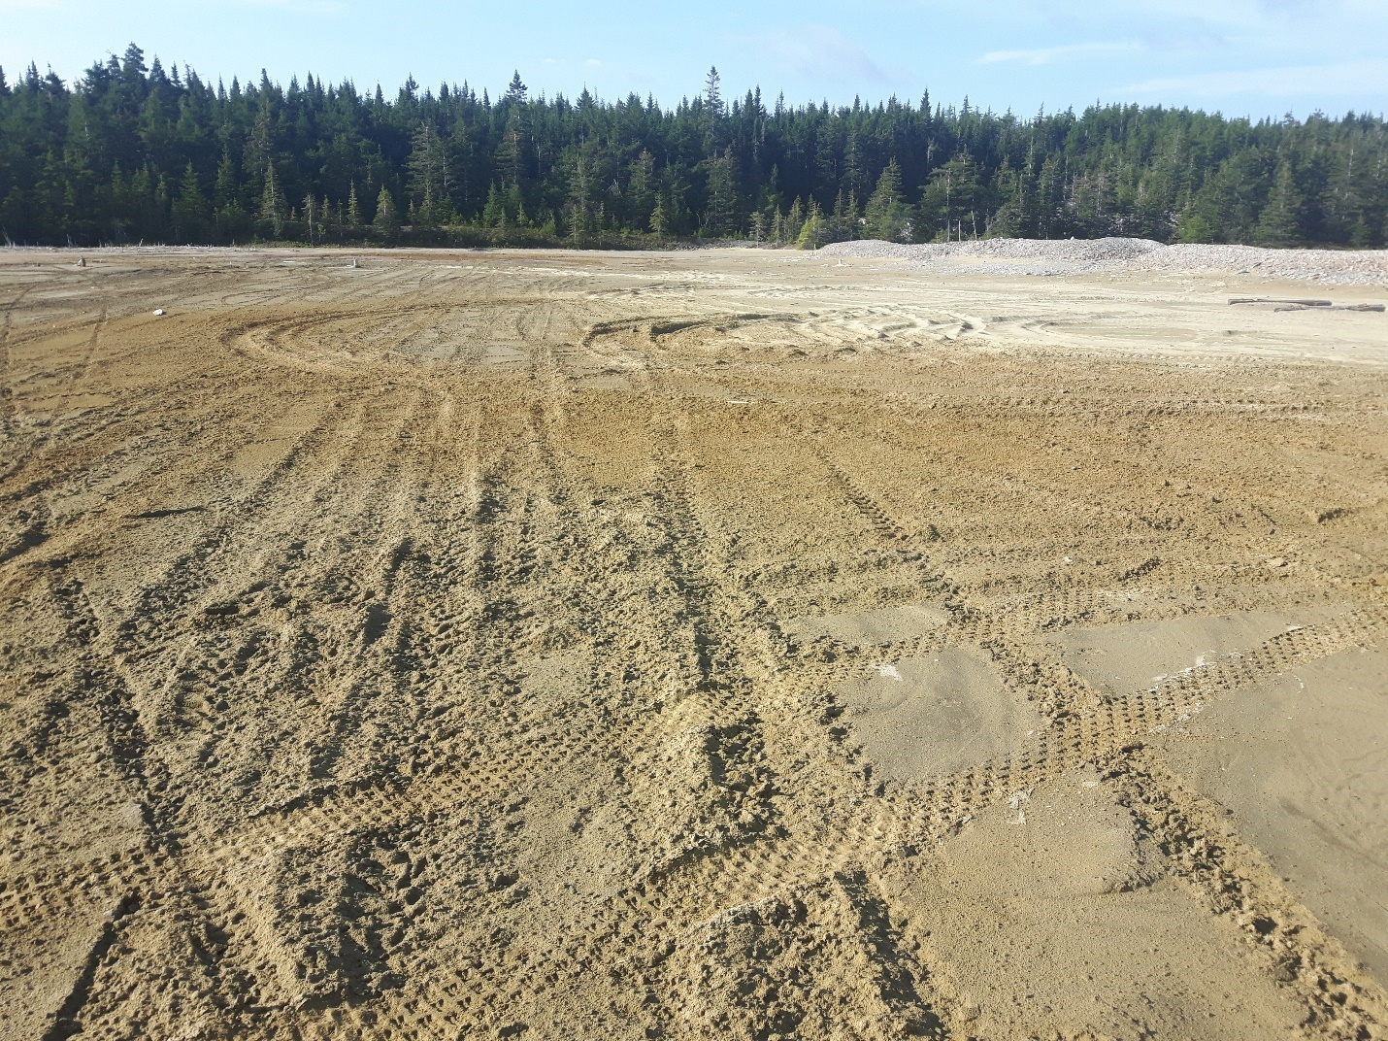
Fig. 1 Stirling tailings impoundment pictured with all-terrain vehicle tracks present. Photo credit Amy Cleaver

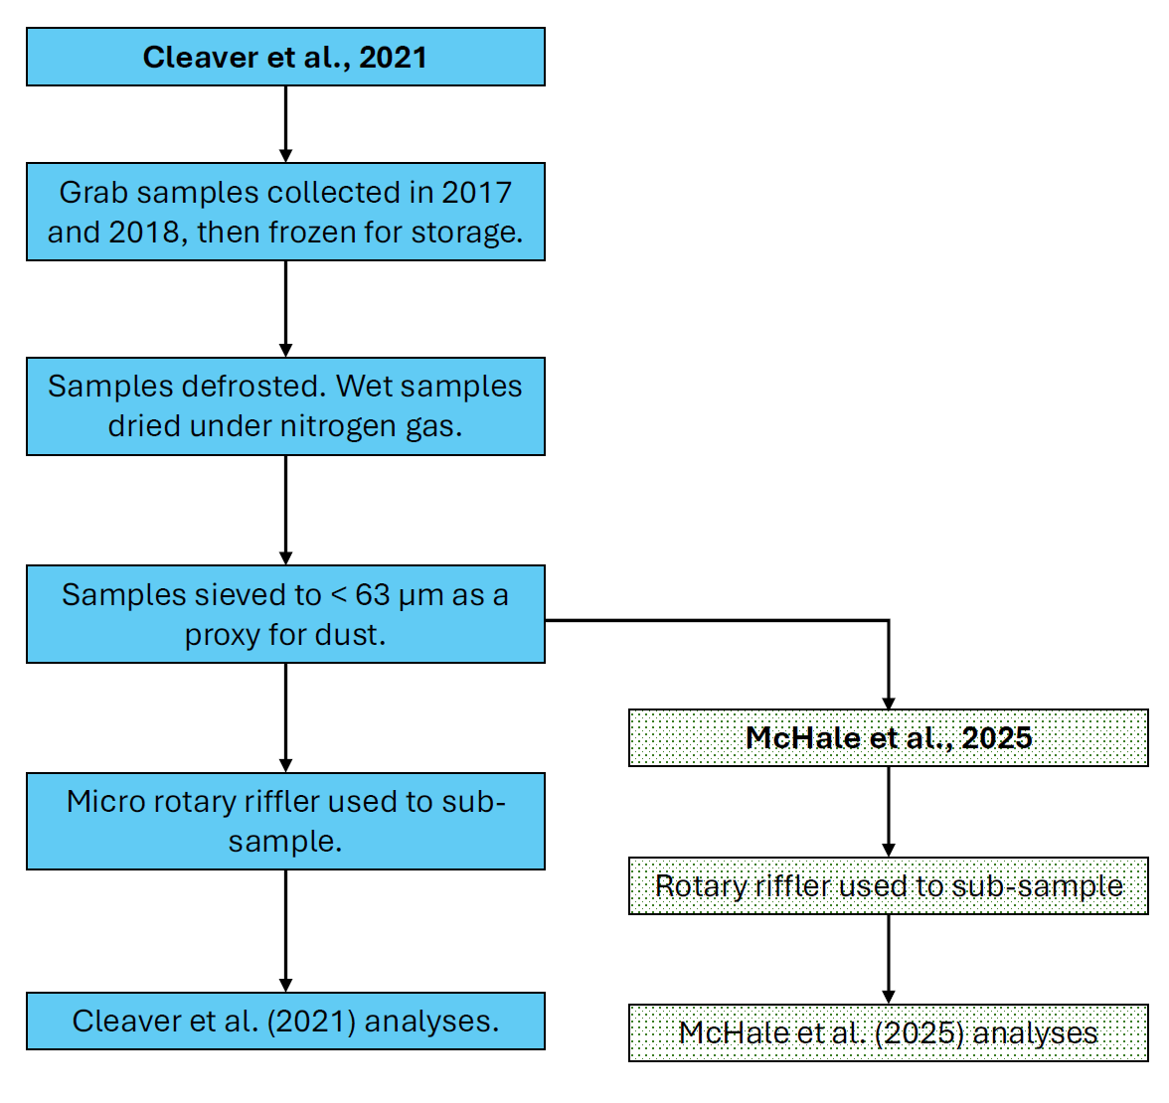
Fig. 2 Flow chart summarising sample preparation

Table 1 Certified reference material types
CRM | Type
900-EMR-512 | Solution
IV-71A | Solution
SOIL-A | Solution
SOIL-B | Solution
TM-25.6 | Solution
TMDA-51.5 | Solution
TMDA-54.6 | Solution
TMDW | Solution
WAVECAL | Solution

Table 2 Percent extracted of certified values in certified reference materials used during elemental analysis of tailings
CRM | Type | % recovered for CRMs in tailings elemental analysis
CRM | Type | As | Cd | Cu | Ni | Pb | Sb | Zn
WAVECAL | Solution | 104 | - | - | - | - | - | -
SOIL-B | Soil | 99 | - | 97 | - | 95 | - | 100
SOIL-A | Soil | - | - | - | - | 96 | - | 98
TMDA-54.6 | Solution | - | 111 | 102 | 105 | 105 | - | 105
TMDW | Solution | - | 113 | - | 102 | - | 110 | -
TMDW | Solution | - | 105 | - | 102 | - | 99 | -
TMDA-54.6 | Solution | - | 103 | - | 102 | - | - | -
TM-25.6 | Solution | - | 111 | - | 108 | - | 109 | -
TM-25.6 | Solution | - | 106 | - | 107 | - | 100 | -

Table 3 Relative percent difference for copper and lead in analytical duplicate for tailings elemental analysis
Tailings duplicate | Cu RPD | Pb RPD
TS1a | 3.90% | 3.54%

Table 4 Percent extracted for given elements in certified reference materials in bioaccessibility extract-solution analysis for NIST 2710a
CRM | % recovered for CRMs analyzed alongside NIST 2710a extract solutions
CRM | Cd | Cu | Ni | Pb | Zn
SOIL-B |  | 98 |  | 92 | 98
IV-71A | 102 | 103 |  | 102 | 102
900-EMR512 | 102 |  |  | 102 | 103
SOIL-A |  | 101 |  |  | 92
TMDW | 105 | 115 | 107 | 95 | 108
TMDA-51.5 | 104 | 101
TMDW | 102 | 100 | 99 | 93 | 104
TMDA-51.5 | 106 | 111

Table 5 NIST 2710a bioaccessibility results with comparison to other studies and method summaries
Data from | Bioaccessibility (%) |  |  |  |  | # of stages | Loading (mg) | Gastric volume (mL) | °C | Incubation (h) | Agitation (rpm) | Extraction solution | Gastric pH
Data from | Cd | Cu | Ni | Pb | Zn
10 mg this study | 62 ± 4 | 82 ± 7 | 250 ± 19 | 87 ± 12 | 48 ± 4 | 1 | 10 | 50 | 37 | 2 | 100 | 0.07M HCl | 1.5
25 mg this study | 55 ± 0.7 | 78 ± 1 | 120 ± 7 | 76 ± 2 | 46 ± 1 | 1 | 25 | 50 | 37 | 2 | 100 | 0.07M HCl | 1.5
Boros et al. (2017) Gastric | 46 | 53 | 13 | 46 | 42 | 1 | 1000 | 100 | 37 | 1 | 28 | Pepsin, sodium citrate, malic acid disodium salt, lactic acid (85%), acetic acid, HCl | 1.8
Boros et al. (2017)  GI | 23 | 37 | 8 | 5 | 12 | 2 | 1000 | 100 | 37 | 5 | 28 | Above + bile salts and pancreatin | 1.8
Xia et al. (2016)  Gastric | 45 | - | - | - | - | 1 | 300 | 30 | 37 | 1 | 30 | Too long to list. As in Wragg et al. (2009) | 1.2
Xia et al. (2016) GI | 26 | - | - | - | - | 3 | 300 | 30 | 37 | 5 | 30 | As in Wragg et al. (2009) | 1.2
Nelson et al. (2013) water incubation | - | - | - | 64 | - | 1 | 1000 | 100 | 37 | 1 | 30 | 0.4M glycine + HCl | 1.5
Nelson et al. (2013)  air incubation | - | - | - | 65 | - | 1 | 1000 | 100 | 37 | 1 | 30 | 0.4M glycine + HCl | 1.5
Paltseva et al. (2018) | - | - | - | 65 | - | 1 | 1000 | 100 | 37 | 1 | 30 | 0.4M glycine + HCl | 1.5
Ono et al. (2016) Gastric | 33 | - | - | 33 | - | 1 | 1000 | 100 | 37 | 1 | 100 | Ultrapure water, pepsin, citrate, malate, lactic acid, acetic acid, HCl | 2.5
Ono et al. (2016) Intestinal | 33 | - | - | 1 | - | 2 | - | - | 37 | 3 | 100 | Ultrapure water, pepsin, citrate, malate, lactic acid, acetic acid, HCl | 2.5
Pelfrêne and Douay (2018) Gastric | 93-108 | - | - | 88–109 | - | 1 | 600 | 22.5 | 37 | 1 | "end over end" | As in Wragg et al. (2009) | 1.2
Pelfrêne and Douay (2018) GI | 89-109 | - | - | 88–109 | - | 3 | 600 | 22.5 | 37 | 5 | "end over end" | As in Wragg et al. (2009) | 1.2
Coa et al. (2019) | - | - | - | 88.4 | - | Pb value (88.4) is an average from three methods. Separate values not given.

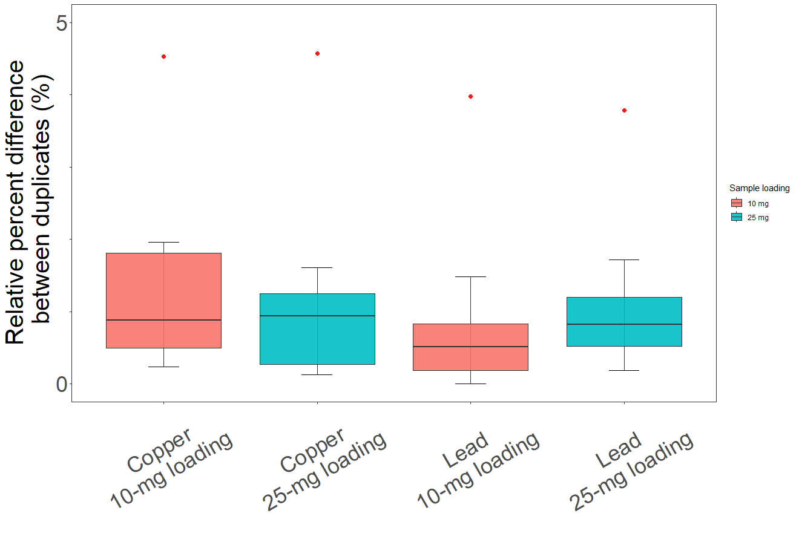
Fig. 3 Box and whisker plot of relative percent difference for bioaccessibility-extract solution duplicates
Table 6 Percent recovered for given elements in certified reference materials, analysed alongside bioaccessibility-solution aliquots for sample TS9b
CRM | % recovered for CRMs analysed alongside TS9b extract solutions
CRM | As | Cd | Cu | Pb | Sb | Zn
SOIL-B |  |  | 99 | 96 |  | 98
IV-71A |  | 99 |  | 100 |  | 100
900-EMR512 |  | 101 |  | 101 | 100 | 102
TMDW | 102 | 93 | 77 | 90 | 99 | 114
TMDW | 99 | 94 | 83 | 92 | 108 | 118
TMDA-51.5 | 102 | 95 | 93 |  | 99
TMDA-51.5 | 99 | 95 | 95 |  | 99

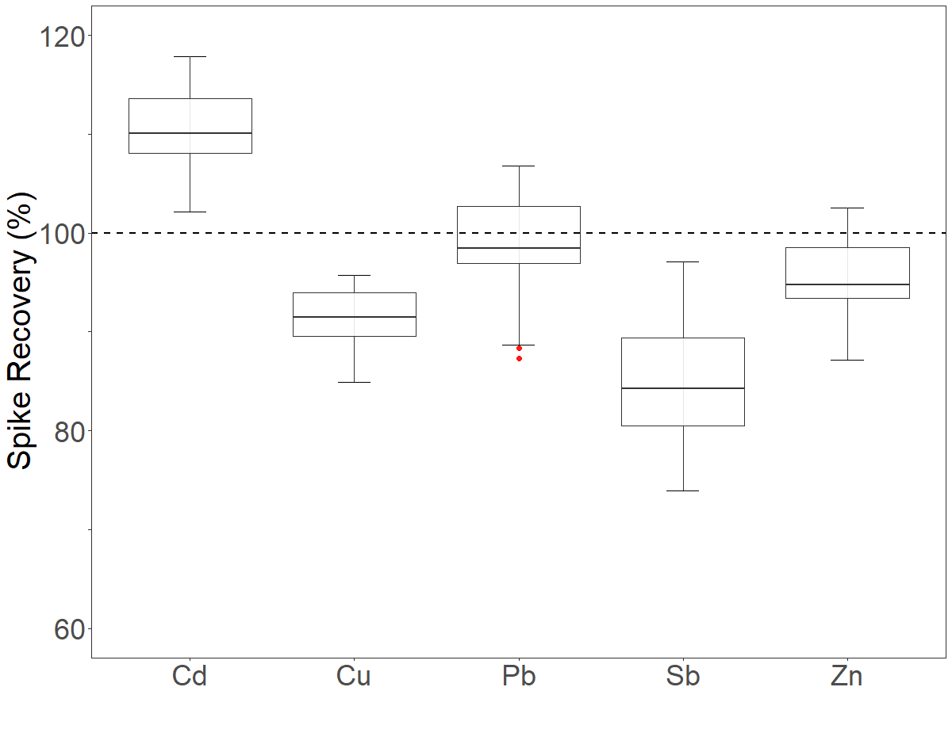
Fig. 4 Box and whisker plot for percentage of copper, and lead recovered from positive controls in bioaccessibility testing

Table 7 Average blank values (ppb) for bioaccessibility analyses. Nine blanks were run per sample per element
 | Sample
 | TS1a | TS1b | TS2 | TS3 | TS5 | TS6 | TS9a | TS9b
Cu (ppb) blank average (n = 9) | 2.898 | 0.419 | 2.236 | 1.039 | 0.314 | 0.045 | 10.434 | 0.170
Pb (ppb) blank average (n = 9) | 12.622 | 1.678 | 1.59 | 9.624 | 1.408 | 2.733 | 25.687 | 3.638

Table 8 Summary of elemental analysis for Stirling tailings, with guideline values from the Canadian Council for Ministers of the Environment (CCME)
Element | Avg. this study*  Sieved < 63µm (ppm) | Avg. Cleaver et al. 2021* Sieved < 63 µm (ppm) | CCME Soil Guideline Parkland (ppm) | CCME Soil Guideline Industrial  (ppm)
Number of samples | N = 8 | N = 7
Zn | 15,611 ± 7,419 | 13,529 ± 4,626 | 250 | 410
Pb | 5,226 ± 2470 | 3,881 ± 1,102 | 140 | 600
Cu | 1,549 ± 328 | 1,631 ± 277 | 63 | 91
As | 222 ± 43 | 232 ± 59 | 12 | 12
Sb | 79 ± 15 | 89 ± 12 | 20 | 40
Cd | 39 ± 18 | 38 ± 10 | 10 | 22

Modal mineralogy
All tailings samples were dominated by sulfide phases. Sample TS1b and TS5, classified as pyrite-poor, were constituted of 62 and 64 wt.% sulfide phases; the five pyrite-rich tailings ranged between 79–83 wt.% sulfides. The remaining sample, TS9b, was 71 wt.% sulfide phases. The primary sulfide was pyrite (FeS₂), samples ranged from 57–81 wt.% pyrite. Dolomite (CaMg(CO₃)₂) and quartz (SiO₂) are present in all samples, ranging from 6.5–9.5 wt.% and 2.5–5.5 wt.% respectively. Carbonate minerals, including Pb and Cu carbonates ranged from 8–14 wt.% of the sample: pyrite-rich tailings were 8–9wt. % carbonate phases, pyrite-poor were 11–12 wt.%, and TS9b 14 wt.%.

Table 9 Modal mineralogy comparison between this study and Cleaver (2021). Standard deviation represents sample heterogeneity with classification of pyrite-poor and pyrite-rich tailings
Mineral | This study |  | Cleaver et al. 2021 |  | % change
Mineral | Wt.% in Pyrite-rich Tailings | Wt. % in Pyrite-poor Tailings | Wt.% in Pyrite-rich Tailings | Wt.% in Pyrite-poor Tailings | Pyrite rich | Pyrite poor
Pyrite | 78 ± 2.8 | 58 ± 0.9 | 51 ± 6 | 22 ± 3 | 53 | 164
Dolomite | 6.3 ± 0.2 | 9.6 ± 0.3 | 21 ± 4 | 29 ± 1 | -70 | -67
Quartz | 2.7 ± 0.3 | 5.7 ± 0.6 | 9.5 ± 2 | 17 ± 2 | -72 | -66
Talc | 1.5 ± 0.4 | 4.6 ± 0.05 | 3.2 ± 1 | 9.6 ± 2 | -53 | -52
Magnesite | 1.1 ± 0.2 | 0.8 ± 0.2 | 1.7 ± 1 | 2.1 ± 0.1 | -35 | -62
Sphalerite | 2.5 ± 1.5 | 3.8 ± 1.7 | 1.7 ± 1 | 1.8 ± 1 | 47 | 111
Clay Minerals | 0.06 ± 0.01 | 0.2 ± 0.005 | 1.4 ± 0.7 | 1.4 ± 0.4 | -96 | -86
Barite | 2.2 ± 0.2 | 2.5 ± 0.2 | 1.4 ± 0.2 | 1.1 ± 0.4 | 57 | 127
Amphiboles | 0.5 ± 0.01 | 3.5 ± 0.01 | 1.3 ± 0.3 | 3.2 ± 0.5 | -62 | 9
Clinochlore | 0.3 ± 0.06 | 0.6 ± 0.02 | 1.2 ± 0.2 | 2.2 ± 0.1 | -75 | -73
Chlorite | 0.5 ± 0.1 | 0.8 ± 0.03 | 1.0 ± 0.2 | 2.0 ± 0.2 | -50 | -60

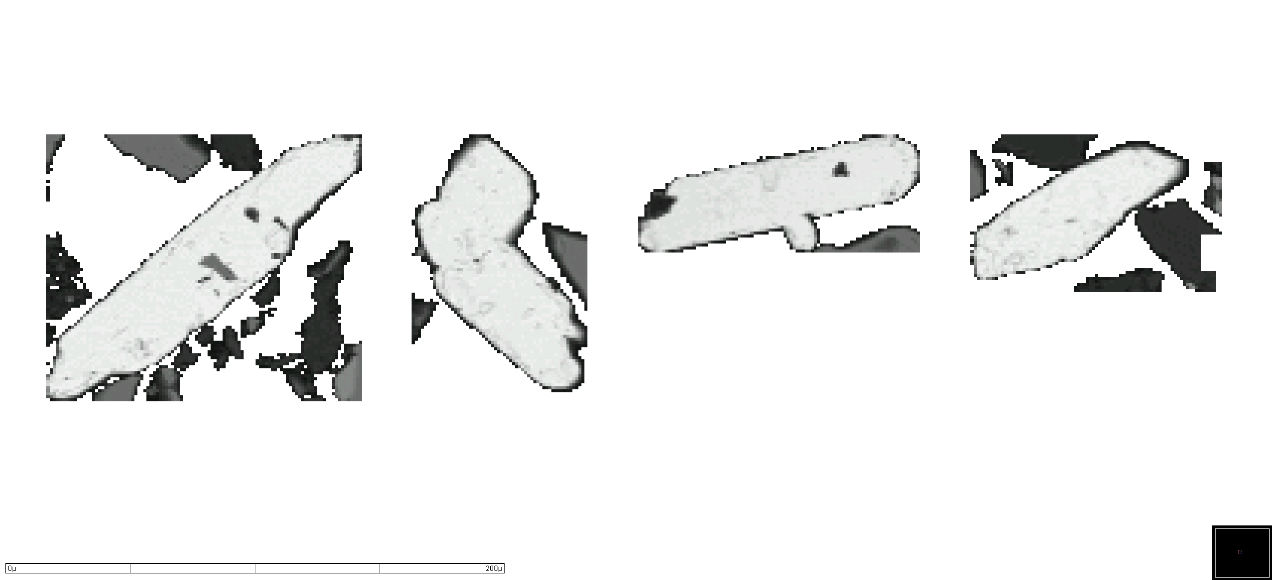
Fig. 5 Sample TS1a, largest elongate cerussite grains. SEM-MLA scale bar = 200 µm

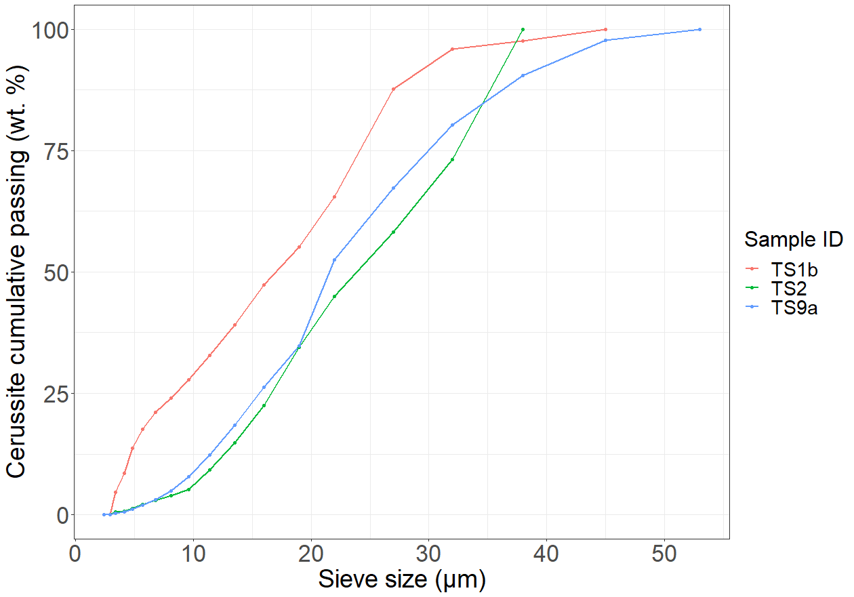
Fig. 6 Particle size of cerussite, determined by automated-mineralogy software, in samples TS1b, TS2, and TS9a

Reference list

Boros, K., Fortin, D., Jayawardene, I., Chénier, M., Levesque, C., & Rasmussen, P. (2017). Comparison of Gastric versus Gastrointestinal PBET Extractions for Estimating Oral Bioaccessibility of Metals in House Dust. International Journal of Environmental Research and Public Health, 14(1), 92. doi:10.3390/ijerph14010092
Cao, P., Fujimori, T., Juhasz, A., & Takaoka, M. (2019). Bioaccessibility of Arsenic and Lead in Polluted Soils Using Three In-vitro Gastrointestinal Simulation Models. IOP Conference Series: Earth and Environmental Science, 265, 012012. doi:10.1088/1755-1315/265/1/012012
Nelson, C. M., Gilmore, T. M., Harrington, J. M., Scheckel, K. G., Miller, B. W., & Bradham, K. D. (2013). Evaluation of a low-cost commercially available extraction device for assessing lead bioaccessibility in contaminated soils. Environmental Science: Processes & Impacts, 15(3), 573. doi:10.1039/c2em30789h
Ono, F. B., Penido, E. S., Tappero, R., Sparks, D., & Guilherme, L. R. G. (2016). Bioaccessibility of Cd and Pb in tailings from a zinc smelting in Brazil: implications for human health. Environmental Geochemistry and Health, 38(5), 1083-1096. doi:10.1007/s10653-015-9774-0
Paltseva, A., Cheng, Z., Deeb, M., Groffman, P. M., & Maddaloni, M. (2018). Variability of Bioaccessible Lead in Urban Garden Soils. Soil Science, 183(4), 123-131. doi:10.1097/ss.0000000000000232
Pelfrêne, A., & Douay, F. (2018). Assessment of oral and lung bioaccessibility of Cd and Pb from smelter-impacted dust. Environmental Science and Pollution Research, 25(4), 3718-3730. doi:10.1007/s11356-017-0760-1
Wragg, J., Cave, M., Taylor, H., Basta, N., Brandon, E., Casteel, S., . . . Van de Wiele, T. (2009). Inter-laboratory trial of a unified bioaccessibility testing procedure.
Xia, Q., Peng, C., Lamb, D., Mallavarapu, M., Naidu, R., & Ng, J. C. (2016). Bioaccessibility of arsenic and cadmium assessed for in vitro bioaccessibility in spiked soils and their interaction during the Unified BARGE Method (UBM) extraction. Chemosphere, 147, 444-450. doi:https://doi.org/10.1016/j.chemosphere.2015.12.091

