Mechanistic Insights and Environmental Ramifications of Cr(III) Oxidation to Cr(VI) in Soil and Groundwater Systems: Bridging Geochemical Mechanisms and Emerging Remediation Strategies
Atta Rasool^{1,*}, Eva Pertile¹, Kateřina Brožová¹, Jan Halfar¹, Kristina Čabanová¹, Petra Malíková¹, Jitka Chromíková¹, Oldřich Motyka¹, Silvie Drabinová¹, Silvie Heviánková¹

¹Faculty of Mining and Geology, VSB–Technical University of Ostrava, 17. listopadu 2172/15, Ostrava-Poruba, 708 00, Czech Republic

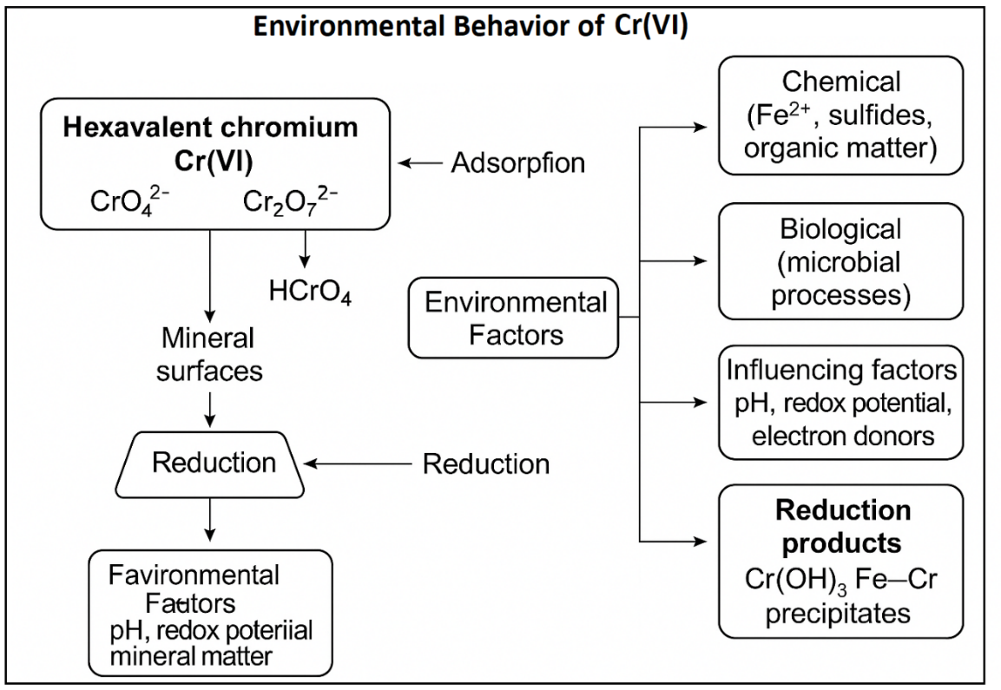
Figure S1. Cr(VI) mobility and reduction pathways. Adsorption, redox conditions, and environmental factors control

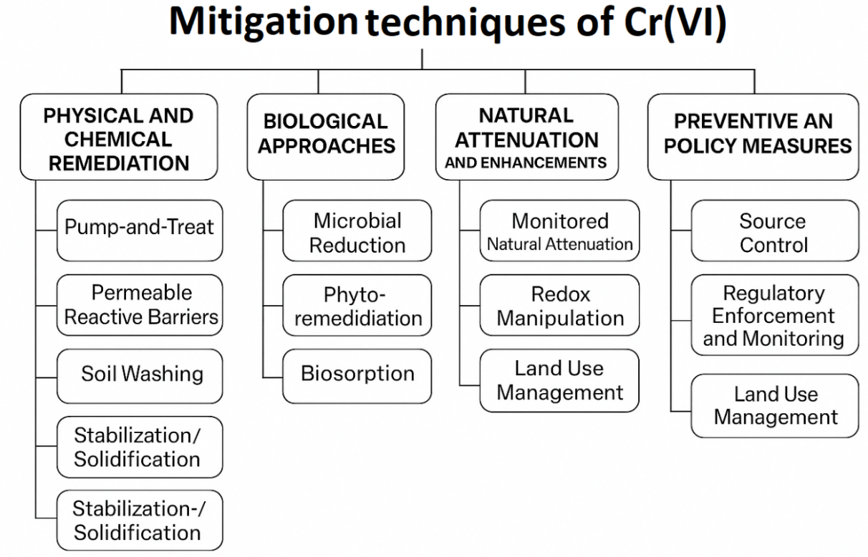

Figure S2. Mitigation Strategies of Cr(VI) Contamination using different approaches, i.e., physical, chemical, and biological.

Table S1. Cr(III) and Cr(VI) Concentrations in Groundwater and Surface Waters
Region | Water Type | Cr(VI) (µg/L) | Cr(III) (µg/L) | Key Characteristics | Reference(s)
Antelope Valley, CA | Groundwater (natural) | <1–32 | Typically <10% of total Cr | Alkaline (pH ~8), oxic, long residence, Cr-bearing schist | (Izbicki et al., 2015)
West-side Central Valley, CA | Groundwater (agricultural) | <1–69 | Low | Cr-rich alluvium, irrigation return, high nitrate, alkaline oxic aquifer | (Guo et al., 2020)
Loess Plateau, China | Groundwater | <4–300 | Not quantified | Loess fissure-pore aquifers; pH 7.8–8.8; high Eh; amphibole/tremolite | (Ning et al., 2025)
Jingyang County, China | Groundwater | Up to 300 | Not quantified | Loess tableland, weathered sandstone, slow groundwater flow | (Ning et al., 2025)
Troodos and coastal aquifers, Cyprus | Groundwater/Spring | ND–26 | ND-few (indirect) µg/L | Ultramafic/mafic ophiolite; fractured aquifers; meteoric recharge | (Zissimos et al., 2021)
Aosta industrial area, Italy | Groundwater (industrial) | 0.09–165 | Not reported | Superficial steel slag deposits, Ca–Mg–HCO₃/SO₄ basins | (Grappein et al., 2021)
Tuscany/Cecina coast, Italy | Groundwater (natural/coastal) | Up to 73 | Not reported | Ophiolitic rocks, Mn-oxide oxidation in coastal alluvium | (Bastianoni et al., 2021)
Aegean and Central Greece | Groundwater/tap water (urban) | Up to 156 | Not reported | Ophiolitic formations + industrial (fly-ash/waste); some public supply exceeding EU limit | (Drougas et al., 2025)
Loess Plateau, China | Surface water | 12-May | Not quantified | Seasonal recharge, moderate DO/Eh | (Ning et al., 2025)
Bauru Basin, São Paulo, Brazil | Groundwater | Up to 130 | Not reported | Sandstone aquifer; high pH >10; Mn-oxide–catalyzed oxidation of Cr(III); chrome-diopside source | (Bertolo et al., 2011)
New Caledonia (ultramafic soils) | Soil pore-water | Up to 700 | Not reported | Phosphate-amended serpentine soil; Mn-mediated Cr(III) oxidation | (Becquer et al., 2003)
León Valley, Mexico | Groundwater | ~12 | Not reported | Ultramafic geology (Sierra Guanajuato); geogenic Cr(VI) source | (Villalobos-Aragón et al., 2012)
Chromite mining area | Surface water | 20-500 | 30-May | Ultramafic rock weathering; mine drainage; oxidizing to slightly reducing | (Kokkinos et al., 2024; Rashid et al., 2023)
Cyprus (Kiti–Pervolia) | GW | Median 4.5 | Not reported | Coastal agricultural recharge | (Zissimos et al., 2021)
Greece (ultramafic areas) | Tap/GW (urban) | >2 up to 156 | Not reported | Ultramafic geology, Mn-catalyzed oxidation, EU exceedances | (Dermatas et al., 2015)
Southern India (tannery areas) | GW | 10 - 190 (0.01-0.19 mg/L) | 0.01- 0.19 mg/L total Cr | Industrial tanning contamination exceeding WHO limit (0.05 mg/L) | (Ali et al., 2022; Brindha and Elango, 2012)

Table S2. Environmental behavior, migration, transformation and fate of Cr(VI)
Process | Description | Environmental Impact | Reference
Leaching and Migration | Cr(VI) moves through unsaturated and saturated zones | Groundwater contamination risk | (Wang et al., 2020; Wei et al., 2021)
Adsorption/Desorption | Cr(VI) weakly adsorbs to oxides and clays; desorption under alkaline pH | Enhanced mobility under high pH | (Liang et al., 2021)
Microbial Reduction | Reduction to Cr(III) via Fe(III)- or sulfate-reducing bacteria | Localized immobilization | (Huang et al., 2024)
Abiotic Reduction | Reduction by Fe²⁺, sulfides, and organic matter | Cr(VI) sequestration in anoxic zones | (Hou et al., 2023)
Post-Fire Redistribution | Cr(VI) formed during fires is water soluble and rapidly mobilized by rain | Rapid surface and subsurface transport | (Burton et al., 2019)

Table S3. Overview of Common Cr(VI) Reducing Agents

Reducing Agent | Formula | Approx. Redox Potential | Environmental Relevance | Limitations Reference
Ferrous iron | Fe²⁺ | +0.77 V (vs. SHE) | Naturally present in suboxic soils and sediments | Ineffective in oxic conditions; pH-sensitive | (Liang et al., 2021)
Zero-valent iron | Fe⁰ | –0.44 V | Widely used in permeable reactive barriers (PRBs) and soil treatments | Surface passivation; limited penetration in compact soils | (Liang et al., 2021; Verma et al., 2025)
Sulfides | HS⁻, S²⁻ | ~–0.24 to –0.27 V | Produced via microbial sulfate reduction in anoxic environments | H₂S toxicity; redox sensitive | (Choppala et al., 2018; Kushkevych et al., 2019)
Organic matter | – | Variable (–0.2 to –0.5 V) | Abundant in soils; supports microbial and abiotic Cr(VI) reduction | Variable efficiency; influenced by bioavailability and structure | (Choppala et al., 2018; Ren et al., 2023)
Calcium polysulfide | CaSₓ | Not defined | Applied in field-scale remediation of Cr(VI)-contaminated sites | Secondary byproducts (e.g., SO₄²⁻); handling precautions | (Graham et al., 2006; Moon et al., 2008)
Sodium dithionite | Na₂S₂O₄ | ~–0.66 V | Rapid-acting reductant in soil washing and ex situ treatments | Instability; short lifetime in solution | (Fan et al., 2023; Telfeyan et al., 2019)

Note: Redox potentials are standard vs SHE and may vary with pH and matrix.

Reference

Ali, H.Q., Yasir, M.U., Farooq, A., Khan, M., Salman, M., & Waqar, M. (2022). Tanneries impact on groundwater quality: A case study of Kasur city in Pakistan. Environmental Monitoring and Assessment, 194, 823. https://doi.org/10.1007/s10661-022-10502-0
Bastianoni, A., Guastaldi, E., Barbagli, A., Bernardinetti, S., Zirulia, A., Brancale, M., & Colonna, T. (2021). Multivariate analysis applied to aquifer hydrogeochemical evaluation: A case study in the coastal significant subterranean water body between “Cecina River and San Vincenzo”, Tuscany (Italy). Applied Sciences, 11, 7595. https://doi.org/10.3390/app11167595
Bertolo, R., Bourotte, C., Hirata, R., Marcolan, L., & Sracek, O. (2011). Geochemistry of natural chromium occurrence in a sandstone aquifer in Bauru Basin, São Paulo State, Brazil. Applied Geochemistry, 26, 1353–1363. https://doi.org/10.1016/j.apgeochem.2011.05.009
Brindha, K., & Elango, L. (2012). Impact of tanning industries on groundwater quality near a metropolitan city in India. Water Resources Management, 26, 1747–1761. https://doi.org/10.1007/s11269-012-9985-4
Dermatas, D., Mpouras, T., Chrysochoou, M., Panagiotakis, I., Vatseris, C., Linardos, N., Theologou, E., Boboti, N., Xenidis, A., Papassiopi, N., & Sakellariou, L. (2015). Origin and concentration profile of chromium in a Greek aquifer. Journal of Hazardous Materials, 281, 35–46. https://doi.org/10.1016/j.jhazmat.2014.09.050
Drougas, C., Kelepertzis, E., Kypritidou, Z., Sigala, E., Matiatos, I., Dotsika, E., Vasileiou, E., Louloudis, G., Mertiri, E., Boeckx, P., Oikonomopoulos, E., & Roumpos, C. (2025). Controls on the geochemical composition of surface water in Alfeios River basin in the transition era of lignite mine closure at Megalopolis, Greece. Science of the Total Environment, 970, 179006. https://doi.org/10.1016/j.scitotenv.2025.179006
Fan, J., Liu, C., Zheng, J., & Song, Y. (2023). Dithionite promoted microbial dechlorination of hexachlorobenzene while goethite further accelerated abiotic degradation by sulfidation in paddy soil. Ecotoxicology and Environmental Safety, 259, 115047. https://doi.org/10.1016/j.ecoenv.2023.115047
Graham, M.C., Farmer, J.G., Anderson, P., Paterson, E., Hillier, S., Lumsdon, D.G., & Bewley, R.J.F. (2006). Calcium polysulfide remediation of hexavalent chromium contamination from chromite ore processing residue. Science of the Total Environment, 364, 32–44. https://doi.org/10.1016/j.scitotenv.2005.11.007
Grappein, B., Lasagna, M., Capodaglio, P., Caselle, C., & Luca, D.A.D. (2021). Hydrochemical and isotopic applications in the western Aosta Valley (Italy) for sustainable groundwater management. Sustainability, 13, 487. https://doi.org/10.3390/su13020487
Guo, H., Chen, Y., Hu, H., Zhao, K., Li, H., Yan, S., Xiu, W., Coyte, R.M., & Vengosh, A. (2020). High hexavalent chromium concentration in groundwater from a deep aquifer in the Baiyangdian Basin of the North China Plain. Environmental Science & Technology, 54, 10068–10077. https://doi.org/10.1021/acs.est.0c02357
Hou, J., Li, Z., Xia, J., Miao, L., Wu, J., & Lv, B. (2023). Role of sulfate-reducing bacteria in the removal of hexavalent chromium by biosynthetic iron sulfides (FeS1+x). Water, 15, 1589. https://doi.org/10.3390/w15081589
Huang, H., Gao, Y.-J., Cao, Z.-X., Tian, Z.-Q., Bai, Y.-F., Tang, Z.-X., Ali, A., Zhao, F.-J., & Wang, P. (2024). Ecotoxicity of hexavalent chromium [Cr(VI)] in soil presents predominate threats to agricultural production with the increase of soil Cr contamination. Journal of Hazardous Materials, 476, 135091. https://doi.org/10.1016/j.jhazmat.2024.135091
Kokkinos, E., Kotsali, V., Tzamos, E., & Zouboulis, A. (2024). Acid mine drainage neutralization by ultrabasic rocks: A chromite mining tailings evaluation case study. Sustainability, 16, 8967. https://doi.org/10.3390/su16208967
Kushkevych, I., Dordević, D., & Vítězová, M. (2019). Toxicity of hydrogen sulfide toward sulfate-reducing bacteria Desulfovibrio piger Vib-7. Archives of Microbiology, 201, 389–397. https://doi.org/10.1007/s00203-019-01625-z
Moon, D.H., Wazne, M., Jagupilla, S.C., Christodoulatos, C., Kim, M.G., & Koutsospyros, A. (2008). Particle size and pH effects on remediation of chromite ore processing residue using calcium polysulfide (CaS5). Science of the Total Environment, 399, 2–10. https://doi.org/10.1016/j.scitotenv.2008.03.040
Rashid, A., Ayub, M., Ullah, Z., Ali, A., Sardar, T., Iqbal, J., Gao, X., Bundschuh, J., Li, C., Khattak, S.A., Ali, L., El-Serehy, H.A., Kaushik, P., & Khan, S. (2023). Groundwater quality, health risk assessment, and source distribution of heavy metals contamination around chromite mines: Application of GIS, sustainable groundwater management, geostatistics, PCAMLR, and PMF receptor model. International Journal of Environmental Research and Public Health, 20, 2113. https://doi.org/10.3390/ijerph20032113
Telfeyan, K., Migdisov, A.A., Pandey, S., Vesselinov, V.V., & Reimus, P.W. (2019). Long-term stability of dithionite in alkaline anaerobic aqueous solution. Applied Geochemistry, 101, 160–169. https://doi.org/10.1016/j.apgeochem.2018.12.015
Verma, Y., Verma, A., Bhaskaralingam, A., Dhiman, P., Wang, T., Kumar, A., & Sharma, G. (2025). Application of zero-valent iron and its derivatives in the removal of toxic metal ions from groundwater. Water, 17, 1524. https://doi.org/10.3390/w17101524
Villalobos-Aragón, A., Ellis, A.S., Armienta, M.A., & Morton-Bermea, O. (2012). Geochemistry and Cr stable isotopes of Cr-contaminated groundwater in León valley, Guanajuato, México. Applied Geochemistry, 27, 1783–1794. https://doi.org/10.1016/j.apgeochem.2012.02.013
Wei, Y., Xu, X., Zhao, L., Chen, X., Qiu, H., & Gao, B. (2021). Migration and transformation of chromium in unsaturated soil during groundwater table fluctuations induced by rainfall. Journal of Hazardous Materials, 416, 126229. https://doi.org/10.1016/j.jhazmat.2021.126229

