Supplementary pages
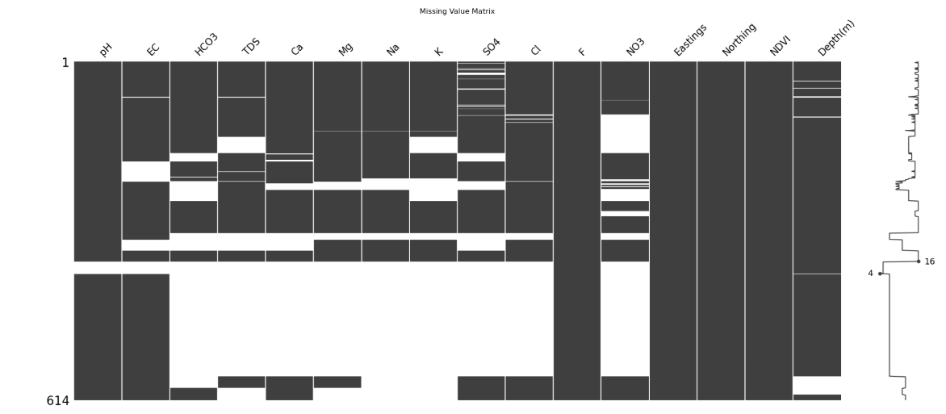
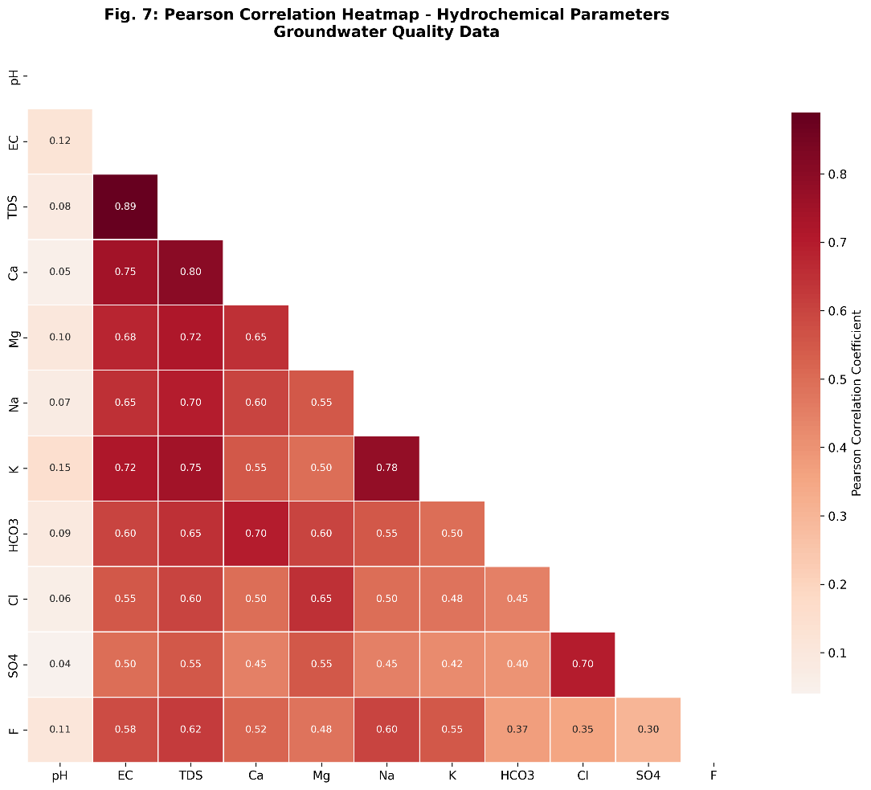
Figure S1. Unbalanced sample data before resampling.
Figure S2. Person Correlation Matrix

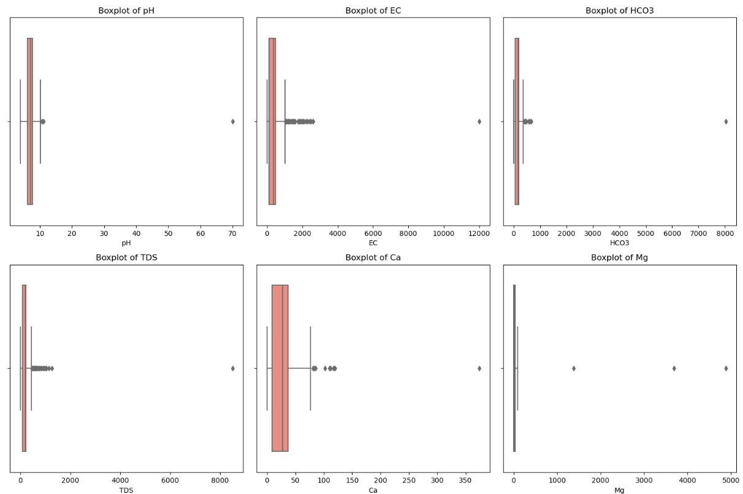
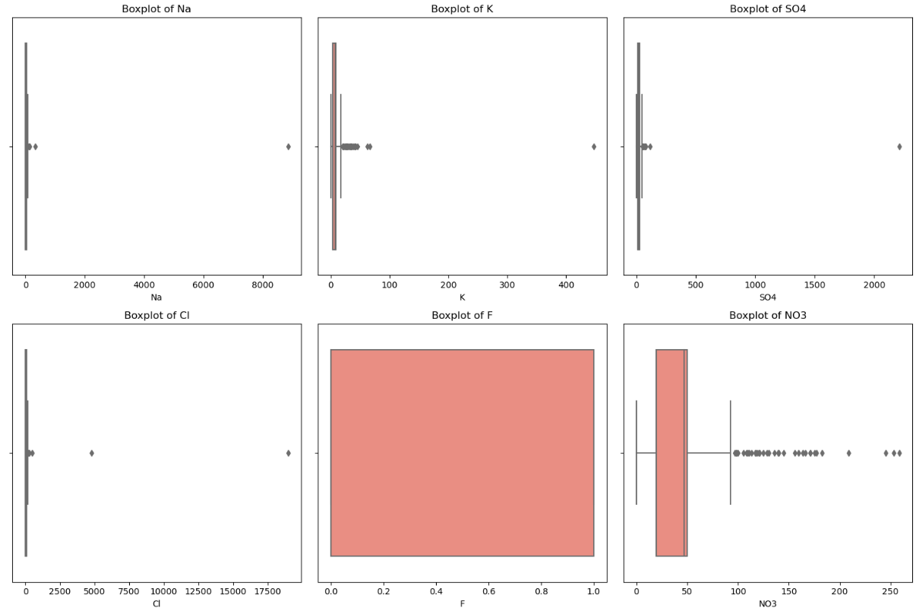
Figure S3. Boxplot for the predictor's distribution used for the random forest model.

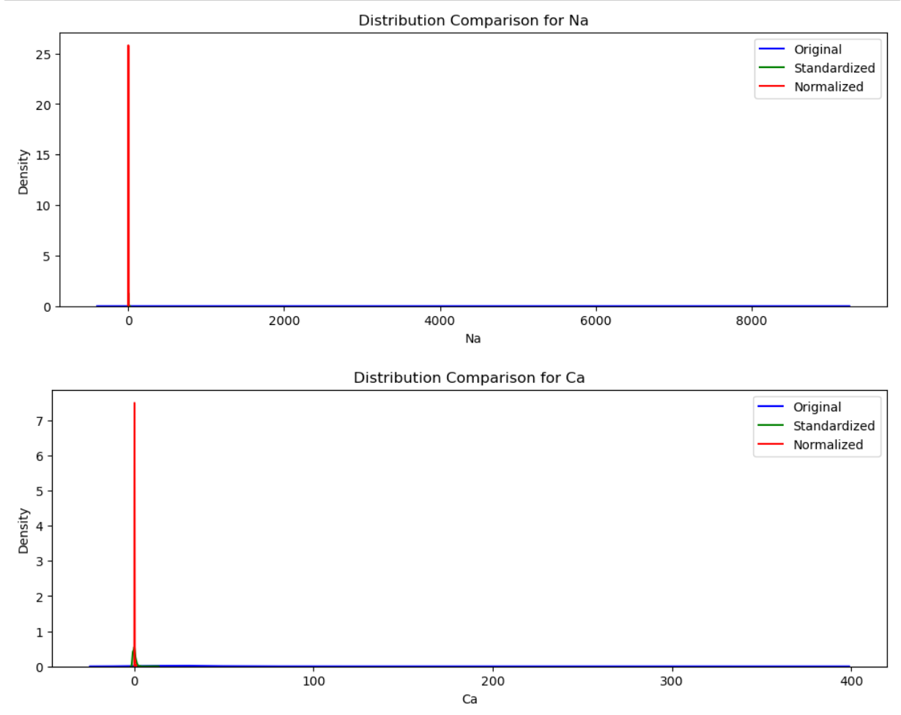
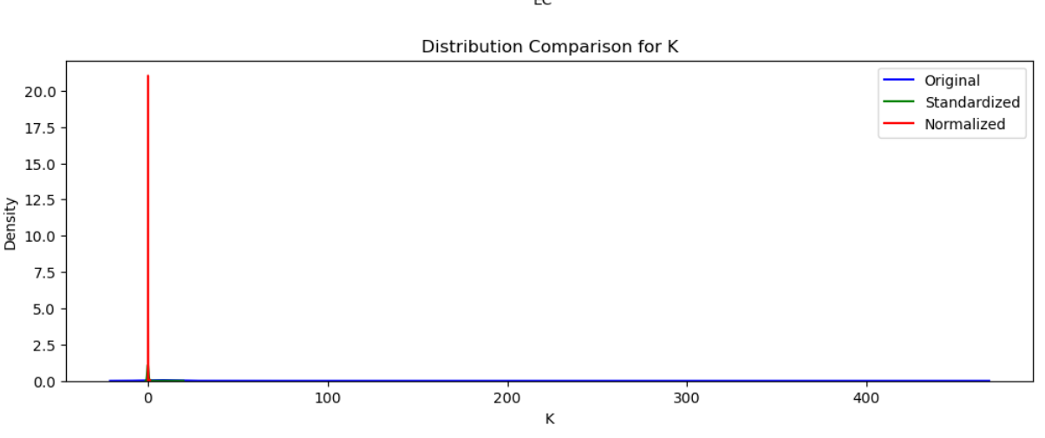
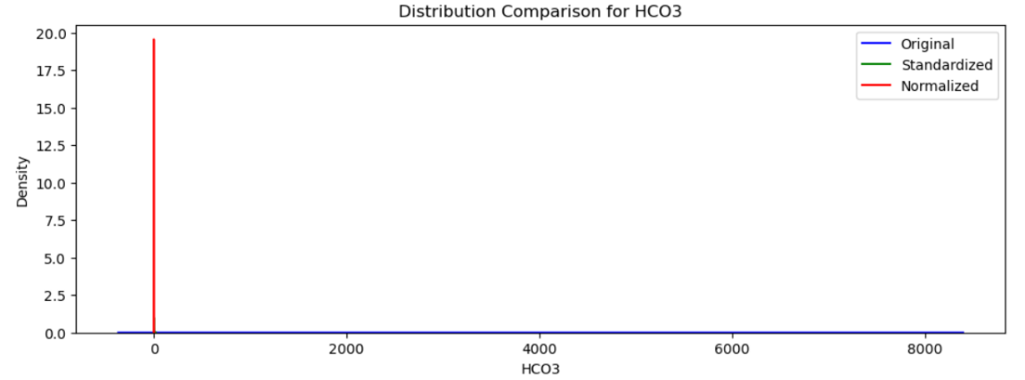
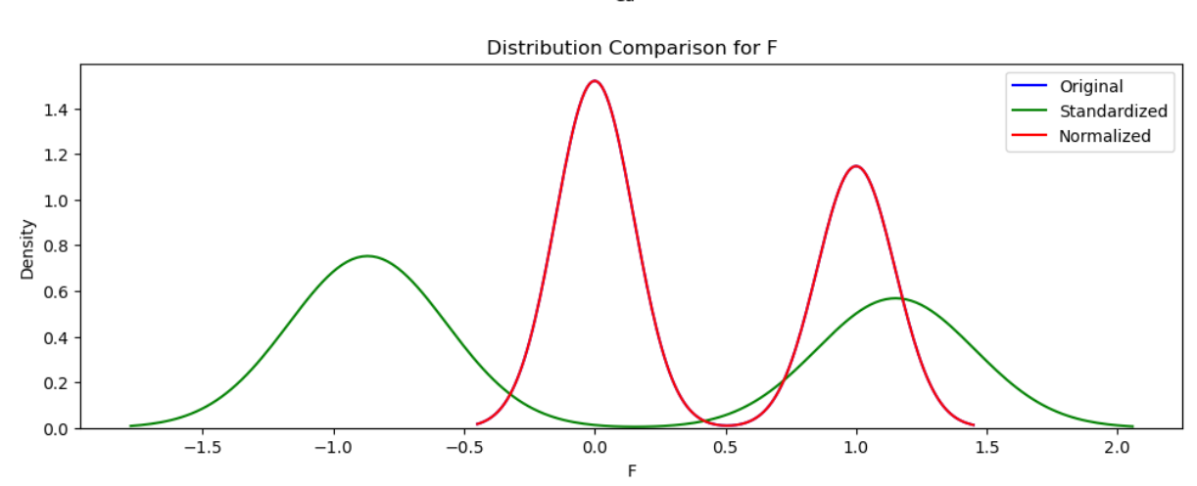
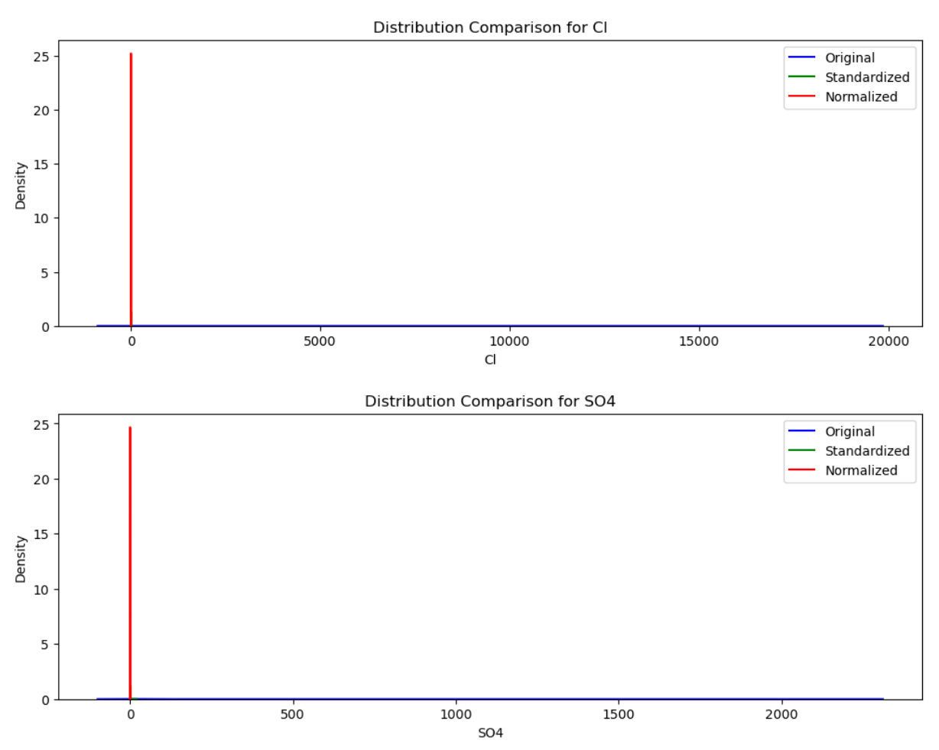
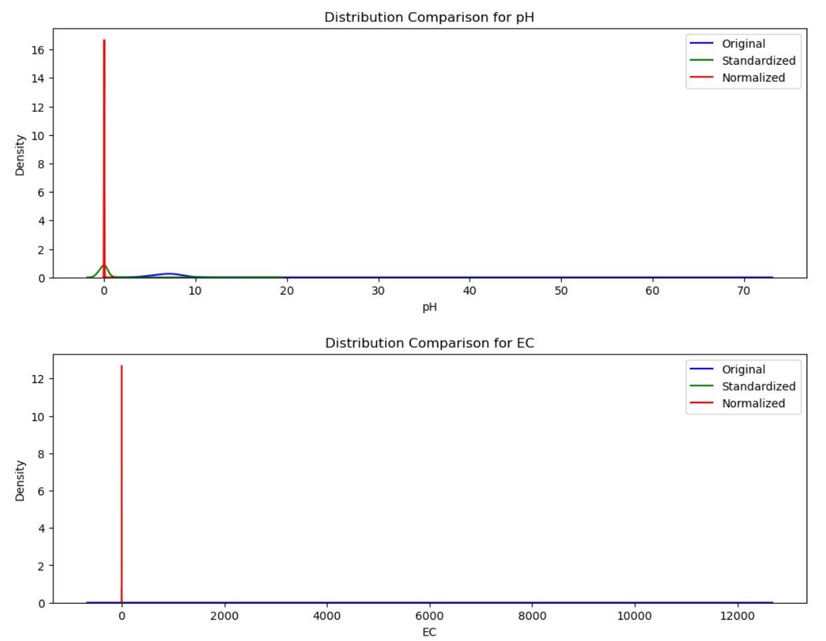

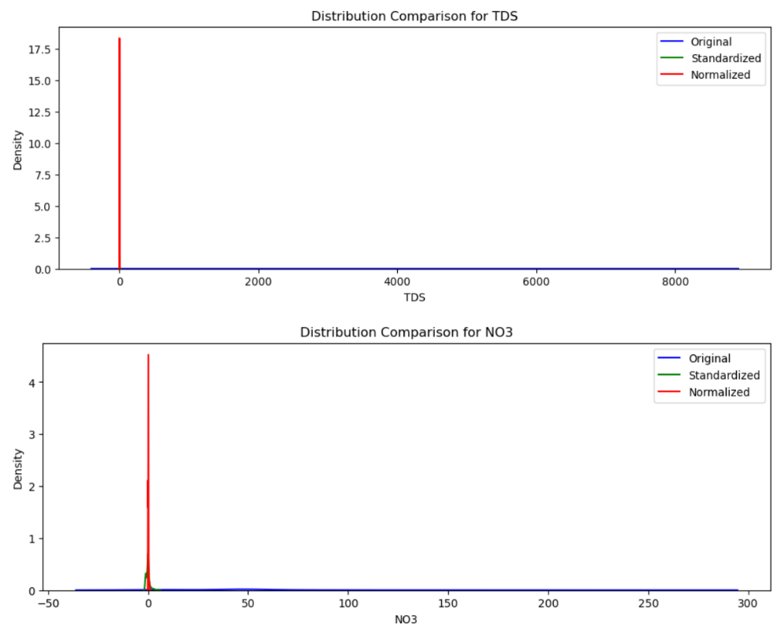
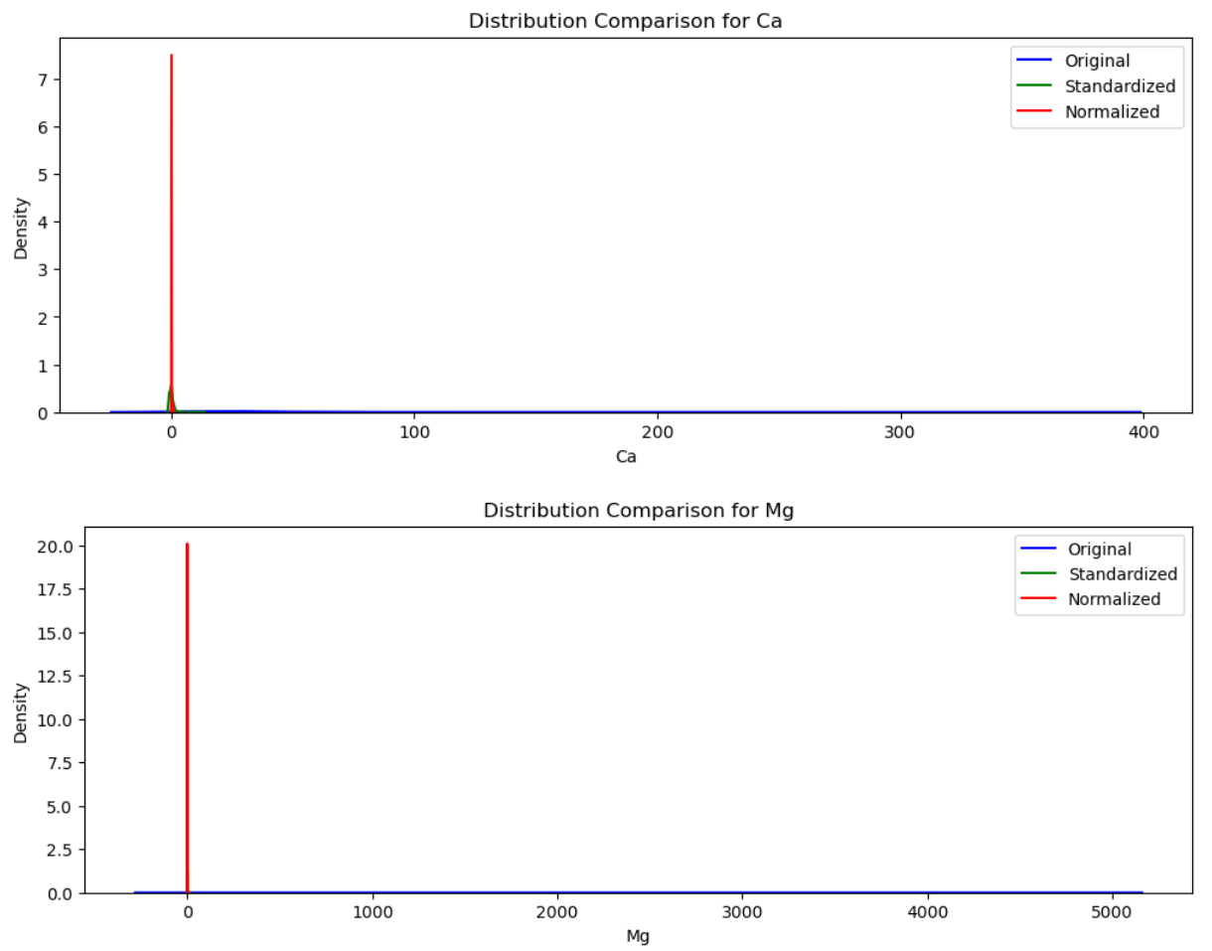

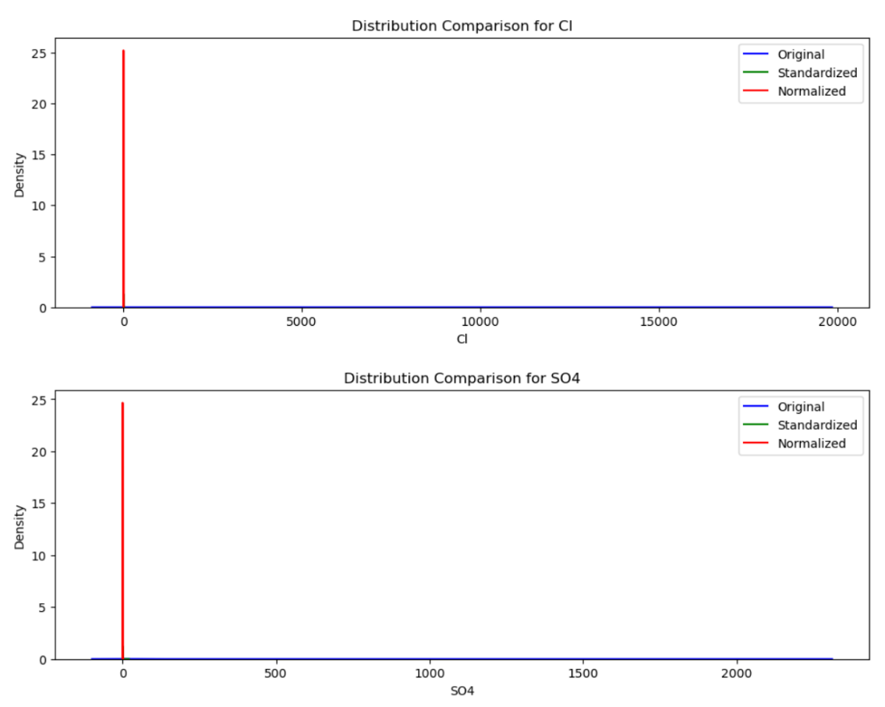
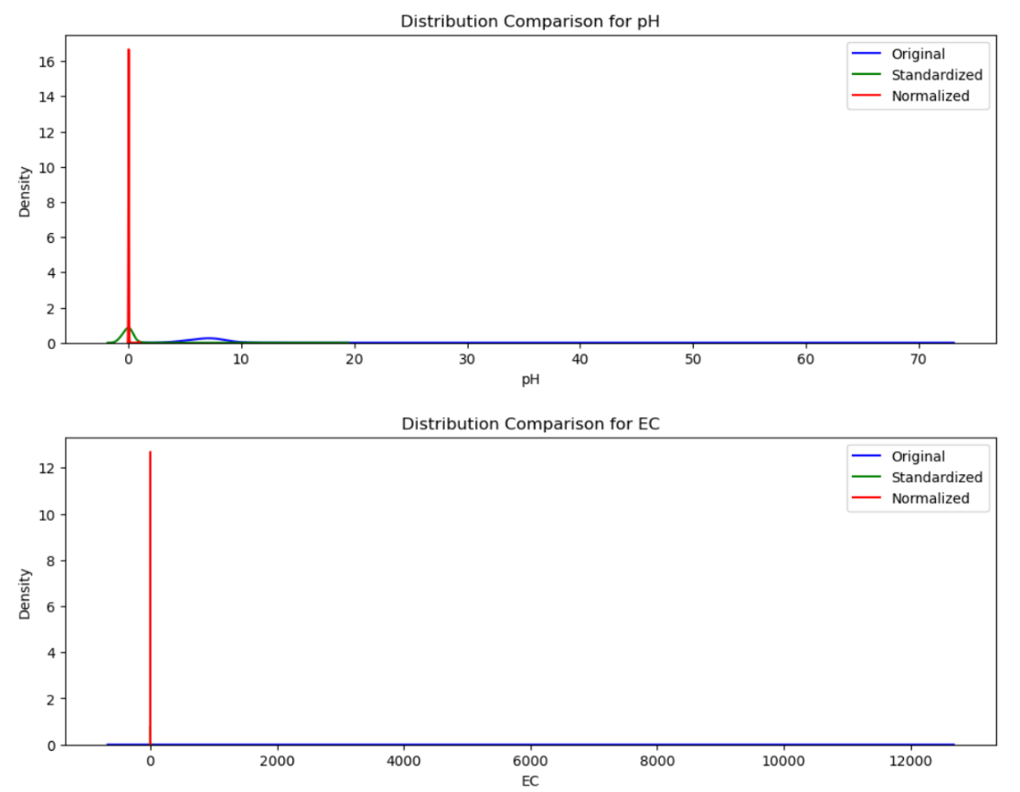
Figure S4. Comparison of the original, standardized, and normalized distributions of groundwater quality data

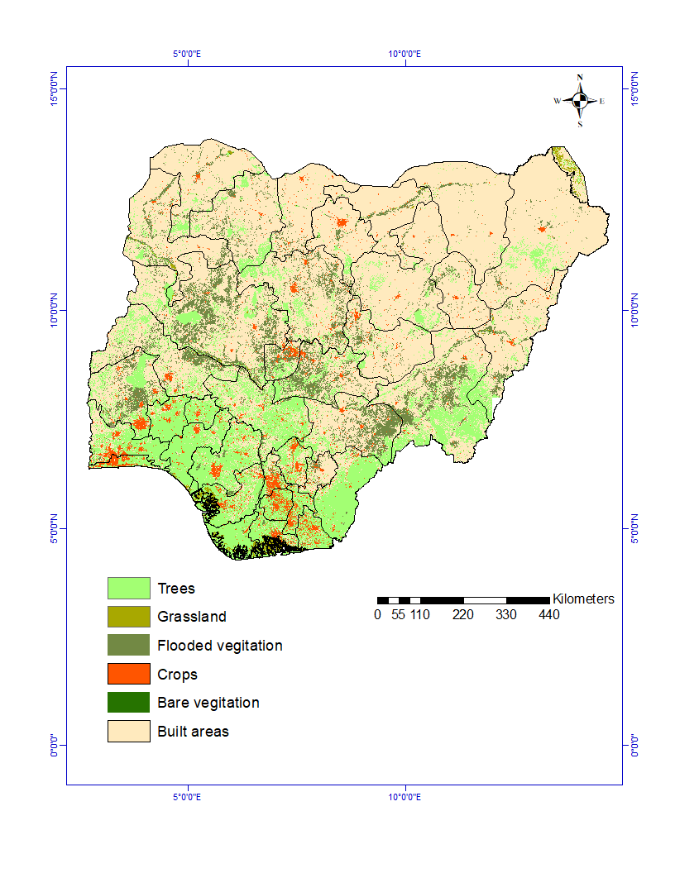
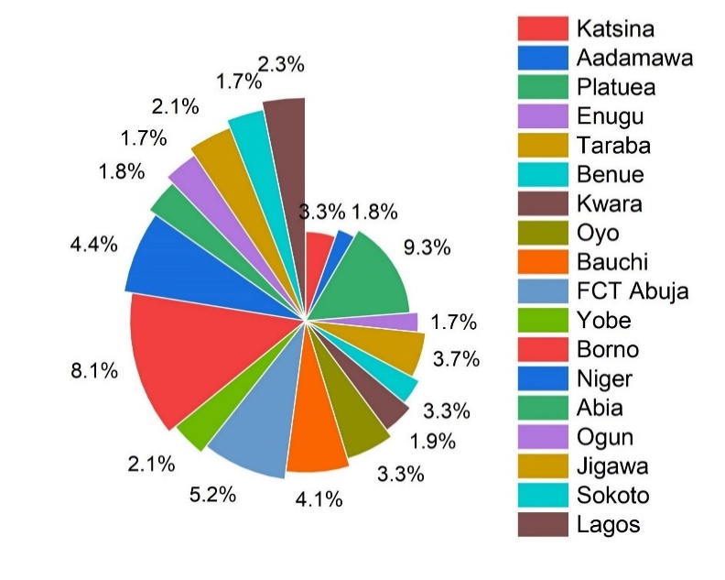
Figure S5. Pie chart illustrating the occurrence of F⁻ ion in Nigeria's groundwater
LULC

Figure S6. Spatial depiction of the land-use types.

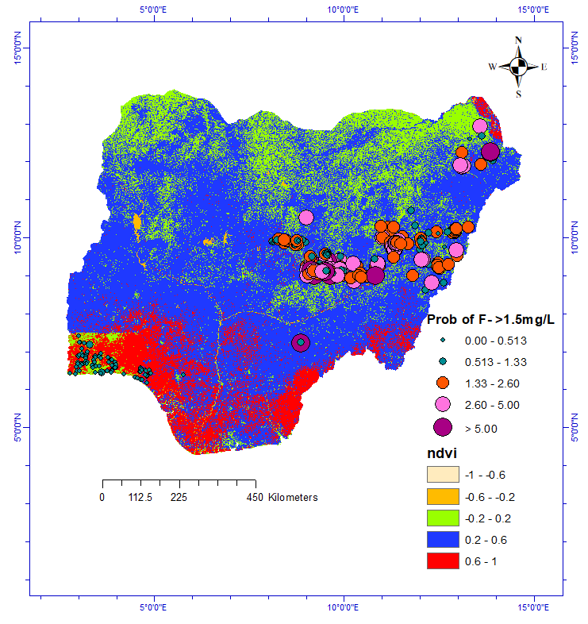
Figure S7. Spatial depiction of the NDVI types.
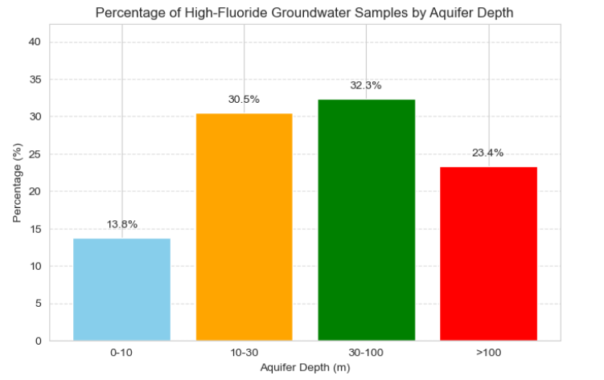
Figure S8. Percentage of Fluoride samples based on aquifer depths

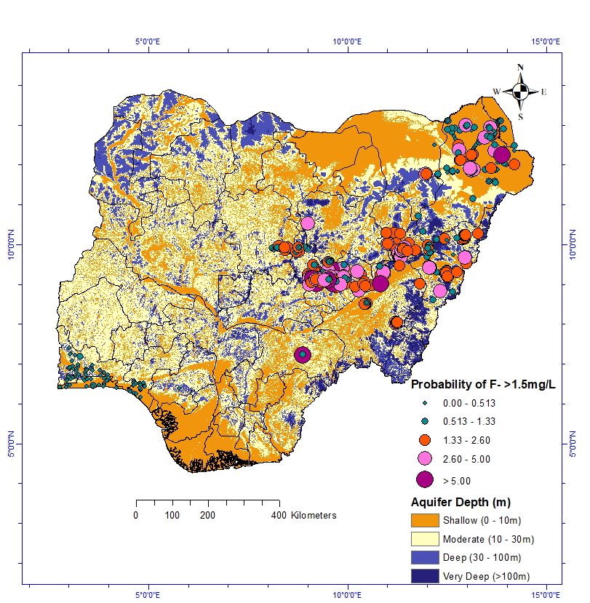
Figure S9. Groundwater depth map of Nigeria
Table S10. Definition of the Parameters
Parameter | Symbol | Unit | Description
Chemical Con. (F⁻) | C | mg/L | Concentration of chemicals in groundwater
Ingestion Rate | IR | L/day | Amount of water consumed daily
Exposure Duration | ED | years | Length of time over which exposure occurs
Exposure Frequency | EF | days/year | How frequently does exposure occur throughout the year
Body Weight | BW | kg | The average body weight of the exposed individual
Averaging Time | AT | days | Period over which exposure is averaged
Reference Dose | RfD | mg/kg-day | Safe daily exposure level without significant risk
Water Adjustment Factor | WAF | dimensionless | Accounts for bioavailability and other adjustments

Table S11. Interpretation of Risks
HQ Value | Risk Level | Interpretation
<1 | Acceptable Risk | No significant health effects expected
1 | Threshold Level | At the safety limit
>1 | Unacceptable Risk | Potential for adverse health effects

Table S12. Avoidance Values
Parameter | Typical Value | Common Range | Notes
IR | 2 L/day | 1-3 L/day | Adult water consumption rate
EF | 350 days/year | 250-365 days/year | Accounts for occasional absences
ED | 30 years | 1-70 years | Residential exposure scenario
BW | 70 kg | 15-80 kg | Adult body weight
AT | ED × 365 days | - | For non-carcinogenic effects
RfD | Chemical-specific | Varies | Depends on the specific contaminant
WAF | 1 | 0.1-1.0 | Default = 1.0 if no specific data

Table S13. Number of Samples of the study areas
State | Town(s) / Area(s) | No. of Samples
Lagos | Shodi/Isolo, Southwestern Nigeria | 25
Oyo / Ogun | Ibadan, Abeokuta, Coastal Aquifers | 96
Plateau | Langtang, Jos, Shendam, Angware | 157
Gombe | Kaltungo, Lapan, Billiri, Shelleng | 77
Borno | Maiduguri, Hawul, Gubio, New Marte | 186
Adamawa | Hong, Numan, Gashaka | 20
Bauchi | Bogoro, Tafawa Balewa | 10
Taraba | Bali, etc. | 33
Yobe | Damaturu | 10

n=614
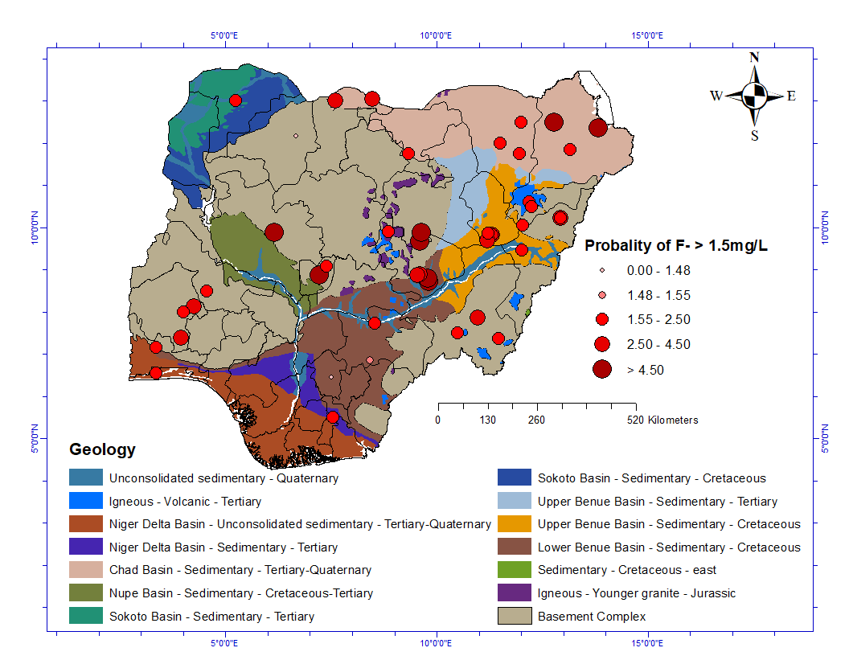
Figure S14.Spatial distribution of groundwater F⁻ based on measured concentrations from compiled literature (Table 3).
Table S15. Statistical Description
Parameter | mean | std | min | max
pH | 7.12728 | 2.809111 | 3.97 | 70
EC | 534.0646 | 743.9529 | 0.06 | 12000
HCO₃⁻ | 174.442 | 473.5183 | 0.9 | 8028.45
TDS | 212.8149 | 509.5733 | 0.02 | 8500
Ca²⁺ | 24.22358 | 30.43436 | 0.006 | 374
Mg²⁺ | 42.13385 | 330.7659 | 0.01 | 4879
Na⁺ | 45.93155 | 488.1133 | 0.07 | 8857
K⁺ | 8.768986 | 28.02014 | 0.05 | 447.1
SO₄⁻ | 22.74524 | 122.0071 | 0 | 2210.66
Cl⁻ | 96.60686 | 990.1208 | 0.1 | 18970.2
F⁻ | 0.324104 | 0.468421 | 0 | 1
NO₃⁻ | 42.48336 | 50.49864 | 0.01 | 258.56
NDVI | 0.324523 | 0.242164 | 0 | 1
Depth (m) | 108.1809 | 160.2362 | 0 | 618
Table S16. The state of Nigeria is affected by high F⁻ concentrations in groundwater exceeding the WHO drinking water guidelines.
S/N | State | Town | F⁻ in mg/L | Mean (mg/L) | References
1. | Katsina | Zango | 0.01-3.16 | 0.94 | [1-4]
 |  | North Katsina | 0.18-3.70
2. | Adamawa | Hong | 0.06-2.58 | 1.33 | [3, 5]
 |  |  | 1.65-2.13  1.51-1.71 | 1.03  1.03 | [6]
 |  | Hong (Gashaka) | 0.00-2.30 | 1.2 | [7]
 |  | Numan | 0.3-1.90 | 1.33 | [8]
3. | Plateau | Langtang | 1.10-6.00  0.12-10.30  0.06-4.60 | 3.6  2.47  2.47 | [9-12]
 |  | Langtang (North) | 0.65-6.60 | 3.6 | [13]
 |  | Jos | 0.50-1.92 | - | [14].
 |  | Angware | 1.00-4.00 | 2.4 | [15]
 |  | Shendam | 1.81-3.12 |  | [16]
4. | Gombe | Kaltungo | 0.10-3.95  1.58-2.30  1.29-1.94  0.00-1.90  0.06-2.10  0.03-1.81 | 1.65  1.65 | [17].  [18].  [19-22]
 |  | Lapan | 0.35-3.46 | 1.94 | [23]
 |  | Billiri | 0.01-1.84 |  | [24]
 |  | Shelleng | 0.09-2.19 | 1.14 | [25]
5. | Enugu | Igbo Ethnic | 0.00-0.63 | 0.6 | [26]
6. | Taraba | Bali | 0.5-4.1 | 1.74 | [27].
 |  | Gossol | 0.20-2.50 | 1.35 | [28]
7. | Kwara | Ilorin | 0.0-2.50 | 1.25 | [29]
8. | Benue | Makurdi | 0.34-2.06 | 1.26 | [30].
 |  | Bi  Oju | 0.08-1.82  0.01-1.54 | 0.77 | [31]
9. | Oyo | Ibadan | 0.01-3.60  0.01-3.70 | 0.671 | [32, 33]
 |  | Ogbomosho | 1.35-2.75 | 1.35 | [1, 34]
 |  | Iresa-Apa (sundere) | 0.00-1.78 |  | [35]
10. | Bauchi | Bogoro | 0.52-1.60 | 0.52 | [36]
 |  |  | 0.80-4.58 |  | [37]
 |  | Tafawa Balewa/Dass | 0.10-4.62 |  | [37]
11. | FCT Abuja | Kuje | 0.11-5.72 | - | [38]
 |  | FCT (North-Central) | 0.47-1.84 | 1.28 | [39]
12. | Yobe | Yobe | 0.06-2.28 | 0.66 | [40]
 |  | Damaturu | 0.00-2.00 |  | [41]
 |  | Northeastern | 0.00-2.2 |  | [42]
13. | Borno | Maiduguri | 0.02-2.42 |  | [40]
 |  | Hawul | 0.76-1.72 | 0.63 | [43]
 |  | Gubio Cross  New Marte | 0.00-4.6  0.00-9.0 | - | [44]
14. | Niger | Gussoro | 0.05-4.90 | 2.29 | [45]
15. | Abia | Nnono (Ikwuano) | 0.40-2.00 | 0.76 | [46]
16. | Ogun | South Abeokuta | 0.48-1.84 | 1.23 | [47, 48]
17. | Jigawa | Dutse | 0.00-2.30 | 0.52 | [49]
18. | Sokoto |  | 0.02-1.90 | - | [50]
19. | Lagos | Shodi/Isolo | 0.07-2.20 |  | [51]

References
1. Olasehinde, P.I., et al., Statistical Assessment of Groundwater Quality in Ogbomosho, Southwest Nigeria. American Journal of Mining and Metallurgy,, 2015. 3(1): p. 21-28.
2. Aminu, T., Amadi, Akobundu N, Fluoride Contamination of Shallow Groundwater in Parts of Zango Local Government Area of Katsina State, Northwest Nigeria. Journal of Geosciences and Geomatics, 2014. 2(5): p. 178-185.
3. Amadi, A.N., et al., Comparative Geological study and physico-chemical parameters of Groundwater in Hong and Zango Settlements in Northern Nigeria. Journal of Chemical Society of Nigeria, 2019. 44(2): p. 292 -300.
4. Nwankwoalat, H.O., A.N. Amadi, and A. Tukor, Fluoride Contamination of Groundwater and Health Implications in Zango, Katsina State, Nigeria. Scientia African, 2016. 15(2): p. 160-174.
5. Okunlola, I.A., et al., Quality assessment of groundwater from shallow aquifers in Hong area, Adamawa state, northeastern Nigeria. Ife Journal of Science, 2016. 18: p. 17.
6. Ankidawa, B.A., et al., Assessment of Fluoride Concentration in Groundwater in Hong and Environs, Adamawa State, Northeastern Nigeria. Nigeria Journal of Engineering Science and Technology Research 2019. 5(2): p. 28-39.
7. Hussaini Jagaba, A., et al., Defluoridation of Drinking Water by Activated Carbon Prepared from Tridax Procumbens Plant (A Case Study of Gashaka Village, Hong L. G. A., Adamawa State, Nigeria). International Journal of Computational and Theoretical Chemistry, 2019. 7(1): p. 1-5.
8. Saleh, M.B. and B.M.G. Idris, Exploiting Cohesive Geophysical Medium to Weigh the Natural Hit of Solid Waste Dumpsite in Nassarawo-Demsa, Adamawa State, Nigeria. IOSR Journal of Applied Geology and Geophysics (IOSR-JAGG), 2020. 8(3): p. 52-62.
9. Goyit, M.P., O.A. Solomon, and R.J. Kutshik, Distribution of fluoride in surface and ground water: a case study of Langtang North, Plateau State, Nigeria. International Journal of Biological and Chemical Sciences, 2018. 12(2): p. 1057-1067.
10. Dibal, H.U., et al., Seasonal Variation in Fluoride Content in Groundwaters of Langtang Area, Northcentral Nigeria. Contemporary Trends in Geoscience, 2017. 6(1): p. 11-27.
11. Dibal, H., U, et al., Overview of fluoride distribution in major aquifer units of northern Nigeria. Health, 2012. 04(12): p. 1287-1294.
12. Dibal, H.U., et al., Hydrogeochemical appraisal of fluoride in groundwater of Langtang area, Plateau State, Nigeria. Global Journal of Geological Sciences, 2016. 14(1).
13. Daffi, R.E., J.E. Lagasi, and I.I. Ahuchaogu, Assessment of the Physico-chemical and Bacteriological Parameters of Groundwater for Domestic Consumption in Parts of Lantang North, Plateau State, Nigeria. Nigerian Research Journal of Engineering and Environmental Sciences, 2022. 7(2): p. 476-485.
14. Andesikuteb Yakubu, A., et al., Analysis of Groundwater Quality Around Some Dumpsites in Jos Metropolis, Plateau State, Nigeria. Kaduna State University Environmental Science Journal (KESJ), 2020. 1(2): p. 1-14.
15. Nur, A., J.M.I. Ishaku, and J.A. Bulus, Application of Chemometric Techniques in Groundwater Quality Investigation in Angware Area Jos North-Central Nigeria. International Journal of Earth Sciences and Engineering, 2011. 4(6): p. 965-972.
16. Abusu, C.O., Hydrogeochemical Characterization of Groundwater in Kankara, Northwestern Nigeria. Sustainable Water Resources Management, 2019. 5(4): p. 1615-1625.
17. Isah, H.A., U.A. Mohammed, and A.A. Mohammed, Environmental distribution of fluoride in drinking waters of Kaltungo area, North-Eastern Nigeria. American Journal of Environmental Protection, 2014. 3(6): p. 19-24.
18. Onoja, S.B., M.O. Udochukwu, and J.F. Malum, Investigation on Groundwater Quality and Treatment for Fluoride Reduction in Kaltungo, Gombe State, Nigeria, in New Visions in Science and Technology Vol. 3. 2021. p. 50-66.
19. Ishaku, J.M. and A. Abdulhakeem, Hydrogeochemical Assessment of Groundwater in Kaltungo and Environs, Northeastern Nigeria. Global Journal of Geological Sciences 2010. 8(2): p. 1-20.
20. Mukkafa, S., et al., Occurrence of Fluoride in the Groundwater of Kaltungo Area and Environs, North Eastern Nigeria. Journal of Geoscience and Environment Protection, 2019. 07(08): p. 167-179.
21. Saleh, S., et al., Physiochemical Analysis of Water from Some Selected Boreholes and Hand-dug wells in Kaltungo, Gombe State, Northeast, Nigeria. European Journal of Environment and Earth Sciences, 2022. 3(1): p. 48-53.
22. Onoja, S.B., M.O. Isikwue, and J.F. Malum, Physico-chemical Characterization of Groundwater of Kaltungo, Gombe State, Nigeria and Treatment for Flouride Removal. Nigerian Journal of Technology, 2017. 36(2).
23. Giwa, A.S., et al., Assessment of high fluoride in water sources and endemic fluorosis in the North-Eastern communities of Gombe State, Nigeria. Environmental Pollutants and Bioavailability, 2021. 33(1): p. 31-40.
24. Danbature, W.L., et al., Spectrophotometric Determination of Flouride in Some Local Government Areas of Gombe State. European International Journal of Science and Humanities, 2015. 3: p. 1-6.
25. Ankidawa, B.A., et al., Geochemical Assessment of Groundwater of Shelleng and Environs, Adamawa State, North-Eastern Nigeria. Taraba Journal of Engineering and Technology (TAJET), 2019. 1(2): p. 36-50.
26. Ogbu, I., O. Okoro, and E. Ugwaja, Well Waters Fluoride in Enugu, Nigeria. 2012. p. 96-99.
27. Abubakar, B. and M. Ibrahim, Assessment of Boreholes Water Quality in Bali Local Government, Taraba State, Nigeria. FUTY Journal of the Environment, 2016. 10(1): p. 1-10.
28. Olalekan, A., B. Abubakar, and K. Abdul Mumini, Physico-chemical characteristics of borehole water quality in Gassol Taraba State, Nigeria. African Journal of Environmental Science and Technology, 2015. 9(2): p. 143-154.
29. Olatunji, J.A., et al., Assessment of Groundwater Quality of Ilorin Metropolis using Water Quality Index Approach. Nigerian Journal of Technological Development, 2015. 12(1): p. 18-21.
30. Iwar, R.T., et al., Fluoride levels in deep aquifers of Makurdi, North-central, Nigeria: an appraisal based on multivariate statistics and human health risk analysis. Environ Monit Assess, 2021. 193(8): p. 477.
31. Akaahan, T.J., H.O.A. Oluma, and R. Sha’Ato, Physico-chemical and Bacteriological Quality of Water from Shallow Wells in Two Rural Communities in Benue State, Nigeria. Pakistan Journal of Analytical & Environmental Chemistry 2010. 11(1): p. 73-78.
32. Amanambu, A.C. and C.N. Egbinola, Geogenic contamination of groundwater in shallow aquifers in Ibadan, south-west Nigeria. Management of Environmental Quality: An International Journal, 2015. 26(3): p. 327-341.
33. Egbinola, C.N. and A.C. Amanambu, Groundwater contamination in Ibadan, South-West Nigeria. Springerplus, 2014. 3: p. 448.
34. Olasehinde, P.I., et al., Occurrence of Fluoride and some Heavy Metals in Groundwater Ogomosho Nigeria. Journal of Natural Sciences Research, 2016. 6(13): p. 55-61.
35. Adejumo, R.O., et al., Physicochemical Constituents of Groundwater and its Quality in Crystalline Bedrock, Nigeria. International Journal of Civil Engineering and Technology (IJCIET), 2018. 9(8): p. 887-903.
36. Yohanna, A., et al., Investigation of Groundwater Contamination in Some Selected Areas of Bogoro and Environs, North-East Nigeria. Fudma Journal of Sciences, 2022. 6(1): p. 358-367.
37. Paul, E.D., et al., Fluoride Contents of Drinking Water Sources from Caries and Fluorosis Endemic Local Government Areas of Southwestern Bauchi State, Nigeria. Bokkos Journal of Science Report (B-JASREP), 2021. 1(3): p. 80-86.
38. Ibrahim, K.O., et al., Physico-Chemical Evaluation of Groundwater in Kuje, Federal Capital Territory, Abuja, Nigeria. Nigerian Journal of Technological Development, 2015. 12(1): p. 1-5.
39. Igibah, E.C., et al., Hydro-geochemical autographs, attribute indicators and health threat evaluation of Fluoride and Ironic elements variability in ground water in Abuja North-central Nigeria. Fuel Communications, 2022. 10.
40. Waziri, M., U.S. Musa, and S. Hati, Assessment of Fluoride Concentrations in Surface Waters and Groundwater Sources in Northeastern Nigeria. Resources and Environment, 2012. 2(2): p. 67-72.
41. Umara, B., M. Yaji, and A. Fannami, Groundwater Contamination in Damaturu, Nigeria. Arid Zone Journal of Engineering, Technology and Environment. , 2004. 4: p. 45-50.
42. Abdullahi, Y., P. Moses, and V.B. Kwaya, Evaluation of the Phytoplanktons Species Diversity, Distribution and Physicochemical Characteristics of Pindiga Pond in Gombe State of Nigeria. Journal of Applied Sciences and Environmental Management, 2019. 23(10): p. 1835-1839.
43. Kwari, W.J., Ground Water Quality Assessment: A Case Study of Groundwater from Hand Dug Wells in Hawul Local Government Area of Borno State. International Journal of Advanced Research, 2015. 3(2): p. 537-546.
44. Bura, B., et al., Occurrence and Distribution of Fluoride in Groundwater of Chad Formation Aquifers in Borno State, Nigeria. International Journal of Hydrology, 2018. 2(4): p. 528‒537.
45. Muhammed, O.N., et al., Assessment of Surface and Groundwater Quality in Gussoro Gold Mining Site, North-Central Nigeria. Nigeria Journal of Pure and Applied Science, 2017. 9(2): p. 138-147.
46. Ndukwe, V.A., et al., Assessment of some physicochemical properties of groundwater quality in Ikwuano Region of southeastern Nigeria. Journal of Applied Sciences and Environmental Management, 2019. 23(8).
47. Emenike, C.P., I.T. Tenebe, and P. Jarvis, Fluoride contamination in groundwater sources in Southwestern Nigeria: Assessment using multivariate statistical approach and human health risk. Ecotoxicol Environ Saf, 2018. 156: p. 391-402.
48. Samuel, O.A., et al., Human health risk assessment data of trace elements concentration in tap water-Abeokuta South, Nigeria. Data Brief, 2018. 18: p. 1416-1426.
49. Ali, K.Y., B.M. Saleh, and K.M. Adam, Assessment of Water Quality from Shallow Hand-Dug Wells in Dutse Town, North West Nigeria. Arid Zone Journal of Basic and Applied Research, 2022. 1(4): p. 47-61.
50. Umar, A.I., et al., Effects of Some Goitrogens on Iodine Distributions in Pipe-Borne Water, Borehole Water, and Well Water of Sokoto State, Nigeria. International Journal of Pure and Applied Science, 2021. 21(9): p. 29-40.
51. Gbadebo, A.M., Groundwater fluoride and dental fluorosis in southwestern Nigeria. Environ Geochem Health, 2012. 34(5): p. 597-604.

