Figure S1. Forest plot of prostate cancer relative risks in epidemiologic studies of Agent Orange/TCDD exposure. Whiskers show 95% confidence intervals, except where not reported (indicated by *). HR: hazard ratio; MRR: mortality relative risk; OR: odds ratio; ppt: parts per trillion; RR: relative risk; SEA: Southeast Asia; SIR: standardized incidence ratio; SMR: standardized mortality ratio; TCDD: 2,3,7,8-tetrachlorodibenzo-p-dioxin; US: United States; VN: Southeast Asia military service in Vietnam.
Figure S2. Forest plot of prostate cancer relative risks in epidemiologic studies of military service in Vietnam. Whiskers show 95% confidence intervals, except where not reported (indicated by *). ADVA: Australian Department of Veterans’ Affairs; AIHW: Australian Institute of Health and Welfare; MOR: mortality odds ratio; MRR: mortality relative risk; OR: odds ratio; PC: prostate cancer; PR: prevalence ratio; RR: relative risk; SIR: standardized incidence ratio; SMOR: standardized morbidity odds ratio; SMR: standardized mortality ratio; SMRR: ratio of standardized mortality ratios; US: United States.
Figure S3. Forest plot of prostate cancer relative risks in epidemiologic studies of occupational or accidental industrial exposure to TCDD. Whiskers show 95% confidence intervals, except where not reported (indicated by *). 2,4-D: 2,4-dichlorophenoxyacetic acid; 2,4,5-T: 2,4,5-trichlorophenoxyacetic acid; HR: hazard ratio; MRR: mortality relative risk; ppb: parts per billion; RR: relative risk; SIR: standardized incidence ratio; SMR: standardized mortality ratio; TCDD: 2,3,7,8-tetrachlorodibenzo-p-dioxin; TEQ: toxic equivalency quotient for dioxins; US: United States.
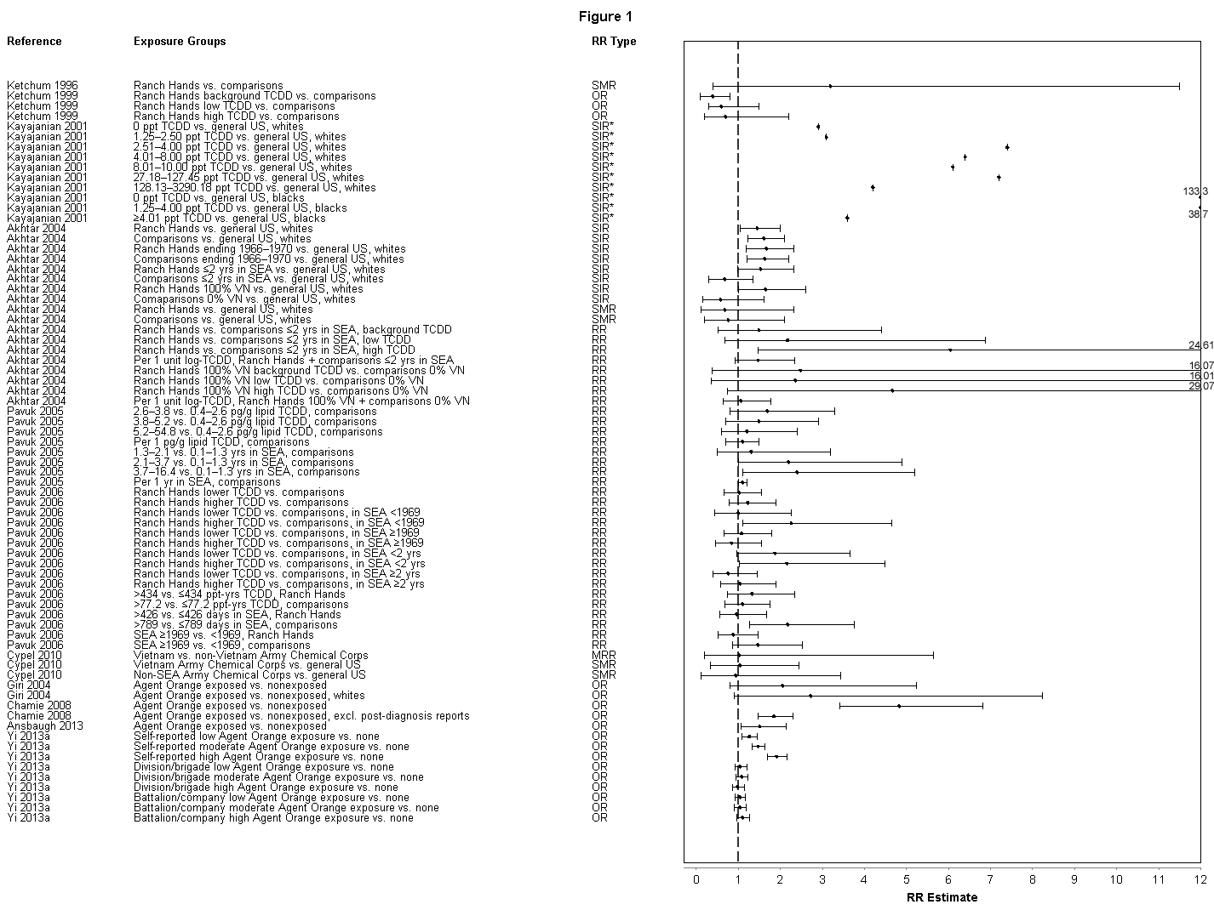
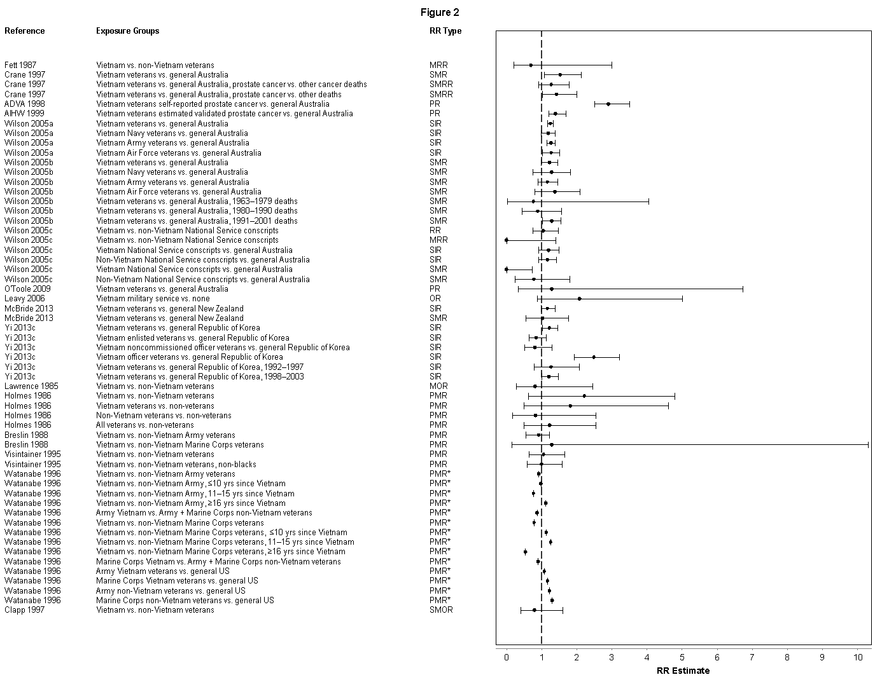
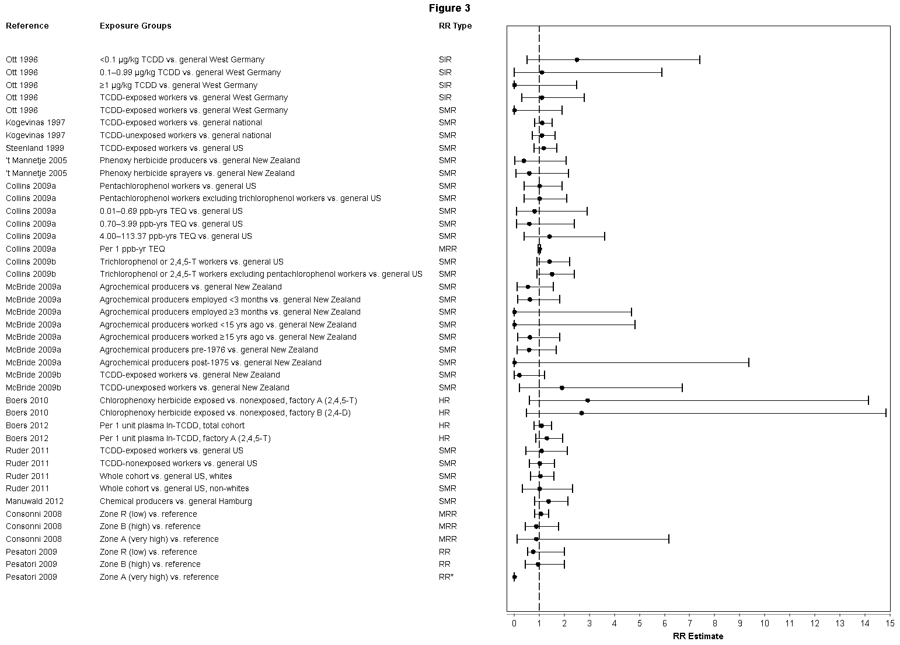
Table S1. Cohorts of herbicide production workers and sprayers included in the International Association for Research on Cancer/National Institute of Occupational Safety and Health (IARC/NIOSH) pooled analysis (Kogevinas et al., 1997)
Country | Type | Sex | N TCDD-exposed | N TCDD-unexposed | Period of follow-up | Comments
Australia | S | M | 1,840 | 0 | 1951–1983
Austria | P | MF | 159 | 0 | 1971–1991
Canada | S | M | 1,142 | 81 | 1950–1992
Denmark | P | MF | 0 | 1,920 | 1947–1992
Denmark | P | MF | 0 | 198 | 1951–1992
Finland | P | MF | 62 | 0 | 1939–1991
Germany | P | MF | 576 | 59 | 1956–1989
Germany | P | MF | 1,307 | 42 | 1952–1989 | Updated (men only) by Manuwald et al., 2012
Germany | P | MF | 313 | 179 | 1965–1989
Germany | P | MF | 126 | 15 | 1951–1989
Italy | P | MF | 205 | 0 | 1970–1991
Italy | P | MF | 0 | 60 | 1967–1991
The Netherlands | P | MF | 524 | 38 | 1955–1991 | Updated by Boers et al., 2010, 2012 (Factory A)
The Netherlands | P | MF | 0 | 419 | 1965–1991 | Updated by Boers et al., 2010, 2012 (Factory B)
New Zealand | P | MF | 782 | 0 | 1969–1990 | Updated by 't Mannetje et al., 2005; extended by McBride et al., 2009a, 2009b
New Zealand | S | MF | 699 | 0 | 1972–1990 | Updated by 't Mannetje et al., 2005
Sweden | P | MF | 244 | 0 | 1965–1990
United Kingdom | P | M | 0 | 1,565 | 1947–1990
United Kingdom | P | M | 145 | 0 | 1960–1989
United Kingdom | P | M | 572 | 369 | 1975–1991
United Kingdom | P | M | 0 | 345 | 1963–1991
United Kingdom | P | M | 0 | 271 | 1969–1991
United Kingdom | P | M | * | * | 1969–1991
United Kingdom | S | M | 0 | 1,992 | 1647–1990
United States | P | M | 437 | 0 | 1951–1987 | Updated by Steenland et al., 2009
United States | P | M | 96 | 0 | 1968–1987 | Updated by Steenland et al., 2009
United States | P | M | 691 | 0 | 1961–1987 | Updated by Steenland et al., 2009
United States | P | M | 354 | 0 | 1957–1987 | Updated by Steenland et al., 2009
United States | P | M | 113 | 0 | 1961–1987 | Updated by Steenland et al., 2009
United States | P | M | 121 | 0 | 1957–1987 | Updated by Steenland et al., 2009
United States | P | M | 96 | 0 | 1960–1987 | Updated by Steenland et al., 2009
United States | P | M | 452 | 0 | 1948–1987 | Updated by Steenland et al., 2009
United States | P | M | 2,089 | 0 | 1942–1987 | Updated by Steenland et al., 2009; also studied by Collins et al., 2009a, 2009b and Ruder & Yin, 2011
United States | P | M | 265 | 0 | 1949–1987 | Updated by Steenland et al., 2009
United States | P | M | 163 | 0 | 1957–1987 | Updated by Steenland et al., 2009
United States | P | M | 258 | 0 | 1953–1987 | Updated by Steenland et al., 2009
Total |  |  | 13,831 | 7,553
M: men; MW: men and women; P: herbicide production workers; S: sprayers; TCDD: 2,3,7,8-tetrachlorodibenzo-p-dioxin
* 479 workers could not be classified with regard to TCDD exposure

