Supplementary material

Patterns of obesity development before the diagnosis of cardiovascular disease
Dhana K, van Rosmalen J, Vistisen D, Ikram MA, Hofman A, Franco OH, Kavousi M

Table S1. Characteristics of study participants by subgroup at their first clinical examination.
Figure S1. Trajectories of body mass index, waist circumference, systolic and diastolic blood pressure.
Figure S2. Trajectories of fasting plasma glucose, total cholesterol, HDL cholesterol, and predicted 10-year CVD risk.

Table S1. Characteristics of study participants at their first clinical examination.
Characteristics* | Individuals developing CVD during follow-up (n=1748) |  |  | Individuals without CVD during follow-up (n=4378)
Characteristics* | Stable weight (n=1534) | Progressive weight gain (n=112) | Progressive weight loss (n=102) | CVD-free  (n=2184) | Non-CVD mortality  (n=2194)
Time before diagnosis/last visit, years | 8.1 (4.04, 13.1) | 11.2 (6.9, 14.6) | 11.9 (9.2, 15.0) | 18.7 (17.4, 19.6) | 10.6 (5.7, 22.2)
Women (%) | 868 (56.6) | 75 (67.0) | 66 (64.7) | 1496 (68.5) | 1282 (58.5)
Current smoker (%) | 400 (26.1) | 20 (18.9) | 25 (25.0) | 420 (19.4) | 574 (26.2)
Antihypertensive treatment (%) | 278 (18.1) | 43 (38.1) | 31 (30.8) | 286 (13.1) | 397 (18.1)
Anti-diabetic treatment† (%) | 47 (8.0) | 9 (14.1) | 9 (12.2) | 121 (6.5) | 54 (6.0)
Statins treatment† (%) | 79 (13.4) | 16 (23.4) | 8 (10.8) | 379 (20.1) | 93 (10.1)
Age, years | 71.6 ± 8.8 | 69.4 ± 8.6 | 71.9 ± 7.7 | 62.9 ± 5.4 | 72.6 ± 8.7
Glucose†, mg/dl | 106.2 ± 22.7 | 114.6 ± 27.5 | 115.1 ± 30.7 | 104.0 ± 22.5 | 107.4 ± 27.2
Cholesterol†, mg/dl | 225.6 ± 36.3 | 225.9 ± 35.2 | 220.3 ± 35.7 | 229.6 ± 36.9 | 221.9 ± 38.2
HDL cholesterol†, mg/dl | 52.7 ± 14.4 | 50.2 ± 14.8 | 50.9 ± 16.8 | 56.3 ± 15.0 | 53.9 ± 17.1
Systolic blood pressure, mmHg | 144.7 ± 22.3 | 146.5 ± 20.6 | 144.9 ± 21.9 | 132.6 ± 20.2 | 141.7 ± 22.3
Diastolic blood pressure, mmHg | 74.6 ± 12.0 | 77.5 ± 11.0 | 73.1 ± 11.2 | 73.8 ± 10.6 | 73.7 ± 12.0
Body mass index, kg/m² | 25.9 ± 3.2 | 31.7 ± 4.8 | 30.1 ± 4.2 | 26.2 ± 3.6 | 26.2 ± 3.9
Waist circumference, cm | 90.1 ± 10.4 | 99.9 ± 13.2 | 97.2 ± 10.3 | 88.1 ± 10.9 | 91.1 ± 11.2
*Values are mean ± SD, numbers (percentages), or median (IQR) .
Abbreviations: HDL, high density lipoprotein; CVD, cardiovascular disease; n, number.
† Fasting measurements of Lipids and glucose and treatment were available in the third, fourth and fifth visits of the original Rotterdam Study cohort (N=3529).

The mean values of the characteristics of study participants in Table S1 are based on single measures at the baseline/first visit in the Rotterdam Study. Therefore, some differences from the predicted mean values, i.e. the results of the latent class trajectory analysis presented in the Figures 2 and 3, might be observed.
Figure S1: Trajectories of body mass index, waist circumference, systolic and diastolic blood pressure
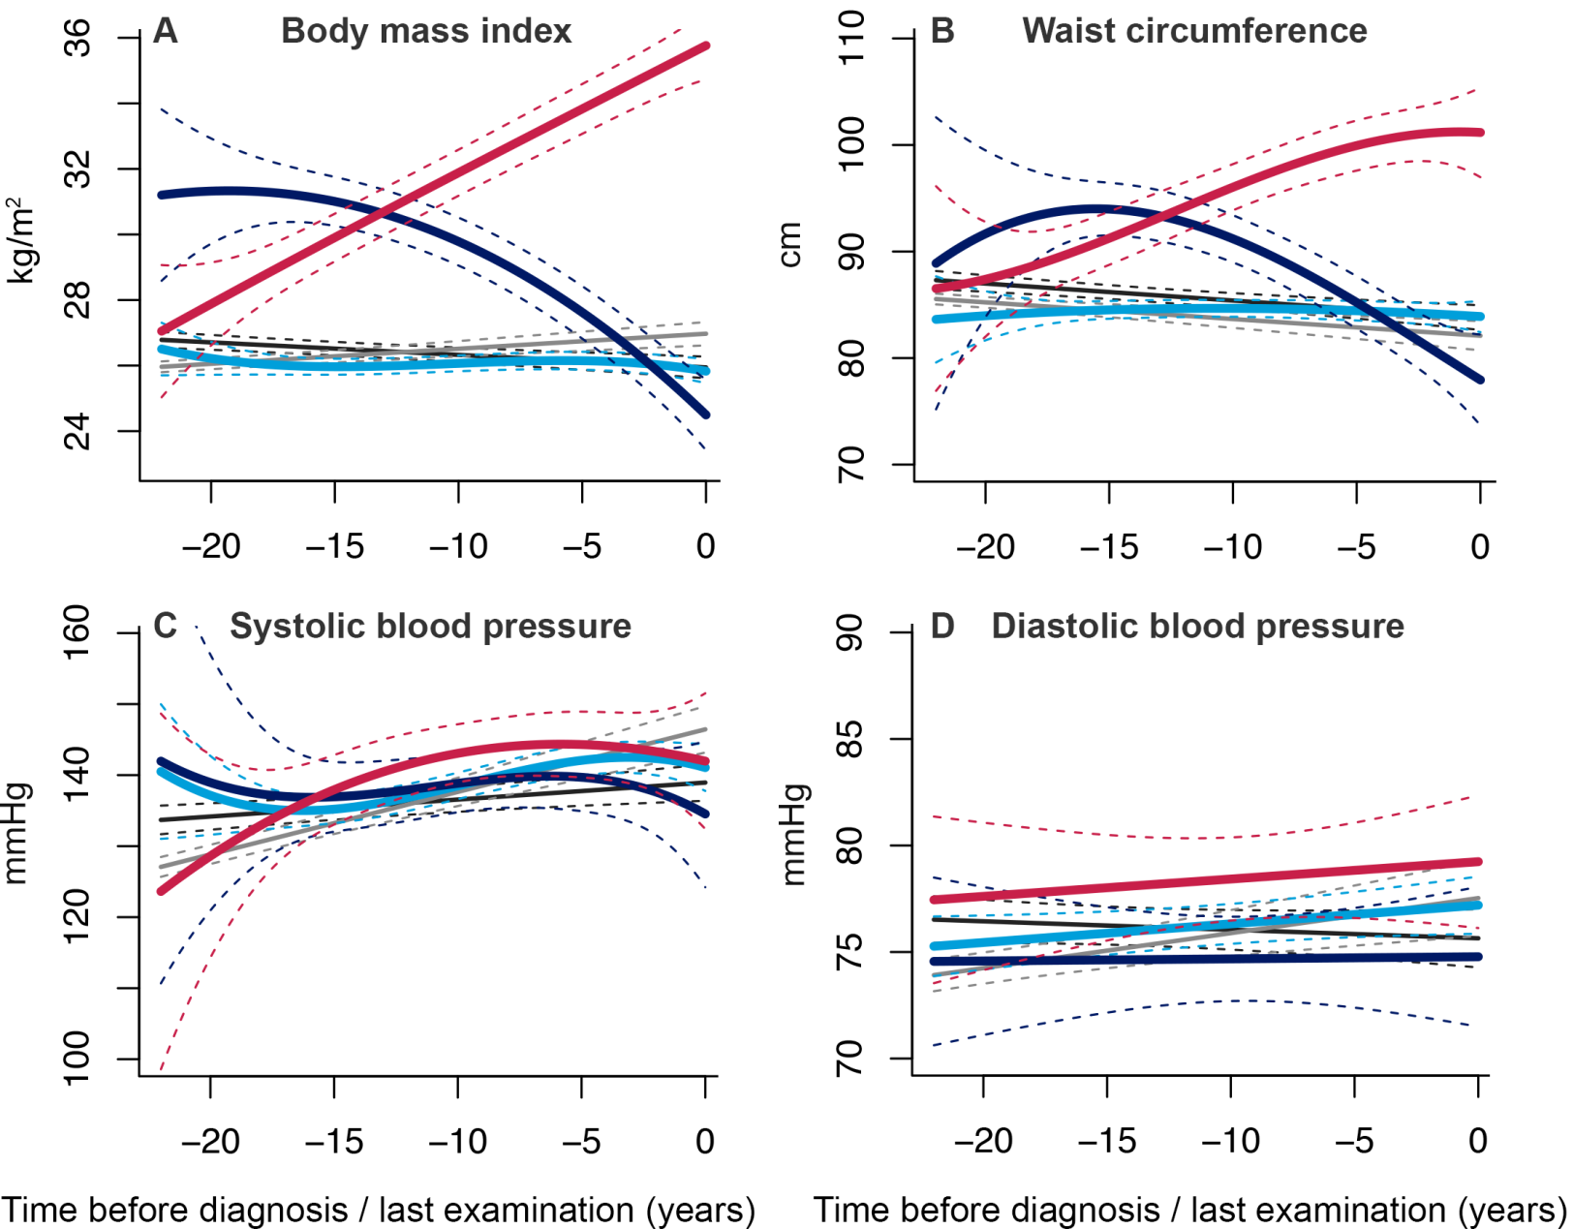

Trajectories for risk factors during 22 years of follow-up until diagnosis of CVD, death or censoring from the study. The figures represent a hypothetical woman of 65 years old. Trajectories for blood pressure represent a person on anti-hypertensive treatment.
Light blue: “stable weight” (including 87.8% of CVD patients); dark blue: “progressive weight loss” (including 5.8% of CVD patients); red: “progressive weight gain” (including 6.4% of CVD patients); gray: “CVD-free”; black: “non-CVD mortality” groups.

Figure S2: Trajectories of fasting plasma glucose, total and HDL cholesterol, and ACC/AHA 10 year CVD risk
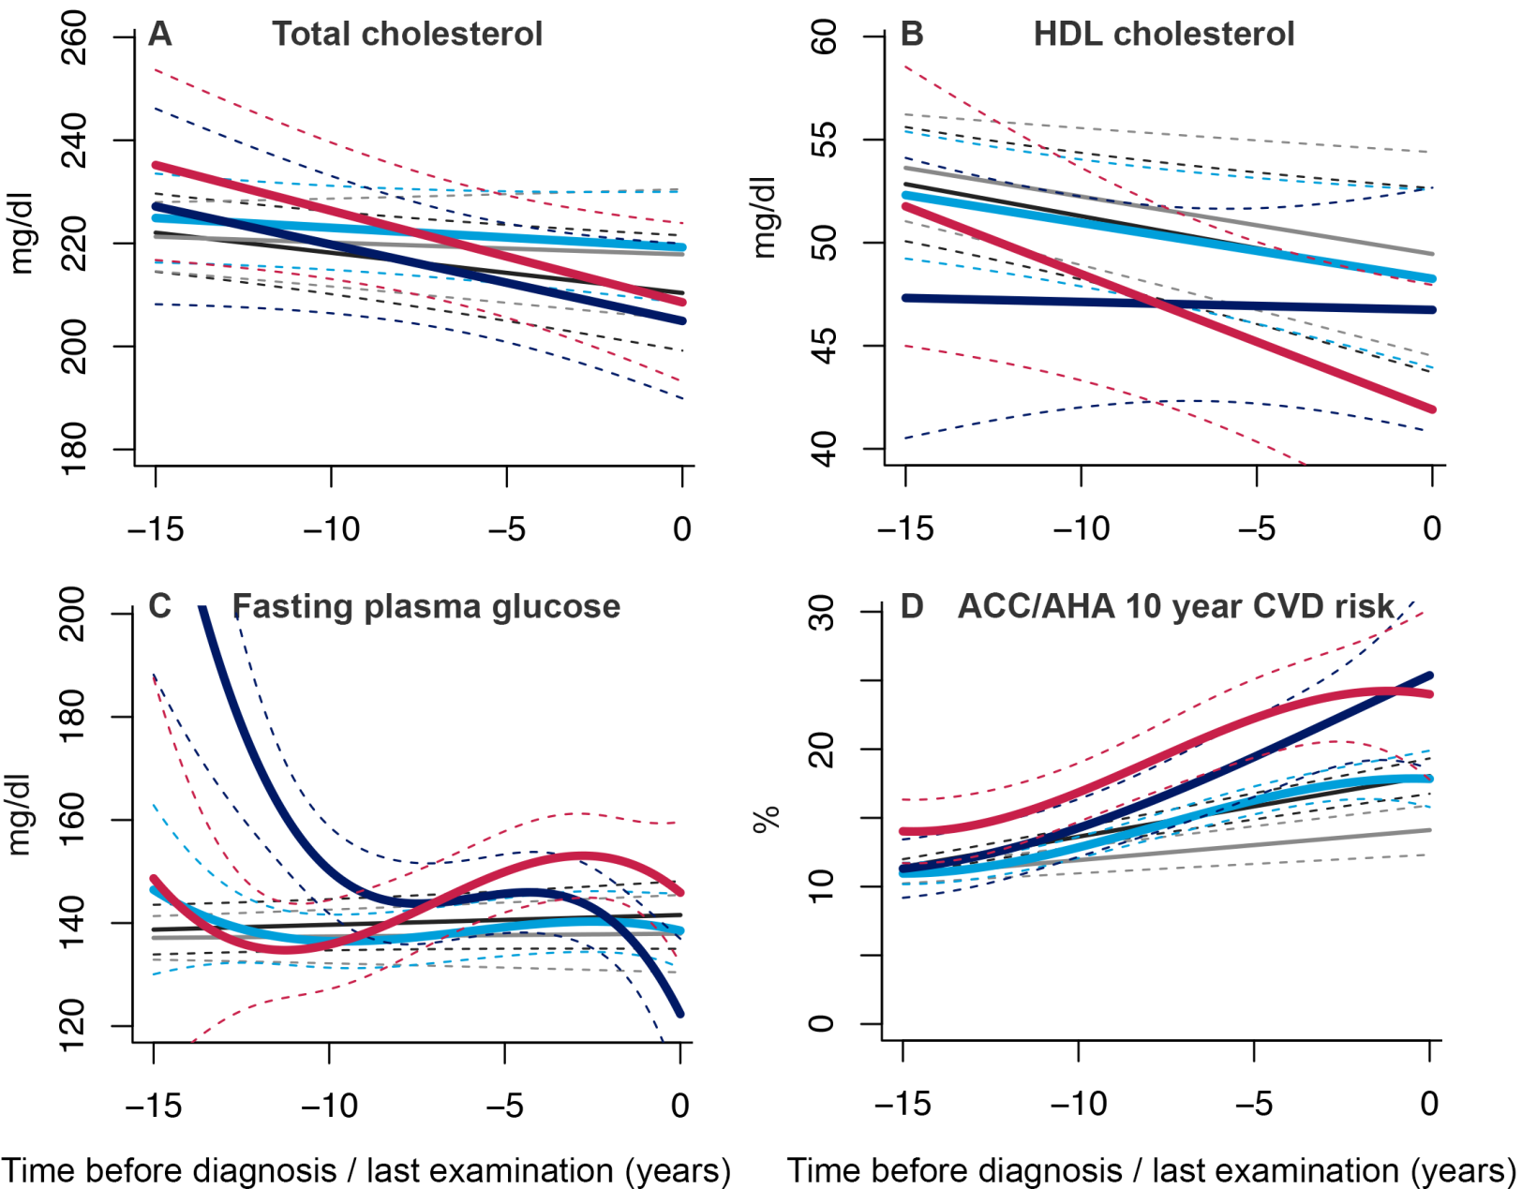

Abbreviation: HDL cholesterol, high-density lipoprotein cholesterol; ACC/AHA, American College of Cardiology/American Heart Association
Trajectories for risk factors during 15 years of follow-up until diagnosis of CVD, death or censoring from the study. The figures represent a hypothetical woman of 65 years old, on lipid- or glucose-lowering treatment during 15 years of follow-up until diagnosis of CVD, death or censoring from the study.
Light blue: “stable weight” (including 87.8% of CVD patients); dark blue: “progressive weight loss” (including 5.8% of CVD patients); red: “progressive weight gain” (including 6.4% of CVD patients); gray: “CVD-free”; black: “non-CVD mortality” groups.

