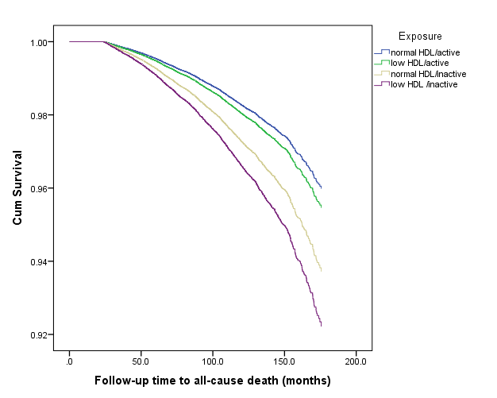
Figure S1. Survival curves for all-cause mortality according to exposure: meeting physical activity guidelines and normal HDL-C concentration (reference group); meeting physical activity guidelines and low HDL-C concentration; not meeting physical activity guidelines and normal HDL-C concentration; not meeting physical activity guidelines and low HDL-C concentration. Here, low HDL-C defined as <1.03 mmol·L⁻¹ in men and <1.30 mmol·L⁻¹ in women.

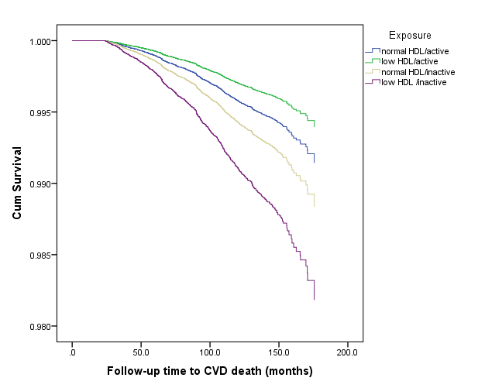
Figure S2. Survival curves for cardiovascular disease (CVD) mortality according to exposure: meeting physical activity guidelines and normal HDL-C concentration (reference group); meeting physical activity guidelines and low HDL-C concentration; not meeting physical activity guidelines and normal HDL-C concentration; not meeting physical activity guidelines and low HDL-C concentration. Here, low HDL-C defined as <1.03 mmol·L⁻¹ in men and <1.30 mmol·L⁻¹ in women.

Table S1. Participants’ age, high-density lipoprotein cholesterol (HDL-C), and physical activity by survey and survey year*

Survey and year | N | Age, years | HDL-C,  mmol·L⁻¹ | Physical activity, min·wk⁻¹
HSE1998 | 8265 | 47.3±17.1 | 1.43±0.41 | 117±254
HSE1999 | 2637 | 42.5±16.2 | 1.39±0.42 | 76±327
HSE2003 | 5524 | 48.2±16.5 | 1.54±0.39 | 83±203
HSE2004 | 1336 | 41.6±14.5 | 1.42±0.36 | 77±186
HSE2006 | 4745 | 48.0±16.1 | 1.52±0.39 | 158±321
HSE2008 | 4274 | 47.8±16.4 | 1.52±0.38 | 177±315
SHS1995 | 4168 | 41.9±12.9 | 1.43±0.44 | 79±180
SHS1998 | 4019 | 46.8±15.3 | 1.44±0.44 | 122±276
SHS2003 | 2088 | 50.7±16.4 | 1.52±0.37 | 153±306
Overall | 37059 | 46.6±16.2 | 1.47±0.41 | 118±269

*Values are mean±standard deviation. Physical activity includes moderate- and vigorous-intensity physical activities.
Table S2. Cox proportional hazard ratios (HR) for associations between physical activity, high-density lipoprotein cholesterol (HDL-C) and all-cause mortality in subsample with medication data (n=18,928)

Meeting physical activity guidelines* | HDL-C† | Deaths/N | Age- and sex-adjusted HR (95% CI) | Fully-adjusted HR (95% CI)‡
Yes | Normal | 104/3653 | 1.0 (Reference) | 1.0 (Reference)
Yes | Low | 22/744 | 0.84 (0.53, 1.33) | 0.79 (0.49, 1.26)
No | Normal | 1181/11,116 | 1.63 (1.33, 2.00) | 1.39 (1.13, 1.70)
No | Low | 442/3,415 | 1.95 (1.57, 2.41) | 1.61 (1.29, 2.00)

*Here, physical activity excludes domestic activity and meeting physical activity guidelines is defined as taking part in at least 150 minutes per week of moderate-intensity physical activity, or at least 75 minutes per week of vigorous-intensity physical activity, or any combination of moderate- and vigorous-intensity physical activity equivalent to at least 7.5 MET-hr·wk⁻¹.
† Here, low HDL-C defined as <1.03 mmol·L⁻¹ in men and <1.30 mmol·L⁻¹ in women.
‡Model adjusted for age, sex, smoking, total cholesterol, systolic blood pressure, body mass index, longstanding illness, and social class.

Table S3. Cox proportional hazard ratios (HR) for associations between physical activity, high-density lipoprotein cholesterol (HDL-C) and all-cause mortality in subsample aged 40 years and older (n=23,386)

Meeting physical activity guidelines* | HDL-C† | Deaths/N | Age- and sex-adjusted HR (95% CI) | Fully-adjusted HR (95% CI)‡
Yes | Normal | 143/4714 | 1.0 (Reference) | 1.0 (Reference)
Yes | Low | 34/694 | 1.16 (0.80, 1.67) | 1.12 (0.77, 1.64)
No | Normal | 1462/14325 | 1.67 (1.40, 1.98) | 1.44 (1.20, 1.71)
No | Low | 512/3653 | 2.12 (1.76, 2.55) | 1.78 (1.46, 2.15)

*Here, physical activity excludes domestic activity and meeting physical activity guidelines is defined as taking part in at least 150 minutes per week of moderate-intensity physical activity, or at least 75 minutes per week of vigorous-intensity physical activity, or any combination of moderate- and vigorous-intensity physical activity equivalent to at least 7.5 MET-hr·wk⁻¹.
† Here, low HDL-C defined as <1.03 mmol·L⁻¹ in men and <1.30 mmol·L⁻¹ in women.
‡Model adjusted for age, sex, smoking, total cholesterol, systolic blood pressure, body mass index, longstanding illness, and social class.
Table S4. Cox proportional hazard ratios (HR) for associations between physical activity, high-density lipoprotein cholesterol (HDL-C) and all-cause mortality with adjustment for survey year and other potential confounders

Meeting physical activity guidelines* | HDL-C† | Deaths/N | Fully-adjusted HR (95% CI)‡
Yes | Normal | 170/9,234 | 1.0 (Reference)
Yes | Low | 40/1,664 | 1.03 (0.73, 1.47)
No | Normal | 1514/20,487 | 1.38 (1.17, 1.63)
No | Low | 526/5,674 | 1.64 (1.37, 1.97)

*Here, physical activity excludes domestic activity and meeting physical activity guidelines is defined as taking part in at least 150 minutes per week of moderate-intensity physical activity, or at least 75 minutes per week of vigorous-intensity physical activity, or any combination of moderate- and vigorous-intensity physical activity equivalent to at least 7.5 MET-hr·wk⁻¹.
† Here, low HDL-C defined as <1.03 mmol·L⁻¹ in men and <1.30 mmol·L⁻¹ in women.
‡Model adjusted for age, sex, smoking, total cholesterol, systolic blood pressure, body mass index, longstanding illness, social class, and survey year.

Table S5. Associations between the covariates and mortality

Variable |  | Hazard ratio (95% CI)*
Age (per year) |  | 1.10 (1.09, 1.11)
Male sex |  | 1.46 (1.32, 1.62)
Smoking habit
 | Never | 1.0 (Reference)
 | Ex-smoker | 1.32 (1.19, 1.46)
 | <10 per day | 1.91 (1.58, 2.31)
 | 10-19 per day | 2.32 (1.99, 2.69)
 | 20+ per day | 3.45 (2.98, 3.99)
Social occupational group
 | Professional | 1.0 (Reference)
 | Managerial | 1.29 (0.98, 1.69)
 | Skilled non-manual | 1.41 (1.07, 1.86)
 | Skilled manual | 1.49 (1.14, 1.95)
 | Semi-skilled manual | 1.42 (1.08, 1.87)
 | Unskilled manual | 1.62 (1.21, 2.17)
 | Other | 2.26 (1.24, 4.13)
Meeting physical activity guidelines |  | 0.71 (0.61, 0.83)
Total cholesterol† |  | 0.99 (0.94, 1.03)
HDL-C† |  | 0.97 (0.93, 1.01)
Systolic blood pressure† |  | 1.08 (1.04, 1.12)
Body mass index
 | Underweight | 2.59 (1.87, 3.59)
 | Normal weight | 1.0 (Reference)
 | Overweight | 0.75 (0.68, 0.83)
 | Obese | 0.83 (0.74, 0.94)
Long-term illness |  | 1.40 (1.28, 1.53)

*Hazard ratios are mutually adjusted for all variables present.
†Effects estimated per standard deviation.
Table S6. Calculation of population attributable risks based on all-cause mortality

A. Population attributable risk for physical activity

Meets physical activity guidelines | Cases  (all cause mortality) | Non-cases | Total
No | 2040 | 24121 | 26161
Yes | 210 | 10688 | 10898
Total | 2250 | 34809 | 37059

Incidence in the exposed (non-active) (I_{e} ) = 7.8 per 100
Incidence in the unexposed (active) (I_{u} ) = 1.9 per 100
Incidence in both combined (I_{p} ) = 6.1 per 100.

Attributable risk (I_{e} – I_{u}) = 5.87 (75.3%)
Population attributable risk (I_{p} – I_{u}) = 4.14 (68.2%).

A reduction of 4.1 new mortality cases per 100 population (exposed and unexposed) is expected if everybody adheres to the physical activity guideline. Such reduction represents a 68.2% reduction of the incidence in the population.

B. Population attributable risk for HDL-C

HDL-C cut point | Cases  (all cause mortality) | Non-cases | Total
Low | 566 | 6772 | 7338
Normal | 1684 | 28037 | 29721
Total | 2250 | 34809 | 37059

Incidence in the exposed (low HDL) (I_{e} ) = 7.7 per 100
Incidence in the unexposed (normal HDL) (I_{u} ) = 5.7 per 100
Incidence in both combined (I_{p} ) = 6.1 per 100.

Attributable risk (I_{e} – I_{u}) = 2.0 (26.0%)
Population attributable risk (I_{p} – I_{u}) = 0.4 (6.6%).

A reduction of 0.4 new mortality cases per 100 population (exposed and unexposed) is expected if everybody has normal HDL-C. Such reduction represents a 6.6% reduction of the incidence in the population.

