Panayotes Demakakos¹ • Jane P Biddulph¹ • Cesar de Oliveira¹ • Georgios Tsakos¹ • Michael G Marmot¹

Subjective social status and mortality: the English Longitudinal Study of Ageing

¹Department of Epidemiology and Public Health, University College London, London, UK

Panayotes Demakakos, email: p.demakakos@ucl.ac.uk, tel: +44 20 7679 1712
--
Supplemental File – Online Appendix
Figure S1 presents the distribution of subjective social status at baseline in participants aged 50 to 64 years. The sample used to create this graph is the original sample of 9312 men and women aged ≥50 years prior to imputing 660 missing at random SSS values.
Figure S2 presents the distribution of subjective social status at baseline in participants aged ≥65 years. The sample used to create this graph is the original sample of 9312 men and women aged ≥50 years prior to imputing 660 missing at random SSS values.
Table S1 presents the descriptive statistics for subjective social status at baseline by age group. The sample used to create this graph is the original sample of 9312 men and women aged ≥50 years prior to imputing 660 missing at random SSS values.
Table S2 presents the associations between subjective social status and all-cause and cause-specific mortality in the original sample of 9312 men and women aged ≥50 years prior to imputing 660 missing at random SSS values.

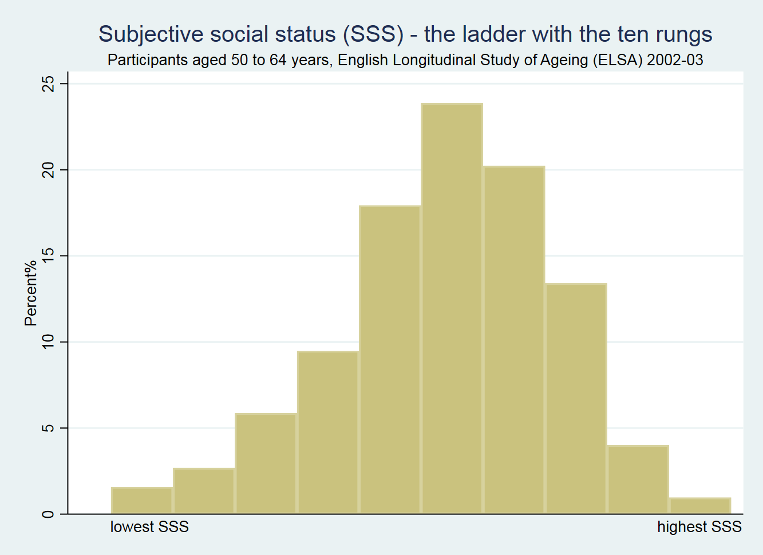
Figure S1. The distribution of subjective social status in participants aged 50 to 64 years – English Longitudinal Study of Ageing (ELSA) 2002-03.

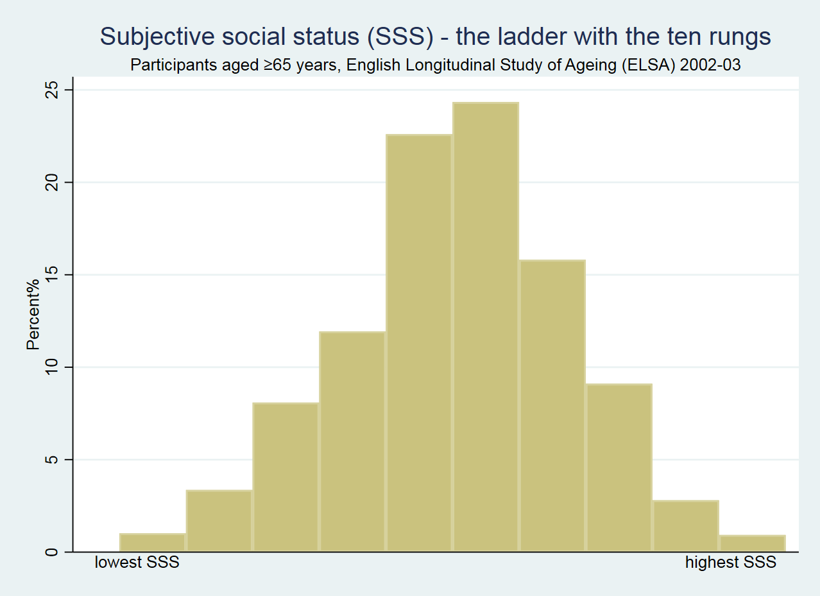
Figure S2. The distribution of subjective social status in participants aged ≥65 years – English Longitudinal Study of Ageing (ELSA) 2002-03

Table S1: Subjective social statusª: the descriptive statistics by age, English Longitudinal Study of Ageing (ELSA) 2002-2003
 | Age group: 50-64 years |  | Age group: ≥65 years
Number of participants | 4998 |  | 4314
Mean SSS (Standard Deviation) | 5.9 (1.8) |  | 5.6 (1.7)
25th centile | 5 |  | 5
Median SSS | 6 |  | 6
75th centile | 7 |  | 7
ª Subjective social status has not been reversed – higher values denote higher SSS.

Table S2: The associations between subjective social status and all-cause and cause-specific mortality by age, English Longitudinal Study of Ageing 2002-2013ª
 | Age group: 50-64 years |  | Age group: ≥65 years
All-cause mortality
No of deaths | 373 |  | 1636
Deaths / 1000 person years | 7.4 (6.7-8.1) |  | 43.7 (41.6-45.8)
Model 1 HR (95% CI)ª | 1.25 (1.18-1.32) |  | 1.07 (1.04-1.10)
Model 2 HR (95% CI)^{b} | 1.24 (1.17-1.31) |  | 1.07 (1.04-1.10)
Model 3 HR (95% CI)^{c} | 1.12 (1.05-1.18) |  | 1.03 (1.00-1.06)
Cardiovascular mortality
No of deaths | 86 |  | 578
Deaths / 1000 person years | 1.7 (1.4-2.1) |  | 15.4 (14.2-16.7)
Model 1 HR (95% CI)ª | 1.37 (1.23-1.53) |  | 1.10 (1.05-1.15)
Model 2 HR (95% CI)^{b} | 1.38 (1.23-1.54) |  | 1.10 (1.05-1.16)
Model 3 HR (95% CI)^{c} | 1.16 (1.03-1.30) |  | 1.06 (1.01-1.11)
Cancer mortality
No of deaths | 186 |  | 466
Deaths / 1000 person years | 3.7 (3.2-4.2) |  | 12.4 (11.4-13.6)
Model 1 HR (95% CI)ª | 1.13 (1.05-1.22) |  | 1.05 (1.00-1.11)
Model 2 HR (95% CI)^{b} | 1.13 (1.05-1.23) |  | 1.06 (1.00-1.11)
Model 3 HR (95% CI)^{c} | 1.05 (0.97-1.14) |  | 1.02 (0.97-1.08)
Other mortality
No of deaths | 101 |  | 592
Deaths / 1000 person years | 2.0 (1.6-2.4) |  | 15.8 (14.8-17.2)
Model 1 HR (95% CI)ª | 1.36 (1.23-1.51) |  | 1.06 (1.01-1.11)
Model 2 HR (95% CI)^{b} | 1.34 (1.21-1.48) |  | 1.06 (1.01-1.11)
Model 3 HR (95% CI)^{c} | 1.19 (1.07-1.33) |  | 1.00 (0.96-1.05)
Sample sizes
No of participants | 4998 |  | 4314
Person years of follow-up | 50700 |  | 37481
HR = Hazard ratio; CI = Confidence interval
Model 1 represents the unadjusted association
Model 2 is adjusted for age, sex, and marital status
Model 3 is adjusted for age, sex, marital status, smoking, physical activity, BMI and elevated depressive symptoms
ªHazard ratios denote hazard change per unit decrease in SSS

