Supporting Material

Cardiovascular mortality attributable to dietary risk factors in 51 countries in the WHO European Region from 1990 to 2016: A Systematic Analysis of the Global Burden of Disease Study

Table of Contents

List of Abbreviations… 6
Modelling approach (overview)… 8
Risk exposure data and modelling strategy… 9
Relative risks, population attributable fractions and mediation factors… 10

Table 1 Considered Countries in the WHO European Region 8
Table 2 Relative risks for diet-related cardiovascular diseases for both sexes by age, risk and outcome (incl. uncertainty intervals) 12
Table 3 Cause and risk factor specific mediation factors (incl. uncertainty intervals) 14
Table 4 Citation of the epidemiological studies used to evaluate the causal relationship between dietary risk-outcome pairs 17
Table 5 Death rate (age-standardized), number of deaths of cardiovascular diseases (CVDs) attributable to dietary risks from 1990 to 2016 (including 95% uncertainty interval) 20

Figure 1 Diet-related CVD deaths from 1990 to 2016 in Albania 32
Figure 2 Age- and gender-specific diet-related CVD deaths (bars) and share of diet-related on total CVD deaths (lines) from 1990 to 2016 in Albania 32
Figure 3 Diet-related CVD deaths from 1990 to 2016 in Andorra 33
Figure 4 Age- and gender-specific diet-related CVD deaths (bars) and share of diet-related on total CVD deaths (lines) from 1990 to 2016 in Andorra 33
Figure 5 Diet-related CVD deaths from 1990 to 2016 in Armenia 34
Figure 6 Age- and gender-specific diet-related CVD deaths (bars) and share of diet-related on total CVD deaths (lines) from 1990 to 2016 in Armenia 34
Figure 7 Diet-related CVD deaths from 1990 to 2016 in Austria 35
Figure 8 Age- and gender-specific diet-related CVD deaths (bars) and share of diet-related on total CVD deaths (lines) from 1990 to 2016 in Austria 35
Figure 9 Diet-related CVD deaths from 1990 to 2016 in Azerbaijan 36
Figure 10 Age- and gender-specific diet-related CVD deaths (bars) and share of diet-related on total CVD deaths (lines) from 1990 to 2016 in Azerbaijan 36
Figure 11 Diet-related CVD deaths from 1990 to 2016 in Belarus 37
Figure 12 Age- and gender-specific diet-related CVD deaths (bars) and share of diet-related on total CVD deaths (lines) from 1990 to 2016 in Belarus 37
Figure 13 Diet-related CVD deaths from 1990 to 2016 in Belgium 38
Figure 14 Age- and gender-specific diet-related CVD deaths (bars) and share of diet-related on total CVD deaths (lines) from 1990 to 2016 in Belgium 38
Figure 15 Diet-related CVD deaths from 1990 to 2016 in Bosnia and Herzegovina 39
Figure 16 Age- and gender-specific diet-related CVD deaths (bars) and share of diet-related on total CVD deaths (lines) from 1990 to 2016 in Bosnia and Herzegovina 39
Figure 17 Diet-related CVD deaths from 1990 to 2016 in Bulgaria 40
Figure 18 Age- and gender-specific diet-related CVD deaths (bars) and share of diet-related on total CVD deaths (lines) from 1990 to 2016 in Bulgaria 40
Figure 19 Diet-related CVD deaths from 1990 to 2016 in Croatia 41
Figure 20 Age- and gender-specific diet-related CVD deaths (bars) and share of diet-related on total CVD deaths (lines) from 1990 to 2016 in Croatia 41
Figure 21 Diet-related CVD deaths from 1990 to 2016 in Cyprus 42
Figure 22 Age- and gender-specific diet-related CVD deaths (bars) and share of diet-related on total CVD deaths (lines) from 1990 to 2016 in Cyprus 42
Figure 23 Diet-related CVD deaths from 1990 to 2016 in the Czech Republic 43
Figure 24 Age- and gender-specific diet-related CVD deaths (bars) and share of diet-related on total CVD deaths (lines) from 1990 to 2016 in the Czech Republic 43
Figure 25 Diet-related CVD deaths from 1990 to 2016 in Denmark 44
Figure 26 Age- and gender-specific diet-related CVD deaths (bars) and share of diet-related on total CVD deaths (lines) from 1990 to 2016 in Denmark 44
Figure 27 Diet-related CVD deaths from 1990 to 2016 in Estonia 45
Figure 28 Age- and gender-specific diet-related CVD deaths (bars) and share of diet-related on total CVD deaths (lines) from 1990 to 2016 in Estonia 45
Figure 29 Diet-related CVD deaths from 1990 to 2016 in the EU-28 46
Figure 30 Age- and gender-specific diet-related CVD deaths (bars) and share of diet-related on total CVD deaths (lines) from 1990 to 2016 in the EU-28 46
Figure 31 Diet-related CVD deaths from 1990 to 2016 in Finland 47
Figure 32 Age- and gender-specific diet-related CVD deaths (bars) and share of diet-related on total CVD deaths (lines) from 1990 to 2016 in Finland 47
Figure 33 Diet-related CVD deaths from 1990 to 2016 in France 48
Figure 34 Age- and gender-specific diet-related CVD deaths (bars) and share of diet-related on total CVD deaths (lines) from 1990 to 2016 in France 48
Figure 35 Diet-related CVD deaths from 1990 to 2016 in Georgia 49
Figure 36 Age- and gender-specific diet-related CVD deaths (bars) and share of diet-related on total CVD deaths (lines) from 1990 to 2016 in Georgia 49
Figure 37 Diet-related CVD deaths from 1990 to 2016 in Germany 50
Figure 38 Age- and gender-specific diet-related CVD deaths (bars) and share of diet-related on total CVD deaths (lines) from 1990 to 2016 in Germany 50
Figure 39 Diet-related CVD deaths from 1990 to 2016 in Greece 51
Figure 40 Age- and gender-specific diet-related CVD deaths (bars) and share of diet-related on total CVD deaths (lines) from 1990 to 2016 in Greece 51
Figure 41 Diet-related CVD deaths from 1990 to 2016 in Hungary 52
Figure 42 Age- and gender-specific diet-related CVD deaths (bars) and share of diet-related on total CVD deaths (lines) from 1990 to 2016 in Hungary 52
Figure 43 Diet-related CVD deaths from 1990 to 2016 in Iceland 53
Figure 44 Age- and gender-specific diet-related CVD deaths (bars) and share of diet-related on total CVD deaths (lines) from 1990 to 2016 in Iceland 53
Figure 45 Diet-related CVD deaths from 1990 to 2016 in Ireland 54
Figure 46 Age- and gender-specific diet-related CVD deaths (bars) and share of diet-related on total CVD deaths (lines) from 1990 to 2016 in Ireland 54
Figure 47 Diet-related CVD deaths from 1990 to 2016 in Israel 55
Figure 48 Age- and gender-specific diet-related CVD deaths (bars) and share of diet-related on total CVD deaths (lines) from 1990 to 2016 in Israel 55
Figure 49 Diet-related CVD deaths from 1990 to 2016 in Italy 56
Figure 50 Age- and gender-specific diet-related CVD deaths (bars) and share of diet-related on total CVD deaths (lines) from 1990 to 2016 in Italy 56
Figure 51 Diet-related CVD deaths from 1990 to 2016 in Kazakhstan 57
Figure 52 Age- and gender-specific diet-related CVD deaths (bars) and share of diet-related on total CVD deaths (lines) from 1990 to 2016 in Kazakhstan 57
Figure 53 Diet-related CVD deaths from 1990 to 2016 in Kyrgyzstan 58
Figure 54 Age- and gender-specific diet-related CVD deaths (bars) and share of diet-related on total CVD deaths (lines) from 1990 to 2016 in Kyrgyzstan 58
Figure 55 Diet-related CVD deaths from 1990 to 2016 in Latvia 59
Figure 56 Age- and gender-specific diet-related CVD deaths (bars) and share of diet-related on total CVD deaths (lines) from 1990 to 2016 in Latvia 59
Figure 57 Diet-related CVD deaths from 1990 to 2016 in Lithuania 60
Figure 58 Age- and gender-specific diet-related CVD deaths (bars) and share of diet-related on total CVD deaths (lines) from 1990 to 2016 in Lithuania 60
Figure 59 Diet-related CVD deaths from 1990 to 2016 in Luxembourg 61
Figure 60 Age- and gender-specific diet-related CVD deaths (bars) and share of diet-related on total CVD deaths (lines) from 1990 to 2016 in Luxembourg 61
Figure 61 Diet-related CVD deaths from 1990 to 2016 in Macedonia 62
Figure 62 Age- and gender-specific diet-related CVD deaths (bars) and share of diet-related on total CVD deaths (lines) from 1990 to 2016 in Macedonia 62
Figure 63 Diet-related CVD deaths from 1990 to 2016 in Malta 63
Figure 64 Age- and gender-specific diet-related CVD deaths (bars) and share of diet-related on total CVD deaths (lines) from 1990 to 2016 in Malta 63
Figure 65 Diet-related CVD deaths from 1990 to 2016 in Moldova 64
Figure 66 Age- and gender-specific diet-related CVD deaths (bars) and share of diet-related on total CVD deaths (lines) from 1990 to 2016 in Moldova 64
Figure 67 Diet-related CVD deaths from 1990 to 2016 in Montenegro 65
Figure 68 Age- and gender-specific diet-related CVD deaths (bars) and share of diet-related on total CVD deaths (lines) from 1990 to 2016 in Montenegro 65
Figure 69 Diet-related CVD deaths from 1990 to 2016 in the Netherlands 66
Figure 70 Age- and gender-specific diet-related CVD deaths (bars) and share of diet-related on total CVD deaths (lines) from 1990 to 2016 in the Netherlands 66
Figure 71 Diet-related CVD deaths from 1990 to 2016 in Norway 67
Figure 72 Age- and gender-specific diet-related CVD deaths (bars) and share of diet-related on total CVD deaths (lines) from 1990 to 2016 in Norway 67
Figure 73 Diet-related CVD deaths from 1990 to 2016 in Poland 68
Figure 74 Age- and gender-specific diet-related CVD deaths (bars) and share of diet-related on total CVD deaths (lines) from 1990 to 2016 in Poland 68
Figure 75 Diet-related CVD deaths from 1990 to 2016 in Portugal 69
Figure 76 Age- and gender-specific diet-related CVD deaths (bars) and share of diet-related on total CVD deaths (lines) from 1990 to 2016 in Portugal 69
Figure 77 Diet-related CVD deaths from 1990 to 2016 in Romania 70
Figure 78 Age- and gender-specific diet-related CVD deaths (bars) and share of diet-related on total CVD deaths (lines) from 1990 to 2016 in Romania 70
Figure 79 Diet-related CVD deaths from 1990 to 2016 in Russia 71
Figure 80 Age- and gender-specific diet-related CVD deaths (bars) and share of diet-related on total CVD deaths (lines) from 1990 to 2016 in Russia 71
Figure 81 Diet-related CVD deaths from 1990 to 2016 in Serbia 72
Figure 82 Age- and gender-specific diet-related CVD deaths (bars) and share of diet-related on total CVD deaths (lines) from 1990 to 2016 in Serbia 72
Figure 83 Diet-related CVD deaths from 1990 to 2016 in Slovakia 73
Figure 84 Age- and gender-specific diet-related CVD deaths (bars) and share of diet-related on total CVD deaths (lines) from 1990 to 2016 in Slovakia 73
Figure 85 Diet-related CVD deaths from 1990 to 2016 in Slovenia 74
Figure 86 Age- and gender-specific diet-related CVD deaths (bars) and share of diet-related on total CVD deaths (lines) from 1990 to 2016 in Slovenia 74
Figure 87 Diet-related CVD deaths from 1990 to 2016 in Spain 75
Figure 88 Age- and gender-specific diet-related CVD deaths (bars) and share of diet-related on total CVD deaths (lines) from 1990 to 2016 in Spain 75
Figure 89 Diet-related CVD deaths from 1990 to 2016 in Sweden 76
Figure 90 Age- and gender-specific diet-related CVD deaths (bars) and share of diet-related on total CVD deaths (lines) from 1990 to 2016 in Sweden 76
Figure 91 Diet-related CVD deaths from 1990 to 2016 in Switzerland 77
Figure 92 Age- and gender-specific diet-related CVD deaths (bars) and share of diet-related on total CVD deaths (lines) from 1990 to 2016 in Switzerland 77
Figure 93 Diet-related CVD deaths from 1990 to 2016 in Tajikistan 78
Figure 94 Age- and gender-specific diet-related CVD deaths (bars) and share of diet-related on total CVD deaths (lines) from 1990 to 2016 in Tajikistan 78
Figure 95 Diet-related CVD deaths from 1990 to 2016 in Turkey 79
Figure 96 Age- and gender-specific diet-related CVD deaths (bars) and share of diet-related on total CVD deaths (lines) from 1990 to 2016 in Turkey 79
Figure 97 Diet-related CVD deaths from 1990 to 2016 in Turkmenistan 80
Figure 98 Age- and gender-specific diet-related CVD deaths (bars) and share of diet-related on total CVD deaths (lines) from 1990 to 2016 in Turkmenistan 80
Figure 99 Diet-related CVD deaths from 1990 to 2016 in Ukraine 81
Figure 100 Age- and gender-specific diet-related CVD deaths (bars) and share of diet-related on total CVD deaths (lines) from 1990 to 2016 in Ukraine 81
Figure 101 Diet-related CVD deaths from 1990 to 2016 in the United Kingdom 82
Figure 102 Age- and gender-specific diet-related CVD deaths (bars) and share of diet-related on total CVD deaths (lines) from 1990 to 2016 in the United Kingdom 82
Figure 103 Diet-related CVD deaths from 1990 to 2016 in Uzbekistan 83
Figure 104 Age- and gender-specific diet-related CVD deaths (bars) and share of diet-related on total CVD deaths (lines) from 1990 to 2016 in Uzbekistan 83

List of abbreviations

BMI: body‐mass index
CRA: comparative risk assessment
CVD: cardiovascular disease
DALY: disability‐adjusted life‐year
DisMod-MR 2.1: Disease Modelling Bayesian Meta-Regression tool, version 2.1FAO: Food and Agriculture Organization
FPG: fasting plasma glucose
GATHER: Guidelines for Accurate and Transparent Health Estimates Reporting
GBD: Global Burden of Disease
IHD: ischaemic heart disease
LDI: lag distributed income per capita
LMIC: low and middle‐income countries
LRI: lower respiratory infection
MCMC: Markov Chain Monte Carlo simulations
MDG: Millennium Development Goal
MoM: method of moments
NCD: non‐communicable disease
PAF: population attributable fraction
PSC: Prospective Cohort Study
PUFA: polyunsaturated fatty acid
RCT: randomised controlled trial
RMSE: root mean square error
RR: relative risk
SBP: systolic blood pressure
SD: standard deviation
SDG: Sustainable Development Goal
SDI: Socio‐demographic Index
SEV: summary exposure value
SSB: sugar‐sweetened beverages
ST‐GPR: spatiotemporal Gaussian process regression
TMREL: theoretical minimum‐risk exposure level
UI: uncertainty interval
UR: uncertainty ratio
WCRF: World Cancer Research Fund
WHO: World Health Organization
YLD: years lived with disability
YLL: years of life lost

Table 1 Considered Countries in the WHO European Region
Region | Countries
Western Europe | Andorra, Austria, Belgium, Cyprus, Denmark, Finland, France, Germany, Greece, Iceland, Ireland, Israel, Italy, Luxembourg, Malta, Netherlands, Norway, Portugal, Spain, Sweden, Switzerland, United Kingdom
Central Europe | Albania, Bosnia and Herzegovina, Bulgaria, Croatia, Czech Republic, Hungary, Macedonia, Montenegro, Poland, Romania, Serbia, Slovakia, Slovenia
Eastern Europe | Belarus, Estonia, Latvia, Lithuania, Moldova, Russia, Ukraine
Central Asia  + Turkey | Armenia, Azerbaijan, Georgia, Kazakhstan, Kyrgyzstan, Tajikistan, Turkey, Turkmenistan, Uzbekistan
EU-28 | Austria, Belgium, Bulgaria, Croatia, Cyprus, Czech Republic, Denmark, Estonia, Finland, France, Germany, Greece, Hungary, Ireland, Italy, Latvia, Lithuania, Luxembourg, Malta, the Netherlands, Poland, Portugal, Romania, Slovakia, Slovenia, Spain, Sweden, United Kingdom

Modelling approach (overview)
The comparative risk assessment framework was developed by Murray and Lopez who established a causal web of hierarchically organised risks or causes that contribute to health outcomes, which allows for quantification of risks or causes at any level in the framework. In GBD 2016, as in previous iterations of the GBD study, we evaluated a set of behavioural, environmental and occupational, and metabolic risks, where risk-outcome pairs were included based on established evidence rules (see the Supporting Material of GBD 2016 capstone paper). These risks were organised in four hierarchical Levels. At each Level of risk, we evaluated whether risk combinations were additive, multiplicative, or shared common pathways for intervention. This approach allows the quantification of the proportion of risk-attributable burden shared with another risk or combination of risks and the measurement of potential overlaps between behavioural, environmental and occupational, and metabolic risks. Within the GBD two principle types of modelling approaches are applied, a Bayesian meta-regression model (DisMod-MR 2.1) and a spatiotemporal Gaussian process regression model (ST-GPR), to pool data from different sources, control and adjust for bias in data, and incorporate other types of information such as countrylevel covariates. DisMod-MR 2.1 and ST-GPR are mixed effect models that borrow information across age, time, and locations to synthesise multiple sources of data into unified estimates of levels and trends. A detailed description of the likelihood used for estimation, and a full description of improvements made for DisMod-MR 2.1 are described by Vos et al. (2016).
Risk exposure data and modelling strategy
For the risk factor exposure estimation of dietary risks we used a spatio-temporal Gaussian process regression (ST-GPR) framework to estimate the intake of each dietary factor by age, sex, country, and year. In GBD 2016, for all dietary factors other than sodium, we considered data from 24-hour diet recall as the gold standard. For sodium, the 24-hour urinary sodium was considered as gold standard. To estimate the 24-hour urinary sodium based on dietary sodium, we performed an adjustment between these two types of data. For the remaining diet-related risk factors we used dietary data from multiple sources including nationally and sub-nationally representative nutrition surveys, household budget surveys, accounts of national sales, and United Nations FAO Food Balance Sheets and Supply and Utilization Accounts. Additionally, for trans fatty acids we used data of the availability of hydrogenated vegetable oil in packaged foods. Polyunsaturated and trans fatty acids were modelled as a percent of total dietary energy. We modelled missing country-year data from FAO using a space-time Gaussian process regression and lag-distributed country income as the covariate. For each dietary factor, we estimated the global age pattern of consumption based on nutrition surveys (i.e., 24-hour diet recall) and applied that age pattern to the FAO data. Substantive changes in input data compared to GBD 2015 are as follows: (a) reextracting data from all nutrition surveys and standardizing the definition of dietary components across sources; (b) incorporating data gathered through a systematic review of literature for each of our dietary risk factors; (c) using sales data for fruit, vegetables, legumes, processed meats, red meats, sugar-sweetened beverages, and milk. To characterize the distribution of each dietary factor at population level, we use an ensemble approach that separately fit 12 distributions for individual level microdata to specific to each data source’s sampled population. The respective goodness of fit of each family was assessed and a weighting scheme was determined to optimize overall fit to the unique distribution of each risk factor. A global mean of the weights for each risk factor’s data sources was created. We then determined the standard deviation of each population’s consumption through a linear regression that captured the relationship between the standard deviation and mean of intake in nationally representative nutrition surveys using 24-hour diet recalls. Then we applied the coefficients of this regression to the outputs of our ST-GPR model to calculate the standard deviation of intake by age, sex, year, and country. We also quantified the within person variation in consumption of each dietary component and adjusted the standard deviations accordingly. We used Dismod-MR 2.1 to pool effect sizes from included studies in the meta-analyses and to generate outcome-specific dose-response curves for each dietary risk factors and mediation factors related to CVDs.

Relative risks, population attributable fractions and mediation factors
We obtained the relative risk of each disease endpoint per serving of the dietary components from recent dose-response meta-analyses of prospective observational studies, and where available randomized controlled trials (RCTs). In GBD 2016, we specifically updated the relative risks for the relationship between a diet low in legumes and ischemic heart disease, which is now being considered distinctly as opposed to being placed within the category of vegetables. Considering the well-established age trend of the relative risks of metabolic risk factors for cardiovascular disease, we conducted a literature review to identify the most important metabolic mediators for each dietary factor and used the age trend of the relative risk of that mediator(s) and the disease endpoint to estimate the age-specific relative risk for each dietary factors (Appendix Table 2).
To avoid double counting of risk related-disease burdens when the effects of joint risk factors are aggregated, we included corresponding mediation factors offsetting the overlaps of disease burdens between multiple risk factors. Therefore, we first prepared a list of possible mediation-pairs especially between behavioural risks and metabolic risk factors with cardiometabolic outcomes based on Danaei et al (2013). Danaei et al. (2013) assumed that part of the effect of BMI on ischemic heart disease (IHD) is through high systolic blood pressure (SBP), cholesterol and fasting plasma glucose (FPG). The proportion of the BMI effect that can be explained by other metabolic risk factors is the amount of mediation. The difference between the crude RR of BMI on IHD with the RR adjusted for SBP, FPG, and cholesterol reflects the amount of BMI effect on IHD that is mediated and already included in SBP, FPG, and cholesterol. Some mediation factors equal 1 where the whole effect was calculated through other risk factor, e.g. the effect of sugar-sweetened beverages through BMI or salt through SBP, or when we assumed other risk factors are sources of the exposure, for example, fibre is provided by consuming fruit, vegetable, and whole grains. In case of more than one risk factor for an outcome, we estimated the fraction of risk that was mediated through the other risk. This resulted in a matrix of parameters containing each possible pairing of risk factors included in the GBD 2016 using the formula:
$${PAF}_{Joasgt}=1-\prod_{j=1}^{J}{(1-{PAF}_{joasgt}\prod_{i=1}^{J}{(1-{MF}_{jio}))}}$$
where J is a set of risk factors for the aggregation; PAF_{joasgt} is the population attributable fraction for risk 𝑗 for age group 𝑎, sex 𝑠, location 𝑔, and year 𝑡; and MF_{jio} is the mediation factor for risk 𝑗 mediated through 𝑖 for cause 𝑜. Mediation factors can be found in Appendix Table 3. We kept uncertainty of each parameter by generating and following 1000 draws of the estimates to calculate 1000 draws of the posterior distribution of the mediation factor. We did not include risk mediator pairs if the mediation factor was not significant at 5% level (more than 50 out of 1000 draws were negative). We truncated the mediation factor distribution at 1 where the whole effect of the risk factor on the outcome would be assumed to be through the mediator pathway. Further details can be found in the Supporting Material of the GBD 2016 capstone paper.

Table 2 Relative risks for diet-related cardiovascular diseases for both sexes by age, risk and outcome (incl. uncertainty intervals)
Risk - Outcome | Exposure unit | 25-29 years | 30-34 years | 35-39 years | 40-44 years | 45-49 years | 50-54 years | 55-59 years | 60-64 years | 65-69 years | 70-74 years | 75-79 years | 80-84 years | 85-89 years | 90-94 years | 95+  years
Diet low in fruits
Ischaemic heart disease | 100 g/day | 1.254  (1.083 - 1.442) | 1.209  (1.070 - 1.361) | 1.159  (1.054 - 1.271) | 1.131  (1.045 - 1.221) | 1.125  (1.043 - 1.211) | 1.114  (1.039 - 1.193) | 1.099  (1.034 - 1.167) | 1.087  (1.030 - 1.146) | 1.078  (1.027 - 1.13) | 1.070  (1.025 - 1.117) | 1.064  (1.022 - 1.106) | 1.057  (1.020 - 1.095) | 1.057  (1.020 - 1.095) | 1.057  (1.020 - 1.095) | 1.057  (1.020 - 1.095)
Ischaemic stroke | 100 g/day | 2.024  (1.465 - 2.818) | 1.834  (1.390 - 2.444) | 1.621  (1.301 - 2.043) | 1.480  (1.239 - 1.787) | 1.403  (1.204 - 1.653) | 1.333  (1.171 - 1.533) | 1.272  (1.142 - 1.432) | 1.222  (1.116 - 1.348) | 1.181  (1.096 - 1.283) | 1.145  (1.078 - 1.225) | 1.114  (1.061 - 1.175) | 1.054  (1.029 - 1.082) | 1.054  (1.029 - 1.082) | 1.054  (1.029 - 1.082) | 1.054  (1.029 - 1.082)
Hemorrhagic stroke | 100 g/day | 1.688  (1.319 - 2.182) | 1.576  (1.273 - 1.972) | 1.444  (1.215 - 1.732) | 1.365  (1.18 - 1.595) | 1.336  (1.167 - 1.544) | 1.300  (1.150 - 1.483) | 1.260  (1.131 - 1.415) | 1.226  (1.115 - 1.358) | 1.193  (1.099 - 1.305) | 1.164  (1.084 - 1.256) | 1.133  (1.069 - 1.207) | 1.065  (1.034 - 1.100) | 1.065  (1.034 - 1.100) | 1.065  (1.034 - 1.100) | 1.065  (1.034 - 1.100)
Diet low in vegetables
Ischaemic heart disease | 100 g/day | 1.249  (1.089 - 1.446) | 1.205  (1.074 - 1.362) | 1.154  (1.057 - 1.269) | 1.126  (1.047 - 1.219) | 1.121  (1.045 - 1.210) | 1.111  (1.042 - 1.193) | 1.098  (1.037 - 1.168) | 1.086  (1.032 - 1.148) | 1.077  (1.029 - 1.133) | 1.070  (1.027 - 1.120) | 1.064  (1.024 - 1.109) | 1.057  (1.022 - 1.097) | 1.057  (1.022 - 1.097) | 1.057  (1.022 - 1.097) | 1.057  (1.022 - 1.097)
Ischaemic stroke | 100 g/day | 1.249  (1.049 - 1.463) | 1.211  (1.042 - 1.388) | 1.165  (1.033 - 1.300) | 1.132  (1.027 - 1.238) | 1.113  (1.023 - 1.203) | 1.095  (1.020 - 1.170) | 1.079  (1.017 - 1.141) | 1.065  (1.014 - 1.116) | 1.054  (1.012 - 1.096) | 1.044  (1.009 - 1.077) | 1.035  (1.007 - 1.061) | 1.017  (1.004 - 1.029) | 1.017  (1.004 - 1.029) | 1.017  (1.004 - 1.029) | 1.017  (1.004 - 1.029)
Hemorrhagic stroke | 100 g/day | 1.177  (1.046 - 1.326) | 1.153  (1.040 - 1.278) | 1.122  (1.032 - 1.220) | 1.102  (1.027 - 1.184) | 1.095  (1.025 - 1.170) | 1.086  (1.023 - 1.153) | 1.075  (1.020 - 1.134) | 1.066  (1.018 - 1.117) | 1.057  (1.015 - 1.101) | 1.049  (1.013 - 1.086) | 1.040  (1.011 - 1.071) | 1.020  (1.005 - 1.035) | 1.020  (1.005 - 1.035) | 1.020  (1.005 - 1.035) | 1.020  (1.005 - 1.035)
Diet low in legumes
Ischaemic heart disease | 50 g/day | 1.499  (1.180 - 1.890) | 1.453  (1.166 - 1.801) | 1.388  (1.144 - 1.677) | 1.332  (1.125 - 1.573) | 1.287  (1.110 - 1.490) | 1.237  (1.092 - 1.401) | 1.181  (1.071 - 1.303) | 1.139  (1.055 - 1.230) | 1.111  (1.045 - 1.183) | 1.089  (1.036 - 1.146) | 1.074  (1.030 - 1.120) | 1.101  (1.041 - 1.165) | 1.101  (1.041 - 1.165) | 1.101  (1.041 - 1.165) | 1.101  (1.041 - 1.165)
Diet low in whole grains
Ischaemic heart disease | 50 g/day | 1.478  (1.274 - 1.722) | 1.387  (1.225 - 1.578) | 1.285  (1.168 - 1.418) | 1.228  (1.136 - 1.333) | 1.216  (1.129 - 1.313) | 1.194  (1.117 - 1.281) | 1.165  (1.1 - 1.238) | 1.141  (1.086 - 1.203) | 1.125  (1.076 - 1.179) | 1.112  (1.068 - 1.160) | 1.102  (1.062 - 1.145) | 1.097  (1.059 - 1.138) | 1.097  (1.059 - 1.138) | 1.097  (1.059 - 1.138) | 1.097  (1.059 - 1.138)
Ischaemic stroke | 50 g/day | 2.075  (1.669 - 2.517) | 1.863  (1.548 - 2.199) | 1.624  (1.406 - 1.849) | 1.466  (1.309 - 1.625) | 1.380  (1.255 - 1.505) | 1.304  (1.206 - 1.401) | 1.241  (1.165 - 1.316) | 1.189  (1.130 - 1.247) | 1.150  (1.104 - 1.195) | 1.117  (1.081 - 1.151) | 1.090  (1.063 - 1.116) | 1.041  (1.029 - 1.053) | 1.041  (1.029 - 1.053) | 1.041  (1.029 - 1.053) | 1.041  (1.029 - 1.053)
Hemorrhagic stroke | 50 g/day | 1.596  (1.406 - 1.825) | 1.484  (1.333 - 1.662) | 1.349  (1.244 - 1.471) | 1.276  (1.194 - 1.369) | 1.258  (1.182 - 1.344) | 1.232  (1.165 - 1.309) | 1.201  (1.143 - 1.267) | 1.176  (1.126 - 1.233) | 1.150  (1.108 - 1.198) | 1.128  (1.092 - 1.169) | 1.106  (1.076 - 1.139) | 1.050  (1.036 - 1.065) | 1.050  (1.036 - 1.065) | 1.050  (1.036 - 1.065) | 1.050  (1.036 - 1.065)
Diet low in nuts and seeds
Ischaemic heart disease | 4.05 g/day | 1.209  (1.128 - 1.296) | 1.169  (1.105 - 1.239) | 1.124  (1.077 - 1.174) | 1.099  (1.062 - 1.138) | 1.095  (1.060 - 1.133) | 1.088  (1.055 - 1.122) | 1.076  (1.048 - 1.105) | 1.066  (1.042 - 1.092) | 1.059  (1.037 - 1.082) | 1.054  (1.034 - 1.075) | 1.050  (1.032 - 1.069) | 1.046  (1.029 - 1.064) | 1.046  (1.029 - 1.064) | 1.046  (1.029 - 1.064) | 1.046  (1.029 - 1.064)
Diet high in processed meat
Ischaemic heart disease | 50 g/day | 2.568  (1.047 - 4.657) | 2.124  (1.038 - 3.478) | 1.720  (1.028 - 2.489) | 1.545  (1.022 - 2.093) | 1.547  (1.022 - 2.097) | 1.520  (1.022 - 2.037) | 1.467  (1.020 - 1.922) | 1.422  (1.018 - 1.826) | 1.386  (1.017 - 1.750) | 1.354  (1.016 - 1.683) | 1.325  (1.015 - 1.622) | 1.252  (1.012 - 1.475) | 1.252  (1.012 - 1.475) | 1.252  (1.012 - 1.475) | 1.252  (1.012 - 1.475)
Diet high in sugar-sweetened beverages
Ischaemic heart disease | 2.5 g/day | 1.377  (0.933 - 1.883) | 1.311  (0.943 - 1.717) | 1.232  (0.955 - 1.521) | 1.195  (0.961 - 1.436) | 1.186  (0.963 - 1.413) | 1.172  (0.965 - 1.381) | 1.156  (0.968 - 1.343) | 1.14  (0.971 - 1.306) | 1.124  (0.974 - 1.27) | 1.11  (0.977 - 1.238) | 1.095  (0.98 - 1.205) | 1.067  (0.985 - 1.143) | 1.067  (0.985 - 1.143) | 1.067  (0.985 - 1.143) | 1.067  (0.985 - 1.143)

Risk - Outcome | Exposure unit / Category | 25-29 years | 30-34 years | 35-39 years | 40-44 years | 45-49 years | 50-54 years | 55-59 years | 60-64 years | 65-69 years | 70-74 years | 75-79 years | 80-84 years | 85-89 years | 90-94 years | 95+  years
Diet low in fibre
Ischaemic heart disease | 20 g/day | 1.688  (1.415 - 2.028) | 1.622  (1.379 - 1.922) | 1.529  (1.326 - 1.776) | 1.45  (1.280 - 1.654) | 1.387  (1.243 - 1.558) | 1.318  (1.202 - 1.455) | 1.242  (1.156 - 1.342) | 1.184  (1.119 - 1.258) | 1.147  (1.096 - 1.205) | 1.118  (1.077 - 1.163) | 1.097  (1.064 - 1.135) | 1.133  (1.087 - 1.185) | 1.133  (1.087 - 1.185) | 1.133  (1.087 - 1.185) | 1.133  (1.087 - 1.185)
Diet low in seafood omega-3 fatty acids
Ischaemic heart disease | 100 mg/day | 1.291  (1.109 - 1.505) | 1.249  (1.094 - 1.428) | 1.199  (1.077 - 1.338) | 1.173  (1.067 - 1.293) | 1.165  (1.064 - 1.279) | 1.154  (1.06 - 1.260) | 1.140  (1.055 - 1.235) | 1.126  (1.050 - 1.211) | 1.113  (1.045 - 1.189) | 1.101  (1.040 - 1.167) | 1.088  (1.035 - 1.145) | 1.062  (1.025 - 1.102) | 1.062  (1.025 - 1.102) | 1.062  (1.025 - 1.102) | 1.062  (1.025 - 1.102)
Diet low in polyunsaturated fatty acids
Ischaemic heart disease | 5% energy/day | 1.267  (1.098 - 1.452) | 1.211  (1.079 - 1.352) | 1.148  (1.056 - 1.244) | 1.114  (1.044 - 1.186) | 1.111  (1.043 - 1.181) | 1.101  (1.039 - 1.165) | 1.086  (1.033 - 1.140) | 1.075  (1.029 - 1.121) | 1.068  (1.026 - 1.110) | 1.063  (1.025 - 1.102) | 1.060  (1.024 - 1.097) | 1.063  (1.025 - 1.102) | 1.063  (1.025 - 1.102) | 1.063  (1.025 - 1.102) | 1.063  (1.025 - 1.102)
Diet high in trans fatty acids
Ischaemic heart disease | 2% energy/day | 1.901  (1.591 - 2.275) | 1.775  (1.514 - 2.085) | 1.615  (1.415 - 1.848) | 1.517  (1.352 - 1.707) | 1.461  (1.316 - 1.627) | 1.396  (1.274 - 1.535) | 1.323  (1.225 - 1.433) | 1.264  (1.186 - 1.352) | 1.222  (1.157 - 1.294) | 1.186  (1.132 - 1.246) | 1.158  (1.112 - 1.207) | 1.150  (1.107 - 1.197) | 1.150  (1.107 - 1.197) | 1.150  (1.107 - 1.197) | 1.150  (1.107 - 1.197)
Diet high in sodium *
 | Non-Black, Non-Hypertensive | -1.366  (-1.937 - -0.795) | -1.882  (-2.434 - -1.330) | -2.397  (-2.967 - -1.828) | -2.913  (-3.533 - -2.292) | -3.428  (-4.126 - -2.730) | -3.944  (-4.738 - -3.150) | -4.459  (-5.362 - -3.556) | -4.975  (-5.995 - -3.954) | -5.490  (-6.634 - -4.347) | -5.490  (-6.634 - -4.347) | -5.490  (-6.634 - -4.347) | -5.490  (-6.634 - -4.347) | -5.490  (-6.634 - -4.347) | -5.490  (-6.634 - -4.347) | -5.490  (-6.634 - -4.347)
 | Non-Black, Hypertensive | -3.300  (-4.147 - -2.454) | -3.816  (-4.547 - -3.085) | -4.331  (-4.959 - -3.704) | -4.847  (-5.389 - -4.305) | -5.363  (-5.848 - -4.877) | -5.878  (-6.346 - -5.411) | -6.394  (-6.886 - -5.901) | -6.909  (-7.464 - -6.354) | -7.425  (-8.069 - -6.781) | -7.425  (-8.069 - -6.781) | -7.425  (-8.069 - -6.781) | -7.425  (-8.069 - -6.781) | -7.425  (-8.069 - -6.781) | -7.425  (-8.069 - -6.781) | -7.425  (-8.069 - -6.781)
 | Black, Non-Hypertensive | -3.910  (-5.065 - -2.755) | -4.426  (-5.564 - -3.287) | -4.941  (-6.081 - -3.802) | -5.457  (-6.616 - -4.298) | -5.972  (-7.168 - -4.777) | -6.488  (-7.735 - -5.241) | -7.004  (-8.316 - -5.691) | -7.519  (-8.909 - -6.129) | -8.035  (-9.512 - -6.557) | -8.035  (-9.512 - -6.557) | -8.035  (-9.512 - -6.557) | -8.035  (-9.512 - -6.557) | -8.035  (-9.512 - -6.557) | -8.035  (-9.512 - -6.557) | -8.035  (-9.512 - -6.557)
 | Black, Hypertensive | -5.844  (-7.222 - -4.467) | -6.360  (-7.663 - -5.057) | -6.876  (-8.117 - -5.635) | -7.391  (-8.584 - -6.198) | -7.907  (-9.068 - -6.745) | -8.422  (-9.569 - -7.275) | -8.938  (-10.088 - -7.788) | -9.453  (-10.624 - -8.282) | -9.969  (-11.178 - -8.760) | -9.969  (-11.178 - -8.760) | -9.969  (-11.178 - -8.760) | -9.969  (-11.178 - -8.760) | -9.969  (-11.178 - -8.760) | -9.969  (-11.178 - -8.760) | -9.969  (-11.178 - -8.760)
* For diet high in sodium the shifts reported are based on mediation through high systolic blood pressure.

Table 3 Cause and risk factor specific mediation factors (incl. uncertainty intervals)
№ | Cause | Risk Factor | Mediator | Mediation Factor | UI
1 | Ischemic heart disease | Diet low in whole grains | High body‐mass index | 0.04 | 0.03 - 0.05
2 | Hemorrhagic stroke | Diet low in whole grains | High body‐mass index | 0.03 | 0.02 - 0.04
3 | Ischemic stroke | Diet low in whole grains | High body‐mass index | 0.04 | 0.03 - 0.05
4 | Ischemic heart disease | Diet low in whole grains | High total cholesterol | 0.39 | 0.17 - 0.54
5 | Ischemic stroke | Diet low in whole grains | High total cholesterol | 0.15 | 0.04 - 0.24
6 | Ischemic heart disease | Diet low in vegetables | High total cholesterol | 0.04 | 0.03 - 0.05
7 | Ischemic stroke | Diet low in vegetables | High total cholesterol | 0.08 | 0.03 - 0.13
8 | Ischemic heart disease | Diet low in vegetables | High fasting plasma glucose | 0.05 | 0.01 - 0.09
9 | Hemorrhagic stroke | Diet low in vegetables | High fasting plasma glucose | 0.08 | 0.03 - 0.12
10 | Ischemic stroke | Diet low in vegetables | High fasting plasma glucose | 0.08 | 0.03 - 0.12
11 | Ischemic heart disease | Diet low in vegetables | High systolic blood pressure | 0.04 | 0.03 - 0.05
12 | Hemorrhagic stroke | Diet low in vegetables | High systolic blood pressure | 0.04 | 0.02 - 0.05
13 | Ischemic stroke | Diet low in vegetables | High systolic blood pressure | 0.03 | 0.02 - 0.04
14 | Ischemic heart disease | Diet low in seafood omega‐3 fatty acids | High body‐mass index | 0.03 | 0.02 - 0.05
15 | Ischemic heart disease | Diet low in seafood omega‐3 fatty acids | High systolic blood pressure | 0.01 | 0 - 0.02
16 | Ischemic heart disease | Diet low in polyunsaturated fatty acids | High fasting plasma glucose | 0.57 | 0.39 - 0.77
17 | Ischemic heart disease | Diet low in nuts and seeds | High total cholesterol | 0.13 | 0 - 0.24
18 | Ischemic heart disease | Diet low in nuts and seeds | High fasting plasma glucose | 0.03 | 0.02 - 0.06
19 | Ischemic heart disease | Diet low in fruits | High total cholesterol | 0.06 | 0.05 - 0.08
20 | Ischemic stroke | Diet low in fruits | High total cholesterol | 0.05 | 0.04 - 0.06
21 | Ischemic stroke | Diet low in fruits | High fasting plasma glucose | 0.05 | 0.04 - 0.06
22 | Ischemic heart disease | Diet low in fruits | High systolic blood pressure | 0.06 | 0.05 - 0.08
23 | Hemorrhagic stroke | Diet low in fruits | High systolic blood pressure | 0.02 | 0.02 - 0.03
24 | Ischemic stroke | Diet low in fruits | High systolic blood pressure | 0.05 | 0.04 - 0.06
25 | Ischemic heart disease | Diet low in fiber | Diet low in whole grains | 1 | 1 - 1
26 | Ischemic heart disease | Diet low in fiber | Diet low in vegetables | 1 | 1 - 1
27 | Ischemic heart disease | Diet low in fiber | Diet low in fruits | 1 | 1 - 1
28 | Ischemic heart disease | Diet high in trans fatty acids | High total cholesterol | 0.15 | 0.02 - 0.24
29 | Ischemic heart disease | Diet high in trans fatty acids | High systolic blood pressure | 0.15 | 0.02 - 0.24
30 | Ischemic heart disease | Diet high in sugar‐sweetened beverages | High body‐mass index | 1 | 1 - 1
31 | Hemorrhagic stroke | Diet high in sugar‐sweetened beverages | High body‐mass index | 1 | 1 - 1
32 | Ischemic stroke | Diet high in sugar‐sweetened beverages | High body‐mass index | 1 | 1 - 1
33 | Atrial fibrillation and flutter | Diet high in sugar‐sweetened beverages | High body‐mass index | 1 | 1 - 1
34 | Ischemic heart disease | Diet high in sugar‐sweetened beverages | High total cholesterol | 0.1 | 0.05 - 0.15
35 | Ischemic stroke | Diet high in sugar‐sweetened beverages | High total cholesterol | 0.03 | 0 - 0.08
36 | Atrial fibrillation and flutter | Diet high in sugar‐sweetened beverages | High total cholesterol | 0.1 | 0.05 - 0.15
37 | Cardiomyopathy and myocarditis | Diet high in sugar‐sweetened beverages | High total cholesterol | 0.1 | 0.05 - 0.15
38 | Peripheral artery disease | Diet high in sugar‐sweetened beverages | High total cholesterol | 0.1 | 0.05 - 0.15
39 | Ischemic heart disease | Diet high in sugar‐sweetened beverages | High fasting plasma glucose | 0.15 | 0.1 - 0.2
40 | Hemorrhagic stroke | Diet high in sugar‐sweetened beverages | High fasting plasma glucose | 0.22 | 0.12 - 0.33
41 | Ischemic stroke | Diet high in sugar‐sweetened beverages | High fasting plasma glucose | 0.22 | 0.12 - 0.31
42 | Atrial fibrillation and flutter | Diet high in sugar‐sweetened beverages | High fasting plasma glucose | 0.15 | 0.09 - 0.2
43 | Cardiomyopathy and myocarditis | Diet high in sugar‐sweetened beverages | High fasting plasma glucose | 0.15 | 0.1 - 0.2
44 | Peripheral artery disease | Diet high in sugar‐sweetened beverages | High fasting plasma glucose | 0.15 | 0.1 - 0.2
45 | Ischemic heart disease | Diet high in sugar‐sweetened beverages | High systolic blood pressure | 0.31 | 0.28 - 0.34
46 | Hemorrhagic stroke | Diet high in sugar‐sweetened beverages | High systolic blood pressure | 0.65 | 0.58 - 0.73
47 | Ischemic stroke | Diet high in sugar‐sweetened beverages | High systolic blood pressure | 0.65 | 0.57 - 0.72
48 | Atrial fibrillation and flutter | Diet high in sugar‐sweetened beverages | High systolic blood pressure | 0.31 | 0.28 - 0.34
49 | Cardiomyopathy and myocarditis | Diet high in sugar‐sweetened beverages | High systolic blood pressure | 0.31 | 0.28 - 0.34
50 | Hypertensive heart disease | Diet high in sugar‐sweetened beverages | High systolic blood pressure | 1 | 1 - 1
51 | Other cardiovascular and circulatory diseases | Diet high in sugar‐sweetened beverages | High systolic blood pressure | 0.31 | 0.28 - 0.34
52 | Peripheral artery disease | Diet high in sugar‐sweetened beverages | High systolic blood pressure | 0.31 | 0.28 - 0.34
53 | Cardiomyopathy and myocarditis | Diet high in sugar‐sweetened beverages | High body‐mass index | 1 | 1 - 1
54 | Hypertensive heart disease | Diet high in sugar‐sweetened beverages | High body‐mass index | 1 | 1 - 1
55 | Other cardiovascular and circulatory diseases | Diet high in sugar‐sweetened beverages | High body‐mass index | 1 | 1 - 1
56 | Peripheral artery disease | Diet high in sugar‐sweetened beverages | High body‐mass index |  | 1 - 1
57 | Ischemic heart disease | Diet high in sodium | High systolic blood pressure | 1 | 1 - 1
58 | Hemorrhagic stroke | Diet high in sodium | High systolic blood pressure | 1 | 1 - 1
59 | Ischemic stroke | Diet high in sodium | High systolic blood pressure | 1 | 1 - 1
60 | Atrial fibrillation and flutter | Diet high in sodium | High systolic blood pressure | 1 | 1 - 1
61 | Cardiomyopathy and myocarditis | Diet high in sodium | High systolic blood pressure | 1 | 1 - 1
62 | Hypertensive heart disease | Diet high in sodium | High systolic blood pressure | 1 | 1 - 1
63 | Other cardiovascular and circulatory diseases | Diet high in sodium | High systolic blood pressure | 1 | 1 - 1
64 | Peripheral artery disease | Diet high in sodium | High systolic blood pressure | 1 | 1 - 1
65 | Aortic aneurysm | Diet high in sodium | High systolic blood pressure | 1 | 1 - 1
66 | Rheumatic heart disease | Diet high in sodium | High systolic blood pressure | 1 | 1 - 1
67 | Ischemic heart disease | Diet high in processed meat | High body‐mass index | 0.03 | 0.02 - 0.04
68 | Ischemic heart disease | Diet high in processed meat | High fasting plasma glucose | 0.01 | 0.01 - 0.02
69 | Ischemic heart disease | Diet low in nuts and seeds | High body‐mass index | 0.01 | 0 - 0.02

Table 4 Citation of the epidemiological studies used to evaluate the causal relationship between dietary risk-outcome pairs
Risk-outcome pair | Risk factor | Cause of death or injury (outcome) | Citation
1 | Diet low in fiber | Ischemic heart disease | Threapleton DE, Greenwood DC, Evans CE, et al. Dietary fibre intake and risk of cardiovascular disease: systematic review and meta-analysis. BMJ (Clinical research ed) 2013; 347: f6879.
2 | Diet low in fruits | Ischemic heart disease | Hu D, Huang J, Wang Y, Zhang D, Qu Y. Fruits and vegetables consumption and risk of stroke: a meta-analysis of prospective cohort studies. Stroke 2014; 45: 1613–9.
3 | Diet low in fruits | Stroke (hemorrhagic and ischemic) | Hu D, Huang J, Wang Y, Zhang D, Qu Y. Fruits and vegetables consumption and risk of stroke: a meta-analysis of prospective cohort studies. Stroke 2014; 45: 1613–9.
4 | Diet low in legumes | Ischemic heart disease | Afshin A, Micha R, Khatibzadeh S, Mozaffarian D. Consumption of nuts and legumes and risk of incident ischemic heart disease, stroke, and diabetes: a systematic review and meta-analysis. Am J Clin Nutr 2014; 100: 278–88.
5 | Diet low in nuts and seeds | Ischemic heart disease | Afshin A, Micha R, Khatibzadeh S, Mozaffarian D. Consumption of nuts and legumes and risk of incident ischemic heart disease, stroke, and diabetes: a systematic review and meta-analysis. Am J Clin Nutr 2014; 100: 278–88.
6 | Diet low in polyunsaturated fatty acids | Ischemic heart disease | Farvid MS, Ding M, Pan A, et al. Dietary linoleic acid and risk of coronary heart disease: a systematic review and meta-analysis of prospective cohort studies. Circulation 2014; 130: 1568–78.; Mozaffarian D, Micha R, Wallace S. Effects on coronary heart disease of increasing polyunsaturated fat in place of saturated fat: a systematic review and meta-analysis of randomized controlled trials. PLoS Med 2010; 7: e1000252.
7 | Diet low in seafood omega-3 fatty acids | Ischemic heart disease | Chowdhury R, Stevens S, Gorman D, et al. Association between fish consumption, long chain omega 3 fatty acids, and risk of cerebrovascular disease: systematic review and meta-analysis. BMJ (Clinical research ed) 2012; 345: e6698.
8 | Diet low in vegetables | Ischemic heart disease | Wang X, Ouyang Y, Liu J, et al. Fruit and vegetable consumption and mortality from all causes, cardiovascular disease, and cancer: systematic review and dose-response meta-analysis of prospective cohort studies. BMJ 2014; 349: g4490.
9 | Diet low in vegetables | Stroke (hemorrhagic and ischemic) | Hu D, Huang J, Wang Y, Zhang D, Qu Y. Fruits and vegetables consumption and risk of stroke: a meta-analysis of prospective cohort studies. Stroke 2014; 45: 1613–9.
10 | Diet low in whole grains | Ischemic heart disease | Aune D, Keum N, Giovannucci E, et al. Whole grain consumption and risk of cardiovascular disease, cancer, and all cause and cause specific mortality: systematic review and dose-response meta-analysis of prospective studies. BMJ 2016; 353: i2716.
11 | Diet low in whole grains | Stroke (hemorrhagic and ischemic) | Aune D, Keum N, Giovannucci E, et al. Whole grain consumption and risk of cardiovascular disease, cancer, and all cause and cause specific mortality: systematic review and dose-response meta-analysis of prospective studies. BMJ 2016; 353: i2716.
12 | Diet high in processed meat | Ischemic heart disease | Micha R, Wallace SK, Mozaffarian D. Red and processed meat consumption and risk of incident coronary heart disease, stroke, and diabetes mellitus: a systematic review and meta-analysis. Circulation 2010; 121: 2271–83.
13 | Diet high in sodium | Other cardiovascular and circulatory diseases | Aburto NJ, Ziolkovska A, Hooper L, Elliott P, Cappuccio FP, Meerpohl JJ. Effect of lower sodium intake on health: systematic review and meta-analyses. BMJ 2013; 346: f1326.
14 | Diet high in sodium | Endocarditis | Aburto NJ, Ziolkovska A, Hooper L, Elliott P, Cappuccio FP, Meerpohl JJ. Effect of lower sodium intake on health: systematic review and meta-analyses. BMJ 2013; 346: f1326.
15 | Diet high in sodium | Peripheral artery disease | Aburto NJ, Ziolkovska A, Hooper L, Elliott P, Cappuccio FP, Meerpohl JJ. Effect of lower sodium intake on health: systematic review and meta-analyses. BMJ 2013; 346: f1326.
16 | Diet high in sodium | Aortic aneurysm | Aburto NJ, Ziolkovska A, Hooper L, Elliott P, Cappuccio FP, Meerpohl JJ. Effect of lower sodium intake on health: systematic review and meta-analyses. BMJ 2013; 346: f1326.
17 | Diet high in sodium | Atrial fibrillation and flutter | Aburto NJ, Ziolkovska A, Hooper L, Elliott P, Cappuccio FP, Meerpohl JJ. Effect of lower sodium intake on health: systematic review and meta-analyses. BMJ 2013; 346: f1326.
18 | Diet high in sodium | Cardiomyopathy and myocarditis | Aburto NJ, Ziolkovska A, Hooper L, Elliott P, Cappuccio FP, Meerpohl JJ. Effect of lower sodium intake on health: systematic review and meta-analyses. BMJ 2013; 346: f1326.
19 | Diet high in sodium | Hypertensive heart disease | Aburto NJ, Ziolkovska A, Hooper L, Elliott P, Cappuccio FP, Meerpohl JJ. Effect of lower sodium intake on health: systematic review and meta-analyses. BMJ 2013; 346: f1326.
20 | Diet high in sodium | Stroke (hemorrhagic and ischemic) | Aburto NJ, Ziolkovska A, Hooper L, Elliott P, Cappuccio FP, Meerpohl JJ. Effect of lower sodium intake on health: systematic review and meta-analyses. BMJ 2013; 346: f1326.
21 | Diet high in sodium | Ischemic heart disease | Aburto NJ, Ziolkovska A, Hooper L, Elliott P, Cappuccio FP, Meerpohl JJ. Effect of lower sodium intake on health: systematic review and meta-analyses. BMJ 2013; 346: f1326.
22 | Diet high in sodium | Rheumatic heart disease | Aburto NJ, Ziolkovska A, Hooper L, Elliott P, Cappuccio FP, Meerpohl JJ. Effect of lower sodium intake on health: systematic review and meta-analyses. BMJ 2013; 346: f1326.
23 | Diet high in sugar-sweetened beverages | Atrial fibrillation and flutter | Malik VS, Pan A, Willett WC, Hu FB. Sugar-sweetened beverages and weight gain in children and adults: a systematic review and meta-analysis. Am J Clin Nutr 2013; 98: 1084–102.
24 | Diet high in sugar-sweetened beverages | Hypertensive heart disease | Malik VS, Pan A, Willett WC, Hu FB. Sugar-sweetened beverages and weight gain in children and adults: a systematic review and meta-analysis. Am J Clin Nutr 2013; 98: 1084–102.
25 | Diet high in sugar-sweetened beverages | Stroke (hemorrhagic and ischemic) | Malik VS, Pan A, Willett WC, Hu FB. Sugar-sweetened beverages and weight gain in children and adults: a systematic review and meta-analysis. Am J Clin Nutr 2013; 98: 1084–102.
26 | Diet high in sugar-sweetened beverages | Ischemic heart disease | Malik VS, Pan A, Willett WC, Hu FB. Sugar-sweetened beverages and weight gain in children and adults: a systematic review and meta-analysis. Am J Clin Nutr 2013; 98: 1084–102.
27 | Diet high in trans fatty acids | Ischemic heart disease | Mozaffarian D, Clarke R. Quantitative effects on cardiovascular risk factors and coronary heart disease risk of replacing partially hydrogenated vegetable oils with other fats and oils. Eur J Clin Nutr. 2009; 63(Suppl 2): S22-33.

Table 5 Death rate (age-standardized), number of deaths of cardiovascular diseases (CVDs) attributable to dietary risks from 1990 to 2016 (including 95% uncertainty interval)
 | Year | Age-standardized death rate (per 100,000) | Uncertainty Interval |  | Number of deaths | Uncertainty Interval |  | Absolute changes of number of deaths between 2010 and 2016* | Uncertainty Interval
Western | 1990 | 155 | 135 | 177 | 824,027 | 713,008 | 943,836
Europe | 1995 | 131 | 113 | 151 | 765,545 | 659,544 | 881,448
 | 2000 | 109 | 93 | 125 | 695,252 | 594,815 | 801,533
 | 2005 | 88 | 75 | 102 | 619,373 | 528,410 | 719,319
 | 2010 | 71 | 61 | 83 | 568,663 | 480,091 | 664,385
 | 2016 | 64 | 54 | 75 | 594,295 | 496,931 | 700,631 | 25,632 | 16,840 | 36,246
Andorra | 1990 | 95 | 73 | 120 | 68 | 52 | 86
 | 1995 | 82 | 64 | 105 | 77 | 59 | 98
 | 2000 | 63 | 48 | 80 | 63 | 49 | 81
 | 2005 | 55 | 42 | 69 | 71 | 54 | 90
 | 2010 | 53 | 40 | 67 | 83 | 63 | 106
 | 2016 | 54 | 40 | 70 | 94 | 71 | 121 | 12 | 9 | 15
Austria | 1990 | 177 | 145 | 209 | 19,150 | 15,703 | 22,633
 | 1995 | 164 | 137 | 191 | 18,981 | 15,731 | 22,202
 | 2000 | 141 | 118 | 164 | 17,548 | 14,633 | 20,326
 | 2005 | 111 | 92 | 129 | 15,218 | 12,598 | 17,750
 | 2010 | 95 | 78 | 111 | 14,688 | 11,967 | 17,260
 | 2016 | 83 | 68 | 99 | 15,186 | 12,158 | 18,203 | 497 | 192 | 943
Belgium | 1990 | 149 | 128 | 171 | 20,952 | 17,960 | 24,113
 | 1995 | 120 | 102 | 138 | 18,166 | 15,458 | 21,014
 | 2000 | 103 | 88 | 121 | 16,938 | 14,319 | 19,770
 | 2005 | 82 | 69 | 96 | 14,656 | 12,300 | 17,147
 | 2010 | 67 | 56 | 78 | 13,368 | 11,180 | 15,751
 | 2016 | 59 | 48 | 70 | 13,608 | 11,059 | 16,384 | 241 | -121 | 633
Cyprus | 1990 | 191 | 157 | 228 | 1,266 | 1,039 | 1,512
 | 1995 | 168 | 138 | 198 | 1,296 | 1,064 | 1,533
 | 2000 | 147 | 121 | 173 | 1,250 | 1,030 | 1,478
 | 2005 | 124 | 103 | 145 | 1,187 | 982 | 1,396
 | 2010 | 96 | 79 | 113 | 1,107 | 911 | 1,308
 | 2016 | 88 | 73 | 104 | 1,195 | 984 | 1,419 | 88 | 72 | 110
Denmark | 1990 | 177 | 149 | 206 | 13,486 | 11,320 | 15,644
 | 1995 | 156 | 130 | 181 | 12,418 | 10,375 | 14,449
 | 2000 | 114 | 94 | 134 | 9,592 | 7,927 | 11,277
 | 2005 | 87 | 72 | 103 | 7,705 | 6,334 | 9,185
 | 2010 | 66 | 54 | 78 | 6,239 | 5,109 | 7,410
 | 2016 | 55 | 44 | 67 | 5,854 | 4,716 | 7,190 | -385 | -394 | -220
Finland | 1990 | 226 | 199 | 254 | 13,985 | 12,279 | 15,700
 | 1995 | 186 | 163 | 209 | 12,639 | 11,070 | 14,230
 | 2000 | 151 | 132 | 172 | 11,367 | 9,875 | 12,887
 | 2005 | 125 | 107 | 143 | 10,507 | 9,012 | 12,038
 | 2010 | 107 | 91 | 123 | 10,426 | 8,854 | 12,020
 | 2016 | 87 | 72 | 102 | 10,029 | 8,335 | 11,766 | -397 | -519 | -255
France | 1990 | 96 | 81 | 112 | 76,876 | 64,555 | 89,704
 | 1995 | 84 | 71 | 98 | 74,362 | 62,605 | 87,287
 | 2000 | 74 | 63 | 86 | 72,282 | 60,936 | 84,664
 | 2005 | 61 | 52 | 72 | 66,201 | 55,481 | 77,889
 | 2010 | 51 | 43 | 60 | 63,224 | 52,837 | 74,989
 | 2016 | 46 | 38 | 54 | 66,801 | 55,087 | 79,825 | 3577 | 2250 | 4837
Germany | 1990 | 208 | 179 | 237 | 241,104 | 207,231 | 275,194
 | 1995 | 174 | 150 | 199 | 215,255 | 184,848 | 246,574
 | 2000 | 143 | 122 | 165 | 190,847 | 162,745 | 220,486
 | 2005 | 117 | 99 | 135 | 170,870 | 145,025 | 198,151
 | 2010 | 97 | 83 | 114 | 159,150 | 134,048 | 185,849
 | 2016 | 87 | 73 | 103 | 164,639 | 136,783 | 194,795 | 5,489 | 2,735 | 8,946
Greece | 1990 | 153 | 124 | 183 | 20,693 | 16,742 | 24,847
 | 1995 | 140 | 113 | 167 | 21,105 | 17,020 | 25,378
 | 2000 | 129 | 104 | 154 | 21,595 | 17,415 | 25,891
 | 2005 | 115 | 93 | 138 | 21,467 | 17,280 | 25,778
 | 2010 | 106 | 87 | 127 | 22,505 | 18,193 | 27,115
 | 2016 | 100 | 81 | 119 | 25,785 | 20,764 | 31,139 | 3,280 | 2,571 | 4,024
Iceland | 1990 | 164 | 143 | 184 | 440 | 383 | 495
 | 1995 | 142 | 123 | 161 | 422 | 364 | 480
 | 2000 | 117 | 101 | 133 | 379 | 328 | 432
 | 2005 | 91 | 78 | 104 | 338 | 289 | 389
 | 2010 | 76 | 64 | 88 | 326 | 275 | 377
 | 2016 | 69 | 58 | 81 | 353 | 297 | 413 | 27 | 22 | 36
Ireland | 1990 | 222 | 190 | 253 | 8,098 | 6,939 | 9,244
 | 1995 | 193 | 165 | 219 | 7,505 | 6,435 | 8,555
 | 2000 | 159 | 136 | 182 | 6,615 | 5,649 | 7,605
 | 2005 | 114 | 98 | 131 | 5,296 | 4,516 | 6,074
 | 2010 | 88 | 73 | 101 | 4,706 | 3,922 | 5,443
 | 2016 | 79 | 64 | 95 | 4,984 | 4,033 | 5,974 | 279 | 111 | 531
Israel | 1990 | 173 | 137 | 211 | 6,465 | 5,089 | 7,907
 | 1995 | 137 | 110 | 168 | 6,664 | 5,308 | 8,125
 | 2000 | 87 | 66 | 107 | 5,086 | 3,892 | 6,293
 | 2005 | 66 | 50 | 82 | 4,522 | 3,396 | 5,630
 | 2010 | 48 | 36 | 60 | 4,107 | 3,096 | 5,128
 | 2016 | 43 | 32 | 57 | 4,486 | 3,279 | 5,815 | 379 | 183 | 687
Italy | 1990 | 125 | 103 | 151 | 99,131 | 80,969 | 119,356
 | 1995 | 108 | 88 | 129 | 97,285 | 79,379 | 117,329
 | 2000 | 92 | 75 | 110 | 94,600 | 76,768 | 113,066
 | 2005 | 77 | 63 | 92 | 89,411 | 72,444 | 107,491
 | 2010 | 65 | 53 | 79 | 87,349 | 70,177 | 105,710
 | 2016 | 61 | 49 | 74 | 96,977 | 76,694 | 118,592 | 9,628 | 6,516 | 12,882
Luxembourg | 1990 | 170 | 142 | 199 | 821 | 683 | 959
 | 1995 | 136 | 112 | 159 | 709 | 585 | 834
 | 2000 | 111 | 92 | 130 | 634 | 524 | 744
 | 2005 | 91 | 75 | 108 | 581 | 478 | 685
 | 2010 | 71 | 57 | 84 | 521 | 422 | 619
 | 2016 | 62 | 49 | 76 | 568 | 450 | 694 | 48 | 28 | 75
Malta | 1990 | 217 | 181 | 254 | 728 | 607 | 852
 | 1995 | 168 | 139 | 198 | 643 | 532 | 760
 | 2000 | 156 | 128 | 185 | 688 | 565 | 818
 | 2005 | 121 | 100 | 143 | 652 | 539 | 768
 | 2010 | 101 | 82 | 120 | 630 | 513 | 748
 | 2016 | 87 | 68 | 108 | 644 | 506 | 805 | 14 | -7 | 57
Netherlands | 1990 | 145 | 124 | 166 | 26,445 | 22,550 | 30,234
 | 1995 | 127 | 109 | 146 | 25,264 | 21,664 | 28,966
 | 2000 | 109 | 93 | 126 | 23,473 | 20,021 | 27,157
 | 2005 | 81 | 69 | 95 | 19,093 | 16,142 | 22,372
 | 2010 | 61 | 51 | 72 | 16,236 | 13,686 | 19,168
 | 2016 | 52 | 43 | 63 | 16,301 | 13,435 | 19,917 | 65 | -251 | 748
Norway | 1990 | 170 | 145 | 196 | 10,827 | 9,125 | 12,561
 | 1995 | 146 | 123 | 169 | 9,884 | 8,277 | 11,505
 | 2000 | 120 | 100 | 139 | 8,726 | 7,294 | 10,193
 | 2005 | 89 | 74 | 104 | 6,982 | 5,782 | 8,207
 | 2010 | 72 | 60 | 85 | 6,164 | 5,112 | 7,291
 | 2016 | 61 | 49 | 74 | 5,818 | 4,657 | 7,055 | -346 | -456 | -236
Portugal | 1990 | 165 | 139 | 194 | 20,388 | 17,176 | 24,088
 | 1995 | 140 | 117 | 166 | 19,410 | 16,256 | 23,061
 | 2000 | 117 | 98 | 138 | 18,013 | 15,056 | 21,368
 | 2005 | 92 | 77 | 109 | 16,061 | 13,359 | 19,106
 | 2010 | 71 | 58 | 85 | 14,122 | 11,532 | 16,952
 | 2016 | 63 | 51 | 76 | 14,499 | 11,574 | 17,620 | 377 | 43 | 668
Spain | 1990 | 105 | 87 | 127 | 51,313 | 42,146 | 61,824
 | 1995 | 87 | 72 | 105 | 48,879 | 40,081 | 58,960
 | 2000 | 74 | 61 | 89 | 47,392 | 38,739 | 57,454
 | 2005 | 63 | 51 | 76 | 46,596 | 37,780 | 56,377
 | 2010 | 49 | 40 | 60 | 42,038 | 33,827 | 51,563
 | 2016 | 43 | 35 | 53 | 44,617 | 35,661 | 54,825 | 2,579 | 1,833 | 3,262
Sweden | 1990 | 178 | 151 | 202 | 25,594 | 21,643 | 29,202
 | 1995 | 148 | 126 | 170 | 23,227 | 19,648 | 26,725
 | 2000 | 127 | 107 | 146 | 21,381 | 17,924 | 24,755
 | 2005 | 105 | 88 | 122 | 19,018 | 15,832 | 22,083
 | 2010 | 86 | 71 | 100 | 16,681 | 13,771 | 19,562
 | 2016 | 77 | 61 | 93 | 16,164 | 12,849 | 19,567 | -517 | -922 | 5
Switzerland | 1990 | 136 | 116 | 158 | 13,106 | 11,114 | 15,288
 | 1995 | 123 | 104 | 142 | 13,132 | 11,088 | 15,262
 | 2000 | 103 | 87 | 119 | 12,122 | 10,209 | 14,064
 | 2005 | 84 | 70 | 97 | 10,934 | 9,073 | 12,764
 | 2010 | 69 | 57 | 81 | 10,150 | 8,316 | 12,048
 | 2016 | 60 | 44 | 76 | 10,349 | 7,580 | 13,259 | 199 | -735 | 1,211
United Kingdom | 1990 | 184 | 164 | 202 | 153,090 | 136,493 | 168,966
 | 1995 | 157 | 140 | 173 | 138,224 | 122,978 | 152,824
 | 2000 | 123 | 110 | 137 | 114,659 | 101,588 | 127,258
 | 2005 | 93 | 82 | 103 | 92,009 | 81,220 | 102,597
 | 2010 | 69 | 62 | 78 | 74,844 | 66,248 | 84,177
 | 2016 | 62 | 55 | 70 | 75,343 | 66,069 | 85,339 | 499 | -179 | 1,162
Central | 1990 | 373 | 330 | 413 | 451,098 | 400,652 | 498,559
Europe | 1995 | 358 | 316 | 398 | 457,933 | 404,855 | 508,781
 | 2000 | 290 | 252 | 327 | 398,029 | 346,696 | 449,213
 | 2005 | 243 | 210 | 278 | 364,225 | 313,671 | 415,901
 | 2010 | 207 | 178 | 237 | 346,403 | 297,683 | 398,330
 | 2016 | 177 | 150 | 203 | 341,032 | 288,961 | 393,849 | -5,372 | -8,722 | -4,481
Albania | 1990 | 240 | 207 | 274 | 4,181 | 3,607 | 4,718
 | 1995 | 228 | 194 | 261 | 4,322 | 3,706 | 4,913
 | 2000 | 225 | 190 | 264 | 4,717 | 4,000 | 5,504
 | 2005 | 231 | 192 | 272 | 5,662 | 4,703 | 6,616
 | 2010 | 204 | 165 | 244 | 5,912 | 4,798 | 7,080
 | 2016 | 174 | 137 | 212 | 6,085 | 4,813 | 7,475 | 172 | 15 | 395
Bosnia and Herzegovina | 1990 | 359 | 302 | 416 | 10,857 | 9,170 | 12,621
 | 1995 | 335 | 281 | 391 | 10,612 | 8,921 | 12,399
 | 2000 | 239 | 197 | 286 | 8,783 | 7,242 | 10,439
 | 2005 | 195 | 159 | 233 | 8,585 | 6,985 | 10,331
 | 2010 | 166 | 135 | 199 | 8,428 | 6,838 | 10,091
 | 2016 | 153 | 121 | 188 | 9,081 | 7,224 | 11,195 | 653 | 386 | 1,104
Bulgaria | 1990 | 432 | 372 | 489 | 43,251 | 37,209 | 48,821
 | 1995 | 446 | 385 | 505 | 46,834 | 40,303 | 52,806
 | 2000 | 389 | 332 | 448 | 42,120 | 35,809 | 48,665
 | 2005 | 339 | 287 | 394 | 38,975 | 32,883 | 45,492
 | 2010 | 291 | 246 | 342 | 35,574 | 29,772 | 41,929
 | 2016 | 260 | 211 | 319 | 35,298 | 28,440 | 43,692 | -276 | -1332 | 1,763
Croatia | 1990 | 332 | 283 | 376 | 17,757 | 15,256 | 20,073
 | 1995 | 306 | 261 | 348 | 17,273 | 14,782 | 19,610
 | 2000 | 253 | 218 | 290 | 15,136 | 12,992 | 17,347
 | 2005 | 221 | 187 | 257 | 14,255 | 12,021 | 16,648
 | 2010 | 190 | 161 | 220 | 13,910 | 11,701 | 16,171
 | 2016 | 170 | 140 | 203 | 14,208 | 11,607 | 17,005 | 298 | -94 | 834
Czech Republic | 1990 | 415 | 370 | 464 | 47,908 | 42,584 | 53,337
 | 1995 | 352 | 311 | 393 | 42,029 | 37,092 | 46,852
 | 2000 | 271 | 236 | 306 | 34,280 | 29,857 | 38,685
 | 2005 | 224 | 195 | 253 | 30,528 | 26,568 | 34,474
 | 2010 | 190 | 166 | 214 | 29,227 | 25,435 | 33,068
 | 2016 | 159 | 136 | 181 | 28,574 | 24,428 | 32,717 | -653 | -1,007 | -351
Hungary | 1990 | 388 | 338 | 436 | 48,335 | 42,037 | 54,361
 | 1995 | 368 | 323 | 410 | 47,638 | 41,903 | 53,332
 | 2000 | 308 | 266 | 347 | 41,818 | 36,124 | 47,150
 | 2005 | 248 | 211 | 283 | 35,978 | 30,567 | 41,213
 | 2010 | 212 | 179 | 245 | 33,375 | 28,224 | 38,641
 | 2016 | 192 | 160 | 228 | 33,539 | 27,930 | 39,812 | 163 | -294 | 1,171
Macedonia | 1990 | 344 | 281 | 411 | 4,919 | 4,100 | 5,803
 | 1995 | 341 | 278 | 413 | 4,964 | 4,115 | 5,889
 | 2000 | 290 | 229 | 357 | 4,907 | 3,914 | 5,975
 | 2005 | 264 | 210 | 328 | 4,979 | 4,034 | 6,078
 | 2010 | 225 | 177 | 284 | 4,901 | 3,891 | 6,100
 | 2016 | 197 | 152 | 249 | 4,948 | 3,852 | 6,211 | 47 | -38 | 111
Montenegro | 1990 | 260 | 218 | 306 | 1,426 | 1,196 | 1,681
 | 1995 | 288 | 241 | 337 | 1,723 | 1,445 | 2,006
 | 2000 | 268 | 221 | 317 | 1,742 | 1,437 | 2,050
 | 2005 | 241 | 200 | 282 | 1,689 | 1,408 | 1,971
 | 2010 | 202 | 165 | 242 | 1,503 | 1,221 | 1,802
 | 2016 | 186 | 150 | 226 | 1,582 | 1,276 | 1,922 | 79 | 55 | 120
Poland | 1990 | 360 | 314 | 403 | 129,382 | 112,973 | 144,900
 | 1995 | 329 | 285 | 370 | 124,625 | 108,116 | 140,195
 | 2000 | 256 | 221 | 291 | 105,140 | 90,850 | 119,486
 | 2005 | 207 | 179 | 237 | 95,630 | 82,451 | 109,256
 | 2010 | 179 | 154 | 206 | 94,554 | 81,122 | 108,628
 | 2016 | 150 | 125 | 175 | 94,291 | 78,937 | 110,004 | -263 | -2,185 | 1,376
Romania | 1990 | 388 | 332 | 442 | 89,568 | 76,762 | 102,192
 | 1995 | 412 | 352 | 468 | 100,156 | 86,195 | 113,932
 | 2000 | 321 | 269 | 375 | 84,555 | 70,563 | 98,583
 | 2005 | 277 | 230 | 328 | 77,102 | 63,573 | 91,593
 | 2010 | 236 | 195 | 281 | 72,735 | 59,714 | 86,628
 | 2016 | 206 | 167 | 250 | 70,166 | 56,558 | 85,548 | -2,568 | -3,156 | -1,080
Serbia | 1990 | 308 | 254 | 363 | 27,287 | 22,760 | 32,089
 | 1995 | 339 | 282 | 396 | 33,299 | 27,882 | 38,557
 | 2000 | 300 | 248 | 359 | 32,720 | 27,304 | 38,924
 | 2005 | 257 | 209 | 311 | 29,828 | 24,431 | 35,962
 | 2010 | 206 | 166 | 255 | 26,625 | 21,441 | 32,644
 | 2016 | 168 | 134 | 209 | 23,971 | 18,949 | 29,963 | -2,654 | -2,491 | -2,681
Slovakia | 1990 | 439 | 392 | 484 | 21,114 | 18,823 | 23,294
 | 1995 | 386 | 341 | 429 | 19,599 | 17,303 | 21,693
 | 2000 | 336 | 294 | 375 | 18,142 | 15,853 | 20,183
 | 2005 | 298 | 259 | 335 | 17,533 | 15,264 | 19,675
 | 2010 | 250 | 217 | 282 | 16,292 | 14,169 | 18,426
 | 2016 | 206 | 171 | 240 | 15,643 | 13,002 | 18,262 | -649 | -1,167 | -164
Slovenia | 1990 | 248 | 206 | 292 | 5,114 | 4,242 | 6,019
 | 1995 | 217 | 183 | 255 | 4,858 | 4,072 | 5,711
 | 2000 | 157 | 129 | 186 | 3,968 | 3,273 | 4,714
 | 2005 | 125 | 100 | 150 | 3,482 | 2,788 | 4,184
 | 2010 | 100 | 81 | 120 | 3,367 | 2,706 | 4,061
 | 2016 | 86 | 69 | 106 | 3,646 | 2,889 | 4,515 | 280 | 183 | 454
Eastern | 1990 | 357 | 308 | 407 | 812,867 | 703,380 | 928,019
Europe | 1995 | 457 | 395 | 520 | 1,093,710 | 944,391 | 1,243,483
 | 2000 | 438 | 377 | 498 | 1,088,619 | 938,620 | 1,237,444
 | 2005 | 434 | 374 | 492 | 1,117,424 | 962,395 | 1,267,238
 | 2010 | 351 | 300 | 402 | 957,273 | 817,596 | 1,102,742
 | 2016 | 304 | 240 | 376 | 936,950 | 738,494 | 1,162,390 | -20,323 | -79,102 | 59,647
Belarus | 1990 | 349 | 306 | 393 | 38,573 | 33,822 | 43,317
 | 1995 | 435 | 379 | 487 | 49,233 | 42,909 | 55,089
 | 2000 | 445 | 390 | 499 | 51,786 | 45,413 | 58,054
 | 2005 | 443 | 386 | 498 | 53,647 | 46,761 | 60,380
 | 2010 | 397 | 343 | 450 | 51,170 | 44,152 | 58,086
 | 2016 | 313 | 254 | 374 | 44,568 | 36,132 | 53,629 | -6,602 | -8,020 | -4,457
Estonia | 1990 | 391 | 340 | 440 | 6,955 | 6,052 | 7,822
 | 1995 | 419 | 367 | 469 | 7,511 | 6,580 | 8,401
 | 2000 | 332 | 288 | 376 | 6,227 | 5,397 | 7,052
 | 2005 | 272 | 232 | 311 | 5,399 | 4,596 | 6,188
 | 2010 | 197 | 159 | 235 | 4,337 | 3,489 | 5,207
 | 2016 | 170 | 133 | 209 | 4,491 | 3,484 | 5,538 | 155 | -5 | 331
Latvia | 1990 | 395 | 345 | 441 | 12,342 | 10,792 | 13,802
 | 1995 | 452 | 399 | 503 | 13,934 | 12,287 | 15,525
 | 2000 | 350 | 308 | 393 | 10,989 | 9,652 | 12,366
 | 2005 | 339 | 295 | 378 | 10,938 | 9,504 | 12,271
 | 2010 | 267 | 229 | 302 | 9,202 | 7,896 | 10,446
 | 2016 | 232 | 192 | 270 | 9,004 | 7,428 | 10,536 | -198 | -469 | 90
Lithuania | 1990 | 339 | 299 | 378 | 13,891 | 12,261 | 15,475
 | 1995 | 380 | 334 | 422 | 15,795 | 13,905 | 17,568
 | 2000 | 289 | 251 | 326 | 12,400 | 10,783 | 14,003
 | 2005 | 288 | 248 | 324 | 13,417 | 11,533 | 15,116
 | 2010 | 251 | 216 | 285 | 12,619 | 10,829 | 14,357
 | 2016 | 214 | 182 | 247 | 12,187 | 10,339 | 14,157 | -433 | -490 | -200
Moldova | 1990 | 438 | 377 | 502 | 14,446 | 12,382 | 16,577
 | 1995 | 553 | 474 | 628 | 18,955 | 16,280 | 21,530
 | 2000 | 459 | 394 | 524 | 16,289 | 14,045 | 18,625
 | 2005 | 446 | 383 | 511 | 16,833 | 14,480 | 19,259
 | 2010 | 397 | 340 | 458 | 16,314 | 13,980 | 18,685
 | 2016 | 328 | 276 | 381 | 14,746 | 12,420 | 17,069 | -1,568 | -1,560 | -1,616
Russia | 1990 | 349 | 299 | 403 | 507,708 | 433,756 | 585,259
 | 1995 | 450 | 385 | 520 | 697,813 | 596,306 | 804,068
 | 2000 | 435 | 372 | 501 | 708,378 | 605,090 | 815,156
 | 2005 | 425 | 363 | 489 | 719,677 | 614,549 | 830,901
 | 2010 | 336 | 284 | 391 | 606,717 | 513,122 | 705,314
 | 2016 | 291 | 212 | 385 | 598,759 | 432,818 | 794,563 | -7,958 | -80,304 | 89,249
Ukraine | 1990 | 369 | 315 | 420 | 218,952 | 187,284 | 249,152
 | 1995 | 480 | 413 | 545 | 290,469 | 249,859 | 329,793
 | 2000 | 461 | 394 | 521 | 282,549 | 241,444 | 319,273
 | 2005 | 473 | 404 | 538 | 297,513 | 253,682 | 339,064
 | 2010 | 394 | 332 | 453 | 256,914 | 216,377 | 295,804
 | 2016 | 349 | 271 | 450 | 253,196 | 196,460 | 328,161 | -3,718 | -19,917 | 32,357
Central Asia | 1990 | 400 | 352 | 448 | 198,596 | 171,141 | 226,688
+ Turkey | 1995 | 455 | 400 | 510 | 242,158 | 208,570 | 277,055
 | 2000 | 415 | 360 | 469 | 236,424 | 201,864 | 271,660
 | 2005 | 393 | 337 | 450 | 238,716 | 202,155 | 276,904
 | 2010 | 344 | 293 | 397 | 223,109 | 187,175 | 261,258
 | 2016 | 289 | 240 | 343 | 227,360 | 183,808 | 275,990 | 4,251 | -3,367 | 14,731
Armenia | 1990 | 367 | 322 | 406 | 8,122 | 7,166 | 8,983
 | 1995 | 402 | 353 | 446 | 9,637 | 8,502 | 10,638
 | 2000 | 325 | 282 | 368 | 8,741 | 7,568 | 9,866
 | 2005 | 289 | 248 | 328 | 8,441 | 7,222 | 9,655
 | 2010 | 255 | 217 | 294 | 7,933 | 6,743 | 9,194
 | 2016 | 204 | 171 | 238 | 7,686 | 6,392 | 8,963 | -246 | -351 | -231
Azerbaijan | 1990 | 475 | 423 | 528 | 16,512 | 14,739 | 18,249
 | 1995 | 520 | 463 | 578 | 18,430 | 16,441 | 20,419
 | 2000 | 490 | 428 | 549 | 19,428 | 16,965 | 21,758
 | 2005 | 445 | 377 | 509 | 20,835 | 17,739 | 23,713
 | 2010 | 420 | 354 | 485 | 22,435 | 19,020 | 25,906
 | 2016 | 319 | 254 | 391 | 22,418 | 17,743 | 27,380 | -18 | -1,277 | 1,474
Georgia | 1990 | 459 | 401 | 518 | 23,583 | 20,616 | 26,565
 | 1995 | 444 | 390 | 503 | 22,446 | 19,689 | 25,396
 | 2000 | 389 | 336 | 441 | 20,594 | 17,801 | 23,380
 | 2005 | 357 | 306 | 404 | 19,901 | 17,047 | 22,562
 | 2010 | 316 | 271 | 365 | 18,176 | 15,515 | 21,001
 | 2016 | 278 | 227 | 333 | 16,486 | 13,290 | 19,833 | -1,691 | -2,225 | -1,168
Kazakhstan | 1990 | 407 | 360 | 458 | 42,389 | 37,468 | 47,651
 | 1995 | 534 | 471 | 600 | 58,198 | 51,361 | 65,481
 | 2000 | 498 | 433 | 565 | 53,530 | 46,524 | 60,449
 | 2005 | 482 | 409 | 555 | 53,628 | 45,604 | 61,674
 | 2010 | 386 | 328 | 448 | 43,592 | 37,296 | 50,397
 | 2016 | 306 | 248 | 371 | 39,632 | 31,982 | 48,298 | -3,961 | -5,314 | -2,099
Kyrgyzstan | 1990 | 402 | 358 | 443 | 9,420 | 8,407 | 10,375
 | 1995 | 506 | 449 | 562 | 11,745 | 10,444 | 13,005
 | 2000 | 423 | 373 | 475 | 10,635 | 9,402 | 11,897
 | 2005 | 447 | 391 | 507 | 11,681 | 10,234 | 13,157
 | 2010 | 419 | 366 | 472 | 11,248 | 9,819 | 12,585
 | 2016 | 350 | 299 | 402 | 10,627 | 9,137 | 12,225 | -621 | -682 | -360
Tajikistan | 1990 | 402 | 349 | 453 | 8,662 | 7,528 | 9,792
 | 1995 | 445 | 387 | 501 | 9,525 | 8,323 | 10,708
 | 2000 | 448 | 387 | 508 | 9,546 | 8,229 | 10,822
 | 2005 | 441 | 377 | 506 | 10,405 | 8,882 | 11,921
 | 2010 | 374 | 320 | 435 | 10,090 | 8,620 | 11,714
 | 2016 | 310 | 260 | 371 | 9,932 | 8,369 | 11,930 | -158 | -251 | 216
Turkey | 1990 | 129 | 102 | 159 | 41,933 | 33,422 | 51,269
 | 1995 | 135 | 107 | 167 | 50,340 | 39,937 | 61,823
 | 2000 | 111 | 88 | 137 | 47,041 | 37,557 | 57,454
 | 2005 | 86 | 69 | 106 | 39,649 | 31,651 | 48,421
 | 2010 | 72 | 57 | 91 | 37,914 | 29,785 | 47,489
 | 2016 | 67 | 50 | 87 | 44,298 | 33,452 | 57,146 | 6,384 | 3,667 | 9,656
Turkmenistan | 1990 | 518 | 466 | 561 | 7,752 | 6,999 | 8,377
 | 1995 | 576 | 520 | 630 | 9,810 | 8,872 | 10,662
 | 2000 | 535 | 477 | 593 | 10,490 | 9,401 | 11,560
 | 2005 | 481 | 423 | 538 | 10,521 | 9,301 | 11,732
 | 2010 | 417 | 363 | 471 | 10,060 | 8,824 | 11,287
 | 2016 | 376 | 326 | 427 | 10,483 | 9,186 | 11,876 | 423 | 363 | 589
Uzbekistan | 1990 | 444 | 383 | 503 | 40,222 | 34,796 | 45,428
 | 1995 | 529 | 456 | 603 | 52,027 | 45,000 | 58,922
 | 2000 | 512 | 438 | 588 | 56,420 | 48,416 | 64,474
 | 2005 | 511 | 435 | 596 | 63,655 | 54,475 | 74,070
 | 2010 | 436 | 362 | 509 | 61,660 | 51,553 | 71,685
 | 2016 | 394 | 323 | 472 | 65,799 | 54,256 | 78,339 | 4,138 | 2,703 | 6,653
EU-28 | 1990 | 197 | 173 | 221 | 1,228,737 | 1,055,026 | 1,404,167
 | 1995 | 174 | 152 | 197 | 1,175,619 | 1,008,267 | 1,346,307
 | 2000 | 142 | 123 | 162 | 1,043,651 | 886,866 | 1,205,238
 | 2005 | 116 | 100 | 134 | 939,764 | 793,070 | 1,092,995
 | 2010 | 96 | 82 | 111 | 873,025 | 732,255 | 1,023,207
 | 2016 | 85 | 72 | 98 | 894,241 | 736,198 | 1,065,840 | 21,216 | 3,943 | 42,633
WHO-Europe | 1990 | 321 | 281 | 361 | 2,286,588 | 1,960,007 | 2,618,408
Region | 1995 | 350 | 306 | 395 | 2,559,346 | 2,193,356 | 2,933,077
 | 2000 | 313 | 271 | 355 | 2,418,325 | 2,060,389 | 2,781,961
 | 2005 | 290 | 249 | 330 | 2,339,737 | 1,984,851 | 2,707,541
 | 2010 | 243 | 208 | 280 | 2,095,448 | 1,762,111 | 2,445,021
 | 2016 | 208 | 171 | 249 | 2,099,637 | 1,708,193 | 2,532,859 | 4,189 | -53,918 | 87,838
* Red numbers indicate an increase in absolute death numbers between 2010 and 2016.

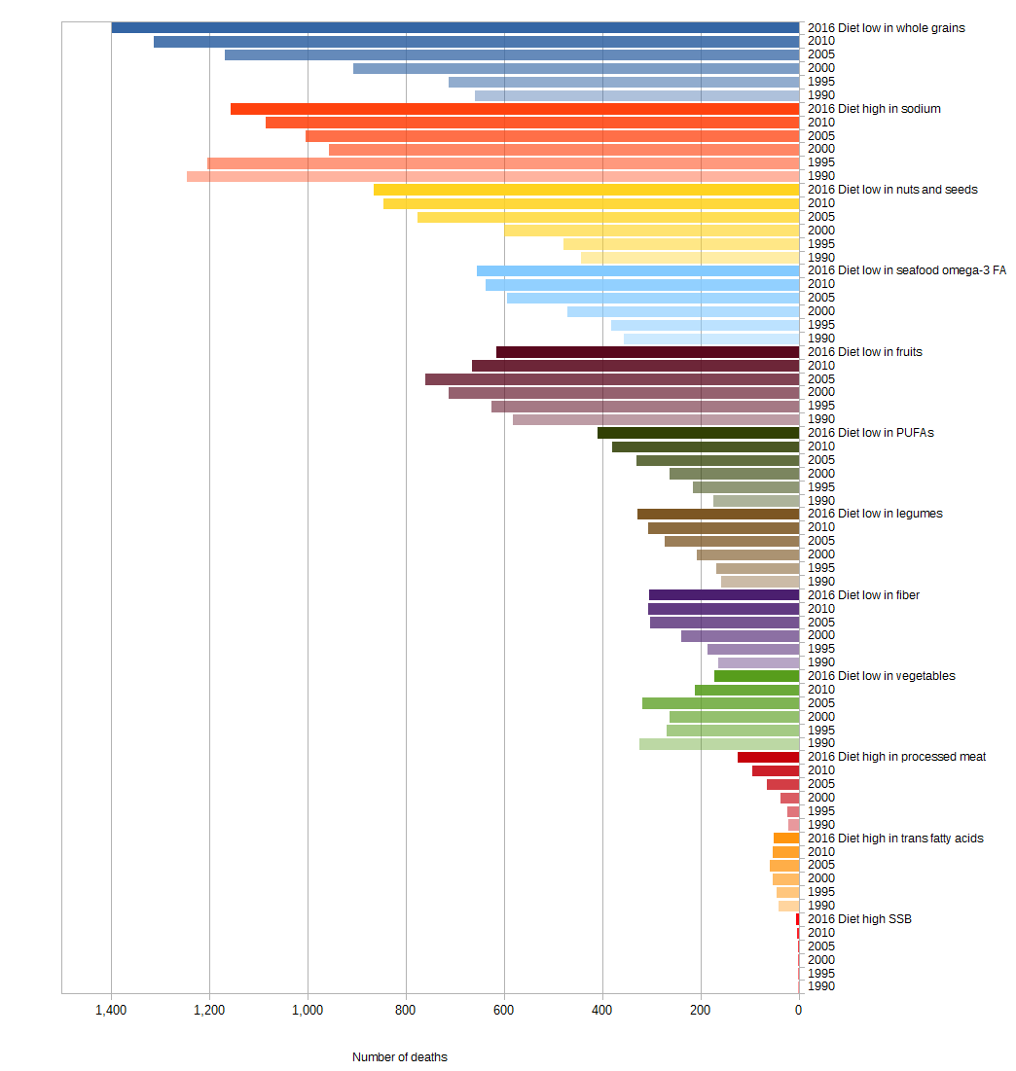
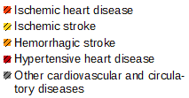
Albania
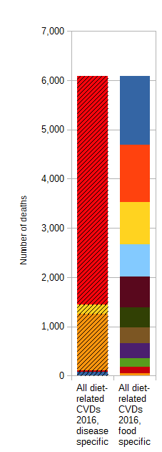
Figure 1 Diet-related CVD deaths from 1990 to 2016 in Albania

a) Male b) Female
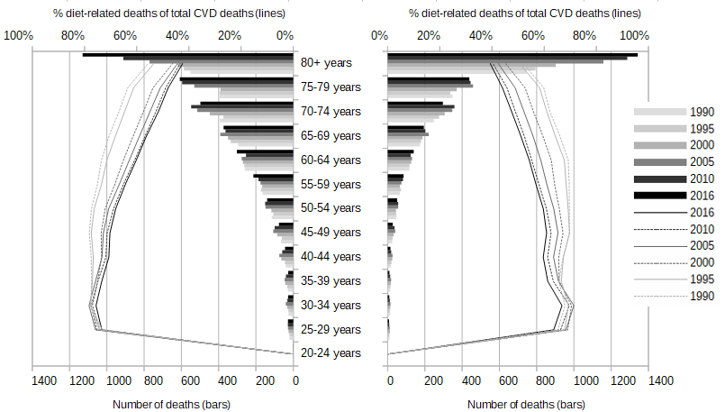
Figure 2 Age- and gender-specific diet-related CVD deaths (bars) and share of diet-related on total CVD deaths (lines) from 1990 to 2016 in Albania
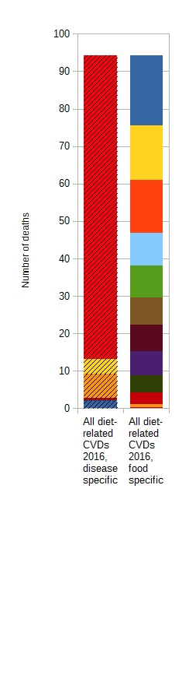
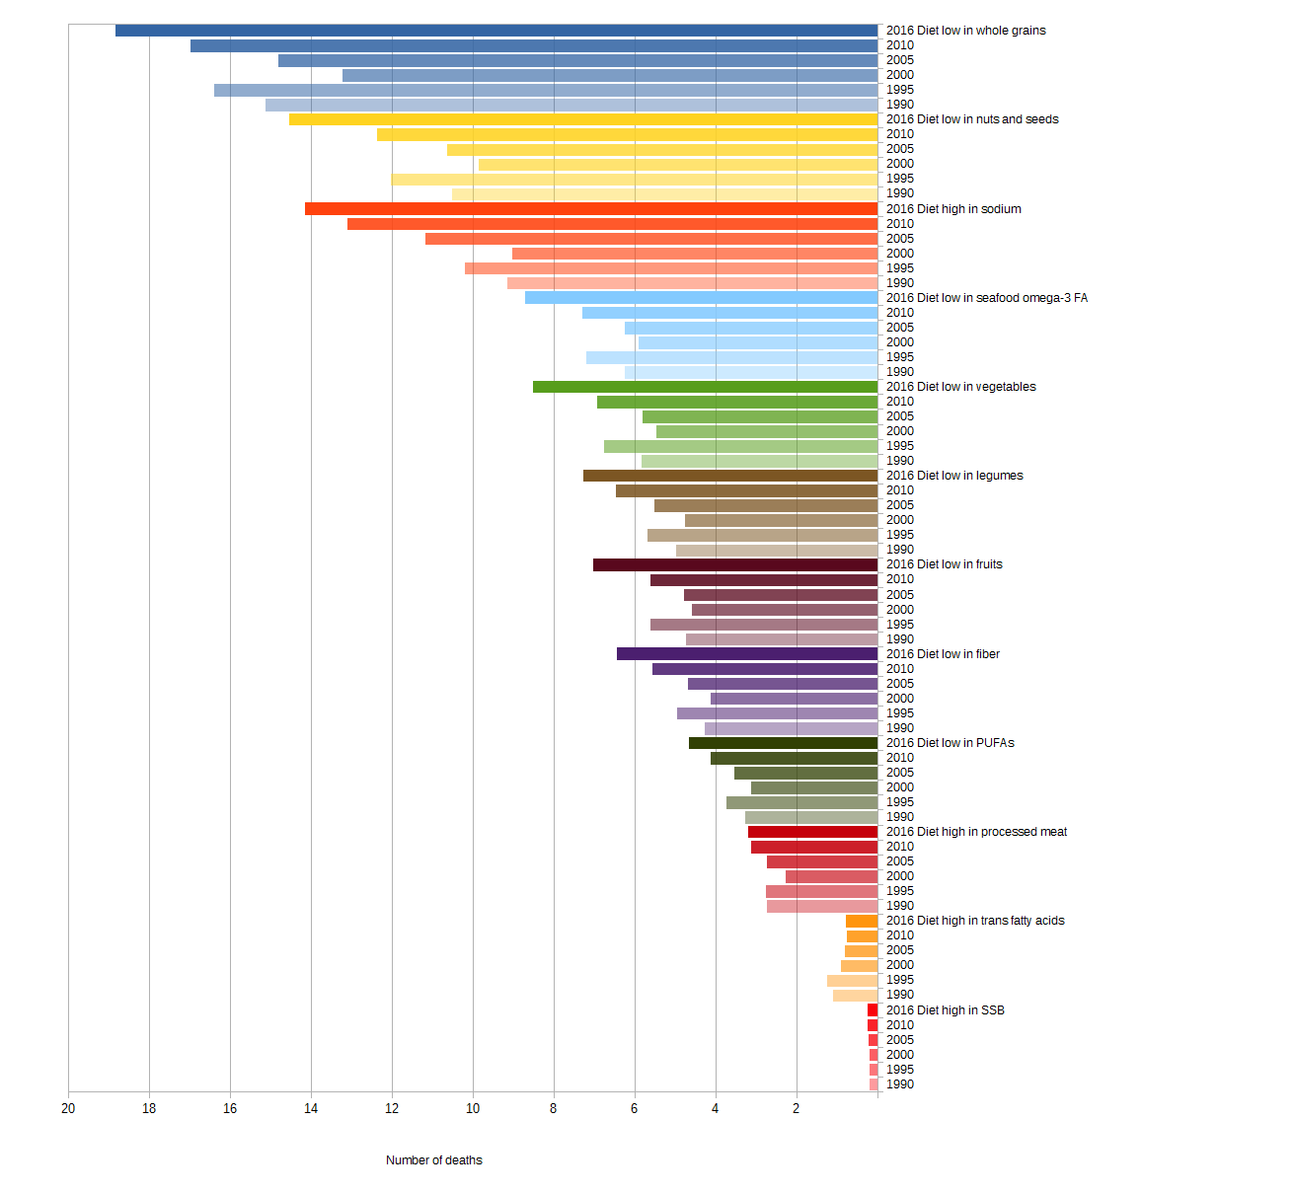
Andorra

Figure 3 Diet-related CVD deaths from 1990 to 2016 in Andorra

a) Male b) Female
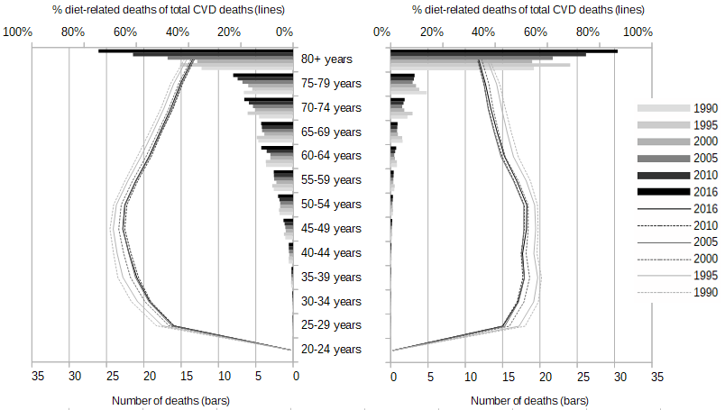
Figure 4 Age- and gender-specific diet-related CVD deaths (bars) and share of diet-related on total CVD deaths (lines) from 1990 to 2016 in Andorra
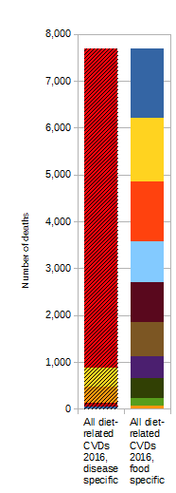
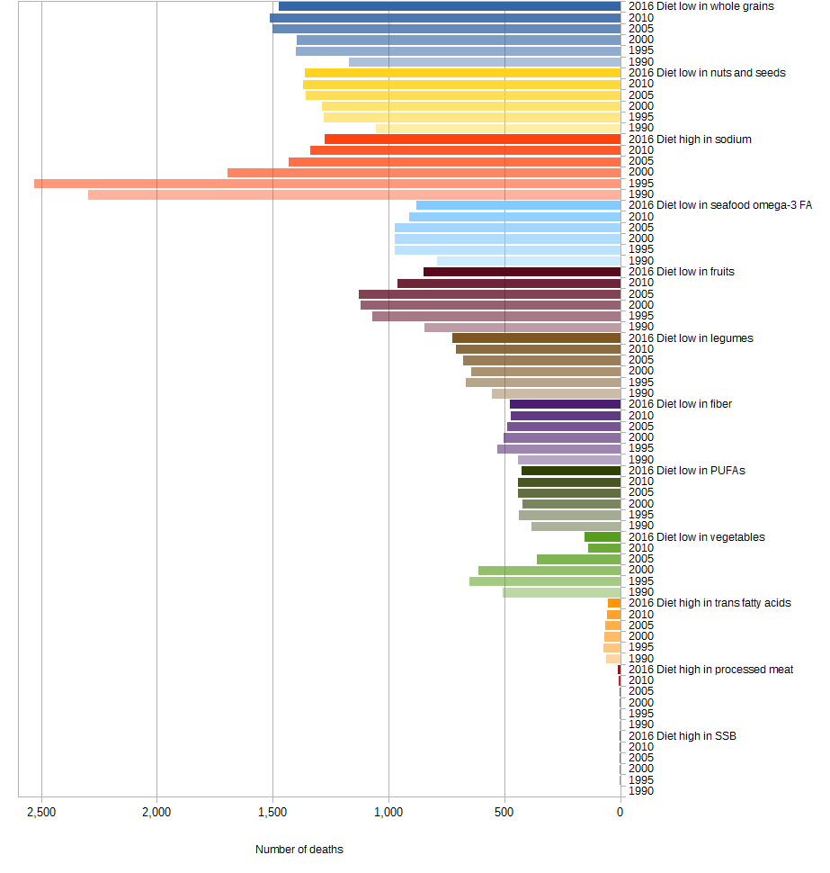
Armenia

Figure 5 Diet-related CVD deaths from 1990 to 2016 in Armenia

a) Male b) Female
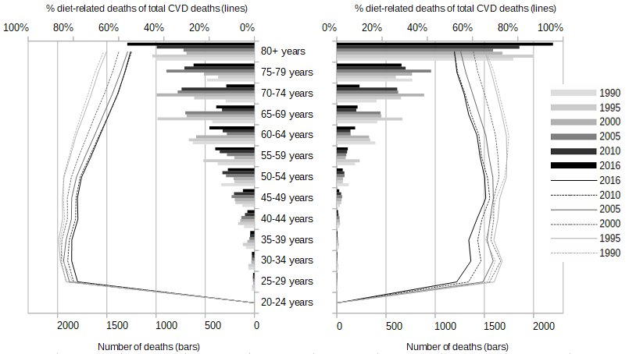
Figure 6 Age- and gender-specific diet-related CVD deaths (bars) and share of diet-related on total CVD deaths (lines) from 1990 to 2016 in Armenia
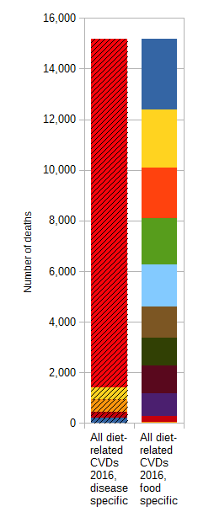
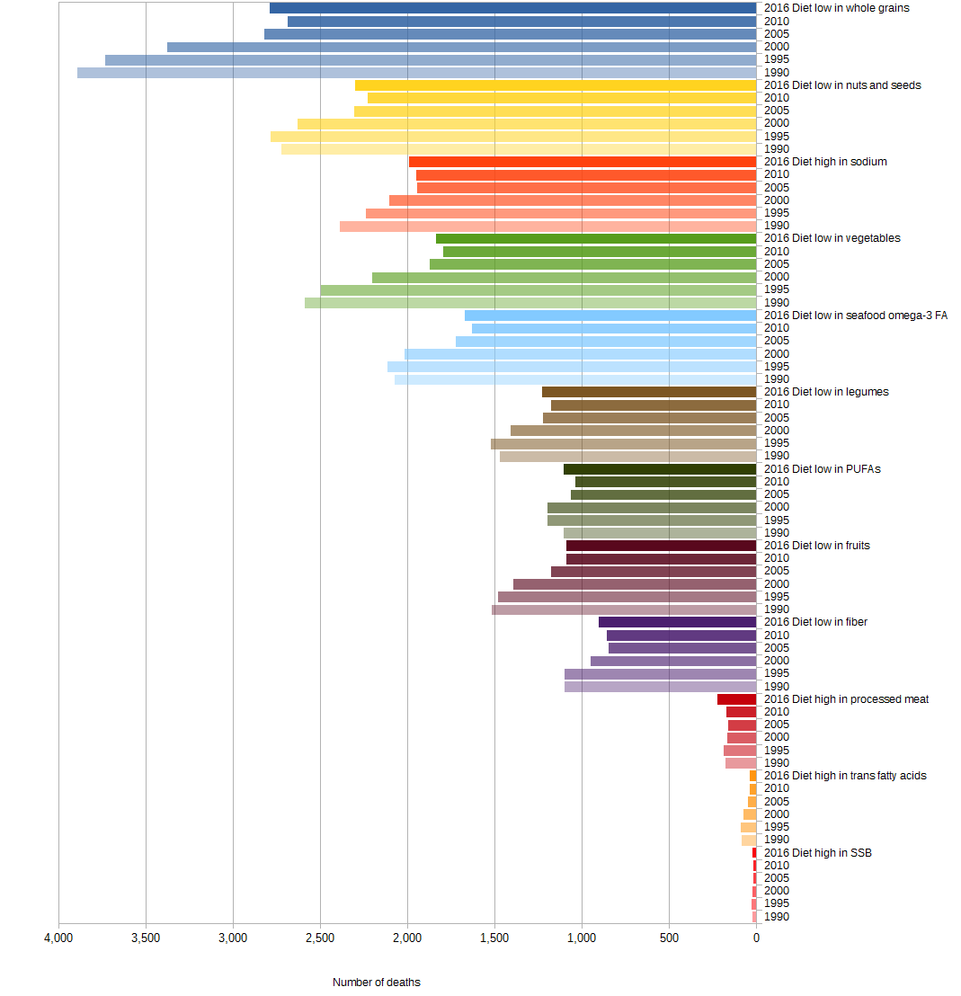
Austria

Figure 7 Diet-related CVD deaths from 1990 to 2016 in Austria

a) Male b) Female
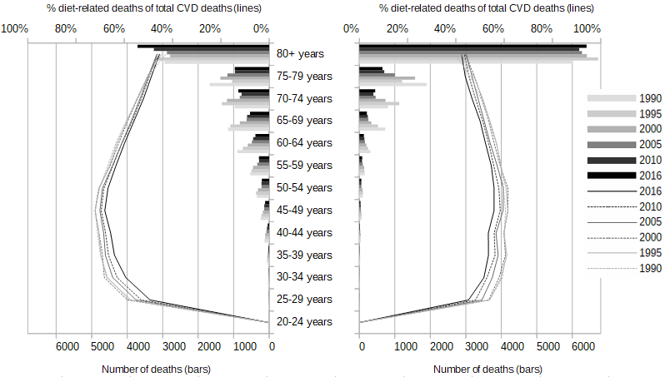
Figure 8 Age- and gender-specific diet-related CVD deaths (bars) and share of diet-related on total CVD deaths (lines) from 1990 to 2016 in Austria
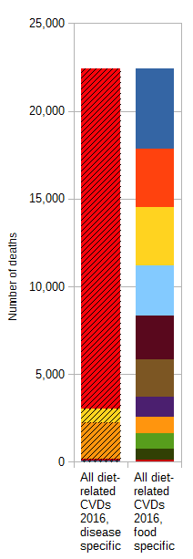
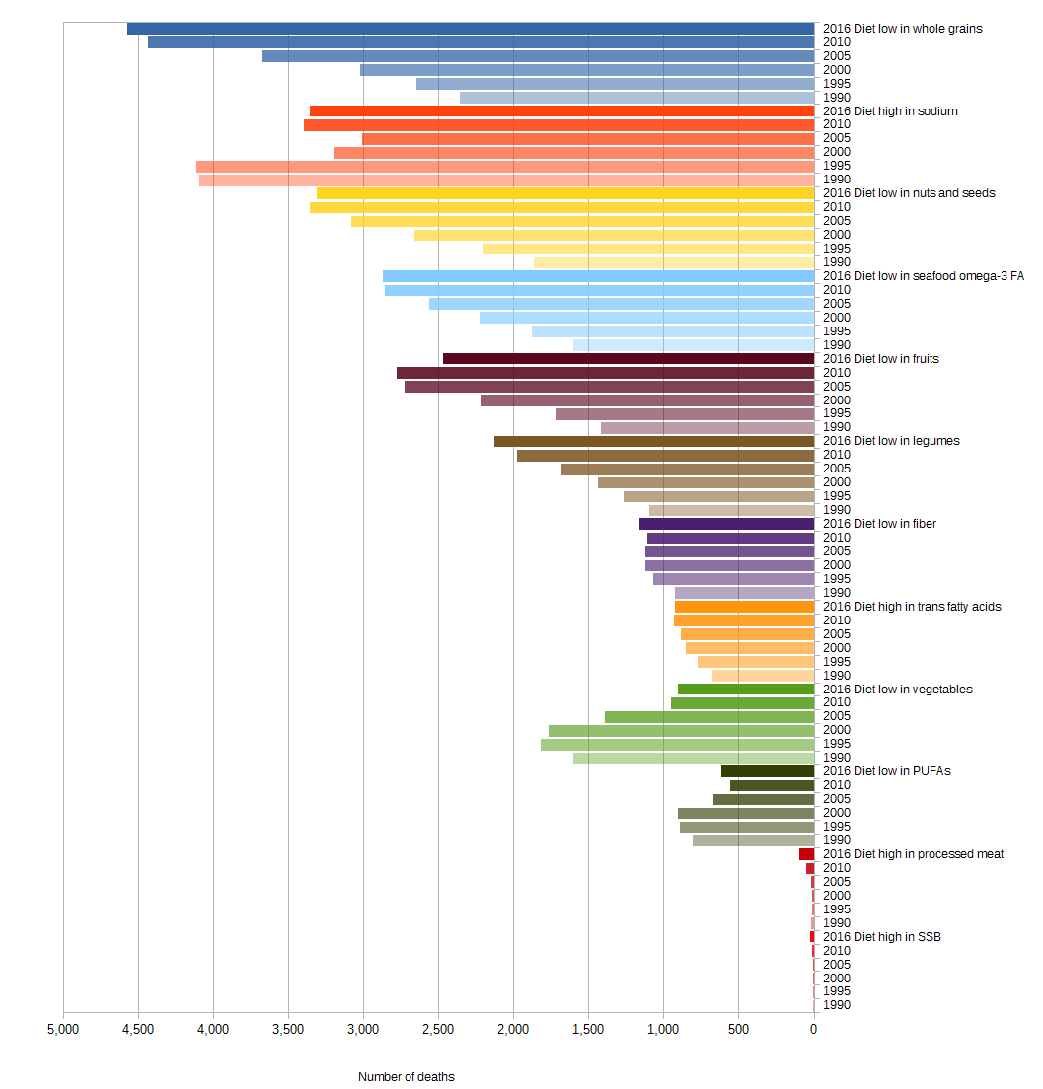
Azerbaijan

Figure 9 Diet-related CVD deaths from 1990 to 2016 in Azerbaijan

a) Male b) Female
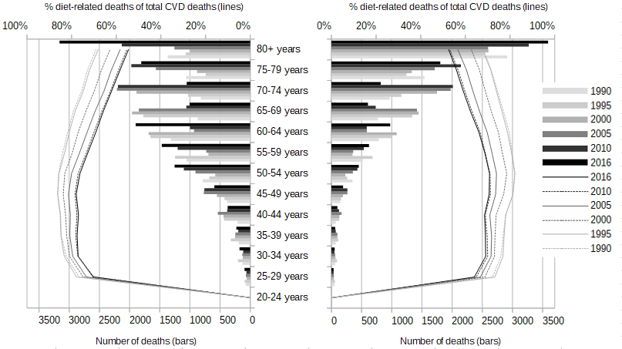
Figure 10 Age- and gender-specific diet-related CVD deaths (bars) and share of diet-related on total CVD deaths (lines) from 1990 to 2016 in Azerbaijan
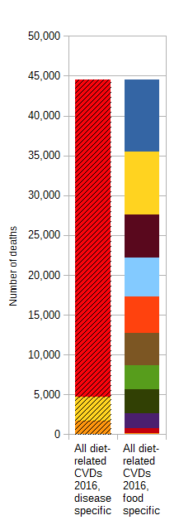
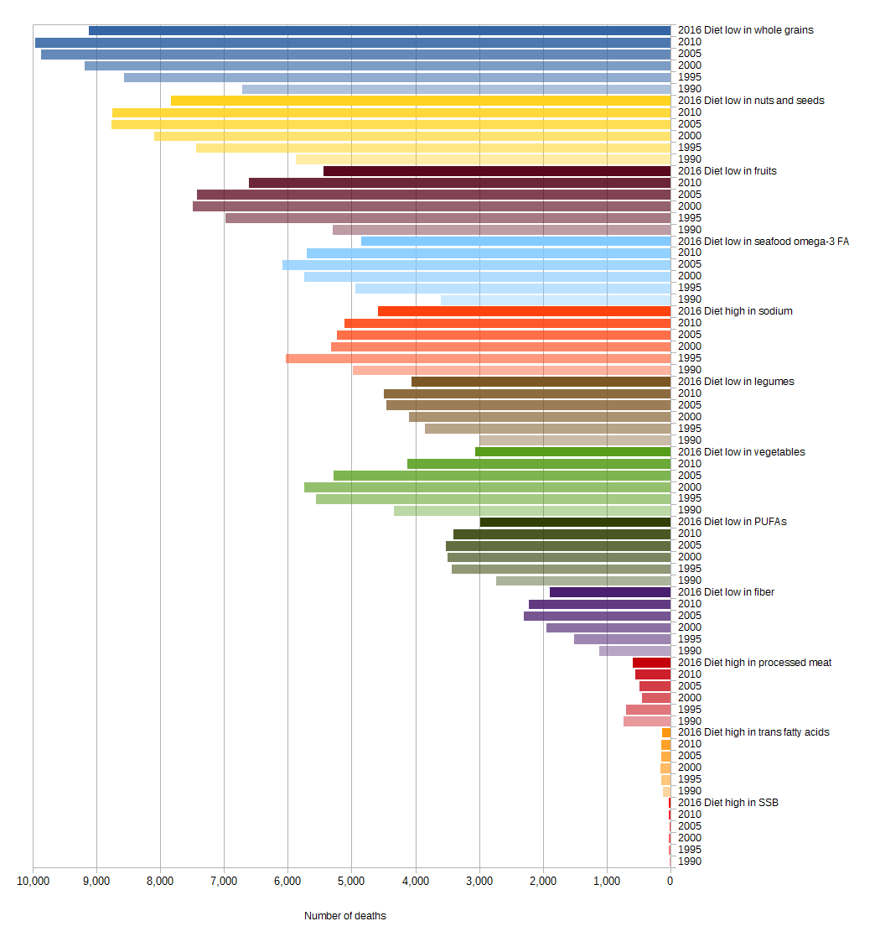
Belarus

Figure 11 Diet-related CVD deaths from 1990 to 2016 in Belarus

a) Male b) Female
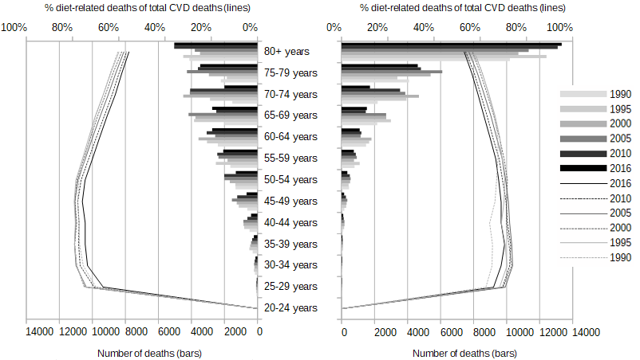

Figure 12 Age- and gender-specific diet-related CVD deaths (bars) and share of diet-related on total CVD deaths (lines) from 1990 to 2016 in Belarus
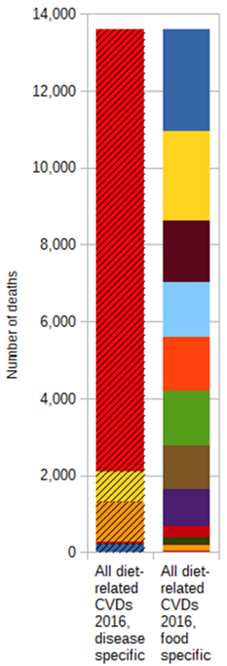
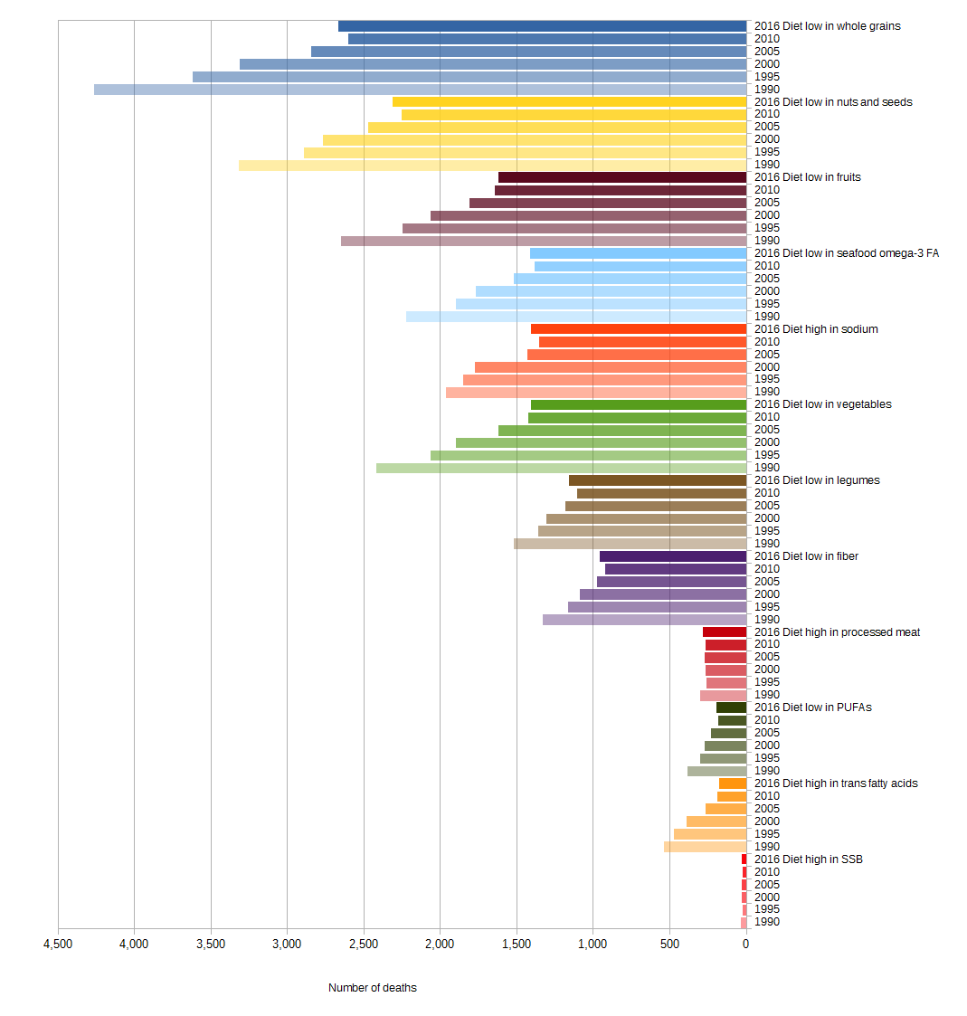
Belgium

Figure 13 Diet-related CVD deaths from 1990 to 2016 in Belgium

a) Male b) Female
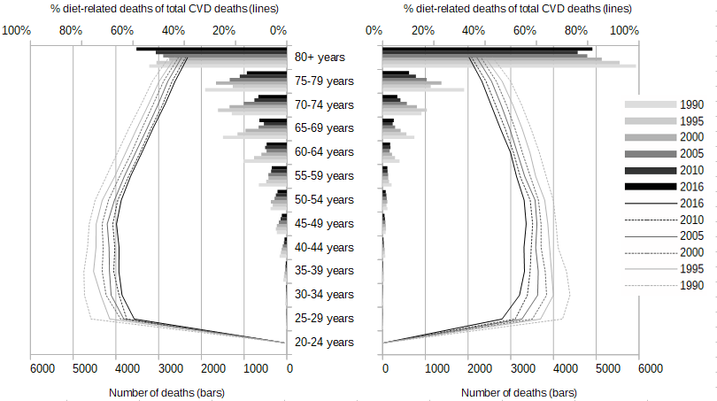
Figure 14 Age- and gender-specific diet-related CVD deaths (bars) and share of diet-related on total CVD deaths (lines) from 1990 to 2016 in Belgium
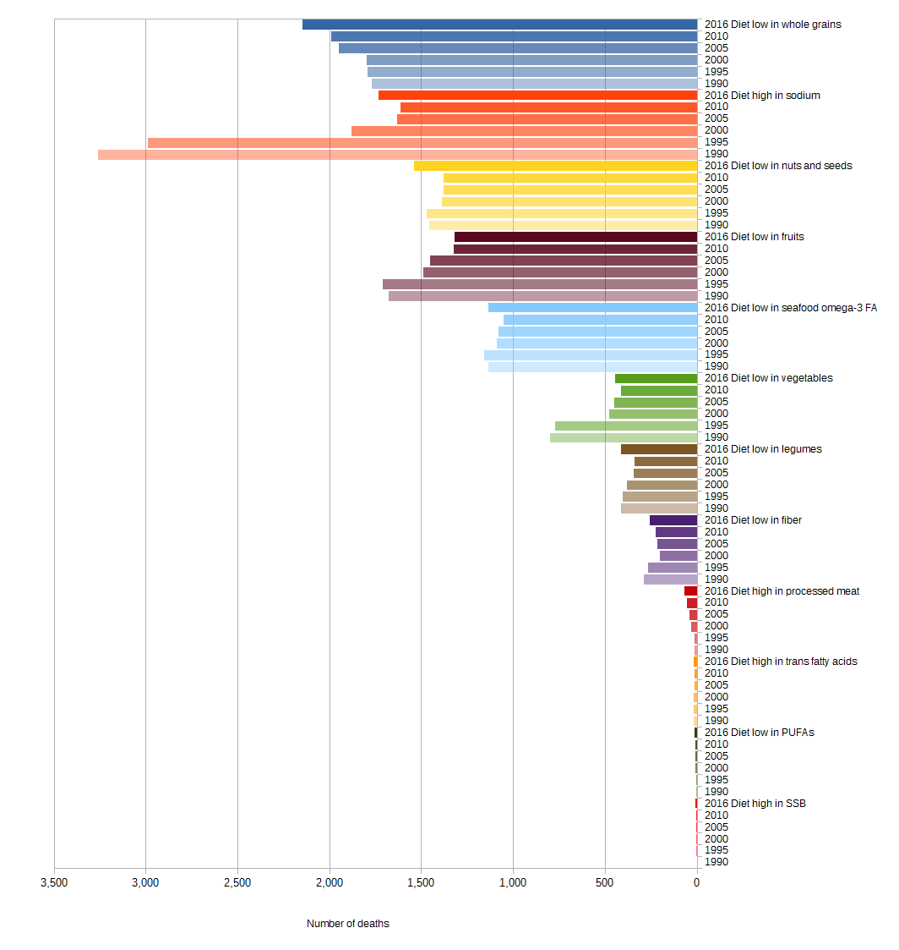
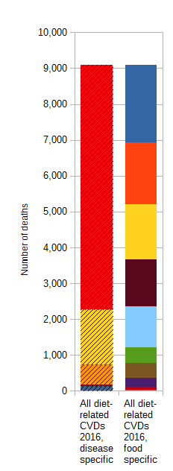
Bosnia and Herzegovina

Figure 15 Diet-related CVD deaths from 1990 to 2016 in Bosnia and Herzegovina

a) Male b) Female
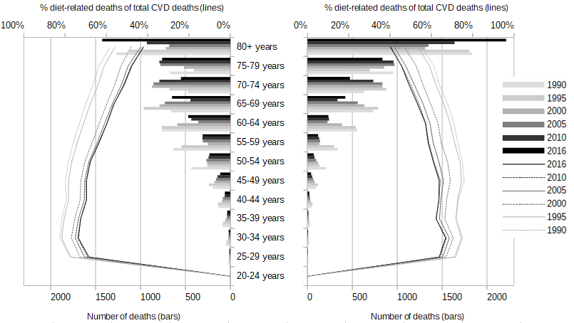
Figure 16 Age- and gender-specific diet-related CVD deaths (bars) and share of diet-related on total CVD deaths (lines) from 1990 to 2016 in Bosnia and Herzegovina
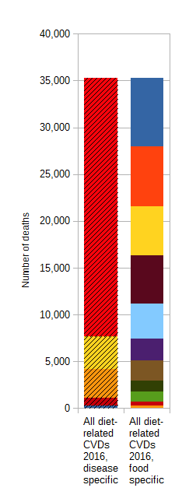
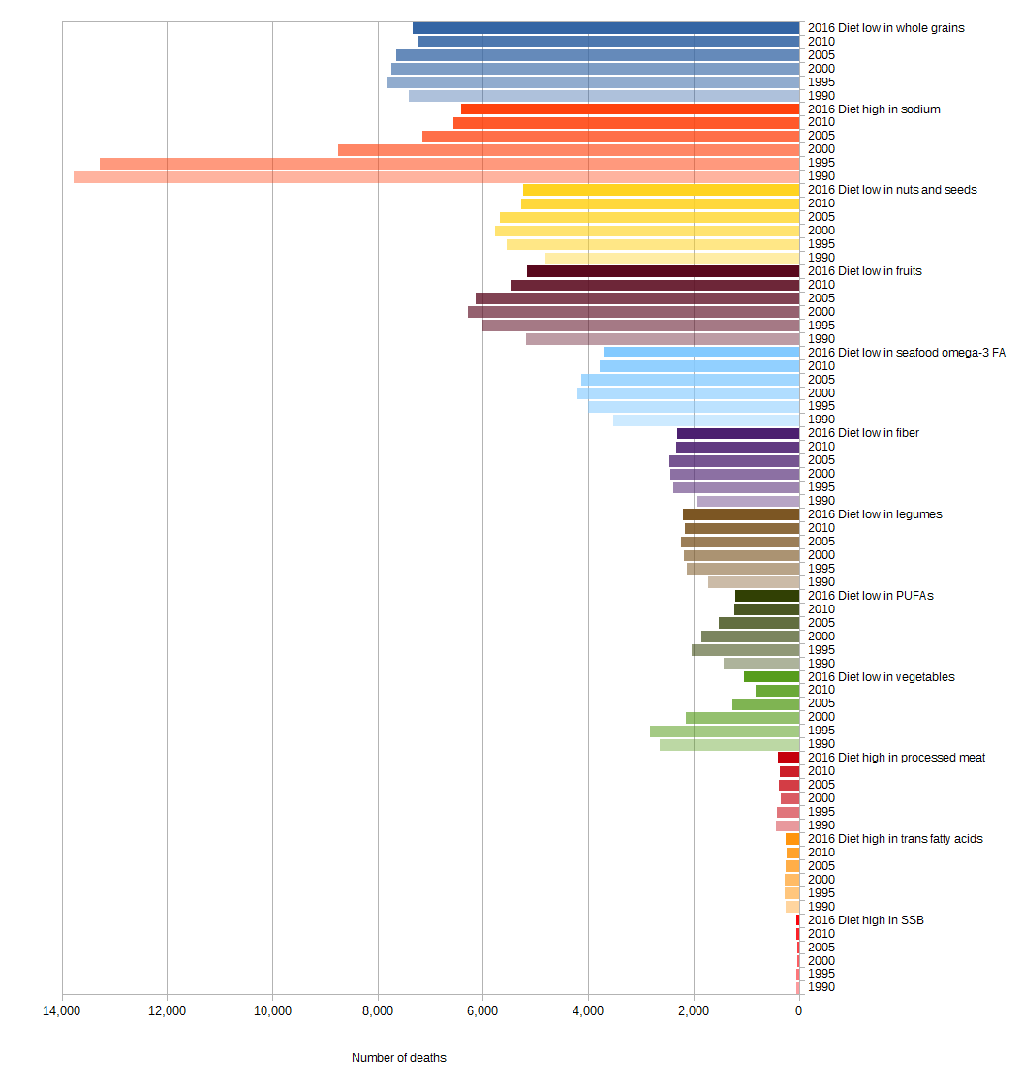
Bulgaria

Figure 17 Diet-related CVD deaths from 1990 to 2016 in Bulgaria

a) Male b) Female
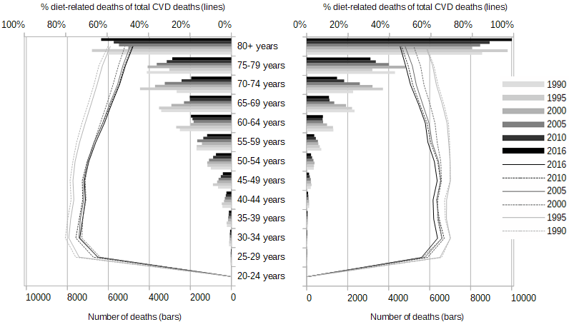
Figure 18 Age- and gender-specific diet-related CVD deaths (bars) and share of diet-related on total CVD deaths (lines) from 1990 to 2016 in Bulgaria
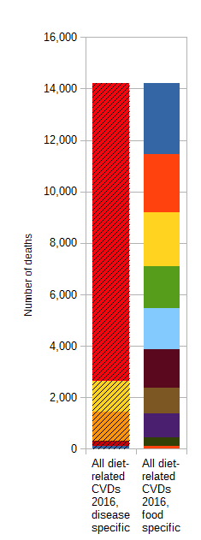
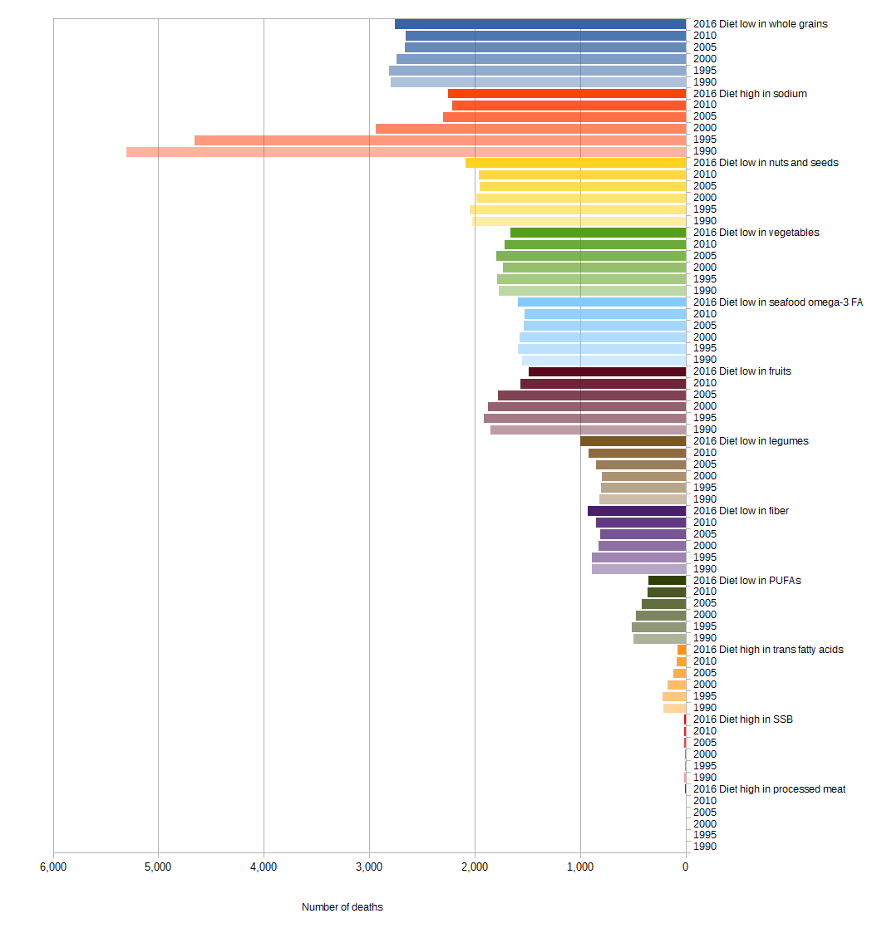
Croatia

Figure 19 Diet-related CVD deaths from 1990 to 2016 in Croatia

a) Male b) Female
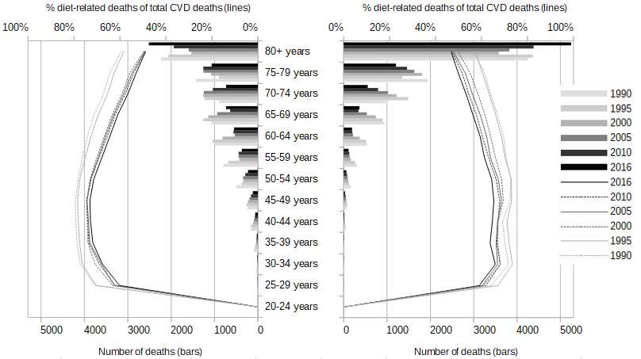
Figure 20 Age- and gender-specific diet-related CVD deaths (bars) and share of diet-related on total CVD deaths (lines) from 1990 to 2016 in Croatia
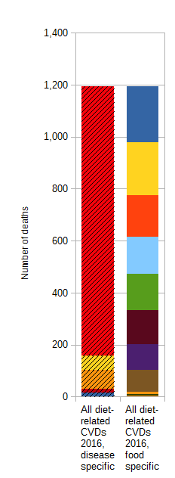
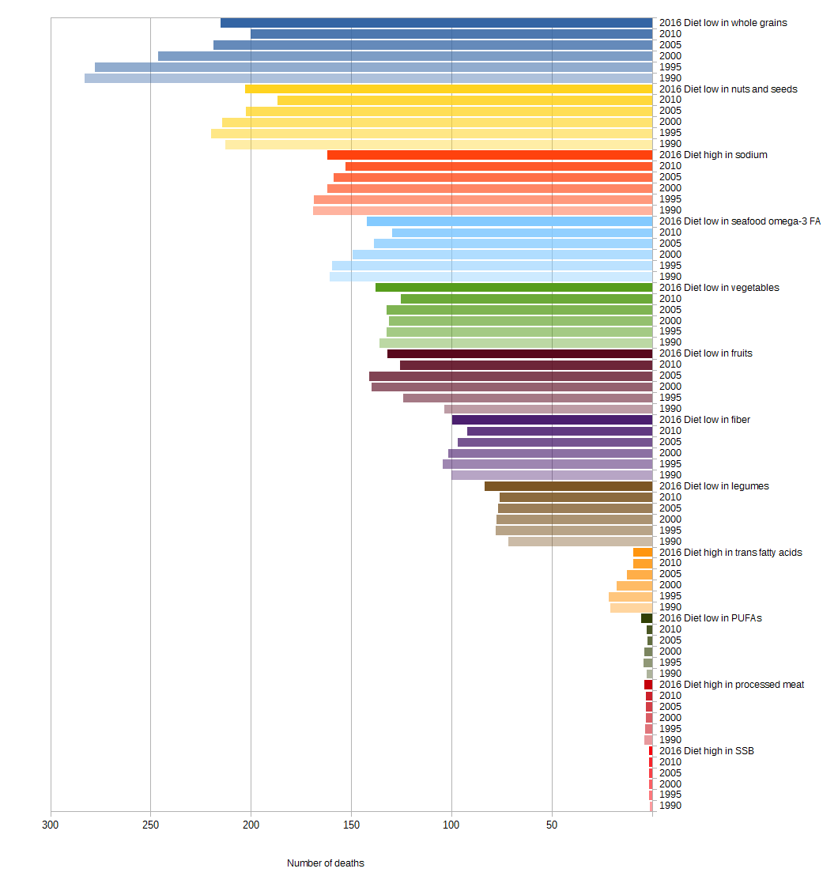
Cyprus

Figure 21 Diet-related CVD deaths from 1990 to 2016 in Cyprus

a) Male b) Female
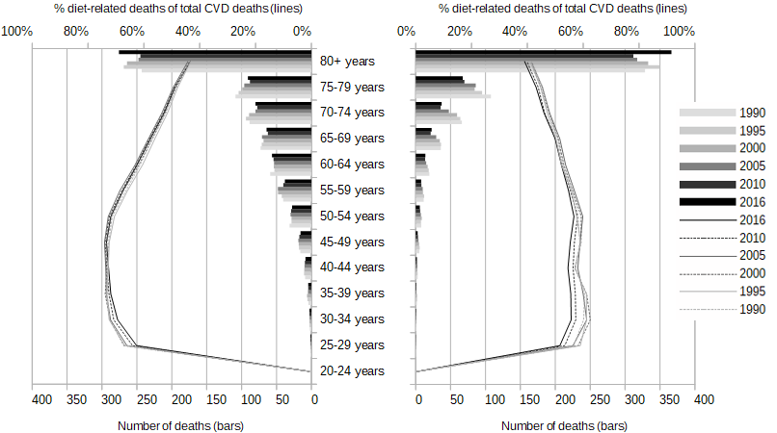
Figure 22 Age- and gender-specific diet-related CVD deaths (bars) and share of diet-related on total CVD deaths (lines) from 1990 to 2016 in Cyprus
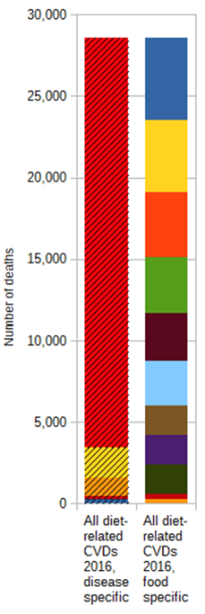
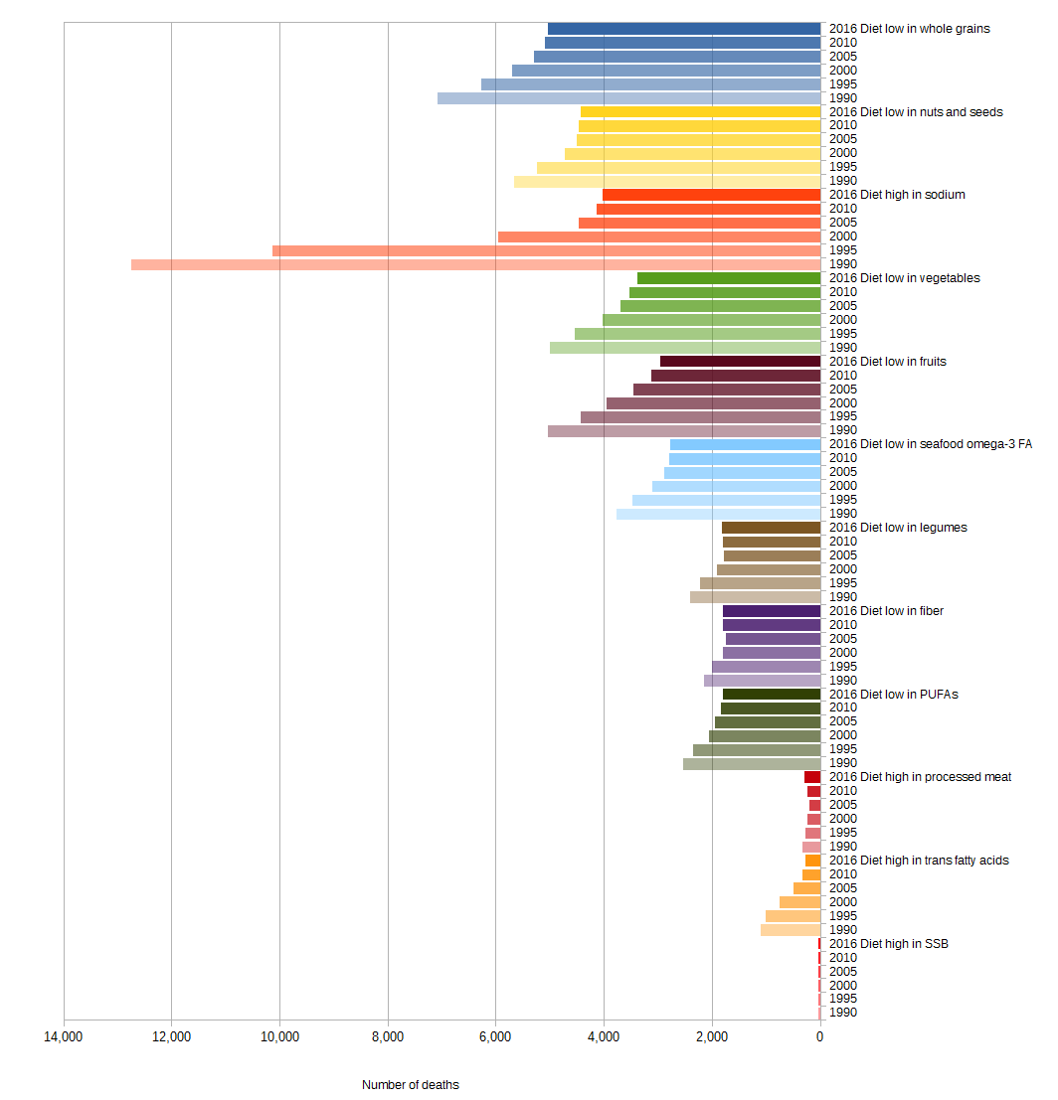
Czech Republic

Figure 23 Diet-related CVD deaths from 1990 to 2016 in the Czech Republic

a) Male b) Female
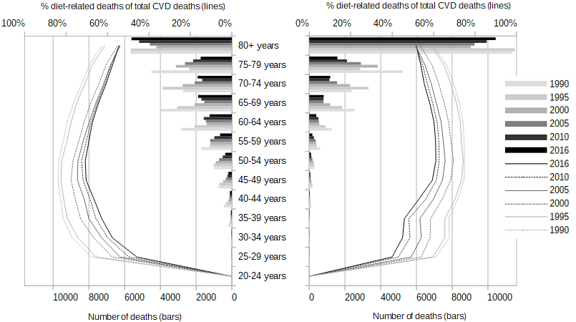
Figure 24 Age- and gender-specific diet-related CVD deaths (bars) and share of diet-related on total CVD deaths (lines) from 1990 to 2016 in the Czech Republic
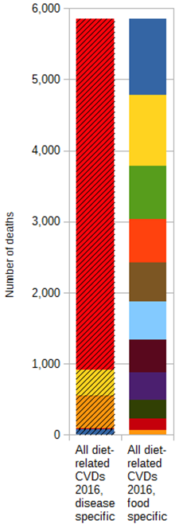
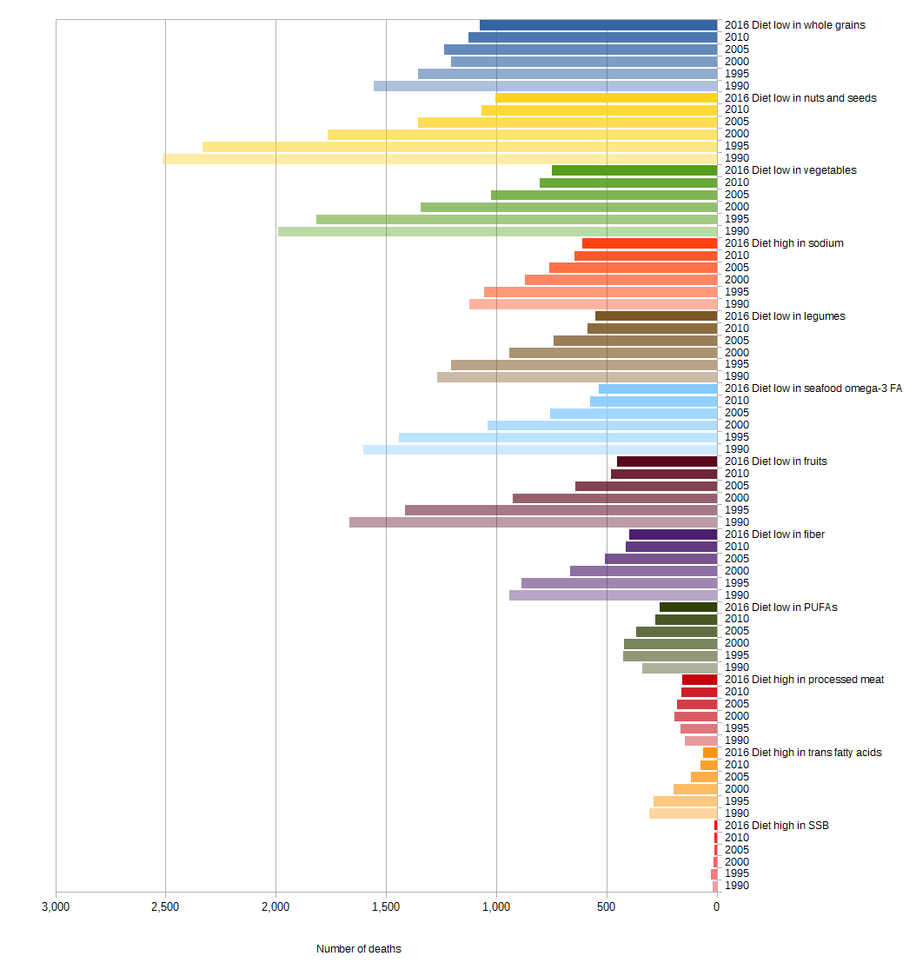
Denmark

Figure 25 Diet-related CVD deaths from 1990 to 2016 in Denmark

a) Male b) Female
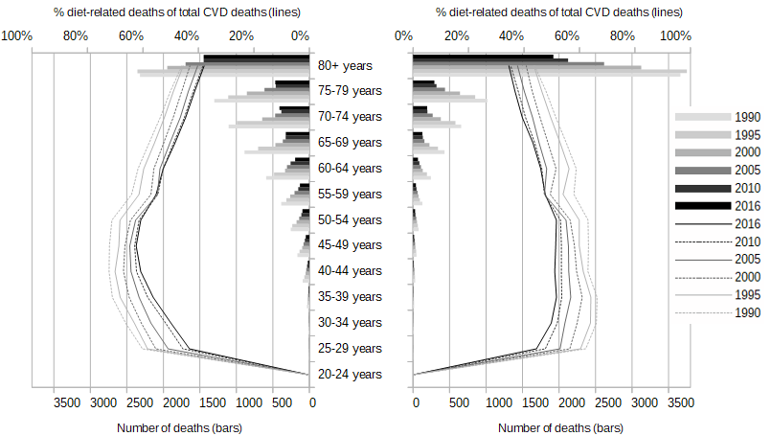
Figure 26 Age- and gender-specific diet-related CVD deaths (bars) and share of diet-related on total CVD deaths (lines) from 1990 to 2016 in Denmark
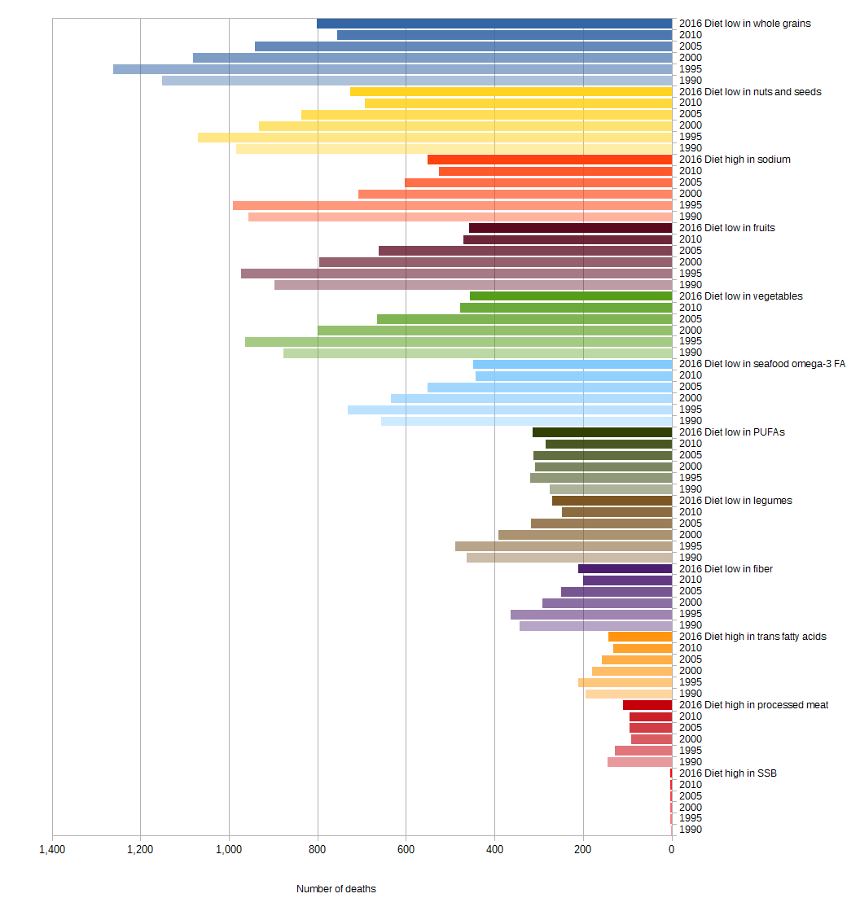
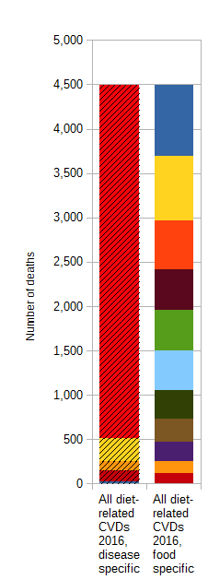
Estonia

Figure 27 Diet-related CVD deaths from 1990 to 2016 in Estonia

a) Male b) Female
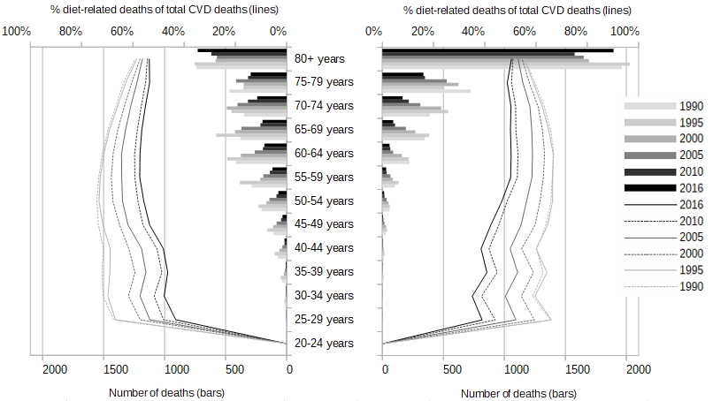
Figure 28 Age- and gender-specific diet-related CVD deaths (bars) and share of diet-related on total CVD deaths (lines) from 1990 to 2016 in Estonia
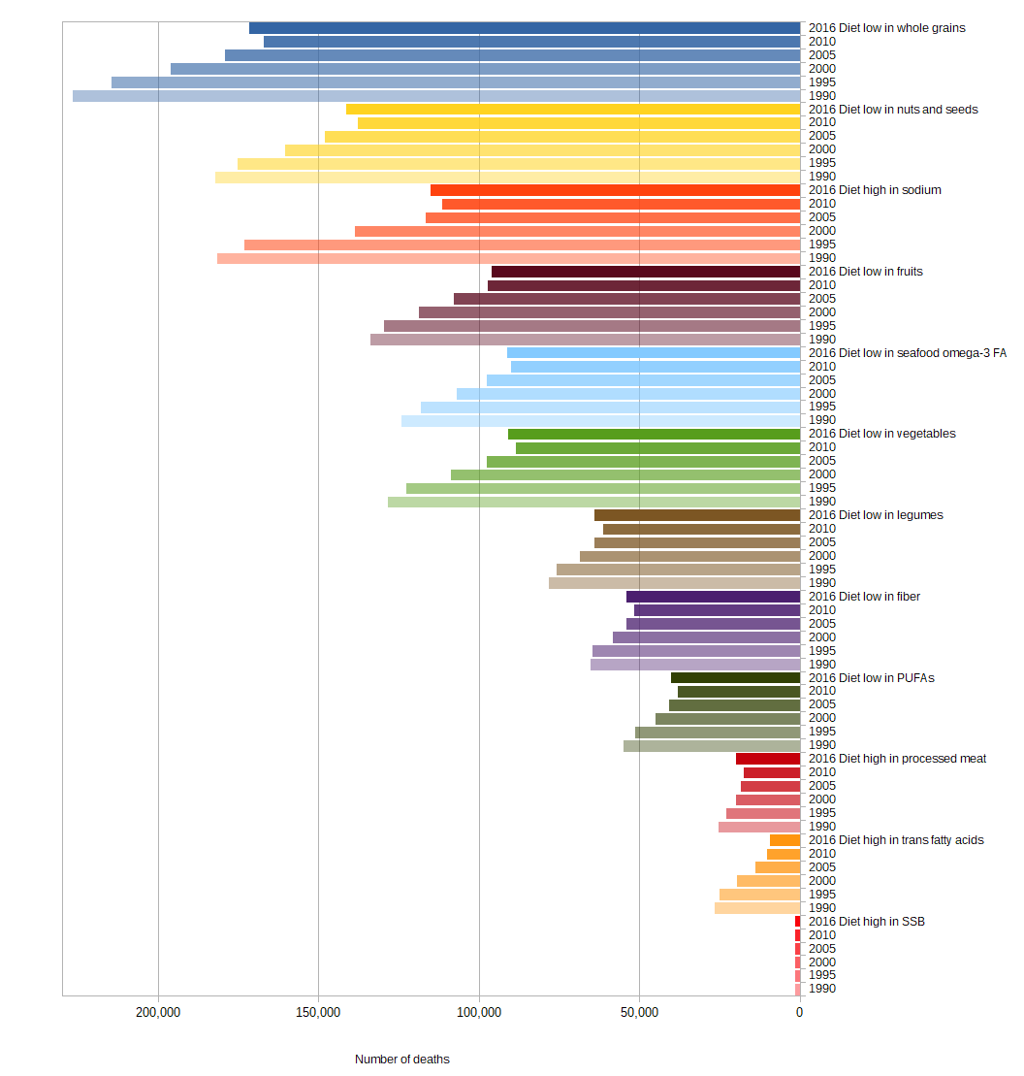
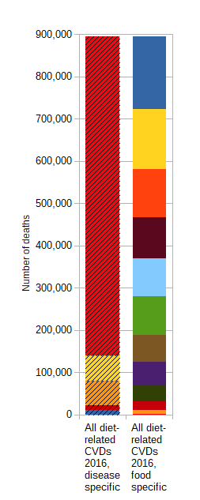
EU-28

Figure 29 Diet-related CVD deaths from 1990 to 2016 in the EU-28

a) Male b) Female
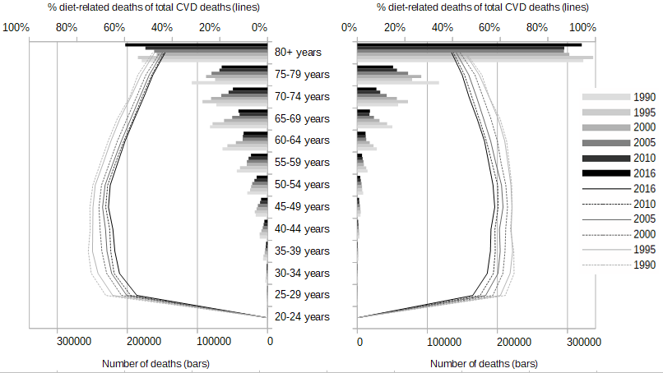
Figure 30 Age- and gender-specific diet-related CVD deaths (bars) and share of diet-related on total CVD deaths (lines) from 1990 to 2016 in the EU-28
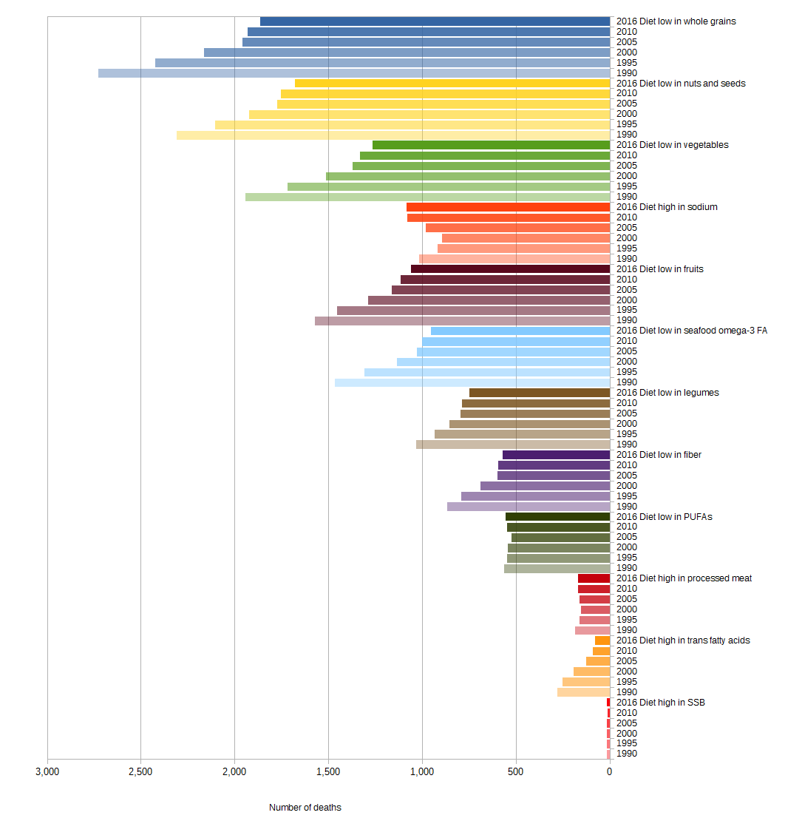
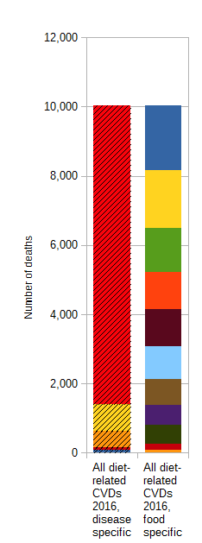
Finland

Figure 31 Diet-related CVD deaths from 1990 to 2016 in Finland

a) Male b) Female
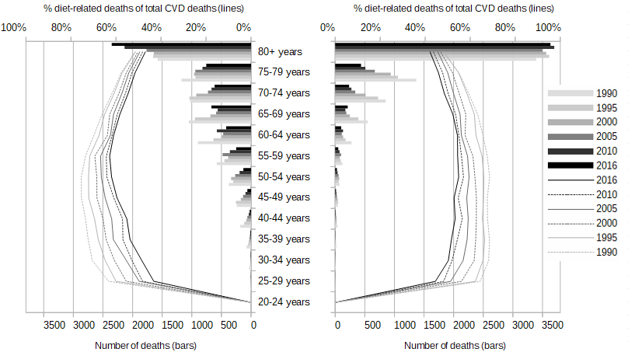
Figure 32 Age- and gender-specific diet-related CVD deaths (bars) and share of diet-related on total CVD deaths (lines) from 1990 to 2016 in Finland
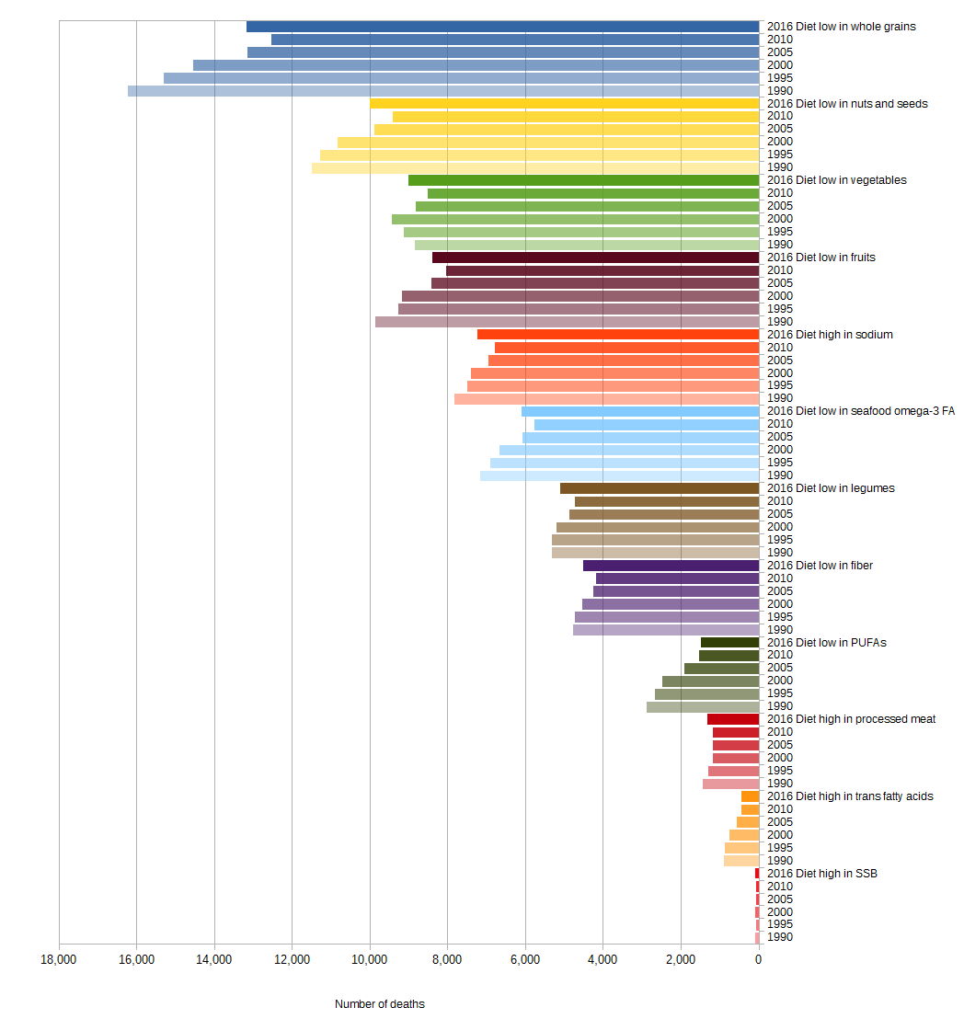
France
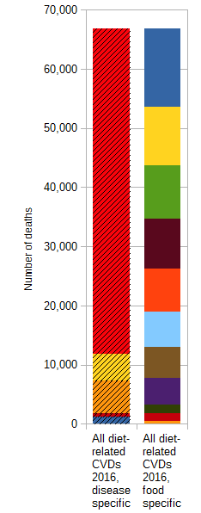
Figure 33 Diet-related CVD deaths from 1990 to 2016 in France

a) Male b) Female
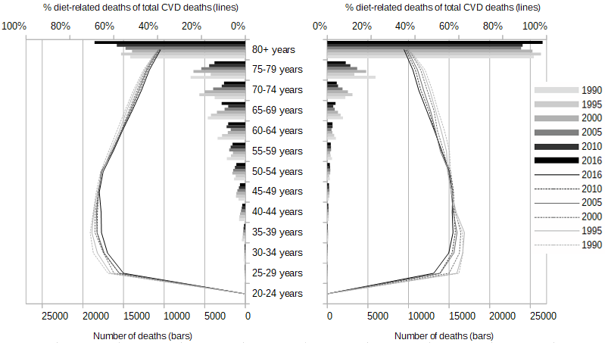
Figure 34 Age- and gender-specific diet-related CVD deaths (bars) and share of diet-related on total CVD deaths (lines) from 1990 to 2016 in France
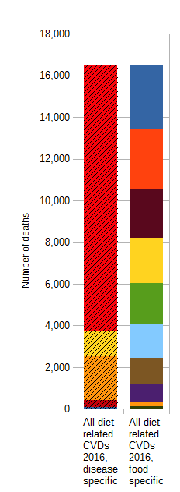
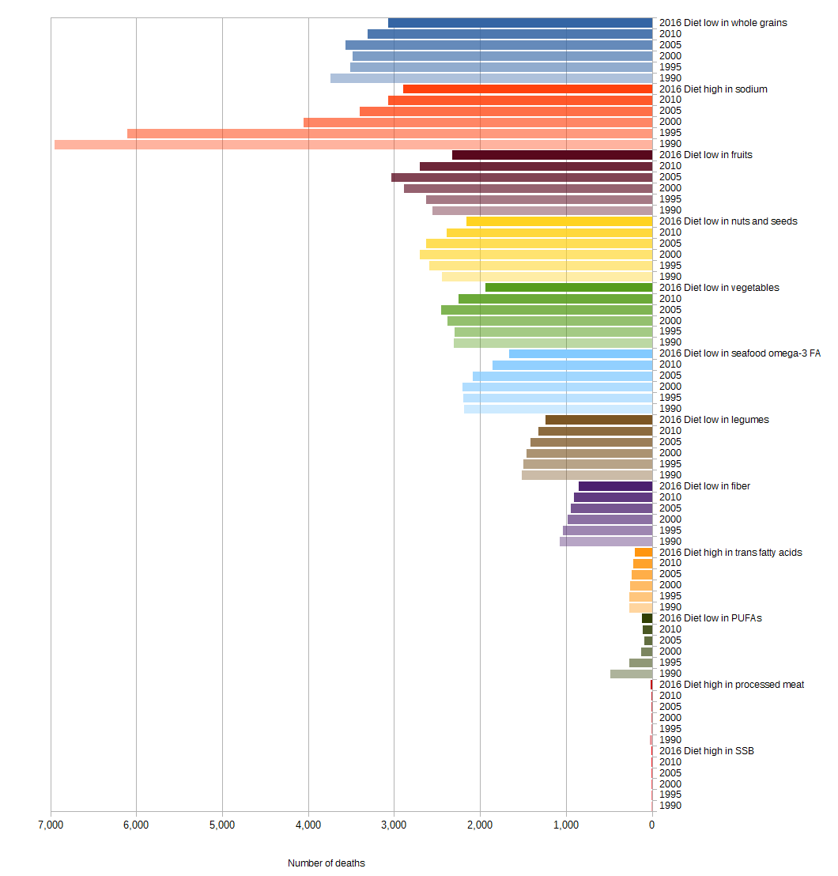
Georgia

Figure 35 Diet-related CVD deaths from 1990 to 2016 in Georgia

a) Male b) Female
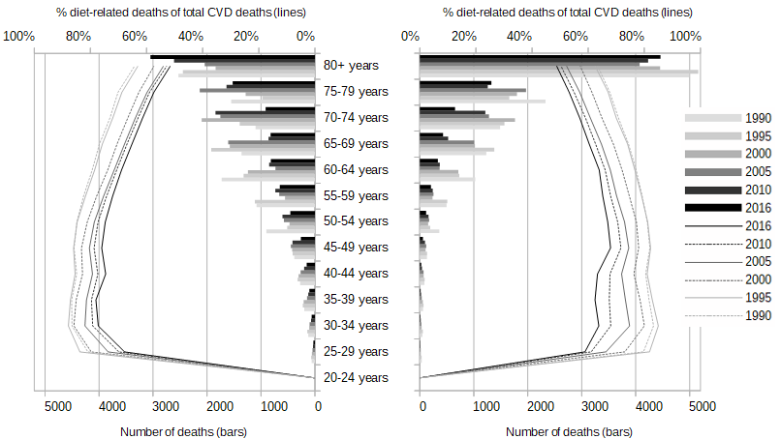
Figure 36 Age- and gender-specific diet-related CVD deaths (bars) and share of diet-related on total CVD deaths (lines) from 1990 to 2016 in Georgia
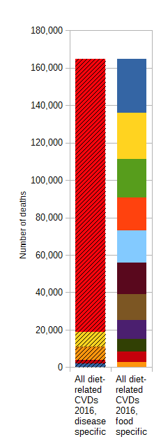
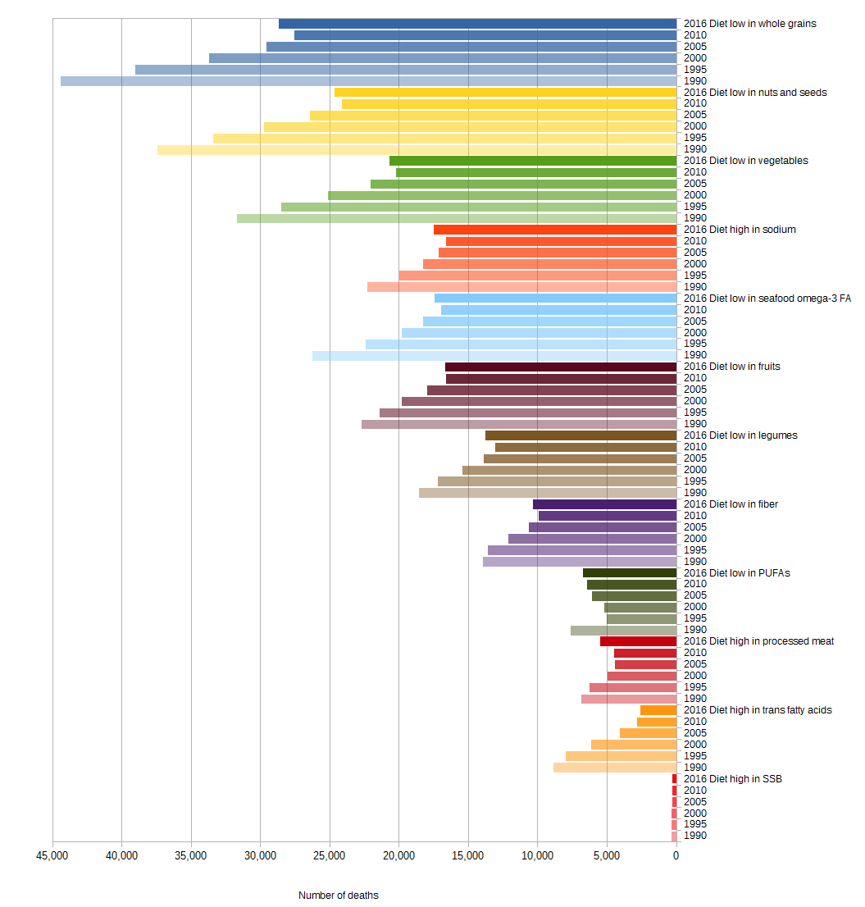
Germany

Figure 37 Diet-related CVD deaths from 1990 to 2016 in Germany

a) Male b) Female
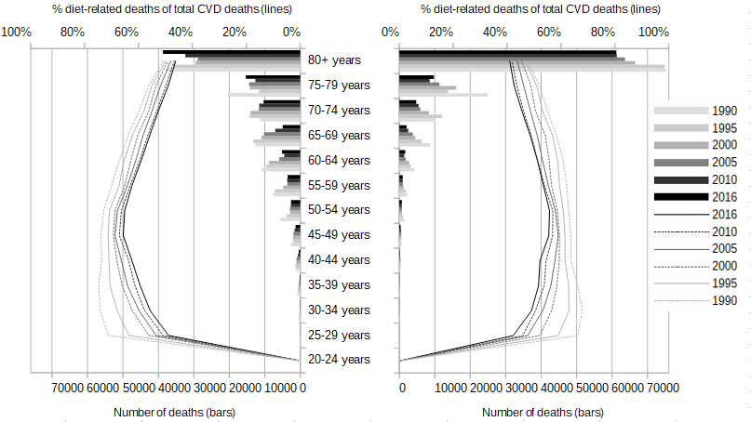
Figure 38 Age- and gender-specific diet-related CVD deaths (bars) and share of diet-related on total CVD deaths (lines) from 1990 to 2016 in Germany
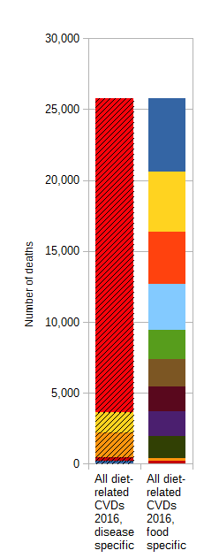
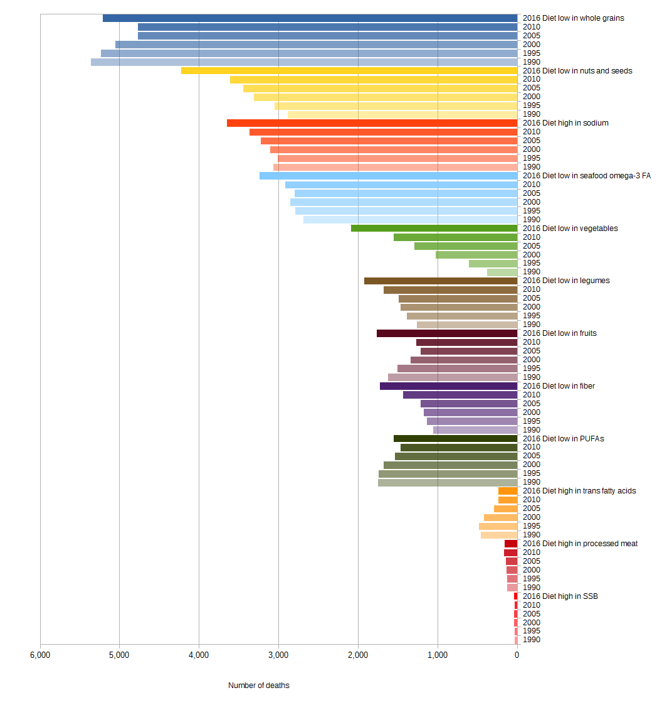
Greece

Figure 39 Diet-related CVD deaths from 1990 to 2016 in Greece

a) Male b) Female
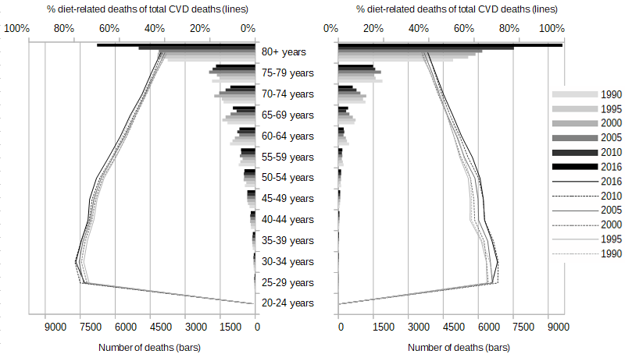
Figure 40 Age- and gender-specific diet-related CVD deaths (bars) and share of diet-related on total CVD deaths (lines) from 1990 to 2016 in Greece
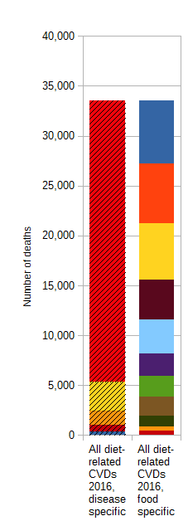
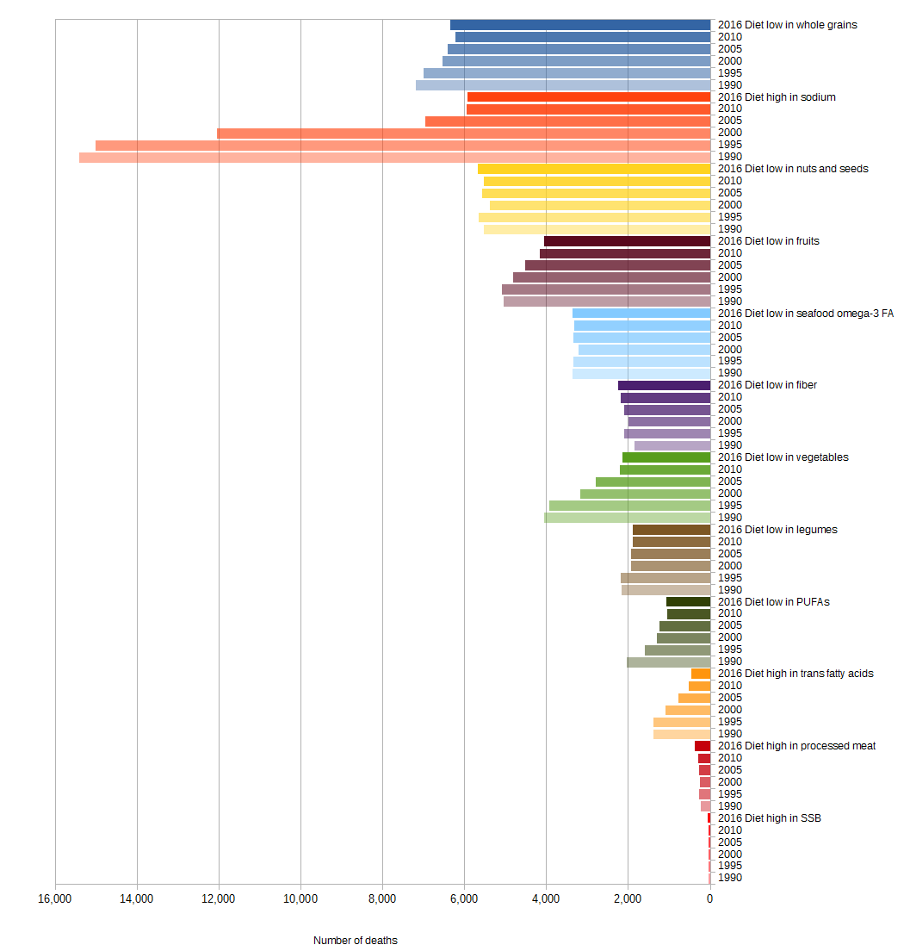
Hungary

Figure 41 Diet-related CVD deaths from 1990 to 2016 in Hungary

a) Male b) Female
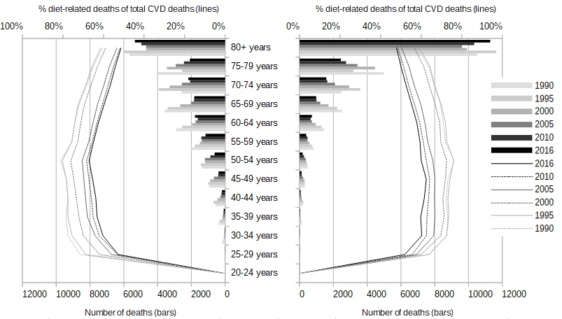
Figure 42 Age- and gender-specific diet-related CVD deaths (bars) and share of diet-related on total CVD deaths (lines) from 1990 to 2016 in Hungary
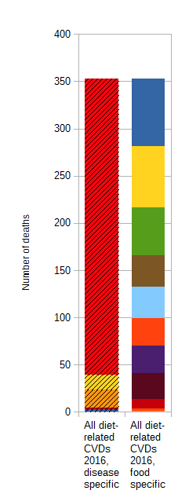
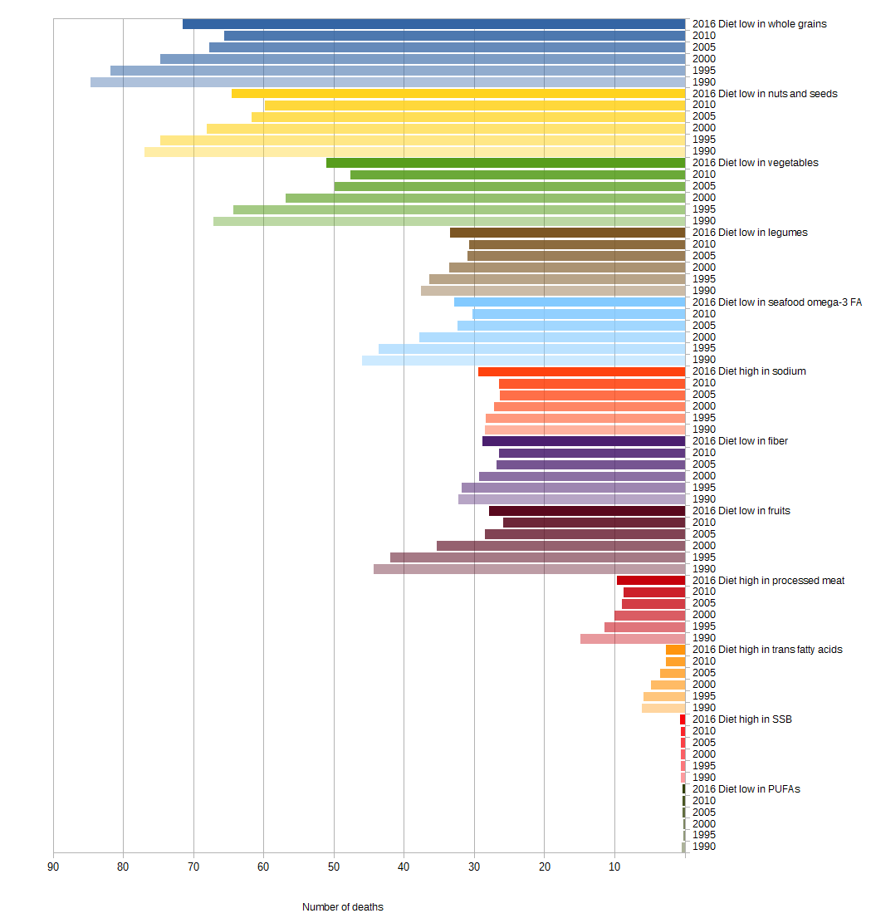
Iceland

Figure 43 Diet-related CVD deaths from 1990 to 2016 in Iceland

a) Male b) Female
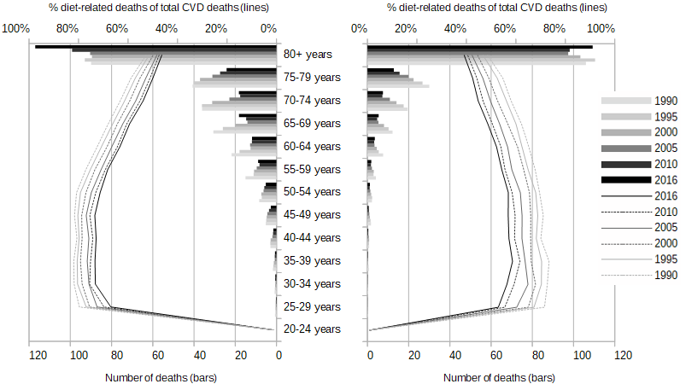
Figure 44 Age- and gender-specific diet-related CVD deaths (bars) and share of diet-related on total CVD deaths (lines) from 1990 to 2016 in Iceland
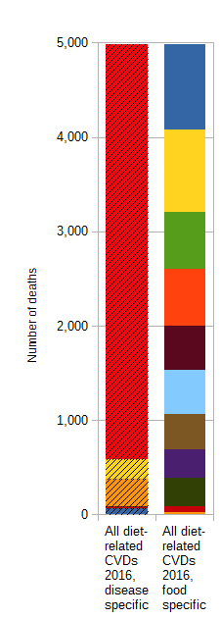
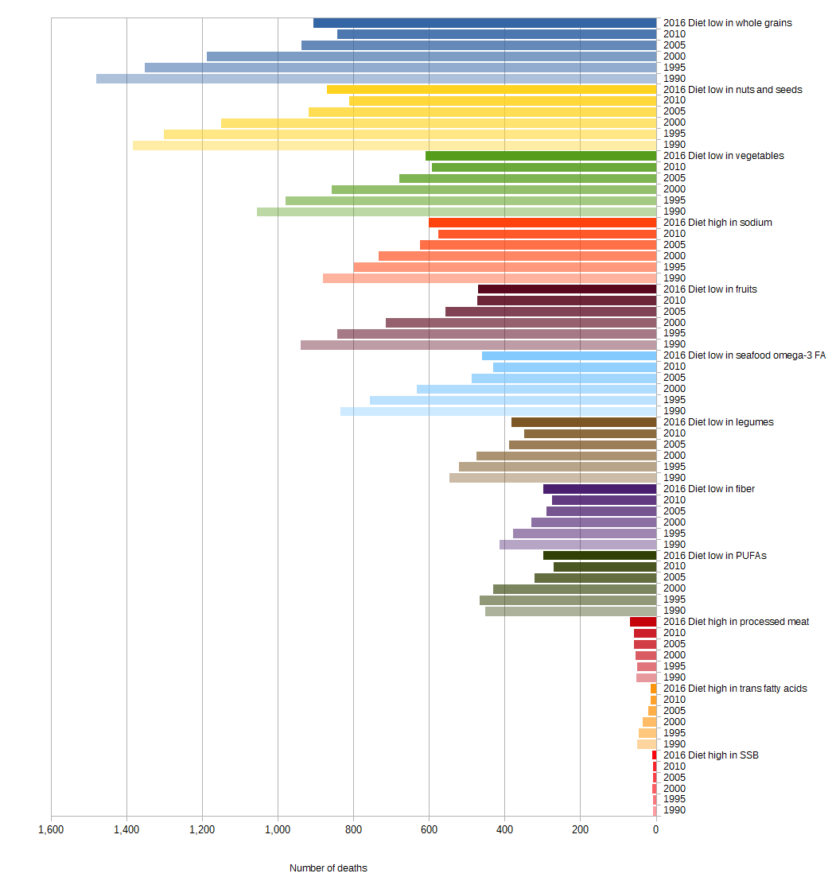
Ireland

Figure 45 Diet-related CVD deaths from 1990 to 2016 in Ireland

a) Male b) Female
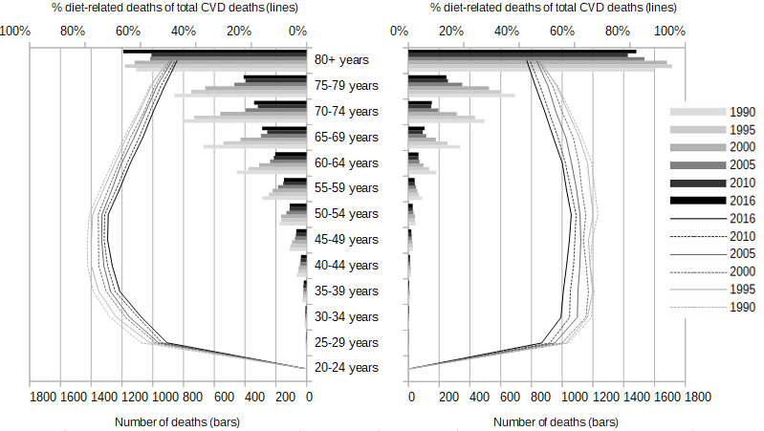
Figure 46 Age- and gender-specific diet-related CVD deaths (bars) and share of diet-related on total CVD deaths (lines) from 1990 to 2016 in Ireland
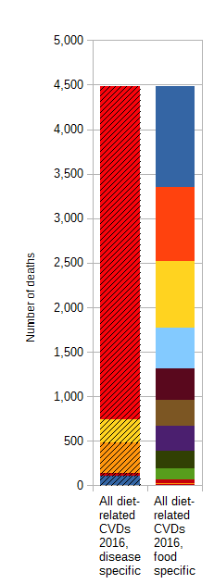
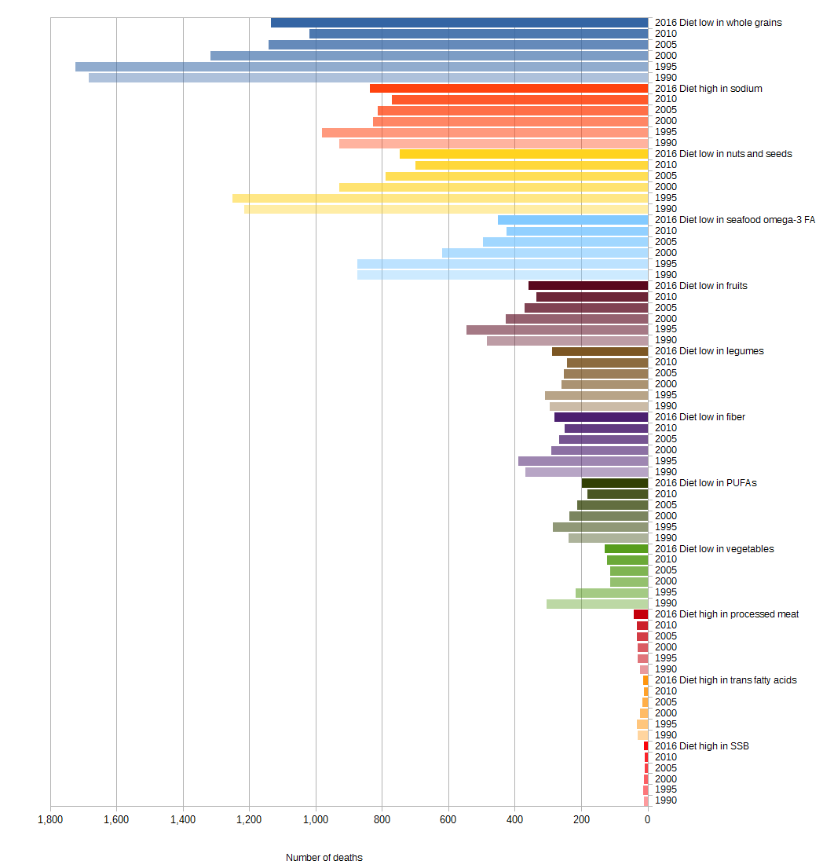
Israel

Figure 47 Diet-related CVD deaths from 1990 to 2016 in Israel

a) Male b) Female
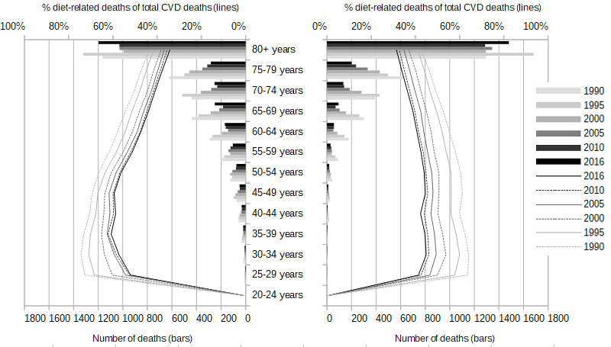
Figure 48 Age- and gender-specific diet-related CVD deaths (bars) and share of diet-related on total CVD deaths (lines) from 1990 to 2016 in Israel
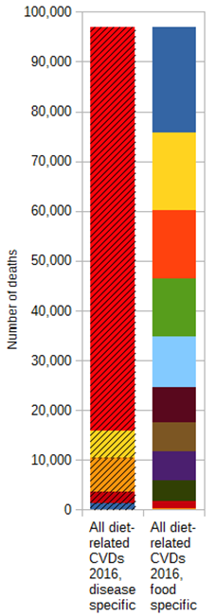
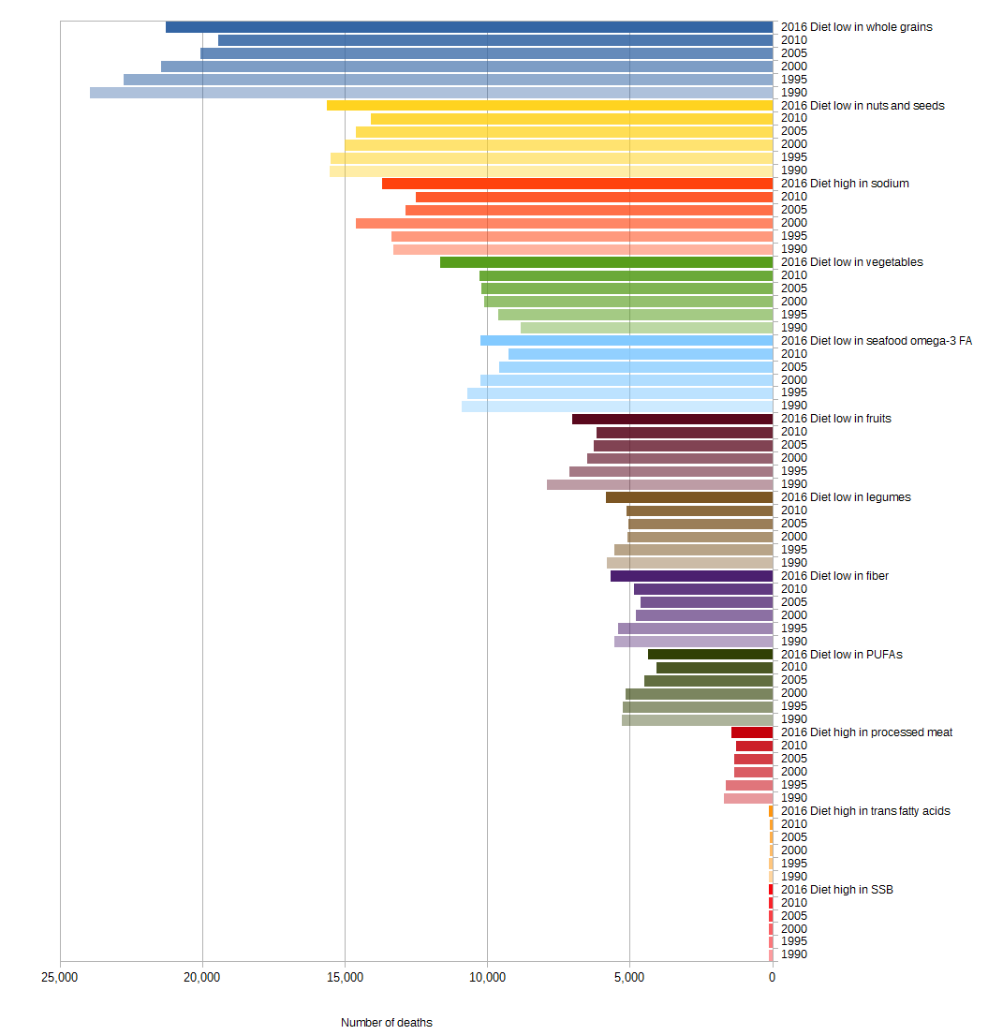
Italy

Figure 49 Diet-related CVD deaths from 1990 to 2016 in Italy

a) Male b) Female
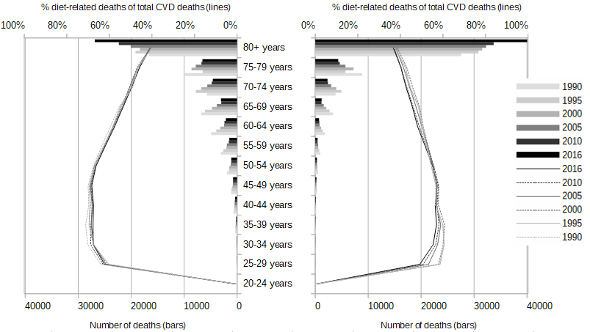
Figure 50 Age- and gender-specific diet-related CVD deaths (bars) and share of diet-related on total CVD deaths (lines) from 1990 to 2016 in Italy
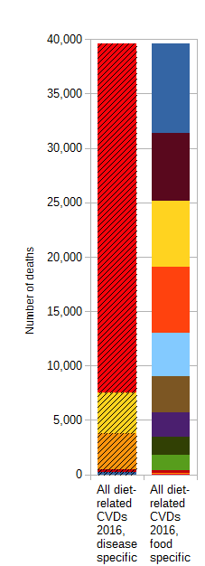
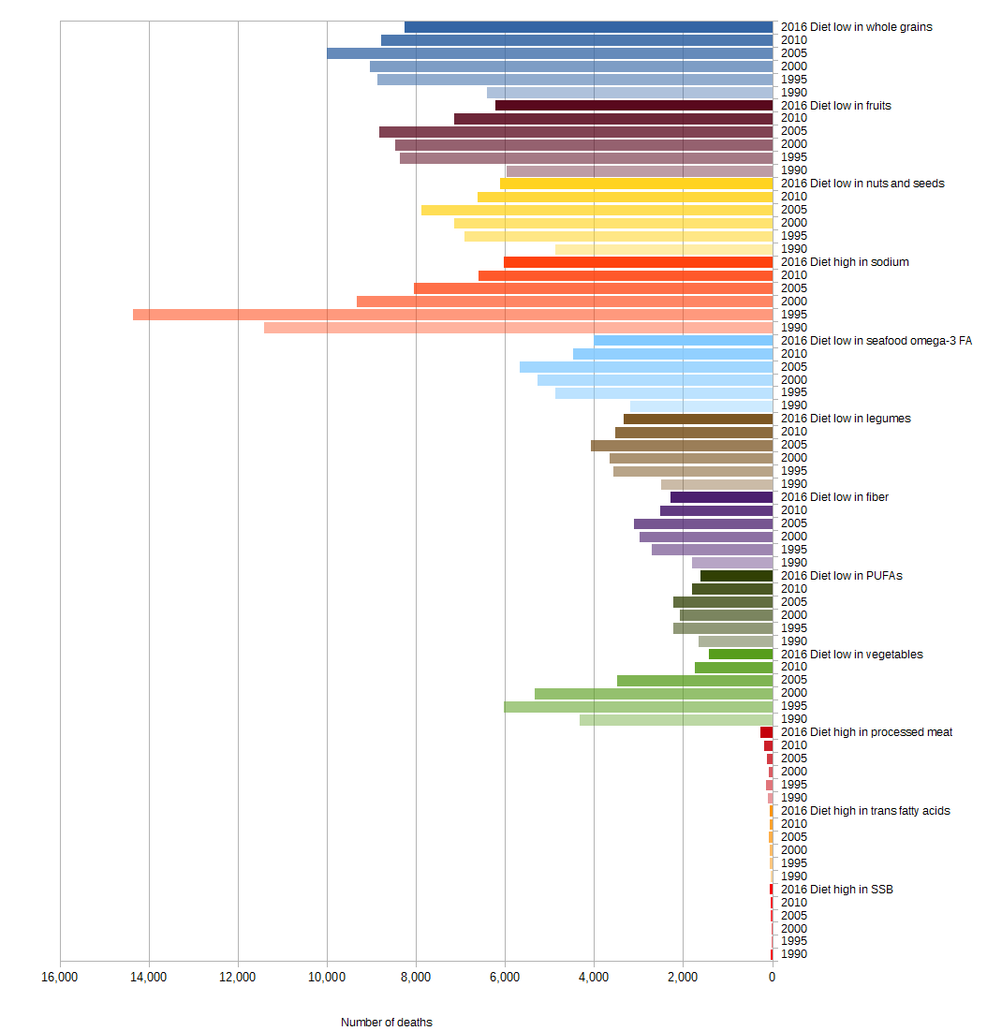
Kazakhstan

Figure 51 Diet-related CVD deaths from 1990 to 2016 in Kazakhstan

a) Male b) Female
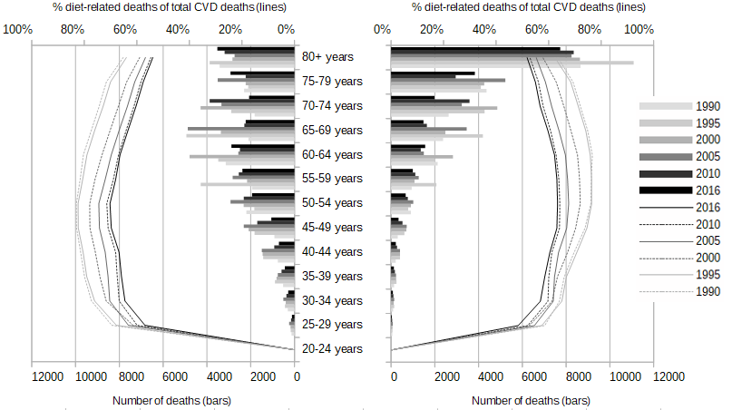
Figure 52 Age- and gender-specific diet-related CVD deaths (bars) and share of diet-related on total CVD deaths (lines) from 1990 to 2016 in Kazakhstan
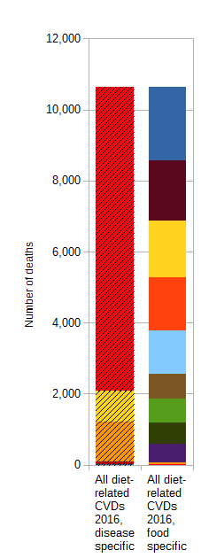
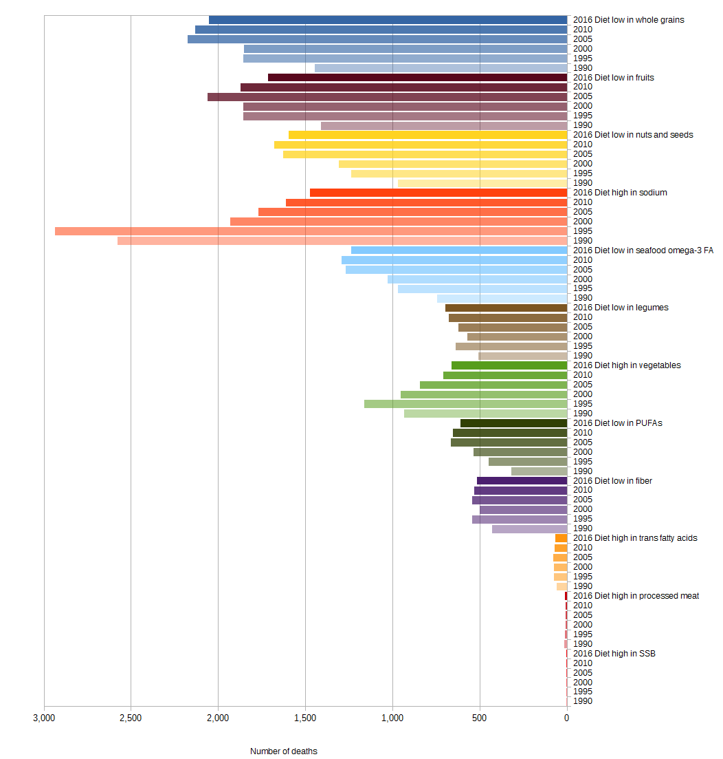
Kyrgyzstan

Figure 53 Diet-related CVD deaths from 1990 to 2016 in Kyrgyzstan

a) Male b) Female
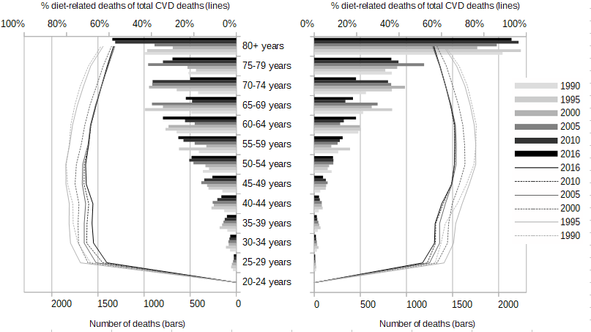
Figure 54 Age- and gender-specific diet-related CVD deaths (bars) and share of diet-related on total CVD deaths (lines) from 1990 to 2016 in Kyrgyzstan
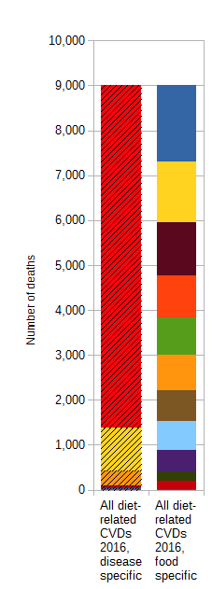
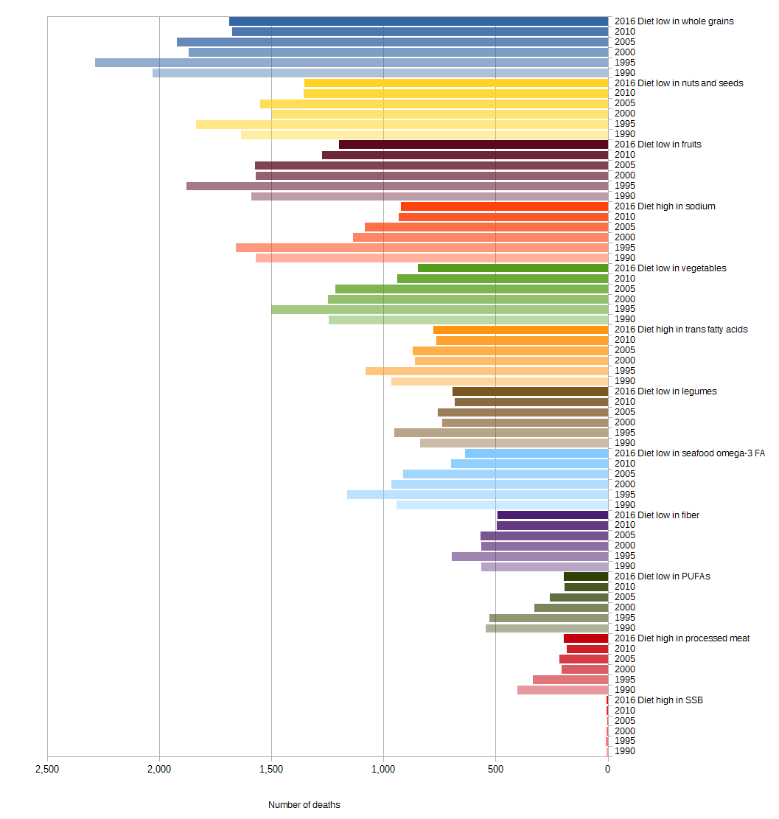
Latvia

Figure 55 Diet-related CVD deaths from 1990 to 2016 in Latvia

a) Male b) Female
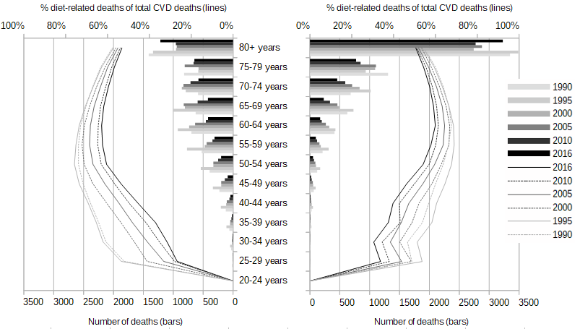
Figure 56 Age- and gender-specific diet-related CVD deaths (bars) and share of diet-related on total CVD deaths (lines) from 1990 to 2016 in Latvia
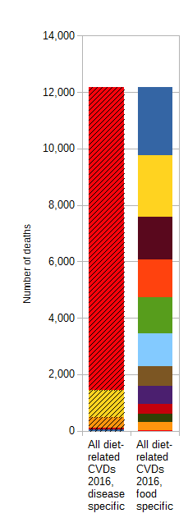
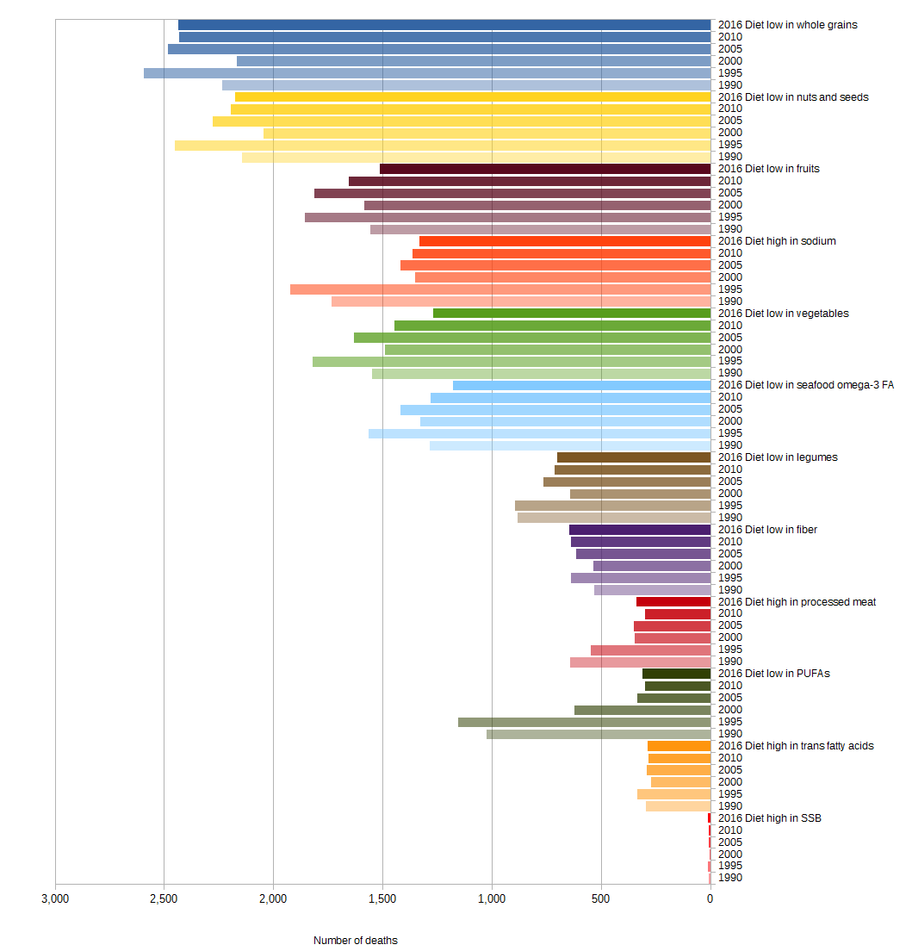
Lithuania

Figure 57 Diet-related CVD deaths from 1990 to 2016 in Lithuania

a) Male b) Female
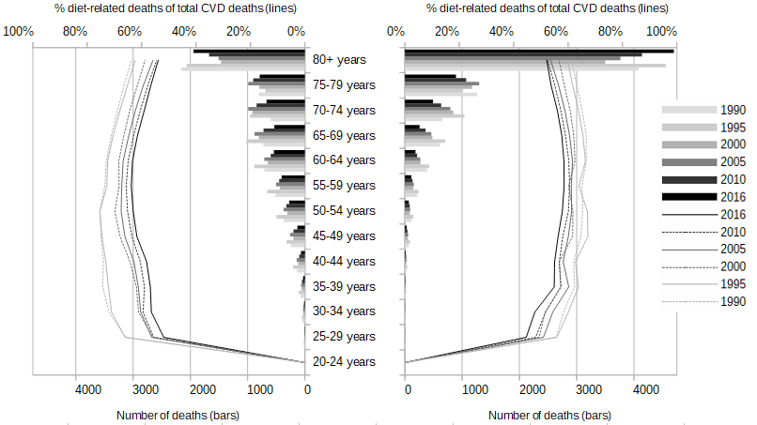
Figure 58 Age- and gender-specific diet-related CVD deaths (bars) and share of diet-related on total CVD deaths (lines) from 1990 to 2016 in Lithuania
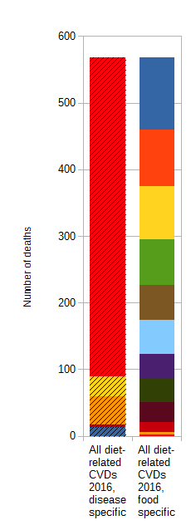
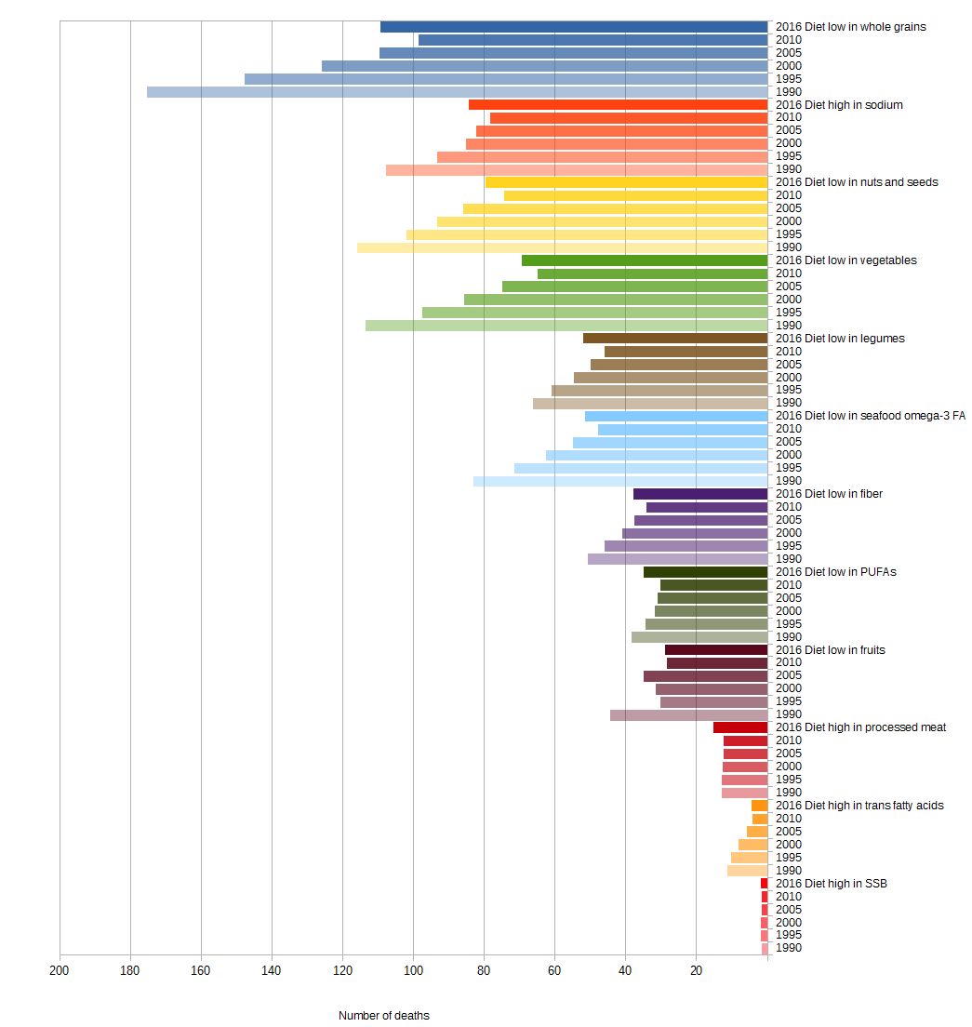
Luxembourg

Figure 59 Diet-related CVD deaths from 1990 to 2016 in Luxembourg

a) Male b) Female
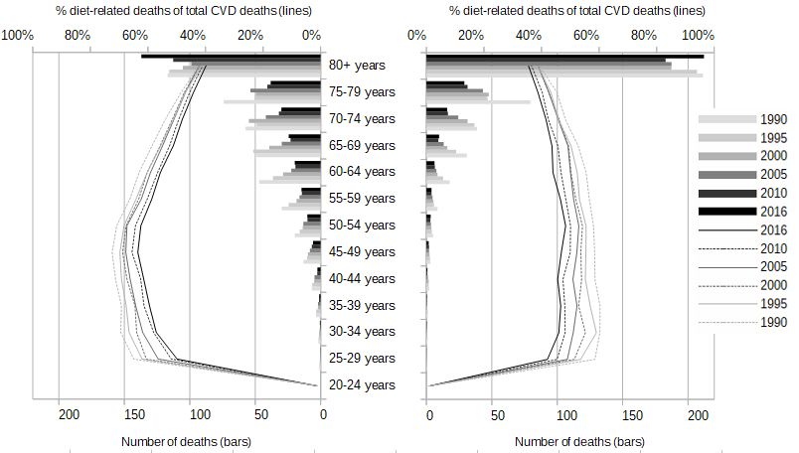
Figure 60 Age- and gender-specific diet-related CVD deaths (bars) and share of diet-related on total CVD deaths (lines) from 1990 to 2016 in Luxembourg
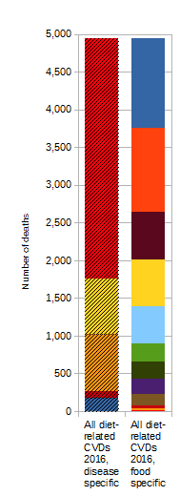
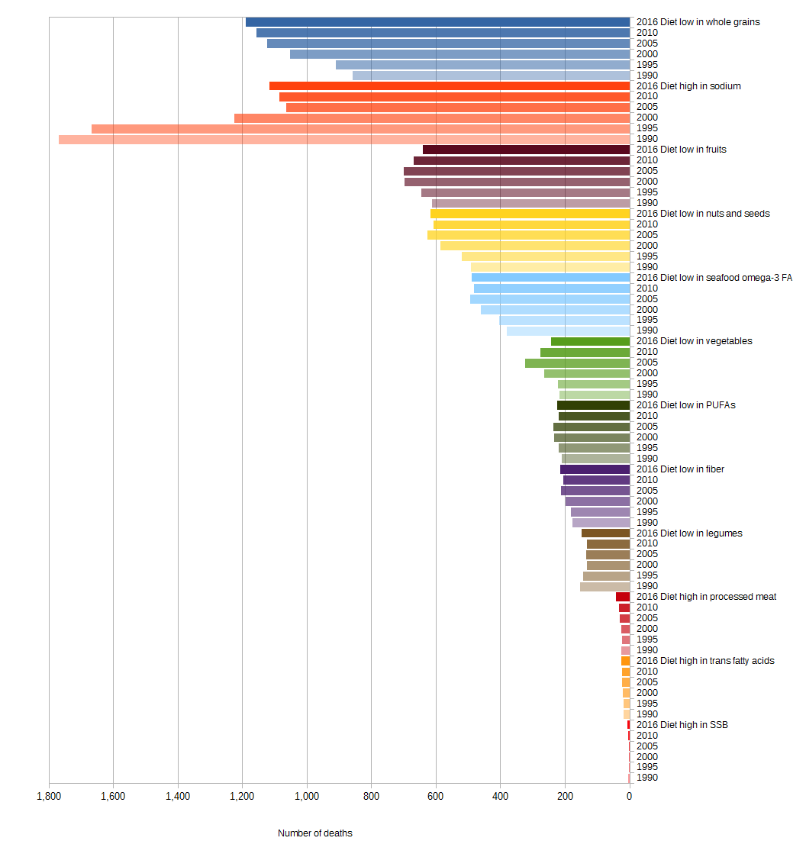
Macedonia

Figure 61 Diet-related CVD deaths from 1990 to 2016 in Macedonia

a) Male b) Female
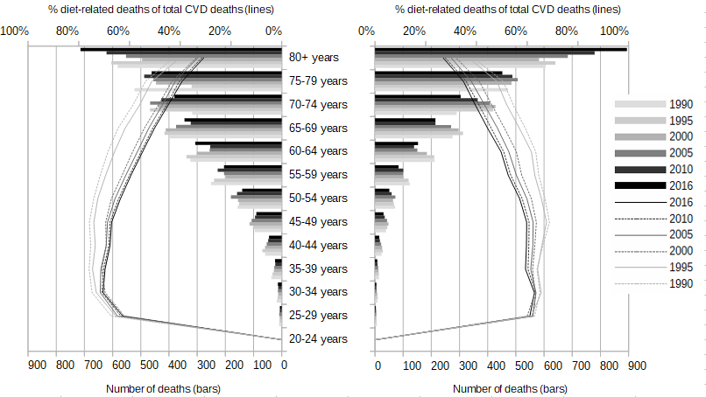
Figure 62 Age- and gender-specific diet-related CVD deaths (bars) and share of diet-related on total CVD deaths (lines) from 1990 to 2016 in Macedonia
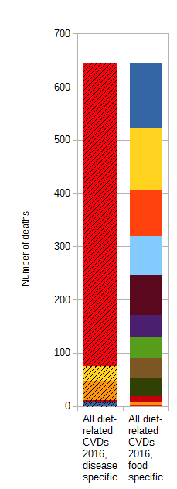
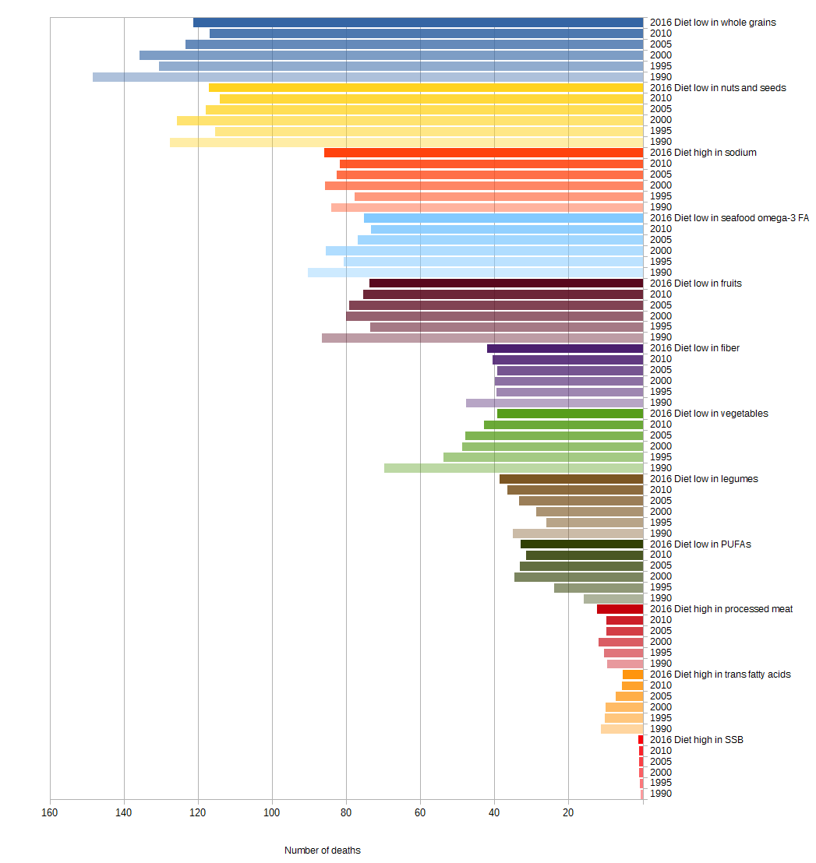
Malta

Figure 63 Diet-related CVD deaths from 1990 to 2016 in Malta

a) Male b) Female
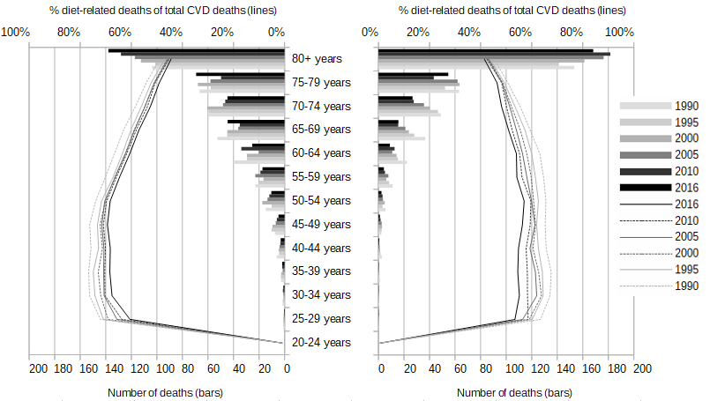
Figure 64 Age- and gender-specific diet-related CVD deaths (bars) and share of diet-related on total CVD deaths (lines) from 1990 to 2016 in Malta
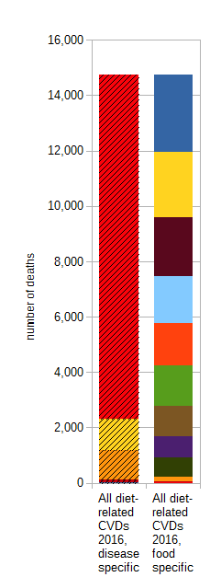
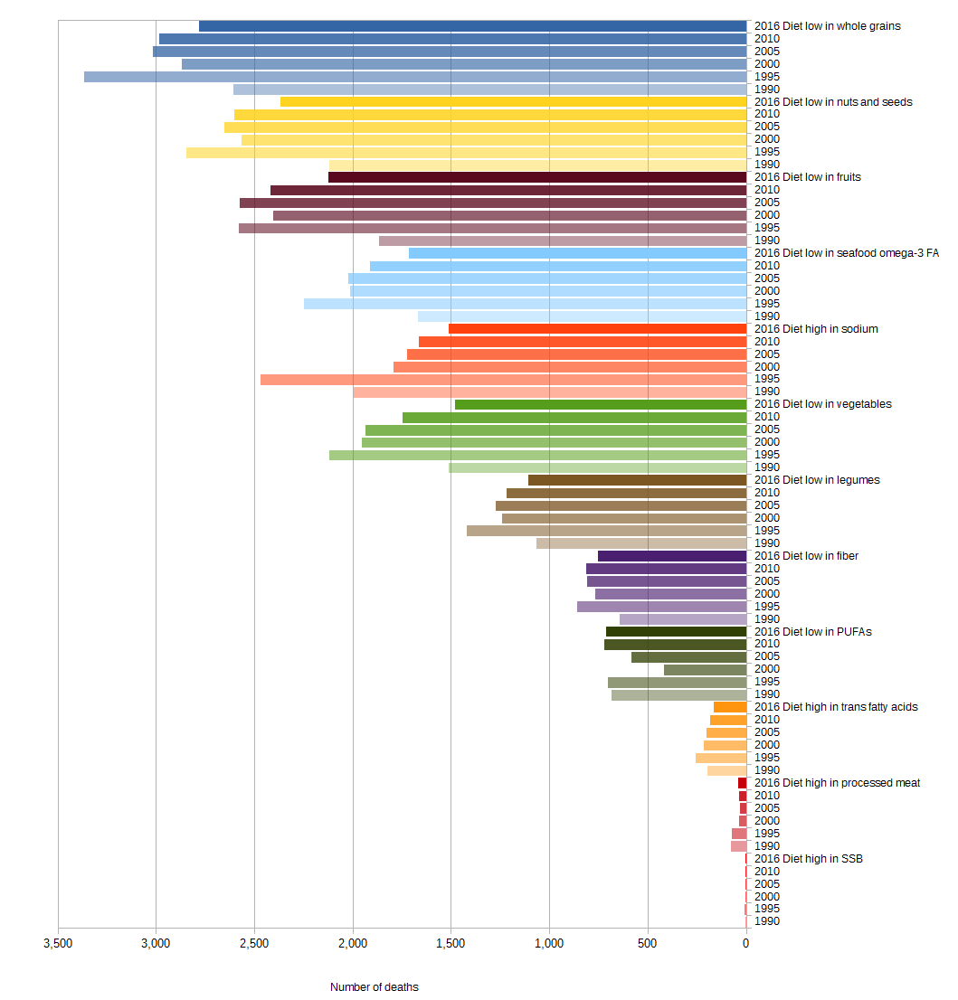
Moldova

Figure 65 Diet-related CVD deaths from 1990 to 2016 in Moldova

a) Male b) Female
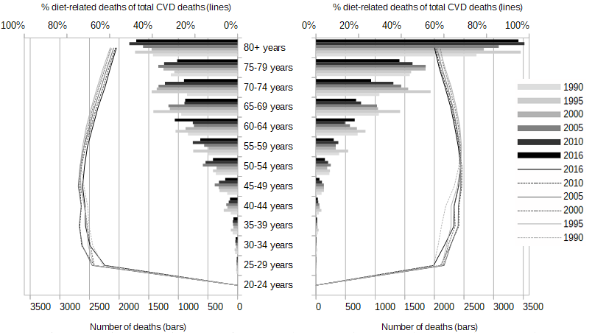
Figure 66 Age- and gender-specific diet-related CVD deaths (bars) and share of diet-related on total CVD deaths (lines) from 1990 to 2016 in Moldova
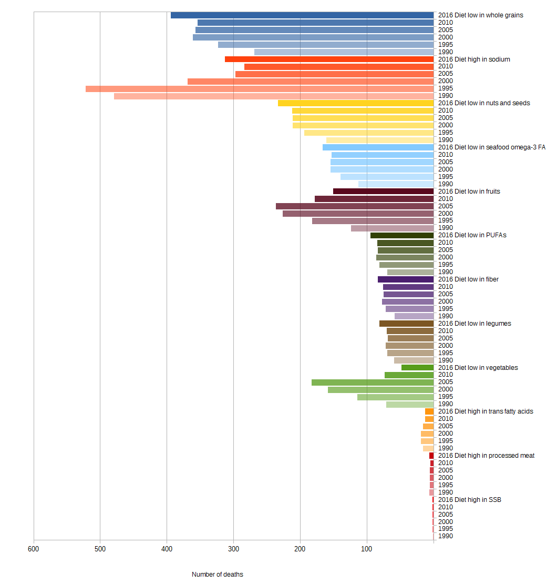
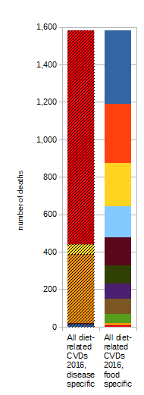
Montenegro

Figure 67 Diet-related CVD deaths from 1990 to 2016 in Montenegro

a) Male b) Female
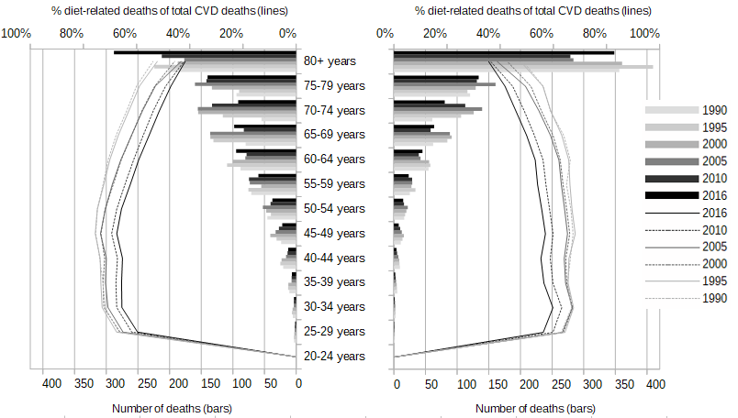
Figure 68 Age- and gender-specific diet-related CVD deaths (bars) and share of diet-related on total CVD deaths (lines) from 1990 to 2016 in Montenegro
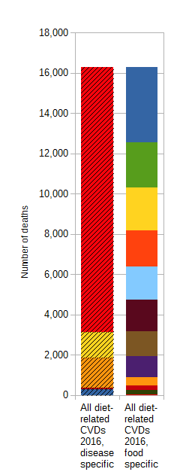
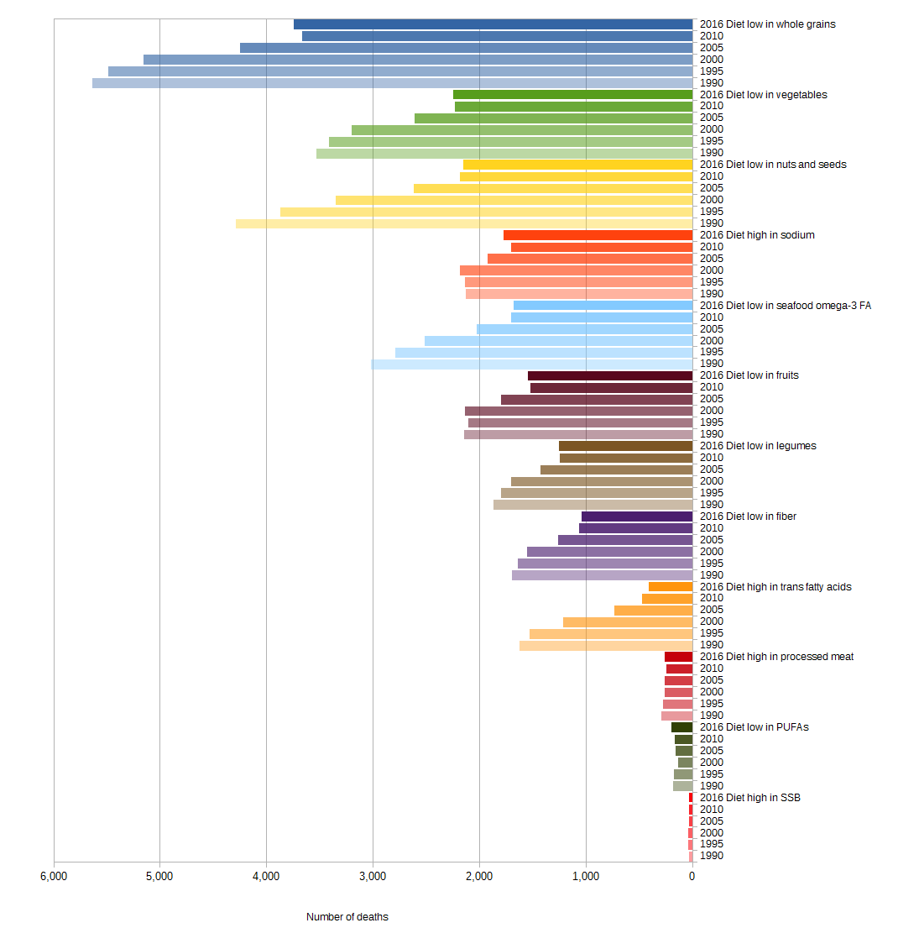
Netherlands

Figure 69 Diet-related CVD deaths from 1990 to 2016 in the Netherlands

a) Male b) Female
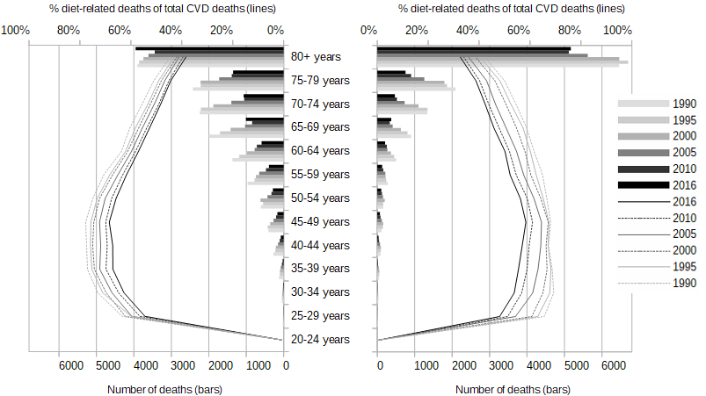
Figure 70 Age- and gender-specific diet-related CVD deaths (bars) and share of diet-related on total CVD deaths (lines) from 1990 to 2016 in the Netherlands
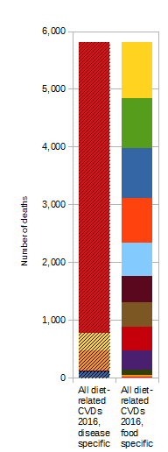
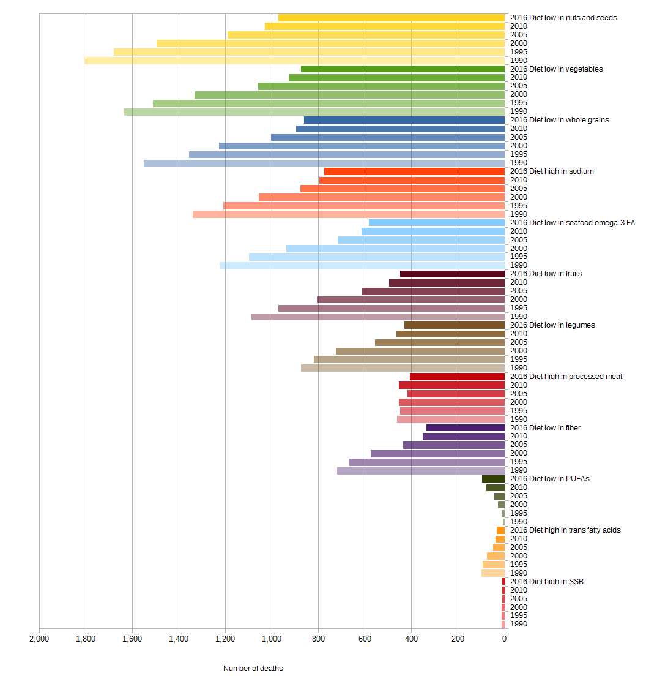
Norway

Figure 71 Diet-related CVD deaths from 1990 to 2016 in Norway

a) Male b) Female
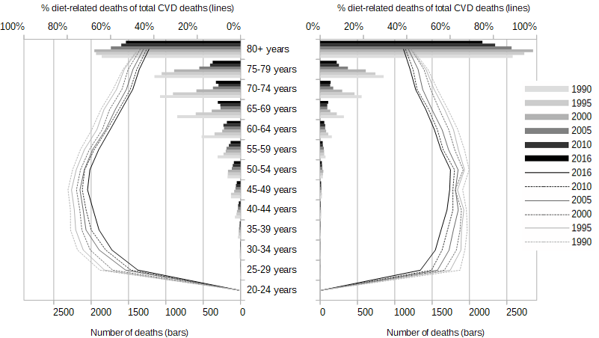
Figure 72 Age- and gender-specific diet-related CVD deaths (bars) and share of diet-related on total CVD deaths (lines) from 1990 to 2016 in Norway
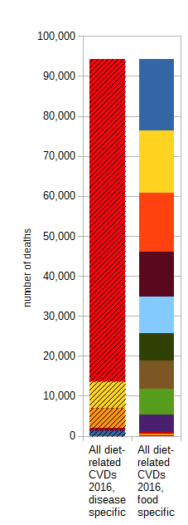
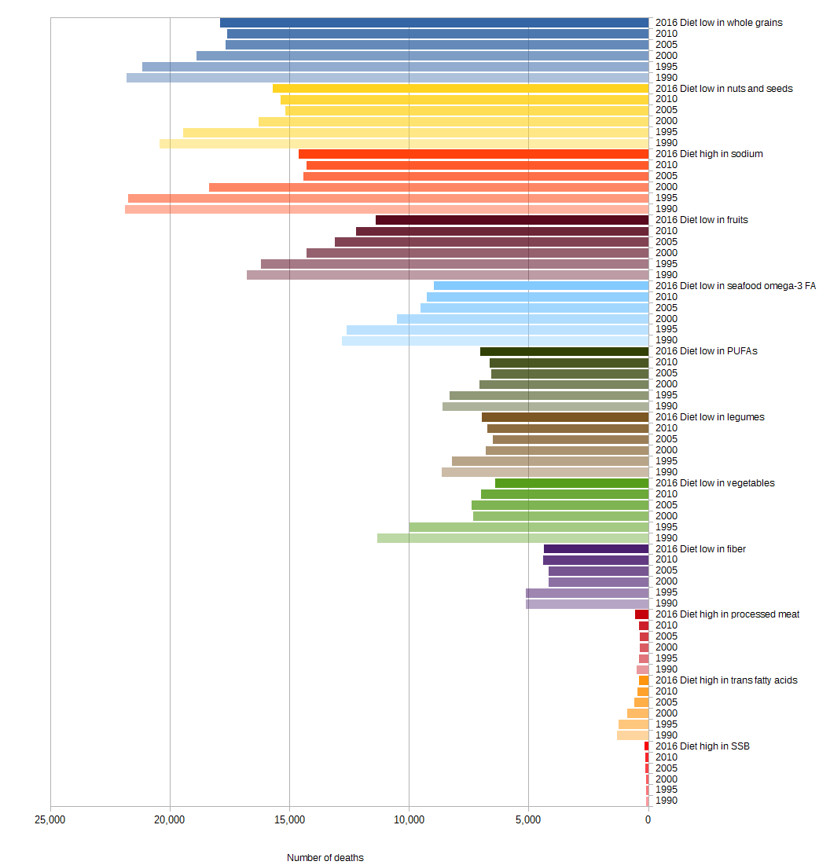
Poland

Figure 73 Diet-related CVD deaths from 1990 to 2016 in Poland

a) Male b) Female
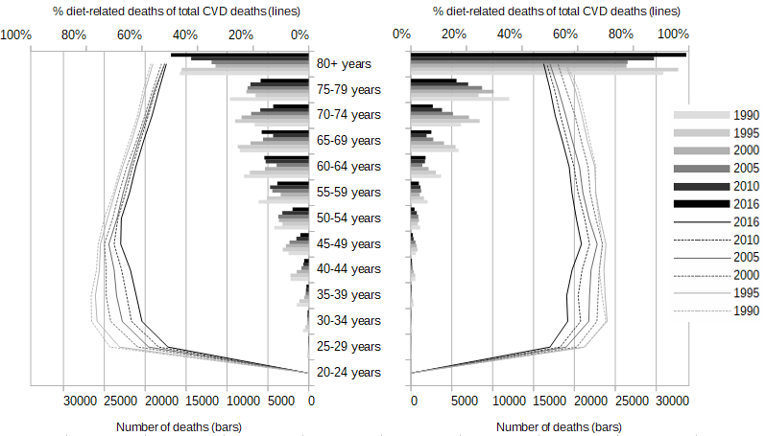
Figure 74 Age- and gender-specific diet-related CVD deaths (bars) and share of diet-related on total CVD deaths (lines) from 1990 to 2016 in Poland
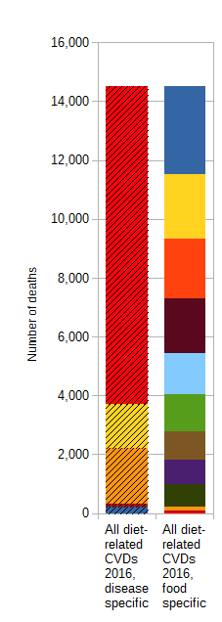
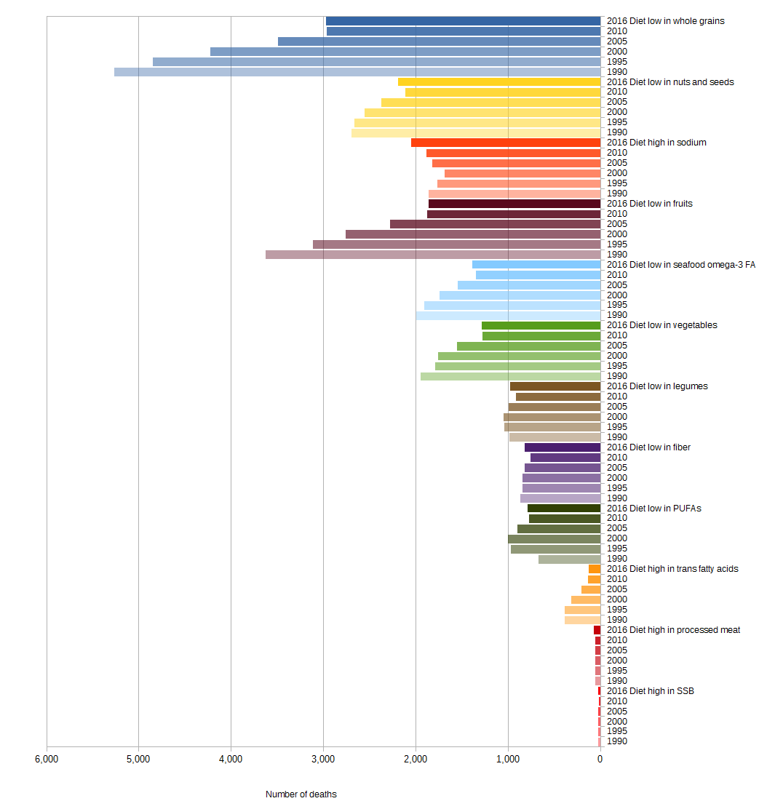
Portugal

Figure 75 Diet-related CVD deaths from 1990 to 2016 in Portugal

a) Male b) Female
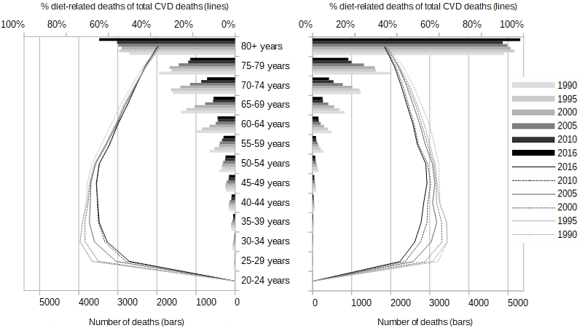
Figure 76 Age- and gender-specific diet-related CVD deaths (bars) and share of diet-related on total CVD deaths (lines) from 1990 to 2016 in Portugal
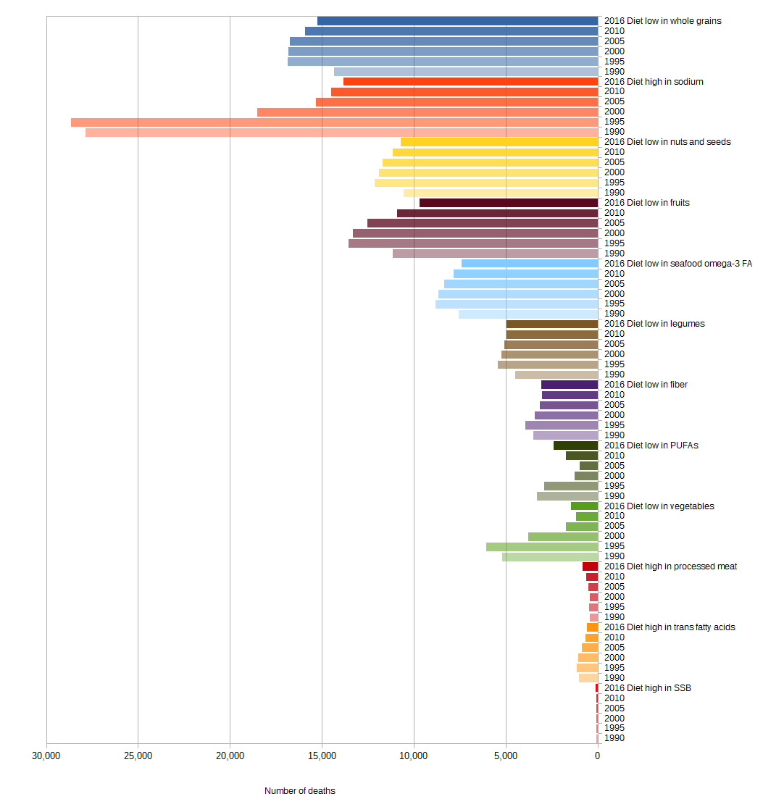
Romania
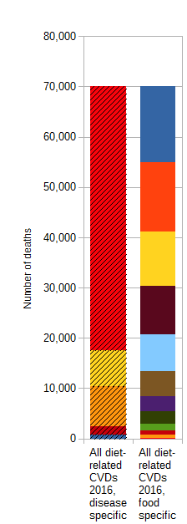
Figure 77 Diet-related CVD deaths from 1990 to 2016 in Romania

a) Male b) Female
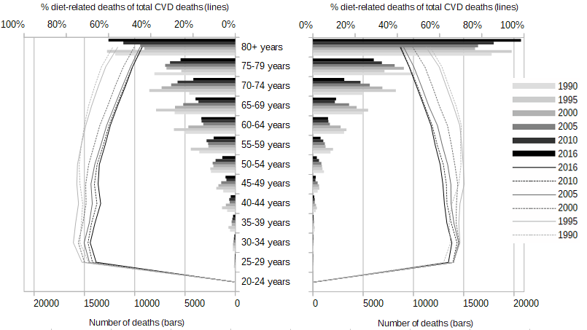
Figure 78 Age- and gender-specific diet-related CVD deaths (bars) and share of diet-related on total CVD deaths (lines) from 1990 to 2016 in Romania
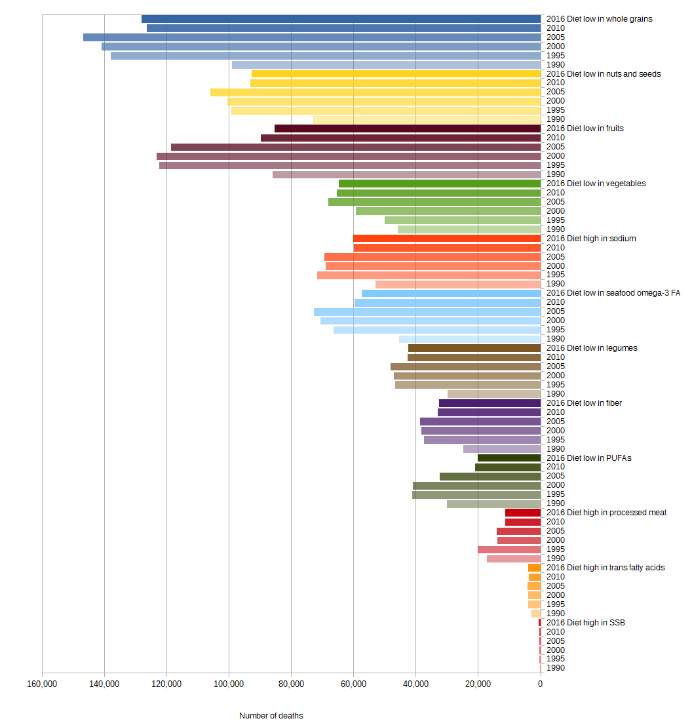
Russia
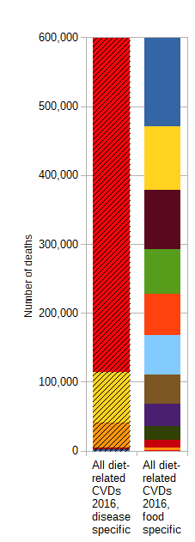
Figure 79 Diet-related CVD deaths from 1990 to 2016 in Russia

a) Male b) Female
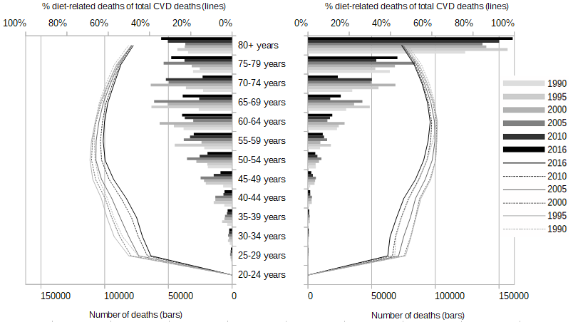
Figure 80 Age- and gender-specific diet-related CVD deaths (bars) and share of diet-related on total CVD deaths (lines) from 1990 to 2016 in Russia
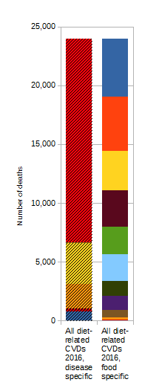
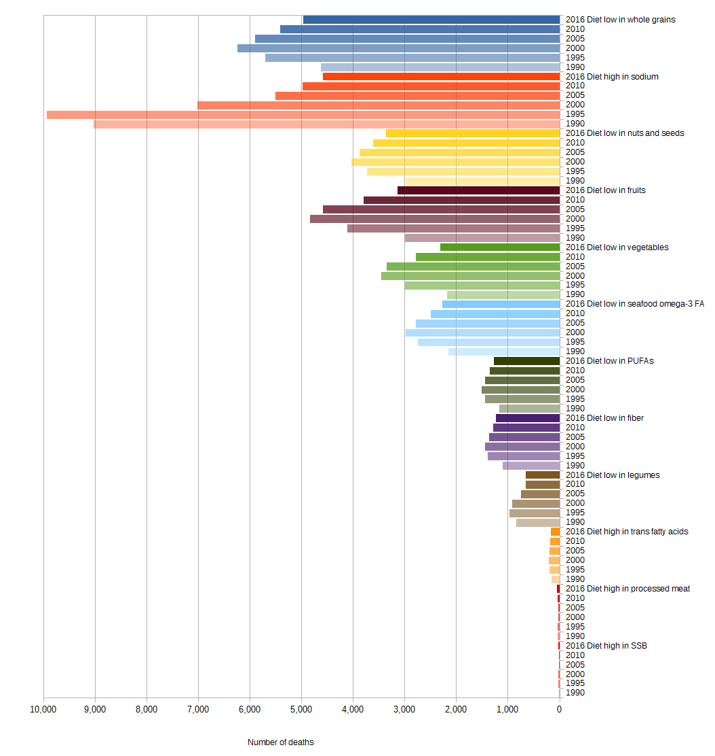
Serbia

Figure 81 Diet-related CVD deaths from 1990 to 2016 in Serbia

a) Male b) Female
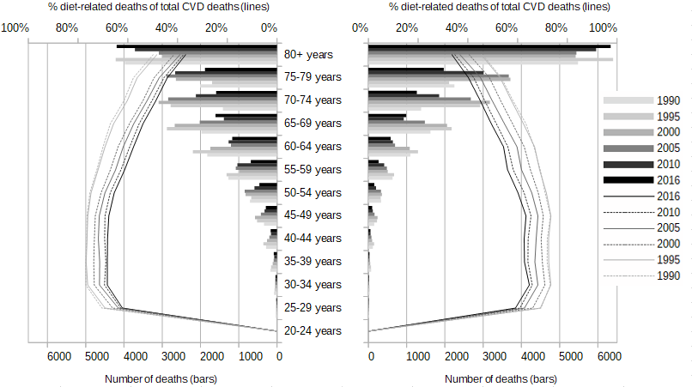
Figure 82 Age- and gender-specific diet-related CVD deaths (bars) and share of diet-related on total CVD deaths (lines) from 1990 to 2016 in Serbia
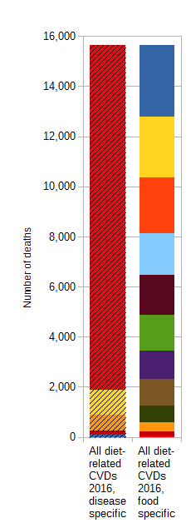
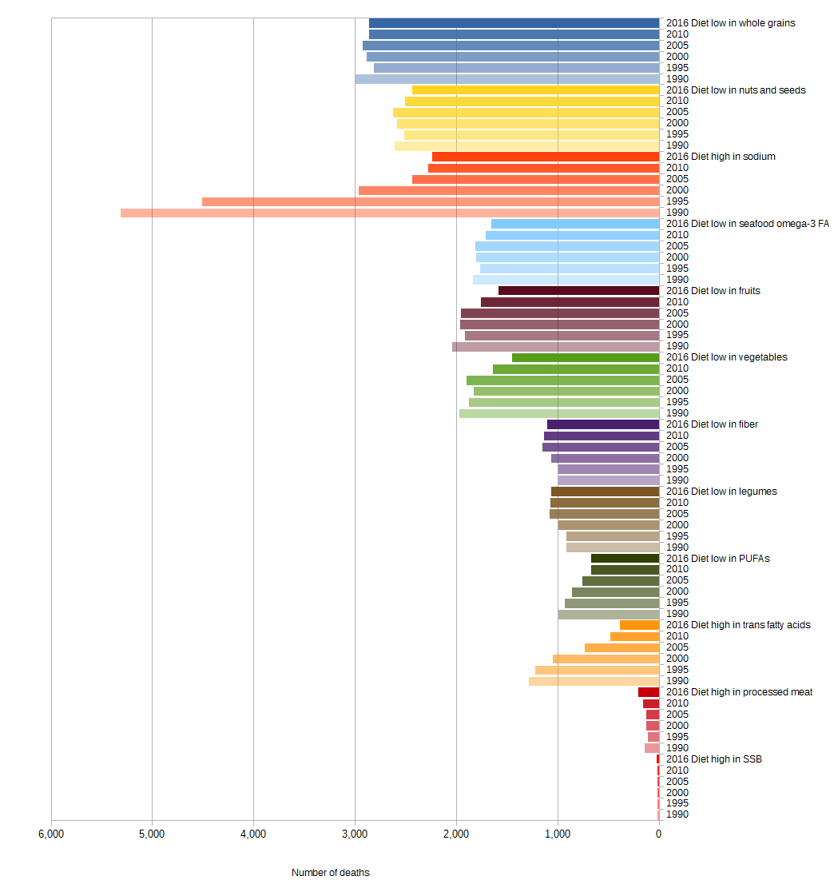
Slovakia

Figure 83 Diet-related CVD deaths from 1990 to 2016 in Slovakia

a) Male b) Female
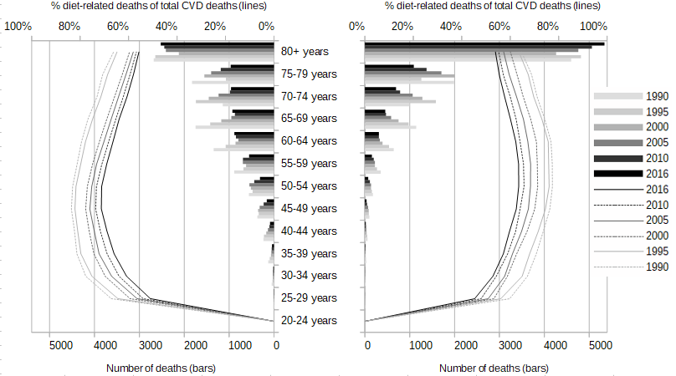
Figure 84 Age- and gender-specific diet-related CVD deaths (bars) and share of diet-related on total CVD deaths (lines) from 1990 to 2016 in Slovakia
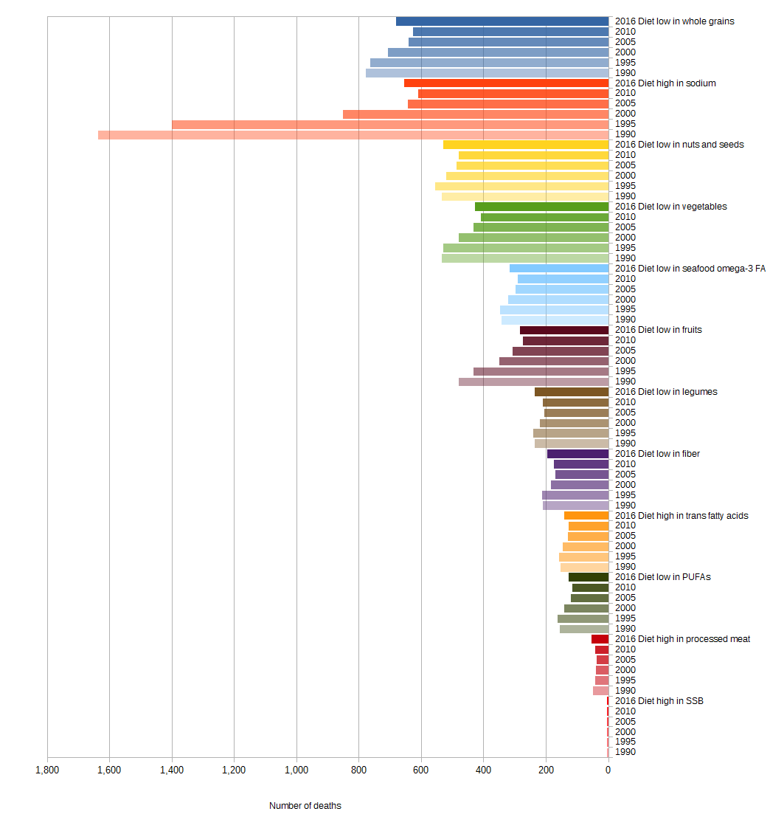
Slovenia
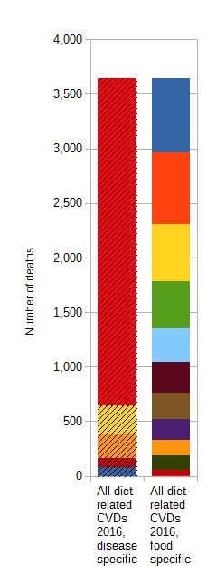
Figure 85 Diet-related CVD deaths from 1990 to 2016 in Slovenia

a) Male b) Female
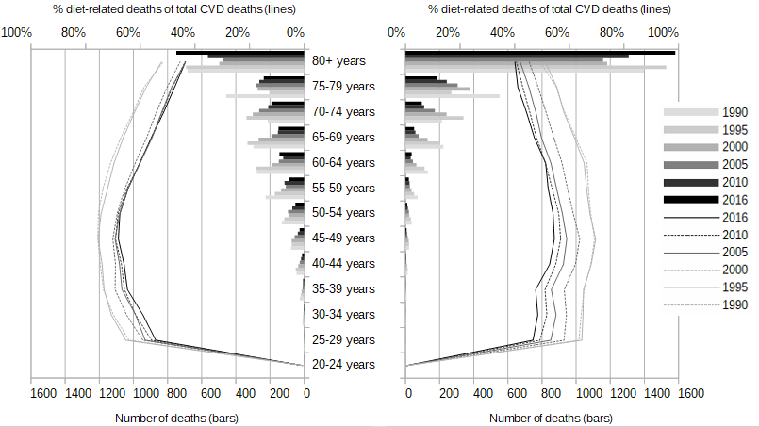
Figure 86 Age- and gender-specific diet-related CVD deaths (bars) and share of diet-related on total CVD deaths (lines) from 1990 to 2016 in Slovenia
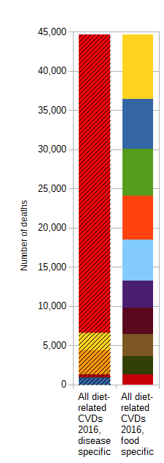
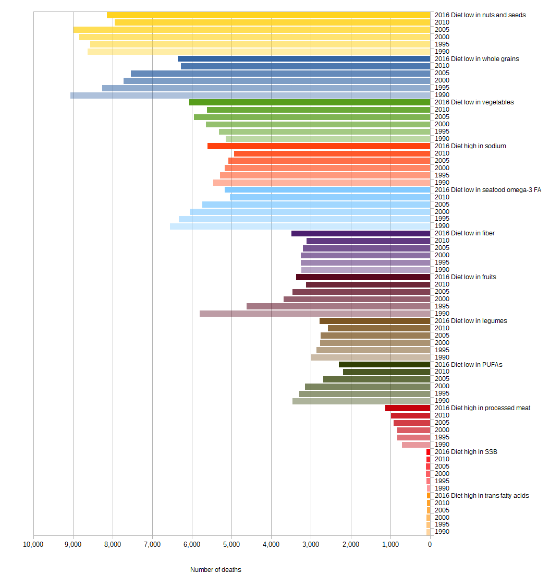
Spain

Figure 87 Diet-related CVD deaths from 1990 to 2016 in Spain

a) Male b) Female
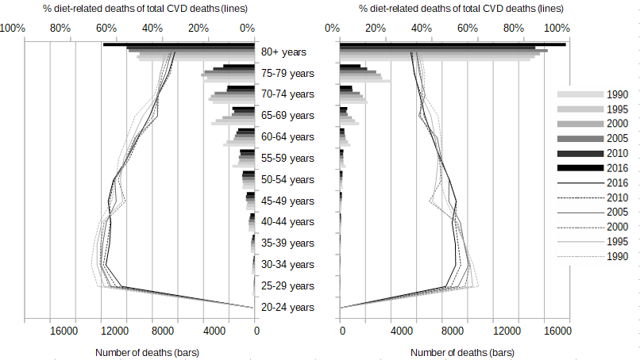
Figure 88 Age- and gender-specific diet-related CVD deaths (bars) and share of diet-related on total CVD deaths (lines) from 1990 to 2016 in Spain
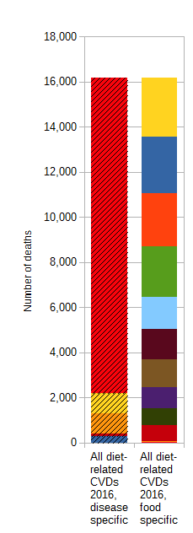
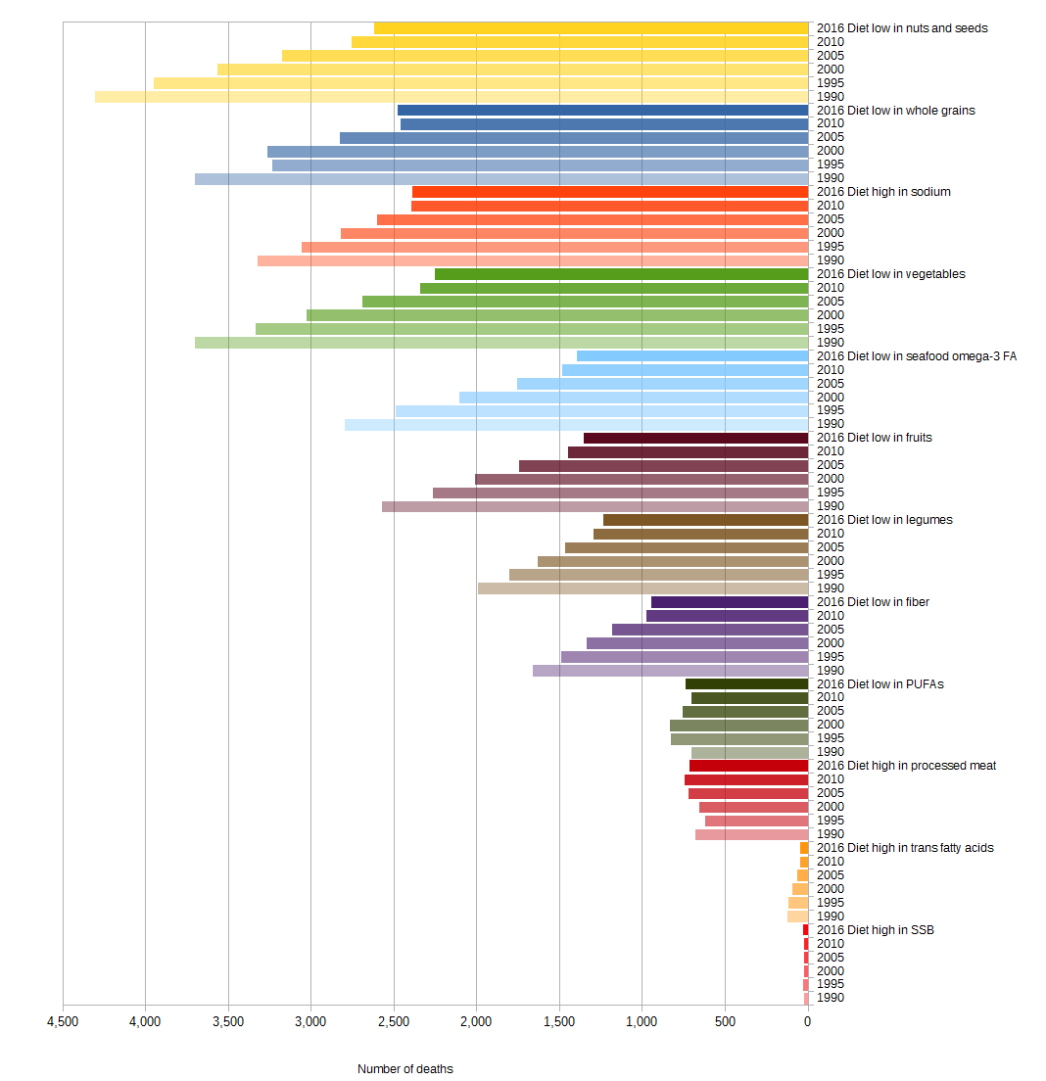
Sweden

Figure 89 Diet-related CVD deaths from 1990 to 2016 in Sweden

a) Male b) Female
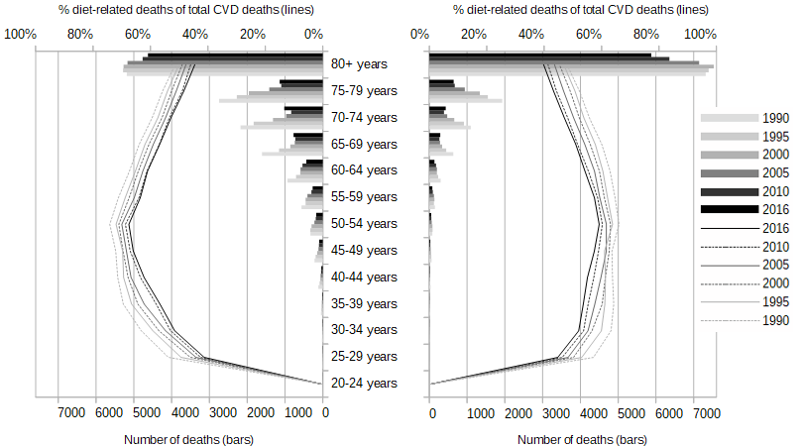
Figure 90 Age- and gender-specific diet-related CVD deaths (bars) and share of diet-related on total CVD deaths (lines) from 1990 to 2016 in Sweden
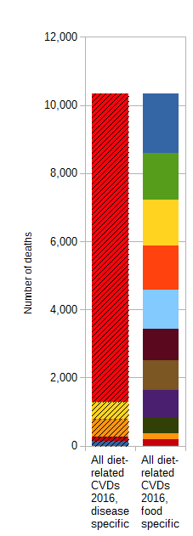
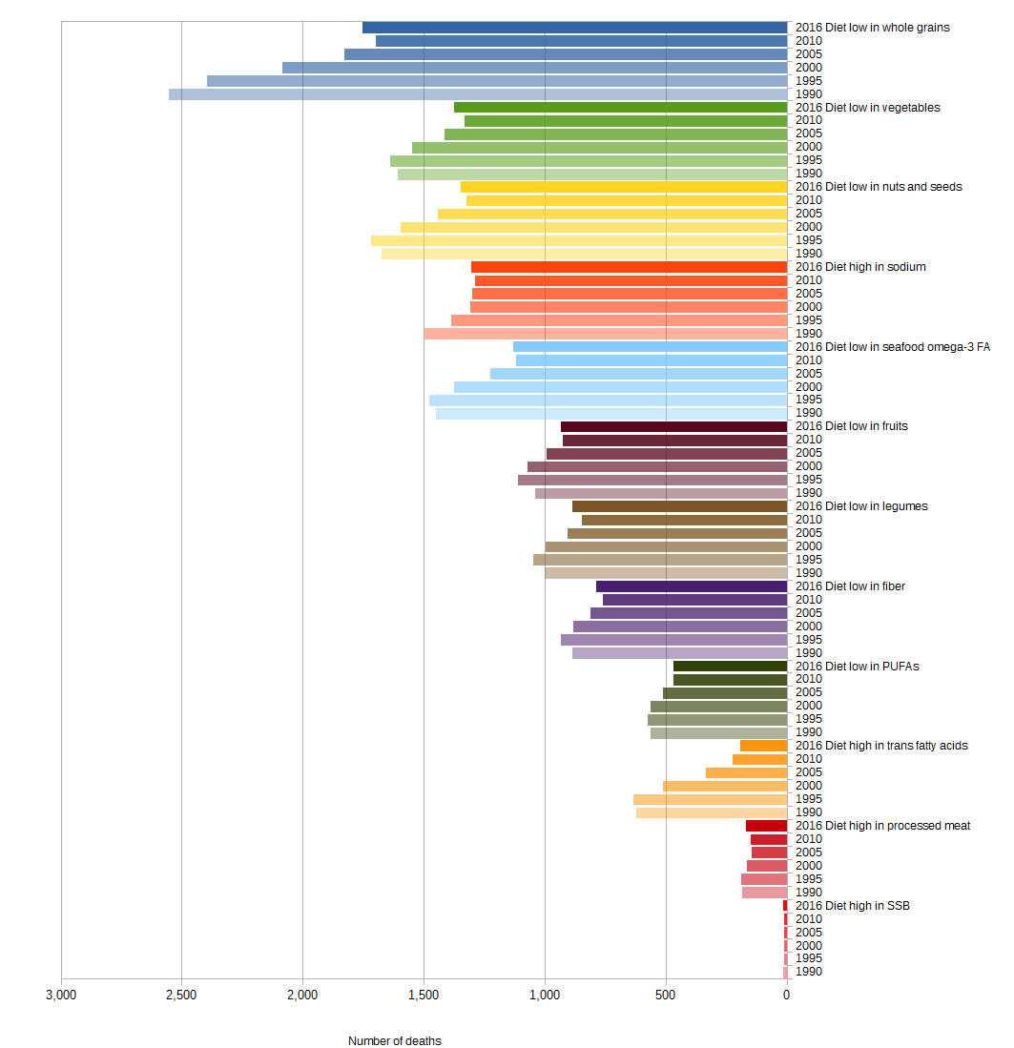
Switzerland

Figure 91 Diet-related CVD deaths from 1990 to 2016 in Switzerland

a) Male b) Female
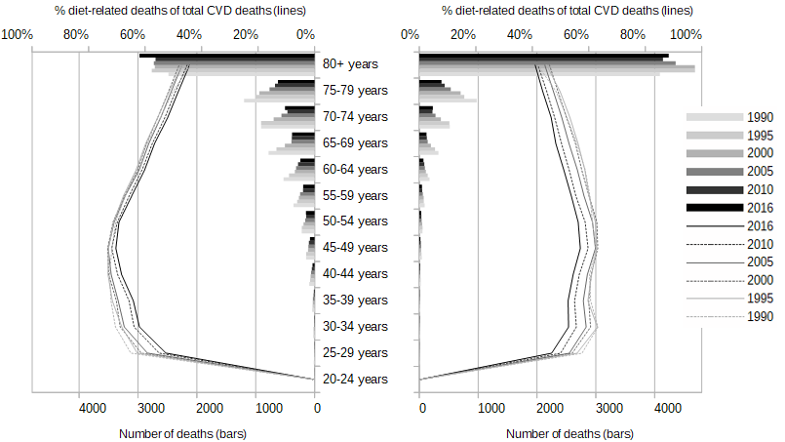
Figure 92 Age- and gender-specific diet-related CVD deaths (bars) and share of diet-related on total CVD deaths (lines) from 1990 to 2016 in Switzerland
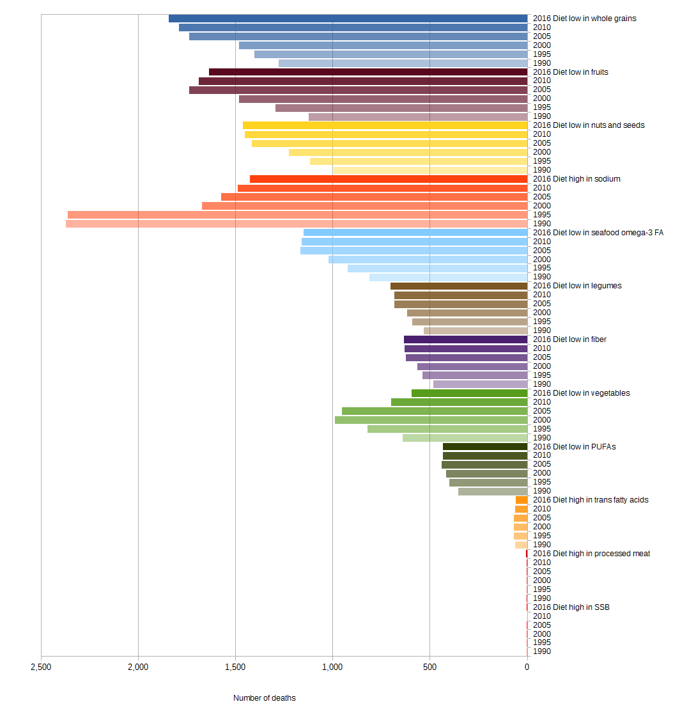
Tajikistan
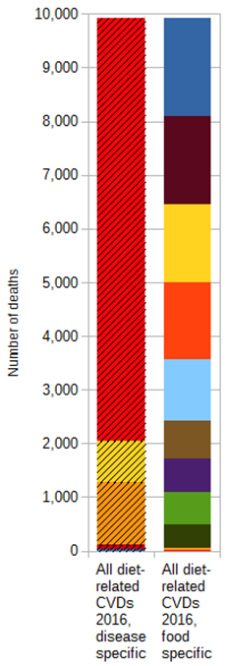
Figure 93 Diet-related CVD deaths from 1990 to 2016 in Tajikistan

a) Male b) Female
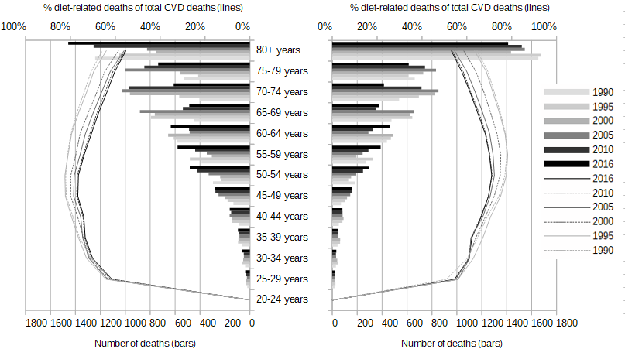
Figure 94 Age- and gender-specific diet-related CVD deaths (bars) and share of diet-related on total CVD deaths (lines) from 1990 to 2016 in Tajikistan
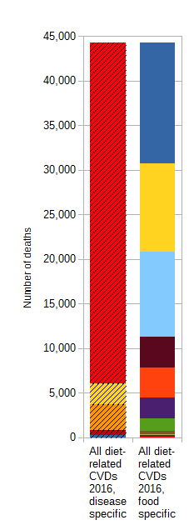
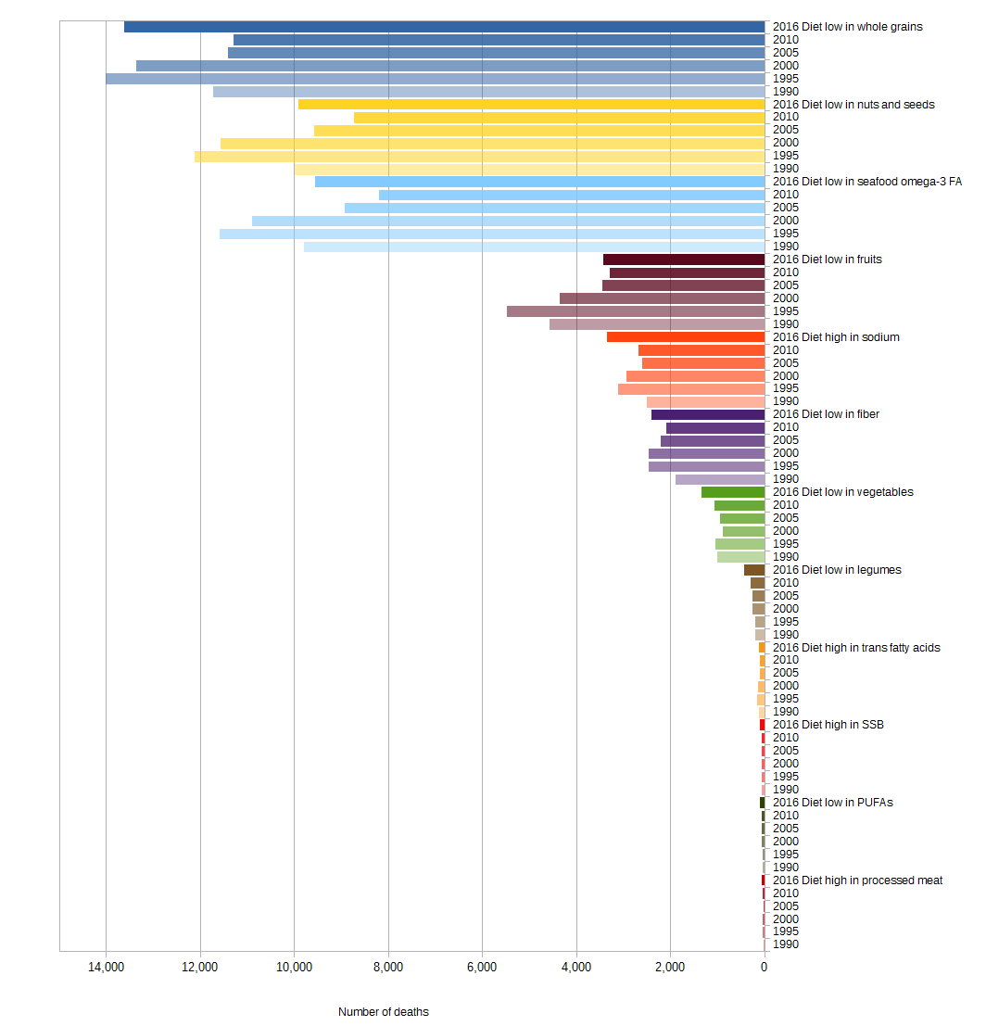
Turkey

Figure 95 Diet-related CVD deaths from 1990 to 2016 in Turkey

a) Male b) Female
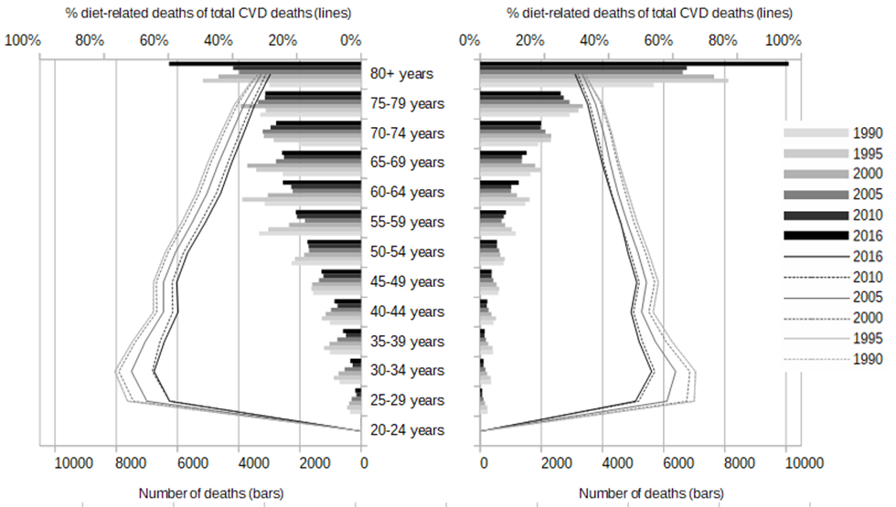
Figure 96 Age- and gender-specific diet-related CVD deaths (bars) and share of diet-related on total CVD deaths (lines) from 1990 to 2016 in Turkey
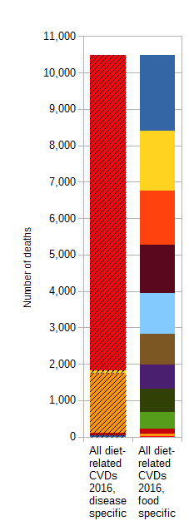
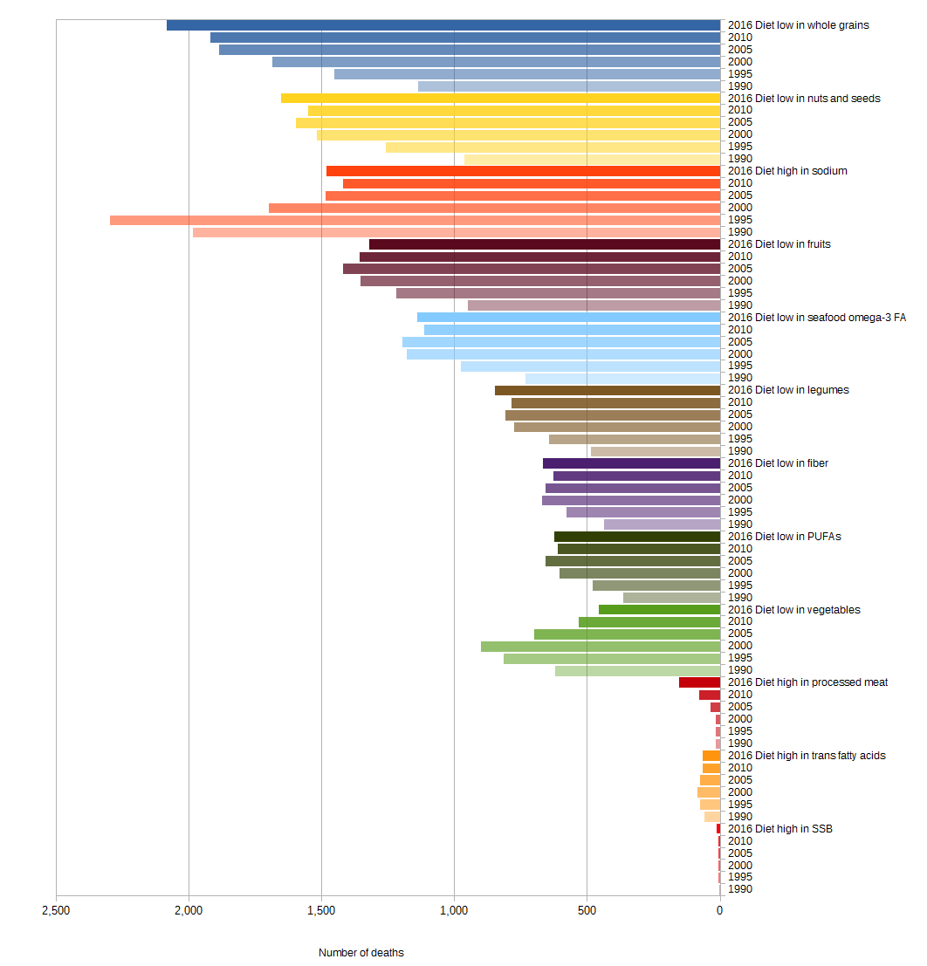
Turkmenistan

Figure 97 Diet-related CVD deaths from 1990 to 2016 in Turkmenistan

a) Male b) Female
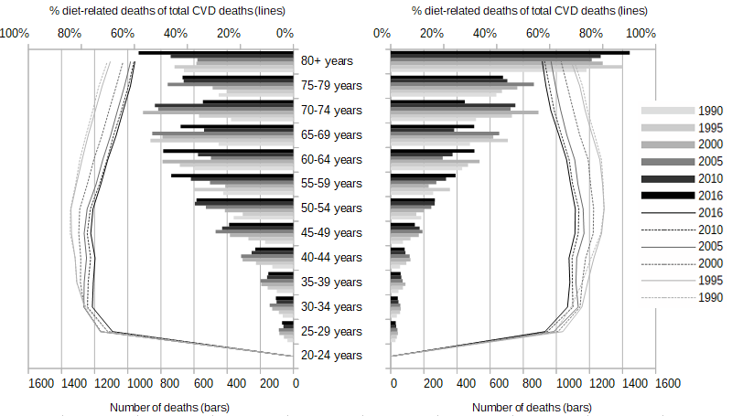
Figure 98 Age- and gender-specific diet-related CVD deaths (bars) and share of diet-related on total CVD deaths (lines) from 1990 to 2016 in Turkmenistan
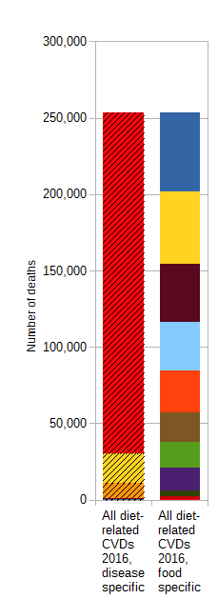
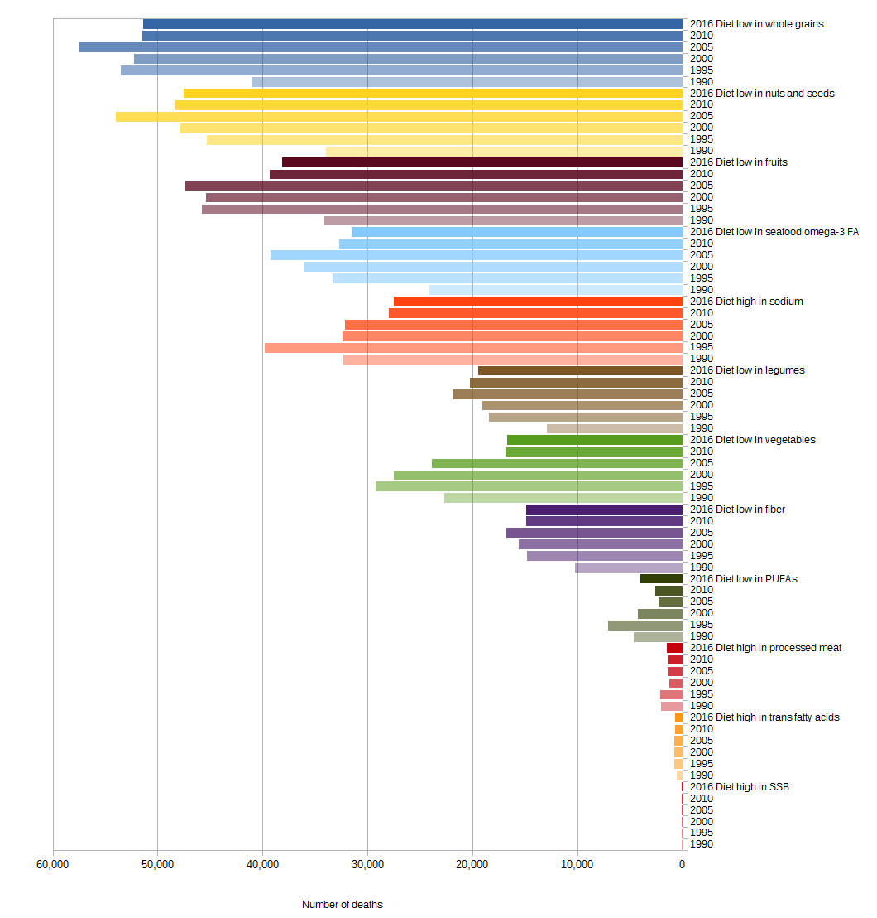
Ukraine

Figure 99 Diet-related CVD deaths from 1990 to 2016 in Ukraine

a) Male b) Female
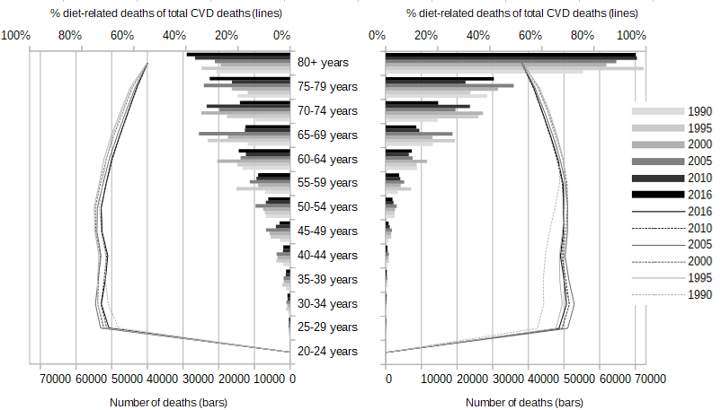
Figure 100 Age- and gender-specific diet-related CVD deaths (bars) and share of diet-related on total CVD deaths (lines) from 1990 to 2016 in Ukraine
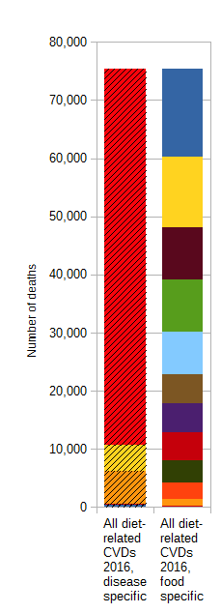
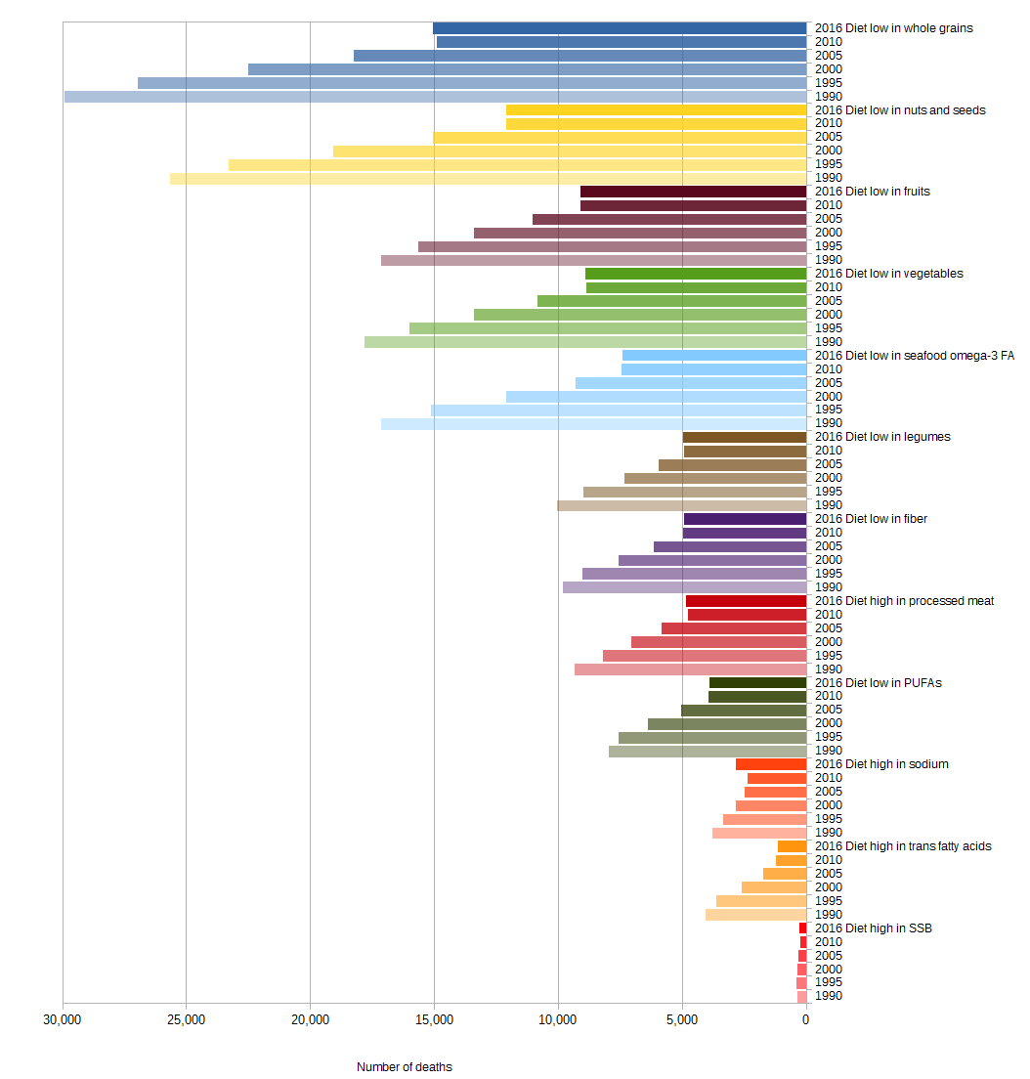
United Kingdom

Figure 101 Diet-related CVD deaths from 1990 to 2016 in the United Kingdom

a) Male b) Female
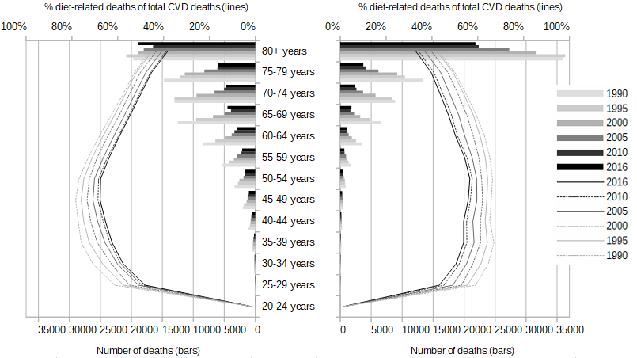
Figure 102 Age- and gender-specific diet-related CVD deaths (bars) and share of diet-related on total CVD deaths (lines) from 1990 to 2016 in the United Kingdom
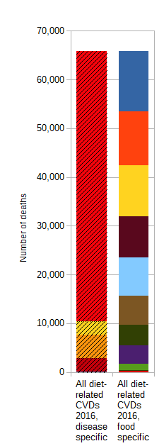
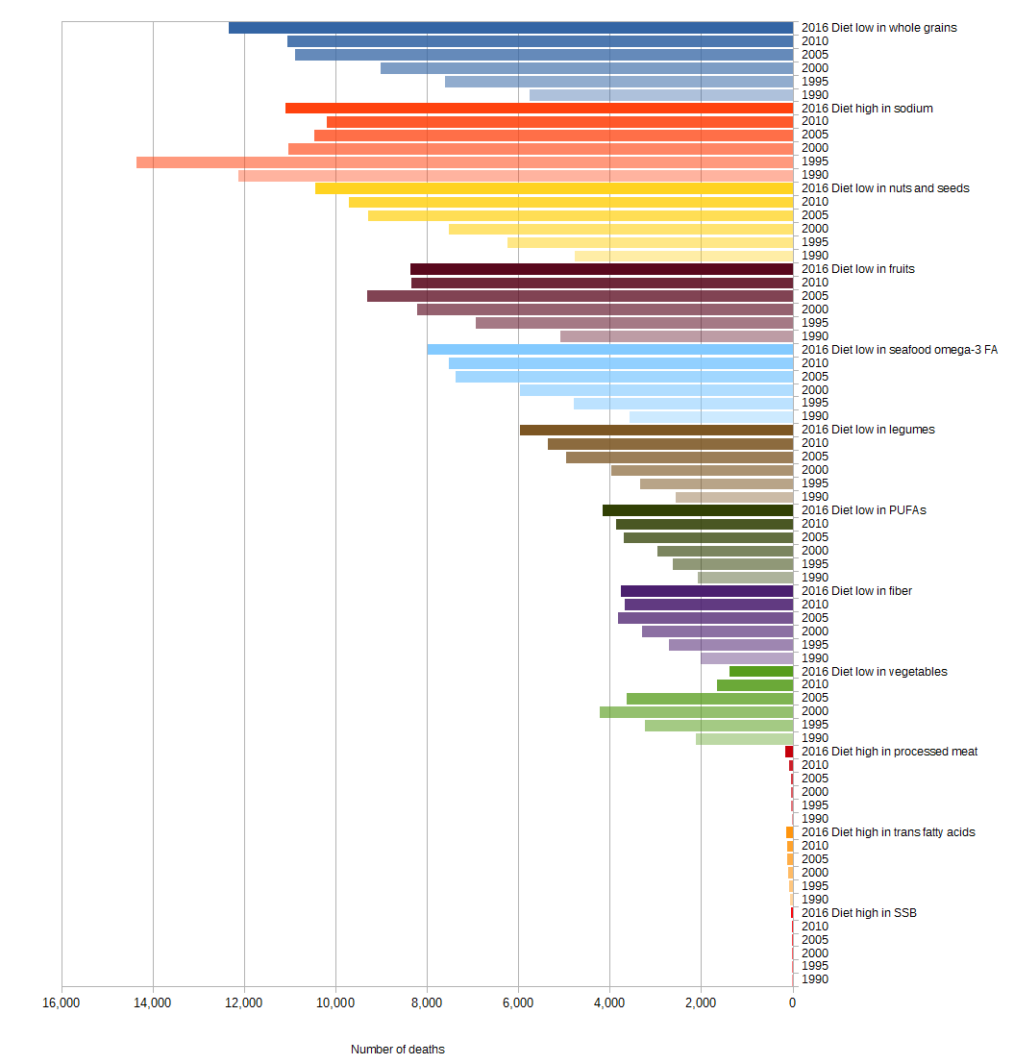
Uzbekistan

Figure 103 Diet-related CVD deaths from 1990 to 2016 in Uzbekistan

a) Male b) Female
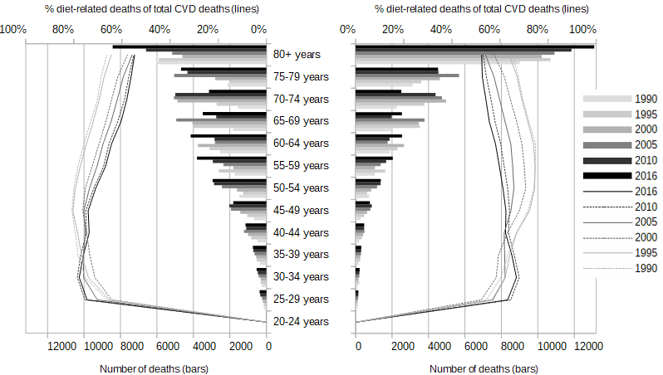
Figure 104 Age- and gender-specific diet-related CVD deaths (bars) and share of diet-related on total CVD deaths (lines) from 1990 to 2016 in Uzbekistan

Murray CJ, Lopez AD. Global mortality, disability, and the contribution of risk factors: Global Burden of Disease Study. Lancet 1997; 349: 1436–42.
GBD 2016 Risk Factors Collaborators. Global, regional, and national comparative risk assessment of 84 behavioural, environmental and occupational, and metabolic risks or clusters of risks, 1990-2016. The Lancet 2017;390:1345–422.
Vos, T., Allen, C., Arora, M., Barber, R. M., Bhutta, Z. A., Brown, A., ... & Coggeshall, M. (2016). Global, regional, and national incidence, prevalence, and years lived with disability for 310 diseases and injuries, 1990–2015: a systematic analysis for the Global Burden of Disease Study 2015. The Lancet, 388(10053), 1545-1602.
Danaei G, Singh GM, Paciorek CJ, et al. (2013). The global cardiovascular risk transition: associations of four metabolic risk factors with national income, urbanization, and Western diet in 1980 and 2008. Circulation; 127: 1493–502, 1502e1-8.
GBD 2016 Risk Factors Collaborators. Global, regional, and national comparative risk assessment of 84 behavioural, environmental and occupational, and metabolic risks or clusters of risks, 1990-2016. The Lancet 2017;390:1345–422.

