Supplement Table 1: Aggregate totals of country-specific ASD prevalences by birth month. N, ASD | N, total births (ASD rate per 10,000)
 | Denmark | Finland | Norway | Sweden | Australia
 | 1987-2004 | 1987-2004 | 1987-2004 | 1987-2004 | 1987-1999
Jan | 1037|94054 (1.1) | 566|89401 (0.63) | 112|87369 (0.13) | 1127|153097 (0.74) | 88|25210 (0.35)
Feb | 1072|89623 (1.2) | 536|84269 (0.64) | 80|83944 (0.1) | 1118|150290 (0.74) | 83|24214 (0.34)
Mar | 1096|100618 (1.09) | 609|97275 (0.63) | 112|94067 (0.12) | 1267|170680 (0.74) | 88|26746 (0.33)
Apr | 1091|99675 (1.09) | 642|94676 (0.68) | 97|93757 (0.1) | 1225|168876 (0.73) | 105|25634 (0.41)
May | 1133|100982 (1.12) | 594|94197 (0.63) | 122|93411 (0.13) | 1304|165897 (0.79) | 92|26228 (0.35)
Jun | 1173|100015 (1.17) | 589|92430 (0.64) | 116|89654 (0.13) | 1176|158544 (0.74) | 83|25567 (0.32)
Jul | 1209|105970 (1.14) | 690|95909 (0.72) | 121|93072 (0.13) | 1316|162050 (0.81) | 96|26003 (0.37)
Aug | 1157|103925 (1.11) | 648|93694 (0.69) | 101|89785 (0.11) | 1188|156830 (0.76) | 113|25652 (0.44)
Sep | 1227|100205 (1.22) | 644|91413 (0.7) | 110|88548 (0.12) | 1254|150079 (0.84) | 106|26463 (0.4)
Oct | 1141|96627 (1.18) | 667|87615 (0.76) | 101|84704 (0.12) | 1215|143701 (0.85) | 90|26072 (0.35)
Nov | 1060|90309 (1.17) | 577|82391 (0.7) | 98|78958 (0.12) | 1146|130018 (0.88) | 101|23751 (0.43)
Dec | 1031|90513 (1.14) | 626|84557 (0.74) | 114|80309 (0.14) | 1165|131130 (0.89) | 89|23975 (0.37)
TOTAL | 13427|1172516 (1.15) | 7388|1087827 (0.68) | 1284|1057578 (0.12) | 14501|1841192 (0.79) | 1134|305515 (0.37)

Supplement Table 2: Percent different in log odds estimates for association of birth month and ASD in Sweden adjusted for maternal education
 | % difference
Jan | -
Feb | 12.9
Mar | 13.0
Apr | 9.7
May | 5.6
Jun | 2.4
Jul | 0.8
Aug | 0.9
Sep | -0.1
Oct | 0.4
Nov | -1.0
Dec | -1.1

Supplement Figure 1: Empirical mode decomposition of Denmark ASD prevalence time series
A
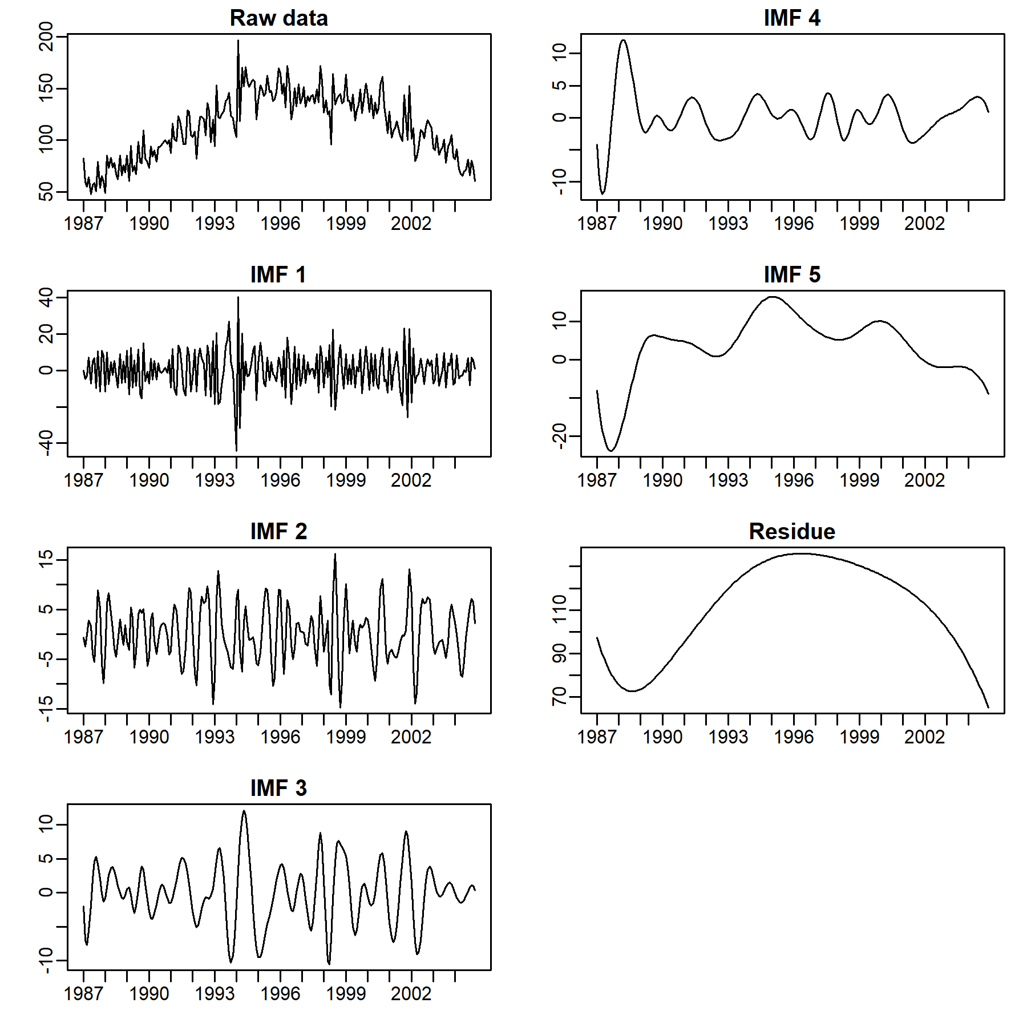
B  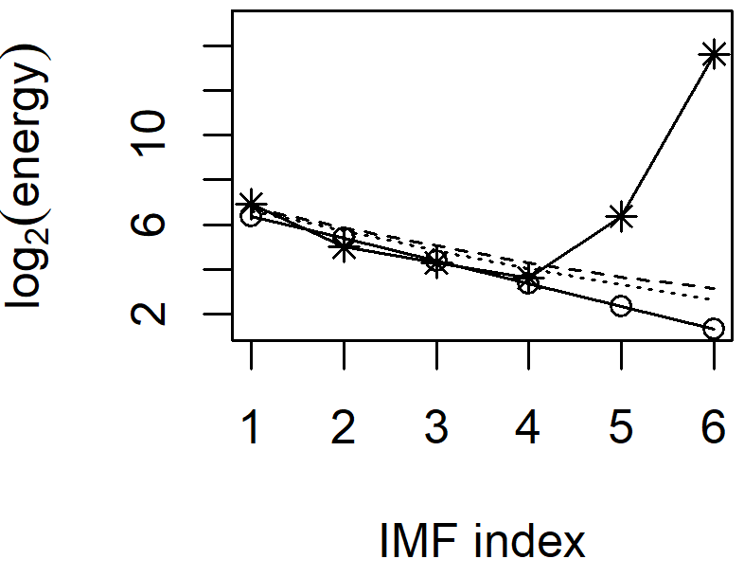 | C  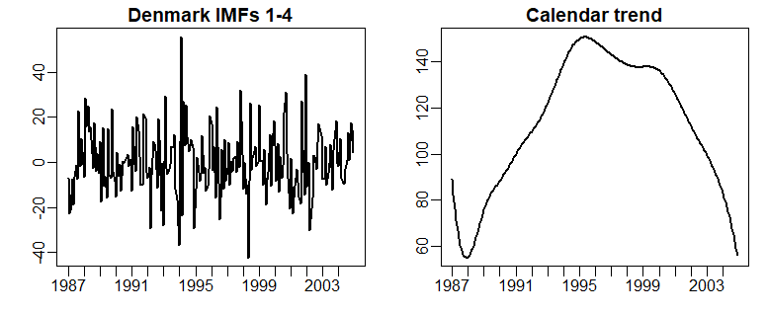

ASD: Autism Spectrum Disorder, IMF: Intrinsic Mode Function.

Supplement Figure 2: Empirical mode decomposition of Finland ASD prevalence time series
A
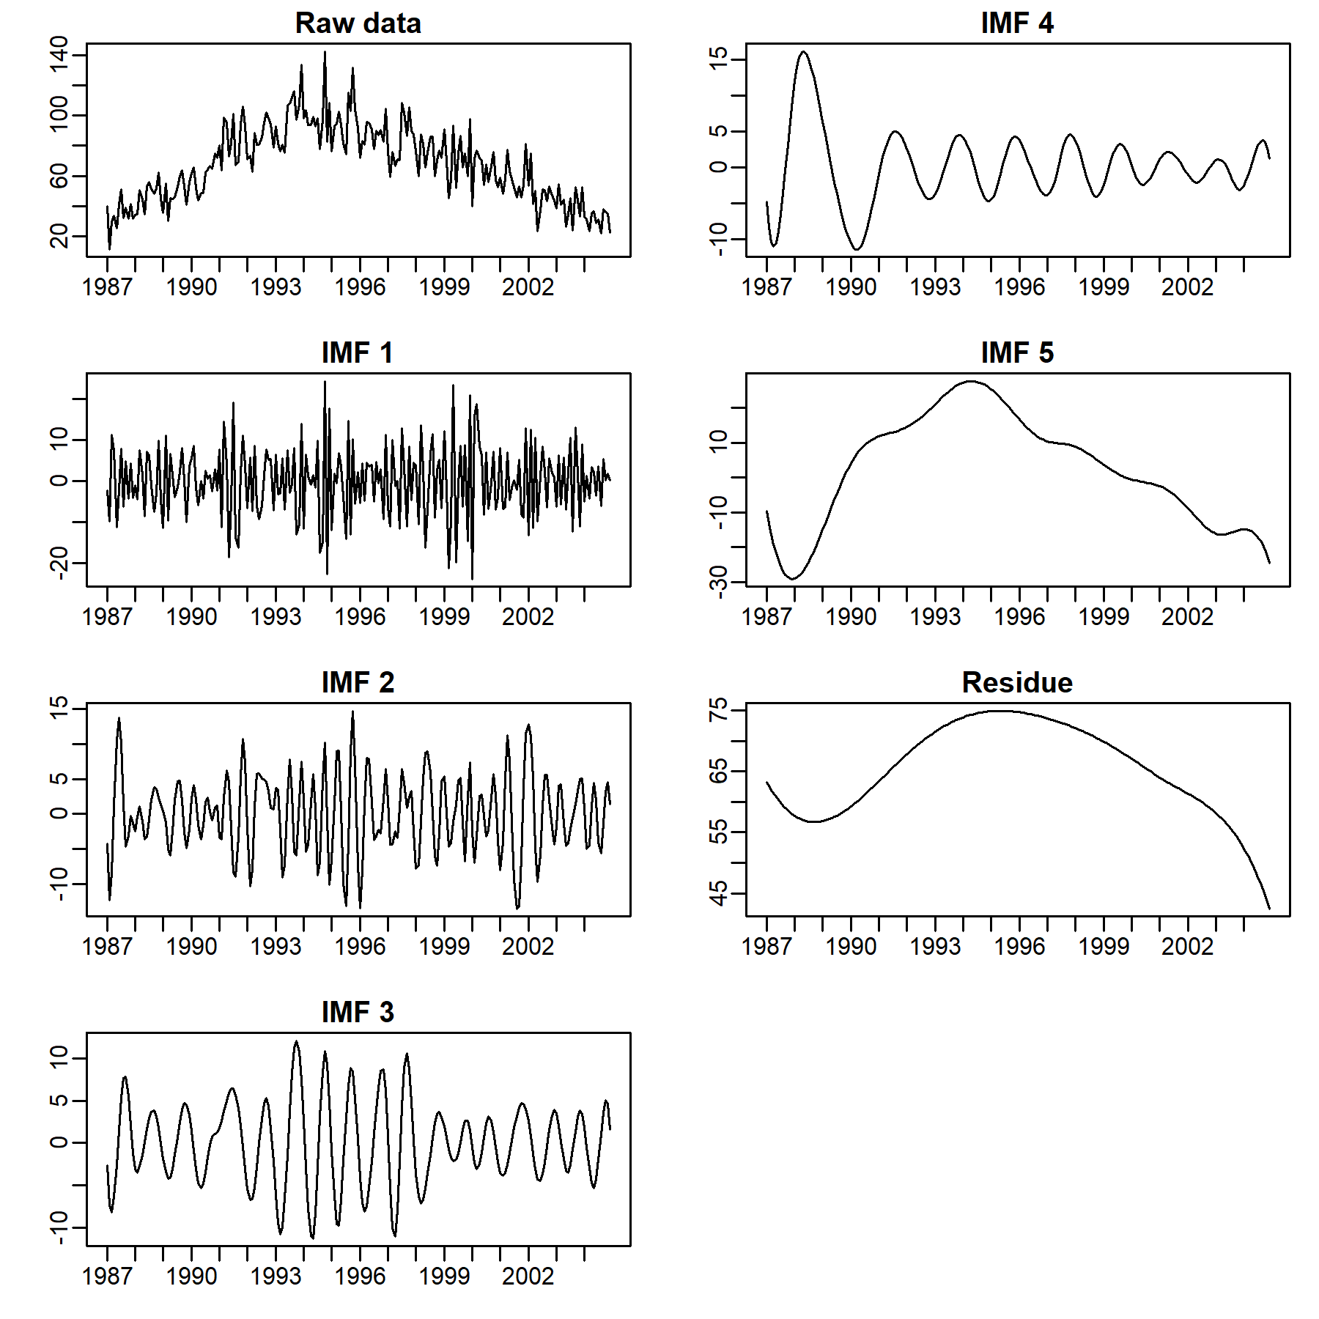
B  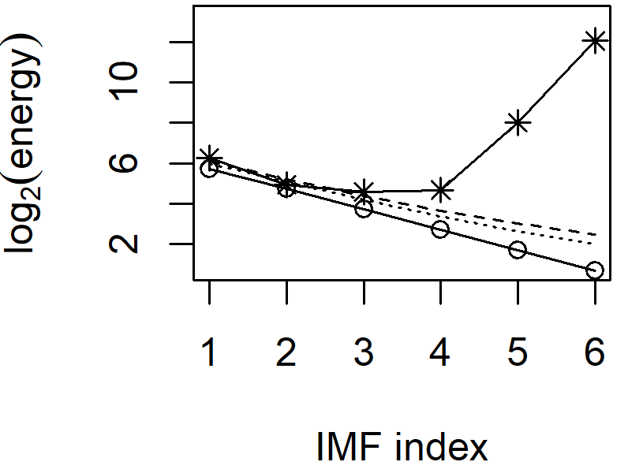 | C  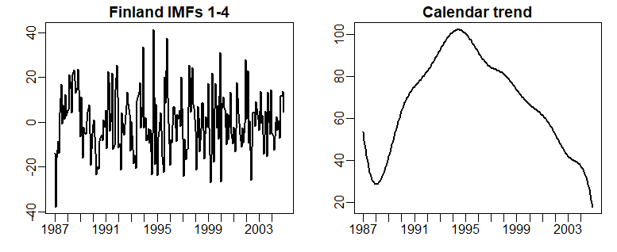

ASD: Autism Spectrum Disorder, IMF: Intrinsic Mode Function.

Supplement Figure 3: Empirical mode decomposition of Norway ASD prevalence time series
A
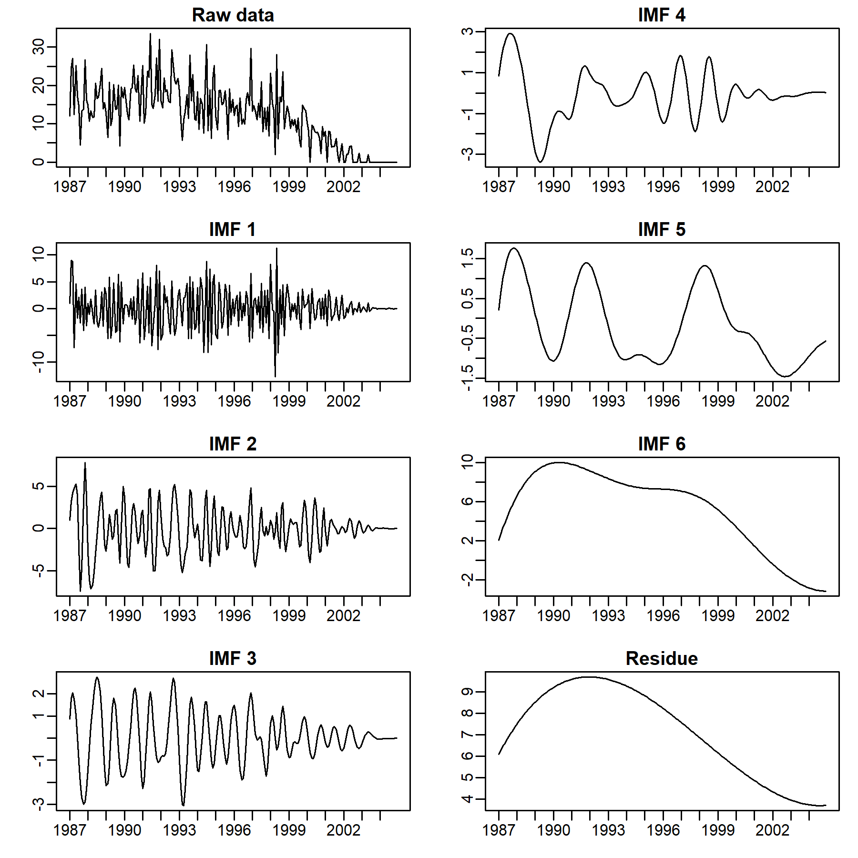
B  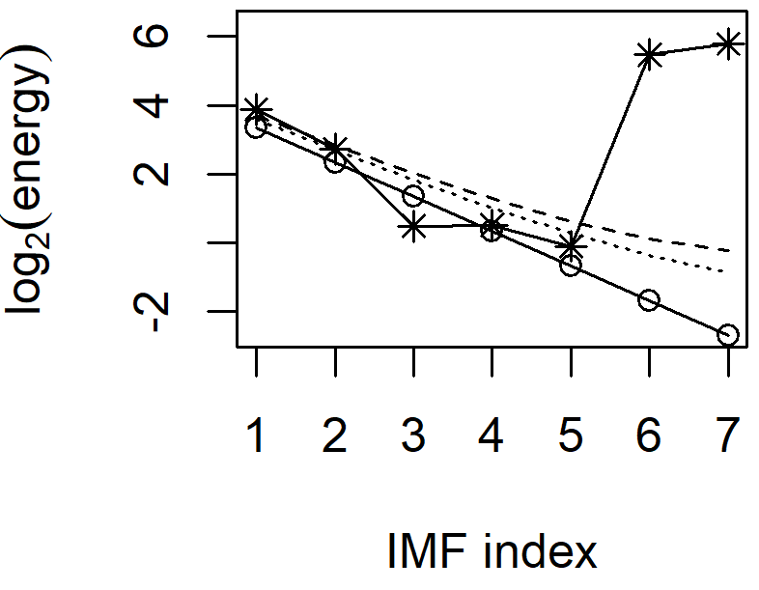 | C  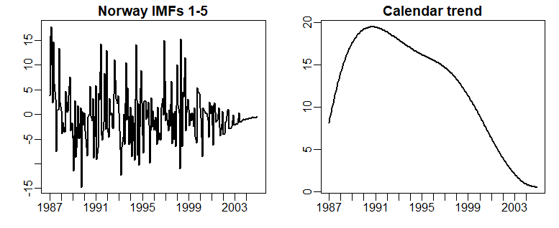

ASD: Autism Spectrum Disorder, IMF: Intrinsic Mode Function.

Supplement Figure 4: Empirical mode decomposition of Sweden ASD prevalence time series
A
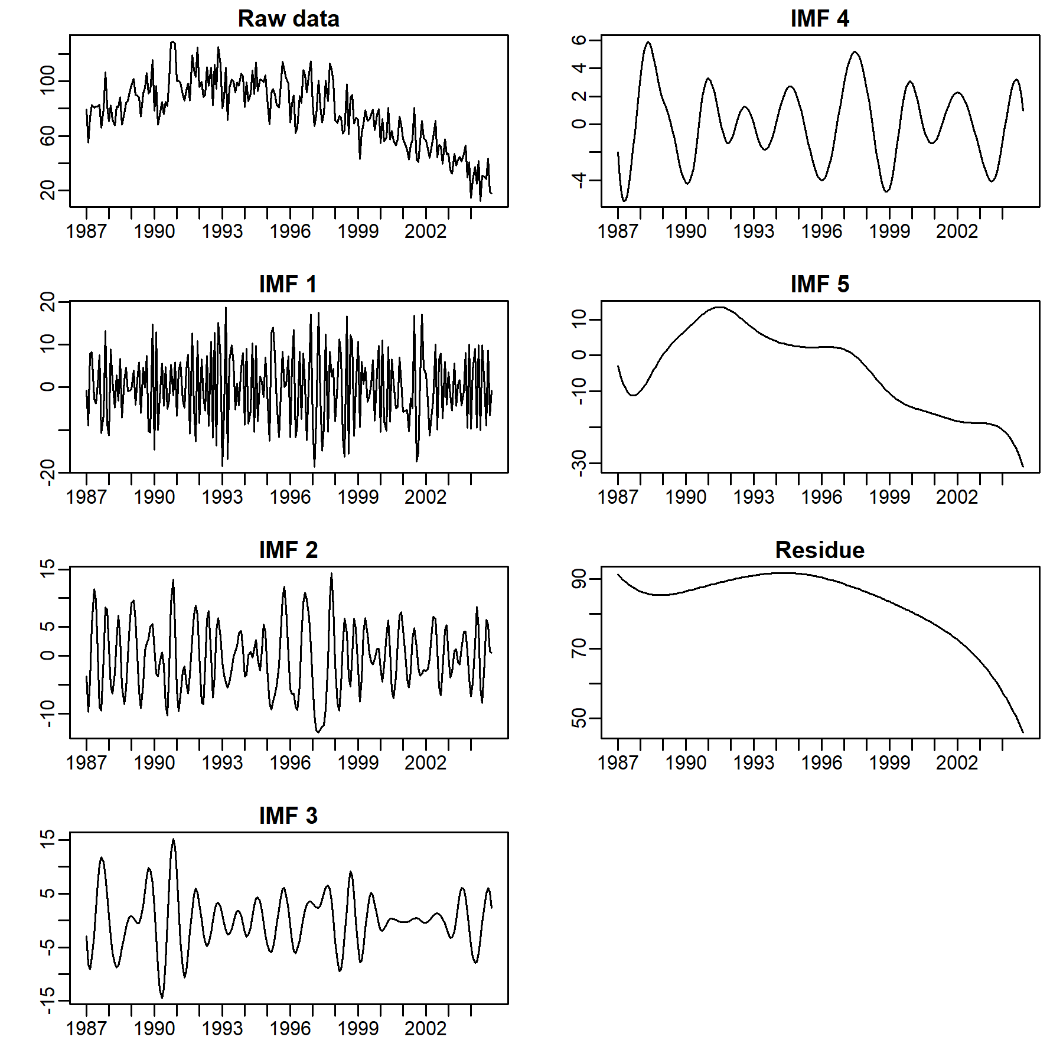
B  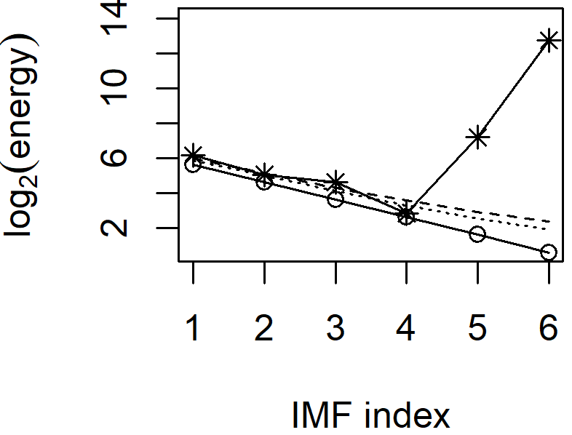 | C  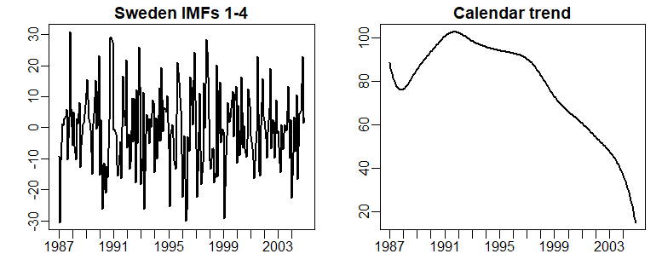

ASD: Autism Spectrum Disorder, IMF: Intrinsic Mode Function.

Supplement Figure 5: Empirical mode decomposition of Western Australia ASD prevalence time series
A
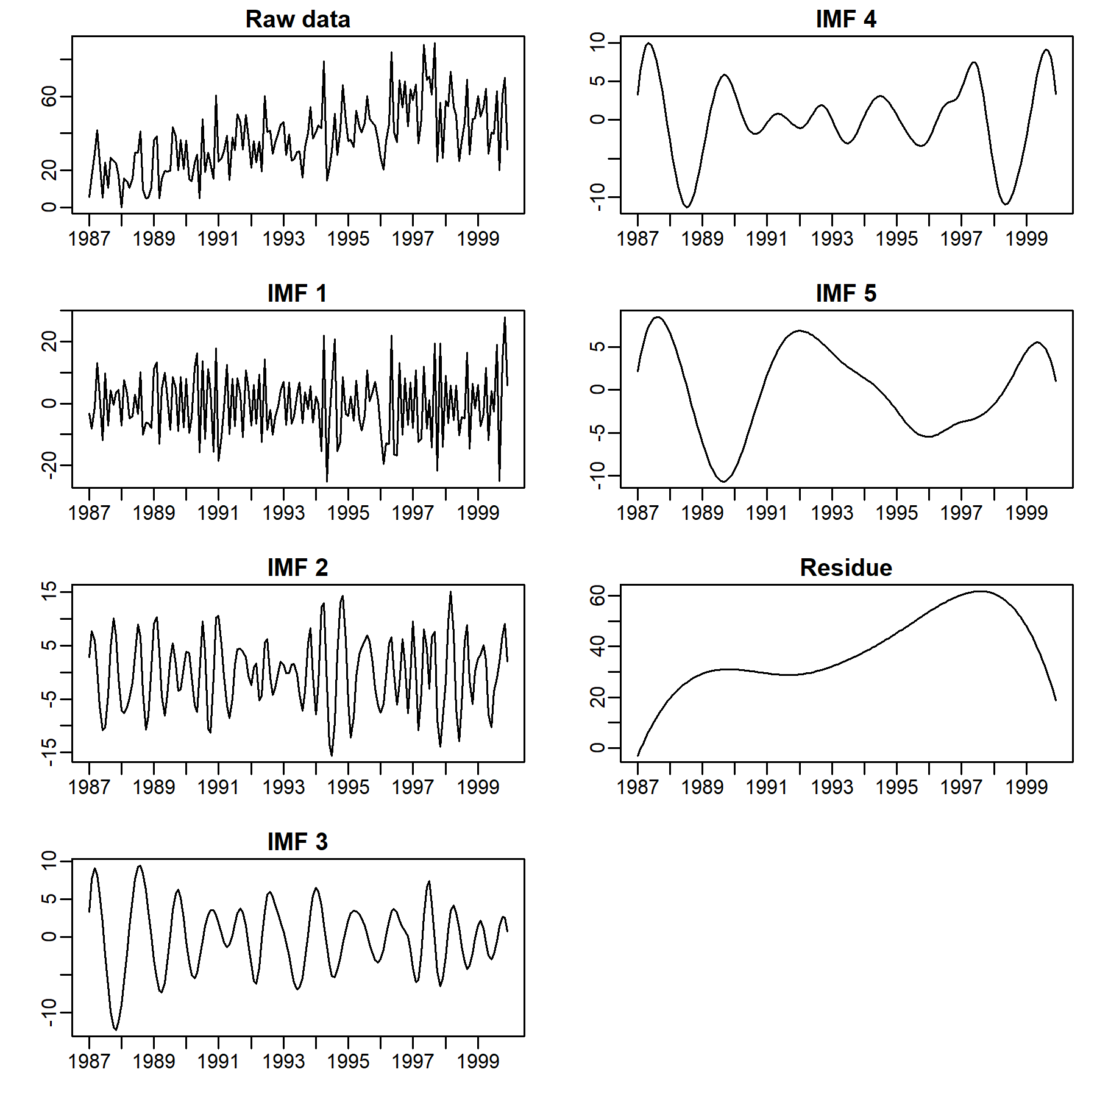
B  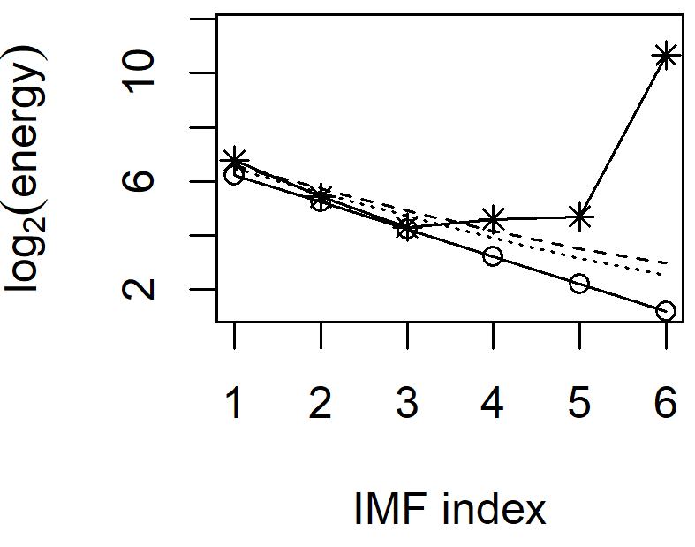 | C  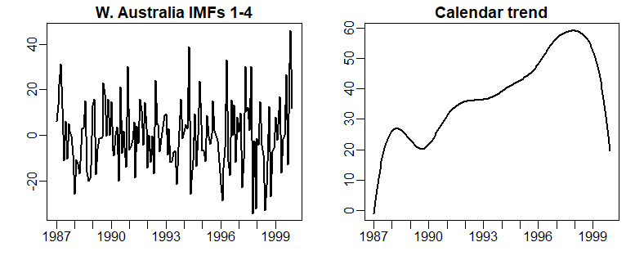

ASD: Autism Spectrum Disorder, IMF: Intrinsic Mode Function.

