Supplementary Materials

Supplementary Table 1. Search terms

PubMed | Embase
(“blood pressure” OR blood pressure[MeSH] OR hypertension OR hypertension[MeSH]) AND (“cardiac arrest” OR cardiac arrest[MeSH] OR “sudden cardiac death” OR sudden cardiac death[MeSH]) AND (“case-control” OR cohort OR cohorts OR prospective OR longitudinal OR “followed up” OR “follow-up” OR “cross-sectional” OR “hazard ratio” OR “relative risk” OR “odds ratio” OR “odds ratios” OR prevalence OR incidence) | (blood pressure OR hypertension OR blood pressure/ OR hypertension/) AND (cardiac arrest OR sudden cardiac death OR cardiac arrest/ OR sudden cardiac death/) AND (case-control OR cohort OR cohorts OR prospective OR longitudinal OR followed up OR follow-up OR cross-sectional OR hazard ratio OR relative risk OR odds ratio OR prevalence OR incidence).

Supplementary Table 2. Cohort studies of hypertension and the risk of sudden cardiac death
First author, publication year, country | Study name or description | Study period | Number of participants, number of cases | Exposure, subgroup | Comparison | Relative risk (95% confidence interval) | Adjustment for confounders
Shaper AG et al., 1993, the United Kingdom²⁹ | British Regional Heart Study (BRHS) | 1978–1980–NA, 8 years follow-up | 5813 men without prior CHD, age 40-59 years: 44 SCDs | Hypertension | Yes vs. no | 2.4 (1.2-4.9) | Age, social class, smoking, heavy drinking, physical activity, blood cholesterol, blood glucose
Weijenberg MP et al., 1996, the Netherlands³⁰ | Zutphen Elderly Study | 1985–1990, 5 years follow-up | 885 men, age 64-84 years: 44 SCDs | Antihypertensive use  Borderline isolated systolic hypertension^{b}  (140 mmHg ≤ SBP < 160 mmHg)  Definite isolated systolic hypertension^{b}  (SBP ≥160 mmHg) | Yes vs. no  (and DBP <75 mmHg)  Yes vs. no  (and SBP <140 mmHg)ª  Yes vs. no  Yes vs. no | 4.32 (1.01-18.40)  8.70 (2.11-35.90)  4.23 (0.86-20.76)  9.20 (1.76-47.97) | Age, BMI, serum total and high-density lipoprotein cholesterol, cigarette smoking, alcohol consumption, use of medications known to lower blood pressure levels without an indication for hypertension, physician who measured the blood pressure
Albert CM et al., 2003, the United States²⁸ | Nurses’ Health Study (NHS) | 1976–1998, 22 years follow-up | 121701 female registered nurses, age 30-55 years: 244 SCDs | Hypertension  Hypertension, age ≤60 years^{b}  Hypertension, age >60 years^{b} | Yes vs. no  Yes vs. no  Yes vs. no | 2.49 (1.87-3.32)  1.94 (1.26-2.98)  3.07 (2.06-4.57) | Age, diabetes, smoking, hypercholesterolemia, parental history of MI before age 60 years, parental history of MI age ≥60 years, BMI, menopausal status, postmenopausal hormone use, prior report of CHD
Straus SMJM et al., 2006, the Netherlands³¹ | Rotterdam Study | 1990–1993–2000, 6.7 years follow-up | 6134 men and women, age ≥55 years: 125 SCDs | Hypertension | Yes vs. no | 2.4 (1.7-3.5) | Age, gender
First author, publication year, country | Study name or description | Study period | Number of participants, number of cases | Exposure, subgroup | Comparison | Relative risk (95% confidence interval) | Adjustment for confounders
Bertoia ML et al., 2012, the United States⁶ | Women’s Health Initiative (WHI) | 1993–1998–2009, 10.8 years follow-up | 160291 post-menopausal women, age 50-79 years: 418 SCDs | Hypertension  Hypertension, without prior CHD^{c} | Yes vs. no  Yes vs. no | 1.46 (1.11-1.93)  1.55 (1.12-2.14) | Age, race, total family income, smoking, resting pulse, BMI, waist-to-hip ratio, WBC, CHD (excluding MI), MI, heart failure, self-reported atrial fibrillation, diabetes mellitus, carotid artery disease
Ohira T et al., 2012, Japan¹¹ | Circulatory Risk in Communities Study (CIRCS) | 1975/1981–2005, 3.5 years follow-up | 26870 men and women, age 30-84 years: nested case-control study: 239 SCD cases, 717 controls | Hypertension | Yes vs. no | 1.52 (1.05-2.19) | Age, sex, examination year, follow-up time, study area, BMI, excess ethanol intake, diabetes mellitus, current smoking, heart rate, atrial fibrillation, SVPC/VPC, major ST-T abnormalities, minor ST-T abnormalities, wide QRS, left high amplitude R wave, abnormal Q wave
Karppi J et al., 2013, Finland¹³ | Kuopio Ischemic Heart Disease Risk Factor Study (KIHD) | 1991–1993–2008, 15.9 years follow-up | 1031 men, age 46-64 years: 59 SCDs | Drug for hypertension | Yes vs. no | 3.82 (2.22-6.56) | Age, SBP, waist circumference, current smoking, alcohol intake, years of education, prevalent CHD, congestive heart failure, diabetes, previous MI, serum 𝛃-carotene, serum low-density lipoprotein cholesterol, serum triglycerides, serum hs-CRP
Rapsomaniki E et al., 2014, the United Kingdom^{34,d} | CALIBER programme | 1997–2010–NA, 5.2 years follow-up | 1258006 men and women free of baseline CVDs, age ≥ 30 years: 2355 cardiac arrest/SCD cases | Hypertension | Yes vs. no | 1.20 (1.15-1.25) | Age, competing risk of other cardiovascular diseases and non-cardiovascular disease mortality
First author, publication year, country | Study name or description | Study period | Number of participants, number of cases | Exposure, subgroup | Comparison | Relative risk (95% confidence interval) | Adjustment for confounders
Mannsverk J et al., 2016, Norway³³ | Tromsø Study | 1994–1995/2001–2002/2007–2008–2010, 12.7 years follow-up | 29582 men and women, age ≥25 years: 332 out-of-hospital sudden deaths | Hypertension | Yes vs. no | 1.75 (1.33-2.29) | Age, sex
Waks JW et al., 2016, the United States¹² | Atherosclerosis Risk in Communities study (ARIC), Cardiovascular Health Study (CHS) | ARIC 1987–1989–2001, 14.1 years follow-up; CHS 1989–1990/1992–1993–2006, 13.1 years follow-up; combined 14.0 years follow-up | ARIC 14609 men and women, age 45-64 years: 291 SCDs; CHS 5568 men and women, age 65-100 years: 195 SCDs; combined 20177 men and women, age 45-100 years: 486 SCDs | Hypertension | Yes vs. no | 2.329 (1.439-3.769) | Age, sex, race, diabetes mellitus, CHD, stroke, SQRT SVG elevation, QRS-T angle, SAI QRST, SAI QRST*age, QRS-T angle*age, QRS-T angle*race, QRS-T angle*diabetes mellitus, QRS-T angle*hypertension, SQRT SVG azimuth*sex

NA, not available; CHD, coronary heart disease; SCD, sudden cardiac death; DBP, diastolic blood pressure; SBP, systolic blood pressure; BMI, body mass index; MI, myocardial infarction; WBC, white blood cell count; SVPC/VPC, supraventricular premature contraction/ventricular premature contraction; ST-T, ST-segment and T-wave; hs-CRP, high sensitivity C-reactive protein; SVG, spatial ventricular gradient; SAI QRST, sum absolute QRST integral. ª Excluded from the meta-analysis considering the extreme relative risk & the very large range of the confidence interval. ^{b} Unique exposures/subgroups excluded from the meta-analysis. ^{c} Subgroup estimates excluded from the primary analysis and used in subgroup and sensitivity analyses. ^{d} Study only included in sensitivity analysis as it assessed a combined outcome of sudden cardiac arrest/sudden cardiac death.

Supplementary Table 3. Cohort studies of blood pressure and the risk of sudden cardiac death
First author, publication year, country | Study name or description | Study period | Number of participants, number of cases | Exposure, subgroup | Comparison | Relative risk  (95% confidence interval) | Adjustment for confounders
Kannel WB et al., 1975, the United States¹⁵ | Albany Study & Framingham Heart Study | Albany 1953–NA, Framingham 1948–1952–NA, 16 years follow-up | 4120 men free of baseline CHD: Albany – 1838 civil servants, age 39-55 years, Framingham – 2282, age 30-62 years: 109 sudden deaths | SBP | Per mmHg | 1.0126 (1.0039-1.0213) | Age, ECG-LVH, metropolitan relative weight, cigarettes/day, cholesterol
Schatzkin A et al., 1984, the United States^{27,a} | Framingham Heart Study | 1948–1952–NA, 26 years follow-up | 2336 men and 2873 women (total 5209) with & without prior CHD, age 30-62 years: 103 sudden unexpected deaths (69 men 34 women) among those without prior CHD | SBP, male, without prior CHD  SBP, female, without prior CHD | Per mmHg  Per mmHg | 1.0106 (1.0004-1.0209)  1.0019 (0.9879-1.0161) | Age, cigarettes, glucose, cholesterol, Framingham relative weight, haematocrit, vital capacity, LVH-ECG, cholesterol*age interaction (male only)
Wannamethee G et al., 1995, the United Kingdom^{16,b} | British Regional Heart Study (BRHS) | 1978–1980–NA, 8 years follow-up | 7735 men, age 40-59 years: 117 SCDs | SBP | ≥161 vs. <128 mmHg | 2.2 (1.2-3.9) | Age
Weijenberg MP et al., 1996, the Netherlands³⁰ | Zutphen Elderly Study | 1985–1990, 5 years follow-up | 885 men, age 64-84 years: 44 SCDs | SBP  DBP | <140 mmHg  140-159 mmHg  ≥160 mmHg  <75 mmHg  75-84 mmHg  85-94 mmHg  ≥95 mmHg | 1.00  4.80 (1.36-16.95)  5.56 (1.54-20.08)  1.00  1.42 (0.37-5.51)  2.03 (0.53-7.73)  3.04 (0.75-12.37) | Age, BMI, serum total and high-density lipoprotein cholesterol, cigarette smoking, alcohol consumption, use of medications known to lower blood pressure levels without an indication for hypertension, physician who measured the blood pressure
First author, publication year, country | Study name or description | Study period | Number of participants, number of cases | Exposure, subgroup | Comparison | Relative risk  (95% confidence interval) | Adjustment for confounders
Jouven X et al., 2001, France¹⁷ | Paris Prospective Study 1 | 1967–1972–1994, 23 years follow-up | 7079 male civil servants free of baseline CHD, age 42-53 years: 118 sudden deaths | SBP | Per 20 mmHg | 1.21 (1.06-1.37) | Age, parental sudden death, parental MI, sport activity, diabetic status, tobacco consumption, BMI, resting heart rate, total cholesterol
Lahtinen AM et al., 2012, Finland¹⁸ | FINRISK 1992 | 1992–2008, 16.8 years follow-up | 5345 men and women, age 25-74 years: 129 SCDs | SBP | Per 10 mmHg | 1.17 (1.08-1.26) | Age, sex, geographic region, HDL/TC ratio, prevalent diabetes, BMI, current smoker, former smoker, physical activity, prevalent CHD
Lahtinen AM et al., 2012, Finland¹⁸ | FINRISK 1997 | 1997–2008, 11.8 years follow-up | 7672 men and women, age 25-74 years: 178 SCDs | SBP | Per 10 mmHg | 1.06 (0.98-1.13) | Age, sex, geographic region, HDL/TC ratio, prevalent diabetes, BMI, current smoker, former smoker, physical activity, prevalent CHD, QT-prolonging drug, Digoxin
Lahtinen AM et al., 2012, Finland¹⁸ | FINRISK 2002 | 2002–2008, 6.8 years follow-up | 8212 men and women, age 25-74 years: 75 SCDs | SBP | Per 10 mmHg | 1.12 (1.02-1.24) | Age, sex, geographic region, HDL/TC ratio, prevalent diabetes, BMI, current smoker, former smoker, physical activity, prevalent CHD, QT-prolonging drug, Digoxin
Lahtinen AM et al., 2012, Finland¹⁸ | Health 2000 | 2000–2001–2008, 8.0 years follow-up | 6400 men and women, age ≥30 years: 112 SCDs | SBP | Per 10 mmHg | 1.06 (0.97-1.16) | Age, sex, geographic region, HDL/TC ratio, prevalent diabetes, BMI, current smoker, former smoker, physical activity, prevalent CHD, QT-prolonging drug, Digoxin
First author, publication year, country | Study name or description | Study period | Number of participants, number of cases | Exposure, subgroup | Comparison | Relative risk  (95% confidence interval) | Adjustment for confounders
Laukkanen JA et al., 2012, Finland^{32,c} | Kuopio Ischemic Heart Disease Risk Factor Study (KIHD) | 1984–1989–2008, 18.9 years follow-up | 2666 men, age 42-61 years: 213 SCDs | SBP  DBP | Per 10 mmHg  Per 10 mmHg | 1.15 (1.07-1.25)  1.17 (1.02-1.35) | Age, alcohol consumption, cigarette smoking, serum low-density lipoprotein cholesterol, type 2 diabetes, BMI, left ventricular hypertrophy, previous MI, family history of CHD, use of antihypertensive medications
Laukkanen JA et al., 2012, Finland^{32,d} | Kuopio Ischemic Heart Disease Risk Factor Study (KIHD) | 1984–1989–2008, 18.9 years follow-up | 2666 men, age 42-61 years: 213 SCDs | SBP  DBP | <123 mmHg  123-132 mmHg  133-145 mmHg  >145 mmHg  <82 mmHg  82-88 mmHg  88-95 mmHg  >95 mmHg | 1.00  0.96 (0.61-1.50)  1.25 (0.82-1.92)  2.04 (1.37-3.03)  1.00  1.03 (0.68-1.56)  1.24 (0.82-1.85)  1.60 (1.06-2.41) | Age, alcohol consumption, cigarette smoking, serum low-density lipoprotein cholesterol, type 2 diabetes, BMI, left ventricular hypertrophy, previous MI, family history of CHD, use of antihypertensive medications
Rapsomaniki E et al., 2014, the United Kingdom^{34,c,e} | CALIBER programme | 1997–2010–NA, 5.2 years follow-up | 1258006 men and women free of baseline CVDs, age ≥ 30 years: 2355 cardiac arrest/SCD cases | SBP  DBP | Per 20 mmHg  Per 10 mmHg | 1.08 (0.99-1.18)  1.11 (1.03-1.21) | Age, sex, primary care practice, smoking, diabetes, total and high-density lipoprotein cholesterol, BMI, blood pressure lowering medications
First author, publication year, country | Study name or description | Study period | Number of participants, number of cases | Exposure, subgroup | Comparison | Relative risk  (95% confidence interval) | Adjustment for confounders
Rapsomaniki E et al., 2014, the United Kingdom^{34,d,e} | CALIBER programme | 1997–2010–NA, 5.2 years follow-up | 1258006 men and women free of baseline CVDs, age ≥ 30 years: 2355 cardiac arrest/SCD cases | SBP  DBP | 90-114 mmHg  115-129 mmHg  130-139 mmHg  140-159 mmHg  160-179 mmHg  ≥180 mmHg  60-74 mmHg  75-84 mmHg  85-89 mmHg  90-94 mmHg  95-99 mmHg  ≥100 mmHg | - (0.87-1.18)  1.00 (0.94-1.06)  1.08 (0.94-1.26)  1.37 (1.15-1.64)  1.67 (1.33-2.10)  2.05 (1.51-2.78)  0.96 (0.81-1.13)  1.04 (1.00-1.08)  1.22 (1.12-1.34)  1.41 (1.24-1.60)  1.63 (1.35-1.96)  2.03 (1.54-2.68) | Age, sex, primary care practice, smoking, diabetes, total and high-density lipoprotein cholesterol, BMI, blood pressure lowering medications
Bogle BM et al., 2018, the United States⁷ | Atherosclerosis Risk in Communities study (ARIC - derivation) | ARIC 1987–1989–NA, 10 years follow-up | 11335 white men and women, age 45-64 years: 95 SCDs  3780 black men and women, age 45-64 years: 50 SCDs | SBP, white^{f}  DBP, white^{f}  SBP, black^{f}  DBP, black^{f} | Per mmHg  Per mmHg  Per mmHg  Per mmHg | 1.025 (1.016-1.035)  0.976 (0.957-0.996)  1.017 (1.005-1.029)  0.995 (0.973-1.017) | Age, sex, total cholesterol, lipid-lowering medication use, hypertension medication use, current smoker, diabetes, BMI

NA, not available; CHD, coronary heart disease; SBP, systolic blood pressure; ECG-LVH, electrocardiographic evidence of left ventricular hypertrophy; SCD, sudden cardiac death; DBP, diastolic blood pressure; BMI, body mass index; MI, myocardial infarction; HDL/TC ratio, high-density lipoprotein-total cholesterol concentration ratio. ª Study only included in subgroup analyses by sex. ^{b} Study excluded from the meta-analysis due to inadequate data (insufficient blood pressure categories for data analysis). ^{c} Data used for linear dose-response analysis. ^{d} Data used for nonlinear dose-response analysis. ^{e} Study only included in sensitivity analysis as it assessed a combined outcome of sudden cardiac arrest/sudden cardiac death. ^{f} Race-specific estimates pooled using the fixed effect model before proceeding to the meta-analysis.

Supplementary Table 4. Relative risks and 95% confidence intervals from the nonlinear dose-response analysis of cohort studies on systolic blood pressure and the risk of sudden cardiac death

Systolic Blood Pressure (mmHg) | Relative Risks (95% Confidence Intervals)
118 | 1.00
120 | 1.01 (0.91-1.11)
125 | 1.05 (0.84-1.33)
130 | 1.15 (0.84-1.57)
135 | 1.28 (0.90-1.84)
140 | 1.46 (1.01-2.12)
145 | 1.71 (1.18-2.48)
150 | 2.00 (1.38-2.91)
155 | 2.39 (1.62-3.53)
160 | 2.87 (1.85-4.44)
165 | 3.43 (2.07-5.70)
170 | 4.15 (2.27-7.59)
175 | 4.99 (2.44-10.18)
180 | 6.04 (2.60-14.03)

Supplementary Table 5. Relative risks and 95% confidence intervals from the nonlinear dose-response analysis of cohort studies on diastolic blood pressure and the risk of sudden cardiac death

Diastolic Blood Pressure (mmHg) | Relative Risks (95% Confidence Intervals)
70 | 1.00
75 | 1.07 (0.73-1.57)
80 | 1.16 (0.61-2.21)
85 | 1.29 (0.57-2.93)
90 | 1.47 (0.61-3.56)
95 | 1.73 (0.74-4.01)
100 | 2.09 (1.01-4.29)
105 | 2.60 (1.39-4.89)
110 | 3.39 (1.44-7.98)
115 | 4.54 (1.06-19.51)
120 | 6.34 (0.62-65.29)

Supplementary Table 6. Quality Assessment of Individual Studies using the Newcastle-Ottawa Quality Assessment Scale

Study | Selection | Comparability | Outcome | Total Score
Kannel WB et al., 1975 | ✕☆☆☆ | ☆☆ | ☆☆☆ | 8
Schatzkin A et al., 1984 | ☆☆☆☆ | ☆☆ | ☆☆☆ | 9
Shaper AG et al., 1993 | ☆☆☆☆ | ☆☆ | ☆☆✕ | 8
Wannamethee G et al., 1995 | ☆☆☆✕ | ☆✕ | ☆☆☆ | 7
Weijenberg MP et al., 1996 | ☆☆☆✕ | ☆☆ | ☆☆☆ | 8
Jouven X et al., 2001 | ✕☆☆☆ | ☆☆ | ☆☆☆ | 8
Albert CM et al., 2003 | ✕☆✕✕ | ☆☆ | ☆☆☆ | 6
Straus SMJM et al., 2006 | ☆☆☆✕ | ☆☆ | ☆☆☆ | 8
Bertoia ML et al., 2012 | ☆☆☆✕ | ☆☆ | ☆☆✕ | 7
Lahtinen AM et al., 2012 | ☆☆☆✕ | ☆☆ | ☆☆☆ | 8
Lahtinen AM et al., 2012 | ☆☆☆✕ | ☆☆ | ☆☆☆ | 8
Lahtinen AM et al., 2012 | ☆☆☆✕ | ☆☆ | ☆☆☆ | 8
Lahtinen AM et al., 2012 | ☆☆☆✕ | ☆☆ | ☆☆☆ | 8
Laukkanen et al., 2012 | ✕☆☆✕ | ☆☆ | ☆☆☆ | 7
Ohira T et al., 2012 | ☆☆☆✕ | ☆☆ | ☆✕✕ | 6
Karppi J et al., 2013 | ☆☆☆✕ | ☆☆ | ☆☆☆ | 8
Rapsomaniki E et al., 2014 | ☆☆☆☆ | ☆☆ | ☆☆✕ | 8
Mannsverk J et al., 2016 | ☆☆☆☆ | ☆☆ | ☆☆☆ | 9
Waks JW et al., 2016 | ☆☆☆✕ | ☆☆ | ☆☆✕ | 7
Khosravi A et al., 2017 | ☆☆☆☆ | ☆☆ | ☆☆✕ | 8
Bogle BM et al., 2018 | ☆☆☆✕ | ☆☆ | ☆☆✕ | 7

Supplementary Fig. 1 Funnel plot of the meta-analysis of cohort studies on hypertension and sudden cardiac death

Supplementary Fig. 2 Influence analysis excluding one study at a time for the meta-analysis of cohort studies on hypertension and sudden cardiac death

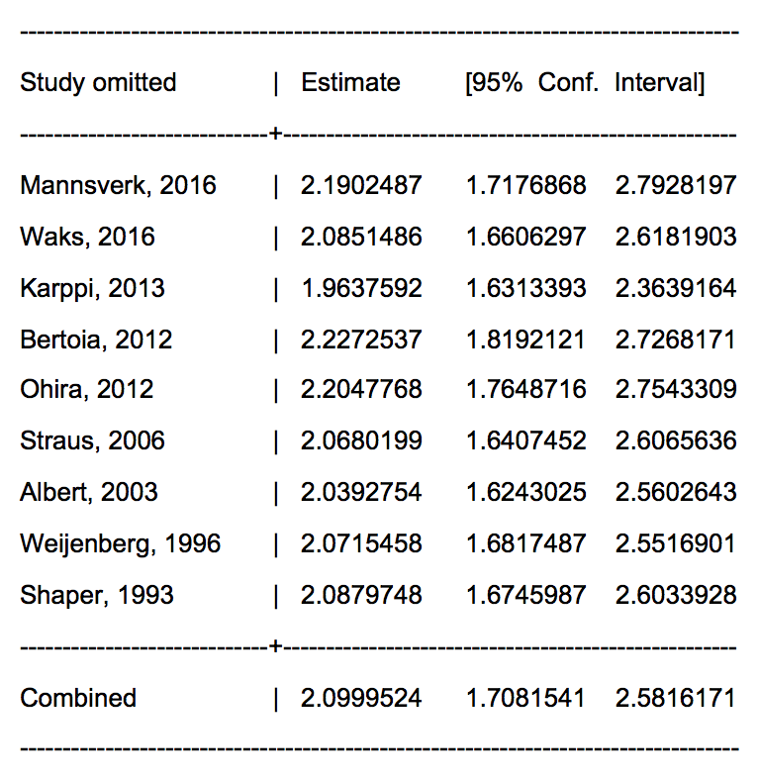

Supplementary Fig. 3 Funnel plot of the meta-analysis of cohort studies on systolic blood pressure and sudden cardiac death

Supplementary Fig. 4 Influence analysis excluding one study at a time for the meta-analysis of cohort studies on systolic blood pressure (per 20 mmHg) and sudden cardiac death
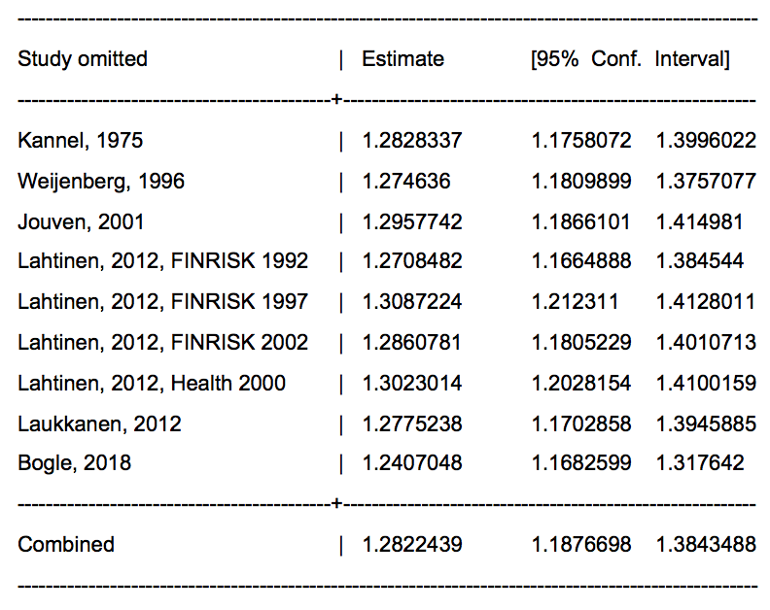

Supplementary Fig. 5 Funnel plot of the meta-analysis of cohort studies on diastolic blood pressure and sudden cardiac death

